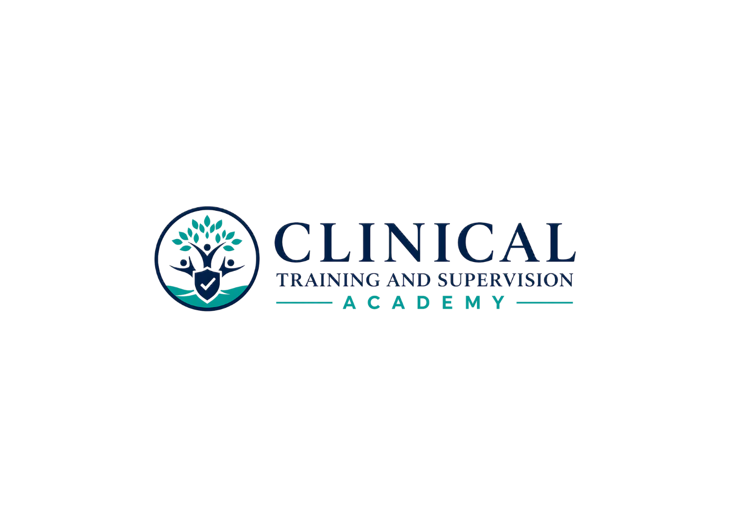
LEARNER ORIENTATION

LPCC California Law & Ethics Exam Preparation
Start Here & Program Orientation
SELF-PACED STUDY | SIX-MONTH ACCESS | NO CE CREDIT
CTA-EP-003 | Version 1.1 | August 7, 2026
Teaching Clinicians How to Think.
WELCOME
This program is designed for California APCCs and other eligible LPCC applicants preparing for the profession-specific California LPCC Law and Ethics Examination. It is an educational study resource, not legal advice, an eligibility determination, official examination content, or a promise of passage.

Program at a Glance
Field | Controlling entry
Formal program | CTA LPCC California Law & Ethics Exam Preparation Program
Public title | LPCC California Law & Ethics Exam Preparation
Program code | CTA-EP-003
Primary audience | California APCCs and other eligible LPCC applicants
Examination | California LPCC Law and Ethics Examination
Separate later examination | NCMHCE - not covered by this program
Format | Self-paced asynchronous study with downloadable and printable resources
Access | Six months from enrollment
Price | $199
CE status | No continuing education credit, evaluation, or certificate
Multimedia | No PowerPoint decks or recordings are required for this program

1. How to Use the Program
- Use the recommended sequence below as a study plan, not as an access requirement.
- Download and print approved learner-facing workbooks, practice materials, rationale files, performance tools, flashcards, and toolkits for personal study during your access term.
- For the strongest diagnostic value, complete each answer-hidden assessment before opening its detailed rationale document, even though learner-facing study files are not sequentially locked.
- Record your answer, confidence, review flags, and timing before checking rationales.
- Review all four option rationales. Correct guesses and low-confidence correct answers still identify study needs.
- Use remediation routes, flashcards, and performance tools to repair the reasoning pattern before retesting.
- Check current official BBS and examination materials near your test date because laws, regulations, forms, fees, and procedures can change.
NO SEQUENTIAL ACCESS LOCKS
All approved learner-facing study materials should be available from the beginning of enrollment. You may study offline and in the order that best supports your preparation. The program may display a recommended order, but it does not require one resource to be completed before another opens.

2. Recommended Study Sequence
Unit | Learner area | Recommended use
00 | Start Here | Program identity, no-CE notice, source-currentness notice, access rules, and study instructions.
01 | LPCC/APCC License-Specific Module | Build the profession-specific foundation: LPCC scope, APCC status, assessment boundaries, advertising, supervision, professional conduct, counseling ethics, and examination distinctions.
02 | Workbook 1 - Informed Consent, Minors, and Family Involvement | Consent, client identity, fees, policies, minors, families, groups, and required disclosures.
03 | Workbook 2 - Telehealth Law and Ethics | Consent, identity/location, jurisdiction, privacy/security, crisis planning, technology, and digital professionalism.
04 | Workbook 3 - Professional Competence | Scope, competence, consultation, supervision, accountability, professional roles, and role clarification.
05 | Workbook 4 - Professional Impairment | Self-monitoring, colleague impairment, consultation, coverage, remediation, and client protection.
06 | Workbook 5 - Preventing Harm and Promoting Client Welfare | Mandated duties, safety, crisis response, nonmaleficence, beneficence, and documentation.
07 | Workbook 6 - Professional Boundaries | Multiple relationships, conflicts, gifts, fees, exploitation, sexual misconduct, and boundary repair.
08 | Workbook 7 - Cultural Humility and Diverse Populations | Dignity, self-determination, intersectionality, language and disability access, advocacy, and organizational barriers.
09 | Workbook 8 - Confidentiality and Information Sharing | Confidentiality, privilege, authorization, subpoenas, court requests, privacy, and multi-person services.
10 | Workbook 9 - Documentation and Records | Record creation, access, amendment, retention, security, technology, and continuity.
11 | Practice Examination A | Complete the 50-question diagnostic form, then use detailed rationales and the performance worksheet.
12 | Practice Examination B | Use the distinct transfer form after reviewing Practice A reasoning errors.
13 | Comprehensive Final Examination | Complete the 100-question cumulative readiness exercise and final remediation plan.
14 | Study Center | Use the 807-card Study Center, decision guides, numbers/timelines, exam traps, readiness checklist, rapid review, schedules, and error log.
15 | Program Close | Create the final test-day plan, review current official candidate materials, and distinguish the later NCMHCE pathway.

3. Assessments and Scores
- CTA assessments use original one-best-answer educational questions. They are not copied or recalled live examination questions.
- Attempts are unlimited. You may repeat assessments after remediation.
- An 80% score may be used as a CTA study-readiness benchmark. It is not the official passing score and does not predict passage.
- Chapter-test technical scoring may use a 70% completion threshold for that chapter-test activity. That internal setting does not control access to other learner materials and is not an official examination passing score.
- A score does not determine licensure or examination eligibility. Eligibility questions must be resolved with the BBS.

4. Source and Update Notice
CTA’s August 2026 release uses current California BBS legal and examination sources and the currently operative counseling-ethics source. High-change topics - including telehealth, advertising, supervision, records, privacy, examination administration, and counseling ethics - should be checked again near your own examination date. CTA will update the program when material official requirements or ethics standards change.

5. Personal Use and Academic Integrity
- Downloads are for the enrolled learner’s personal study use during the access term.
- Do not post, sell, share, upload, or distribute candidate questions, controlled answer materials, flashcards, toolkits, or course files.
- Do not reproduce live, recalled, or third-party proprietary examination questions inside CTA materials or learner discussions.
- Report suspected errors or outdated information to CTA so the controlling source and all dependent files can be reviewed together.

6. Independence and Examination Distinction
IMPORTANT
Clinical Training and Supervision Academy is an independent educational provider and is not affiliated with or endorsed by the California Board of Behavioral Sciences, Pearson VUE, NBCC, CCE, ACA, or another licensing or examination organization. The California LPCC Law and Ethics Examination and the later NCMHCE are separate examinations. This program prepares only for the California LPCC Law and Ethics Examination.

7. Support and Access
- Keep a local personal-study copy of downloaded materials within the permitted-use rules.
- For login, download, display, or quiz issues, contact CTA support and include the program title, device/browser, lesson, and a screenshot when available.
- Six-month access begins at enrollment. Refund, extension, or account exceptions are governed by the current CTA checkout terms and policy, not by this orientation document.
- Before your examination, review the current BBS examination page, current candidate handbook, identification rules, scheduling instructions, and accommodation procedures.
You are ready to begin with the LPCC/APCC License-Specific Module.

