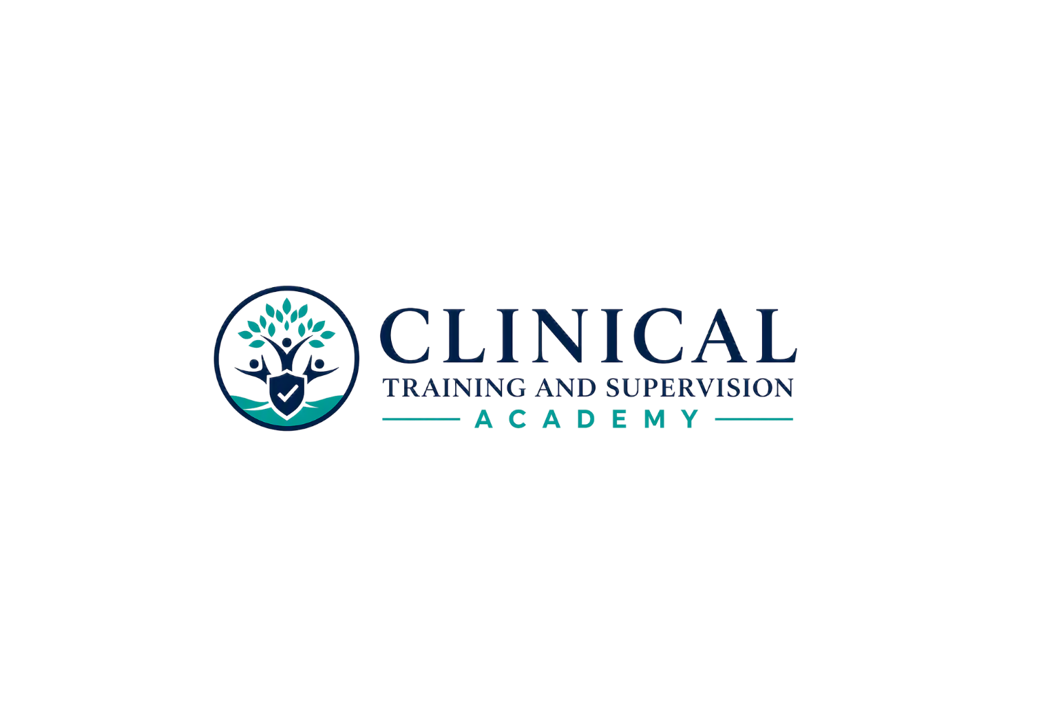
LPCC LAW & ETHICS — STUDY SCHEDULES & ERROR LOG
Flexible 8-week, 4-week, and 2-week pathways plus a structured missed-question repair system
Version 1.1 | August 7, 2026
LEARNER RESOURCE | RELEASE VERSION | NO CE CREDIT
Teaching Clinicians How to Think.

GUIDANCE—NOT ACCESS LOCKING
These pathways recommend order and pacing. Learners may open, download, and print all study materials from the beginning and may study offline. Completion of one resource is not a prerequisite to opening another.

8-Week Standard Pathway
Week | Primary focus | Study objective
1 | Start Here + LPCC/APCC license-specific module + WB1 | Build profession identity, authority, consent, minor/family foundations.
2 | WB2 | Telehealth, technology, social media, privacy/security.
3 | WB3 | Competence, scope, consultation, supervision, roles.
4 | WB4 + WB5 | Impairment, client welfare, harm prevention, judgment.
5 | WB6 + WB7 | Boundaries, exploitation, finances, cultural humility and bias.
6 | WB8 + WB9 | Confidentiality, information sharing, records, documentation, retention/security.
7 | Practice A → remediation → Practice B | Use error categories and chapter routing; do not chase only the score.
8 | Comprehensive Final → targeted review → final-week tools | Concentrate on repeated error patterns, timing rules, and weak chapters.

4-Week Accelerated Pathway
Week | Focus
1 | License-specific module + WB1–WB2
2 | WB3–WB5
3 | WB6–WB9 + rapid review
4 | Practice A → remediation → Practice B → remediation → Comprehensive Final + final review

2-Week Intensive Pathway
Days | Focus
1–2 | License-specific module + WB1
3–4 | WB2–WB3
5–6 | WB4–WB5
7–8 | WB6–WB7
9–10 | WB8–WB9
11 | Practice A + repair
12 | Practice B + repair
13 | Comprehensive Final + targeted review
14 | Numbers/timelines, weak chapters, light final review and logistics

Daily Study Cycle
1. Preview objectives and the chapter Big Idea.
2. Study core content and explain key distinctions aloud.
3. Complete retrieval practice/flashcards without looking first.
4. Complete the chapter assessment or selected practice questions.
5. Read rationales for misses and guesses.
6. Log the error category and exact remediation route.
7. Re-solve one new or rephrased example before marking the concept repaired.

Missed-Question Repair Log
Date | Form/Q | Chosen | Why weaker | Rule/principle | WB/Ch. | Error K/R/S/M/C | Recheck

Repeated-Error Tracker
Error pattern | Count | Examples | Repair action | Status
Knowledge |  |  |  | □ Open □ Repaired
Reasoning/sequence |  |  |  | □ Open □ Repaired
Stem/qualifier |  |  |  | □ Open □ Repaired
Memory retrieval |  |  |  | □ Open □ Repaired
Changed answer |  |  |  | □ Open □ Repaired
Timing/number |  |  |  | □ Open □ Repaired
Role/status |  |  |  | □ Open □ Repaired
Law vs. ethics |  |  |  | □ Open □ Repaired
Overreaction |  |  |  | □ Open □ Repaired
Underreaction |  |  |  | □ Open □ Repaired

Final Targeted Study Plan
Priority | Chapter/concept | Evidence from attempts | Specific repair task | Recheck date
1
2
3
4
5
6
7
8

Source Basis and Currency Control
Source review date: August 7, 2026. California law and current official examination materials control if later changes conflict with this resource. The 2014 ACA Code of Ethics is the operative counseling-ethics source used for this release. CTA will update this resource when a later official ethics code or other material source change becomes effective.
Official source | Reference
California Board of Behavioral Sciences — California Law and Ethics Examination | https://www.bbs.ca.gov/exams/calaw_ethics.html
California Board of Behavioral Sciences — 2026 Statutes and Regulations | https://www.bbs.ca.gov/pdf/publications/lawsregs.pdf
California Board of Behavioral Sciences — Law Changes | https://www.bbs.ca.gov/about/law_changes.html
Pearson VUE — California BBS examination resources | https://www.pearsonvue.com/us/en/bbs.html
American Counseling Association — Ethics Resources | https://www.counseling.org/resources/ethics
American Counseling Association — 2026 Code Revision Project | https://manifold.counseling.org/projects/aca-code-of-ethics
California Legislative Information — Penal Code §11166 | https://leginfo.legislature.ca.gov/faces/codes_displaySection.xhtml?lawCode=PEN&sectionNum=11166.
California Legislative Information — Family Code §6924 | https://leginfo.legislature.ca.gov/faces/codes_displaySection.xhtml?lawCode=FAM&sectionNum=6924.
California Legislative Information — Health & Safety Code §123110 et seq. | https://leginfo.legislature.ca.gov/faces/codes_displayText.xhtml?article=&chapter=1.&division=106.&lawCode=HSC&part=1.&title=
California Legislative Information — Welfare & Institutions Code §15630 | https://leginfo.legislature.ca.gov/faces/codes_displaySection.xhtml?lawCode=WIC&sectionNum=15630.
CURRENTNESS AND UPDATE CONTROL
Approved for learner use under CTA-EP-003. Learners should review current official examination and licensing materials near their examination date. CTA will version and update this resource when material official requirements or ethics standards change.

