**PROJECT TITLE : CREATING A BLOG USING WORDPRESS**

**Brand Name :** ILK^2

**Category :** Air Pods

**Email :** [iswarya.ias@outlook.com](mailto:iswarya.ias@outlook.com)

**Wordpress link : https://ikl24.wordpress.com/2023/10/22/air-pods/**

**Blog creation using wordpress:**

1. Go to wordpress site on Browser:

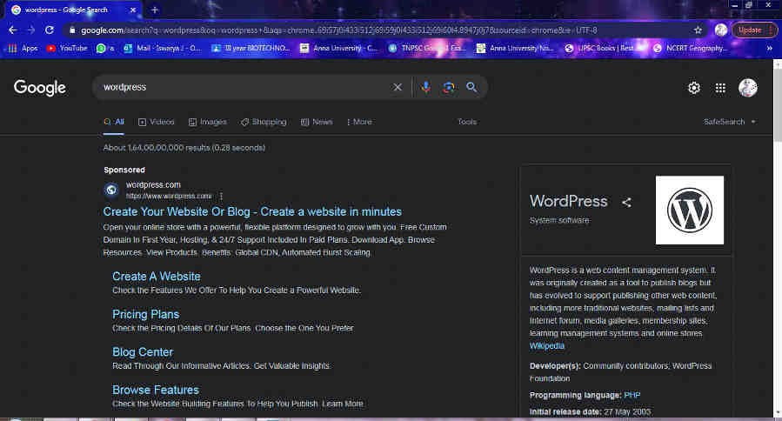

1. Sign in to wordpress:

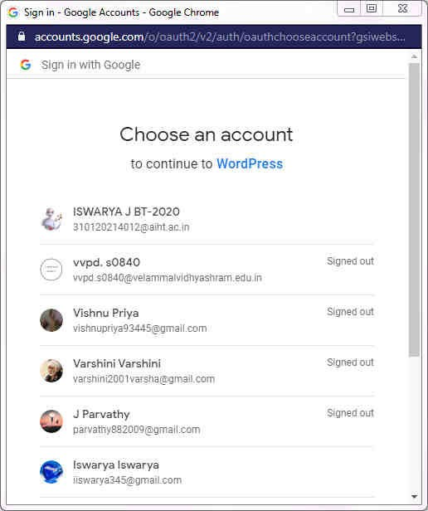

1. Choose a Domain:

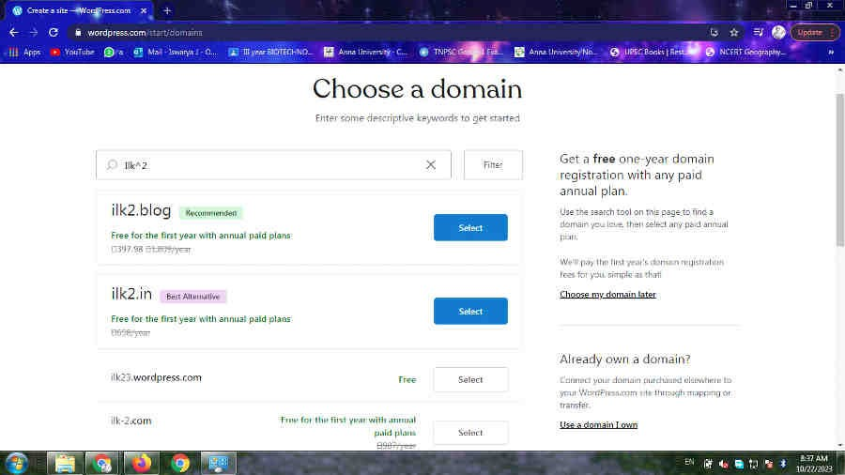

1. Choose flavor of wordpress:

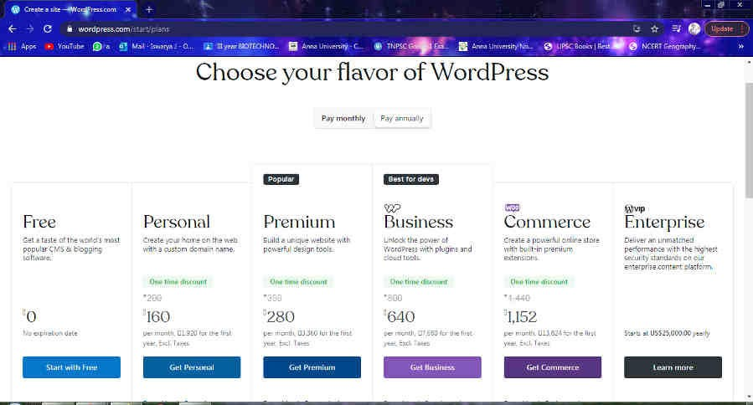

1. Open homepage:

In homepage click bog write on the right side the page.

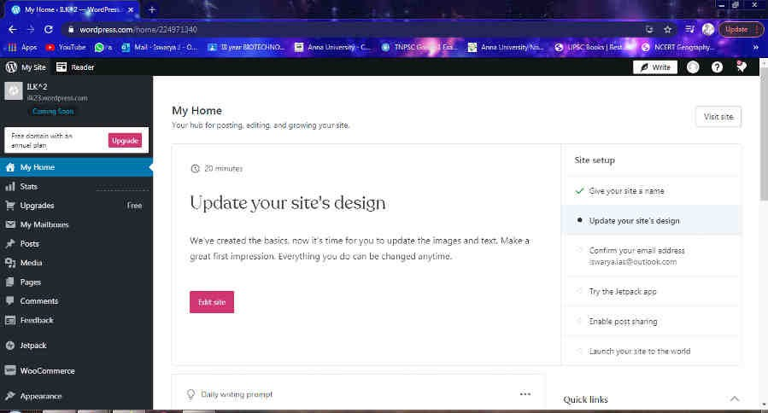

1. Make blog:

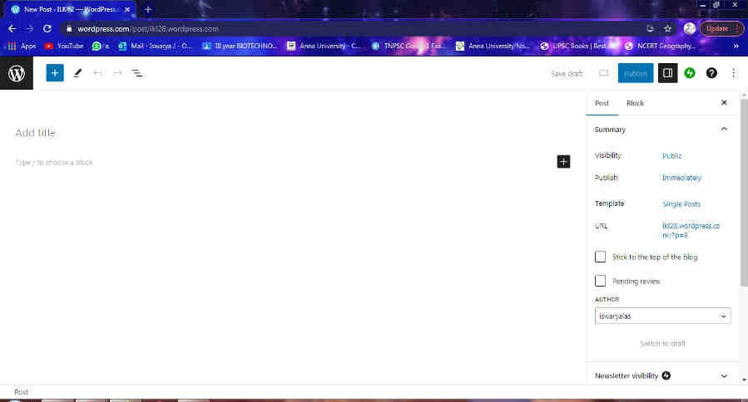

1. Create content of the blog:

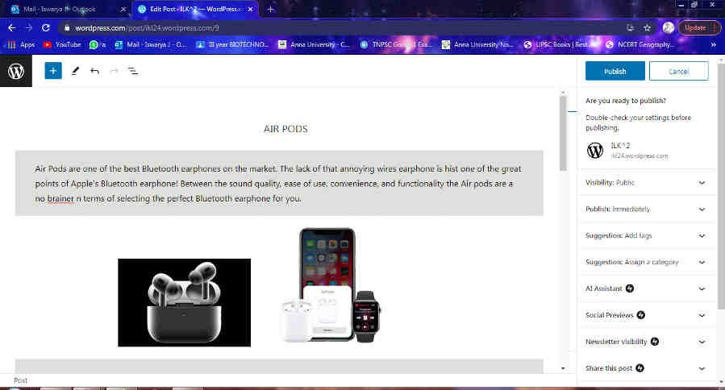

1. Publish the blog post:

