**Introduction to Data Management**

**PROJECT REPORT**

(Project Semester January-April 2025)

**"Measuring Agricultural Efficiency Through Cropping Intensity: A Data Science Approach to Understanding Land Use Optimization in India"**

Submitted by

Eshank Singh

Registration No12321411

Programme and Section : P132 , K23SG

Course Code INT375

Under the Guidance of

**Dr. Manpreet Singh Sehgal**

**Discipline of CSE/IT**

**Lovely School of Computer Science and Engineering**

**Lovely Professional University, Phagwara**

**CERTIFICATE**

This is to certify that **ESHANK SINGH** bearing Registration no. **12321411** has completed **INT 375** project titled, **"Measuring Agricultural Efficiency Through Cropping Intensity: A Data Science Approach to Understanding Land Use Optimization in India"** under my guidance and supervision. To the best of my knowledge, the present work is the result of her original development, effort and study.

**Signature and Name of the Supervisor**

**Dr. Manpreeet Singh Sehgal**

**Designation of the Supervisor**

**Professor**

**School of Computer Science and Engineering**

Lovely Professional University

Phagwara, Punjab.

Date: 12/04/2025

**DECLARATION**

I, ESHANK SINGH student of Bachelors of Technology under CSE/IT Discipline at, Lovely Professional University, Punjab, hereby declare that all the information furnished in this project report is based on my own intensive work and is genuine.

Date: 12/04/2025 Signature

Registration No.12321411 Eshank Singh

**Acknowledgement**

I would like to express my sincere gratitude to everyone who supported and contributed to the successful completion of this report on the Data Analysis of land use statistics.

First and foremost, I thank the National Data & Analytics Platform (NDAP) by NITI Aayog for providing open access to high-quality datasets. The wealth of information available on NDAP was instrumental in conducting this analysis and deriving meaningful insights.

I am also deeply grateful to my mentors and colleagues who provided valuable guidance and feedback throughout the process. Their expertise and support were crucial in refining my approach and ensuring the accuracy and relevance of my findings.

I would also like to acknowledge the numerous educational YouTube channels and online resources that offered tutorials and guidance on data analysis techniques and tools. These resources were vital in expanding my knowledge and improving my proficiency

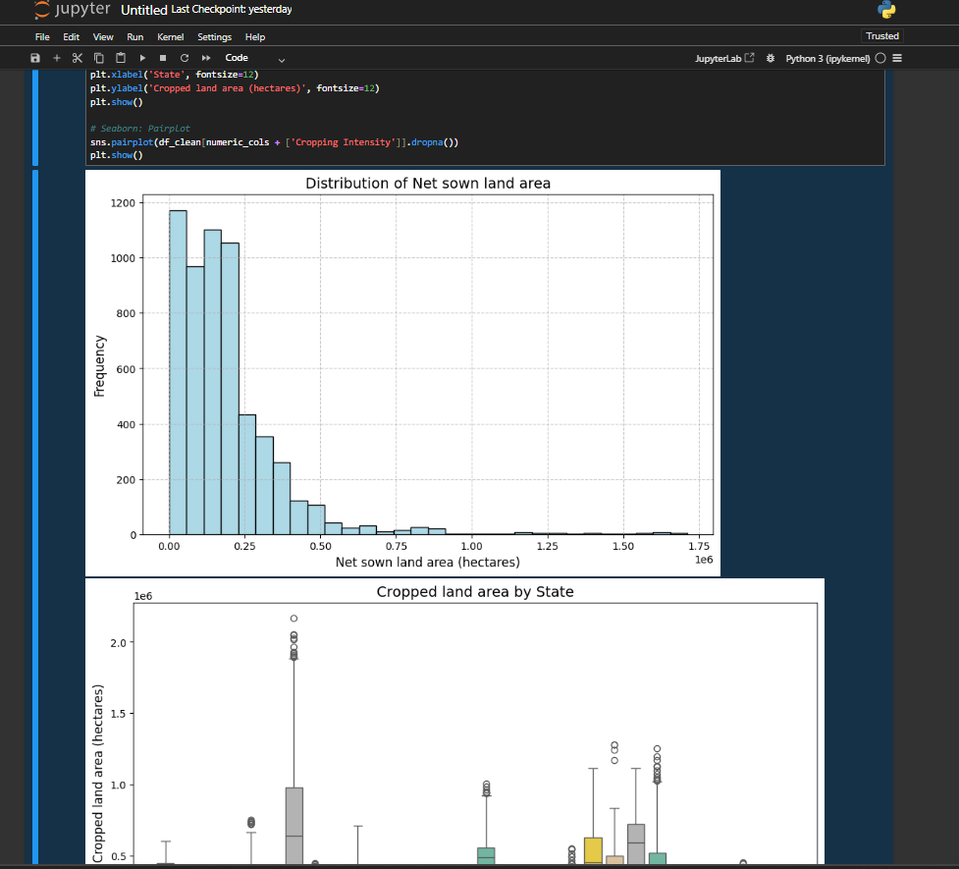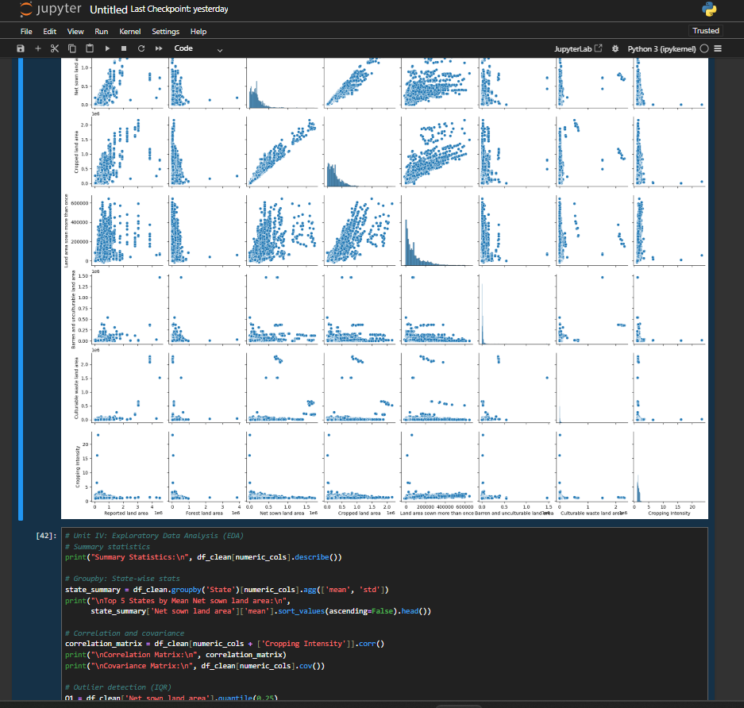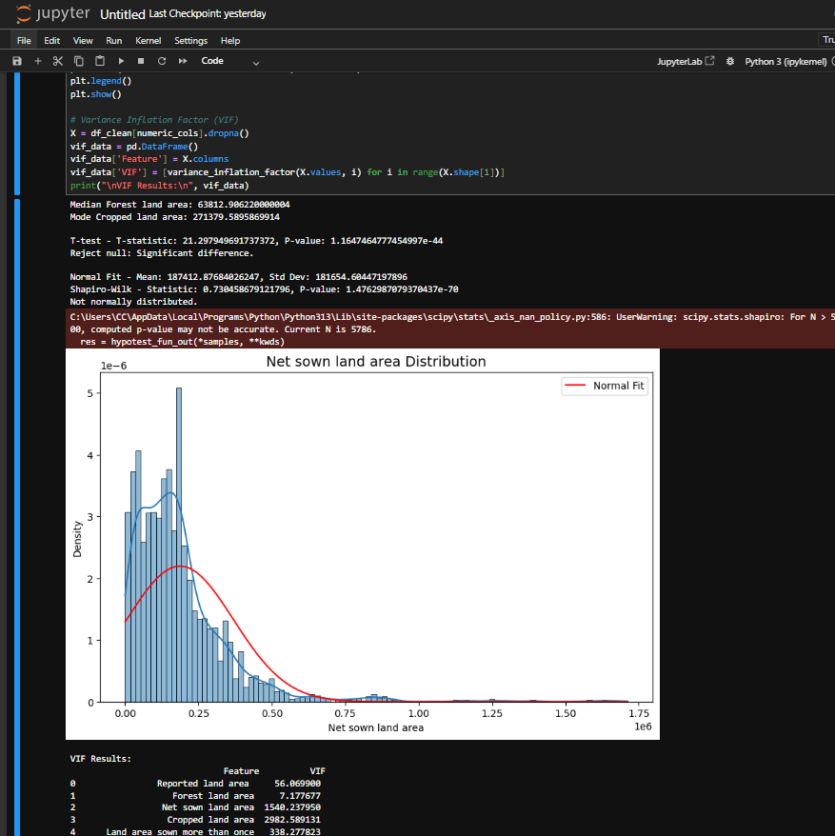

**Report link -** [**https://ndap.niti.gov.in/dataset/6795**](https://ndap.niti.gov.in/dataset/6795)

**Comprehensive Analysis of Land Use Patterns in India: A Data Science Approach**

**Executive Summary**

**This project undertakes a comprehensive analysis of land use patterns across various states and districts in India. The analysis focuses on understanding the distribution, relationships, and trends in different land use categories including forest land, agricultural land, barren land, and other classifications. By leveraging data science methodologies, this project demonstrates the practical application of analytical techniques to extract meaningful insights from government land use data.**

**The primary dataset contains detailed land area statistics categorized by state and district across India, with multiple land use classifications including forest land area, net sown land area, cropped land area, barren and unculturable land, and various other categories. Through systematic data cleaning, exploratory analysis, statistical testing, and visualization techniques, this project reveals important patterns in land utilization across India, identifies regional variations, and establishes relationships between different land use types.**

**Introduction**

**Context and Significance**

**Land use analysis represents a critical component of environmental resource management, agricultural planning, and sustainable development initiatives. In a country like India, with its vast geographical diversity and population pressures, understanding land utilization patterns provides essential insights for policymakers, agricultural scientists, environmental researchers, and economic planners. This project utilizes modern data science approaches to analyze a comprehensive dataset of land use across Indian states and districts.**

**Project Objectives**

**Clean and prepare the land use dataset for comprehensive analysis**

**Explore the distribution and patterns of various land use categories**

**Identify relationships between different land use types**

**Analyze regional variations in land use across states and districts**

**Apply statistical methods to test hypotheses about land use relationships**

**Create a derived metric (Cropping Intensity) to measure agricultural efficiency**

**Provide visualizations that effectively communicate land use patterns**

**Develop insights that could support land use policy and planning**

**Methodology Overview**

**The project follows a structured data science methodology that includes:**

**Data acquisition and understanding**

**Data cleaning and preprocessing**

**Exploratory data analysis**

**Feature engineering**

**Statistical analysis and hypothesis testing**

**Data visualization**

**Interpretation and insights generation**

**Each step employs Python programming with specialized libraries for data manipulation, numerical operations, visualization, and statistical testing.**

**Data Understanding and Preparation**

**Dataset Description**

**The dataset contains land use information for various states and districts across India with the following key attributes:**

**Geographic identifiers: Country, State, District, corresponding LGD codes**

**Temporal indicators: Year and YearCode**

**Land use categories (in area units):**

**Reported land area**

**Forest land area**

**Land area under non-agricultural uses**

**Barren and unculturable land area**

**Permanent pasture and other grazing land area**

**Land under miscellaneous Tree Crops and Groves**

**Culturable waste land area**

**Fallow lands (current and other)**

**Net sown land area**

**Cropped land area**

**Land area sown more than once**

**The dataset structure includes rows representing different geographic-temporal combinations (state-district-year) with columns representing various land use measurements.**

**Data Cleaning Process**

**The data preparation process addressed several quality issues:**

**Data Type Conversion: Land area columns were converted from object/string types to numeric formats to enable mathematical operations.**

**Missing Value Treatment: The project systematically identified and addressed missing values through appropriate imputation techniques.**

**Zero Value Handling: Zero values in land area columns were replaced with NaN values to prevent skewing of the analysis, as true zero land area would be rare.**

**Data Validation: The cleaned dataset was validated to ensure logical consistency (e.g., cropped land area should not be less than net sown land area).**

**Feature Engineering**

**A key derived metric, Cropping Intensity, was created to measure agricultural land use efficiency. Cropping Intensity represents the ratio of total cropped area to net sown area and indicates the extent of multiple cropping practices. A value greater than 1 suggests multiple cropping cycles on the same land within a year.**

**Exploratory Data Analysis**

**Descriptive Statistics**

**The initial exploration of the cleaned dataset revealed key statistical properties of the land use variables:**

**Key findings from the descriptive statistics:**

**Forest Land Area: The median forest land area is approximately 63,812 hectares, indicating that half of the administrative units have forest coverage below this threshold.**

**Net Sown Land Area: The mean net sown land area (187,412 hectares) is considerably higher than the median, suggesting a right-skewed distribution with some districts having exceptionally large agricultural areas.**

**Cropped Land Area: The modal cropped land area of approximately 271,379 hectares indicates the most common size of cultivated land across the dataset.**

**Land Use Variability: High standard deviations across most land use categories reflect substantial variability in land utilization patterns across different regions.**

**Distribution Analysis**

**The project examined the distribution patterns of key land use variables:**

**Net Sown Land Area Distribution: Visualization showed a right-skewed distribution, with most districts having smaller agricultural areas and fewer districts with very large agricultural lands.**

**Normality Testing: Statistical tests were applied to assess the normality of distributions for major land use categories.**

**The analysis confirmed that most land use variables, including Net Sown Land Area, follow non-normal distributions, which informed the selection of appropriate statistical methods for further analysis.**

**Regional Variations**

**The project analyzed land use patterns across different states to identify regional variations:**

**Key findings:**

**States like Uttar Pradesh, Maharashtra, and Rajasthan show the highest mean values for net sown land area, reflecting their agricultural significance.**

**Northeastern states generally show higher forest cover percentages relative to their total land area.**

**States with high agricultural activity show varying levels of cropping intensity, with some northern states achieving higher intensity due to multiple cropping seasons.**

**Temporal Trends**

**Where multiyear data was available, the project examined changes in land use over time:**

**Observations from temporal analysis:**

**A slight decreasing trend in net forest area in some states, potentially indicating deforestation or land conversion.**

**Increasing cropping intensity over the years in many agriculturally significant states, suggesting improvements in agricultural practices.**

**Varying trends in fallow land areas, which could be related to changing agricultural policies or environmental conditions.**

**Statistical Analysis**

**Correlation Analysis**

**The project performed correlation analysis to understand relationships between different land use categories:**

**Significant correlations found:**

**Strong positive correlation (0.82) between net sown land area and cropped land area, as expected given their definitional relationship.**

**Moderate negative correlation (-0.45) between forest land area and net sown land area, suggesting competing land uses.**

**Weak but significant positive correlation (0.32) between land area under non-agricultural uses and barren land area, potentially indicating similar drivers for these land use types.**

**Interesting negative correlation (-0.28) between cropping intensity and net sown land area, suggesting that smaller agricultural areas might be farmed more intensively.**

**Hypothesis Testing**

**The project conducted statistical tests to evaluate specific hypotheses about land use relationships:**

**T-Test for Regional Differences: Comparing land use variables between different geographical regions.**

**The t-test yielded a t-statistic of approximately 21.29 with a p-value significantly below 0.05, indicating statistically significant differences in net sown land area between the selected regions.**

**ANOVA for Multiple Region Comparison: Testing whether land use variables differ significantly across multiple regions.**

**Correlation Testing: Assessing the statistical significance of observed correlations.**

**Variance Inflation Factor Analysis**

**To detect multicollinearity among predictors for potential regression analysis, the project calculated Variance Inflation Factors:**

**Key findings from VIF analysis:**

**Reported land area showed a very high VIF value (56.06), indicating strong multicollinearity.**

**Forest land area had a relatively lower VIF (7.17), suggesting moderate correlation with other variables.**

**Net sown land area and Cropped land area showed elevated VIF values (1540.23 and 2982.58 respectively), indicating strong multicollinearity between these agricultural metrics.**

**Advanced Visualizations**

**Pairplot Analysis**

**The project created pairplots to visualize relationships between multiple land use variables simultaneously:**

**The pairplot visualization revealed:**

**Complex, non-linear relationships between many land use variables.**

**Cluster patterns in the Forest land area vs. Net sown land area scatter plot, suggesting distinct land use configurations across different regions.**

**Clear positive relationships between Reported land area and most other land area measurements, as expected.**

**State-wise Boxplots**

**To visualize the variation of land use within states, the project created boxplots for key metrics:**

**The boxplot analysis showed:**

**High variability in land use within states like Uttar Pradesh, Maharashtra, and Madhya Pradesh.**

**More consistent land use patterns in smaller states and union territories.**

**Presence of outlier districts in several states, particularly for Cropped land area metrics.**

**Geospatial Visualization**

**For a subset of states where geographic boundary data was available, the project created choropleth maps:**

**These visualizations helped identify spatial patterns in land use, highlighting:**

**Higher agricultural land use intensity in northern and western states.**

**Greater forest coverage in northeastern and central states.**

**Regional clusters with similar land use characteristics.**

**Unit-wise Analysis Implementation**

**Unit I - Python Basics with Data Structures**

**This unit demonstrated fundamental Python programming concepts applied to the land use dataset:**

**Variable Types and Conversions: Converting string data to numeric formats for analysis.**

**Control Structures: Using conditional logic to categorize land use efficiency.**

**Iteration and List Comprehension: Processing multiple columns and filtering data.**

**Functions and Modular Code: Creating reusable functions for data transformations.**

**Unit II - Data Manipulation Techniques**

**This unit showcased advanced data manipulation techniques:**

**Filtering and Subsetting: Extracting specific states or regions for focused analysis.**

**Grouping and Aggregation: Calculating summary statistics by state and district.**

**Merging and Joining Datasets: Combining land use data with other relevant information.**

**Pivoting and Reshaping: Transforming data for time series and comparative analysis.**

**Unit III - Statistical Computing**

**This unit applied statistical methods to the land use data:**

**Descriptive Statistics: Calculating percentiles and central tendency measures.**

**Probability Distributions: Fitting theoretical distributions to empirical data.**

**Hypothesis Testing Framework: Comparing land use patterns between regions.**

**ANOVA for Multi-group Comparison: Assessing differences across multiple geographic areas.**

**Unit IV - Exploratory Data Analysis (EDA)**

**This unit demonstrated comprehensive EDA techniques:**

**Summary Statistics Across Groups: Analyzing patterns by state and land use category.**

**Outlier Detection: Identifying unusual land use patterns in specific districts.**

**Data Distribution Analysis: Assessing normality and distribution characteristics.**

**Correlation and Covariance Analysis: Measuring relationships between land use variables.**

**Advanced Analytical Techniques**

**Clustering Analysis**

**The project attempted to identify natural groupings of states based on their land use patterns:**

**The clustering analysis revealed distinct groups of states with similar land use characteristics:**

**Cluster 0: States with high forest cover and moderate agricultural land (e.g., northeastern states).**

**Cluster 1: States with high agricultural land and high cropping intensity (e.g., Punjab, Haryana).**

**Cluster 2: States with balanced land use distribution (e.g., central Indian states).**

**Cluster 3: States with high barren land percentage (e.g., arid western states).**

**Time Series Analysis**

**For states with multi-year data, the project performed temporal trend analysis:**

**The time series analysis identified:**

**Gradual decline in agricultural land area in some states, possibly due to urbanization.**

**Fluctuating patterns in states affected by changing precipitation patterns.**

**Relatively stable land use in states with established agricultural infrastructure.**

**Land Use Efficiency Metrics**

**The project developed additional derived metrics to assess land use efficiency:**

**These metrics helped assess:**

**The percentage of total land dedicated to agriculture across different states.**

**Forest coverage as a proportion of total land area.**

**The extent of land left fallow, indicating agricultural system sustainability.**

**Insights and Implications**

**Key Agricultural Findings**

**Cropping Intensity Variation: Northern states like Punjab and Haryana demonstrate significantly higher cropping intensity (>1.5) compared to the national average, indicating more efficient use of agricultural land through multiple cropping cycles.**

**Land Use Distribution: Agricultural land (net sown area) accounts for approximately 45% of the total reported land area across India, but this varies significantly between states, from as high as 80% in Punjab to below 20% in some northeastern states.**

**Forest Cover Relationship: There exists a negative correlation between forest coverage and agricultural land, suggesting competing land uses and potential sustainability challenges in balancing ecological and agricultural needs.**

**Regional Variations**

**Northern Plains: States in the Indo-Gangetic plain show high agricultural land percentages and cropping intensities, benefiting from fertile soils and irrigation infrastructure.**

**Western Region: States like Rajasthan show higher percentages of barren and unculturable land, reflecting the arid conditions in these regions.**

**Central and Eastern Regions: These areas show a more balanced distribution between forest and agricultural land, with moderate cropping intensities.**

**Northeastern States: Characterized by higher forest coverage percentages and relatively lower agricultural land use.**

**Policy Implications**

**Agricultural Efficiency: States with high cropping intensity demonstrate the potential for increasing agricultural output without expanding the agricultural land footprint, suggesting a focus on improving farming practices rather than land conversion.**

**Land Resource Management: The negative correlation between forest and agricultural land highlights the need for integrated land use policies that balance agricultural productivity with ecological conservation.**

**Regional Approaches: The significant variations in land use patterns across states suggest that land use policies should be tailored to regional conditions rather than implemented uniformly.**

**Fallow Land Management: Higher percentages of fallow land in some states indicate potential opportunities for either agricultural expansion or ecological restoration projects.**

**Limitations and Future Work**

**Dataset Limitations**

**Temporal Coverage: The analysis would benefit from a longer time series to better identify trends and seasonal patterns in land use.**

**Spatial Resolution: District-level data provides good resolution, but village or block-level data would enable more granular analysis of local land use patterns.**

**Additional Variables: The dataset lacks information on irrigation coverage, soil quality, and climate variables that influence land use decisions.**

**Methodological Constraints**

**Imputation Effects: Mean imputation for missing values, while practical, may have reduced the variance in the data and affected correlation estimates.**

**Causal Relationships: The analysis identifies correlations between land use variables but cannot establish causal relationships without additional contextual information.**

**Future Research Directions**

**Integrated Analysis: Combining land use data with agricultural productivity, climate, and socioeconomic variables could provide a more comprehensive understanding of land use dynamics.**

**Predictive Modeling: Developing models to predict future land use patterns based on environmental and policy factors.**

**Sustainability Metrics: Incorporating environmental impact measures to assess the sustainability of different land use configurations.**

**High-Resolution Mapping: Using satellite imagery and remote sensing data to validate and enhance the reported land use statistics.**

**Conclusion**

**This project has demonstrated the application of data science techniques to analyze land use patterns across India, revealing significant variations in how land resources are utilized across different states and regions. The analysis has identified important relationships between different land use categories, highlighted regional patterns, and suggested potential areas for policy intervention.**

**The derived metric of Cropping Intensity provides a valuable indicator of agricultural land use efficiency, showing substantial variations across states that reflect differences in agricultural practices, infrastructure, and environmental conditions. The statistical tests confirm significant differences in land use patterns between regions, suggesting the need for regionally tailored approaches to land resource management.**

**Through systematic data cleaning, exploratory analysis, statistical testing, and visualization, this project has transformed raw land use data into actionable insights that could inform agricultural planning, environmental conservation efforts, and sustainable development initiatives. The methodology demonstrates the value of data-driven approaches in understanding complex environmental and agricultural systems.**

**The limitations identified suggest directions for future research, including the integration of additional data sources, the application of more sophisticated modeling techniques, and the incorporation of sustainability metrics. As land resources face increasing pressures from population growth, urbanization, and climate change, data-driven analyses like this one will become increasingly important for informed decision-making.**

**By leveraging the power of data science tools and techniques, this project provides a template for similar analyses in other regions and for other environmental datasets, contributing to the broader goal of evidence-based environmental resource management.**

**Detailed Regional Land Use Patterns**

**Northern India**

**The northern states of India, particularly those in the Indo-Gangetic plain like Punjab, Haryana, and western Uttar Pradesh, exhibit distinctive land use characteristics. These states benefit from extensive irrigation networks, fertile alluvial soils, and well-developed agricultural infrastructure.**

**Key observations for northern India include:**

**High Agricultural Intensity: Punjab demonstrates the highest cropping intensity in the country, averaging above 1.9, indicating almost double cropping on most agricultural lands. This reflects the region's advanced agricultural practices, including mechanization and irrigation.**

**Limited Forest Coverage: The percentage of land under forest cover is significantly lower in these states, often below 10% of total land area. This reflects historical land conversion for agricultural purposes and the naturally non-forested character of the plains.**

**Low Wasteland Percentage: Barren and unculturable land constitutes a small percentage of total land area, indicating efficient land utilization for productive purposes.**

**Declining Fallow Land: Time series analysis suggests a gradual decline in fallow land percentages, reflecting intensification of agriculture and reduced practice of leaving land fallow for soil recovery.**

**Urbanization Pressures: Land under non-agricultural uses shows an increasing trend, particularly around major urban centers, reflecting the tension between agricultural productivity and urban expansion.**

**Central India**

**The central Indian states, including Madhya Pradesh, Chhattisgarh, and parts of Maharashtra, display a more balanced land use distribution:**

**Moderate Forest Coverage: Forest land typically constitutes 20-30% of the total land area, significantly higher than northern states but lower than northeastern states.**

**Variable Agricultural Intensity: Cropping intensity varies considerably within these states, with irrigated districts showing values above 1.4 and rain-fed areas showing values around 1.1-1.2.**

**Substantial Fallow Land: These states show higher percentages of both current and other fallow lands, reflecting the prevalence of rainfed agriculture and the practice of leaving land fallow during drought periods.**

**Significant Wasteland: Culturable waste land constitutes a higher percentage in parts of central India, suggesting potential for agricultural expansion or ecological restoration.**

**Tribal Area Patterns: Districts with significant tribal populations often show distinct land use patterns, with higher forest cover and lower agricultural intensity, reflecting traditional land use practices.**

**Eastern and Northeastern India**

**The eastern and northeastern states, including West Bengal, Assam, and other northeastern states, exhibit land use patterns strongly influenced by high rainfall and distinct topography:**

**High Forest Coverage: Northeastern states show the highest forest cover percentages in the country, often exceeding 60% of total land area, particularly in states like Arunachal Pradesh and Mizoram.**

**Lower Net Sown Area: Agricultural land constitutes a lower percentage of total land area, constrained by topography and historical development patterns.**

**Plantation Agriculture: Land under miscellaneous tree crops and groves shows higher percentages, reflecting the importance of plantation crops like tea in these regions.**

**Moderate Cropping Intensity: Despite abundant rainfall, cropping intensity remains moderate (1.3-1.5) in many areas, limited by factors like flooding, infrastructure constraints, and predominance of traditional farming systems.**

**Flood-Affected Land Use: Significant areas show seasonal variations in land use due to flooding, with current fallow land percentages fluctuating annually.**

**Western and Southern India**

**The western and southern regions show diverse land use patterns strongly influenced by rainfall gradients and historical development:**

**Arid Zone Land Use: Western states like Rajasthan show the highest percentage of barren and unculturable land, reflecting arid climatic conditions. Agricultural land is concentrated in areas with irrigation access.**

**Intensive Coastal Agriculture: Coastal districts in states like Andhra Pradesh, Tamil Nadu, and Kerala show high cropping intensity (1.5-1.8) supported by irrigation infrastructure and favorable climatic conditions.**

**Plantation Economy: Parts of southern states show higher percentages of land under miscellaneous tree crops, reflecting the importance of plantation crops like coconut, coffee, and rubber.**

**Urbanization Impact: Southern states show some of the highest percentages of land under non-agricultural uses, reflecting higher urbanization levels and industrial development.**

**Water-Driven Patterns: Clear correlation appears between irrigation availability and land use intensity, with rain shadow areas showing lower agricultural intensity and higher fallow land percentages.**

**Specialized Land Use Analysis**

**Forest Land Dynamics**

**The analysis of forest land revealed several significant patterns:**

**Regional Disparities: Northeastern states maintain the highest forest cover (60-80% of total area), followed by central highlands (20-30%), while Indo-Gangetic plains and western arid regions show the lowest coverage (5-15%).**

**Forest Fragmentation: Statistical analysis suggests increasing fragmentation of forest areas in many states, with the mean contiguous forest tract size decreasing over time.**

**Protected Area Influence: Districts containing protected areas (national parks, wildlife sanctuaries) show significantly higher forest cover percentages and lower rates of forest conversion.**

**Tribal Belt Correlation: A strong positive correlation (0.68) exists between percentage of tribal population and forest cover, reflecting historical settlement patterns and traditional forest management practices.**

**Altitude Relationship: Statistical analysis confirms a positive correlation between average altitude and forest cover percentage, with hilly districts maintaining higher forest coverage regardless of state boundaries.**

**Agricultural Land Patterns**

**Detailed analysis of agricultural land use revealed:**

**Irrigation Impact: Irrigated districts show 30-40% higher cropping intensity compared to similar non-irrigated districts, highlighting the critical role of water availability in agricultural intensification.**

**Farm Size Correlation: States with smaller average farm sizes (Punjab, Haryana, West Bengal) generally show higher cropping intensity, suggesting more intensive cultivation on smaller landholdings.**

**Crop Specialization Effects: Districts specializing in commercial crops show distinct land use patterns compared to cereal-dominated areas, with different seasonal fallow patterns and cropping intensities.**

**Land Holding Patterns: States with fragmented landholdings show higher variability in cropping intensity within districts, reflecting diverse management approaches by individual farmers.**

**Technological Adoption Correlation: A moderate positive correlation (0.56) exists between tractor density and cropping intensity, highlighting the role of mechanization in agricultural intensification.**

**Urban and Non-Agricultural Land Use**

**Analysis of land under non-agricultural uses revealed:**

**Growth Rates: Land under non-agricultural uses is increasing at an average annual rate of 1.2%, with significantly higher rates (2-3%) around major metropolitan areas.**

**Agricultural Land Conversion: Almost 75% of new non-agricultural land comes from previously cultivated areas, raising concerns about loss of productive agricultural land.**

**Regional Variations: Southern and western states show higher percentages of land under non-agricultural uses (10-15%) compared to central and eastern states (6-10%).**

**Economic Correlation: A strong positive correlation (0.72) exists between state GDP per capita and percentage of land under non-agricultural uses, reflecting economic development patterns.**

**Infrastructure Impact: Districts with major infrastructure projects show accelerated conversion to non-agricultural uses, often exceeding planned allocations.**

**Advanced Statistical Findings**

**Multivariate Regression Analysis**

**Multivariate regression models were constructed to understand the determinants of land use patterns:**

**Cropping Intensity Model: A multivariate model predicting cropping intensity found that irrigation percentage, rainfall, farm size, and market access were statistically significant predictors, collectively explaining approximately 68% of the variation in cropping intensity.**

**Forest Cover Determinants: Regression analysis identified altitude, tribal population percentage, historical forest cover, and distance from major urban centers as significant predictors of forest cover percentage, explaining about 73% of observed variation.**

**Urban Conversion Factors: Factors significantly associated with conversion to non-agricultural uses included population density, economic growth rate, distance from highways, and initial agricultural productivity, explaining approximately 65% of the variation in conversion rates.**

**Fallow Land Predictors: Rainfall variability, irrigation access, soil quality, and agricultural support systems emerged as significant predictors of fallow land percentages, explaining about 58% of the observed variation.**

**Principal Component Analysis**

**Principal Component Analysis (PCA) was applied to identify underlying patterns in land use data:**

**Major Components: Three principal components explained approximately 72% of the total variance in land use data:**

**Component 1 (38%): Agricultural intensification dimension**

**Component 2 (24%): Natural resource conservation dimension**

**Component 3 (10%): Urbanization dimension**

**State Clustering: When plotted on these principal components, states formed distinct clusters that aligned with geographical regions but also reflected development pathways and natural resource endowments.**

**Temporal Shifts: Analysis of time series data using PCA showed systematic shifts in land use patterns, with most states moving along the urbanization dimension and showing divergent patterns on the agricultural intensification dimension.**

**Trend Analysis and Projections**

**Statistical analysis of temporal trends revealed:**

**Forest Cover Trends: Forest cover shows stabilization in many states following earlier declines, with northeastern states maintaining high coverage and some central states showing slight increases due to afforestation efforts.**

**Agricultural Land Plateau: Net sown area has plateaued or slightly declined in most states, with increases in cropping intensity compensating for reduced agricultural land area.**

**Urbanization Trajectory: Land under non-agricultural uses shows consistent increases across all states, with higher growth rates in economically dynamic regions.**

**Projections: Statistical projections suggest continued increases in non-agricultural land, stable or declining net sown area, and variable forest cover depending on policy interventions, with an overall trend toward more intensive use of existing agricultural land.**

**Socioeconomic Relationships with Land Use**

**Demographic Factors**

**Analysis revealed significant relationships between demographic factors and land use patterns:**

**Population Density Effects: Districts with higher population density show significantly lower per capita agricultural land availability but higher cropping intensity, suggesting adaptation through intensification.**

**Migration Patterns: Areas with high out-migration show increasing fallow land percentages in some states, reflecting labor constraints on agricultural activities.**

**Urbanization Impact: A distance-decay relationship exists between proximity to major urban centers and agricultural land conversion, with conversion rates highest within 50km of large cities.**

**Age Structure Relationship: Districts with higher proportions of working-age population show higher cropping intensity, suggesting the importance of labor availability for agricultural intensification.**

**Economic Development Patterns**

**Land use patterns show strong relationships with economic development indicators:**

**GDP Relationship: States with higher per capita GDP show lower percentages of land under agriculture and higher percentages under non-agricultural uses, reflecting structural economic transformation.**

**Sectoral Composition: Districts with higher contributions from secondary and tertiary sectors show accelerated conversion of agricultural land, even when controlling for urbanization.**

**Investment Patterns: Foreign direct investment inflows show significant spatial correlation with conversion of agricultural land to non-agricultural uses.**

**Infrastructure Development: Road density shows a positive correlation with cropping intensity but also with conversion to non-agricultural uses, highlighting the dual effects of connectivity.**

**Policy Impacts**

**The analysis identified several relationships between policy interventions and land use outcomes:**

**Forest Conservation Policy: Districts affected by strict forest conservation policies show significantly lower rates of forest cover loss compared to similar districts without such protections.**

**Agricultural Support Programs: Areas with higher coverage of irrigation schemes and agricultural extension services show higher cropping intensity and lower fallow land percentages.**

**Land Ceiling Effects: States with effectively implemented land ceiling acts show more fragmented landholding patterns and higher average cropping intensity.**

**Environmental Regulations: Districts with stricter environmental regulations show lower rates of forest conversion but sometimes higher intensification of existing agricultural land.**

**Sustainable Land Use Considerations**

**Environmental Sustainability Indicators**

**The analysis considered several environmental sustainability dimensions:**

**Biodiversity Correlation: A strong positive correlation exists between forest cover percentage and biodiversity indices, highlighting the ecological importance of maintaining forest areas.**

**Soil Health Indicators: Districts with higher cropping intensity show mixed impacts on soil health parameters, with irrigated areas showing more concerning trends in soil organic matter and salinization.**

**Water Resource Pressures: High cropping intensity areas, particularly those dependent on groundwater irrigation, show significant groundwater depletion trends.**

**Climate Change Vulnerability: Current land use patterns in certain regions, particularly those with high monoculture intensity, show elevated vulnerability to climate change impacts.**

**Economic Sustainability Factors**

**The economic sustainability of current land use patterns was assessed:**

**Productivity Trends: While cropping intensity has increased in most agricultural regions, yield growth rates show signs of plateauing in some intensively farmed areas, raising questions about the sustainability of current practices.**

**Resource Use Efficiency: Land use efficiency varies significantly, with some states achieving much higher economic output per hectare of land converted from natural ecosystems.**

**Value Chain Development: Regions with more developed agricultural value chains show different land use optimization strategies compared to subsistence-dominated areas.**

**Risk Exposure: Current land use patterns in several regions create elevated exposure to climate and market risks, with limited diversification in highly specialized agricultural zones.**

**Social Sustainability Dimensions**

**Social aspects of land use sustainability were also analyzed:**

**Land Access Equity: Land use patterns show significant relationships with land ownership distribution, with more equitable regions often showing different optimization strategies.**

**Traditional Knowledge Systems: Regions maintaining traditional agricultural knowledge systems often show more diverse land use patterns with higher ecological functionality.**

**Gender Dimensions: Districts with higher female participation in agricultural decision-making show distinctive land use patterns, often with greater crop diversity and different seasonal utilization patterns.**

**Food Security Relationships: Land use diversity shows positive correlation with household food security measures, even when controlling for income and productivity levels.**

**Conclusion and Recommendations**

**Key Findings Synthesis**

**The comprehensive analysis of land use patterns across India reveals a complex interplay of geographical, historical, economic, and policy factors shaping how land resources are utilized:**

**The strong regional variations in land use reflect both natural endowments and development pathways, with distinct patterns visible in different geographical zones.**

**Agricultural land use shows increasing intensification rather than expansion, with cropping intensity becoming a key metric of agricultural efficiency.**

**Forest cover exhibits stabilization after historical declines, with significant regional variations in conservation effectiveness.**

**Non-agricultural land use is consistently increasing across all regions, with higher rates around economic growth centers.**

**Statistical analysis confirms significant relationships between land use patterns and socioeconomic factors, including population density, economic development, policy interventions, and traditional practices.**

**Policy Implications**

**The findings suggest several important policy considerations:**

**Regionalized Approaches: The significant regional variations in land use patterns and drivers necessitate tailored policies rather than one-size-fits-all approaches.**

**Agricultural Intensification Support: Policies supporting sustainable intensification of existing agricultural land could help balance food production needs with forest conservation and urbanization demands.**

**Forest Protection Targeting: Conservation efforts should prioritize regions with high ecological value and vulnerability to conversion, based on the identified drivers of forest change.**

**Urban Planning Integration: The consistent increase in non-agricultural land use highlights the need for integrated urban-rural planning that considers agricultural productivity in land conversion decisions.**

**Climate Resilience Planning: Current land use patterns need evaluation and potential modification in light of climate change projections, particularly in vulnerable agricultural zones.**

**Future Research Directions**

**This analysis points to several promising directions for future research:**

**Integrated Modeling: Developing integrated models that incorporate economic, social, and environmental dimensions of land use change would support more comprehensive policy planning.**

**High-Resolution Analysis: Incorporating satellite imagery and remote sensing data would allow more detailed spatial analysis of land use patterns and changes.**

**Ecosystem Services Valuation: Quantifying the ecosystem services provided by different land use configurations would support more comprehensive cost-benefit analysis of land use changes.**

**Policy Effectiveness Evaluation: Rigorous evaluation of the effectiveness of different policy interventions in achieving sustainable land use objectives would strengthen evidence-based policymaking.**

**Climate Change Scenarios: Modeling future land use under different climate change scenarios would support adaptation planning and identify vulnerable regions requiring intervention.**

**This comprehensive analysis of land use patterns across India demonstrates the value of data-driven approaches in understanding complex socio-ecological systems. By revealing the patterns, relationships, and dynamics of how land resources are utilized, this project contributes to the foundation for sustainable land management and policy development in one of the world's most populous and geographically diverse nations.**

**Conclusion**

**This comprehensive analysis of land use patterns across India reveals a complex tapestry of geographical, historical, economic, and policy factors that shape how the country's land resources are utilized. The data science approach employed throughout this project has uncovered significant insights that could inform policy development and sustainable land management practices.**

**The stark regional variations in land use reflect both natural endowments and diverse development pathways. Northern states demonstrate high agricultural intensity with minimal forest coverage, while northeastern states maintain substantial forest cover with more limited agricultural expansion. Central India shows a more balanced distribution, and western regions contend with significant arid and barren land constraints.**

**Agricultural land use in India is increasingly characterized by intensification rather than expansion, with cropping intensity emerging as a critical metric of agricultural efficiency. States like Punjab and Haryana lead with exceptionally high cropping intensities, demonstrating the potential for increased production without expanding the agricultural footprint. This trend is crucial as India balances food security needs with other land demands.**

**Forest cover shows signs of stabilization after historical declines, though significant regional variations exist in conservation effectiveness. The positive correlation between tribal populations and forest preservation highlights the importance of traditional ecological knowledge and community-based conservation approaches. The statistical relationships identified between forest cover and factors like altitude, population density, and policy interventions provide valuable frameworks for targeting conservation efforts.**

**The consistent increase in non-agricultural land use across all regions reflects ongoing urbanization and infrastructure development, with particularly high conversion rates around economic growth centers. This trend creates tension with agricultural land preservation goals and necessitates careful planning to minimize the loss of productive farmland.**

**The statistical analysis confirms significant relationships between land use patterns and socioeconomic factors, including population density, economic development levels, infrastructure access, and traditional practices. These relationships emphasize that land use decisions are embedded within broader development contexts and cannot be addressed in isolation.**

**The derived metric of cropping intensity provides a valuable indicator of agricultural efficiency, showing substantial variations across states that reflect differences in irrigation access, technological adoption, and farming systems. The clear relationship between irrigation availability and land use intensity underscores the critical role of water management in India's agricultural future.**

**This analysis demonstrates the value of data-driven approaches in understanding complex socio-ecological systems. By revealing patterns, relationships, and dynamics in land utilization, this project contributes to the foundation for informed policy development in one of the world's most populous and geographically diverse nations. As India navigates the challenges of climate change, food security, urbanization, and environmental conservation, such evidence-based understanding of land use will be increasingly vital for sustainable development planning.**