**SYNOPSIS**

**Project Title:** Colour game

**Introduction:** Colour game in python(tkinter) , GUI based project in python using module tkinter.

**Technology Used**:Python

**Layout:**

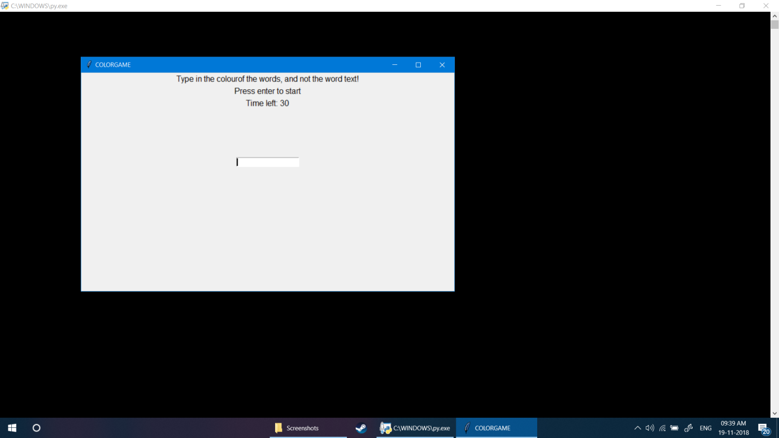

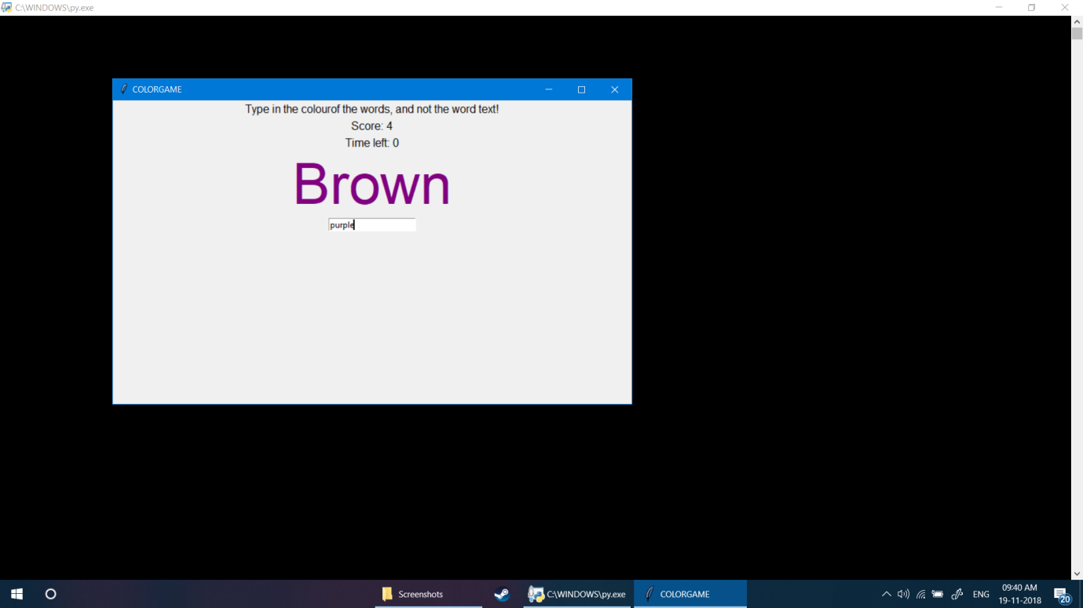

**Project Contents:**

You will find the following files:-

* python project.py
* ishu.docx
* projectpy1.PNG
* projectpy2.PNG

**Required Libraries and Dependencies:**

Python 3 is required to run this project. The Python executable should be in your default path, which the Python installer should have set.

**Submitted By:**

Ishwinder singh(1610991389)

**Department Name:** Computer Science and Engineering.