# Software Requirement Specification

# ( Shopping Website)

# Abstract

This project is a web based online shopping purchasing software. The project object are to facilitate the online shopping web application for desktop and android phone. It is a type of electronic commerce system. This project is an attempt to provide the feel of real shopping store through online medium. It helps in buying the products from the shop anywhere through internet by using an android device. Thus the customer will get the service of online shopping and home delivery both from his favourite shopping store. This system saves both time and travelling cost of customers. Customer can get there product delivered instead of actually going and buying the product from far areas. User can get to know different kinds of fashions and latest gadgets available that they were unaware of by just searching in the system using keywords. They can ,make use of online payment system services as well as cash on delivery payment services.

**Features:**

User Online Registration

Product Inventory Management

Product booking and availability check

# Chapter-1

# Problem Statement

**NEED360 (Shopping Website)**

**PROBLEM STATEMENT-**

In today’s life style, due to busy schedule, people have very less free time which they want to spend with their family or loved one’s rather than going for shopping. Because going for shopping is very time consuming and expensive. You want to purchase best item at a great discount, which is not easy when you have less time. There is no compelling reason to go to the crowded stores or shopping centres during festival seasons. There are certainly outside factors such as increasing petrol prices, difficulty in getting to traditional stores and hassles often associated with shopping malls and other traditional stores to contribute to the increased interest in online shopping.

**INTRODUCTION-**

INTRODUCTION

Online shopping is becoming increasingly popular for variety of reasons.

There are certainly outside factors such as increasing gas prices, difficulty in

getting to traditional stores and hassles often associated with shopping malls and

other traditional stores to contribute to the increased interest in online shopping.

Consumers can get full information about the product with its reviews being

passed by the existing users. If one wants to buy a product he/she is no longer

limited to asking the friends and families because there are many products reviews

on the web which gives opinions of the existing users of the product.

Online shopping sites contain wide variety of goods both high quality and

mild quality keeping in mind the level of people.

INTRODUCTION

Online shopping is becoming increasingly popular for variety of reasons.

There are certainly outside factors such as increasing gas prices, difficulty in

getting to traditional stores and hassles often associated with shopping malls and

other traditional stores to contribute to the increased interest in online shopping.

Consumers can get full information about the product with its reviews being

passed by the existing users. If one wants to buy a product he/she is no longer

limited to asking the friends and families because there are many products reviews

on the web which gives opinions of the existing users of the product.

Online shopping sites contain wide variety of goods both high quality and

mild quality keeping in mind the level of people.

INTRODUCTION

Online shopping is becoming increasingly popular for variety of reasons.

There are certainly outside factors such as increasing gas prices, difficulty in

getting to traditional stores and hassles often associated with shopping malls and

other traditional stores to contribute to the increased interest in online shopping.

Consumers can get full information about the product with its reviews being

passed by the existing users. If one wants to buy a product he/she is no longer

limited to asking the friends and families because there are many products reviews

on the web which gives opinions of the existing users of the product.

Online shopping sites contain wide variety of goods both high quality and

mild quality keeping in mind the level of people.

This project aims to develop an online shopping website for customers, to make shopping very easy. You simply require a PC or a laptop to shop online. With the help of this you can carry out an online shopping from your home. Consumers can get full information about the product with its reviews being passed by the existing users. If one wants to buy a product he/she is no longer limited to asking the friends and families because there are many products reviews on the web which gives opinions of the existing users of the product. Online shopping sites contain wide variety of goods both high quality and mild quality keeping in mind the level of people. Online shopping is becoming increasingly popular for variety of reasons.

**PROPOSED PROJECT-**

* Customer can browse through the product catalogue and add the items to shopping cart. He can proceed to checkout as long as his shopping cart is not empty.
* Customer will require to login to the system when he proceed to checkout, or he can create an account if he not yet have one.
* Customer need to provides full name, email address, phone number, credit card and billing address details when creating an account.
* Customer can login to the system to maintain his account information, such as changing phone number, address, and credit card details, and check the status of his orders.
* Admin can add or delete items and categories. Admin can also see the details of customers, and maintain their activity log for future references.

**TECHNOLOGY-**

PHP, HTML, CSS, JavaScript, MySQL

**TEAM MEMEBERS**

Shubham Kumar (1900270149034)

# Chapter-2

# 1. Introduction

**1.1 Purpose**

This document is meant to delineate the features of shopping website, so as to serve as a guide to the developers on one hand and a software validation document for the prospective client on the other. The Shopping website for electronics item shop web application is intended to provide complete solutions for customers through a single get way using the Internet.It will enable customer to browse through the shop and purchase them online without having to visit the shop physically. The administration module will enable a system administrator to approve and reject requests for new shops and maintain various lists of shop category.

**1.2 Intended Audience**

The intended readers of this document are the developers of the site, testers, website owners, managers and coordinators.

**1 Acronyms and Abbreviations**

|  |  |
| --- | --- |
| **Acronym** | **Meaning** |
| HTTP | Hypertext Transfer Protocol |
| HTTPS | Secure Hypertext Transfer Protocol |
| TCP/IP | Transmission Control Protocol/Internet Protocol |

**1.3 Scope**

Initial functional requirements will be: -

* Secure registration and profile management facilities for Customers
* Adequate searching mechanisms for easy and quick access to particular products and services.
* Creating a Shopping cart so that customers can shop ‘n’ no. of items and checkout finally with the entire shopping carts. Customers can add or delete items in the cart.
* Regular updates to registered customers .
* Uploading ‘Most Purchased’ Items in each category of products in the Shop.
* Strategic data and graphs for Administrators and Shop owners about the items that are popular in each category and age group.
* Maintaining database of regular customers of different needs.
* Shop employees are responsible for internal affairs like processing orders, assure home delivery, getting customer's delivery-time feedback, updating order's status and answering client's queries online.
* Feedback mechanism, so that customers can give feedback for the product or service which they have purchased. Also facility rating of individual products by relevant customers.
* Adequate payment mechanism and gateway for all popular credit cards, cheques and other relevant payment options, as available from time to time.

Initial non functional requirements will be: -

* Secure access of confidential data (user’s details).
* 24 X 7 availability
* Better component design to get better performance at peak time
* Advertisement space where it will effectively catch the customer’s attention and as a source of revenue.
* In addition to the above mentioned points, the following are planned to be delivered if deemed necessary:
* Warehousing within the very ambits of the project
* More payment gateways.

**1.4 References**

* IEEE 830-1998 standard for writing SRS document.
* Fundamentals of Software Engineering, 2nd ed. by Rajib Mall.

**2.Overall Description**

**2.1 Product Perspective**

The product is supposed to be an open source, under the GNU general Public License. It is a web based system implementing client-server model.

The following are the main features that are:

* Cross platform support: Offers operating support for most of the known and commercial operating systems.
* User account: The system allows the user to create their accounts in the system and provide features of updating and viewing profiles.
* Number of users being supported by the system: Though the number is precisely not mentioned but the system is able to support a large number of online users at a time.
* Search: search is simply local search engine based on key words.

**2.2 User Characteristics**

It is considered that the user do have the basic knowledge of operating the internet and to have access to it. The administrator is expected to be familiar with the interface of the tech support system.

**2.3 Operating Environment**

Operating environment for the airline management system is as listed below.

* distributed database
* client/server system
* Operating system: Windows.
* database: Myphp Admin

**2.4 Design and Implementation constraints**

This system is provisioned to be built on the XAMPP which is highly flexible.Decision regarding which database to use should be taken considering the fact that data being exchanged or stored is large, and the appropriate data management system will yield efficient performance.

**2.5 Dependencies**

This software highly depends on type and version of browser being installed in the system i.e. browser version should be used which have HTML5 support.

**3. External Interface Requirement**

**3.1 User Interface**

**1 Login:**

This interface will consist of two compulsory fields namely, “User Name” and “Password”. There will also be options for “New User’s Registration” which will redirect to “Registration” page and a “Forgot Password” option in case a user forgets the password.

If the password entered is correct the Main User Interface opens up else an error message is displayed.

**2 Registration Interface**

The user will enter his personal details like Name, User Name, Password, Date Of Birth, Address, Registration Type, etc.

Users will be warned about any mistakes on data format or any other constrains by validation notes and error messages.

When the button "save" button is clicked, the server will check if the username or email is already taken and alert the user.

If everything is entered correctly and saved a new user will be created.

**3 Personal Data Editing**

If any member wants to change his personal information he can enter his profile by clicking on his name at the top right of the main page and he will be directed to the personal details editing page.

**4. Search**

The customer can enter the type of item he is looking for and the specifications he is interested in them he can click on “Search”. User can also use advanced search for more options. For eg: the user can filter the results basing on various aspects such as size, color , material, brand etc and also they can sort the product display according to their wish (relevance, price in ascending or descending, popularity)

**5 Add as favourites**

The user can shortlist his/her favourite item as a list for future reference.

**6 Cart**

This will be a space for the customer where he/she can store the items he/she whishes to buy. The user can also remove items from cart prior to checkout. Once the user decides to buy the items it cart, the user is directed to the payment page for making payment.

**7 Payment**

The user given options with various modes of payment (online payment through credit/debit cards, via net or mobile banking or cash on delivery) out of which he chooses one. The chose mode of transaction is carried therefore by proper verification and authentication of bank details.

**3.2 Hardware Interface**

Device should be enabled with Internet

**3.3 Software interface**

The user’s browser should be HTML5 compatible for a satisfactory user experience.

It is compatible on all operating system.

**3.4 Communication Interfaces**

The two parties should be connected by LAN or WAN for the communication purpose.

Example:- Chrome Browser etc.

**4. System Features**

**4.1 Description and Priority**

The Shopping Website maintains information on products, classes no of quantity, personal preferences, prices, and Quality . Of course, this project has a high priority because it is very difficult to go to crowed stores for shopping centre specially during festival seasons.

**4.2 Action /Response**

* A shopping cart isn’t just a place for customers to store items pending checkout — it’s another important touchpoint that can deliver additional conversion opportunities. Cross-selling at checkout helps target customers more precisely with products they are likely to be interested in based on the items already in their cart — which can in turn increase the purchase total.

**4.3 Functional Requirements**

* 24*7 Support
* Secure access of confidential data.

**Non Functional Requirements**

**5.1 Performance Requirements**

The system must be interactive and the delays involved must be less .So in every action-response of the system, there are no immediate delays. Also when connecting to the server the delay is based editing on the distance of the 2 systems and the configuration between them so there is high probability that there will be or not a successful connection in less than 20 seconds for sake of good communication.

**5.2 Safety**

Information transmission should be securely transmitted to server without any changes in information

**5.3 Reliability**

As the system provide the right tools for discussion, problem solving it must be made sure that the system is reliable in its operations and for securing the sensitive details.

**5.4 Availability**

If the internet service gets disrupted while sending information to the server, the information can be send again for verification.

**5.5 Security**

The main security concern is for users account hence proper login mechanism should be used to avoid hacking. The tablet id registration is way to spam check for increasing the security. Hence, security is provided from unwanted use of recognition software.

**Chapter-3**

**System Analysis and Design**

**1. Use case Diagram**

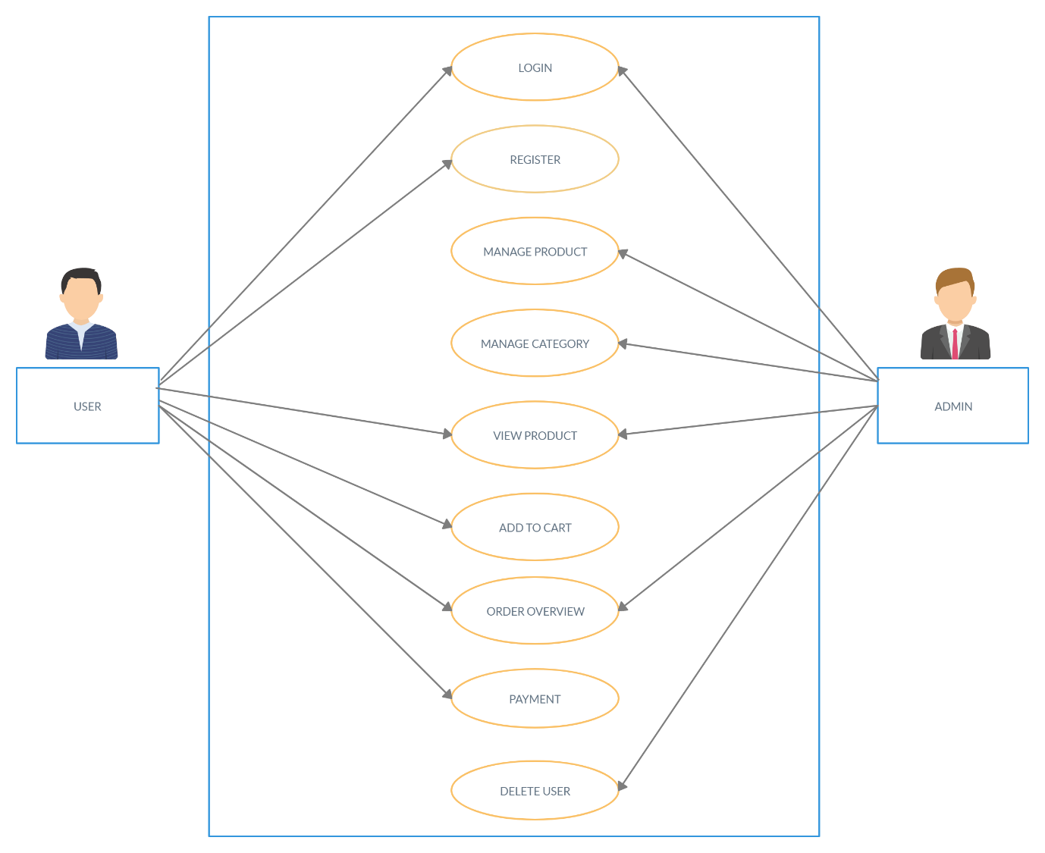

**2. DFD (LEVEL 0)**

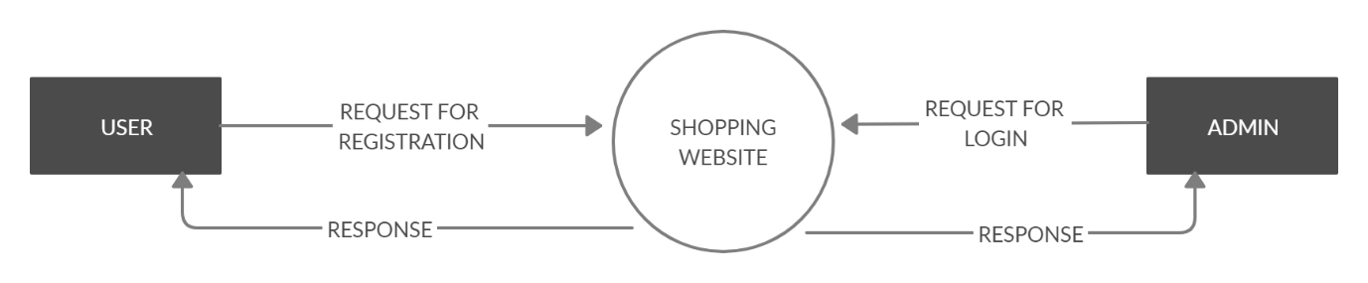

**DFD (LEVEL 1)**

