WinAppDriver

main repo:

https://github.com/microsoft/WinAppDriver

Release repo:

[**https://github.com/Microsoft/WinAppDriver/releases**](https://github.com/Microsoft/WinAppDriver/releases)

**download this from above link and install->** [**WindowsApplicationDriver.msi**](https://github.com/microsoft/WinAppDriver/releases/download/v1.2-RC/WindowsApplicationDriver.msi)

**The default path will be C:\Program Files (x86)\Windows Application Driver\ which contain winAppDriver.exe**

WinAppDriver is based on JSON Wire protocol similar like selenium, Appium.

Tutorial link:

Full 5 videos link:

<https://www.youtube.com/watch?v=Q_HUkWczd34&list=PLEiBaBxmVLi9-Ioe2lys5xpR4S4fUOq7F>

Individual link:

<https://www.youtube.com/watch?v=Q_HUkWczd34>

<https://www.youtube.com/watch?v=7tlRvaObXug>

UI Element locator of winAppDriver:

https://github.com/microsoft/WinAppDriver/blob/master/Docs/AuthoringTestScripts.md

prerequisites of winAppDriver:

1. WinAppDriver only works on Window 10 and above

2. Window 10 sdk

https://developer.microsoft.com/en-us/windows/downloads/windows-10-sdk

3. JAVA 8 OR ABOVE

4. Admin rights on system

5. Windows Developer mode should be on | settings > for developers > developer mode

6. WinAppDriver.exe release

In java we need maven based project having below dependencies

1. selenium latest version

2. appium-client which contain winAppDriver functions

3. junit or testng

4. guava (optional)

Screenshot Reference:

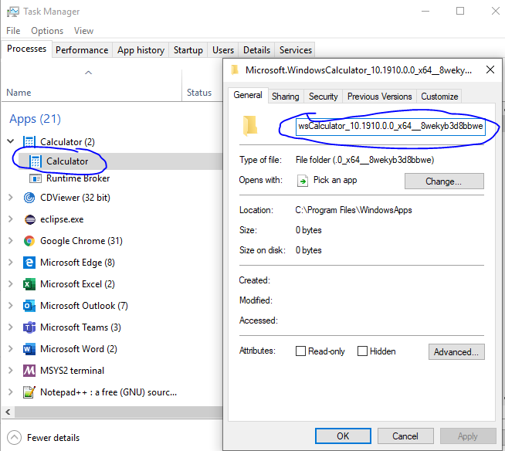

*To get the app id we need to open the app, use task manager and right click on it and see properties and copy the id

*Add !App at the end of the id and paste in above capability

////////////////////////////////////////////////////////////////////////////////////////////

Now to get the locator we use inspect.exe which is a part of Window 10 sdk which we had downloaded in 1st steps

Now go to below location

C:\Program Files (x86)\Windows Kits\10\bin\10.0.18362.0\x64

This version (10.0.18362.0) can be different for you, just search inspect.exe in bin folder search bar and select .exe as per your system mother board like intel and version like x64