|  |
| --- |
| **Contents:**  1. Introduction  1.1 Briefing  1.2 Problem Domain  1.3 Related Studies  1.4 Glossary  2. Problem Definition  2.2 Scope  2.3 Exclusions  2.4 Assumptions  3. Project Planning  3.1 Software Life Cycle Model  3.2 Scheduling  3.3 Cost Analysis  4. Requirement Analysis  4.1 Requirement Matrix  4.2 Requirement Elaboration  5. Design  5.1 Technical Environment  5.2 Hierarchy of Modules  5.3 Detailed Design  5.4 Test Planning  6. Conclusion  7.1 Project Benefits  7.2 Future Scope for improvements  7. References / Bibliography |

**List of Tables:**

Table 1

Table 2

**List of Figures:**

Figure. 1

Figure. 2

Figure. 3

Figure. 4

Figure. 5

Figure. 6

Figure. 7

Figure. 8

**1. Introduction**

1.1 Briefing

Plant identification is the building brick of plant research and development, and is very important for environmental protection and exploration. Usually, the leaves can be easily obtained from a plant and have sufficient visible characteristics for differentiating between their respective plant species.

Plant Leaf Identification is a system which is able to classify **32 different species of plants** on the basis of their leaves using digital image processing techniques. The images are first preprocessed and then their shape, color and texture based features are extracted from the processed image.

A dataset was created using the extracted features to train and test the model. The model used was **Support Vector Machine Classifier** and was able to classify with **90.05% accuracy**.

.

1.2 Problem Domain

* Business Domain
* In field of Education
* Retail Industries
* Technical Domain
  + - Machine Learning
    - Software
      * Matlab

1.3 Related Study

* **Robotic vision continues to be treated including different methods for processing, analyzing, and understanding. All these methods produce information that is translated into decisions for robots. Image identifying can be used as one of the best method for teaching the robot.**
* **In Cyber security image identifier is generally used in the biometric as they are used for storing biometric data and then it can be used for security purpose.**

1.4 Glossary

1. Area Processes

A category of image-processing techniques that calculate the value of each output-image pixel from the corresponding input-image pixel and its neighbors. Examples include half toning, sharpening and median filtering.

1. Block

The object in the environment which shall be abstracted into the system.

1. Discrepancy

An illogical or surprising lack of compatibility or similarity between two or more facts.

1. Generic

Characteristic of or relating to a class or group of things

1. Photometry

It is the science of the measurement of light, in terms of its perceived brightness

1. Pixel

A square unit of visual information that represents a tiny part of a digital image.

1. scene clutter

Cover with scattered or disordered things that impede movement

1. sophisticated

Having or showing a lot of experience and knowledge

1. warping

Make or become bent or twisted out of shape

**2. Problem Definition**

2.1Scope

* The project focuses on indentifying the images based on the algorithm. It will give the result in percentage about the probability of being the exact same product. Graphics data is becoming increasingly important in image processing app1ications. The future image processing applications of satellite based imaging ranges from planetary exploration to surveillance applications.
* Comparison of image with the set of data in the database in the database of the table to cluster about the highest chances for identifying the object.

2.2 Exclusions

* Datasets for the images will been taken from the internet.
* Database for algorithm is taken from the internet.

2.3 Assumptions

* User has Operating System of Windows in his/her computer.
* User has stable Internet Connection.
* User has sets of database for identifying objects in his/her computer.

**3. Project Planning**

3.1 Software Life Cycle Model

The first SDLC to be developed and implemented was the classic Waterfall Model. In "The Waterfall" approach, the whole process of software development is divided into separate phases. In Waterfall model, typically, the outcome of one phase acts as the input for the next phase sequentially. In this model phases do not overlap. The next phase is started only after the defined set of goals is achieved for previous phase and it is signed off.

It does not allow for much reflection or revision. Once an application is in the testing stage, it is very difficult to go back and change something that was not well-documented or thought upon in the concept stage.

In this Project we have used a modified and more comprehensive form of the Waterfall Model called the Iterative Waterfall Model.

Iterative process starts with a simple implementation of a subset of the software requirements and iteratively enhances the evolving versions until the full system is implemented. At each iteration, design modifications are made and new functional capabilities are added. During each iteration, the development module goes through the requirements, design, implementation and testing phases. Each subsequent release of the module adds function to the previous release. Parallel development can be planned. Testing and debugging during smaller iteration is easy.

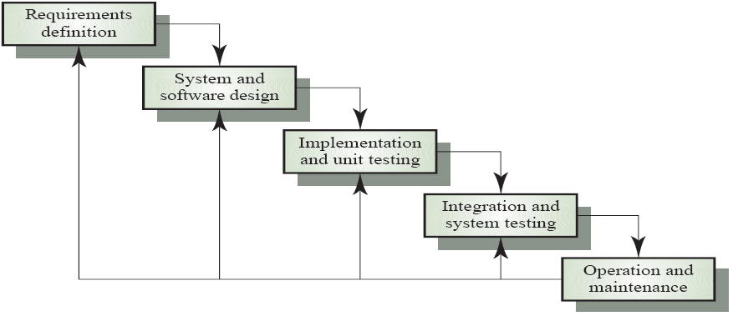

Figure 1: Iterative Waterfall Model

## 3.2 Scheduling

In project management, a schedule consists of a list of project’s terminal elements with intended start and finish dates. We have represented the scheduling of our project with the help of a Gantt chart. A Gantt chart is a type of bar chart that illustrates a project schedule. It projects the start and the finish dates of each terminal elements and summary elements of a project.

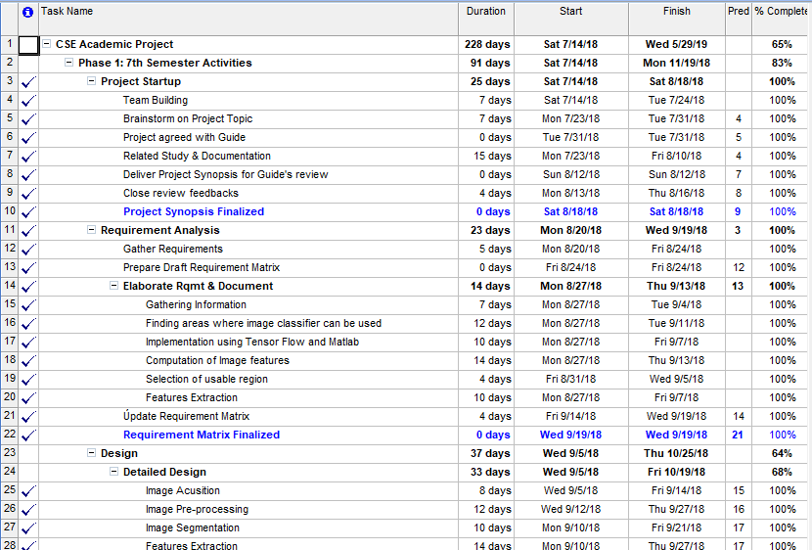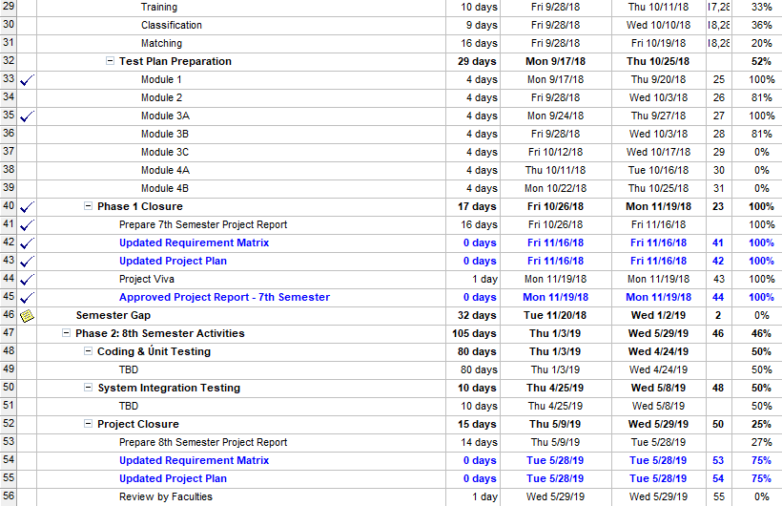

Figure 2: Project Plan

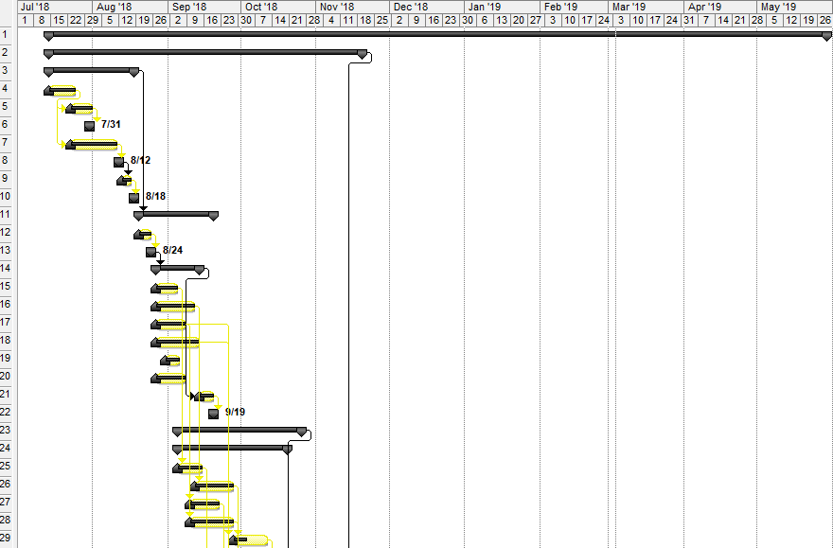

Figure 3. Gantt Chart(page 1)

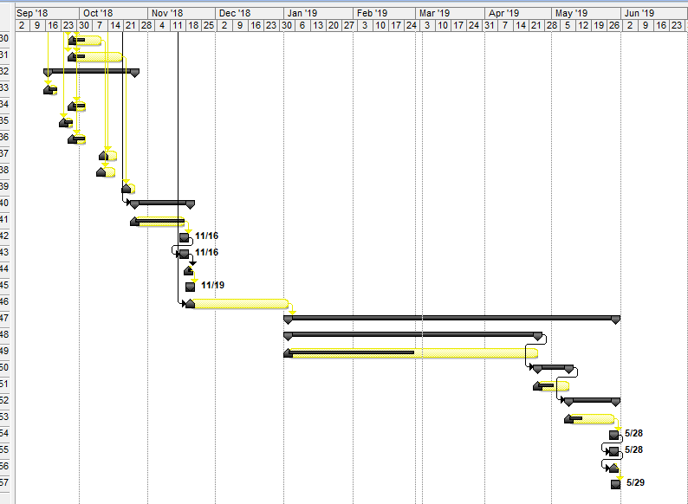

Figure 4. Gantt Chart(page 2)

**3.3 Cost Analysis**

A project is feasible if it is possible to finish it within fixed budget constraints. Cost Analysis, sometimes also referred to as Cost/Benefit Analysis (CBA), is a systematic approach used to calculate and compare the benefits and cost of a project.

For the purpose of this project, we are using a heuristic estimation technique called Constructive Cost Estimation Model (COCOMO).

The basic COCOMO estimation model is given by the following expressions:

Effort = a1х (KLOC)^a2 pm

Tdev = b1x (Effort)^b2 Months

P= Effort/ Tdev

Where

• KLOC is the estimated size of the software product expressed in Kilo Lines of Code.

• P is the no of persons required to complete the work.

• a1, a2, b1, b2 are constants for each category of software products.

• Tdev is the estimated time to develop the software, expressed in months. • Effort is the total effort required to develop the software product, expressed in person months (PMs).

The coefficients a1, a2, b1, b2 for various types of software projects:

|  |  |  |  |  |
| --- | --- | --- | --- | --- |
| Software Projects | a1 | a2 | b1 | b2 |
| Organic | 2.4 | 1.05 | 2.5 | 0.35 |
| Semi-detached | 3.0 | 1.12 | 2.5 | 0.32 |
| Embedded | 3.6 | 1.20 | 2.5 | 0.38 |

**Table 1: Constants for Cost Analysis**

Effort Calculation for Fingerprint Attendance System is given below:

Consider Lines of Code = 10000

i.e. value of KLOC is 10

Organic: Effort = 2.4(KLOC) 1.05 PM

= 2.4*(10)1.05

= 2.4 * 11.220

= 26.92 pm

Semi-detached: Effort = 3.0(10)1.12 PM

=3.0*13.18

=39.5 pm

Embedded: Effort = 3.6(10)1.20 PM

= 3.6*15.84

= 5

## **4. Requirement Analysis**

## 4.1 Requirement Matrix

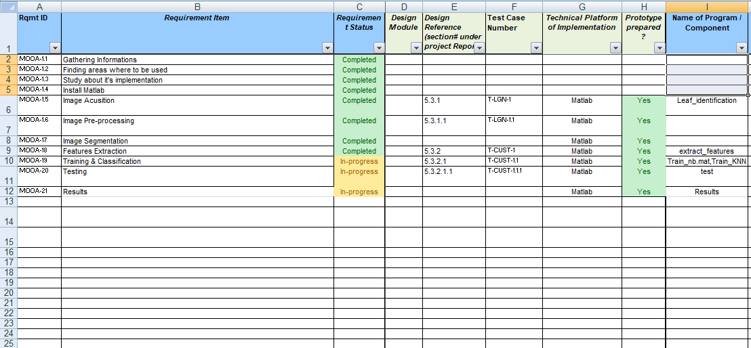

Figure 5: Requirement Matrix

4.2 Requirement Elaboration

**4.2-1-** Update training image

**4.2-2-** Insert Test image

**4.2-3-** Check the Result in the pop up box

5. Design

5.1 Technical Environment

The interface development involved use of the following software and programming languages mentioned below

1. implementation of Machine Learning (version 3.0).
2. Firebase a for building server side.
3. 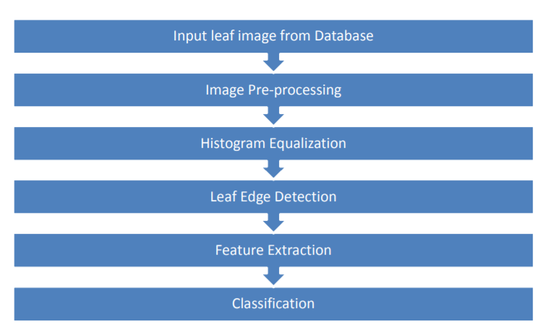Matlab for developing software

Thus the project can be summarized as a mixture of Server Side Scripts and third party libraries and Matlab used as tools to build this whole interface or platform.

5.2 Hierarchy of Modules

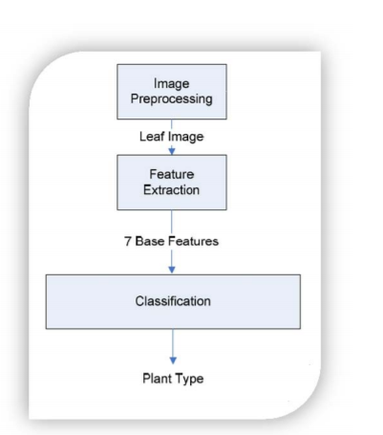

Figure 6 : Flow Chart Image processing model

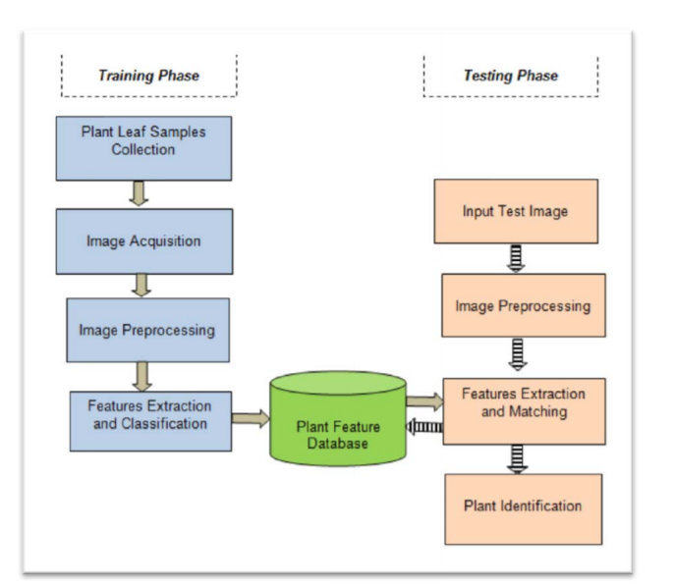

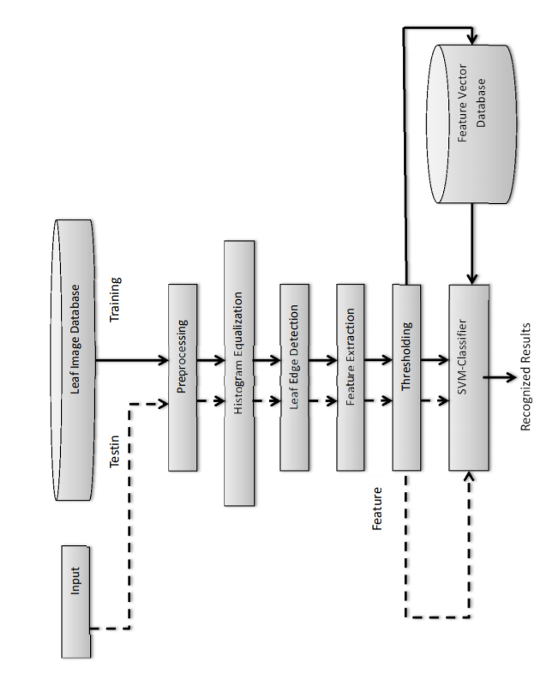

Figure 7: Flow Diagram

Figure 8: Hierarchy Model Of Image Identifier

5.3 Detailed Design

5.3.1 Image Acusition

After the image has been obtained, various methods of processing can be applied to the image to perform the many different vision tasks

5.3.2 Image Pre-processing

Image pre-processing may have dramatic positive effects on the quality of feature extraction and the results of image analysis.

5.3.3 Image Segmentation

Image segmentationis the process of partitioning a digital image into multiple segments

5.3.4 Features Extraction

Features Extraction starts from an initial set of measured data and builds derived values (features) intended to be informative and non-redundant, facilitating the subsequent learning and generalization steps

5.3.5 Training & Classification

Training & Classification is the problem of identifying to which of a set of categories (sub-populations) a new observation belongs, on the basis of a training set of data containing observations (or instances) whose category membership is known.

5.4 Test Plan

|  |  |
| --- | --- |
| Test Case 1.(t1) | Check Image acusition |
| Test case 2.(t2) | Check Image Pre-processing |
| Test case 3.(t3) | Check Image Segmentation |
| Test case 4. (t4) | Check Features Extraction |
| Test case 5.(t5) | Test & Results |

Table No. 2 : Table for test cases

**6. Conclusion**

6.1 Project Benefits

* The project allows users with relevant pieces of information about the objects and their relationships.
* It can be used in learning purpose as anyone can click pictures of plants and animals etc. and they can get information about it.

6.2 Future Scope for improvements

* The future of image processing will involve scanning the heavens for other intelligent life out in space. Also new intelligent, digital species created entirely by research scientists in various nations of the world will include advances in image processing applications. Due to advances in image processing and related technologies there will be millions and millions of robots in the world in a few decades time, transforming the way the world is managed.
* With increasing power and sophistication of modern computing, the concept of computation can go beyond the present limits and in future, image processing technology will advance and the visual system of man can be replicated. The future trend in remote sensing will be towards improved sensors that record the same scene in many spectral channels.

**7. References / Bibliography**

<https://onlinelibrary.wiley.com/doi/pdf/10.1002/9781118618387.app1>

<http://valgrind.org/docs/manual/drd-manual.html>

<https://web.stanford.edu/class/ee368/Project_07/reports/ee368group12.pdf>

<https://www.researchgate.net/post>

<https://engineering.purdue.edu>

<https://www.ukessays.com/essays/computer-science/image-processing-for-future-applications-computer-science-essay.php>

<https://pdfs.semanticscholar.org/7656/d3db8962a5a75d162842065319155db73af8.pdf>

<http://fourier.eng.hmc.edu/e161/lectures/e161ch1.pdf>

<https://www.marutitech.com/working-image-recognition/>

https://www.tineye.com/search/0cf3a49dbee55d38a9bcfa9db50f9401dab370e9/

https://www.cs.ubc.ca/~lowe/papers/pope96b.pdf