Milestone 1 System Planning: Project Charter
Team G
Bhavya Mandala – 1233591153
Ishwariya Pandi - 1233885850
Adhithi Satish Kumar- 1233343815
Vaishmitha Reddy Biyyapu – 1233298757
Instructor Name: Dr. Derex Griffin
Date Due: OCT 18, 2024

Table of Contents
Company History 3
Problem Statement 4
Technology Solution Statement 4
Project Benefits 5
Stake Holders 6
Project Plan 7
Technology Tools 10
Current Solutions 12
References 14

Company History

IniTech Solutions was founded in 2008 as a rapidly expanding technology firm that provides software development and IT consulting services. In the years since, the company has grown internationally, furthering its operations to help clients of different types. Despite this, an internal audit that was done some time ago revealed that the asset management operations were ineffective in terms of automation and standardization of procedures followed in maintaining and managing the IT assets. This has made operational costs go higher, data has turned out to be incorrect, and decision-making processes are performed slowly. With a view to overcoming these problems, IniTech Solutions is looking to implement an IT Asset Management System that can help the company to manage its assets in a more professional and efficient manner.

Problem Statement

Intech Solutions' inability to manage IT assets automatically results in uneven data collecting and ineffective departmental tracking. This has led to a high rate of errors, with 33% of calculations involving assets being inaccurate, which has delayed decision-making. The existing asset tracking system's dependency on Excel sheets makes it impossible to optimize expenditure and support hardware, which makes it challenging to provide precise financial predictions and executive dashboards. Better decision-making, more efficient tracking, and increased data accuracy all depend on the implementation of a centralized IT Asset Management System (ITAM).

Technology Solution Statement

To improve accuracy and optimize resource allocation, a centralized, automated IT Asset Management System (ITAM) will replace decentralized excel-based tracking.

Project Benefits
- Reduction of data input errors to almost zero by using the centralized IT Asset Management System can enable fixed financial reporting and more informed decision-making by 33%.
- The system should improve unnecessary expenditure through better utilization of its visibility, hence optimizing resources to assure quicker deployment and recovery of assets by 15%.
- Improved hardware support processes will result in up to 20% less downtime and increased productivity by making more operable assets available to staff sooner.
- Automating the asset management process is expected to increase overall operational efficiency by 30%, free up employees to work on higher-value activities, and further optimize overall company performance.

Performance Indicator | Measurement Method
Data Accuracy | Measure data entry errors before and after.
Cost Savings | Comparing pre- and post-implementation cost reduction calculation.
Downtime Reduction | Track average downtime before and after system implementation.
Operational Efficiency | Assess time spent on tasks before and after automation.
Table 1: Performance Indicator measurement table

Stakeholders

“People who have an interest in an information system are called stakeholders” (Tilley, 2019, p.6) The management group in charge of the system, end users both inside and outside the organization, and IT professionals such as system analysts, programmers, and network administrators involved in both development and maintenance are examples of stakeholders. Three stakeholders and the key PESTEL elements that influence their decision to support the technology solution:
Chief Information Officer (CIO) - Technological Factor: The CIO is responsible for improving IT infrastructure. The new centralized IT Asset Management System's technology innovations, such as automation and connection with existing systems, will improve operational efficiency, reduce downtime, and streamline asset tracking.
Chief Financial Officer (CFO) - Economic Factor The CFO is primarily interested in cost savings and ROI. The solution is economically beneficial due to the 15% decrease in wasteful spending and enhanced accuracy in financial reporting achieved by automation, resulting in better budget management and resource allocation.
IT Support Manager - Social Factor: Social considerations such as workforce efficiency impact the IT Support Manager's decisions. Employee productivity will rise as a result of streamlined hardware support procedures and less manual labor, which is in line with the company's social mission of empowering its staff.

Project Plan

Systems Planning: The goal of this stage is to comprehend the Bhavya Mandala Project's scope. It include identifying the project charter, establishing specific goals, and assessing the business needs. To guarantee smooth development, tasks are scheduled and monitored on a regular basis. Feedback from stakeholders is essential to achieving goal alignment.

Systems Analysis: During this stage, the asset management practices and systems in place are assessed. To determine the system specifications, user needs, and technical requirements of the new system, extensive information collecting is done.

Systems Design: This stage entails developing the system's architectural design. Building user interfaces, data flow, and the general system structure that allow asset monitoring, reporting, and other essential functionalities are the main goals of the design phase. Additionally, it involves integrating database schema and operations to guarantee the system meets requirements.
Systems Development: Various components, including the asset tracking system, automation features, and registration system, are coded and configured during this phase. While incorporating reporting capabilities and other unique features that were specified during the design stage, developers concentrate on developing scalable solutions.

Systems Testing: During testing, the functionality, security, and performance of the system are carefully assessed. To make sure the produced system satisfies all business and technical criteria, verification and validation are carried out. Problems including errors, snags in performance, and possible weaknesses are found and fixed.

Systems Implementation and Rollout: After successful testing, the system is deployed into the production environment. Training sessions are conducted to ensure that users understand the new system, and legacy data from previous tracking systems (such as Excel sheets) is migrated into the new system. The rollout is done across the organization following a structured deployment plan.

Systems Support and Maintenance: Following the deployment, continuous support and maintenance activities ensure that the system operates efficiently. This includes monitoring system performance, fixing issues, and ensuring system security from unauthorized access or malware. Regular updates and improvements are provided based on user feedback and performance assessments.

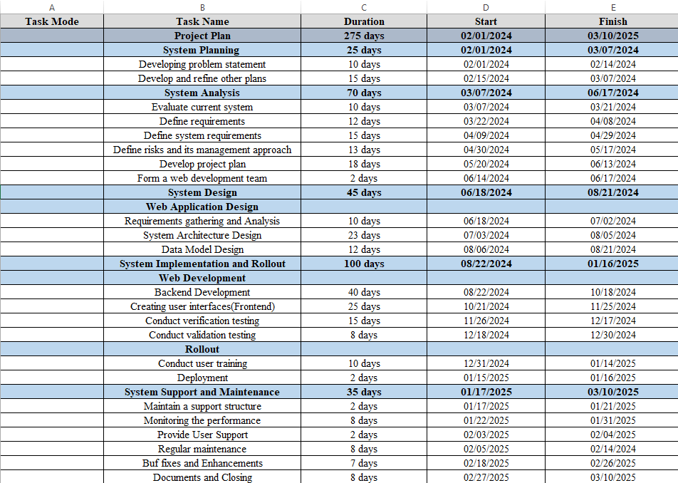
Fig 1: Project charter

Technology Tools

Amazon Web Services (AWS) or Microsoft Azure (Cloud Computing):
The cloud-native architecture offered by AWS or Azure offers highly accessible, scalable, and secure environments for hosting and managing the IT Asset Management System (ITAM). For expanding asset management requirements, these platforms ensure disaster recovery, remote access, and elastic scalability.

MySQL or PostgreSQL (Relational Databases):
These are both open-source options with strong data management features. They make it possible to handle serialized asset tracking and stockroom management effectively by supporting structured data storage, querying, and relational integrity.

React.js (Frontend Development):
React.js is a popular JavaScript library used for building dynamic and interactive user interfaces. Its component-based architecture makes it easier to manage application state through context API, which enables the ITAM system to effectively display data across multiple modules, including reporting and asset tracking.

Node.js or Django (Backend Development):
These frameworks handle the ITAM system's backend functionality and API. Fast performance and scalability in asset management tasks are ensured by these frameworks, which handle data requests, automated workflows, and integrations.

Power Automate or Zapier (Automation Tools):
Power Automate and Zapier combine workflows, automate repetitive processes like inventory updates, and enhance operational efficiency by providing real-time changes and minimizing manual labor.

Power BI or Tableau (Business Intelligence):
Business intelligence software, such as Power BI or Tableau, is used to create interactive dashboards and reports. They improve data-driven decision-making by giving executives up-to-date information on asset utilization, financial forecasts, and spending trends.

GitHub or GitLab (Version Control):
Both of these platforms are necessary for controlling the source code for the ITAM and promoting developer cooperation. They guarantee consistency and version control among development teams working on various system components.

A strong, scalable, and effective IT asset management system that satisfies IniTech Solutions' operational requirements and expansion is ensured by this mix of technological solutions.

Current Solutions

Ivanti IT Asset Management Suite: With extra support for cloud-based assets, Ivanti offers a complete solution for managing both software and hardware assets. Robust automation, robust security, and comprehensive reporting functions are all integrated within the suite. It offers auditing and compliance capabilities for IT infrastructures and is especially helpful for controlling endpoint devices (Ivanti, 2023).

ManageEngine AssetExplorer: A web-based IT asset management tool called ManageEngine AssetExplorer is intended to track and manage software and hardware assets across the course of their lives. With its user-friendly interface and features like audit capability and licensing control, even smaller enterprises can utilize it (ManageEngine, 2024).

BMC Helix Discovery: This cloud-based application, which spans both on-premises and cloud architecture, automates the identification and monitoring of IT assets. For complex IT infrastructures, it guarantees accurate tracking and offers comprehensive asset visibility (BMC, 2023).

The benefits and drawbacks of using COTS (commercial off-the-shelf) solutions as opposed to in-house or on-premises solutions:

Pros: Because COTS systems are pre-built and ready for use, they allow for speedier deployment. They typically have lower costs than in-house solutions because there are no up-front development expenses. Vendors test and update COTS products frequently to make sure the software is safe, compliant, and up to date with emerging technologies. Vendor support also lessens the requirement for internal IT staff to oversee and maintain the system.

Cons: Deep customization required to satisfy specific organizational demands may not be present in COTS systems. Businesses rely on vendors to provide updates and patches; therefore, it could be problematic if the vendor alters its roadmap or discontinues a product. Additionally, there's the chance of vendor lock-in, which makes it costly and difficult to transition to a different product because of migration expenses and integration difficulties.

References
- Ivanti (2023). Ivanti IT Asset Management - Optimize your IT asset visibility and usage. Retrieved from https://www.ivanti.com/resources/v/doc/ivi/1518/09df52232b6f
- BMC (2023). BMC Helix Discovery - Deliver comprehensive visibility for your IT assets. Retrieved from https://www.bmc.com/it-solutions/bmc-helix-discovery.html
- AssetExplorer. Retrieved from https://www.manageengine.com/products/asset-explorer/
- ManageEngine (2024). IT Asset Management Software – ManageEngine
- Tilley, S. (2020). Systems Analysis and Design (12th ed.). Cengage.

