Milestone 2 System Analysis: Requirements
Name of the project: Centralized Asset Management Platform
Team G
Bhavya Mandala – 1233591153
Ishwariya Pandi - 1233885850
Adhithi Satish Kumar- 1233343815
Vaishmitha Reddy Biyyapu – 1233298757
Instructor Name: Dr. Derex Griffin
Date Due: Nov 03, 2024

Table of Contents

Background 3
Problem Statement 3
Technology Solution 3
Fact Finding Techniques 4
Business Function 1 6
Purpose 6
Process Map 7
Business Requirements 8
Business Function 2 9
Purpose 9
Process Map 10
Business Requirements 11
Business Function 3 12
Purpose 12
Process Map 13
Business Requirements 18
Business Function 4 21
Purpose 21
Process Map 22
Business Requirements 23
References 24

Background

Problem Statement

Decentralized asset monitoring in Excel sheets restricts fulfilling fiscal objectives for expenditure optimization and hardware support. The lack of data accuracy, consistency, and validation makes it difficult to create executive dashboards and accurate cost forecasts, which slows decision-making and asset management.

Technology Solution Statement

To improve accuracy and optimize resource allocation, a centralized, automated IT Asset Management System (ITAM) will replace decentralized excel-based tracking.

Fact Finding Techniques
Fact-finding is a technique of gathering information by using different methods of data collection. It includes samples of available documents, studies, observations, and interviews. Among the techniques mentioned earlier, two fact-finding techniques that would be further discussed are:
Interviews
Interviews are one of the most traditional methods of collecting detailed, qualitative information directly from the stakeholders, users, or individuals who have direct involvement with the system. Their objective ranges from uncovering user needs, clearing ambiguities, to collecting specific requirements. Effective communication is the way to success; it is essential that the system analyst drives the conversation in interviews.
Interview techniques can be classified as :
1. Unstructured Interviews: These are sessions that do not restrain the structure. The respondent can free his mind to talk about whatever he feels like. The interviews are quite helpful in doing some research in new areas or complex parts of the system; for example, users' perceptions about asset tracking.
2. Structured Interviews: These are those question-and-interview sessions that are pre-planned. Normally, such sessions use a limitation to particular choices for response. Structured interviews are ideal for consistent data collection, especially if the research targets various participants, such as stockroom managers across different locations.
Examples:
- Who maintains and tracks the inventory within the stockroom?
- What kind of issues does one face while tracking serial numbers while ordering?
- How would you check if the data gets correctly updated in the system for any asset record update?
Conduct a User Survey or Questionnaires
Surveys are another efficient technique for gathering data. In order to reach a larger population, surveys are just about the ultimate technique. Analysts write a questionnaire that is completed and returned by the users. If analysts draft and phrase the questions well, then questionnaires may be effective in revealing the system's goals.
There are two kinds of questionnaires:
- Free-format: These do not have pre-defined responses but give the respondents an opportunity to give their responses in some detail with regard to what they think and experience.
- Fixed-format: This involves the arrangement of questions that are generally predetermined, such as multiple-choice, ratings, or rankings, which users can select between pre-set responses.
This method has the advantages of being low-cost and allows quantitative information to be gathered from a large number. However, anonymity can result in incomplete responses since it is not possible to probe for ambiguous answers with the absence of non-verbal cues.
Examples of Survey Questions:
- How often do you have problems in asset requests not being met due to stock errors?
- On a scale from 1 to 5, with 5 being the highest, how would you rate the ease of use for the current asset request process?
- What kind of detailed enhancements would you like to have with regard to the stockroom management system?
Business Function 1: Serialized Asset Management

Purpose
Serialized Asset Management is a comprehensive system for tracking and managing IT assets, with each asset assigned a unique number. This technique provides detailed monitoring of each item, ensuring that no two assets have the same identifier. This procedure is overseen by the Asset Manager and the Head of IT Service Management, who ensure that the status, location, and condition of all assets are regularly recorded in a central database.
The major purpose of Serialized Asset Management is to improve asset availability, traceability, and accountability across its entire lifecycle, from acquisition to disposal. The system facilitates audit processes, improves operational efficiency, and allows for informed decision-making by keeping detailed asset records. This consolidated repository also reduces redundancies and improves data integrity by unifying all asset-related information, including maintenance schedules, repair histories, consumption trends, and asset states. Furthermore, this system offers real-time updates, allowing team members to effortlessly track assets, eliminate misplacement risks, and improve inventory report accuracy, guaranteeing that IT assets are efficiently employed and managed.

Process Map
Figure 1: Serialized Asset Management Process
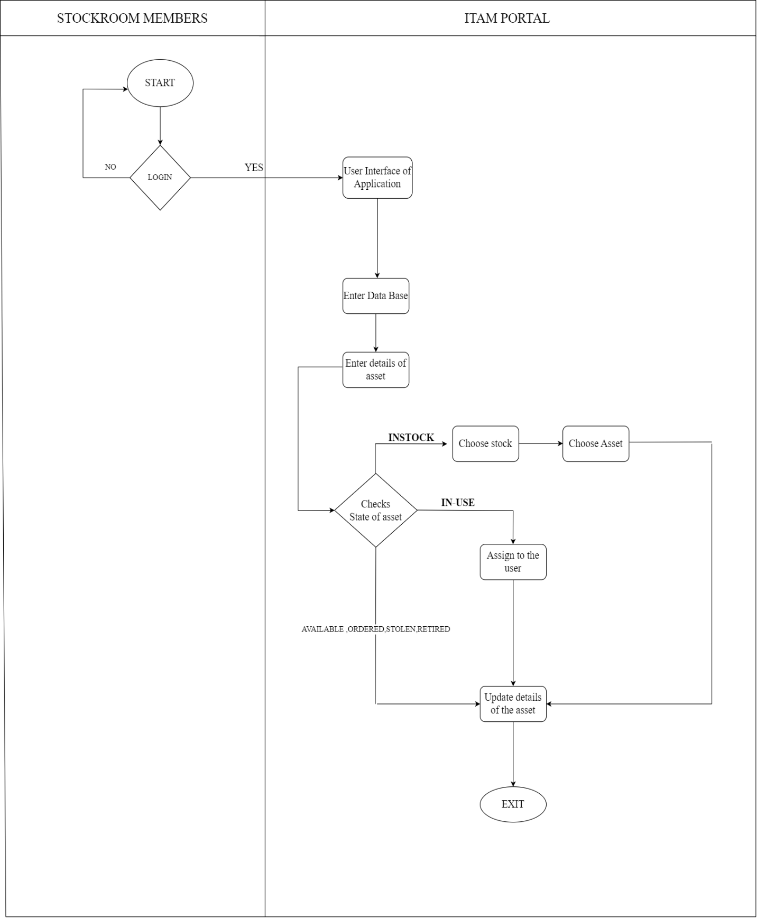
Business Requirements

- The system will require users to authenticate with valid login credentials before granting access to the site.
- The system will assign a unique serial number to each asset for identification.
- The system will notify the user when a login attempt fails.
- The system will integrate with a centralized asset data repository for asset management.

Business Function 2: Stockroom Management

Purpose
IT asset distribution, management, and storage are handled centrally and securely by the Stockroom Management function. Markers like building tags, room classification, address, and security standards allow each stockroom to be uniquely identifiable and operate as an autonomous hub. The facility director, who is in charge of room maintenance, and the asset manager, who is in charge of stored assets, are important stakeholders who guarantee efficient resource management and a structured organization. Stockroom information is reinforced with improved data from the facilities management database, facilitating precise inventory tracking and efficient space utilization. The system's real-time inventory visibility enables stockroom custodians to effectively fulfil user asset demands while upholding asset accountability. Custodians may swiftly find objects, assign unique identifiers to assets for accurate tracking, and view pending requests. Additionally, the system helps custodians by monitoring past-due items and alerting users of return deadlines, guaranteeing a user-centered approach to inventory management, and encouraging systematic asset allocation.

Process Map
Figure 2: Stockroom Management Process
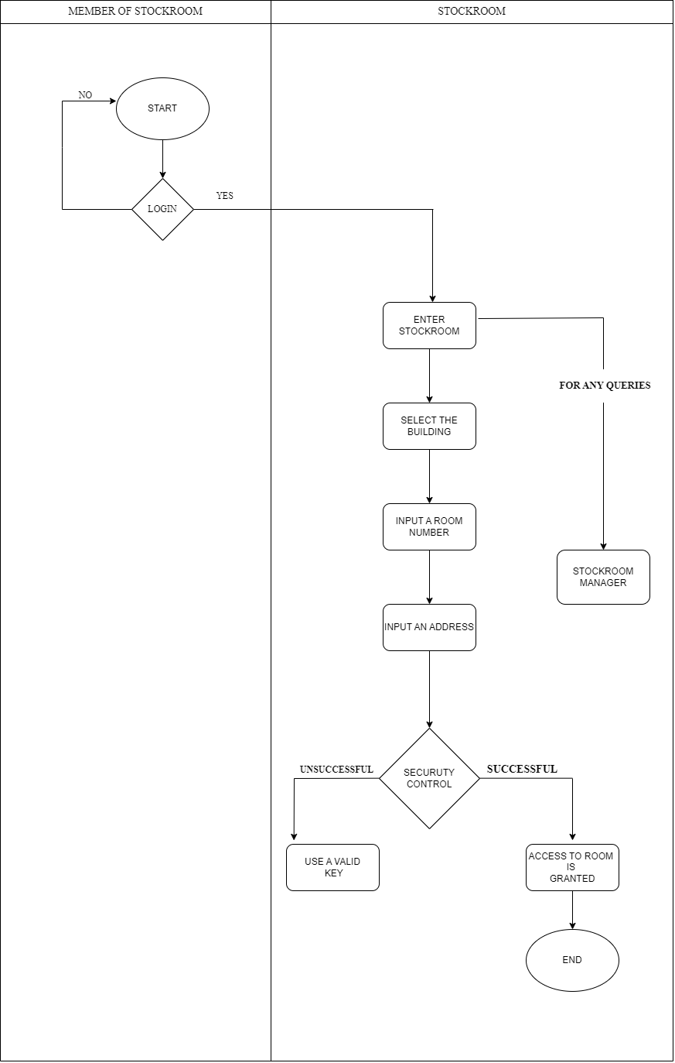

Business Requirements
- The system will allow users to enter the stockroom after security verification.
- The system will continue to provide real-time inventory visibility, allowing custodians to precisely monitor asset availability.
- The system will assign each asset a unique identification number to facilitate traceability and inventory management.
- The system will send alerts to custodians for past-due items to maintain accountability.

Business Function 3: Asset Entry and Request Process

Purpose
The ITAM framework will guide the management of company assets through their entire life cycle. The primary objective is to establish a central database about business-owned assets. It will update the status of the assets correctly and make access easy. It includes creating user-friendly interfaces to cater for diverse users at different points of their needs in asset management. Indeed, a good software solution for asset management saves lots of time and makes life easy by solving a variety of common problems that arise due to incorrect data, limited reporting, and tracking stage-of-life movement of assets. Such a comprehensive approach towards the software makes the process of asset management quite efficient. The Director of Deskside Support oversees the Asset Entry process: each asset receives a tag ID unique to it, adding it into this system, even creating new storage locations. This means everything that is acquired can be tracked. The Asset Request is managed by the Director of IT Service Management. This provides the user with a facility to request assets directly from the asset management team, ensuring that the user needs are represented and communicated to them.
In the Asset Fulfillment process, which is also managed by the Director of IT Service Management, during the asset lifecycle, it responds to the user's request, making certain that required assets are provided in a timely manner.

Process Map
Figure 3.1: Asset Entry Process
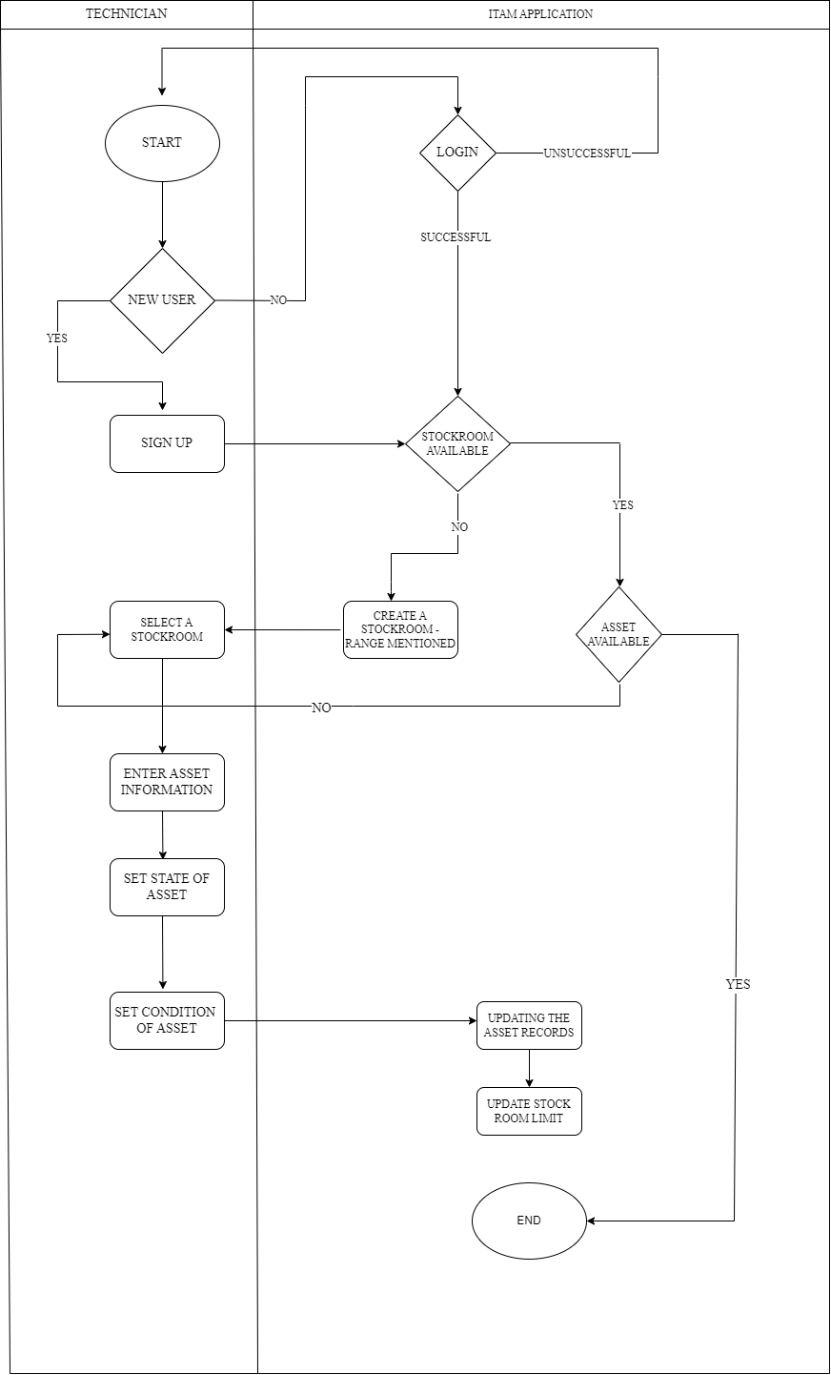

Figure 3.2 Asset Request Process
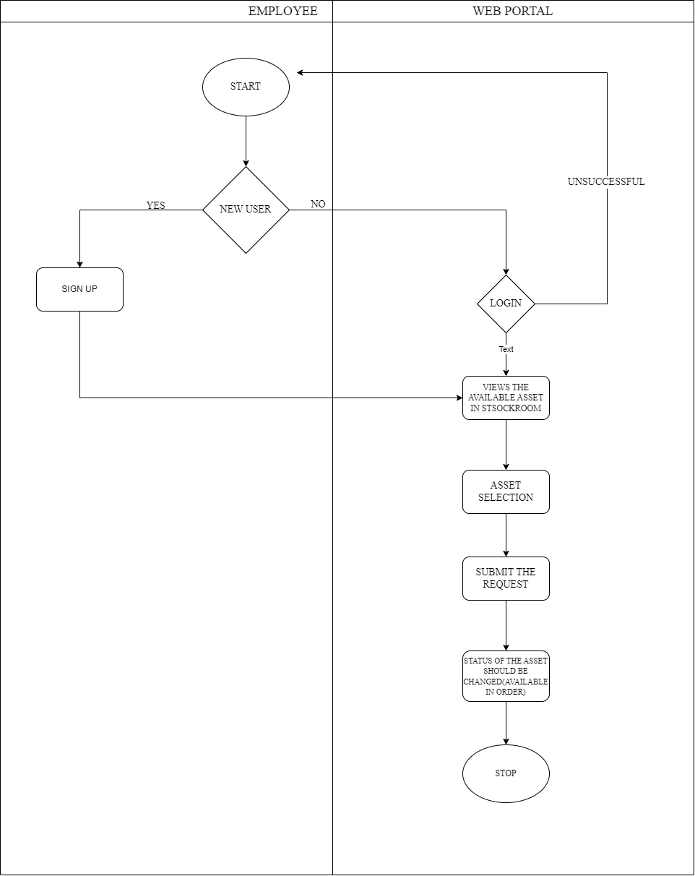
Figure 3.3 Asset Fulfilment Process
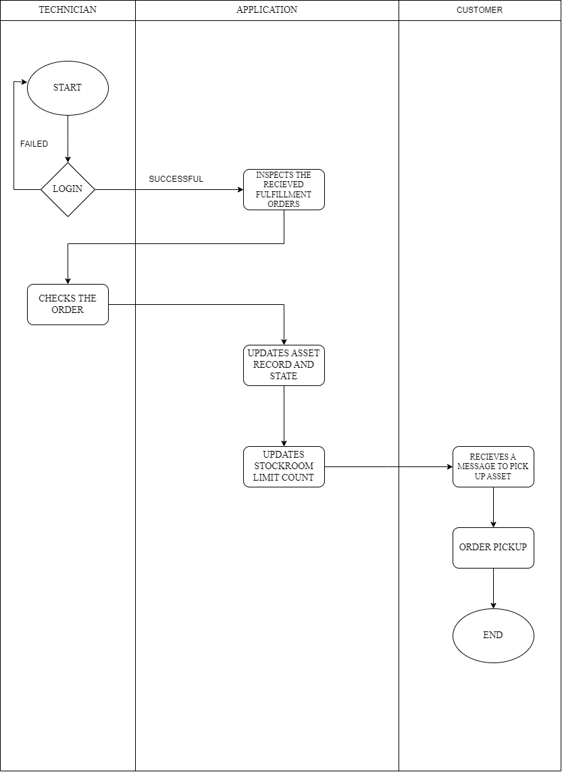
Figure 3.4 Asset Support Process
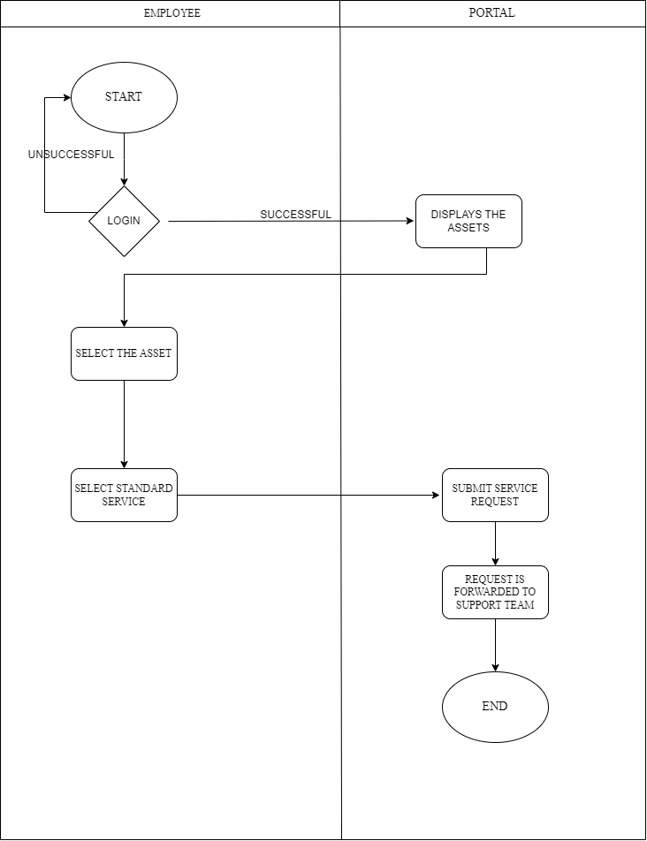
Figure 3.5 Asset Retirement Process
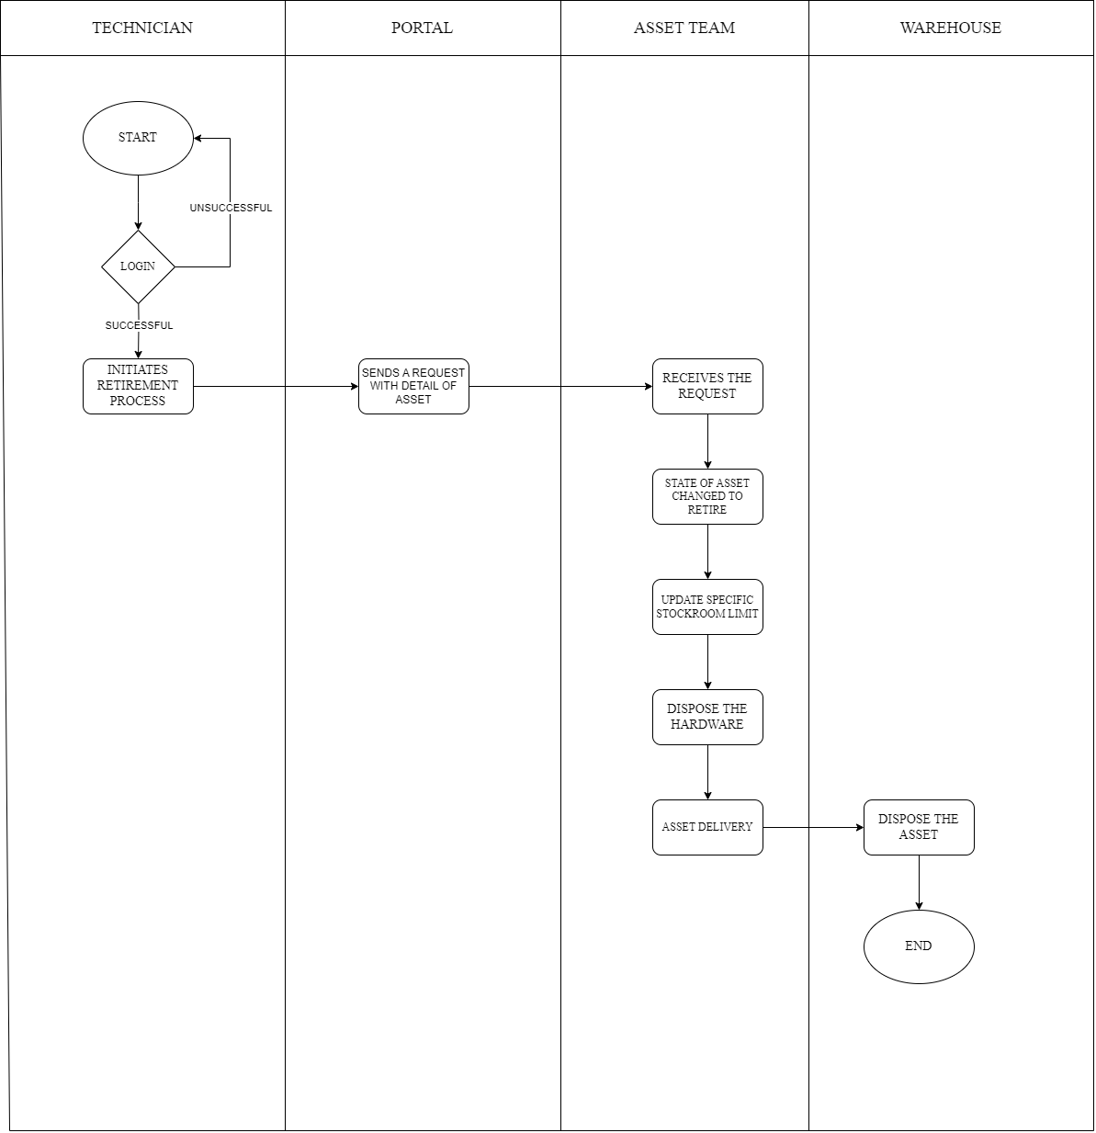

Business Requirements
Asset Entry Process Requirements:
- The system will assign a unique tag ID to every asset upon entry.
- The system will provide users with the functionality to create a new asset, including fields for description, category, and location.
- The system will allow the addition of new storage areas in the asset database.
- The system will validate all input data against errors and duplication.
- The system will confirm successful asset registration to the user.

Asset Request Process Requirements:
- The system will allow users to create asset requests that are directed to the asset management team.
- The system will provide a web interface for users to specify the type, quantity, and any specific requirements of the asset needed.
- The system will track the status of each asset request and keep the user updated on its progress.
- The system will notify users when their asset requests are acknowledged and completed.
- This system will provide a search functionality to enable users to identify the assets that are available to request.

Asset Fulfillment Process Requirements:
- The system will provide functionality for custodians to assign assets to identified users.
- The system will generate reports on how efficiently asset requests are being fulfilled, and the related turnaround times.
- The system will include a workflow around asset returns from users, and document said returns.
- The system will allow for temporary assignment of assets with due dates for said asset return.

Asset Support Process Requirements:
- The system will be able to allow tracking and management of incoming support queries by the support staff.
- The system will generate reports on the trend and resolution of support requests it receives.
- The System will thus be able to track how much time it takes for the response to a raised support request and ensure SLAs are met.
- The system will provide auto-responses for frequently asked support inquiries for efficiency.

Asset Retirement Process Requirements:
- This system will enable technicians to retire an asset from this system if it is no longer in use.
- The system will make the retirement of an asset subject to documentation with a reason and method of disposal.
- The system will retain a record of all retired assets for auditing purposes.
- System will allow for reallocation of useable components from the retired asset to any other asset in order to maximize resource utilization.
- System will send notifications to relevant stakeholders once the asset is retired and removed from inventory.

Business Function 4: System Security Overview

Purpose
The goal of System Security in Serialized Asset Management is to create strong data protection procedures that protect user information and asset details while discriminating access depending on user role. This function, managed by the Chief Information Security Officer (CISO), is responsible for preserving sensitive corporate data and ensuring that only authorized individuals have access to certain asset management functionalities. The security system contains an Identity Confirmation Tool for single sign-on (SSO) capabilities, which allows users to authenticate once and obtain access to interconnected applications, hence improving security while maintaining user convenience. This security technique protects sensitive data, such as asset status, location, and assigned user, against unauthorized access and potential breaches. System Security increases the overall asset management lifecycle's resilience by including security protocols within the asset management process. Access controls, role-based permissions, and centralized monitoring allow for proactive management of possible security concerns, adding an extra layer of protection to fulfill organizational and compliance standards.

Process Map
Figure 4 System Security Overview Process:
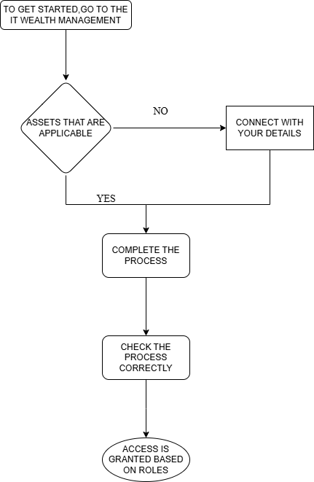

Business Requirements
- The system will require all users to authenticate using the Identity Confirmation Tool before accessing the site.
- The system will assign access rights based on job roles to control data accessibility.
- The system will log all user activity to ensure continuous security monitoring and compliance.
- The system will alert users when authentication attempts are unsuccessful to prevent unauthorized access.

References
1. Ivanti (2023). Ivanti IT Asset Management - Optimize your IT asset visibility and usage.
Retrieved from https://www.ivanti.com/resources/v/doc/ivi/1518/09df52232b6f
2. Asset Explorer. Retrieved from https://www.manageengine.com/products/asset-explorer/
3. Tilley, S. (2020). Systems Analysis and Design (12th ed.). Cengage.
4. Gavrikova, E., Volkova, I., & Burda, Y. (2020). Strategic aspects of asset management: An overview of current research. Sustainability, 12(15), 5955.
5. Schuman, C. A., & Brent, A. C. (2005). Asset life cycle management: towards improving physical asset performance in the process industry. International Journal of Operations & Production Management, 25(6), 566-579.

