Milestone 3: System Design
IT Asset Management System
Team G
Bhavya Mandala – 1233591153
Ishwariya Pandi - 1233885850
Adhithi Satish Kumar- 1233343815
Vaishmitha Reddy Biyyapu – 1233298757
Instructor Name: Dr. Derex Griffin
Date Due: Nov 16, 2024

Table of Contents
Background 3
Problem Statement 3
Technology Solution 3
Process Maps 4
Functions and Requirements Table 6
User Interface 10
Serialized Asset Tracking 10
Description 10
Stockroom Management 19
Description 19
Infrastructure Architecture: 29
Network Topology 29
Information Architecture 30
Entity Relationship Diagram 32
Security Architecture 33
Technology tools 35
References 39

Background

Problem Statement
Decentralized asset monitoring in Excel sheets restricts fulfilling fiscal objectives for expenditure optimization and hardware support. The lack of data accuracy, consistency, and validation makes it difficult to create executive dashboards and accurate cost forecasts, which slows decision-making and asset management.

Technology Solution
To improve accuracy and optimize resource allocation, a centralized, automated IT Asset Management System (ITAM) will replace decentralized excel-based tracking.

Process Maps
Serialized asset tracker:
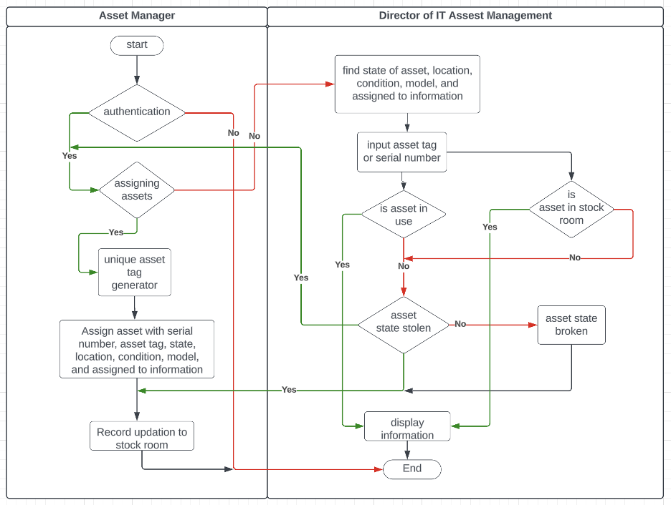

Stockroom management:
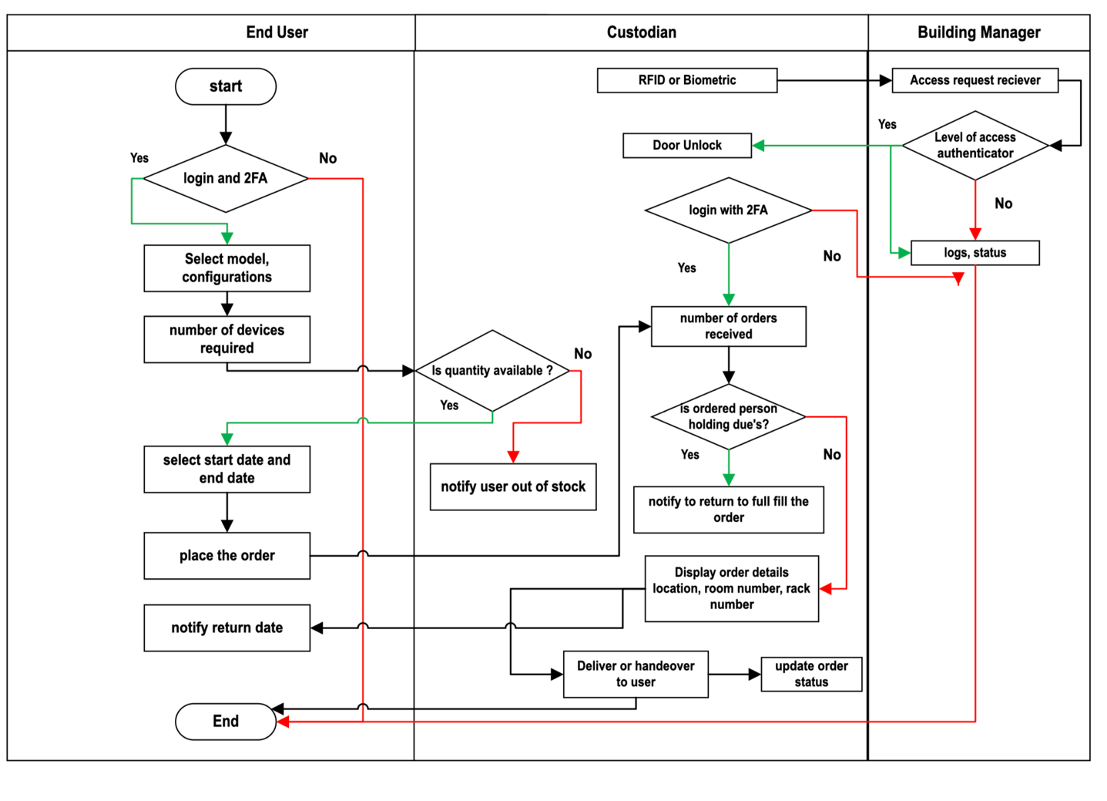

Functions and Requirements Table
Function | Requirement
Verify user identities and ensure secure system access. | - User authentication via username and password.  - Recovery mechanism for forgotten passwords.  - Encryption of user credentials to ensure data security.
Act as the main dashboard for users post-authentication, presenting essential information and enabling access to different system functionalities. | - Display employee name, ID, and last login time.  - Option for users to manage their profiles (e.g., update contact information, change password).  - Display a list of unsubmitted asset orders, including details like order ID, submission date, and current status.
Maintain a comprehensive database of all assets available in the stock room, along with their specifications and status. | - The system must store details of all assets in the stockroom, including specifications and current status.  - Each asset entry must have a unique identifier (e.g., asset ID or serial number).  - Capture hardware specifications (e.g., CPU, RAM, disk size) and software configurations.  - Provide graphical representations of stock room inventory levels and asset allocation.  - Implement secure access to the database with role-based permissions for viewing or editing data.
Allow users to submit requests for the assets they need. | - Order form with fields for employee ID, device name, quantity, and specifications.  - Validation of order details to ensure completeness and accuracy.  - Notification system to alert users and stock room administrators of new orders.
Provide comprehensive details about each asset to help users make well-informed choices when placing orders. | - Provide detailed specifications for each device, covering both hardware and software features.  - Enable users to search for and filter assets based on criteria such as brand or specific attributes.  - Connect with external databases or resources to ensure device information remains current and accurate.
Create summaries of submitted orders to simplify tracking and monitoring. | - Display summary of orders including employee name, ID, device specifications, and order status.  - Option to filter and search orders based on various criteria (e.g., date, status).  - Export functionality to generate reports in different formats (e.g., PDF, CSV).
Monitor assets that remain unreturned after the designated period. | - Dedicated page to view unsubmitted assets with details such as employee ID, device name, and dates borrowed.  - Judgment-based overdue asset marking and initiation of follow-up actions, like sending reminders to employees.  - Inventory management system to indicate asset status once returned.  - These features and demands together give a concrete structure to the stock room management system in order to satisfy the needs of both users and administrators while tracking assets efficiently and maintaining the order fulfillment process.

User Interface

Serialized Asset Tracking

Description
Serialized Asset Tracking is a methodical process of tracking and managing IT assets where each asset in the system has been assigned a unique identifier, or in other words, a serial number. This system provides the capability to track specified components at any stage in the lifecycle of an asset, from acquisition to disposition, by making the process uniquely identifiable. The Asset Manager and the Head of IT Service Management oversee the system, and their role is to ensure records are kept and updated in the central database regarding critical asset information: status, location, condition, maintenance schedules, repair history, and consumption trends.

The aim of Serialized Asset Tracking is to maximize the availability, accountability, and traceability of assets. Comprehensive recording in the system assists audits, efficiency of operations, and enables data-driven decision-making. This system consolidates all asset-related information; hence, there will be no duplications and data integrity can be guaranteed. Moreover, real-time updating is crucial. It helps the team track the asset easily and thereby reduces the chance of misplacing them. It also makes the inventory more accurate.

Eventually, serialized asset tracking ensures that IT assets are well managed to minimize operational disruption and maximize utilization of the assets. The system will avail data at a very detailed and accurate level that will enhance organizational efficiency, reduce operational costs, and provide full assurance that the assets put to good use and well-maintained during their lifecycle.
Login
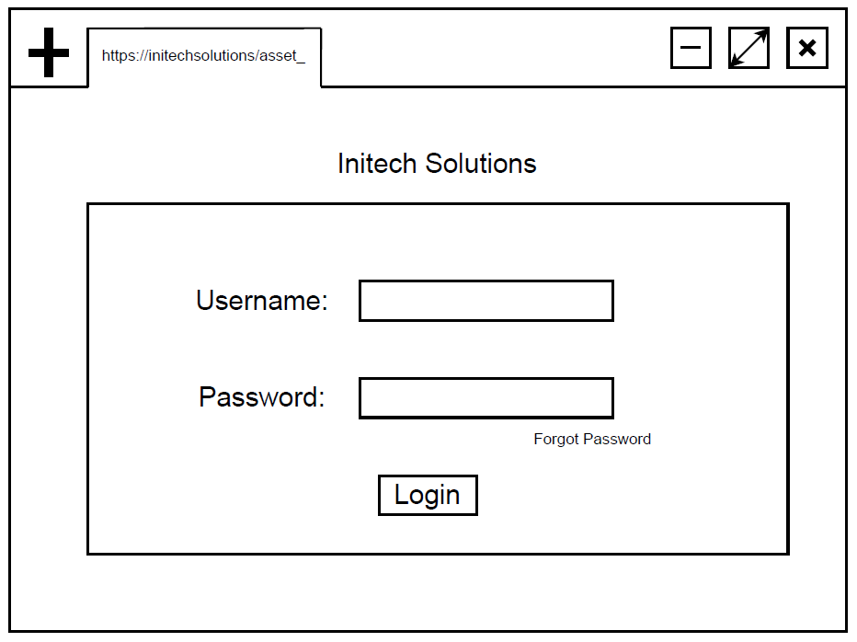

Verification

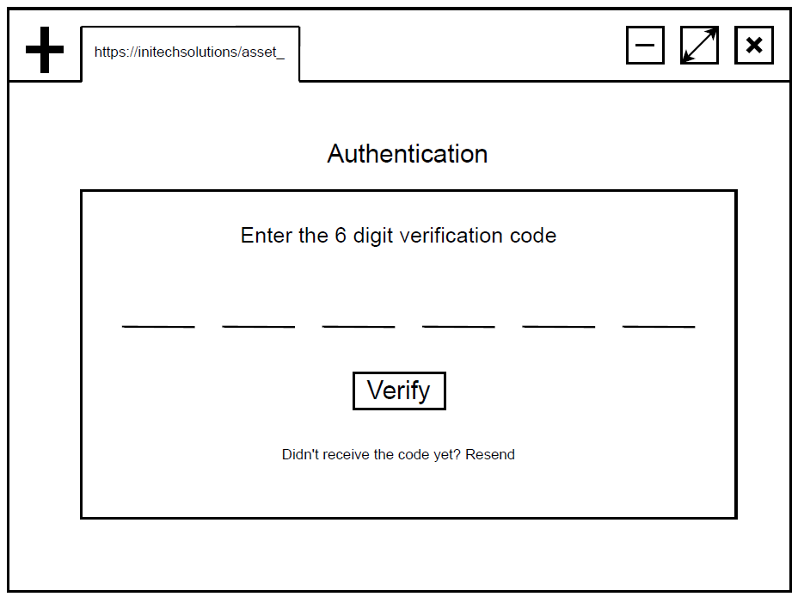

If authentication is failed in case of wrong code or time out

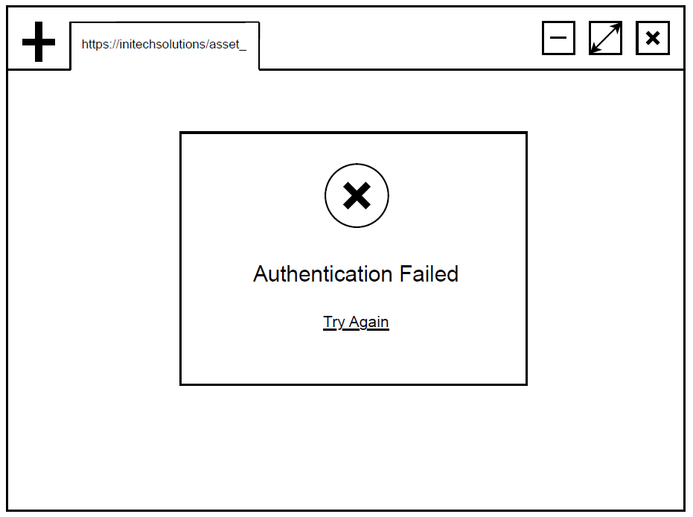

If verification is failed multiple times and no attempts remind

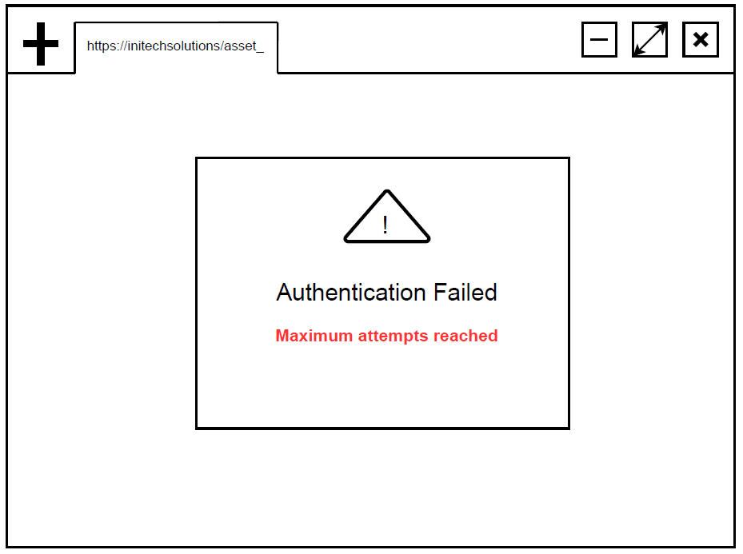

Asset Tracking Dashboard

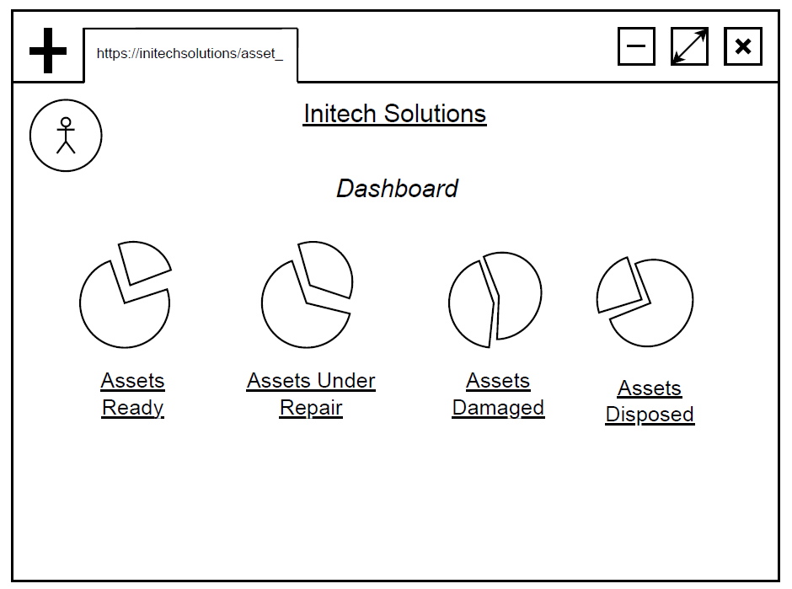

Asset List

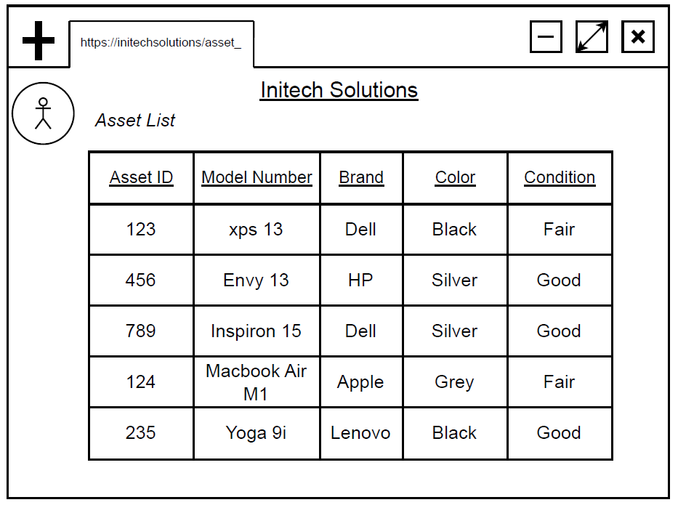

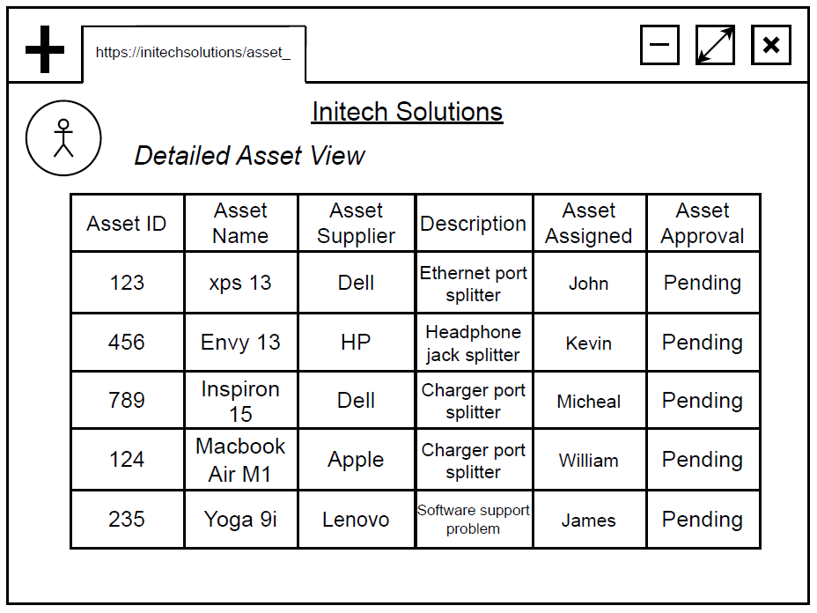

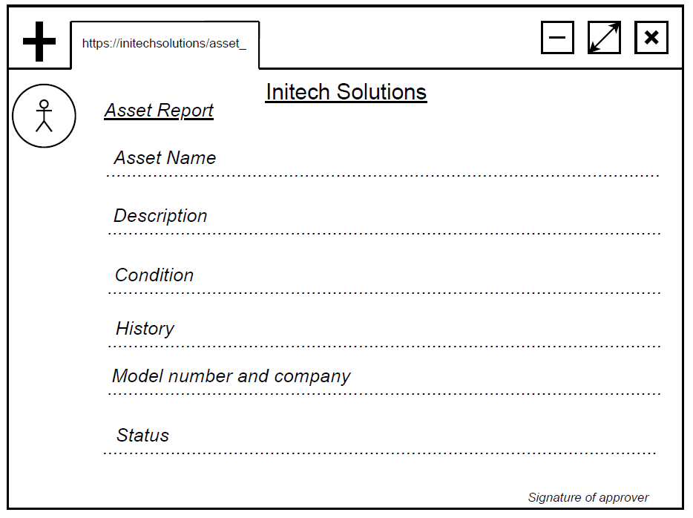

Stockroom Management
Description
The database schema brings together user, asset, security, and service request management into a unified system. The System Security Overview entity monitors critical security mechanisms such as authentication, authorization, encryption, and logging. These methods are related to Authentication, which manages user login credentials. The End User entity holds user information such as name, email, and contact information, whereas Session Details track user activity by recording login and logout timestamps. These relationships guarantee secure and traceable user interactions within the system.
For asset and service management, the Institutional Asset Tracking entity keeps track of serial numbers, models, locations, conditions, and assigned users. This is aided by Stock Room Management, which tracks storage capacity and location. The Request and Service Management entity records user service requests, including request types, statuses, and associated users. The Asset Entry and Service Request entity connects individual service requests to their respective assets, bridging the gap between asset tracking and request management. These networked entities provide for effective management of people, assets, and services while retaining security and traceability.

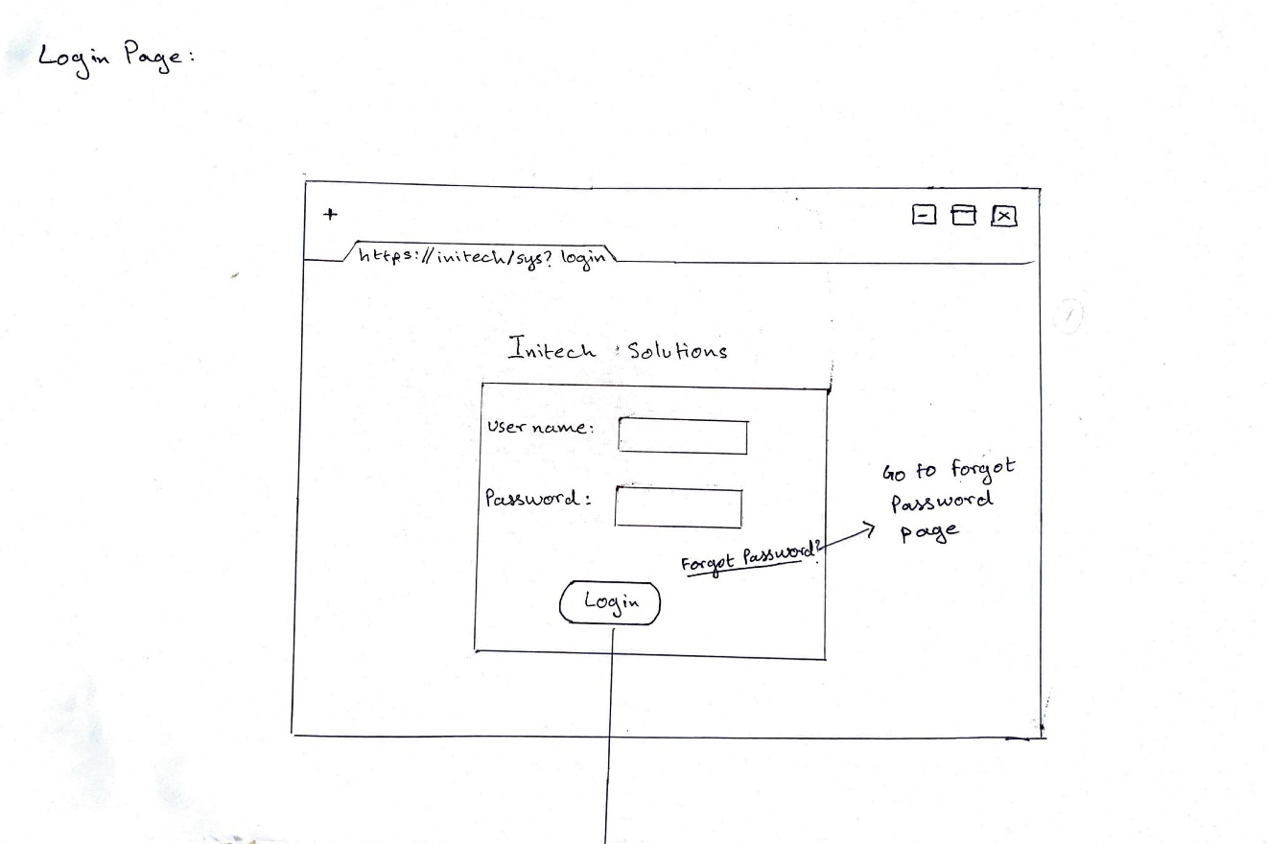

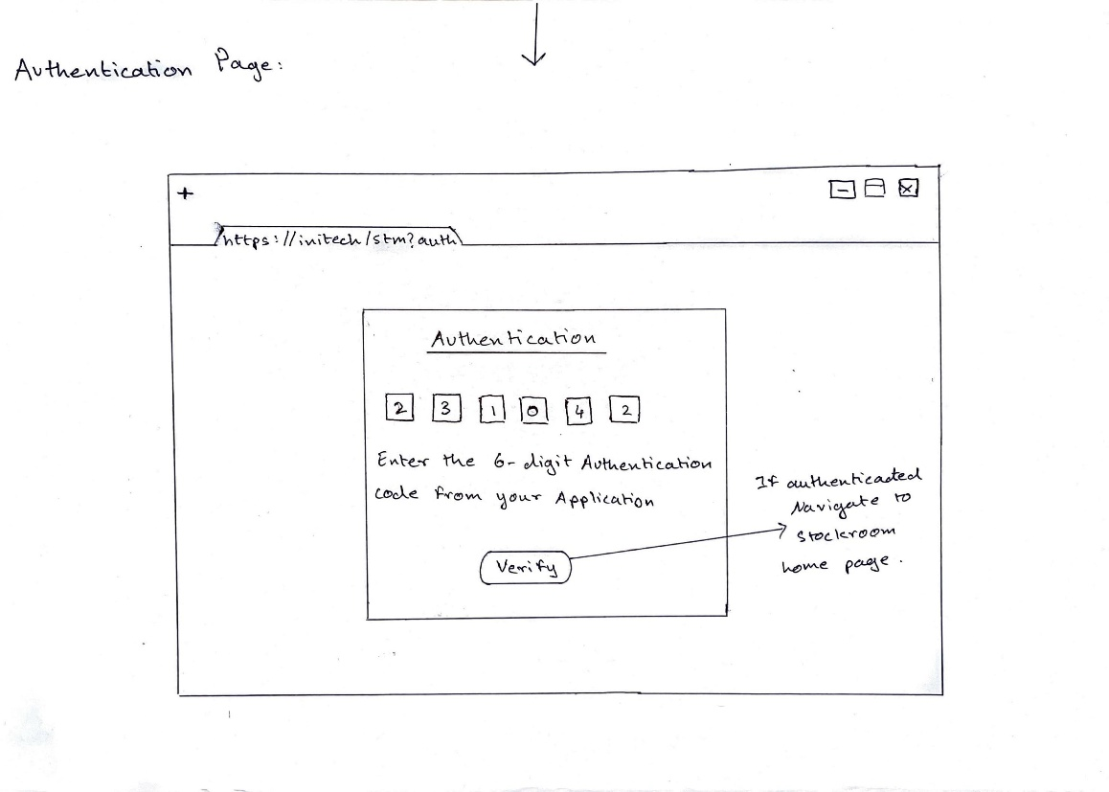

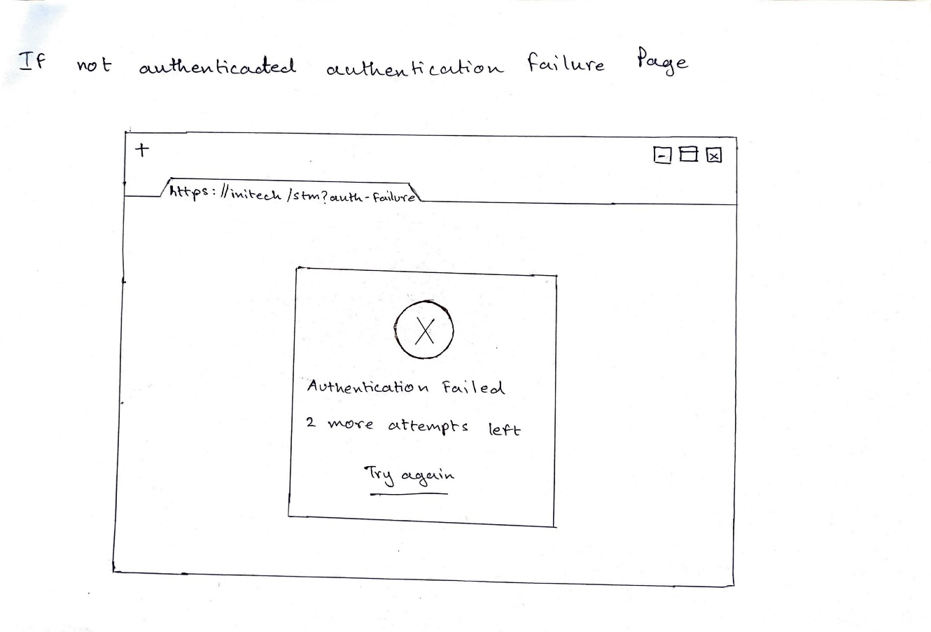

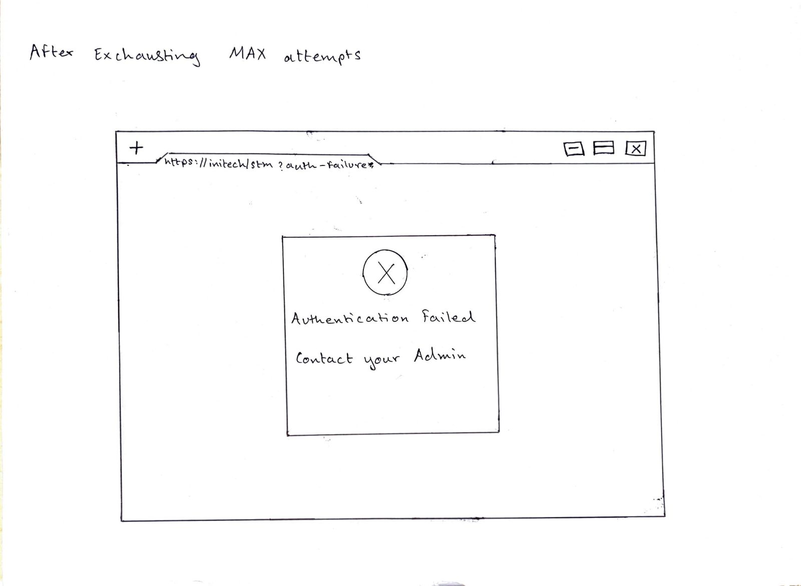

Additionally, provisions are made for users who forget their password, ensuring accessibility while maintaining data integrity.
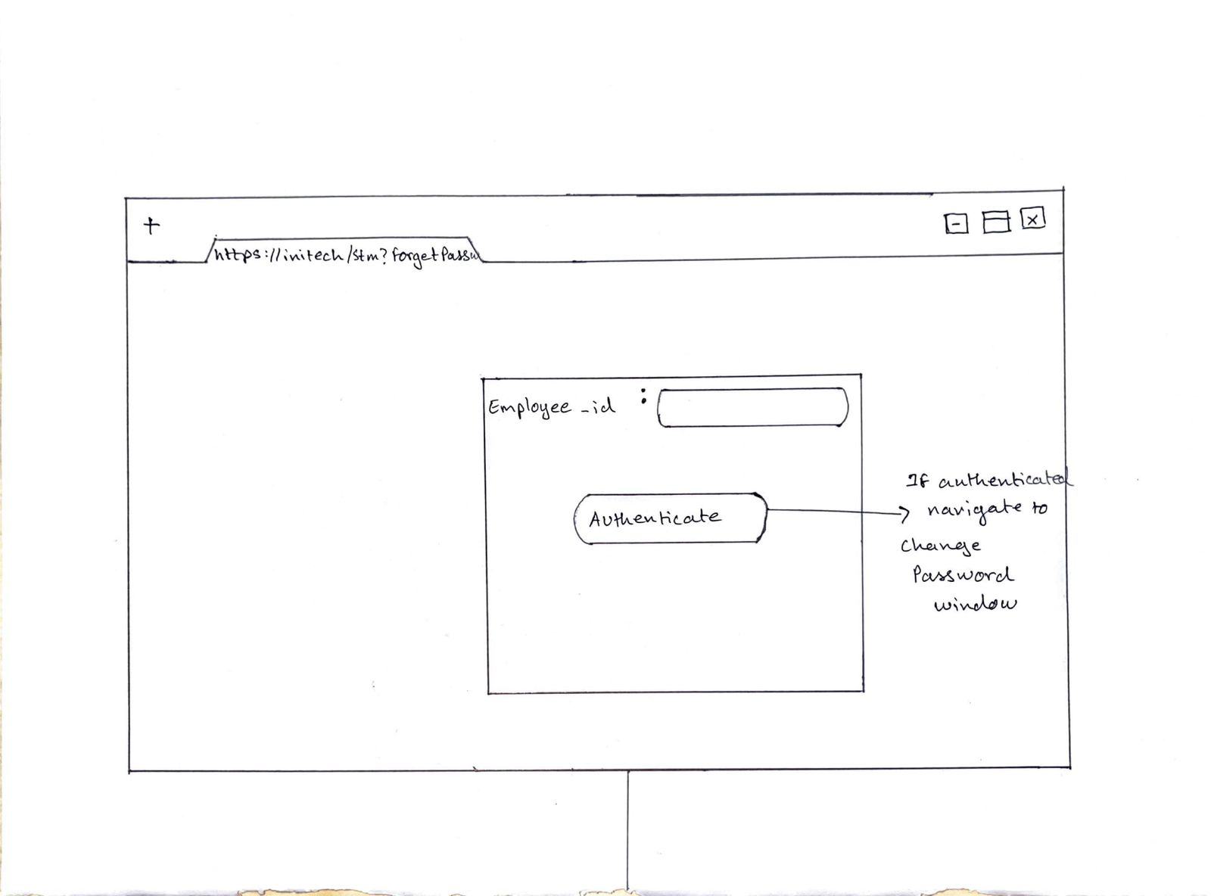
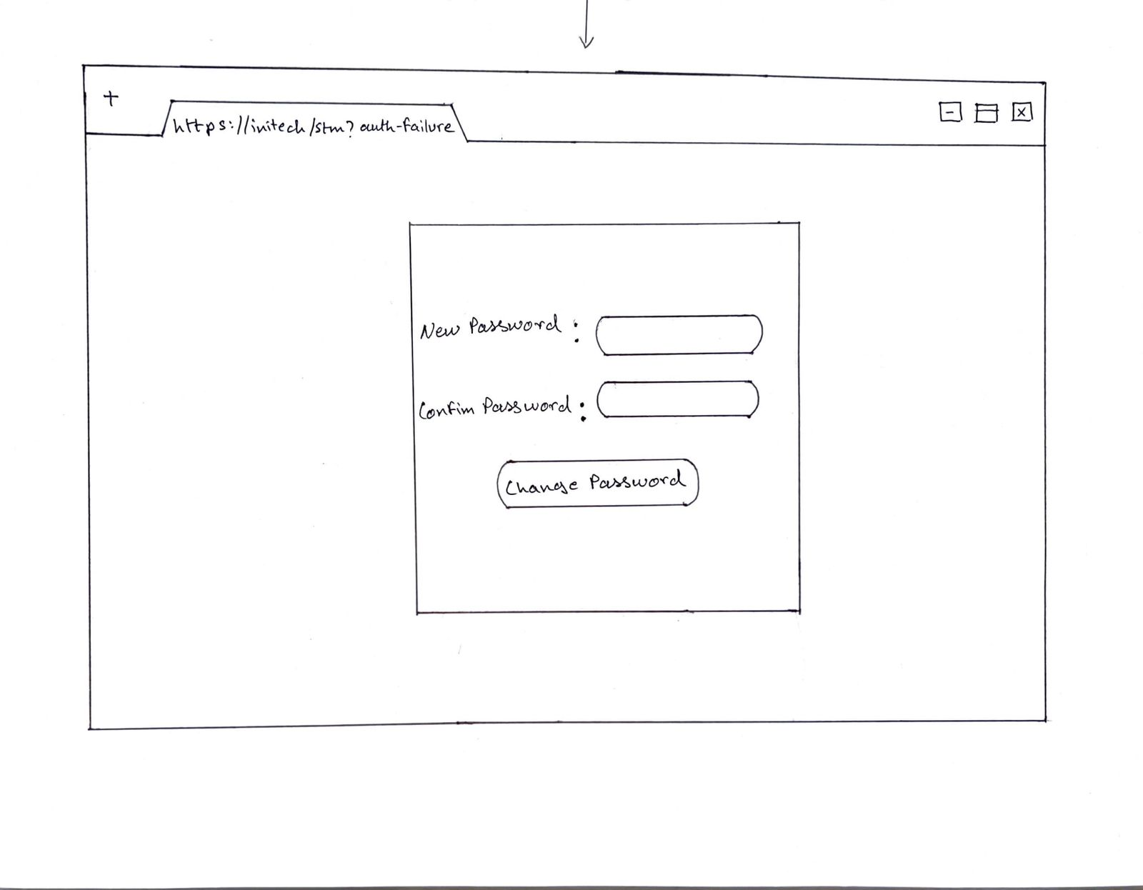

Once authenticated, users are directed to the stock room home page, which serves as the central hub for navigating the system. Here, employees can view their own details such as name, ID, and last login time, providing a personalized experience. The inclusion of a profile option allows users to manage their account settings, further enhancing usability.
The heart of the system lies in its ability to record and manage various assets within the stock room. Assets such as Asus ZenBook, Lenovo ThinkPad, HP Pavilion x360, and HP monitors are meticulously cataloged, with detailed information provided for each item. and graphical representations of the stock room's state, enabling users to make informed decisions when selecting assets for procurement or allocation.
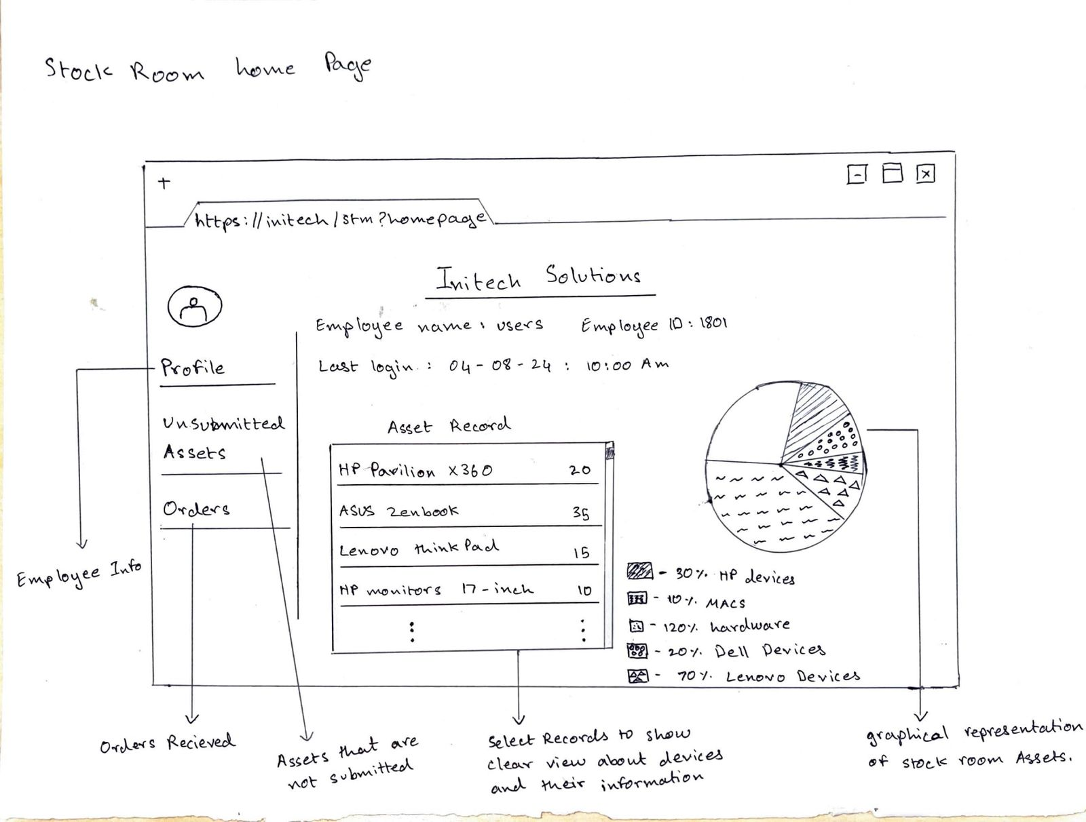
Asset Record consist of list of assets and their hardware specifications, software configurations and device information that contains location and unique id.
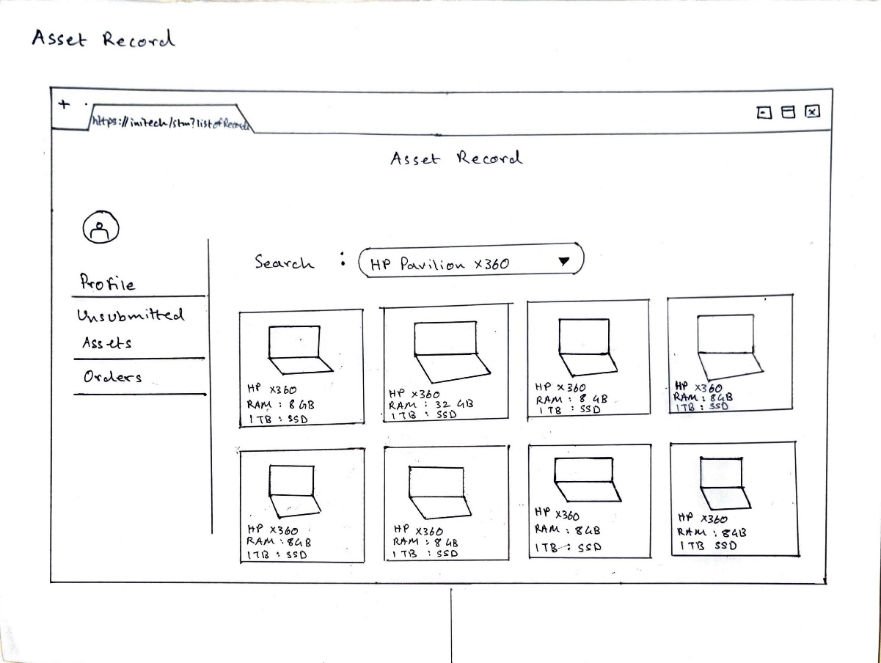
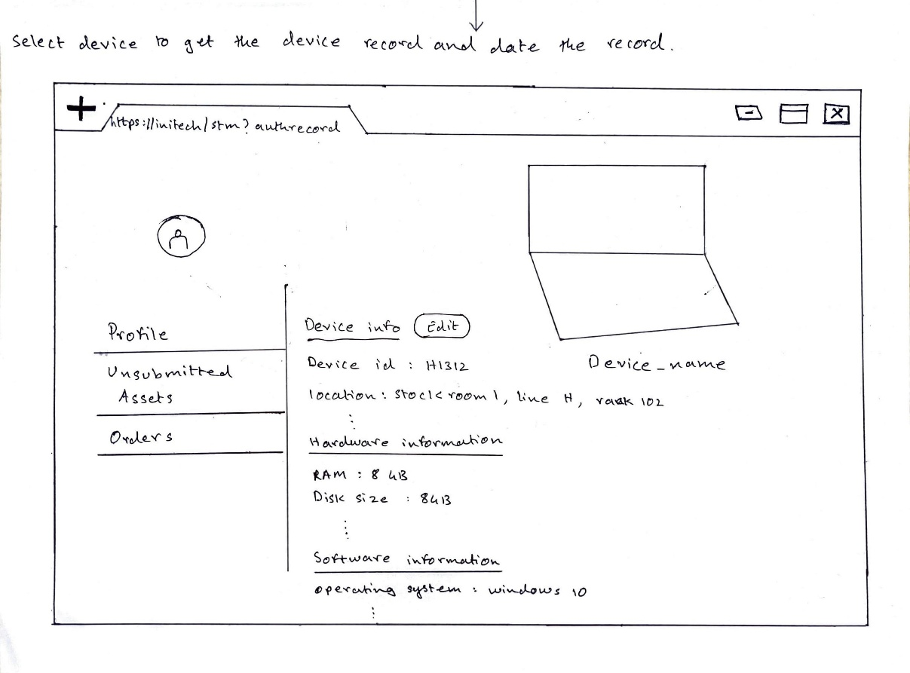

The ordering process is streamlined through the system, with clear guidelines provided for placing orders. Employees are required to input essential details such as their ID, device name, CPU count, RAM, disk size, and quantity, ensuring that all necessary information is captured accurately. This not only simplifies the procurement process but also minimizes errors and delays associated with manual order entry. Furthermore, the system offers a comprehensive overview of placed orders through the order summary feature. This summary includes essential information such as employee name, ID, device specifications, and configurations, providing a convenient reference point for tracking and monitoring orders throughout their lifecycle.

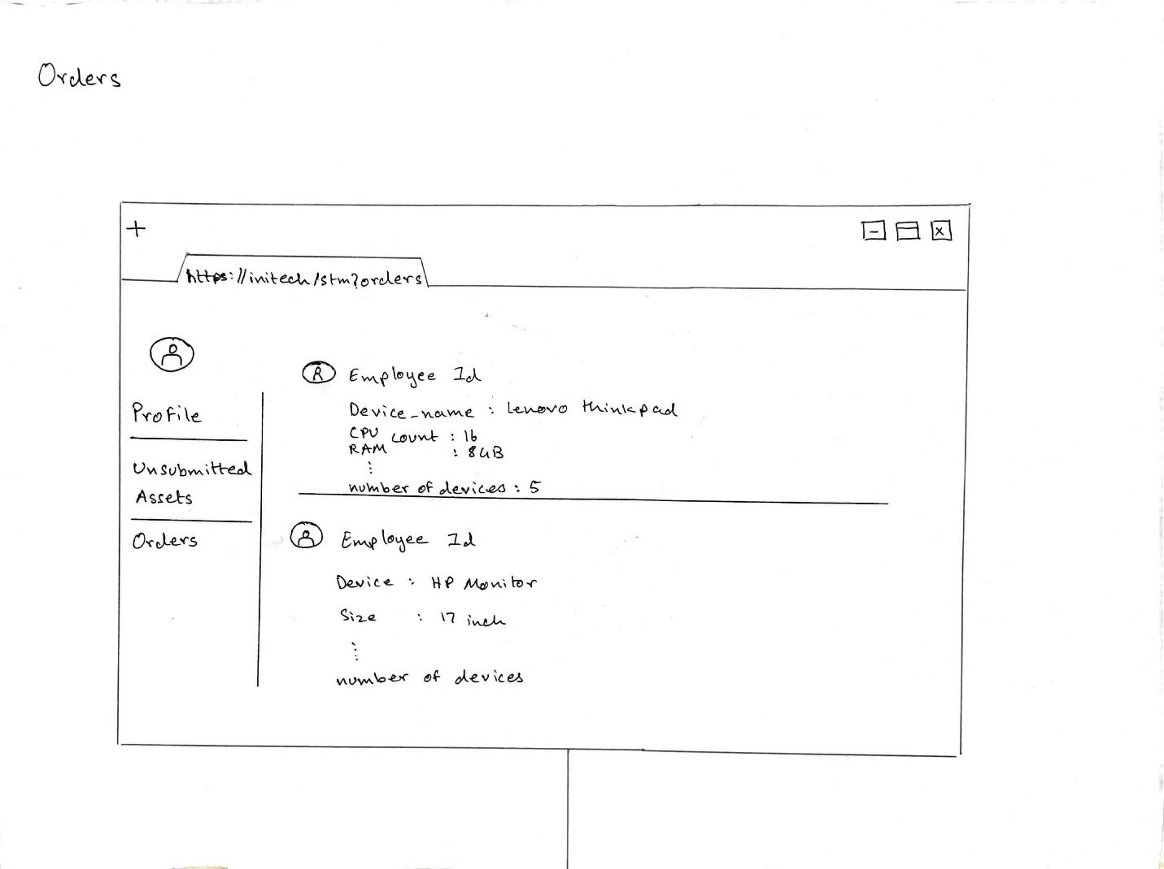
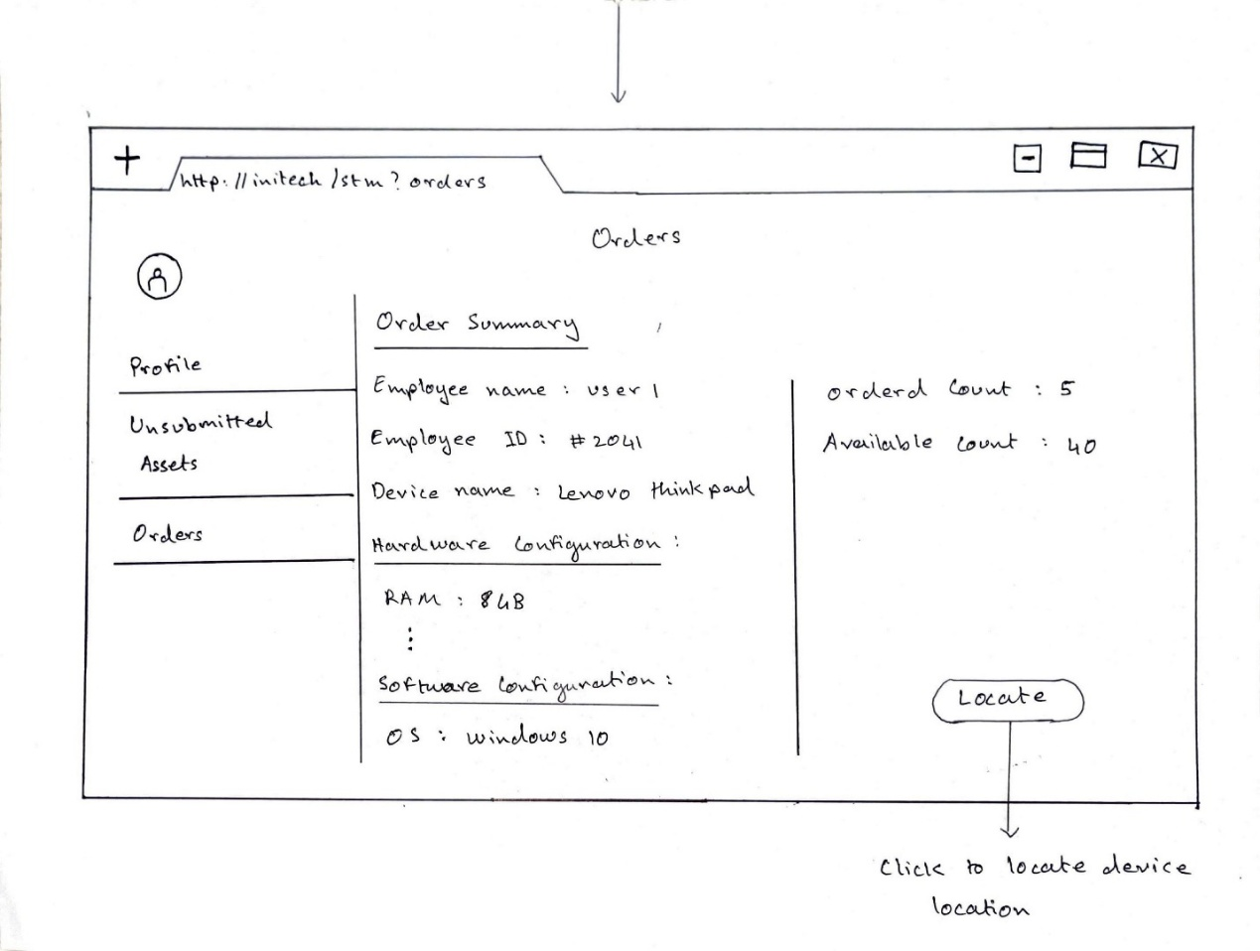
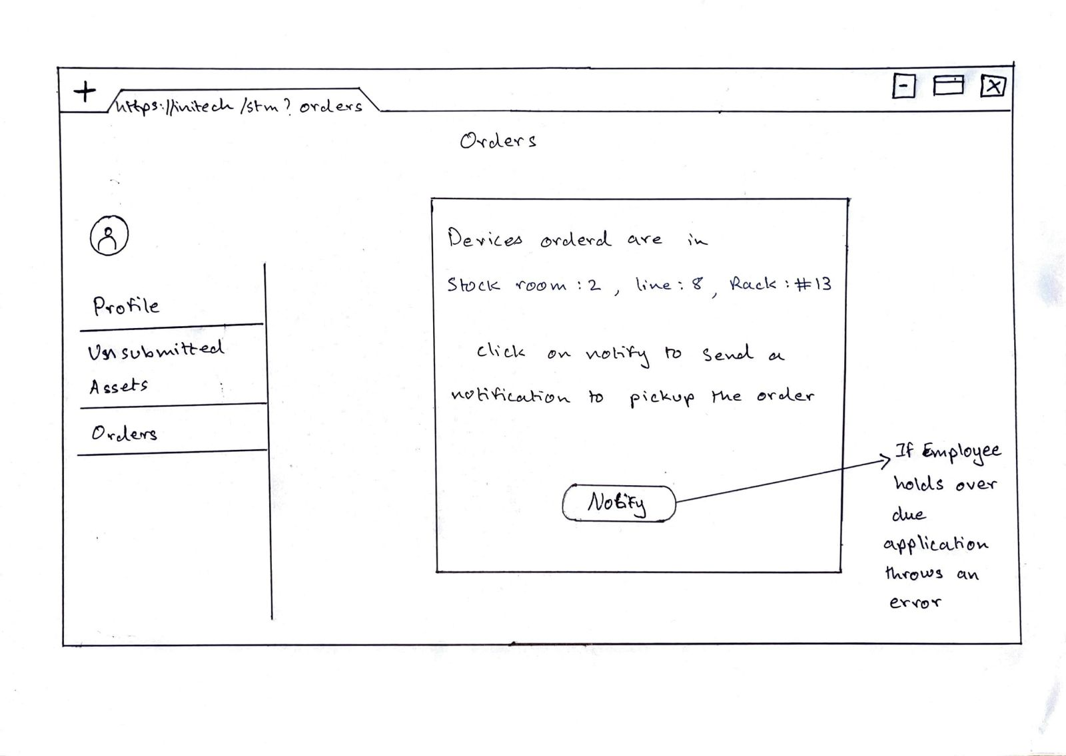

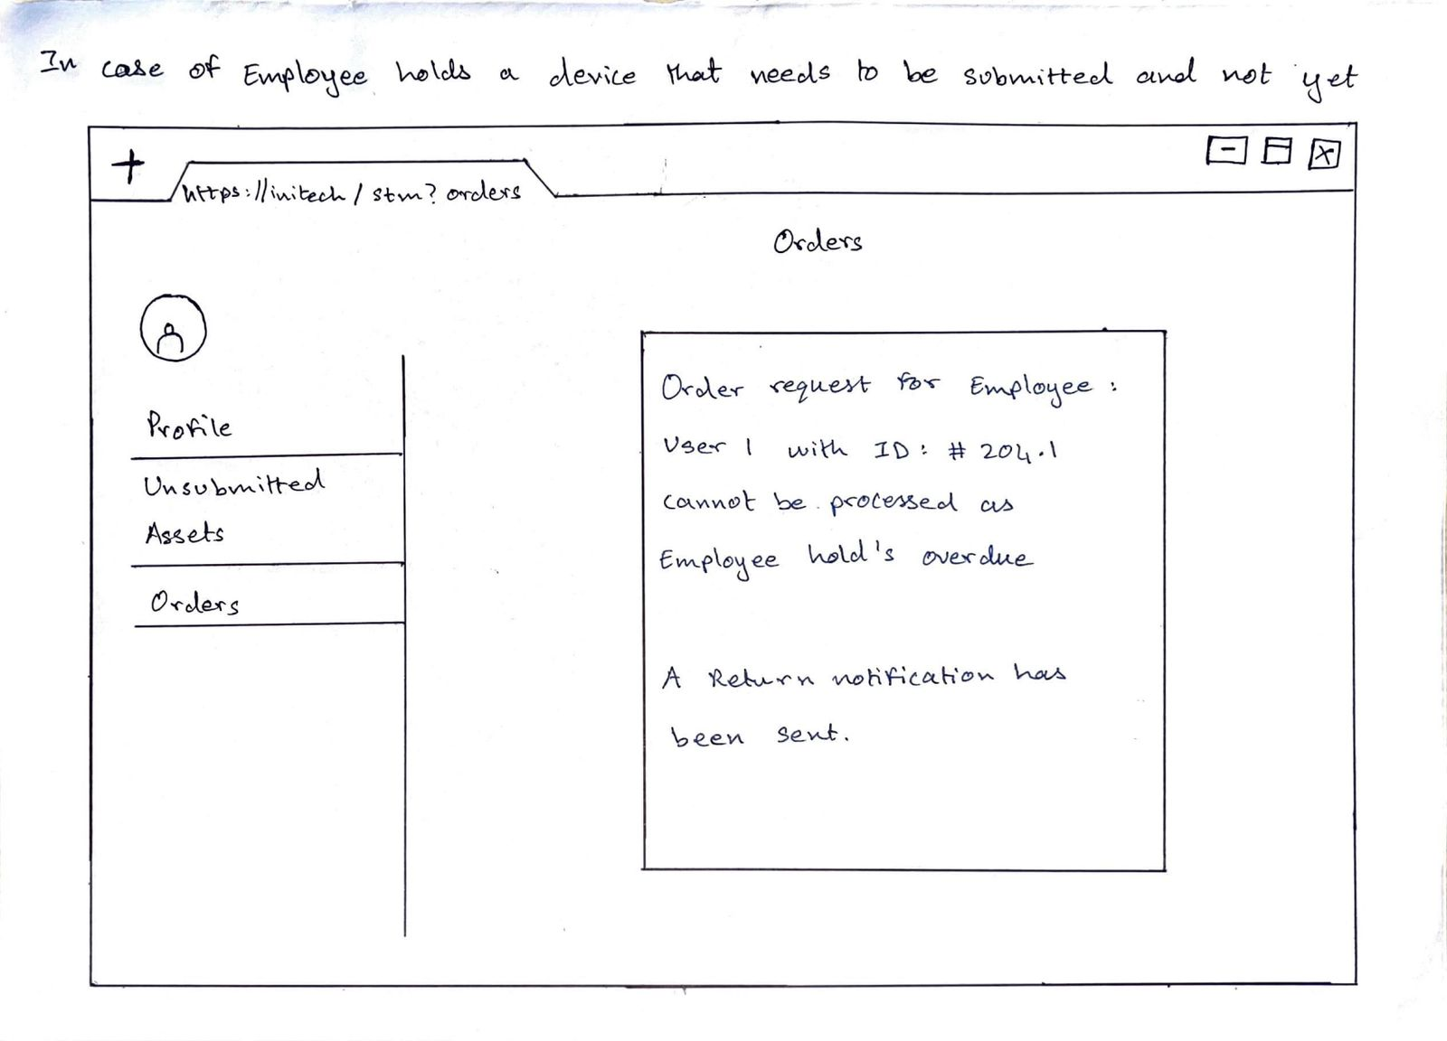

The system also addresses the tracking of unsubmitted assets. A dedicated page is provided to monitor assets that have not been returned within the specified timeframe. This page displays relevant information such as employee ID, device name, and start and end dates, allowing stock room personnel to take appropriate action to recover missing assets.
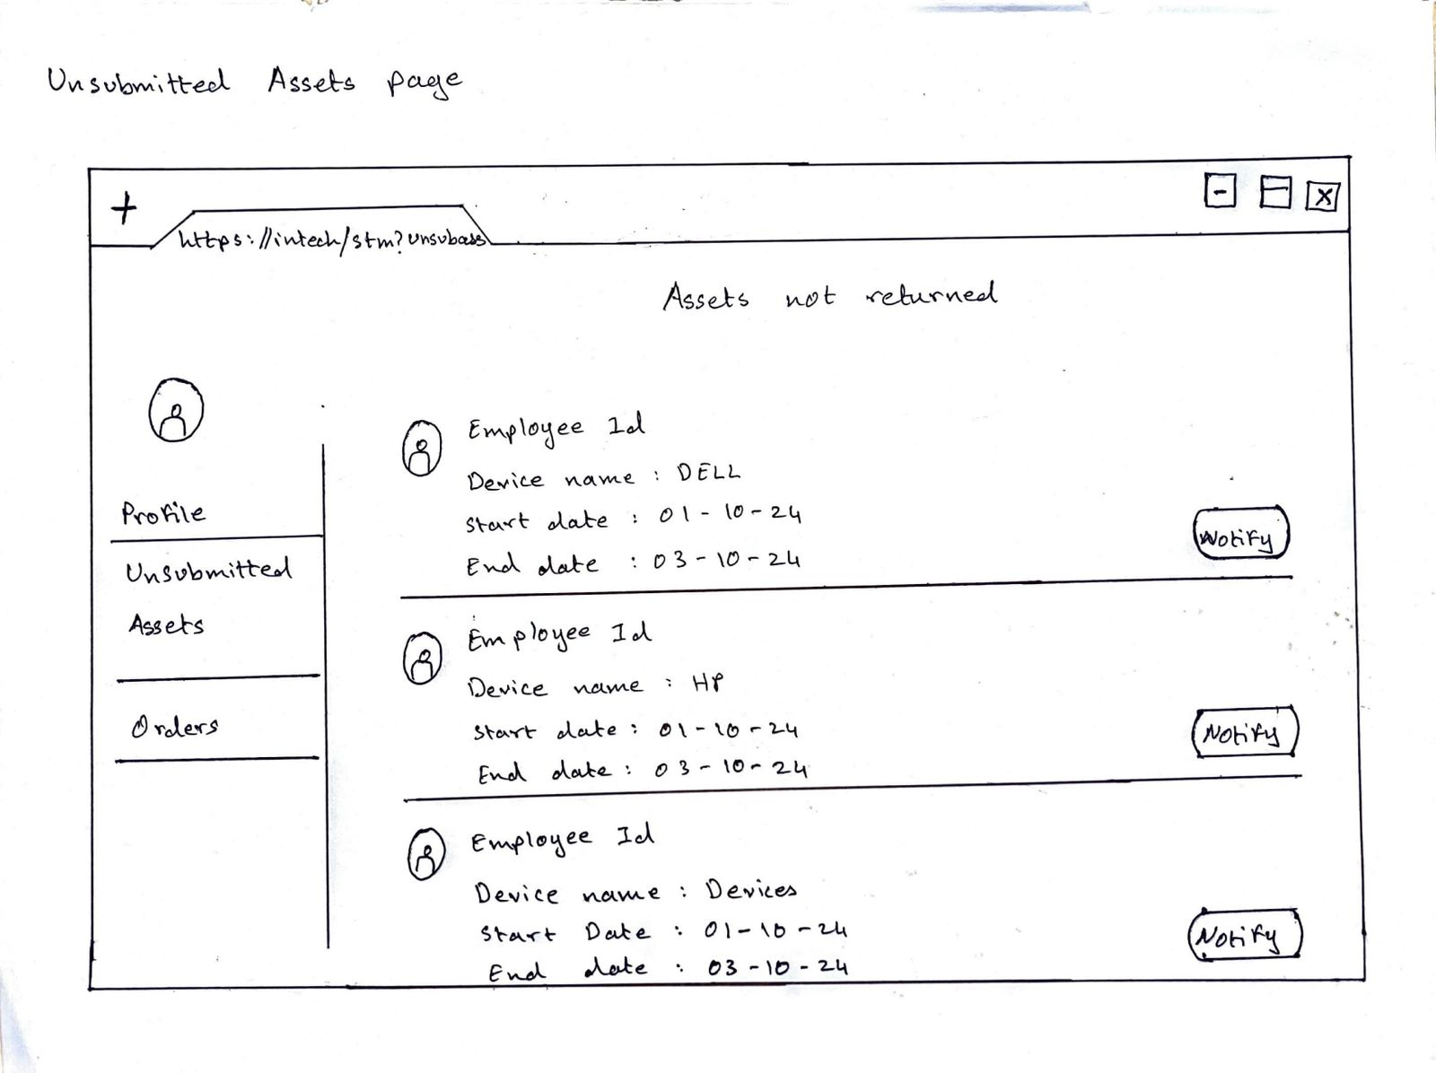

Infrastructure Architecture:

Network Topology
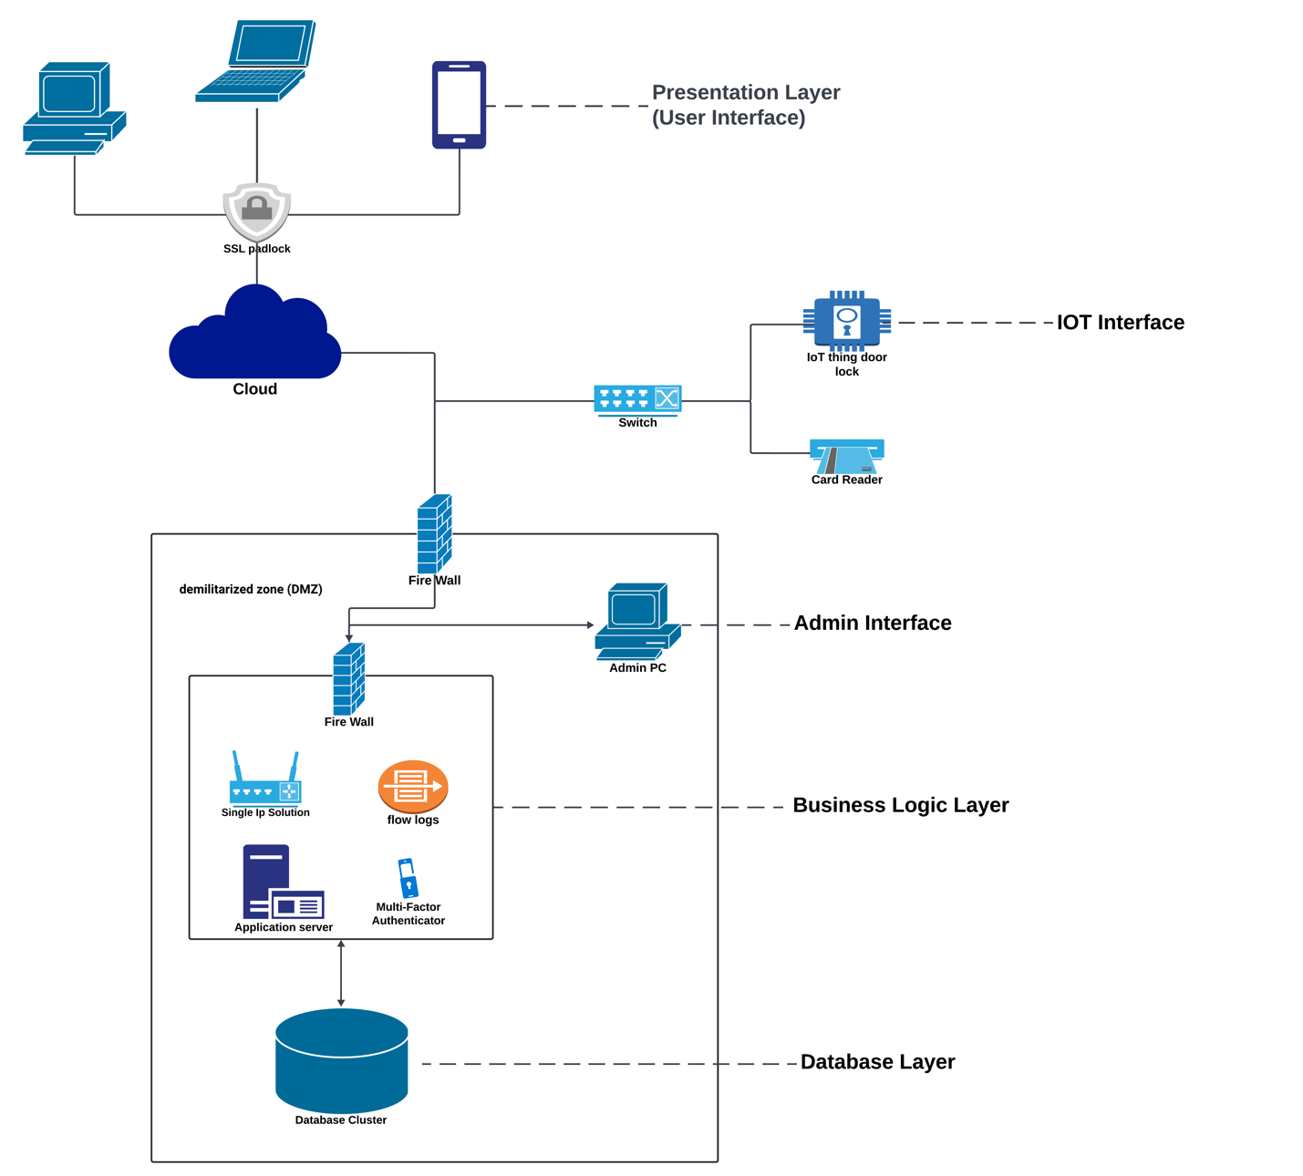

While implementing a technology solution in a firm successfully, one has to take into consideration certain components necessary to support the processes of Serialized Asset Tracker and Stockroom Management.
Process of Serialized Asset Tracking:
The employees of the Serialized Asset Tracker scenario use desktop computers, laptops, tablets, and cellphones to connect with the system for tracking assets. These devices can act as endpoints to reach the Serialized Asset Management system. There is a need for servers to allow the backend functions in the process being carried out for the Serialized Asset Tracker, which includes processing, storing, and managing data.
Among these, the following would be included: An Application Server that controls the execution of business logic of the Serialized Asset Management system. It will manage tasks including user authentication, maintenance scheduling, and asset tracking.
Database Server: This will store all the information about serialized assets regarding their location, status, and users assigned. Ensuring data is scalable, secure, and integral.
The devices, or endpoints, and servers require network infrastructure to connect with each other. Infrastructure will ensure in the system that transport of data and communication run smoothly.
Stockroom Management Process:
Stockroom Management In this scenario, employees interacting with the system to manage and control their inventory in the stockroom do so with the same device types as listed in the above scenario: desktop computers, laptops, tablets, and smartphones. For the business process of Stockroom Management itself, the use of servers is the same as described for the Serialized Asset Tracker process for data storage and execution of business logic, including:
Application Server: The actualizing server of the business logic concerning stock tracking, stock replenishment, and issuance in a stockroom management system.
Database Server: This server will store inventory information about suppliers, stock movements, and levels.
Networking Infrastructure: The same infrastructure for networking is to be developed for communication devices and servers along the Stockroom Management process.
It can add administrative workstations in order to make system administration chores easier: permission management among users, configuration of security settings, and monitoring system health. Finally, infrastructure composed of endpoints for user engagement, servers to run business logic and store data, and finally network infrastructure that will enable it all to connect is needed for the implementation of the technological solution inside a corporation. This can be taken further by enhancing system administration and security with administrative workstations and their respective security mechanisms.

Information Architecture

Entity Relationship Diagram
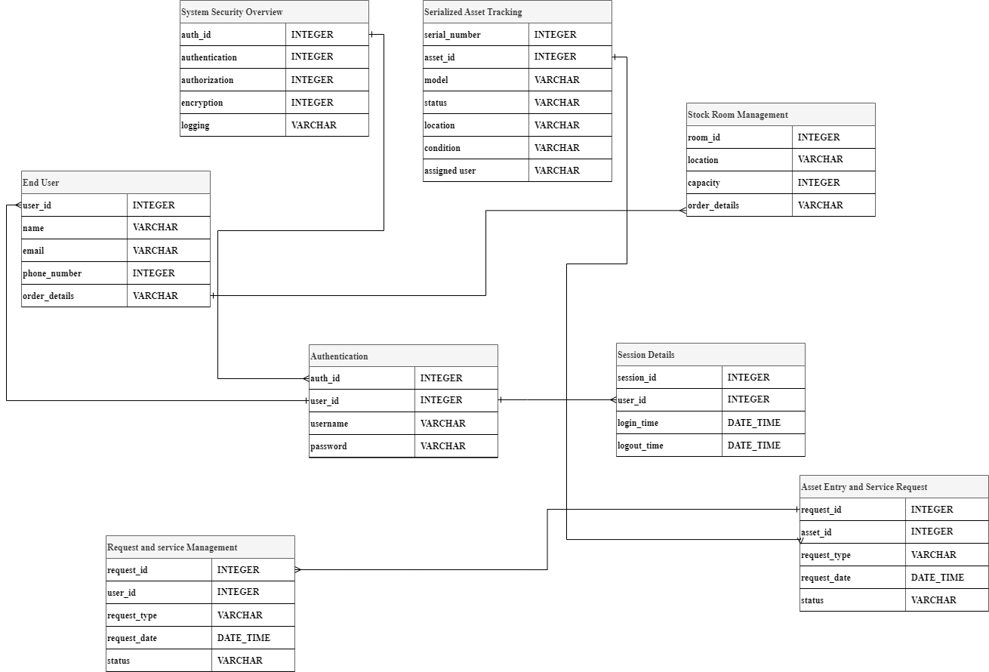

The ERD summarizes the basic system architecture involved in asset tracking, security, user administration, and stockroom management in an orderly way. This includes critical components such as System Security Overview, Asset Entry and Service Request, Stock Room Management, and Serialized Asset Tracking.

The System Security Overview object contains security methods such as logging, encryption, and authentication. The Serialized Asset Tracking keeps individual assets with unique IDs. The Asset Entry and Service Request entity logs the requests made by users regarding asset entry or tasks associated with the services. Stock Room Management organization tracks physical inventory storage locations.

The relations between these entities enable them to share and communicate information between one another. A typical example would be Asset Entry and Service Request with Serialized Asset Tracking. A many-to-one relationship in this could mean that, though not described, one asset may have more than one request, but each request has only one asset assigned to it. The relationship between the System Security Overview entity and both the Asset Entry and Service Request entities is one to one; each request has only one associated security overview.

One-to-many: The relationship between the entity of Serialized Asset Tracking and that of Stock Room Management is such that one stockroom can have several assets, while an asset is related to only one stockroom.

The ERD gives much-needed understanding of system architecture and data flow that is very important for the efficient design and development of a system. It does this by clearly illustrating components, properties, and relationships of the system. More or less entities and relationships will be required in dependency of project needs and intricacies.

These represent the security of the system, user management, authentication, session management, request and service management, stock room management, and serialized asset tracking within the system. Based on the established relationships between these entities, the different components connect to and depend on each other to support various segments of the system in facilitating data flow and interaction between them.

Security Architecture
Robust login and authentication processes are prioritized in the security architecture of the Serialized Asset Tracker and Stockroom Management systems to ensure that only authorized users have access to sensitive data and functionality.

Both systems require users to supply credentials for authentication, which typically include a username and password. This initial authentication step serves as the first line of defense against unauthorized access. To validate submitted credentials, a centralized user database stores user data such as encrypted passwords and related roles or permissions.
SSL/TLS encryption is used to improve security by preventing login credentials from being intercepted over the network. Password rules are intended to encourage the use of strong and unique passwords by requiring minimum length, complexity, and regular updates. To resist brute-force attacks, various measures such as account lockout—which includes temporarily locking a user's account after numerous unsuccessful login attempts—may be employed.
When a user successfully authenticates, a session token is generated and connected to their account. This eliminates the need for repeated authentication for each request and enhances the user experience by retaining authentication status during system interactions.
Furthermore, the systems include logging and monitoring tools for tracking user actions, attempted logins, and security events. Managers can use these logs to identify potential security problems, observe odd system usage patterns, and respond quickly in the case of a security breach or unauthorized access attempt.

In summary, the login and authentication processes for the Serialized Asset Tracker and Stockroom Management systems are bolstered by a variety of security layers that successfully prohibit unauthorized access while maintaining the integrity and confidentiality of sensitive data stored on the systems.

Technology Tools

To develop and implement the IT Asset Management (ITAM) solution, the following technology tools have been selected, categorized for clarity:
- Cloud Computing (IaaS)
  - Tools: AWS, Microsoft Azure, Google Cloud Platform (GCP)
  - Reason: These platforms provide scalable, flexible, and reliable infrastructure to host centralized ITAM software. Their pay-as-you-go models reduce upfront physical infrastructure costs while offering high availability and global accessibility.
- Web Application Development Frameworks
  - Tools: Angular, React.js, Django, Node.js
  - Reason: These frameworks streamline the development of responsive, interactive, and user-friendly interfaces. They offer extensive libraries, robust features, and strong community support, ensuring rapid development and easy maintenance.
- Relational Databases
  - Tools: PostgreSQL, MySQL, Microsoft SQL Server
  - Reason: These databases ensure data consistency, integrity, and efficient querying of structured asset information. Features like ACID compliance enhance data reliability.
- API Integration Tools
  - Tools: GraphQL, Apache Camel, MuleSoft, Microsoft Power Automate
  - Reason: APIs facilitate seamless integration with existing systems, including network monitoring and procurement tools. Integration tools ensure data synchronization across platforms.
- Security and Compliance
  - Tools: Vulnerability and patch management tools
  - Reason: These tools ensure the ITAM system complies with regulatory standards and is safeguarded against potential security threats.
- Monitoring and Logging
  - Tools: Prometheus, Grafana
  - Reason: These tools optimize resource utilization by tracking performance and analyzing logs for troubleshooting and compliance.
- Reporting and Analytics
  - Tools: Data visualization tools (e.g., Tableau, Power BI)
  - Reason: They provide actionable insights into asset lifecycles, supporting informed decisions on inventory and financial planning.

Current Solutions
Ivanti IT Asset Management Suite: With additional support for cloud-based assets, Ivanti provides a comprehensive solution for managing software and hardware assets. The package integrates sophisticated automation, robust security, and comprehensive reporting tools. It provides auditing and compliance capabilities for IT infrastructures and is particularly useful for endpoint device management (Ivanti, 2023).
ManageEngine Asset Explorer: It is a web-based IT asset management application designed to track and manage software and hardware assets throughout their lifecycles. Even smaller businesses can benefit from its user-friendly interface and features like as auditing and licensing control (ManageEngine, 2024).
BMC Helix Discovery: This cloud-based technology automates the identification and monitoring of IT assets, supporting both on-premises and cloud architectures. For complicated IT infrastructures, it ensures accurate tracking and complete asset visibility (BMC, 2023).

Commercial Off-the-Shelf (COTS): it products are pre-built, ready-to-use software or hardware solutions intended for widespread use by numerous businesses. These solutions are cost-effective since the development cost is shared by multiple users, and they can be implemented fast without the requirement for specialized development. While COTS systems have limited customization options, they frequently include vendor support and regular upgrades, ensuring their functionality and security. However, firms that use COTS solutions may face scalability issues and reliance on the manufacturer for continual updates and support.
Pros: Because COTS solutions are pre-built and ready to use, they enable faster deployment. They often cost less than in-house solutions since there are no upfront development expenditures. Vendors constantly test and upgrade COTS products to ensure that the software is safe, compliant, and up to date with emerging technology. Vendor support reduces the need for internal IT professionals to monitor and maintain the system.
Cons: COTS solutions may not provide the deep customization required to meet specific organizational goals. Businesses rely on vendors for updates and patches, therefore it could be troublesome if the vendor changes its roadmap or discontinues a product. Furthermore, there is the possibility of vendor lock-in, which makes switching to a new product expensive and difficult due to migration costs and integration issues.

References
- Tilley, S. (2020). Systems Analysis and Design (12th ed.). Cengage.
- Ivanti (2023). Ivanti IT Asset Management - Optimize your IT asset visibility and usage.
- Retrieved from https://www.ivanti.com/resources/v/doc/ivi/1518/09df52232b6f
- Asset Explorer. Retrieved from https://www.manageengine.com/products/asset-explorer/
- Gavrikova, E., Volkova, I., & Burda, Y. (2020). Strategic aspects of asset management: An overview of current research. Sustainability, 12(15), 5955.
- Schuman, C. A., & Brent, A. C. (2005). Asset life cycle management: towards improving physical asset performance in the process industry. International Journal of Operations & Production Management, 25(6), 566-579.

