Project -StudentRecords CRUD (Create, Read, Update, Delete) application using AWS DynamoDB, S3 on Cloud9
Ishwariya pandi
ASU Id: 1233885850
Information Technology, Arizona State University
IFT 512: Advanced Big Data Analytics/AI
Durgesh Sharma
09/28/2025

Project -StudentRecords CRUD (Create, Read, Update, Delete) application using AWS DynamoDB, S3 on Cloud9

Section 1:

IshupandiStudentDynamoDBProject/

--createTable.py

--insertFromFile.py

--viewAllStudents.py

--updateStudent.py

--deleteStudent.py

--queryStudents.py

--uploadToS3.py

--student.json

--readme.md

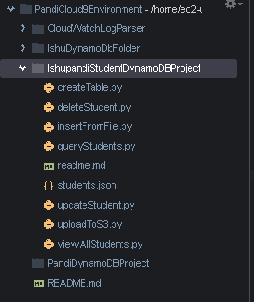

Installing screenshot:

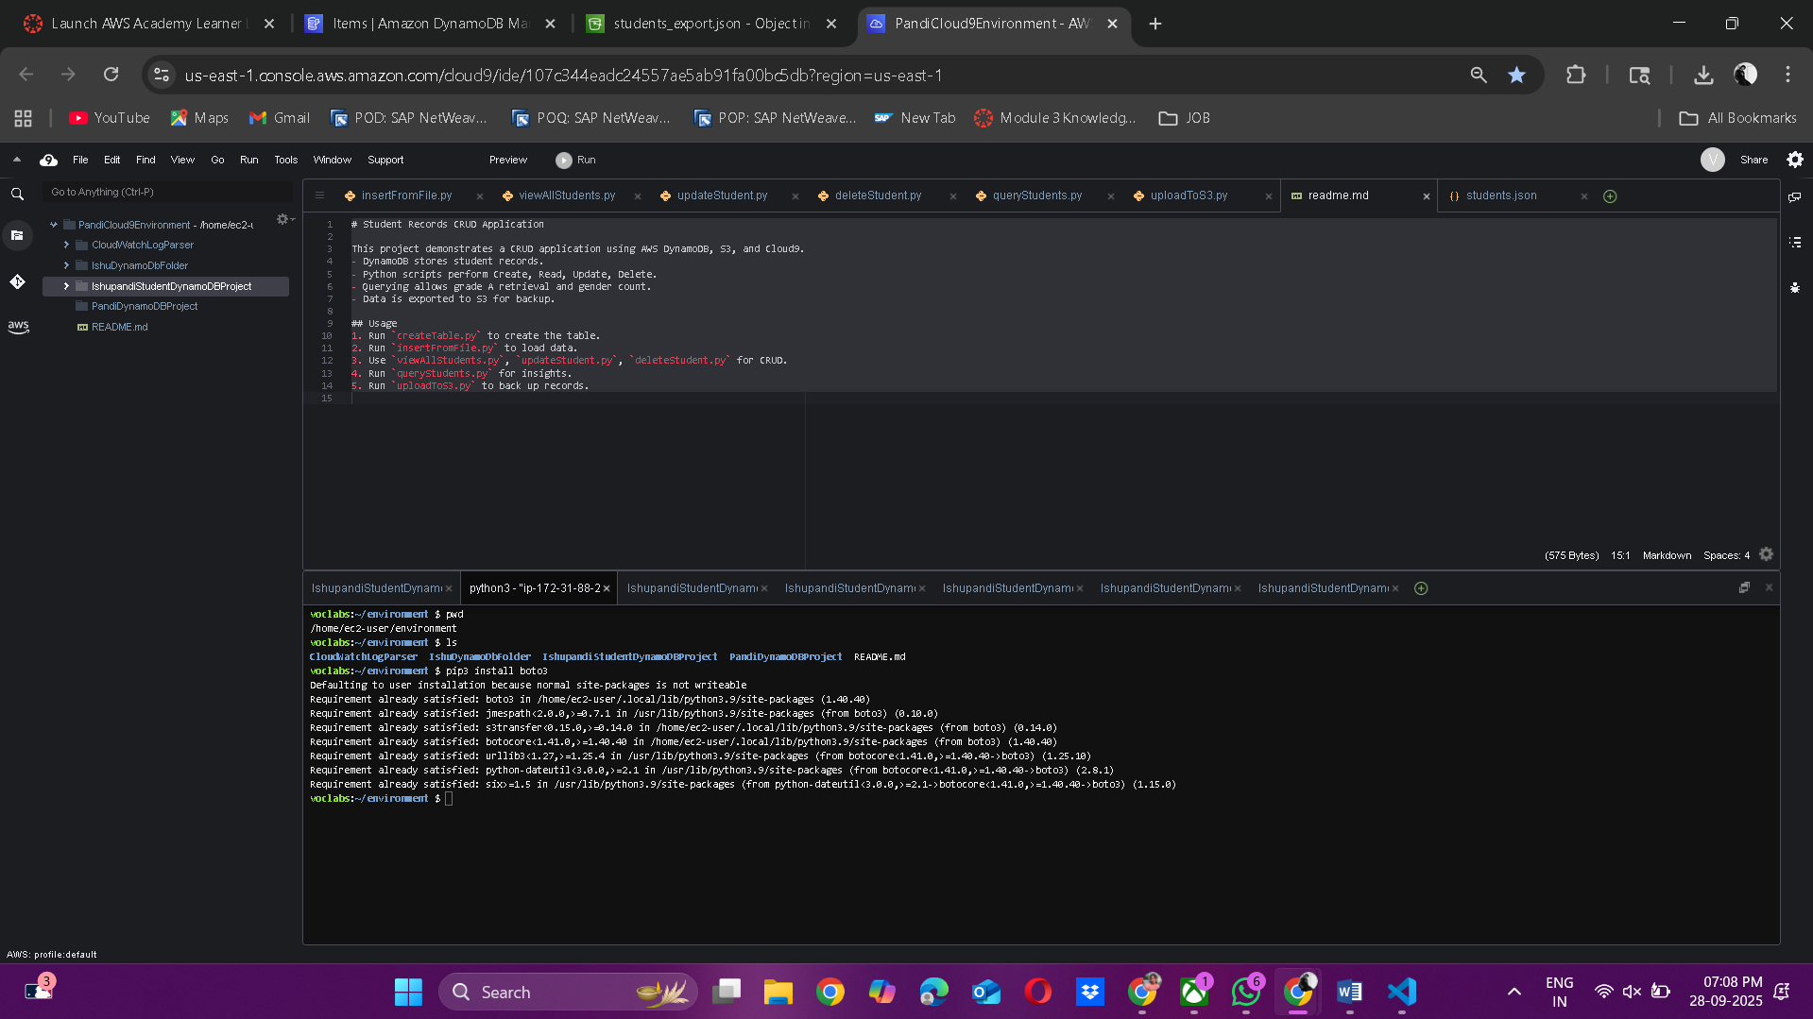

Section 2: Screenshots

Screenshot of students.json in DynamoDB

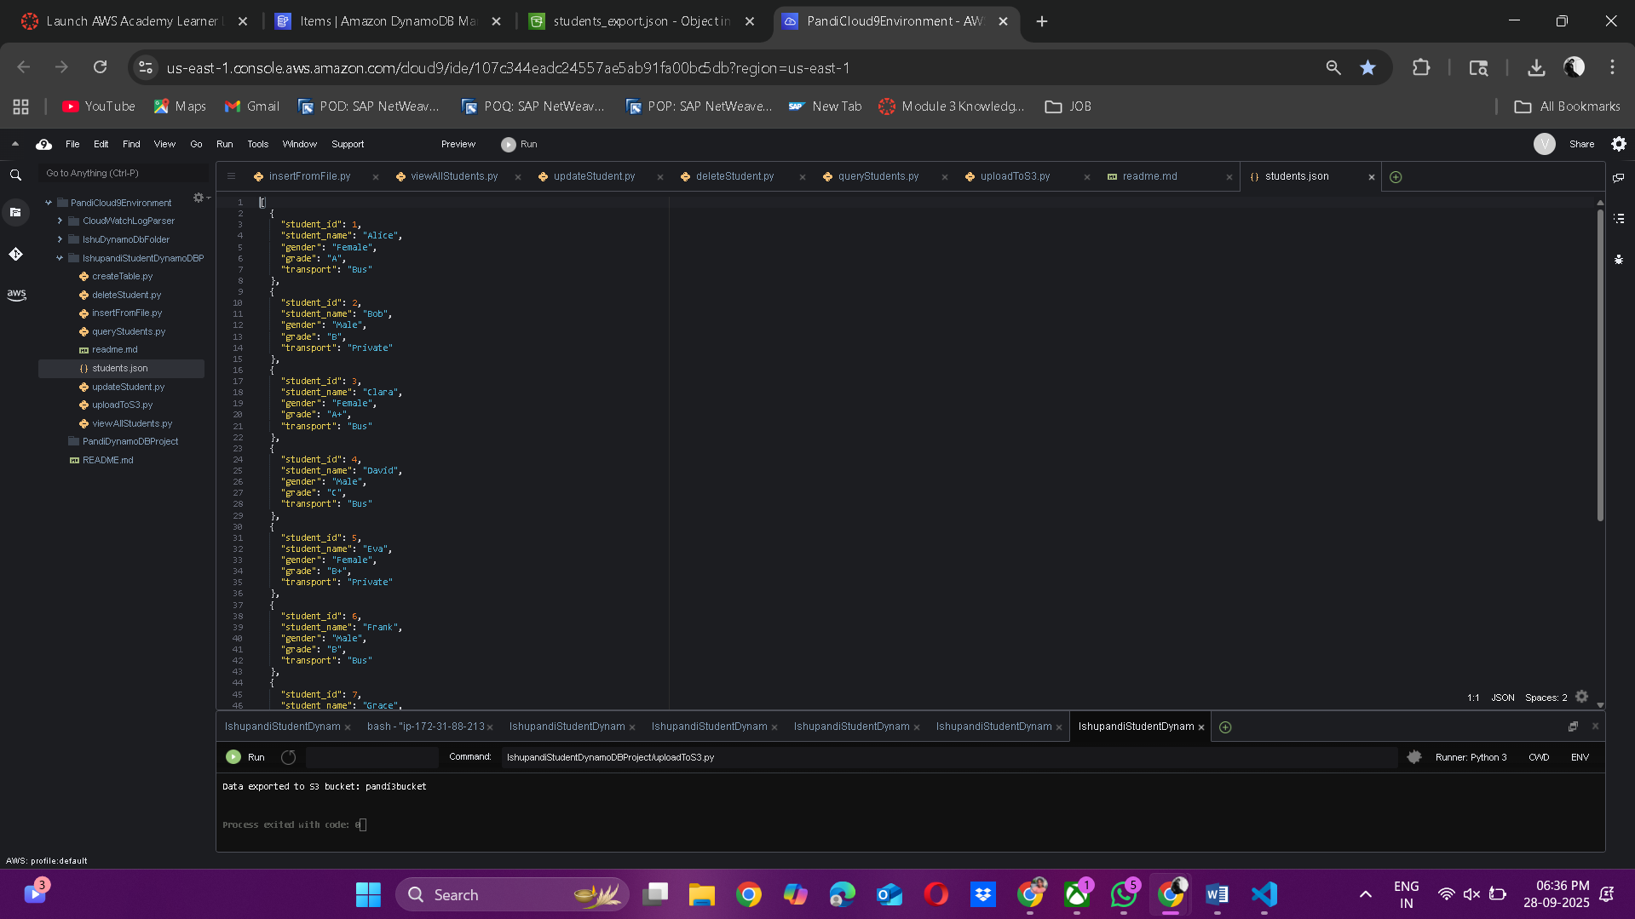

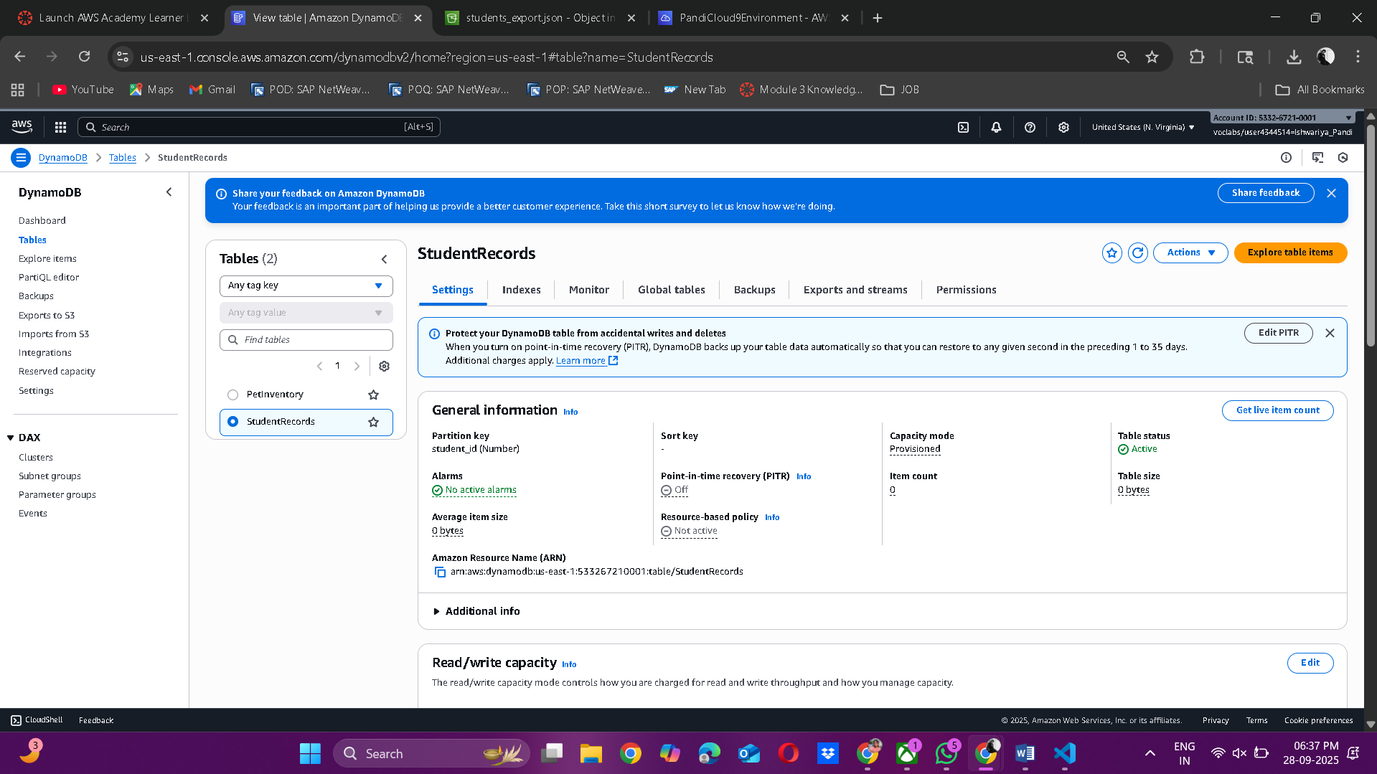

Screenshot of table in DynamoDB
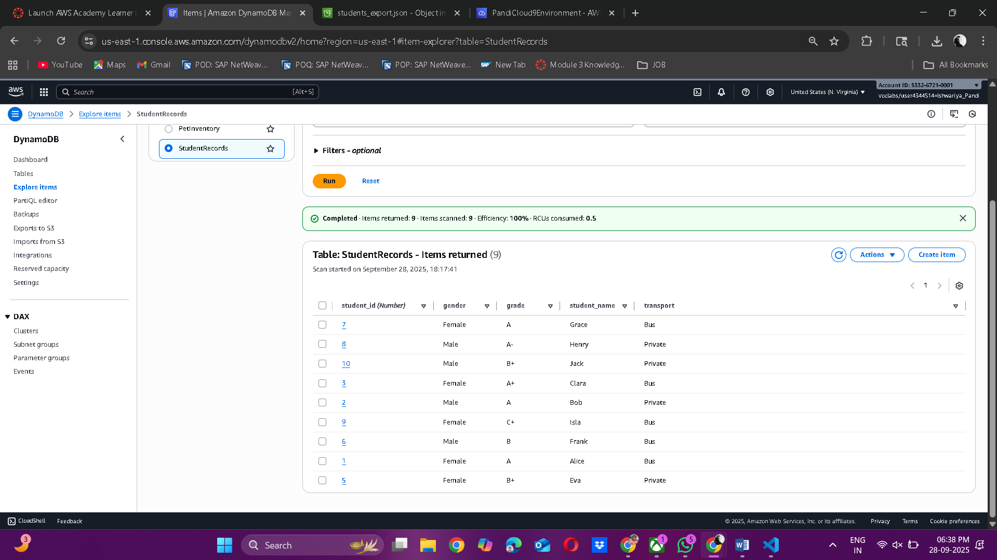

Screenshot of JSON uploaded in S3:
1.
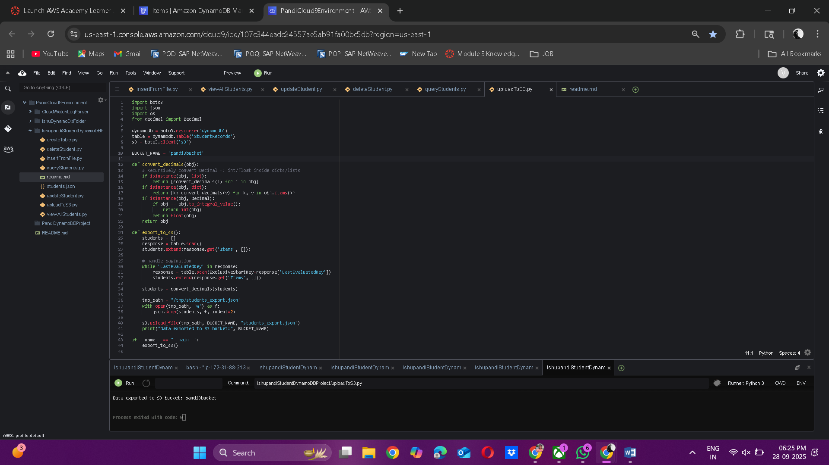

2.
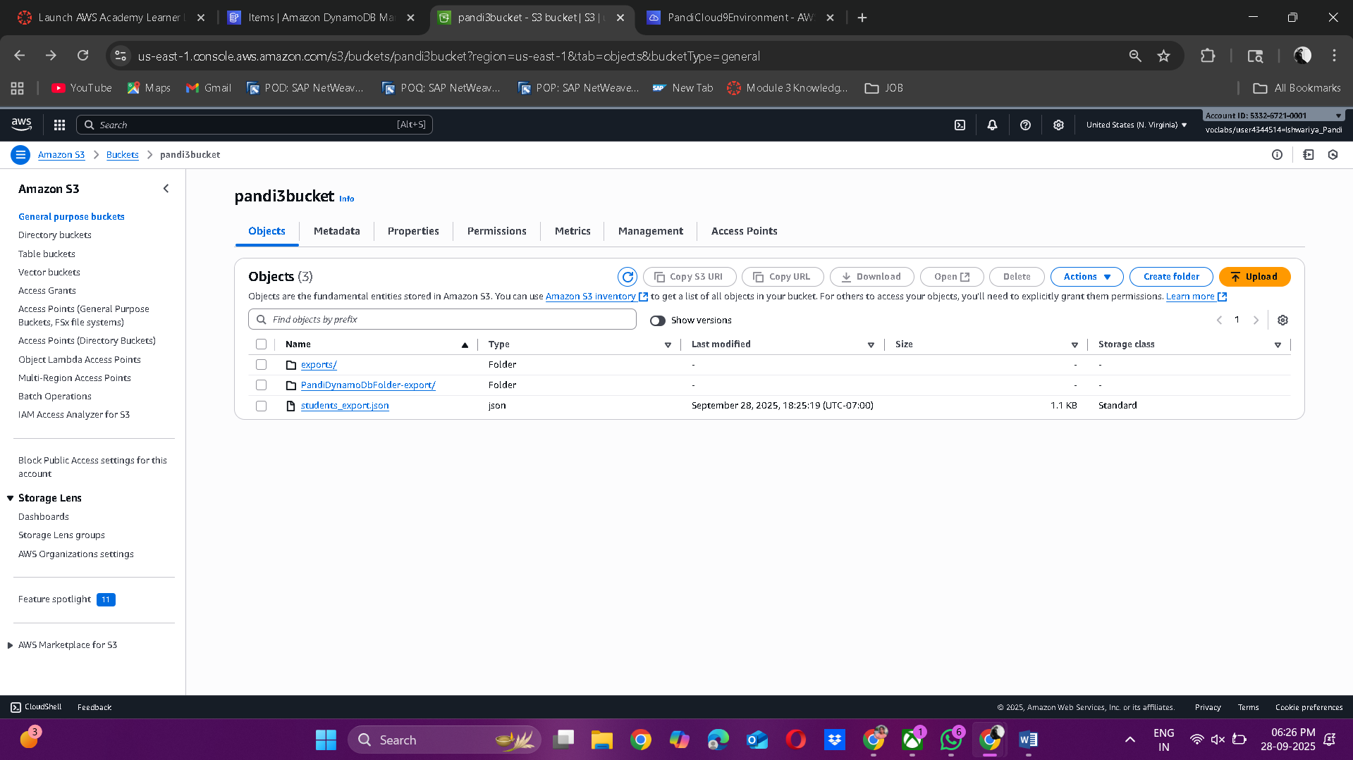
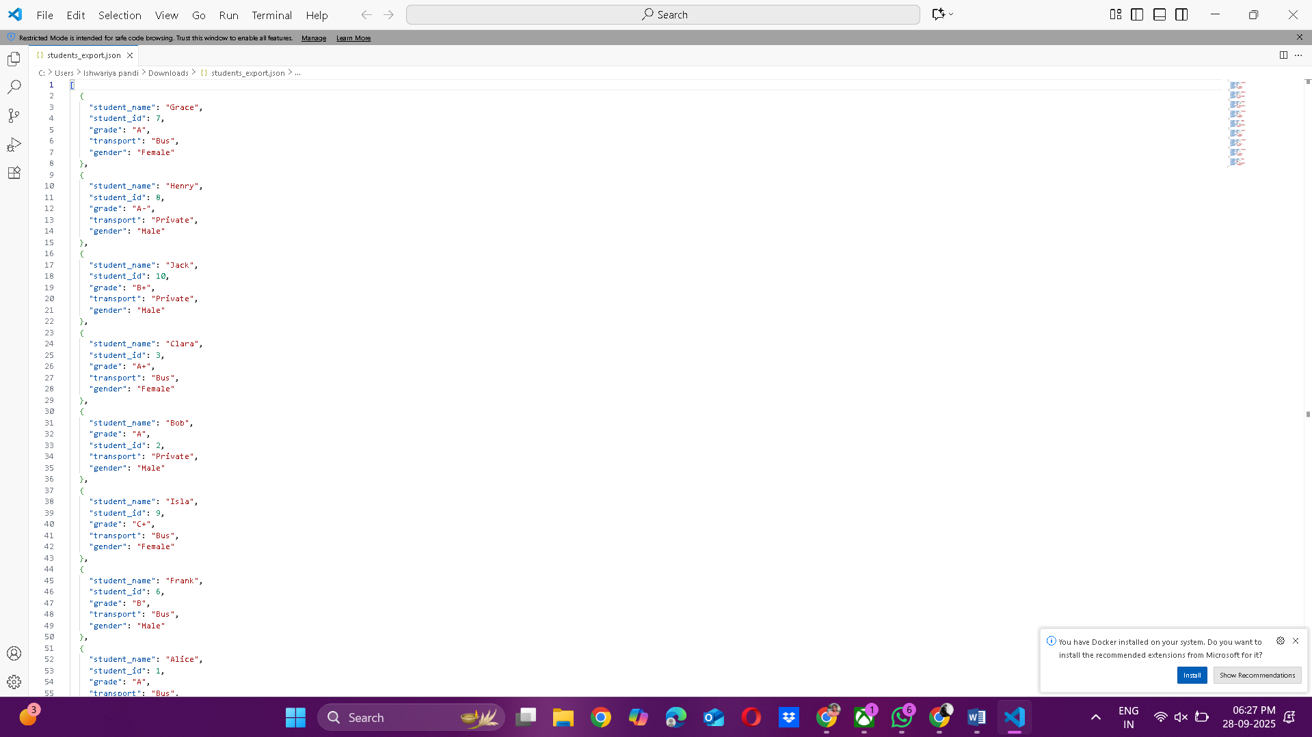

Section 3: CRUD Code- all Python code files
- createTable.py
import boto3

dynamodb = boto3.resource('dynamodb')

def create_table():
table = dynamodb.create_table(
TableName='StudentRecords',
KeySchema=[
{'AttributeName': 'student_id', 'KeyType': 'HASH'}
],
AttributeDefinitions=[
{'AttributeName': 'student_id', 'AttributeType': 'N'}
],
ProvisionedThroughput={'ReadCapacityUnits': 5, 'WriteCapacityUnits': 5}
)
table.wait_until_exists()
print("Table created:", table.table_name)

if __name__ == "__main__":
create_table()
output:
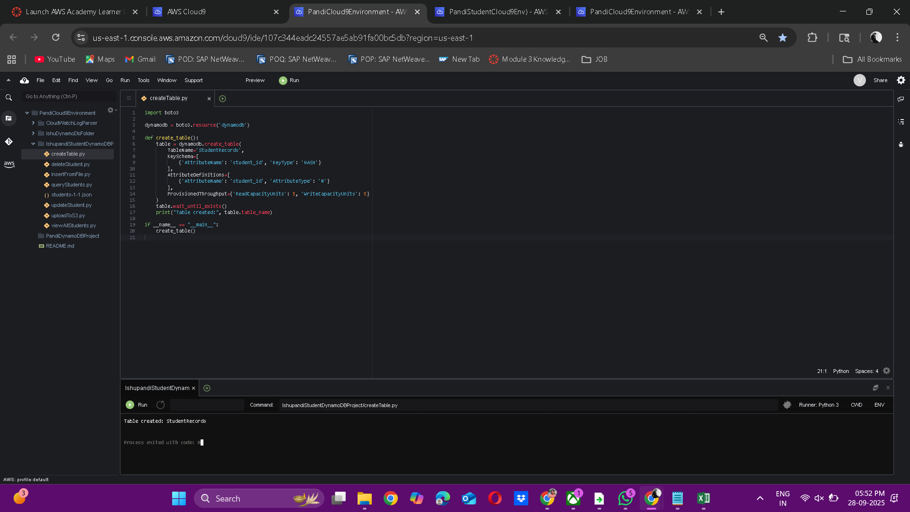

- insertFromFile.py
import boto3
import json
import os
import sys

dynamodb = boto3.resource('dynamodb')
table = dynamodb.Table('StudentRecords')

def get_json_path():
# 1) prefer students.json next to this script
script_dir = os.path.dirname(os.path.abspath(__file__))
candidate = os.path.join(script_dir, 'students.json')
if os.path.exists(candidate):
return candidate
# 2) fallback to commonly used upload path
fallback = '/mnt/data/students-1-1.json'
if os.path.exists(fallback):
return fallback
return None

def insert_data():
print("Current working directory:", os.getcwd())
print("Script location:", os.path.abspath(__file__))

path = get_json_path()
if not path:
print("ERROR: students.json not found.")
print("Put students.json in the project folder or copy /mnt/data/students-1-1.json here.")
sys.exit(1)

print(f"Loading student data from: {path}")
with open(path, 'r') as f:
students = json.load(f)
for student in students:
table.put_item(Item=student)
print("Data inserted successfully.")

if __name__ == "__main__":
insert_data()
output:
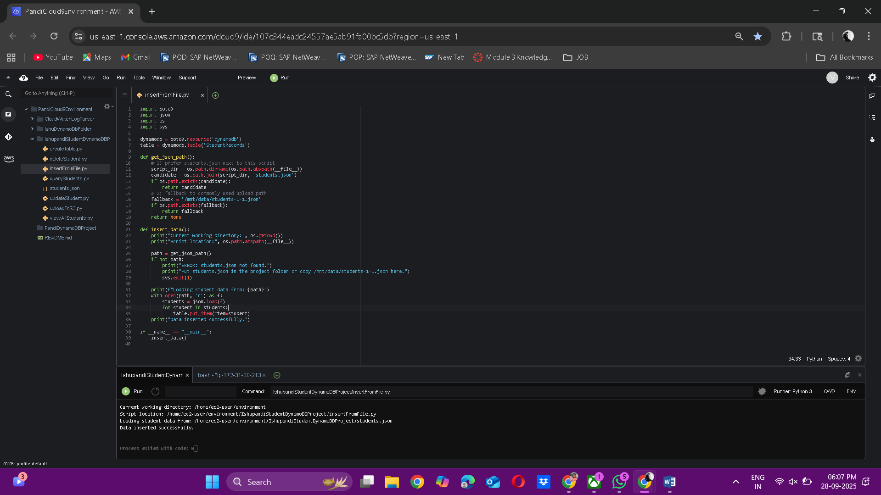
In dynamoDb:
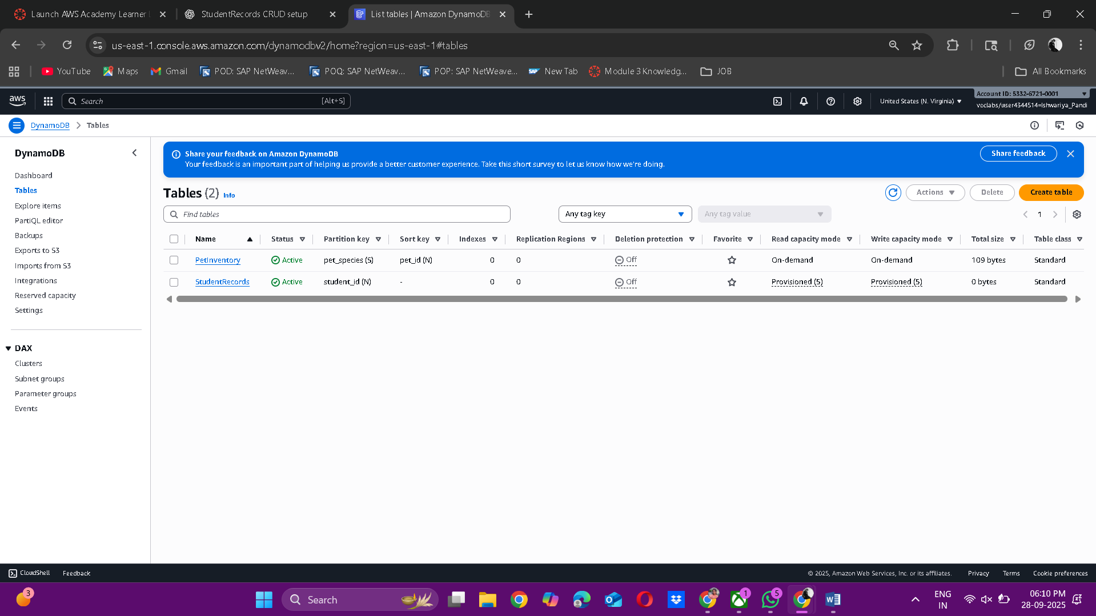
- viewAllStudents.py
import boto3

dynamodb = boto3.resource('dynamodb')
table = dynamodb.Table('StudentRecords')

def view_all():
response = table.scan()
for student in response['Items']:
print(student)

if __name__ == "__main__":
view_all()
output:
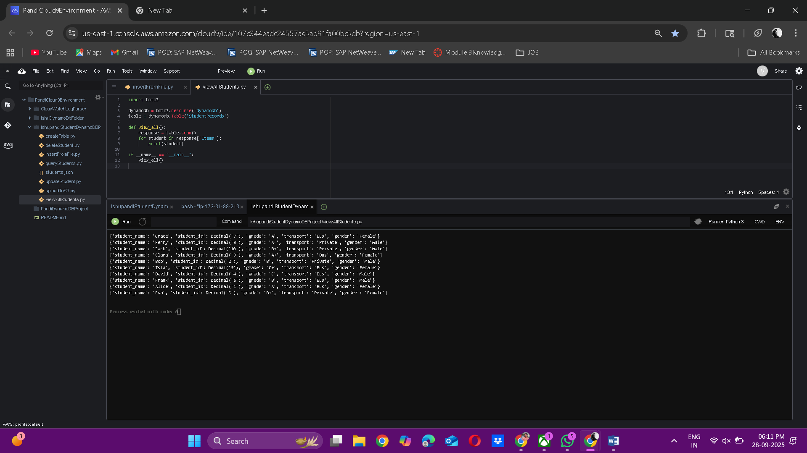
- updateStudent.py

import boto3

dynamodb = boto3.resource('dynamodb')

table = dynamodb.Table('StudentRecords')

def update_student(student_id, new_grade):

response = table.update_item(

Key={'student_id': student_id},

UpdateExpression="set grade=:g",

ExpressionAttributeValues={':g': new_grade},

ReturnValues="UPDATED_NEW"

)

print("Updated:", response)

if __name__ == "__main__":

update_student(2, "A") # Example: Bob’s grade updated to A

output:
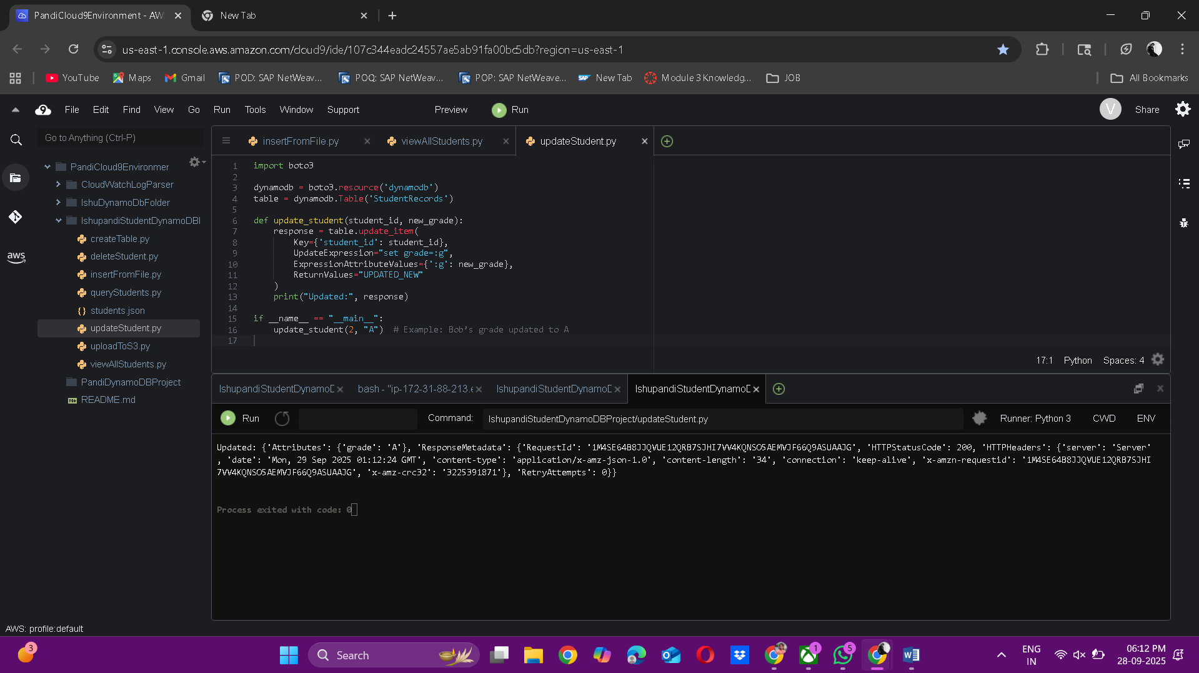
In dynamodb:
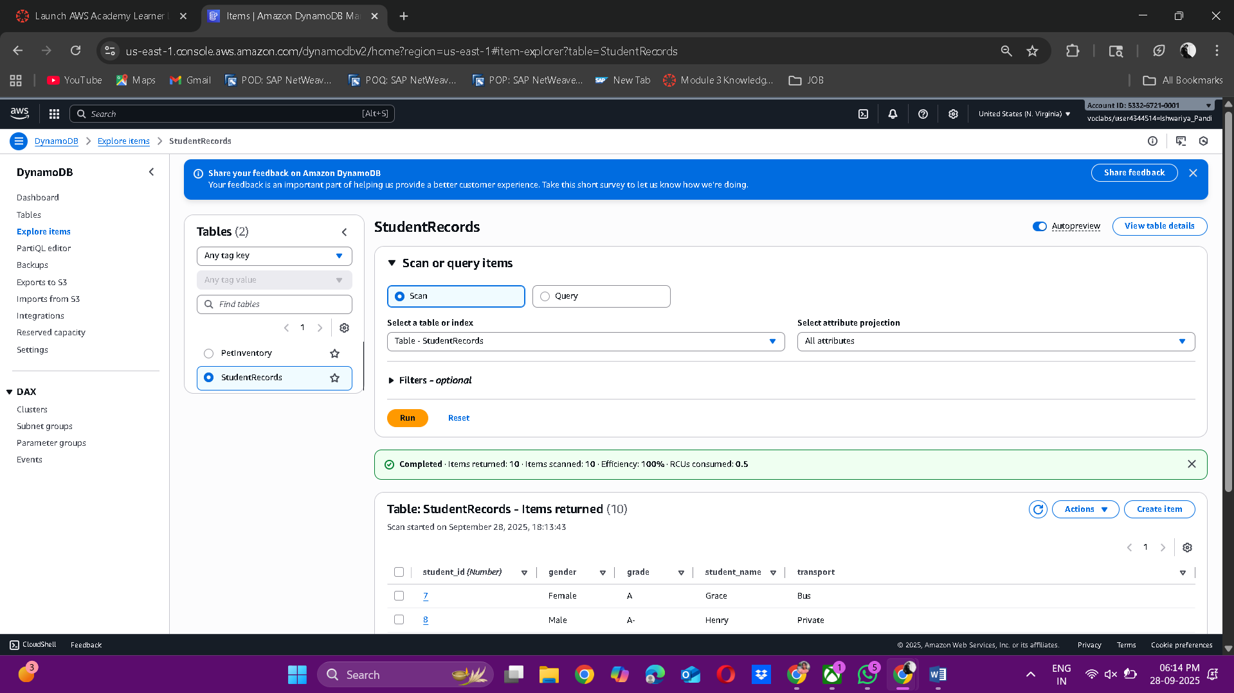

- deleteStudent.py
import boto3

dynamodb = boto3.resource('dynamodb')
table = dynamodb.Table('StudentRecords')

def delete_student(student_id):
response = table.delete_item(Key={'student_id': student_id})
print("Deleted:", response)

if __name__ == "__main__":
delete_student(4) # Example: Delete David

output:
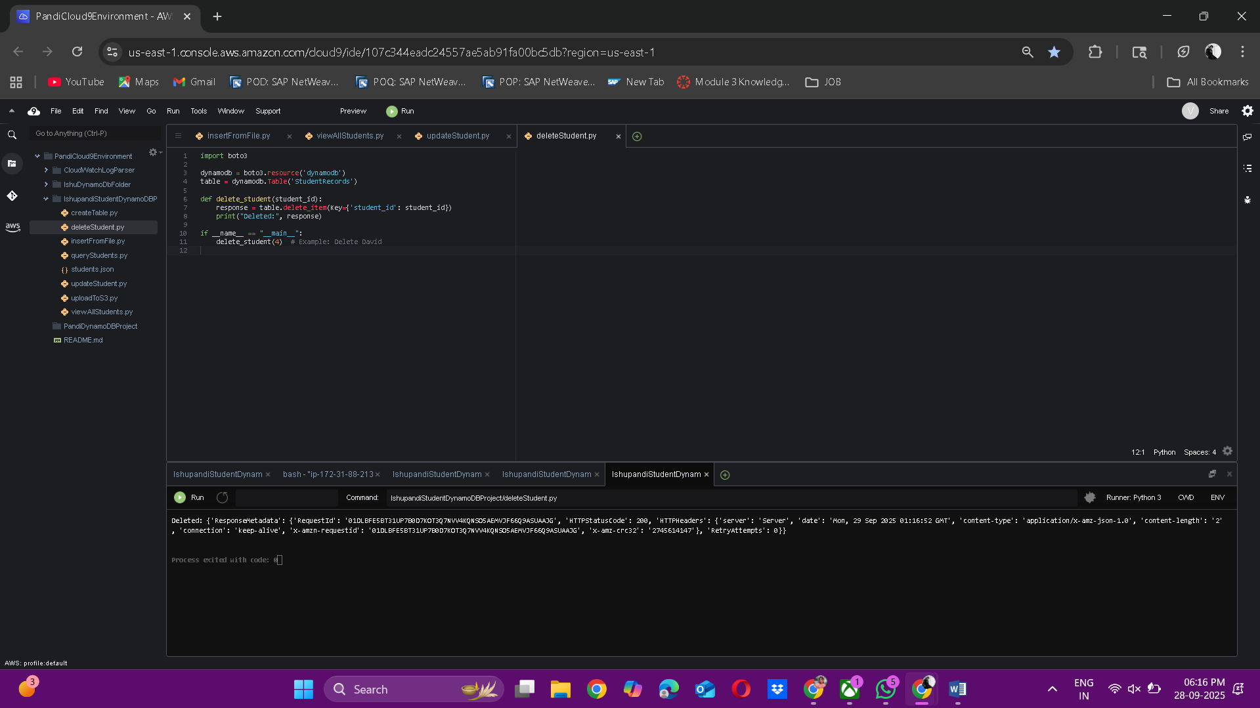
In dynamoDb:
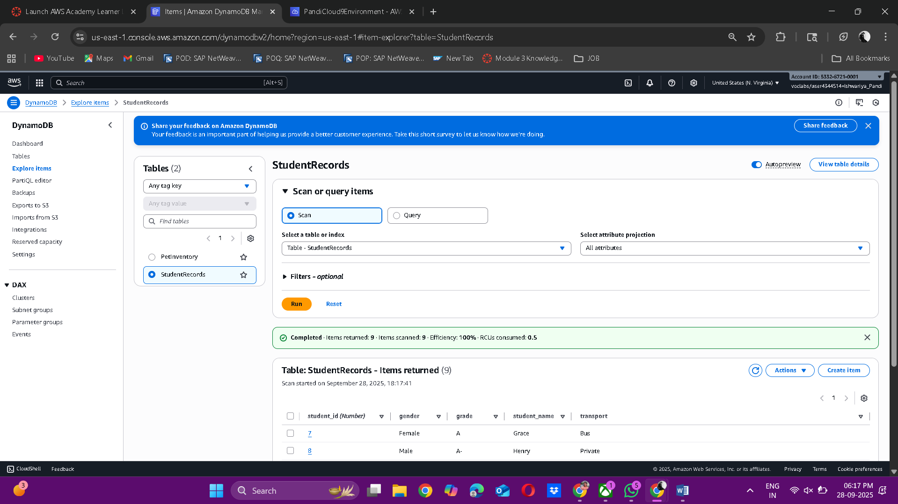

- queryStudents.py
import boto3

dynamodb = boto3.resource('dynamodb')
table = dynamodb.Table('StudentRecords')

def query_students():
# Scan for grade A
response = table.scan(
FilterExpression="grade = :g",
ExpressionAttributeValues={":g": "A"}
)
print("Students with grade A:")
for student in response['Items']:
print(student)

# Count male/female
response = table.scan()
males = sum(1 for s in response['Items'] if s['gender'] == 'Male')
females = sum(1 for s in response['Items'] if s['gender'] == 'Female')

print("Total Male Students:", males)
print("Total Female Students:", females)
if __name__ == "__main__":
query_students()
output:
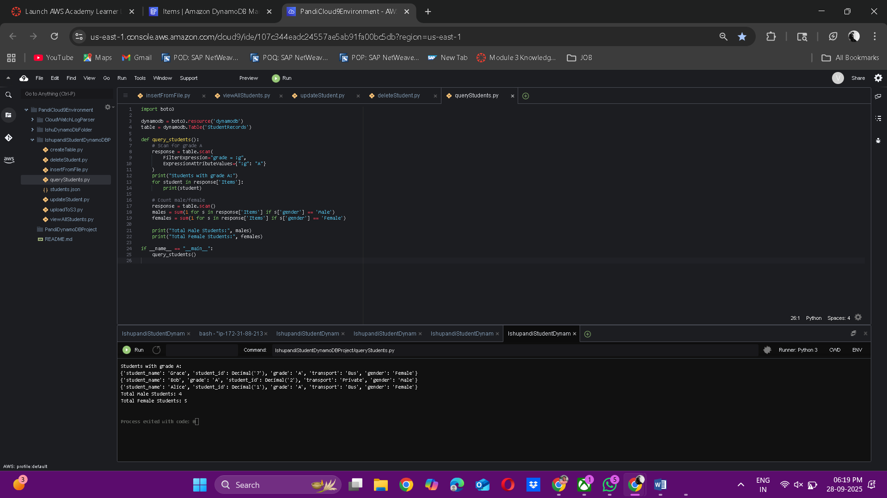
- uploadToS3.py
import boto3, json

dynamodb = boto3.resource('dynamodb')
table = dynamodb.Table('StudentRecords')
s3 = boto3.client('s3')
BUCKET_NAME = 'your-name-student-records-bucket'
def export_to_s3():
response = table.scan()
students = response['Items']

with open("/tmp/students_export.json", "w") as f:
json.dump(students, f)

s3.upload_file("/tmp/students_export.json", BUCKET_NAME, "students_export.json")
print("Data exported to S3 bucket:", BUCKET_NAME)

if __name__ == "__main__":
export_to_s3()
output:

In dynamodb:



Section 4: Query Results
- queryStudents.py
import boto3

dynamodb = boto3.resource('dynamodb')
table = dynamodb.Table('StudentRecords')

def query_students():
# Scan for grade A
response = table.scan(
FilterExpression="grade = :g",
ExpressionAttributeValues={":g": "A"}
)
print("Students with grade A:")
for student in response['Items']:
print(student)

# Count male/female
response = table.scan()
males = sum(1 for s in response['Items'] if s['gender'] == 'Male')
females = sum(1 for s in response['Items'] if s['gender'] == 'Female')

print("Total Male Students:", males)
print("Total Female Students:", females)

if __name__ == "__main__":
query_students()

Output:
Students with grade A:
{'student_name': 'Grace', 'student_id': Decimal('7'), 'grade': 'A', 'transport': 'Bus', 'gender': 'Female'}
{'student_name': 'Bob', 'grade': 'A', 'student_id': Decimal('2'), 'transport': 'Private', 'gender': 'Male'}
{'student_name': 'Alice', 'student_id': Decimal('1'), 'grade': 'A', 'transport': 'Bus', 'gender': 'Female'}
Total Male Students: 4
Total Female Students: 5

Output Screenshot:


Section 5: README.md-explain purpose and usage

# Student Records CRUD Application

This project demonstrates a CRUD application using AWS DynamoDB, S3, and Cloud9.
- DynamoDB stores student records.
- Python scripts perform Create, Read, Update, Delete.
- Querying allows grade A retrieval and gender count.
- Data is exported to S3 for backup.

## Usage
1. Run `createTable.py` to create the table.
2. Run `insertFromFile.py` to load data.
3. Use `viewAllStudents.py`, `updateStudent.py`, `deleteStudent.py` for CRUD.
4. Run `queryStudents.py` for insights.
5. Run `uploadToS3.py` to back up records.

