**Project Team-46**

**Analyzing Big Data**

**Project Step 2:** Data Analysis

Aathira Vazaiel Raghavan - 1233857497

Adhithi Satish Kumar -1233343815

Ishwariya Pandi -1233885850

Vaishmitha Reddy Biyyapu- 1233298757

**Dr.Asmaa Elbadrawy**

**Due Date- 04/27/2025**

**“Data Preparation”**

**“Task 1: Preparing Data for the Recommender System”**

**“Selected Task”:**

1. **“Build a recommender system that recommends books to read for every user based on their personal tastes and previous book ratings.”**

**“Code:”**

import pandas as pd

import numpy as np

from scipy.sparse import csr_matrix

from sklearn.neighbors import NearestNeighbors

r_df = pd.read_csv('Ratings.csv', delimiter=';', on_bad_lines='skip')

if 'User-ID' not in r_df.columns:

if len(r_df.columns) == 3:

r_df.columns = ['User-ID', 'ISBN', 'Rating']

else:

print("Unexpected columns found:", r_df.columns)

raise ValueError("Please check your Ratings.csv file format.")

r_df['User-ID'] = r_df['User-ID'].astype(str)

r_df['ISBN'] = r_df['ISBN'].astype(str)

r_df['Rating'] = pd.to_numeric(r_df['Rating'], errors='coerce')

r_df.dropna(subset=['Rating'], inplace=True)

top_u = r_df['User-ID'].value_counts().nlargest(500).index

top_b = r_df['ISBN'].value_counts().nlargest(500).index

r_df = r_df[r_df['User-ID'].isin(top_u) & r_df['ISBN'].isin(top_b)]

r_clean = r_df.groupby(['User-ID', 'ISBN']).agg({'Rating': 'mean'}).reset_index()

u_mapng = {usr: idx for idx, usr in enumerate(r_clean['User-ID'].unique())}

b_mapng = {bk: idx for idx, bk in enumerate(r_clean['ISBN'].unique())}

rev_u_map = {idx: usr for usr, idx in u_mapng.items()}

rev_b_map = {idx: bk for bk, idx in b_mapng.items()}

r_clean['u_idx'] = r_clean['User-ID'].map(u_mapng)

r_clean['b_idx'] = r_clean['ISBN'].map(b_mapng)

spar_matx = csr_matrix((r_clean['Rating'], (r_clean['u_idx'], r_clean['b_idx'])))

nn_modl = NearestNeighbors(metric='cosine', algorithm='brute', n_neighbors=11, n_jobs=-1)

nn_modl.fit(spar_matx)

dist, indx = nn_modl.kneighbors(spar_matx)

recs = []

for u_idx in range(spar_matx.shape[0]):

sim_u = indx[u_idx][1:]

sim_s = 1 - dist[u_idx][1:]

sim_u_ratings = spar_matx[sim_u]

u_ratings = spar_matx[u_idx].toarray().flatten()

read_b = set(np.where(u_ratings > 0)[0])

cand_bks = set(sim_u_ratings.nonzero()[1]) - read_b

w_scores = {}

for b_idx in cand_bks:

rat_sim = sim_u_ratings[:, b_idx].toarray().flatten()

valid_idx = rat_sim > 0

if np.any(valid_idx):

w_sum = np.dot(sim_s[valid_idx], rat_sim[valid_idx])

w_total = np.sum(sim_s[valid_idx])

if w_total > 0:

w_avg = w_sum / w_total

w_scores[b_idx] = w_avg

top_5_bks = sorted(w_scores.items(), key=lambda x: x[1], reverse=True)[:5]

for b_idx, sc in top_5_bks:

recs.append({

'User_ID': rev_u_map[u_idx],

'Book_ID': rev_b_map[b_idx],

'Recommendation_Score': round(sc, 2)

})

recs_df = pd.DataFrame(recs)

b_df = pd.read_csv('Booksv.csv', delimiter=';', on_bad_lines='skip')

b_df.columns = b_df.columns.str.strip()

if 'ISBN' not in b_df.columns:

for col in b_df.columns:

if col.lower() == 'isbn':

b_df.rename(columns={col: 'ISBN'}, inplace=True)

break

if 'Book-Title' not in b_df.columns:

for col in b_df.columns:

if col.lower() in ['book-title', 'title', 'booktitle']:

b_df.rename(columns={col: 'Book-Title'}, inplace=True)

break

b_df['ISBN'] = b_df['ISBN'].astype(str)

recs_df['Book_ID'] = recs_df['Book_ID'].astype(str)

merge_df = recs_df.merge(b_df, left_on='Book_ID', right_on='ISBN', how='left')

merge_df.rename(columns={'Book-Title': 'Book_Title'}, inplace=True)

final_df = merge_df[['User_ID', 'Book_ID', 'Book_Title', 'Recommendation_Score']]

final_df.to_csv('Book_Recommendations1.csv', index=False)

print("Recommendations saved to 'Book_Recommendations1.csv'")

**Code Screenshot:**

**1)**

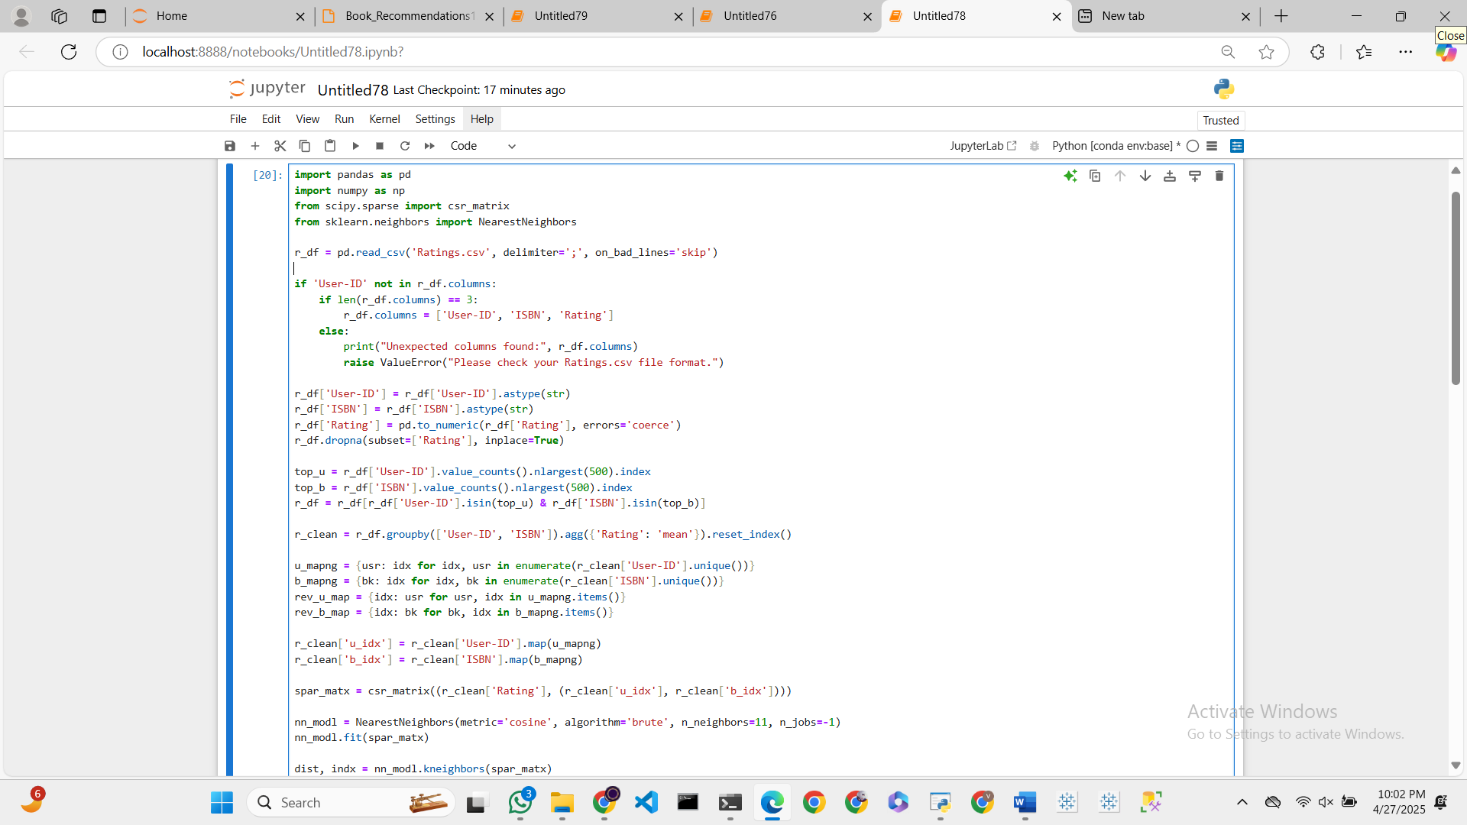

**2)**

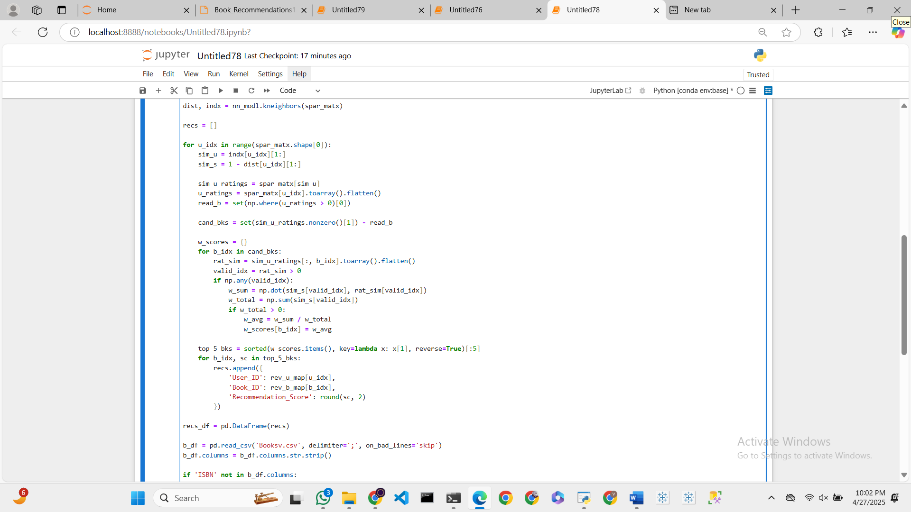

**3)**

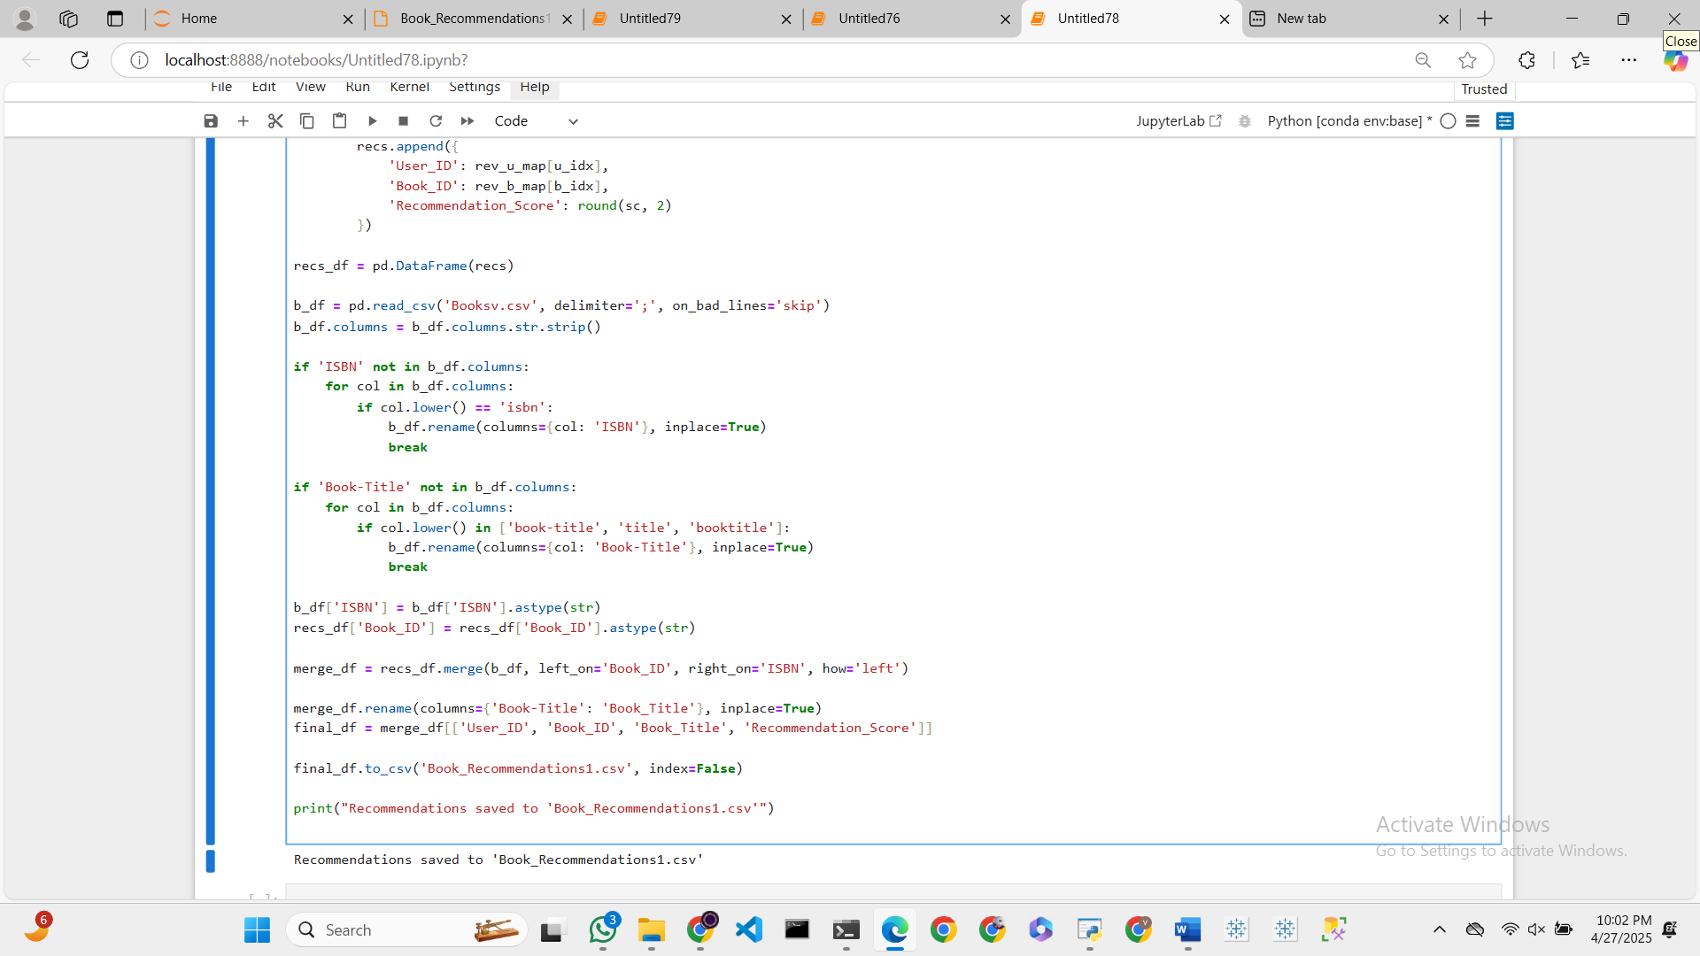

**Output:**

**1)**

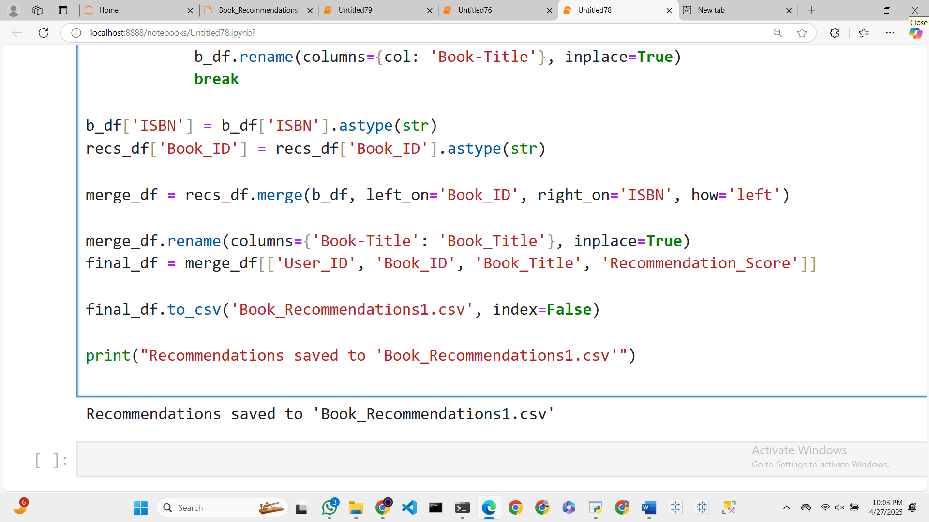

**2)**

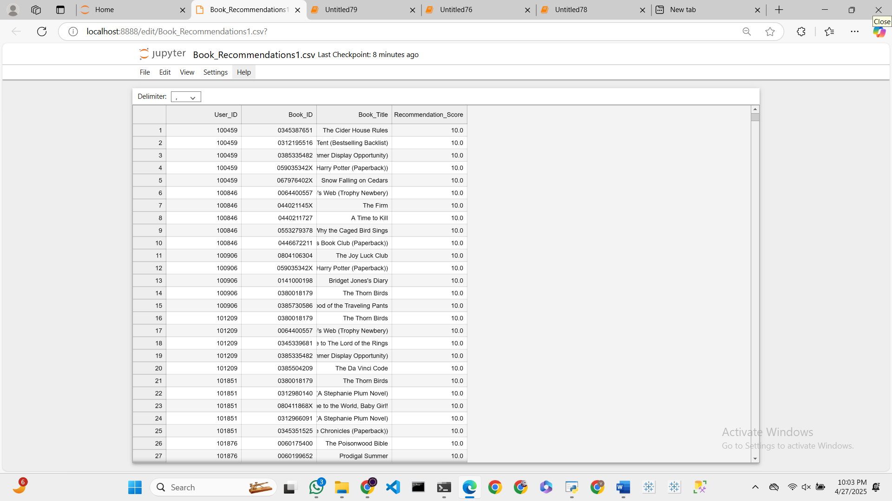

**“EXPLANATION:”**

This recommender system script takes a user-book ratings dataset and provides personalized book recommendations through collaborative filtering. First, the data is preprocessed by loading the ratings file, correcting column names if needed, removing invalid rows, and truncating the dataset to the top 500 most active users and top 500 most rated books. This Truncating improves performance while keeping the most relevant interactions for important recommendations. Then users and books are given distinct numerical indices, and a sparse matrix is created in which rows represent users, columns represent books, and values represent their corresponding ratings. Sparse matrices are employed since they are effective when handling high-dimensional data with a lot of missing values. The model subsequently calculates user similarity through the Nearest Neighbors algorithm using cosine similarity, comparing the similarity of rating patterns among users but using rating tendencies rather than actual values. The top 10 similar users per user are identified through this. In generating recommendations, the system identifies books rated by these similar users but not yet read by the target user. The score for each candidate book is calculated as a weighted average of ratings of similar users, where the weights are determined from user similarity. The 5 books with highest scores are selected as recommendations per user. Finally, the recommendations are enriched by joining book titles from a separate dataset on ISBNs. The final output has the user ID, book ID, book title, and recommendation score and stores them to a CSV file, hence the results are already prepared and can be used or submitted.