1. Book Conference Meeting Room

curl --location 'http://localhost:8080/api/conference-rooms/booking' \

--header 'Content-Type: application/json' \

--data '{

"startTime": 1705692600,

"endTime": 1705693500,

"participants": 5,

"userId" : 1

}'

Response:

{

"roomBookingId": 1,

"startDateTime": "2024-01-19T19:30:00.000+00:00",

"endDateTime": "2024-01-19T19:45:00.000+00:00",

"userName": "Singhal",

"conferenceRoomDto": {

"roomId": 2,

"floor": 2,

"name": "Beauty",

"size": 7

}

}

**Request Fields Definition-**

This api startTime & endTime input is in epoch time so it’s easy to send from FE to BE and BE can validate at backend layer.

startTime - when meeting room should be booked.

endTime – when meeting will get ended.

Participants - Participants is the no of people who will be going to join this meeting.

userId – User who is going to do this book the meeting room.

**Response Field Definition –**

roomBookingId – Auto Generated Booking Id once booking confirmed

conferenceRoomDto – conference room details.

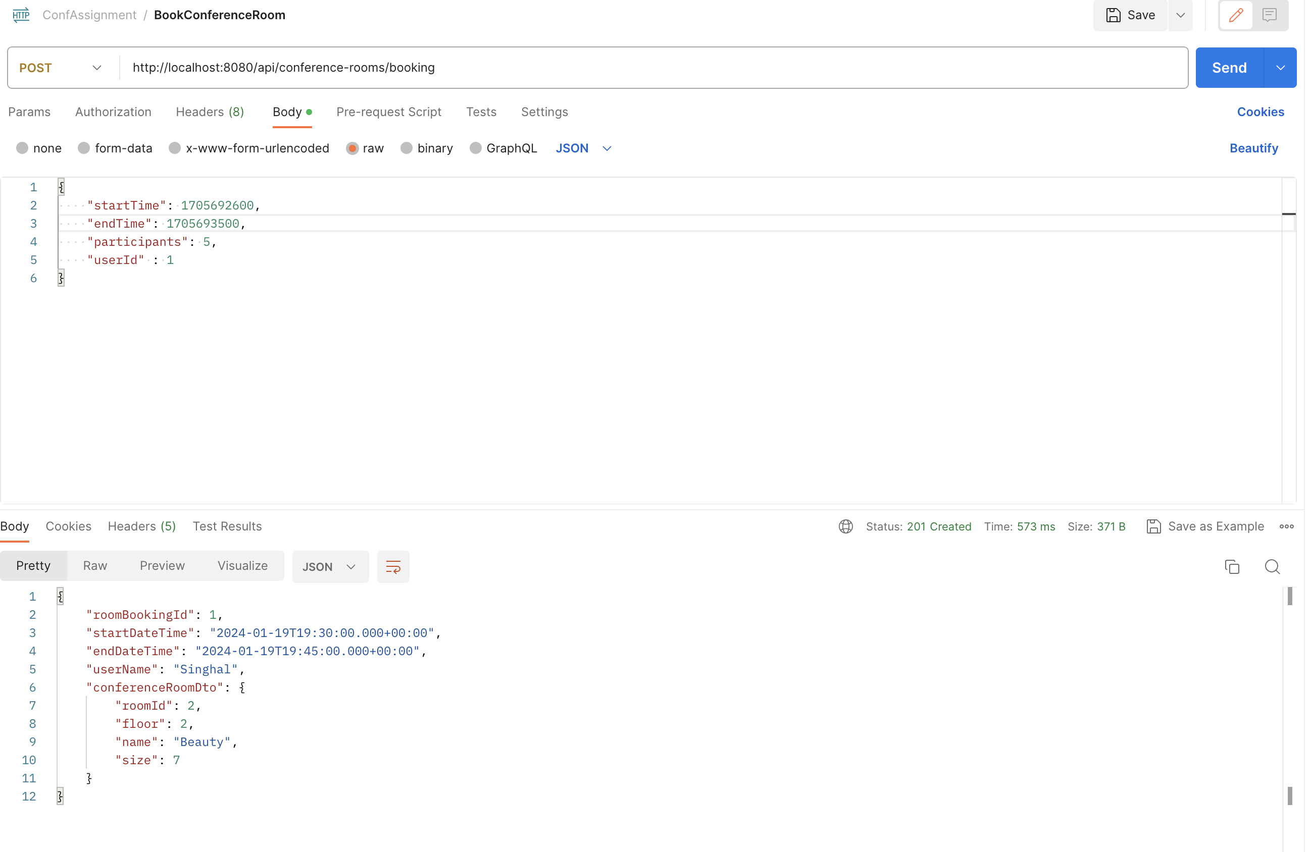

1. FindConferenceMeetingRoom

curl --location 'http://localhost:8080/api/conference-rooms/findroom?startTime=1705690800&endTime=1705691700'

Response:

{

"availableConferenceRooms": [

{

"roomId": 1,

"floor": 1,

"name": "Amaze",

"size": 3

},

{

"roomId": 2,

"floor": 2,

"name": "Beauty",

"size": 7

},

{

"roomId": 3,

"floor": 3,

"name": "Inspire",

"size": 12

},

{

"roomId": 4,

"floor": 4,

"name": "Strive",

"size": 20

}

]

}

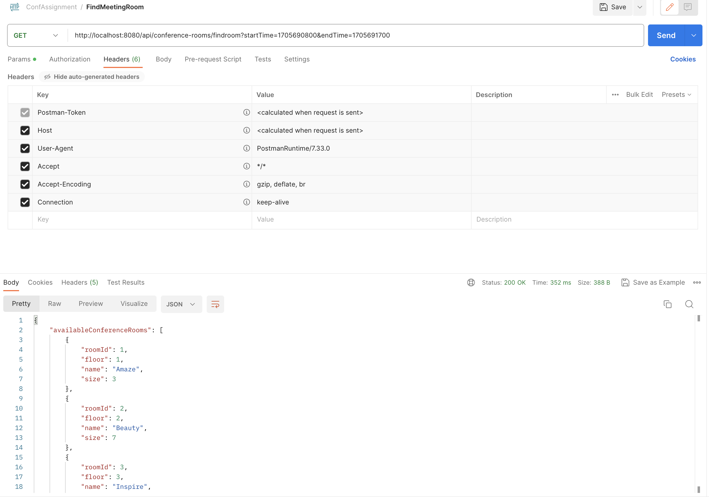

**Request Fields Definition-**

This api startTime & endTime input is in epoch time so it’s easy to send from FE to BE and BE can validate at backend layer.

startTime - when meeting room should be booked.

endTime – when meeting will get ended.

**Response Field Definition –**

availableConferenceRooms – available conference room details.