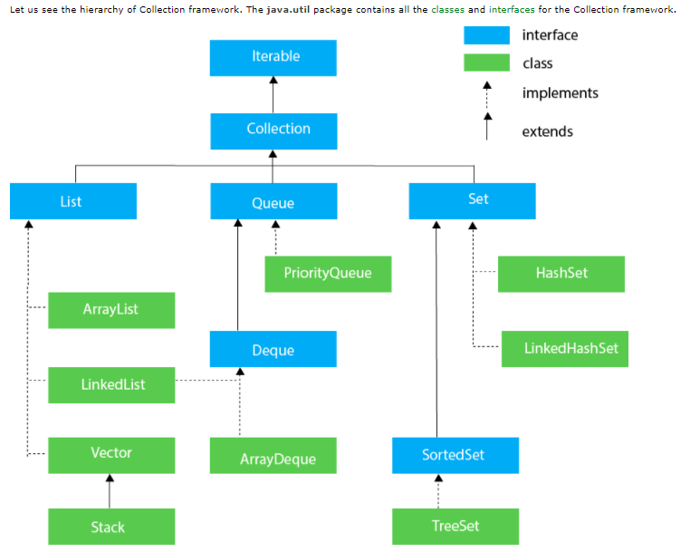

Dec Char Dec Char Dec Char Dec Char

--------- --------- --------- ----------

0 NUL (null) 32 SPACE 64 @ 96 `

1 SOH (start of heading) 33 ! 65 A 97 a

2 STX (start of text) 34 " 66 B 98 b

3 ETX (end of text) 35 # 67 C 99 c

4 EOT (end of transmission) 36 $ 68 D 100 d

5 ENQ (enquiry) 37 % 69 E 101 e

6 ACK (acknowledge) 38 & 70 F 102 f

7 BEL (bell) 39 ' 71 G 103 g

8 BS (backspace) 40 ( 72 H 104 h

9 TAB (horizontal tab) 41 ) 73 I 105 i

10 LF (NL line feed, new line) 42 * 74 J 106 j

11 VT (vertical tab) 43 + 75 K 107 k

12 FF (NP form feed, new page) 44 , 76 L 108 l

13 CR (carriage return) 45 - 77 M 109 m

14 SO (shift out) 46 . 78 N 110 n

15 SI (shift in) 47 / 79 O 111 o

16 DLE (data link escape) 48 0 80 P 112 p

17 DC1 (device control 1) 49 1 81 Q 113 q

18 DC2 (device control 2) 50 2 82 R 114 r

19 DC3 (device control 3) 51 3 83 S 115 s

20 DC4 (device control 4) 52 4 84 T 116 t

21 NAK (negative acknowledge) 53 5 85 U 117 u

22 SYN (synchronous idle) 54 6 86 V 118 v

23 ETB (end of trans. block) 55 7 87 W 119 w

24 CAN (cancel) 56 8 88 X 120 x

25 EM (end of medium) 57 9 89 Y 121 y

26 SUB (substitute) 58 : 90 Z 122 z

27 ESC (escape) 59 ; 91 [ 123 {

28 FS (file separator) 60 < 92 \ 124 |

29 GS (group separator) 61 = 93 ] 125 }

30 RS (record separator) 62 > 94 ^ 126 ~

31 US (unit separator) 63 ? 95 _ 127 DEL

**Patterns:**

1. Sliding Windows
2. Two Pointers
3. Slow and Fast Pointers
4. Merge Intervals
5. Cyclic Sort
6. In Place Reverse of Linked List
7. Tree BFS
8. Tree DFS
9. Two Heaps
10. Subsets
11. Modified Binary Search
12. Top K Elements
13. K-way Merge
14. DP
15. Topological Sort