**Introduction**

Why Unix

* Base of all OS
* Developed in 1970 by Ken Thompson, Dennis Ritchie and other in AT&T labs.
* Kernel

Key Features of Unix

* Multi User Support
* Multitasking
* Shell Scripting
* Security
* Portability
* Communication
* Process Tracking

Architecture of Unix System

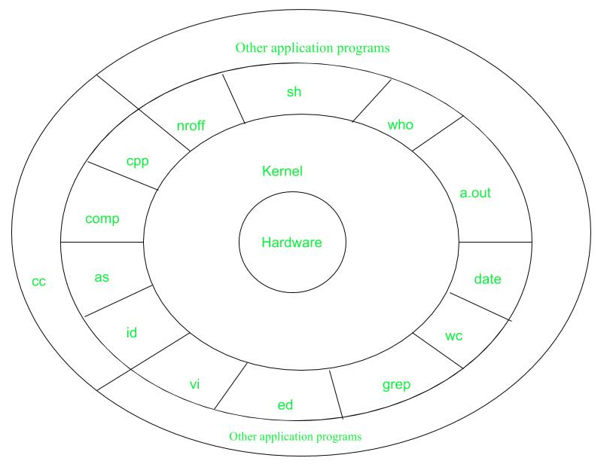

Installation:

Step 1: Download Oracle Virtual Box

[Download_Old_Builds_7_0 – Oracle VM VirtualBox](https://www.virtualbox.org/wiki/Download_Old_Builds_7_0)

Step 2: Download Unix/Linux OS

[VirtualBox Images (osboxes.org)](https://www.osboxes.org/virtualbox-images/)

Step 3: Install Virtual Box

Step 4: Import downloaded VDI in VM.