Dr. D. Y. Patil Educational Federation’s
Dr. D. Y. Patil College of Engineering & Innovation
Approved by AICTE, Recognized by Government of Maharashtra
An Autonomous Institute Affiliated to Savitribai Phule Pune University
Accredited by NAAC with “A” Grade
DEPARTMENT OF COMPUTER ENGINEERING
Program / Class | S.Y. B.Tech
Division / Batch | C (C3)
Name of Student | Ishwari Umakant Yadav
PRN Number | 251010182
Course Name | AI Specialist- BFSI
SMARTBRIDGE | SKILLWALLET
PERSONAL FINANCE ADVISOR BOT
AI-Powered Personal Financial Planning Assistant

Synopsis
Personal Finance Advisor Bot is a web-based capstone project intended to help users understand their monthly finances and think through practical savings goals. The user enters income and expense information through a website form. The application uses the submitted values to present a financial summary and, where the configured AI service responds successfully, tailored guidance. The goal is to make basic budgeting information easier to review in one place.
The project combines a browser-based interface with a Python Flask application and supporting service/model modules. Configuration such as an AI provider key should be supplied through the deployment environment rather than written into source code or included in screenshots.

Project Objectives
- Collect monthly income and expense details through a clear web form.
- Calculate and present useful summary figures from the entered data.
- Provide AI-assisted budgeting suggestions when the AI integration is available.
- Support goal-oriented thinking, such as planning toward a user-selected savings target, if that feature is enabled in the deployed app.
- Present results in a form that is understandable to a student or general user.

Website Home Screen

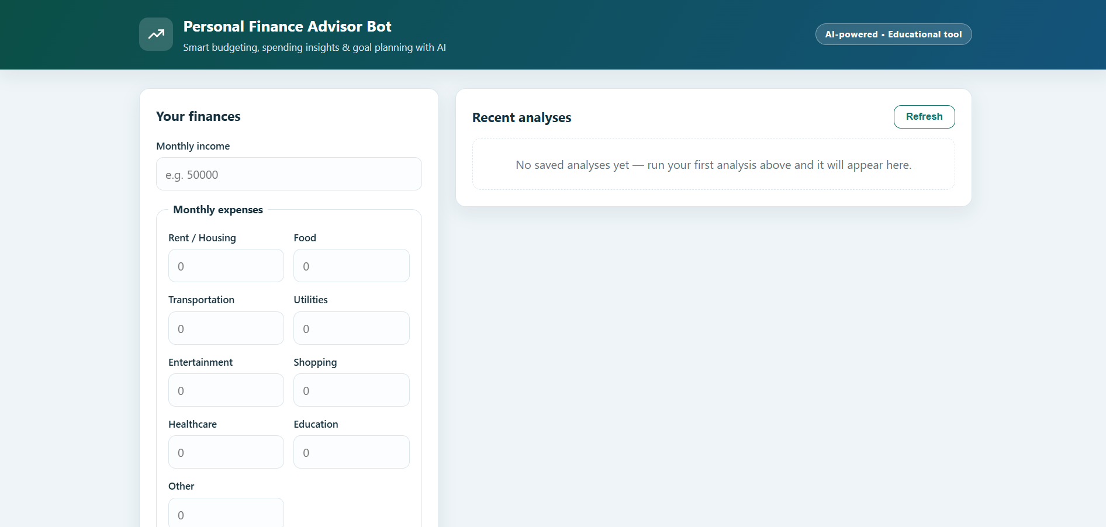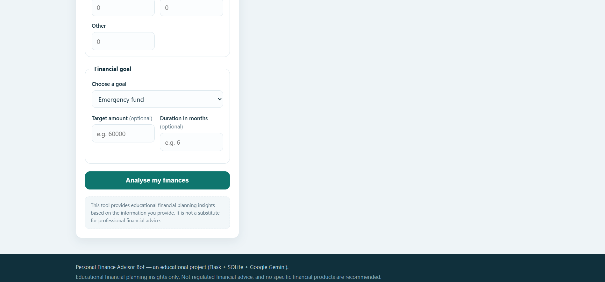

1. Introduction
Managing personal finances requires awareness of income, spending, and the amount available for saving. A person may know their total income but still find it difficult to see how everyday spending affects a target. A simple finance-advisor interface can organize the information and provide a starting point for planning.

1.1 Problem Statement
Users may need a straightforward way to enter income and expense categories, review a calculated summary, and receive suggestions that help them reflect on spending. The project addresses this need with a browser-based personal-finance assistant.

1.2 Proposed Solution
The application accepts financial inputs, processes the information in the web application, and returns a summary to the user. An AI service can be used to generate recommendations based on the submitted context. The advice is informational and should not be treated as professional financial or investment advice.

1.3 Intended Users
- Students learning budgeting and saving habits.
- Individuals who want a quick overview of monthly cash flow.
- Users exploring a savings target and possible budgeting adjustments.

1.4 Scope and Limitations
The report describes the intended user journey and the visible website outputs. Features such as saved history or a separate goal-planning screen should only be documented with screenshots if they are actually present in the running version. AI-generated recommendations can vary and depend on the provider, configuration, and availability.

2. Technology Overview
The repository is a Python web project. The deployment troubleshooting previously identified a Flask application entry point in app.py, with supporting finance and AI service modules. The exact runtime behavior should be confirmed against the current repository and deployed version.

2.1 Main Components
- Web interface: presents the form and displays the returned finance summary and recommendations.
- Flask application (app.py): handles web requests and connects the interface to application services.
- Finance service (finance_service.py): supports financial processing and calculations.
- AI service (gemini_service.py): integrates with the configured Gemini service when enabled.
- Data/model layer (models.py and persistence components, where used): supports structured application data and any implemented saved records.

2.2 Configuration and Safety
- Keep API keys in environment variables or deployment secrets, not in committed source files.
- Use fictional sample values in report screenshots.
- Avoid showing passwords, API keys, tokens, personal account information, or real financial details.
- Review the returned calculations before relying on them for personal decisions.

2.3 Repository
GitHub repository: https://github.com/ishwari-yadav/personal-finance-advisor
The repository is the source location for the application. The deployed website and its behavior may change independently of the documentation, so screenshots should be captured from the current working deployment.

3. Website Workflow and Working
The following steps describe the user journey. Place screenshots directly after the step they illustrate so the reader can follow the interaction in sequence.

3.1 Open the Website
The user opens the deployed website and reviews the landing page. The page should provide a clear way to start entering monthly financial details.

3.2 Enter Monthly Financial Details
The user enters their monthly income and the expense amounts requested by the form. They should use reasonable, fictional values when capturing screenshots for documentation.
The user then chooses a preset savings goal or enters a custom goal if the form offers that option. Before submitting, the user can review the values for mistakes.
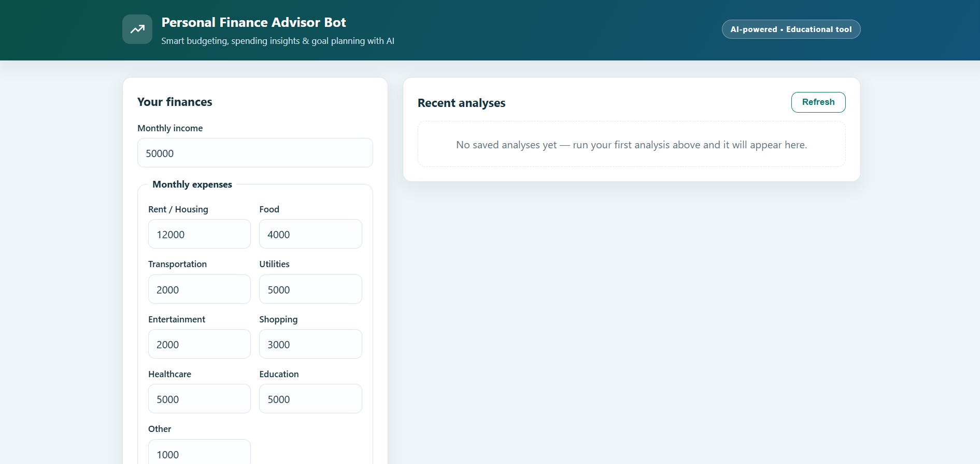

3.3 Submit the Form
The user selects the website's submit/analyze control. The browser sends the entered information to the application for processing. Do not add a loading screenshot unless the live website visibly displays a distinct loading or processing state.

3.4 Review the Analysis
After processing, the website presents the result. Depending on the implemented version, this may include totals, the amount remaining after expenses, a savings-rate figure, and AI-generated budgeting recommendations. The screenshot should show the actual result produced by the running app.
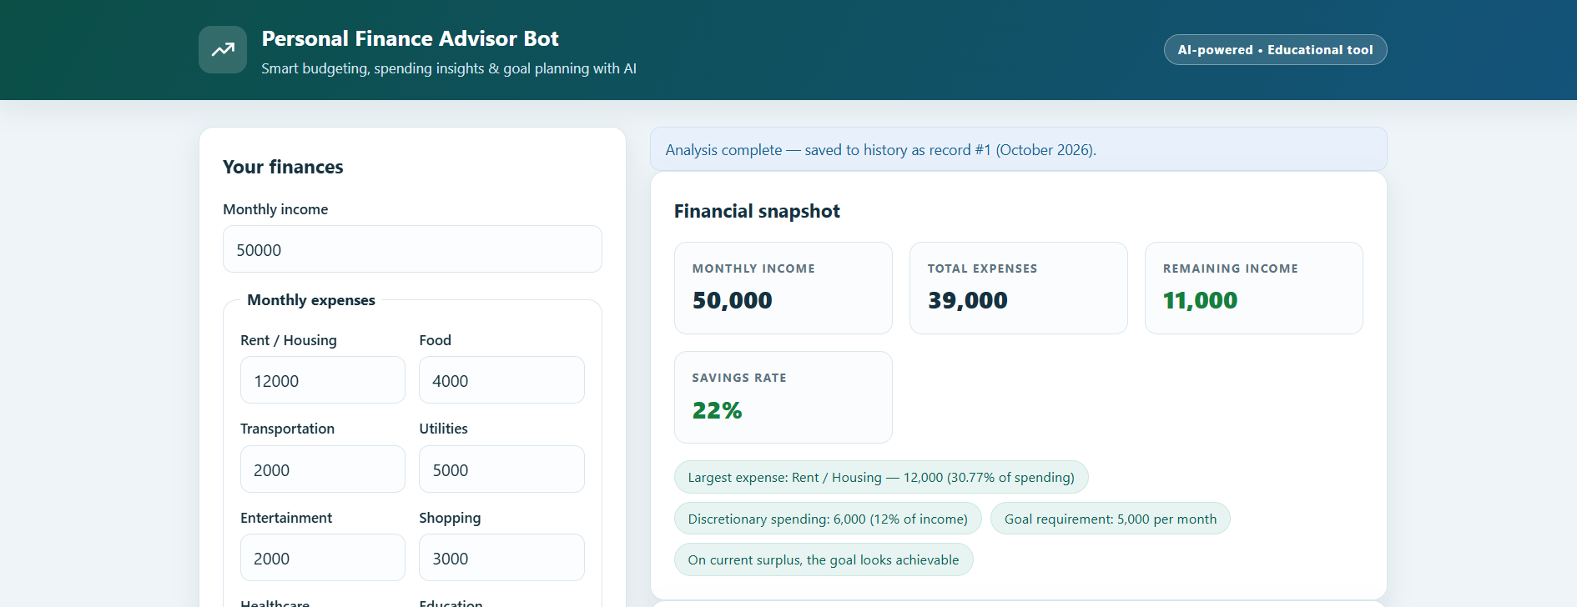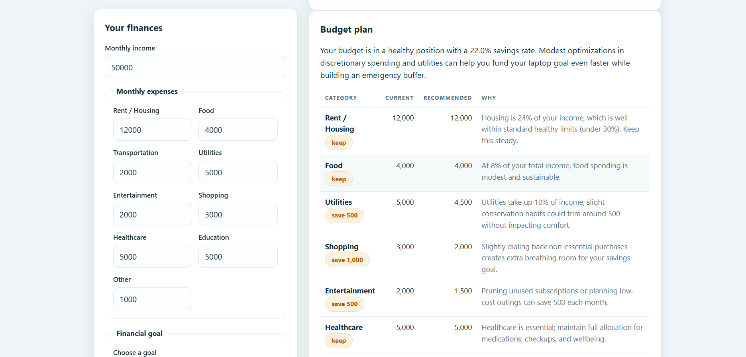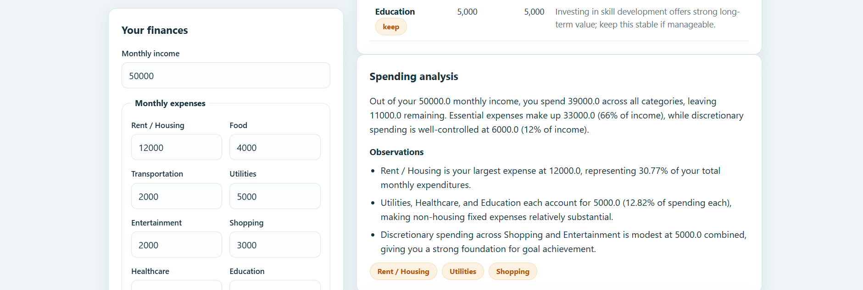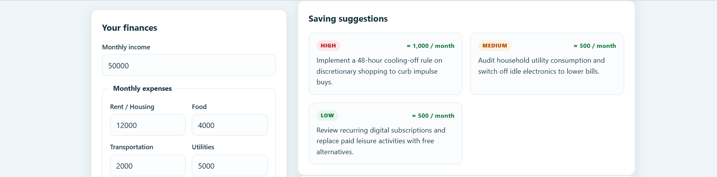

3.5 Goal Planning and Saved History
Users can select a predefined financial goal or enter a custom one, specify a target amount and duration, and receive calculated monthly savings requirements along with AI-generated strategies and suggestions.
The application saves completed analyses, allowing users to reopen recent results and review their financial summaries and recommendations without re-entering their details.

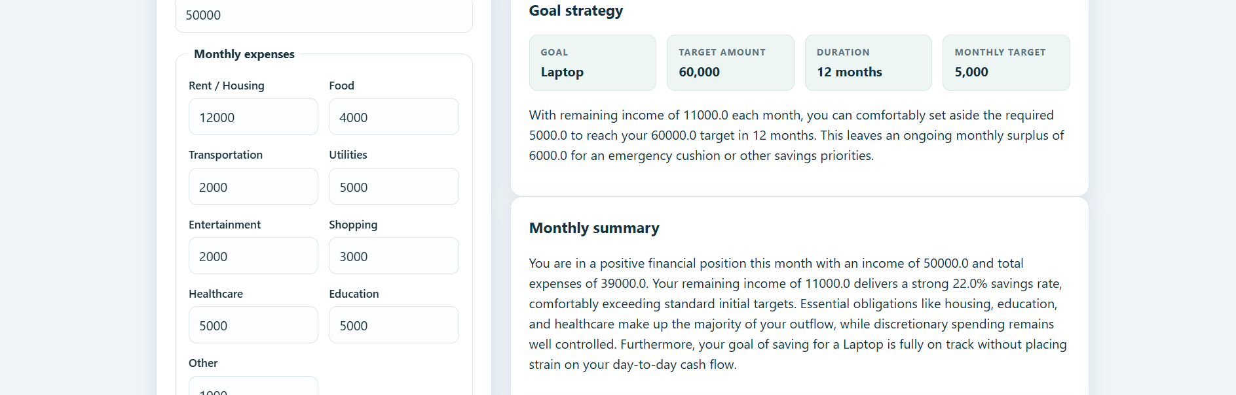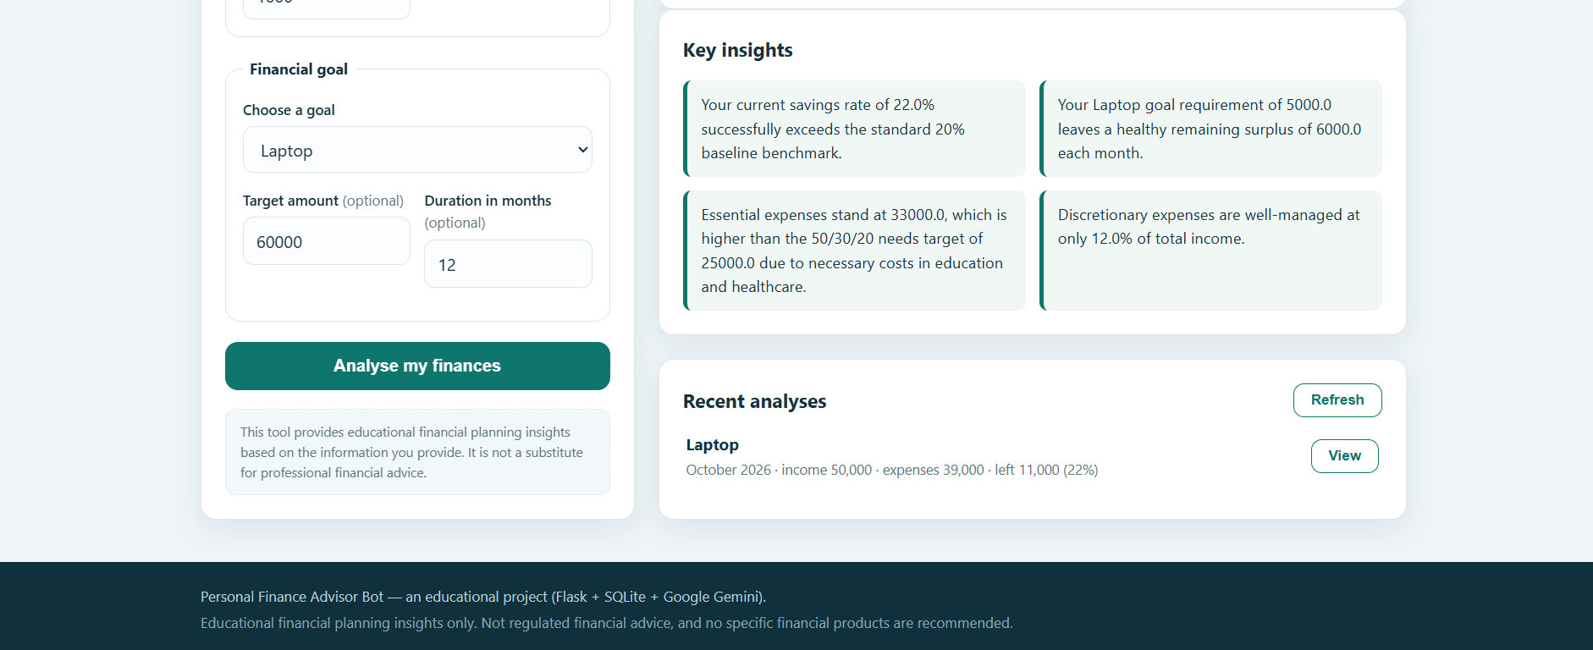

4. Financial Analysis and Recommendations
The analysis screen is the key output of the application. When documenting it, explain only the figures and advice visible in the current version. The example descriptions below are general interpretations of common budgeting metrics, not a claim that every metric is implemented.

4.1 Common Summary Values
- Total monthly expenses: the sum of the expense categories entered by the user, if the app calculates this total.
- Remaining amount: monthly income minus the expenses included in the calculation, if shown by the app.
- Savings rate: the proportion of income remaining or saved, if this metric is implemented. The exact formula should match the application.
- Recommendations: suggestions returned by the configured AI service, if the service call succeeds.

4.2 Interpreting Recommendations
Recommendations may suggest reviewing a high spending category, setting a realistic savings amount, or tracking spending over time. Users should compare suggestions with their real obligations and circumstances. AI output can be incomplete or incorrect, so it should be reviewed critically.

4.3 Goal-Oriented Planning
Where goal planning is supported, the user can compare a target with the amount they may be able to set aside. A useful explanation should state the target, the assumed monthly contribution, and any time estimate that the website actually calculates. If no separate goal output is present, describe the goal only as an input option and omit the optional goal-result screenshot.

4.4 Example Test Scenario
Test | Action | Expected visible behavior
1 | Open the landing page | The homepage and form entry point are visible.
2 | Enter fictional income and expenses | The form accepts the available fields.
3 | Submit the form | The app attempts to process the inputs and show a result.
4 | Review the result | The visible analysis matches the submitted sample values; recommendations appear if the AI service responds.
5 | Check optional features | Goal planning/history are documented only if present in the deployed app.
Record the actual result of each test when you run it. This report does not claim that tests were executed during document preparation.

5. Testing and Deployment Notes

5.1 Functional Checks
- Confirm the homepage loads from the submitted deployment URL.
- Check required fields and form validation using fictional values.
- Submit a valid form and verify that the result page appears.
- Compare any displayed totals with the submitted inputs.
- Check the AI recommendation area and note how the app behaves if the AI provider is unavailable.
- If available, test goal-planning and saved-history actions separately.

5.2 Deployment Configuration
A Flask deployment needs an application object that the hosting platform can discover. During troubleshooting, the project was adjusted to expose a top-level app object created from the app factory. The exact deployment entry-point setting should be checked against the hosting provider's current configuration.
If the site returns a server error, inspect the deployment logs, environment variables, dependency installation, route handling, and AI-provider configuration. Do not expose secret values when sharing logs.

5.3 Security and Privacy
- Never include secret keys in the report, screenshots, source repository, or public issue descriptions.
- Use invented example finances in screenshots and demonstrations.
- Do not imply that the application connects to a user's bank unless that integration is actually implemented.
- Treat recommendations as educational guidance rather than guaranteed financial outcomes.

6. Conclusion and Future Scope
The Personal Finance Advisor Bot demonstrates a web-based approach to organizing income and expense inputs and presenting a financial summary. Its usefulness depends on accurate input handling, clear presentation of calculations, and reliable behavior of the configured AI service. The accompanying screenshots should document the real website at each stage of the user journey.

6.1 Future Enhancements
- Improve validation and clearer explanations for each financial field.
- Add transparent explanations of the formulas used for each displayed metric.
- Provide accessible, printable summaries and clear error messages.
- If appropriate, add opt-in persistence and a clearly labeled history screen.
- Improve recommendation quality with guardrails, user review, and transparent limitations.
- Add automated tests for calculations, routes, validation, and service failures.

