AI Loan Eligibility Checker Report

NASSCOM Qualification & Project Submission Report

Project Name: AI Loan Eligibility Checker
Live Demo:
nasscom-project-one.vercel.app
Author / Repository: Ishwari Bhende
Github source: ishwaribhende-ops/Nasscom-project
Tech Stack: [e.g. HTML, CSS, JavaScript, AI API], hosted on Vercel

Executive Summary
AI Loan Eligibility Checker is a simple, accessible web application that helps users understand their borrowing position before they apply for a loan. It combines four tools in one interface: a loan eligibility checker, a credit score analyzer, an EMI calculator, and an AI chat assistant for financial tips. The goal is to give quick, easy-to-understand guidance to people who find banking terms and loan criteria confusing. The app is clearly marked as informational only and not official financial advice.

Core Features & Capabilities

Loan Eligibility Checker  Evaluates user inputs such as income, obligations and requested amount to indicate whether a loan is likely to be approved. | Credit Score Analyzer  Interprets a credit score and explains what range it falls in and how it may affect loan decisions.
EMI Calculator  Calculates the monthly installment from loan amount, interest rate and tenure, so users can plan repayments. | AI Financial Tips  Chat-style assistant where users ask finance questions and receive AI-generated, plain-language tips.

Interface Architecture & Dashboard Overview

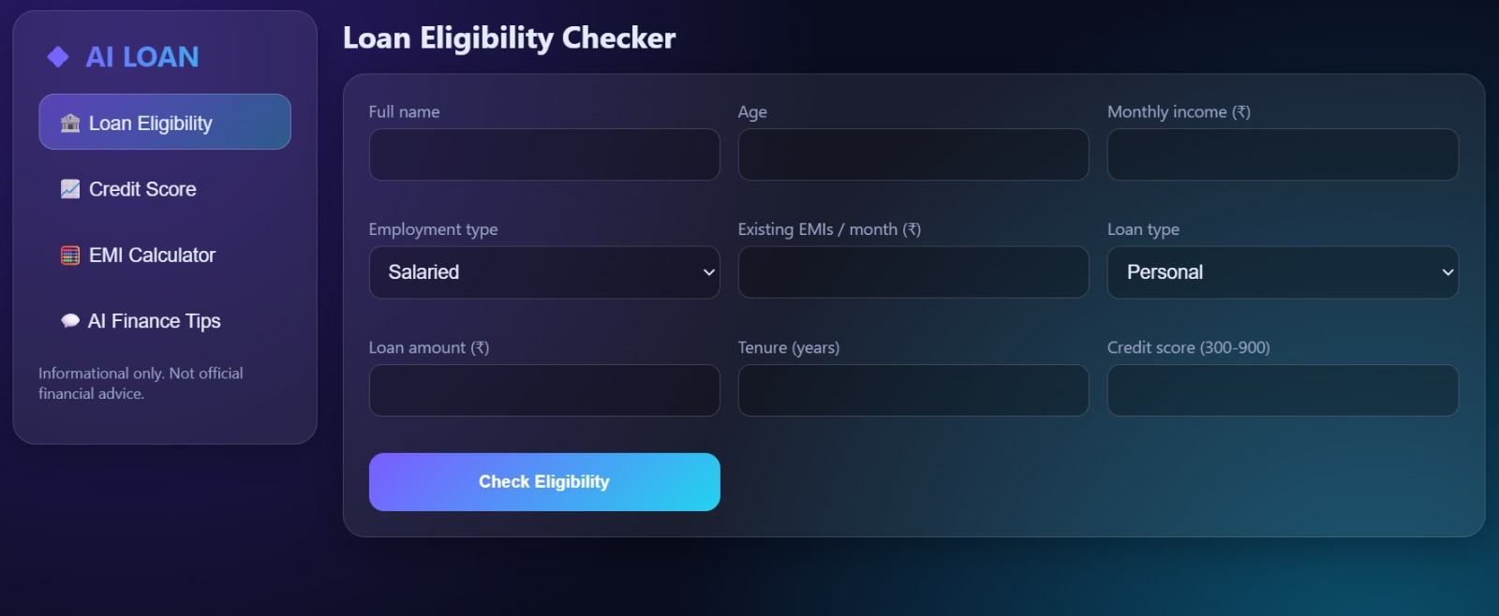

Figure 1: Main interface with navigation across Loan Eligibility, Credit Score, EMI Calculator and AI Finance Tips. (Video Timestamp: 00:00)

​System Architecture & Tech Stack

Layer | Technologies Used | Description
Frontend UI | [HTML, CSS, JavaScript / framework] | Responsive single-page interface with tabbed navigation between the four tools.
Calculation Logic | Client-side JavaScript | Runs the EMI formula and the eligibility and credit score rules instantly in the browser.
AI Integration | [AI API, e.g. Gemini] | Answers user questions in the AI Finance Tips chat with plain-language guidance.
Deployment | Vercel | Hosted with automatic builds and a public HTTPS link.

​Module Deep-Dive: Loan Eligibility & Credit Score
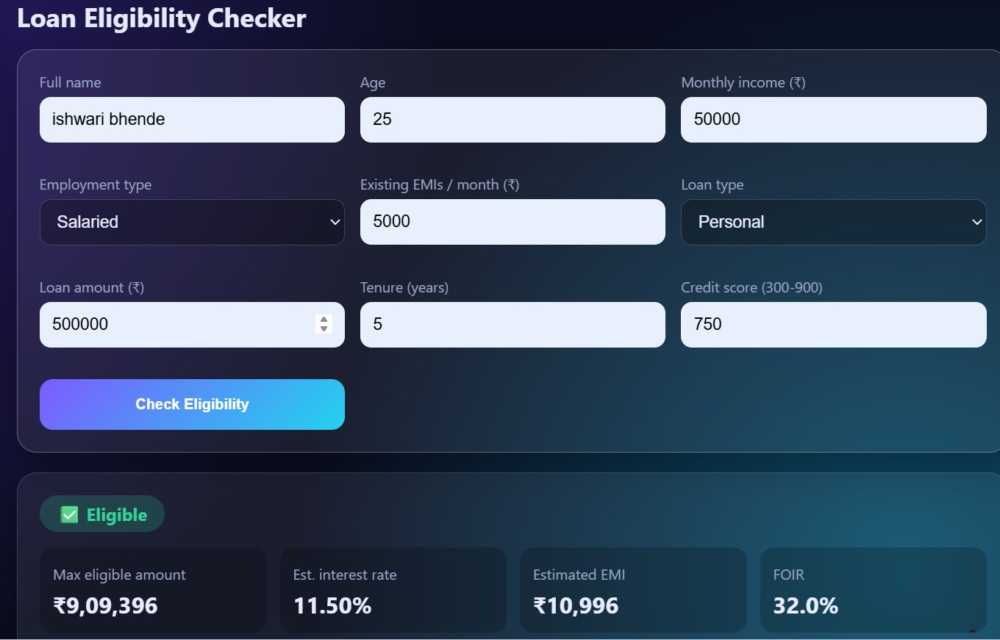

Figure 2: Loan Eligibility Checker and Credit Score Analyzer producing results from user inputs. (Video Timestamp: 00:00 - 00:00)

​Workflow & Data Flow Architecture
The user selects a tool from the navigation bar and enters basic details such as income, loan amount, interest rate, tenure or credit score. The application processes these inputs and returns a clear result:
  - Eligibility Result: Indication of approval likelihood based on the entered financial details.
  - Credit Score Insight: Score category with a short explanation of its impact on borrowing.
  - EMI Breakdown: Monthly installment calculated from principal, rate and tenure.
  - AI Guidance: Free-form questions answered by the AI assistant in simple language.

​EMI Calculator & AI Finance Tips

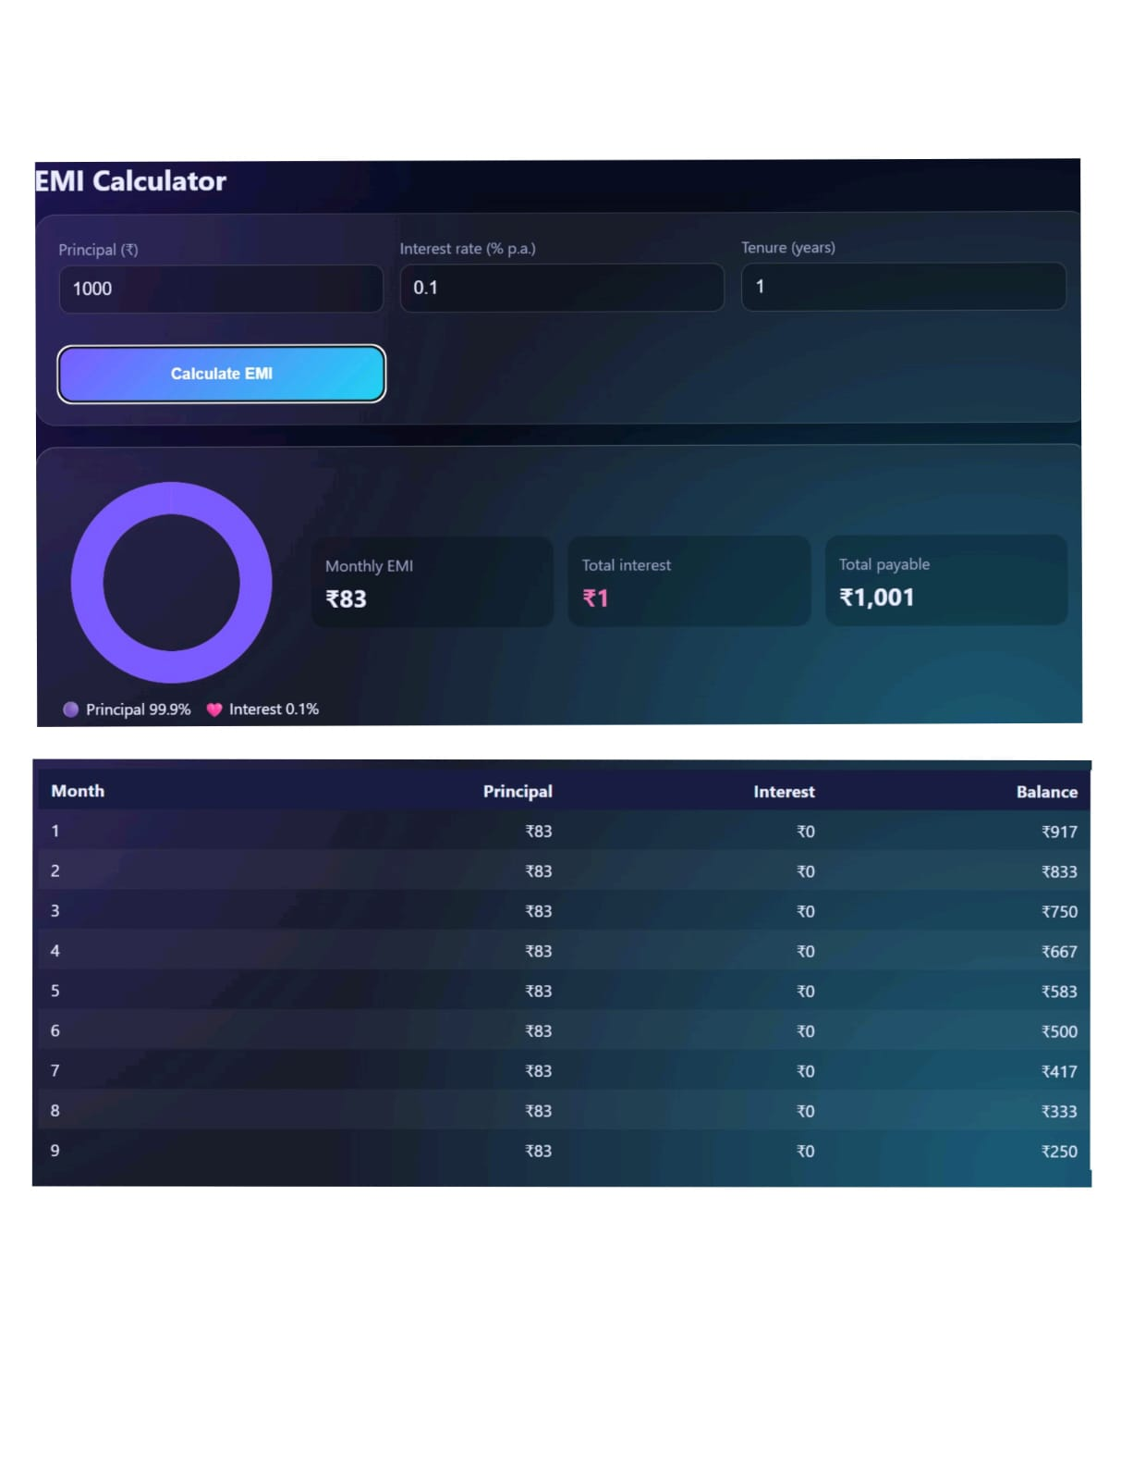

Figure 3: EMI Calculator and AI Financial Tips chat assistant in use. (Video Timestamp: 00:00 - 00:00)

​Installation & Deployment Guide
To run the project locally or evaluate for submission verification, execute the following commands:
# 1. Clone the repository
git clone https://github.com/[username]/[repository].git

# 2. Navigate to project root & install dependencies cd [repository]
npm install

# 3. Configure Environment Variables (if an AI API is used) echo "API_KEY=your_api_key" > .env

# 4. Start local development server npm run dev

​Conclusion & Project Roadmap
AI Loan Eligibility Checker turns confusing loan and credit concepts into quick, understandable answers. The project demonstrates how simple calculation tools and generative AI can be combined into one accessible financial-literacy experience.
Future Expansion: Planned developments include user accounts to save past checks, integration with real credit bureau data, bank-specific eligibility rules, multi-language support and downloadable eligibility reports.

