PROJECT REPORT
AI-Powered Hiring Intelligence &
Candidate Analytics Platform
A recruitment-agency screening and shortlisting system

Subject: Enterprise Java (EJ) Mini Project
Class: TYBScIT | Division: A

1. Group Members
Sr. No. | Name of Student | SAP ID | Class | Division
1 | Ishwari Kshirsagar | 53013240102 | TYBScIT | A
2 | Pratiksha Kunwar | 53013240104 | TYBScIT | A
3 | Shreya Pillai | 53013240088 | TYBScIT | A
4 | Manju Dhami | 53013240100 | TYBScIT | A

2. Project Overview
The AI-Powered Hiring Intelligence & Candidate Analytics Platform is a simplified Applicant Tracking System (ATS) built for a recruitment agency. The agency is engaged by client companies to source and screen candidates on their behalf. Instead of candidates applying through a job portal, the agency feeds resumes into the system in bulk. The platform parses every resume, runs an ATS completeness check, scores each candidate against every open job using a skill-and-experience match model, ranks them, and produces a shortlist that each client company can review through its own login.
It is not a job portal - there is no candidate-facing side. The system has two roles: an agency Administrator who runs the whole pipeline, and Client-company Recruiters who only see the shortlist for their own jobs.
Technology: React.js frontend, a screening/matching engine, and a specified Spring Boot + PostgreSQL backend (JWT-secured, layered Controller-Service-Repository architecture). The demo runs on a browser-local database seeded with 3 client companies, 8 jobs and 52 synthetic resumes across 10 job categories.

3. Requirements of the Project

3.1 Functional Requirements
- User authentication & roles - the system shall allow users to log in with role-based access (Administrator, Recruiter) secured with JWT tokens.
- Client company management - the Administrator shall be able to register and manage client companies the agency screens for.
- Job description management - the Administrator and Recruiters shall be able to create and edit job descriptions, including required skills and a minimum-maximum experience range.
- Bulk resume ingestion - the Administrator shall be able to feed candidate resumes into the system individually or in bulk (plain-text resumes are parsed directly; PDF/DOCX are stored and flagged for manual review).
- Resume parsing - the system shall extract the candidate's name, email, phone, skills, total experience and education from each resume.
- ATS completeness check - the system shall score how complete and machine-readable each resume is (0-100) and raise flags such as 'no email found' or 'fewer than 3 recognised skills'.
- Candidate-to-job matching - the system shall compute a match score (%) for every candidate against every open job, combining skill coverage (70%) and experience fit (30%), and produce the matched skills, missing skills and a plain-language explanation.
- Automatic ranking & shortlisting - the system shall rank all candidates for a job in descending order of match score and automatically shortlist the strongest matches.
- Manual shortlist decisions - Recruiters and the Administrator shall be able to override the automatic decision by marking a candidate Shortlisted, Rejected or Reset; a manual decision is preserved when the job is re-scored.
- Interview question generation - the system shall generate likely interview questions for a candidate based on their extracted skill set.
- Analytics dashboards - the system shall display analytics: most common skills in the pool, screening funnel, skill-gap (required vs available) and resumes ingested per month, scoped to the logged-in user's data.
- Data isolation - a Recruiter shall only be able to see their own company's jobs, shortlists and analytics, never another client's data or the raw candidate pool.
- Hiring reports (planned) - the system shall provide a downloadable PDF report summarising candidates, match scores and skill gaps for a client.
- Demo data controls - the Administrator shall be able to load a bundled sample resume dataset and reset the database to its seeded state.

3.2 Non-Functional Requirements
- Performance - the system should parse, score and rank at least a few hundred resumes for a job within an acceptable response time.
- Security - passwords must be stored using strong hashing (BCrypt); all API endpoints must be protected using Spring Security with JWT tokens and role-based authorization.
- Scalability - the backend (Spring Boot + PostgreSQL) should be layered so that additional AI providers or analytics modules can be added without major redesign.
- Usability - the dashboard should present rankings, scores and charts in a clear, recruiter-friendly way, using a plain neutral interface with no distracting styling.
- Reliability - resume ingestion, analysis and database writes should fail gracefully with clear error messages and without losing already-ingested data.
- Maintainability - the codebase should follow a layered architecture (Controller -> Service -> Repository) so modules can be updated independently.
- Data privacy - candidate personal data and resumes must only be accessible to authorised roles, in line with basic data-protection practice.
- Portability - the application should be deployable on any standard Java 17/21 environment with a PostgreSQL instance; the frontend on any static host.

4. Working Pages of the Project
The following 15 pages were captured from the running application. Each screenshot is followed by a detailed description of what the page does and how it works.

4.1 Login Page
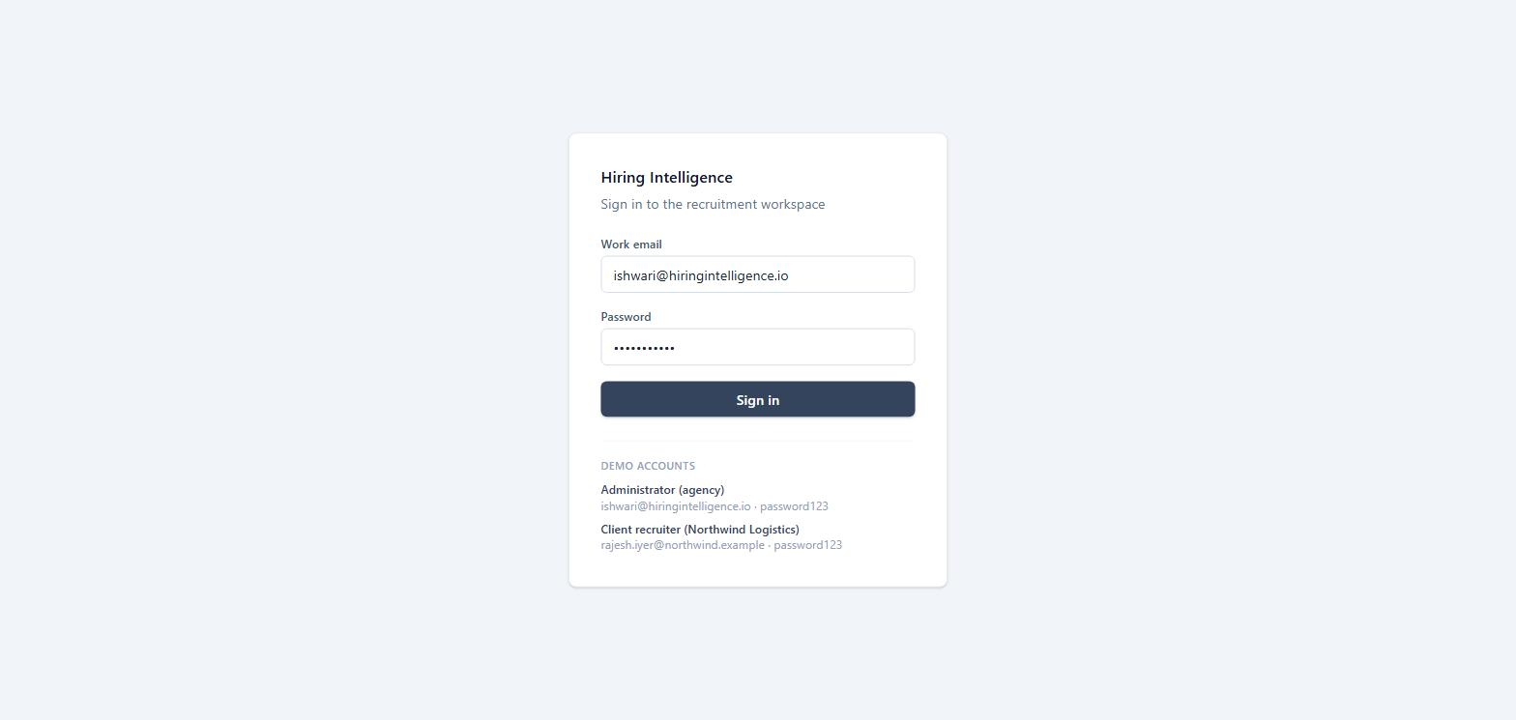
Working description:
- The single entry point to the application. There is no self-service sign-up and no candidate login - accounts are provisioned by the agency.
- The user enters a work email and password. On submit the credentials are checked against the users table; on success a session token is issued and the user is redirected to their Overview page. An invalid combination shows an inline 'Invalid email or password' message.
- A 'Demo accounts' panel lists the two available logins (agency Administrator and a client-company Recruiter). Clicking a demo account fills the form so the two roles can be compared quickly.
- The role is derived from the account itself, not chosen at login, so a Recruiter can never accidentally enter the Administrator workspace.

4.2 Administrator Overview (Dashboard)
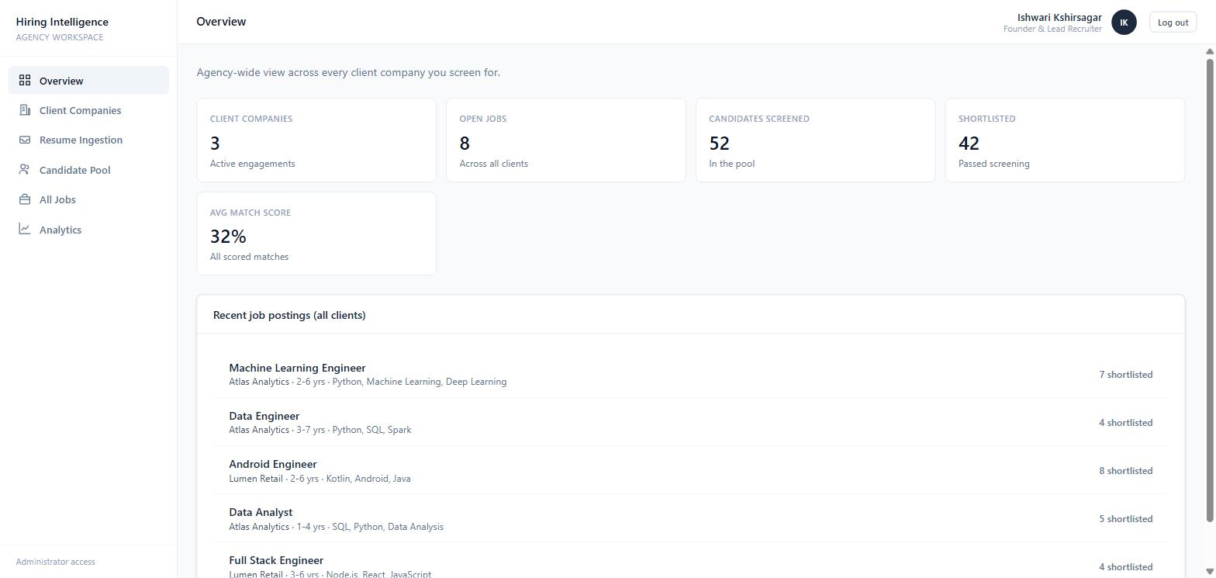
Working description:
- The landing page for the agency Administrator. It gives an agency-wide picture across every client company.
- Five summary tiles show: number of client companies, total open jobs across all clients, candidates screened (size of the pool), how many candidates have been shortlisted, and the average match score of all scored candidate-job pairs. All figures are computed live from the database.
- Below the tiles, 'Recent job postings (all clients)' lists the newest jobs from every company with the client name, experience range, top required skills and how many candidates have been shortlisted for each. Each row links straight to that job's shortlist.
- The left sidebar shows the Administrator-only navigation: Overview, Client Companies, Resume Ingestion, Candidate Pool, All Jobs and Analytics.

4.3 Client Companies
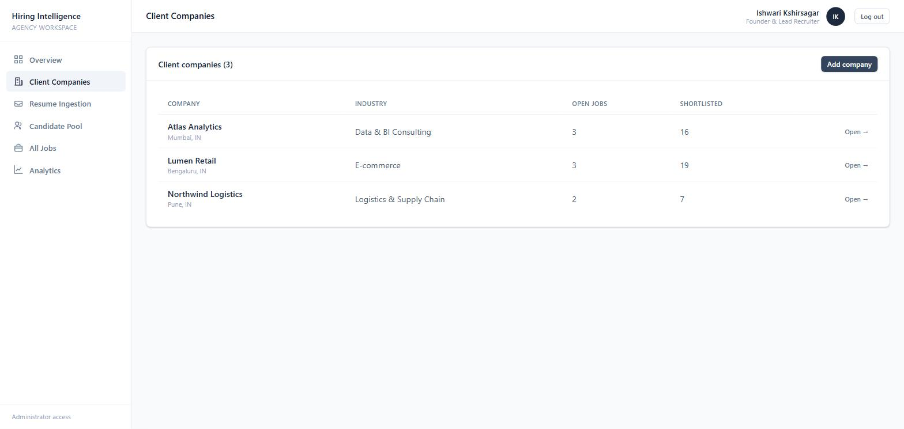
Working description:
- An Administrator-only page listing every company the agency screens for.
- The table shows each company's name and location, its industry, the number of open jobs it currently has, and how many candidates have been shortlisted for it in total.
- Clicking a row opens that company's detail page. 'Add company' opens a form to register a new client (name, industry, location, contact person and contact email).
- This page is the top of the Administrator's workflow - a client is registered here first, then jobs are posted for it and resumes are screened against those jobs.

4.4 Client Company Detail
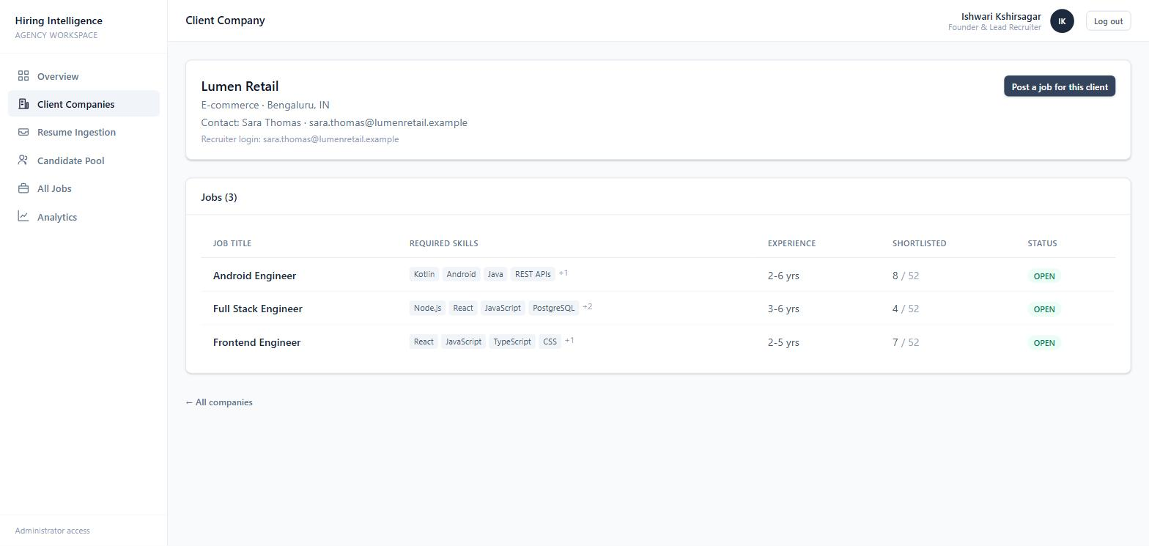
Working description:
- Opened from the Client Companies list. The header card shows the company profile - industry, location, the client-side contact, and the email address the client's Recruiter uses to log in.
- The 'Jobs' table lists every job the agency is running for this client, with required skills, experience range, how many candidates are shortlisted out of how many were screened, and the job status.
- The 'Post a job for this client' button opens the New Job form with this company pre-selected, so the Administrator can add roles on the client's behalf.
- This screen is how the Administrator manages one engagement end to end.

4.5 Candidate Pool
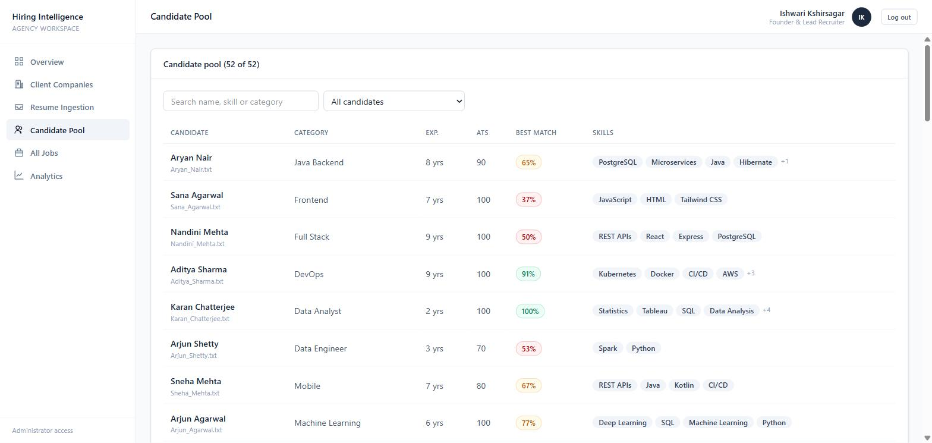
Working description:
- An Administrator-only view of every resume that has been ingested into the system - the raw talent pool that client Recruiters never see directly.
- Each row shows the candidate's name and source file, their detected job category, years of experience, ATS completeness score, their best match score against any job (colour-coded green/amber/red), and their top extracted skills.
- A search box filters by name, skill or category. A dropdown filters to candidates who have a strong match somewhere (>= 55) or to resumes the ATS check flagged as incomplete (< 60).
- Clicking a candidate opens their full profile. This page lets the Administrator audit the quality and coverage of the pool.

4.6 All Jobs (Administrator)
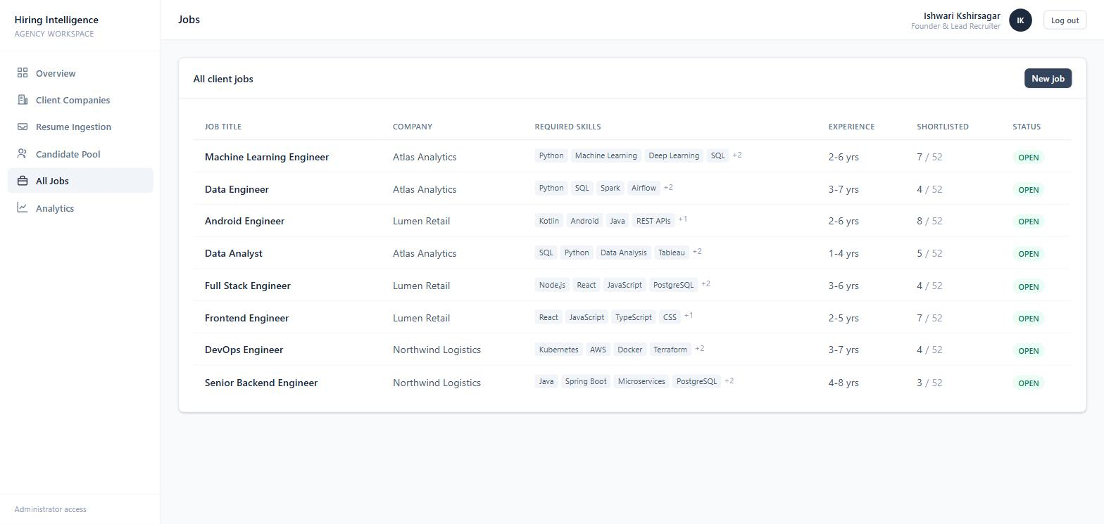
Working description:
- A single table of every open job across all client companies, sortable by any column.
- Columns: job title, client company, required skills, experience range, shortlisted-out-of-screened count, and status. Because the Administrator screens for several clients at once, the company column makes it clear which engagement each job belongs to.
- Clicking a row opens the job's shortlist. 'New job' opens the creation form with a company selector.
- The same page shown to a Recruiter is automatically scoped to only that Recruiter's company and hides the company column.

4.7 Job & Shortlist
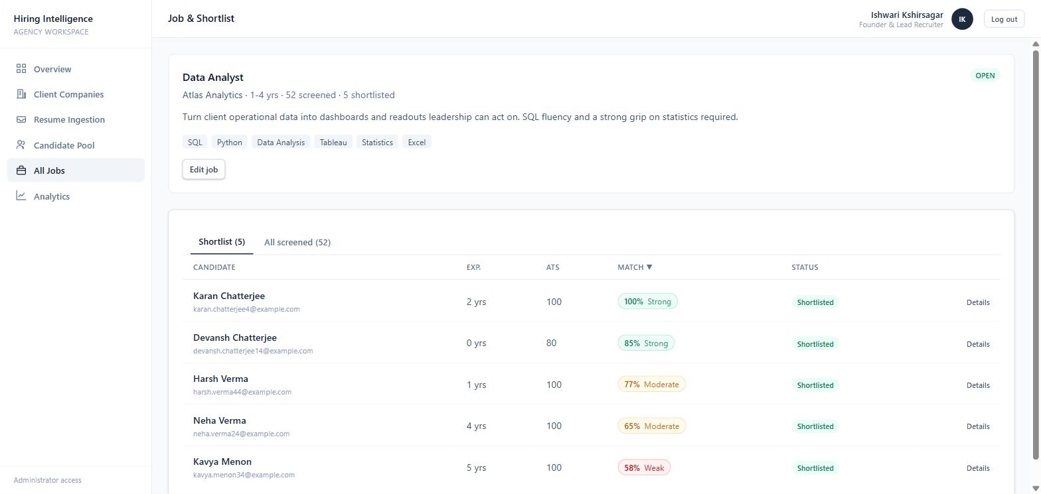
Working description:
- The core output of the product. The header card shows the job description, required skills, experience window, and counts of screened vs shortlisted candidates.
- Two tabs: 'Shortlist' (the candidates the system auto-selected) and 'All screened' (every candidate scored against this job).
- Each candidate row shows years of experience, ATS score, the match score with a Strong / Moderate / Weak label, and the current status. Rows are sorted by match score, highest first.
- The list is produced automatically: every candidate is scored against the job, ranked, and the top scorers above the threshold are marked Shortlisted.

4.8 Match Explanation & Decision Controls
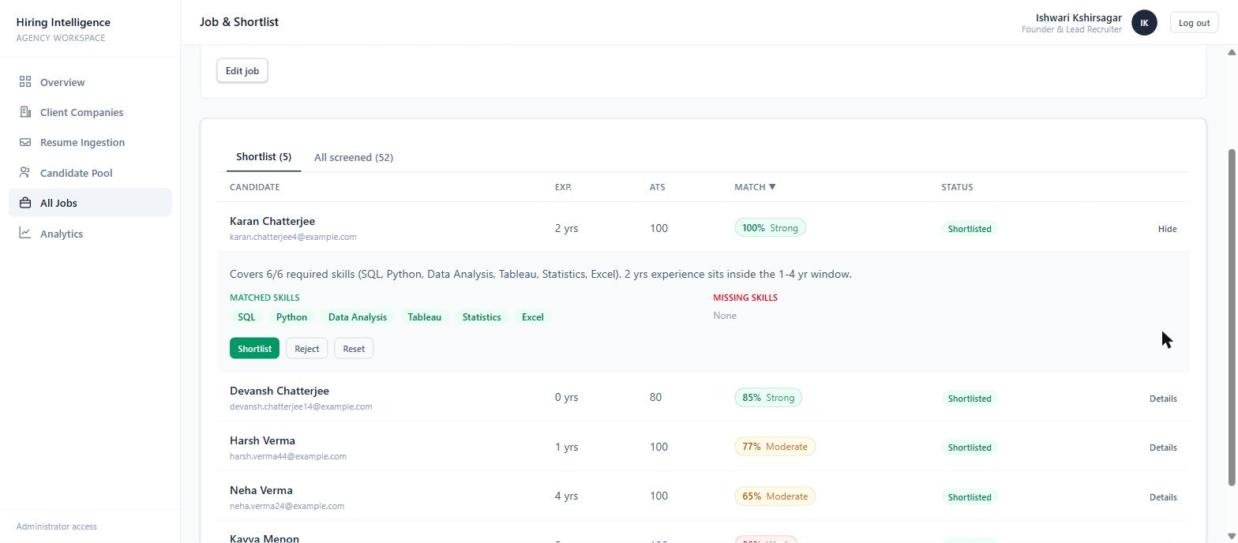
Working description:
- Expanding a candidate row on the Job & Shortlist page reveals why they scored as they did.
- A plain-language explanation is shown, for example: 'Covers 6/6 required skills (SQL, Python, Data Analysis, Tableau, Statistics, Excel). 2 yrs experience sits inside the 1-4 yr window.'
- 'Matched skills' and 'Missing skills' are listed as coloured tags so the recruiter can see the gap at a glance.
- Three buttons - Shortlist, Reject, Reset - let the recruiter override the automatic decision. A manual decision is locked and is preserved even when the job is edited and every candidate is re-scored.

4.9 Candidate Profile
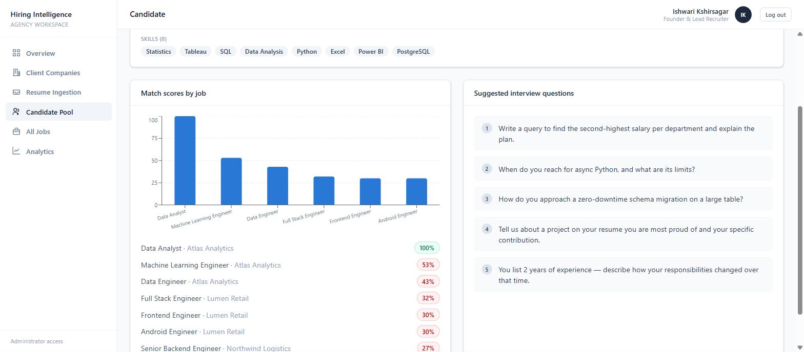
Working description:
- A full view of one candidate, opened from the pool, a shortlist or an ingestion result.
- The header shows contact details, years of experience, the ATS completeness score, and any ATS flags. Below it are the resume summary and the complete list of extracted skills.
- 'Match scores by job' plots this candidate's match score against every open job as a bar chart, with the exact percentages listed beneath and each job linking to its shortlist. For a Recruiter this list is filtered to only their own company's jobs.
- 'Suggested interview questions' are generated from the candidate's skill set - for a data analyst, questions about SQL window functions, async Python, and zero-downtime schema migration, plus two general questions.

4.10 Analytics Dashboard
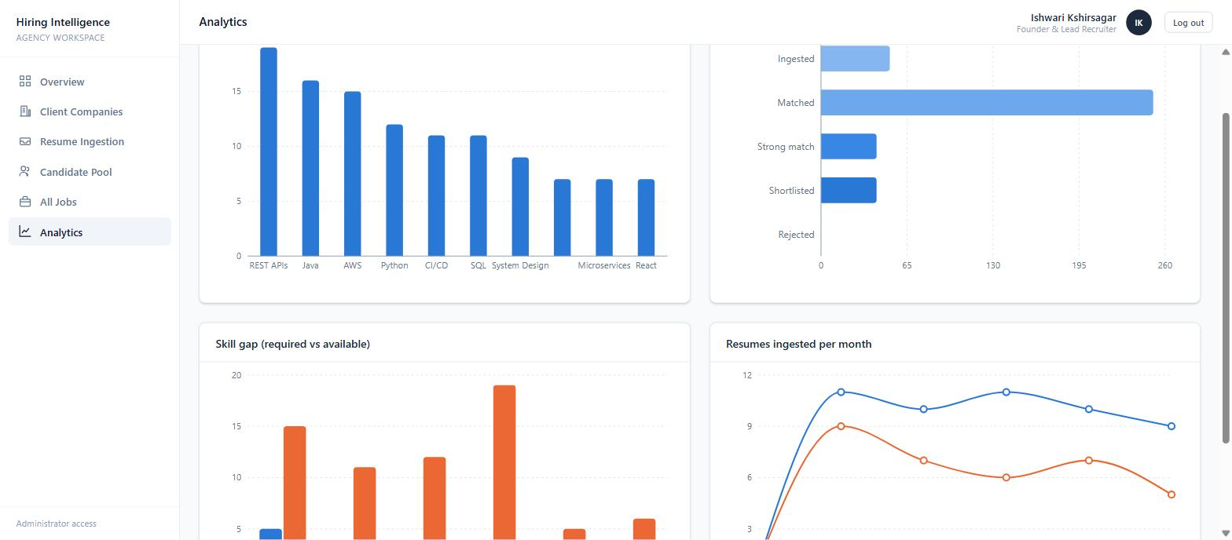
Working description:
- Four charts, each computed live from the database and scoped to the logged-in user (agency-wide for the Administrator, own-company for a Recruiter).
- Most common skills in the pool - a bar chart of the skills that appear most often across screened candidates, useful for judging supply.
- Screening funnel - how many candidates move from Ingested, to Matched, to Strong match, to Shortlisted, to Rejected.
- Skill gap (required vs available) - for the most-demanded skills, how many jobs require the skill versus how many candidates have it.
- Resumes ingested per month - a trend line of ingestion volume and how many of those candidates were later shortlisted.

4.11 New Job Form
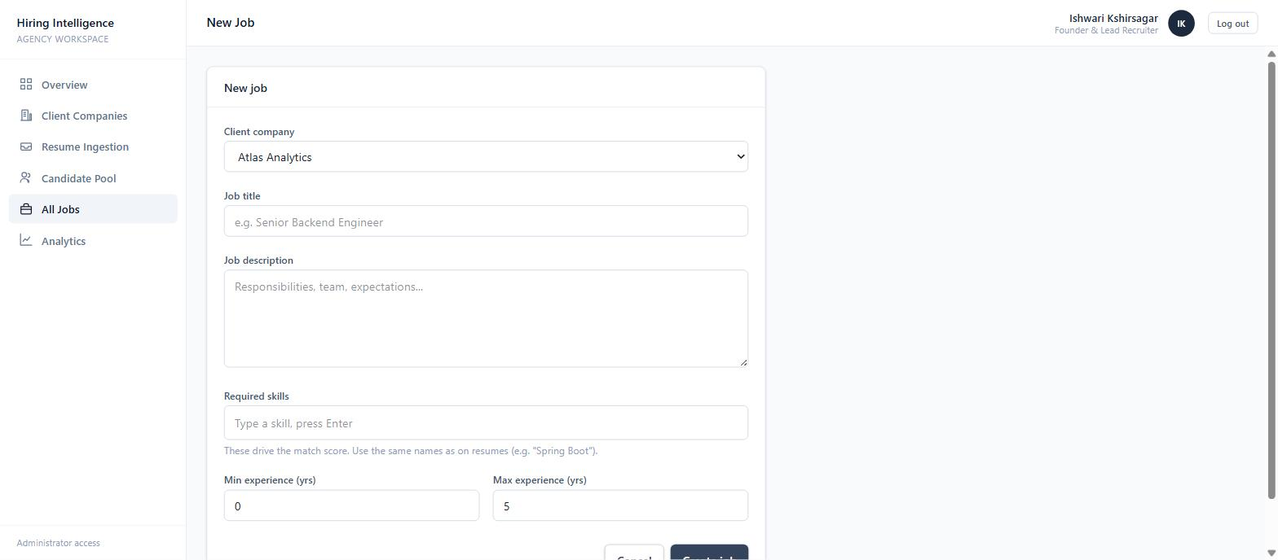
Working description:
- Used to create a job description. For the Administrator the form starts with a 'Client company' selector; for a Recruiter the company is fixed to their own.
- Fields: job title, a free-text description, a tag-style 'Required skills' input (type a skill and press Enter), and minimum / maximum years of experience.
- The required skills drive the match score directly - the help text reminds the user to name them the same way they appear on resumes (for example 'Spring Boot').
- On save the job is created and every candidate in the pool is immediately scored against it, so the shortlist is ready as soon as the page redirects.

4.12 Resume Ingestion
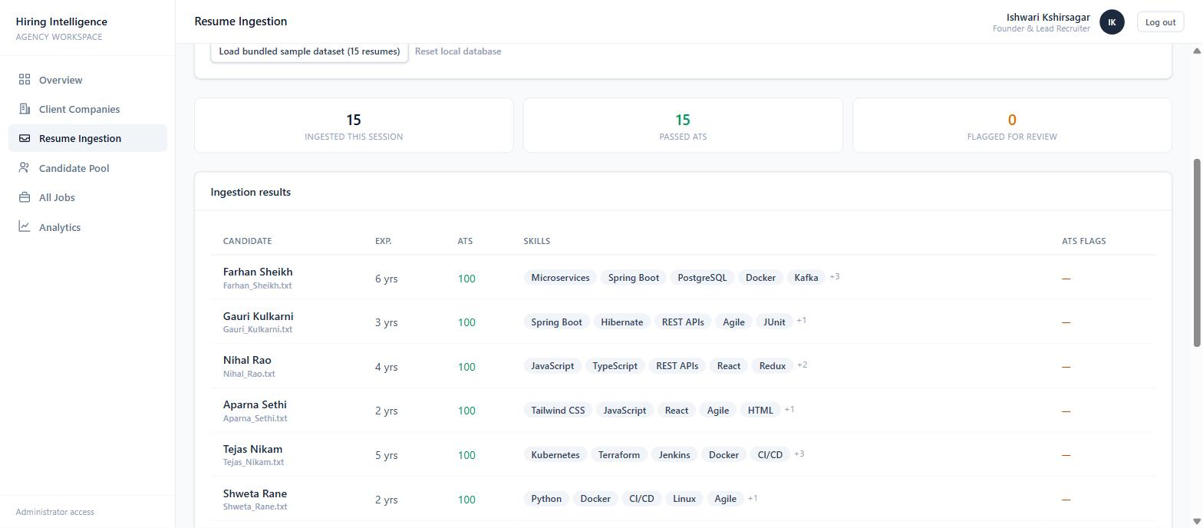
Working description:
- The Administrator-only screen for feeding resumes into the system on behalf of clients.
- Resumes can be dropped onto the upload area - .txt / .csv / .json files are parsed directly, while .pdf / .docx files are stored and flagged for manual review (binary resumes cannot be read in the browser demo). 'Load bundled sample dataset' adds 15 ready-made resumes for demonstrations.
- As each resume is processed it passes through parsing, the ATS completeness check, and scoring against every open job. The three tiles summarise the batch: total ingested, how many passed the ATS check, and how many were flagged.
- The 'Ingestion results' table lists each new candidate with their experience, ATS score, extracted skills and any ATS flags, each name linking to the full profile.

4.13 Client Recruiter Overview
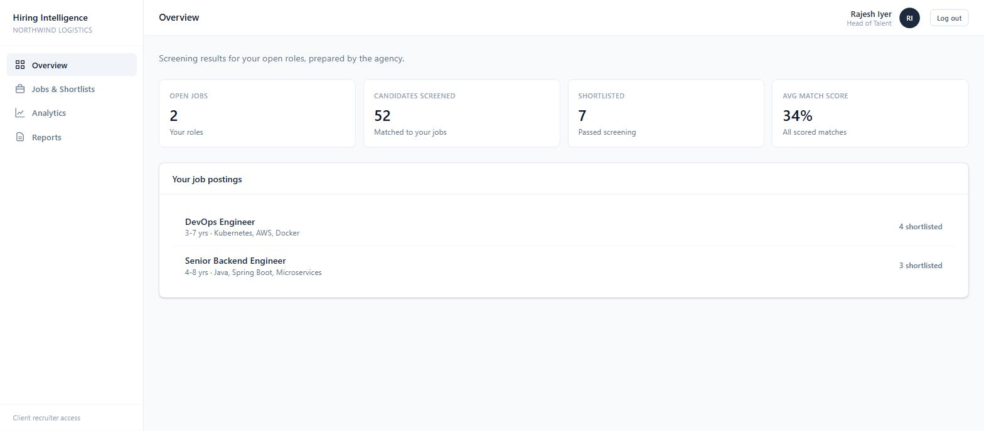
Working description:
- The landing page for a client-company Recruiter (here, Northwind Logistics). The workspace name in the sidebar and the reduced navigation (Overview, Jobs & Shortlists, Analytics, Reports) show that this is a client view, not the agency view.
- The summary tiles are scoped to this client only: their open jobs, candidates screened against their roles, how many were shortlisted, and the average match score for their jobs.
- 'Your job postings' lists only this company's jobs with the shortlist count for each.
- The Recruiter cannot see other clients, the raw candidate pool, or the ingestion screen - the same components simply render a restricted slice of the data.

4.14 Recruiter - Jobs & Shortlists
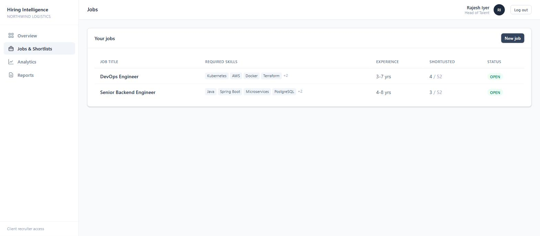
Working description:
- The Recruiter's job list, showing only their own company's roles - there is no company column because every row belongs to them.
- Each row shows required skills, experience range, the shortlisted-of-screened count and status. Clicking a row opens the same Job & Shortlist page the Administrator uses, with the same match explanations and Shortlist / Reject / Reset controls.
- 'New job' lets the Recruiter post a role for their own company directly, without going through the agency.
- This is the main working screen for a client - they review the agency's shortlist and make hiring decisions here.

4.15 Reports
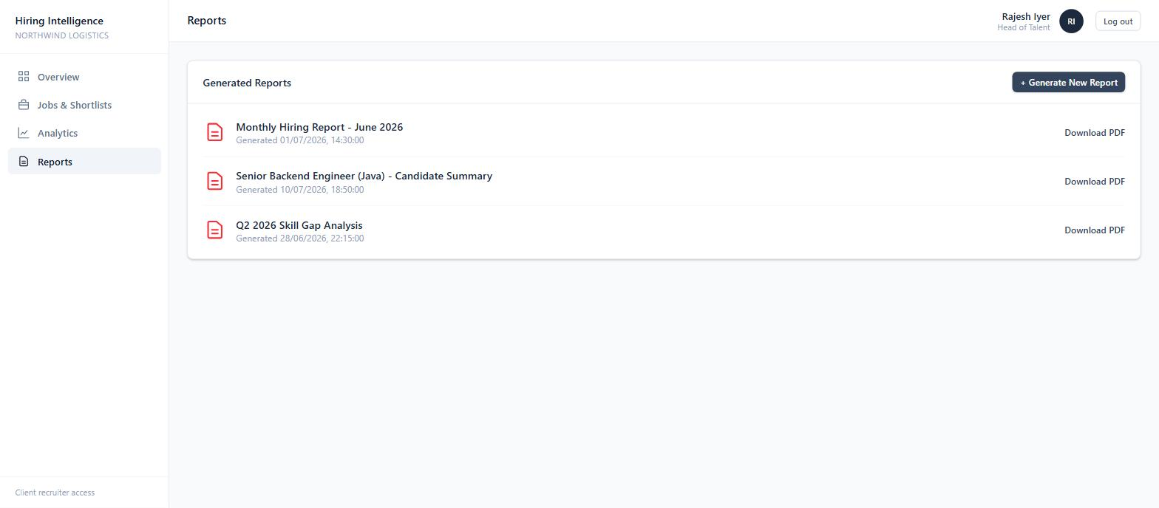
Working description:
- A list of generated hiring reports (for example 'Monthly Hiring Report', 'Candidate Summary', 'Skill Gap Analysis') with the date each was generated and a download link.
- In the intended design a report is a downloadable PDF that summarises a batch of candidates - their match scores, strongest skills and the skill gaps for a role - which is the document the agency hands to a client.
- This screen is currently a working placeholder: the list and the 'Generate New Report' action are wired up, but PDF generation is planned for a later version because it sits on top of data (scores, rankings, gaps) that the rest of the system now produces.
- It is included here to show the full navigation and the intended reporting workflow.

5. Summary
The project delivers a complete, working recruitment-agency screening tool. An agency Administrator registers client companies, posts their jobs, and ingests resumes in bulk. Every resume is parsed, checked for completeness, and automatically scored and ranked against every open job, with a plain-language explanation of each score. Client Recruiters log into their own isolated workspace to review the resulting shortlist and record hiring decisions. Analytics dashboards summarise the pipeline for both roles. The screening logic, data model and REST API are specified for a Spring Boot + PostgreSQL backend, with the frontend already running against a matching local database.

