SOFTWARE PROJECT MANAGEMENT
Hiring Intelligence Platform
Design Document
Project plan diagrams (WBS, AOA, AON, CPM, PERT) and software design diagrams (use case, class, ER)
Item | Detail
Version | 2.0 (React frontend, Spring Boot backend, Neon PostgreSQL)
Repository | github.com/ishwariksh06/Hiring_intelligence
Live system | hiring-intelligence-eight.vercel.app (frontend), hiring-intelligence-api.onrender.com (backend)
Project period | 27 August 2026 to 20 September 2026
Companion document | Hiring_Intelligence_Test_Plan_and_Report.docx
Project Team
Team Member | SAP ID | Role
Pratiksha Kunwar | 53013240104 | Product Manager
Shreya Pillai | 53013240088 | Tester
Ishwari Kshirsagar | 53013240102 | Developer
Table of Contents
1. Introduction 3
1.1 Purpose 3
1.2 The product in one paragraph 3
1.3 Intended readers 3
2. System Overview and Architecture 4
2.1 Architecture 4
2.2 Screening logic 4
2.3 Roles 4
3. Project Planning Diagrams 5
3.1 Basis of the schedule 5
3.2 Work Breakdown Structure (WBS) 6
3.3 Activity-on-Node (AON) precedence diagram 7
3.4 Activity-on-Arrow (AOA) network diagram 8
3.5 Critical Path Method (CPM) diagram 9
3.6 PERT chart 10
4. Software Design Diagrams 12
4.1 Use case diagram 12
4.2 Class diagrams 14
4.3 Class diagram: services and screening engine 15
4.4 Entity-Relationship (ER) diagram 16
5. Interface, Security and Error Design 17
5.1 REST API 17
5.2 Screens 17
5.3 Security design 18
5.4 Error handling 18
6. Design Decisions and Known Limits 19
6.1 Decisions 19
6.2 Known limits 19

1. Introduction

1.1 Purpose
This document describes the design of the Hiring Intelligence Platform and the plan used to build it. It has two halves. Section 3 holds the project management diagrams: work breakdown structure, activity-on-arrow and activity-on-node networks, critical path and PERT. Section 4 holds the software design diagrams: use case, class and entity-relationship. Section 5 adds the interface, security and error design that the diagrams do not show.

1.2 The product in one paragraph
Hiring Intelligence is a resume screening tool for a recruitment agency. An administrator adds client companies and their jobs, and uploads resumes. The system reads each resume, extracts skills and experience, runs an ATS (applicant tracking system) readiness check, and scores every candidate against every job. Recruiters from a client company log in and see only their own jobs and the ranked shortlist.

1.3 Intended readers
- Project team members (development, testing, documentation)
- The project guide and evaluators
- Anyone who continues the project after this release

2. System Overview and Architecture

2.1 Architecture
The system has three tiers. The browser runs a single-page React application. It calls a stateless REST API written in Spring Boot. The API stores everything in PostgreSQL.
Tier | Technology | Responsibility
Presentation | React 19, Vite, Tailwind CSS, Recharts, Axios (hosted on Vercel) | Login, dashboards, job and candidate screens, charts; adapts to phone width with a slide-out menu
Application | Java 21, Spring Boot 3, Spring Security, JWT (hosted on Render in Docker) | Authentication, role checks, validation, resume parsing, ATS scoring, matching, ranking, analytics, caching
Data | PostgreSQL on Neon; H2 in memory for automated tests | Users, companies, jobs, candidates, matches, reports

2.2 Screening logic
Two numbers are calculated for every candidate. Both are simple and can be explained to a client.
Score | How it is calculated
Match score (per job) | round( skill coverage x 70 + experience fit x 30 ). Skill coverage is matched required skills divided by all required skills, compared without regard to upper or lower case. Experience fit is 1.0 inside the job's experience window and falls towards 0 the further the candidate is outside it.
ATS score (per resume) | Additive checks: email 20, phone 10, at least 3 recognised skills 30, years of experience stated 20, education found 10, text of at least 200 characters 10. A score of 60 or more passes.

2.3 Roles
Role | What the role may do
ADMIN (agency) | Everything: all companies, all jobs, the candidate pool, resume ingestion, reports, analytics, reset of demo data
RECRUITER (client) | Only the recruiter's own company: its jobs and ranked shortlists, candidate profiles for those jobs, analytics and reports for that company

3. Project Planning Diagrams

3.1 Basis of the schedule
The project ran from 27 August to 20 September 2026 (the first and last commits in the repository). The work was split into twelve activities, A to L. Durations are planning estimates in days, chosen to fit that real span. They are not time-sheet records, because no time was tracked task by task. If your team has better figures, change the durations and the critical path and PERT numbers below will change with them.
ID | Activity | Predecessors | Duration (d) | ES | EF | LS | LF | Slack | Critical? | Linked WBS
A | Requirements & scope | - | 2 | 0 | 2 | 0 | 2 | 0 | Yes | 1.1, 1.2
B | Frontend prototype (v1) | A | 3 | 2 | 5 | 7 | 10 | 5 | No | 2.1, 3.1
C | Screening engine design | A | 3 | 2 | 5 | 2 | 5 | 0 | Yes | 2.2
D | Database / ER design | A | 2 | 2 | 4 | 3 | 5 | 1 | No | 2.3
E | Spring Boot backend + JPA | C, D | 5 | 5 | 10 | 5 | 10 | 0 | Yes | 3.2
F | Frontend-API integration | B, E | 3 | 10 | 13 | 10 | 13 | 0 | Yes | 3.3
G | Project documentation | B, C | 2 | 5 | 7 | 19 | 21 | 14 | No | 7.1, 7.3
H | Neon database setup | E | 2 | 10 | 12 | 11 | 13 | 1 | No | 4.1
I | Deploy (Vercel + Render) | F, H | 2 | 13 | 15 | 13 | 15 | 0 | Yes | 4.2
J | Test plan + test cycle 1 | I | 3 | 15 | 18 | 15 | 18 | 0 | Yes | 5.1, 5.2, 7.2
K | Defect fixing | J | 3 | 18 | 21 | 18 | 21 | 0 | Yes | 6.1
L | Re-test & release v2.0 | K, G | 2 | 21 | 23 | 21 | 23 | 0 | Yes | 5.3, 6.2
ES/EF = earliest start/finish, LS/LF = latest start/finish, slack = LS - ES. Shaded rows are on the critical path. Project duration: 23 days.

3.2 Work Breakdown Structure (WBS)
The WBS splits the product into seven work packages. Each leaf is tagged with the schedule activity (A to L) that carries it out, so the WBS and the network diagrams stay linked.
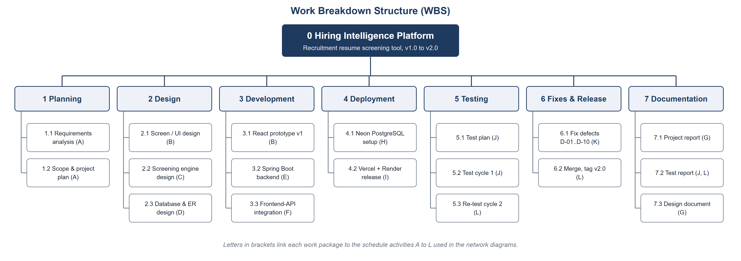
Figure 1. Work Breakdown Structure of the Hiring Intelligence Platform

3.3 Activity-on-Node (AON) precedence diagram
Each box is an activity with its duration. An arrow from X to Y means Y cannot start until X has finished (finish-to-start). A has three successors (B, C, D); E waits for both C and D; L waits for both K and G.
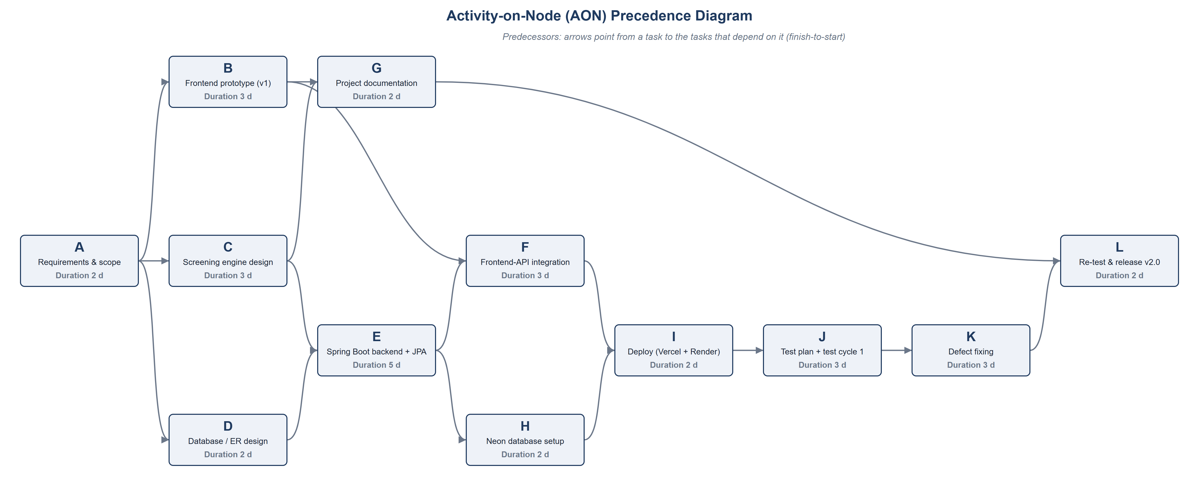
Figure 2. AON precedence diagram

3.4 Activity-on-Arrow (AOA) network diagram
In the arrow diagram the activities are arrows and the circles are events (points in time). Dashed arrows are dummy activities of zero length. They are needed where an activity depends on only some of the activities that finish at a node. For example G depends on B and C but not on D, so G starts at event 7, which is fed by dummies from events 3 and 4. Under each event number, the green figure is the earliest time the event can happen and the red figure is the latest time it can happen without delaying the project.
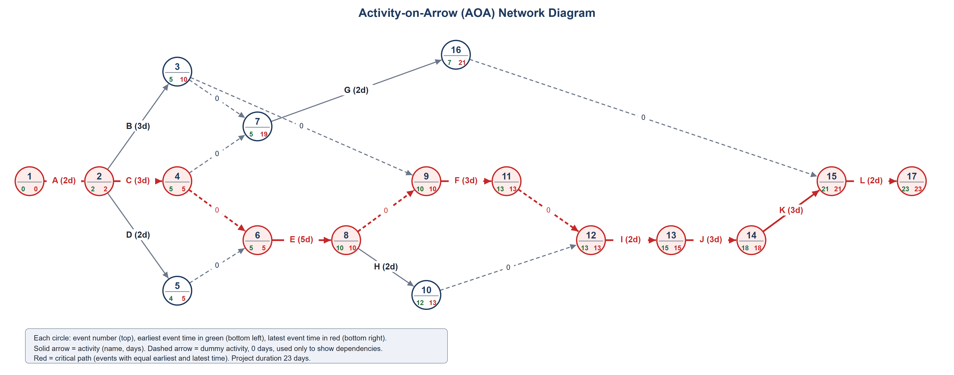
Figure 3. AOA network with earliest and latest event times; critical path in red

3.5 Critical Path Method (CPM) diagram
The critical path is the longest chain of dependent activities. Any delay on it delays the whole project. Here it is A, C, E, F, I, J, K, L, with a total of 23 days. Activities D and H have one day of slack, B has five, and G (documentation) has fourteen, so they can slip by that much without moving the release date.
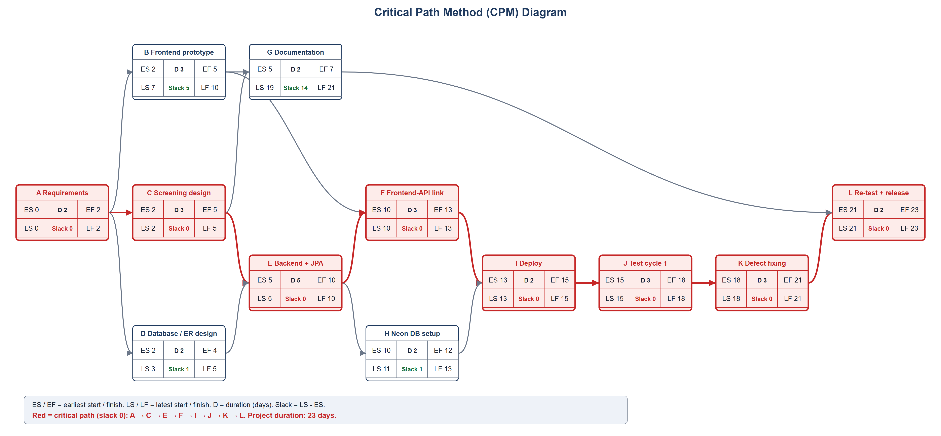
Figure 4. CPM diagram: earliest and latest times, slack and the critical path
Reading the result: the critical path runs through the screening engine design, the backend, the integration and the deployment and test steps. The backend (5 days) is the largest single activity on it, so a delay there is the biggest schedule risk.

3.6 PERT chart
PERT uses three estimates per activity: optimistic (O), most likely (M) and pessimistic (P). The expected time is te = (O + 4M + P) / 6 and the variance is ((P - O) / 6) squared. The most likely estimates are the durations used in the CPM.
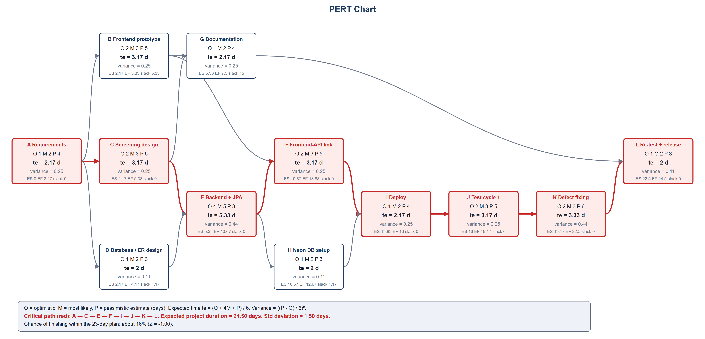
Figure 5. PERT chart with three-point estimates and the expected critical path

PERT estimates
ID | Activity | O | M | P | Expected te | Variance | ES | EF | Critical?
A | Requirements & scope | 1 | 2 | 4 | 2.17 | 0.25 | 0 | 2.17 | Yes
B | Frontend prototype (v1) | 2 | 3 | 5 | 3.17 | 0.25 | 2.17 | 5.33 | No
C | Screening engine design | 2 | 3 | 5 | 3.17 | 0.25 | 2.17 | 5.33 | Yes
D | Database / ER design | 1 | 2 | 3 | 2 | 0.11 | 2.17 | 4.17 | No
E | Spring Boot backend + JPA | 4 | 5 | 8 | 5.33 | 0.44 | 5.33 | 10.67 | Yes
F | Frontend-API integration | 2 | 3 | 5 | 3.17 | 0.25 | 10.67 | 13.83 | Yes
G | Project documentation | 1 | 2 | 4 | 2.17 | 0.25 | 5.33 | 7.5 | No
H | Neon database setup | 1 | 2 | 3 | 2 | 0.11 | 10.67 | 12.67 | No
I | Deploy (Vercel + Render) | 1 | 2 | 4 | 2.17 | 0.25 | 13.83 | 16 | Yes
J | Test plan + test cycle 1 | 2 | 3 | 5 | 3.17 | 0.25 | 16 | 19.17 | Yes
K | Defect fixing | 2 | 3 | 6 | 3.33 | 0.44 | 19.17 | 22.5 | Yes
L | Re-test & release v2.0 | 1 | 2 | 3 | 2 | 0.11 | 22.5 | 24.5 | Yes

Result | Value
Expected project duration (sum of te on the critical path) | 24.5 days
Variance of the critical path (sum of variances) | 2.25
Standard deviation | 1.5 days
Planned duration from CPM | 23 days
Z = (planned - expected) / standard deviation | -1
Probability of finishing within the planned 23 days | about 16%

What this tells the team: the plan is tight. Because the pessimistic estimates are longer than the optimistic ones, the expected finish is about a day and a half later than the 23-day plan, and the chance of hitting 23 days is only about 16%. A 27-day target (Z = 1.67, about 95%) would be safer.

4. Software Design Diagrams

4.1 Use case diagram
Two actors use the system. Both can log in, view the dashboard and analytics, work with reports and jobs, see the ranked shortlist and set a candidate's status. Only the administrator manages companies, ingests resumes, sees the whole candidate pool and resets the demo data. Two use cases are included in others: viewing a shortlist includes scoring and ranking, and ingesting resumes includes parsing and the ATS check.
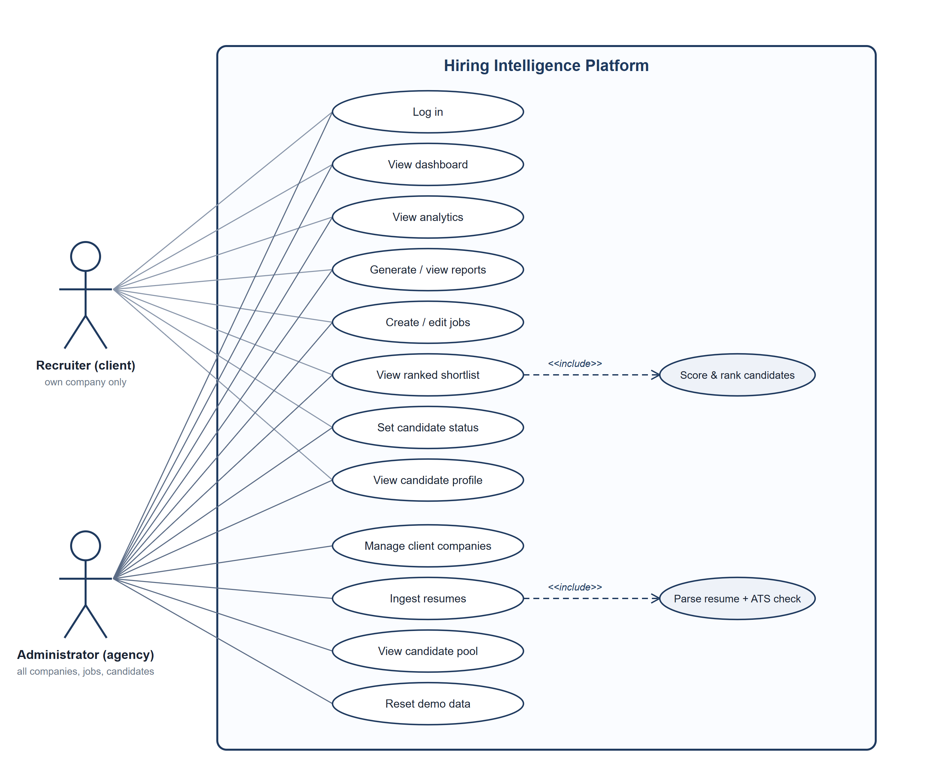
Figure 6. Use case diagram

Key use cases
Use case | Actor | Description
Log in | Both | The user sends email and password. The system checks the password hash, refuses after 5 failures within 15 minutes, and returns a signed token valid for 12 hours together with the role and company.
Ingest resumes | Administrator | The administrator uploads PDF, DOCX, TXT, MD, CSV or JSON files, or posts resume text as JSON. Each resume is parsed, given an ATS score and saved, then all open jobs are re-scored.
View ranked shortlist | Both | For one job, candidates are listed by match score, highest first, with matched and missing skills and a written explanation. A recruiter can only open jobs of their own company.
Set candidate status | Both | Move a candidate on a job between Review, Shortlisted and Rejected. A manual choice is locked so re-scoring does not undo it.
Create / edit job | Both | Title, description, required skills and an experience range. The minimum may not be above the maximum (a maximum of 0 means no upper limit). Saving re-scores all candidates.
Manage client companies | Administrator | List, view and add the companies the agency recruits for.
Reset demo data | Administrator | Wipe all tables and reload the sample dataset.

4.2 Class diagrams
The domain model has six entity classes and three enumerations. Relationships are stored as UUID foreign keys (companyId, jobId, candidateId) rather than as object references. This keeps the entities simple and lets the same code run on H2 and PostgreSQL. The Match class is the link between a Job and a Candidate and carries the score, the matched and missing skills and the status.
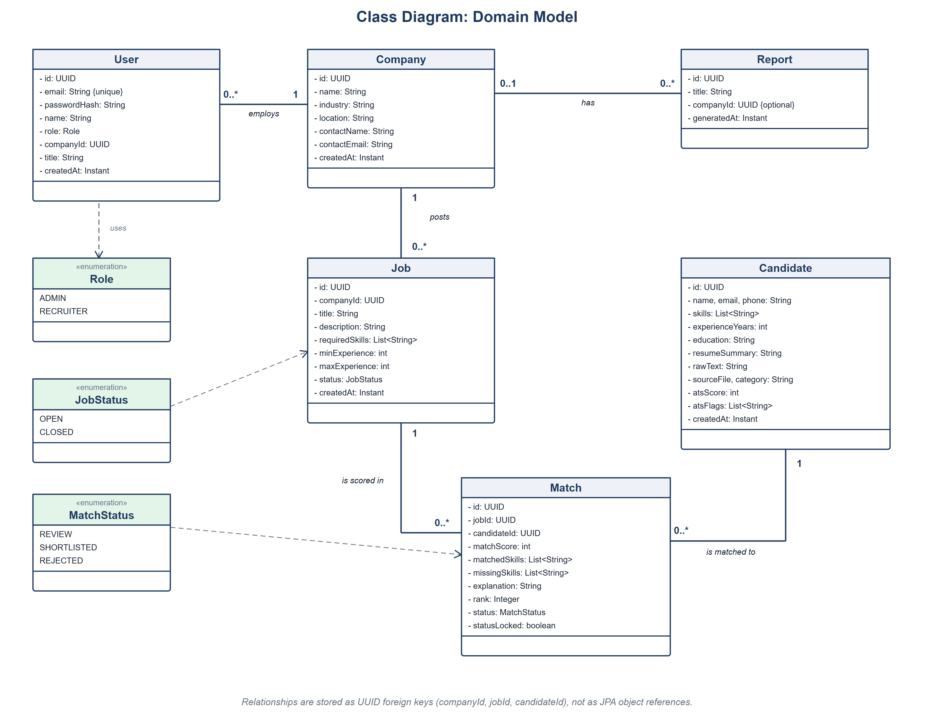
Figure 7. Class diagram: domain model

4.3 Class diagram: services and screening engine
Controllers call the services. IngestionService uses ResumeParser (which uses SkillDictionary) and AtsChecker, and asks ScreeningService to re-score jobs with Matcher. AuthService issues tokens through JwtService and consults LoginRateLimiter. ReadCache holds recent dashboard, analytics and list results for five minutes and is cleared whenever a controller writes data.
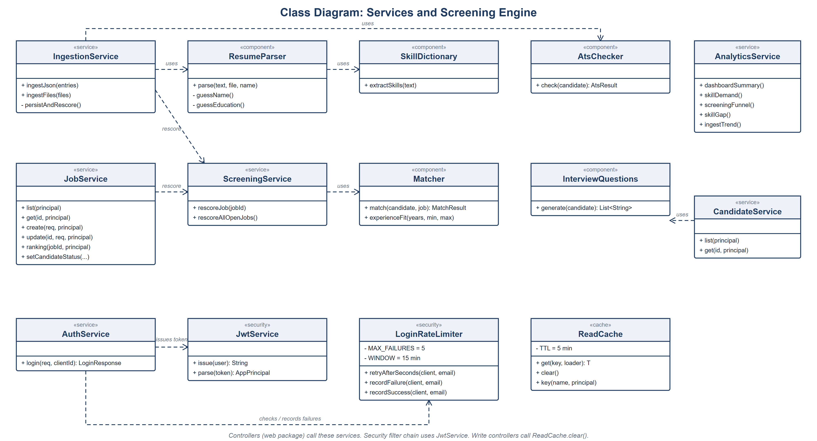
Figure 8. Class diagram: services, screening engine, security and cache

4.4 Entity-Relationship (ER) diagram
The database has six tables. A company has many users (recruiters), jobs and reports. A job and a candidate are linked through the matches table, which has a unique constraint on the pair (job_id, candidate_id), so a candidate is scored at most once per job. List-valued fields such as skills are stored as text through a JPA AttributeConverter.
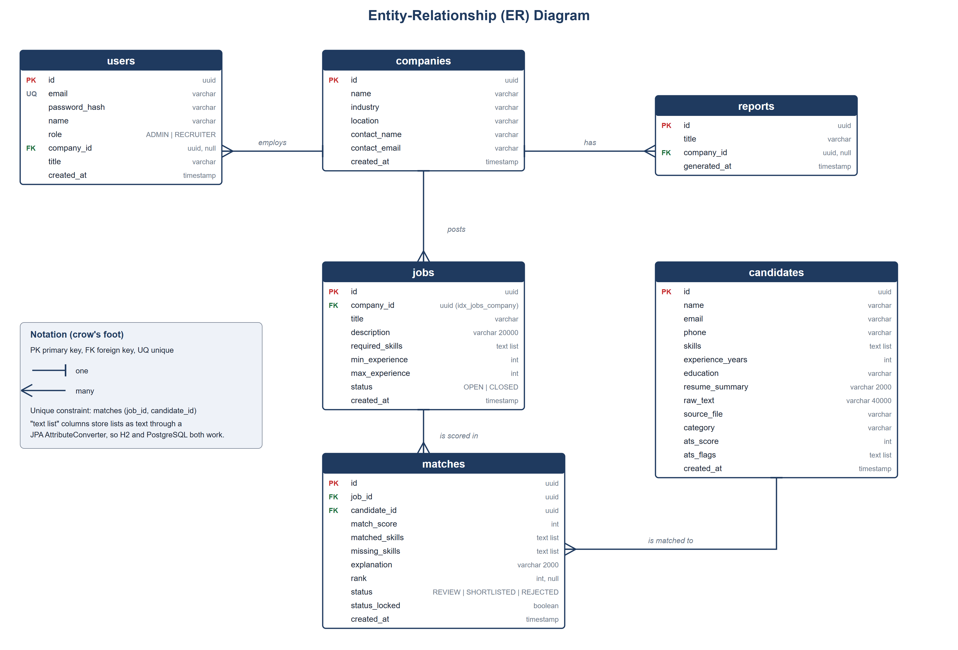
Figure 9. Entity-relationship diagram (crow's foot notation)

5. Interface, Security and Error Design

5.1 REST API
Method | Path | Who | Purpose
POST | /api/auth/login | Public | Log in, returns token, role, company
GET | /api/dashboard/summary | Both | Overview tiles and recent jobs
GET / POST | /api/companies | Admin | List or add companies
GET | /api/companies/{id} | Admin | One company
GET / POST | /api/jobs | Both | List jobs (own company for recruiters) or create one
GET / PUT | /api/jobs/{id} | Both | View or edit a job
GET | /api/jobs/{id}/candidates | Both | Ranked shortlist for the job
PATCH | /api/jobs/{id}/candidates/{candidateId} | Both | Set candidate status
GET | /api/candidates | Admin | Whole candidate pool
GET | /api/candidates/{id} | Both | Candidate profile and interview questions
POST | /api/resumes | Admin | Ingest resumes (JSON body or multipart files)
GET | /api/analytics/skills | funnel | skill-gap | trend | Both | Chart data
GET / POST | /api/reports, /api/reports/generate | Both | List or generate reports
POST | /api/admin/reset | Admin | Reload demo data

5.2 Screens
Screen | Who | Content
Login | Both | Email and password; demo accounts shown only on the demo deployment
Overview | Both | Summary tiles and recent jobs
Client Companies, Company detail | Admin | Companies with job and shortlist counts
Resume Ingestion | Admin | Upload files or paste JSON, reset demo data
Candidate Pool, Candidate profile | Admin (pool), both (profile) | Skills, ATS score and flags, per-job scores, interview questions
Jobs, Job and shortlist, Job form | Both | Job list, ranked shortlist with status buttons, create and edit
Analytics | Both | Skill demand, screening funnel, skill gap, resumes per month
Reports | Both | Generate and list reports

5.3 Security design
- Passwords are stored as BCrypt hashes. Login returns a signed JWT (HS256, 12 hours) that carries the user id, role and company.
- Every /api path except login needs a valid token. Admin-only endpoints are protected with method-level role checks. Recruiters are limited to their own company's data in the service layer.
- Five failed logins for the same client and email within 15 minutes are blocked with HTTP 429 and a Retry-After header.
- The backend refuses to start if the JWT secret is shorter than 32 bytes.
- Uploads are limited to PDF, DOCX, TXT, MD, CSV and JSON, and empty files are refused.
- CORS allows only the configured front-end origins.

5.4 Error handling
Status | When | Body
400 | Validation fails, minimum above maximum experience, bad file type, empty batch | JSON with timestamp, status, error and a readable message
401 | No token, bad token, wrong password | Same JSON shape
403 | Token is valid but the role or company does not allow the action | Same JSON shape
404 | Unknown id | Same JSON shape
429 | Too many failed logins | Same shape plus a Retry-After header

6. Design Decisions and Known Limits

6.1 Decisions
- Plain Java scoring instead of a machine-learning model: the rules are easy to explain to a client and to test.
- UUID foreign keys instead of JPA relations: simpler entities and identical behaviour on H2 and PostgreSQL.
- Stateless JWT instead of server sessions: the backend can be restarted or scaled without losing logins.
- A small in-memory cache cleared on every write: faster dashboards without adding a cache server.
- Neon PostgreSQL: a managed database with no server to run.

6.2 Known limits
- PDF and DOCX files are accepted, but their text is not yet extracted, so only text-like files are fully parsed (defect D-11 in the test report).
- The read cache is per server instance; running several backend instances would need a shared cache.
- The login throttle is kept in memory, so it resets when the backend restarts.
- The Render backend is in a different region from the Neon database, which adds delay on the first request after a change.
- Schedule durations in Section 3 are estimates, not recorded time.

