SOFTWARE PROJECT MANAGEMENT
Hiring Intelligence Platform
Software Test Plan and Test Report
Version 2.0 (React frontend, Spring Boot backend, Neon PostgreSQL): test cycle 1 and re-test cycle 2
Dates of testing: 19-20 September 2026
Item | Detail
Project | Hiring Intelligence: a resume screening and candidate ranking tool for a recruitment agency
Repository | github.com/ishwariksh06/Hiring_intelligence
Live frontend | hiring-intelligence-eight.vercel.app (Vercel)
Live backend | hiring-intelligence-api.onrender.com (Render) with Neon PostgreSQL
Prepared by | Ishwari Kshirsagar (project owner); test automation and report drafted with Claude
Table of Contents

1. Introduction

1.1 Purpose
This document describes how the Hiring Intelligence Platform was tested and what the tests found. It is both the test plan (what will be tested and how) and the test report (what was run and the results). Each result below is marked as measured in this test cycle, or as planned but not yet executed. Nothing marked "planned" has been presented as a result.

1.2 The system under test
Hiring Intelligence helps a recruitment agency screen resumes for its client companies. An administrator adds companies and jobs and uploads resumes. The backend parses each resume, extracts skills and experience, runs an ATS (applicant tracking system) readiness check, and scores every candidate against every job. Recruiters from a client company log in and see only their own company jobs and the ranked shortlist.
Layer | Technology
Frontend | React 19, Vite, Tailwind CSS, Axios, Recharts; hosted on Vercel
Backend | Java 21, Spring Boot 3, Spring Security, Spring Data JPA, JWT (jjwt); hosted on Render (Docker)
Database | Neon serverless PostgreSQL in production; embedded H2 for automated tests
Screening engine | ResumeParser, SkillDictionary, AtsChecker, Matcher, InterviewQuestions (plain Java classes)

1.3 Scope

In scope
- Authentication, role-based access control and company data isolation
- Company, job, resume-ingestion, candidate and report APIs
- Screening logic: parsing, ATS scoring, match scoring, ranking
- Dashboard and analytics screens
- Deployed system: Vercel frontend, Render backend, Neon database
- Security, performance and usability of the above

Out of scope
- Neon, Vercel and Render platform internals
- Parsing of scanned image-only PDFs (no OCR feature exists)
- Load beyond the small sample described in Section 9.1

1.4 Definitions
Term | Meaning
Black-box testing | Testing through inputs and outputs only, with no use of the source code
White-box testing | Testing designed from the source code: branches, paths and boundaries
Alpha testing | Testing by the project team in a controlled setting before release
Beta testing | Testing by real users outside the team, in their own setting
ATS | Applicant tracking system; here, a check of whether a resume has the fields such systems need
RBAC | Role-based access control

2. Test Strategy

2.1 Approach
Testing follows the V-model. Each development level has a matching test level, and the tests get broader as we move from single classes to the whole deployed system.
Level | What is tested | How
Unit (white-box) | Matcher, AtsChecker, ResumeParser, JwtService | JUnit 5 and AssertJ; measured with JaCoCo
Integration (black-box) | HTTP API, security filter chain, JPA, seeding | Spring Boot test with MockMvc on in-memory H2
System | Deployed frontend + backend + Neon | Live API calls and a browser run of login and dashboard
Acceptance (alpha) | Realistic recruiter workflows | Checklist run by the project owner (Section 8)
Acceptance (beta) | Real external users | Plan and feedback form prepared; not yet executed (Section 8)

2.2 Test environments
Environment | Configuration
Automated | Windows 11, Java 21.0.12, Maven wrapper, Spring Boot test context, H2 in-memory database seeded with demo data
Live system | Vercel (frontend), Render free plan (backend), Neon PostgreSQL (Singapore region), demo data seeded
Browser | Chromium-based browser embedded in the Claude desktop app; Node v25.8.2 for the frontend build

2.3 Entry and exit criteria
Entry criteria | Exit criteria
Code builds; backend starts against the database; seed data present | All automated tests pass
Test accounts (admin and recruiter) available | No open Critical or High defects
Test cases written before execution | Every functional requirement traced to at least one test
 | Line coverage at least 80%; branch coverage at least 70%
 | Typical API response under 1 second

2.3.1 Test types covered
Test type | Where in this document | Status
Black-box functional | Section 4 | Executed
White-box (statement, branch, path) | Section 5 | Executed
Unit | Section 5 | Executed
Integration and API | Section 4 | Executed
System (end to end) | Section 7 | Executed
Regression | Section 7.3 | Executed
Smoke and sanity | Section 7.2 | Executed
Security | Section 9.2 | Executed
Performance and load | Section 9.1 | Executed (small scale)
Database and data integrity | Section 9.4 | Executed
Negative and error-guessing probes | Section 10.1 | Executed (4 of 6 failed)
Static analysis (lint) | Section 9.5 | Executed
Alpha | Section 8.1 | Executed
Beta | Section 8.2 | Planned, not executed
Usability | Section 9.3 | Partly executed
Compatibility (browsers, devices) | Section 9.3 | Partly executed (1 browser, 1 phone size)
Accessibility | Section 9.3 | Planned, not executed

3. Risk Analysis
Testing effort was directed to the areas where a fault would hurt most.
Risk | Likeli-hood | Impact | Test response
A recruiter sees another company's candidates | Medium | High | RBAC and isolation tests TC_SEC_03-08
Forged or expired tokens accepted | Low | High | JWT tamper, expiry and wrong-key tests WB_22-25
Wrong candidate ranking | Medium | High | Boundary tests on scoring WB_01-12 and ordering TC_JOB_06
Resume parsing misses or invents data | High | Medium | Parser tests WB_17-19; alpha checks
Slow responses on the live system | High | Medium | Timed requests, Section 9.1
Bad input crashes the API | Medium | Medium | Validation and malformed input tests

4. Black-Box Testing
Black-box tests treat the system as a closed box. The tester knows what the system should do from the requirements, sends inputs, and checks outputs. All 34 cases below are automated in ApiBlackBoxTest.java and run against the full Spring application (real security filters, real database layer, seeded data).

4.1 Techniques used
- Equivalence partitioning: inputs were split into valid and invalid classes, and one representative from each was tested. Example: login with a valid user, a wrong password, an unknown user and blank fields.
- Boundary value analysis: values at and around limits were tested. Example: experience of -1 (invalid) against 0 and 2 (valid); resume length 199 against 200 characters (white-box section).
- Decision table testing: the access rules (role by endpoint) are tested as a table in Section 4.3.
- Error guessing: SQL injection strings, malformed JSON, malformed UUIDs, wrong content type, garbage tokens.
- State-based testing: a logged-out user (no token) against a logged-in user, and an expired token against a fresh one.

4.2 Equivalence classes and boundaries
Input | Valid class | Invalid classes | Test IDs
Login email + password | Existing user, correct password | Wrong password; unknown user; blank; SQL injection; malformed JSON | TC_AUTH_01-07
Job title | Non-blank text | Blank | TC_JOB_01-02
Job min/max experience | 0 or higher | Negative (-1) | TC_JOB_01, 03
Job id in URL | Existing UUID | Non-existent UUID; not a UUID | TC_JOB_04-05
Company name | Non-blank text | Blank | TC_COMP_01-02
Resume batch | One or more entries / file | Empty batch; wrong content type | TC_ING_01-04
Bearer token | Valid, unexpired | Missing; garbage | TC_SEC_01-02

4.3 Decision table: who can call what
Endpoint | Admin | Recruiter | No token
GET /api/companies | 200 | 403 | 401
GET /api/candidates | 200 | 403 | 401
POST /api/resumes | Allowed | 403 | 401
POST /api/admin/reset | Allowed | 403 | 401
GET /api/jobs | All jobs | Own company only | 401

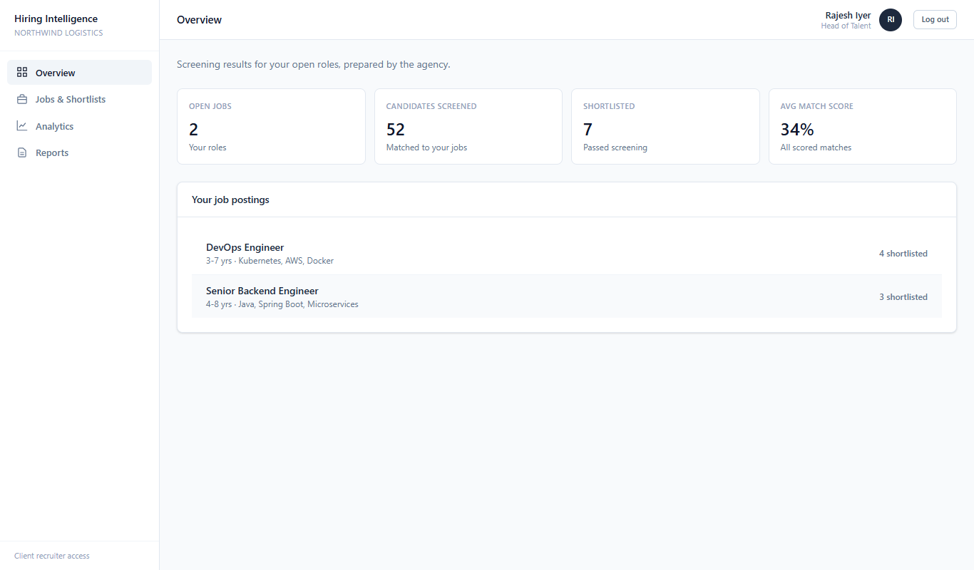
Figure 1. Recruiter (Northwind Logistics) sees only 2 own jobs and a reduced menu
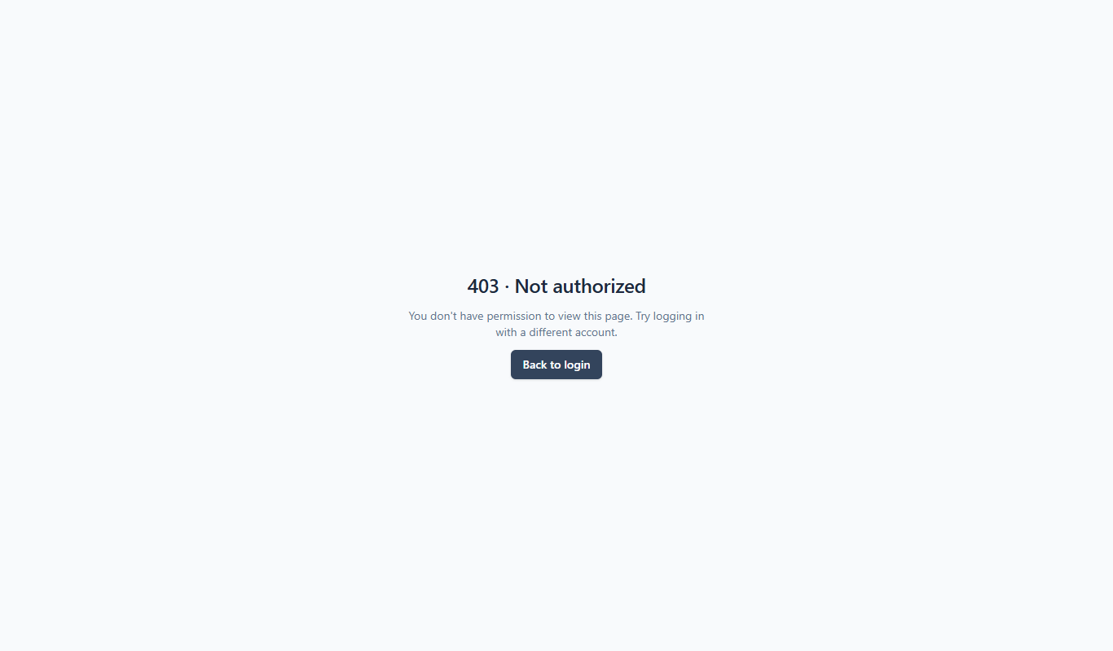
Figure 2. Recruiter opening /companies is blocked with 403 Not authorized

4.4 Test cases and results
ID | Description | Input | Expected result | Result
TC_AUTH_01 | Login with valid admin credentials | ishwari@... / password123 | 200, role ADMIN, JWT returned | Pass
TC_AUTH_02 | Login with valid recruiter credentials | rajesh.iyer@... / password123 | 200, role RECRUITER | Pass
TC_AUTH_03 | Wrong password | valid email, "wrong" | Rejected, no token | Pass
TC_AUTH_04 | Unknown user | nobody@x.com | Rejected, no token | Pass
TC_AUTH_05 | Blank email and password | "" / "" | 4xx (validation) | Pass
TC_AUTH_06 | Malformed JSON body | {bad | 4xx, no stack trace | Pass
TC_AUTH_07 | SQL injection in email/password | ' OR '1'='1' -- | Rejected, no token | Pass
TC_SEC_01 | Protected endpoint without token | GET /api/jobs | 401 | Pass
TC_SEC_02 | Garbage bearer token | Bearer abc.def.ghi | 401 | Pass
TC_SEC_03 | Recruiter lists companies | GET /api/companies | 403 | Pass
TC_SEC_04 | Recruiter lists candidate pool | GET /api/candidates | 403 | Pass
TC_SEC_05 | Recruiter ingests resumes | POST /api/resumes | 403 | Pass
TC_SEC_06 | Recruiter calls admin reset | POST /api/admin/reset | 403 | Pass
TC_SEC_07 | Admin lists companies | GET /api/companies | 200 | Pass
TC_SEC_08 | Recruiter sees only own company jobs | GET /api/jobs (recruiter vs admin) | Single companyId; fewer jobs than admin | Pass
TC_SEC_09 | CORS preflight, allowed origin | Origin localhost:5173 | 200 | Pass
TC_SEC_10 | CORS preflight, unknown origin | Origin evil.example | 403 | Pass
TC_JOB_01 | Admin creates a valid job | title, skills, 2-5 yrs | 2xx, title echoed | Pass
TC_JOB_02 | Job with blank title | title "" | 4xx (validation) | Pass
TC_JOB_03 | Job with negative experience | minExperience -1 | 4xx (validation) | Pass
TC_JOB_04 | Fetch non-existent job | all-zero UUID | 404 | Pass
TC_JOB_05 | Fetch job with malformed id | not-a-uuid | 4xx | Pass
TC_JOB_06 | Ranked candidates ordering | GET /api/jobs/{id}/candidates | Sorted by matchScore, descending | Pass
TC_COMP_01 | Create company | name "Acme Test Co" | 2xx, name echoed | Pass
TC_COMP_02 | Create company with blank name | name "" | 4xx (validation) | Pass
TC_ING_01 | Ingest resume as JSON | rawText with skills | 2xx | Pass
TC_ING_02 | Ingest resume as uploaded text file | multipart resume.txt | 2xx | Pass
TC_ING_03 | Ingest an empty batch | [] | 400 "No resume entries supplied" | Pass (after test fix, D-06)
TC_ING_04 | Ingest with wrong content type | text/plain | 4xx | Pass
TC_DASH_01 | Dashboard summary loads | GET /api/dashboard/summary | 200 | Pass
TC_ANL_01 | Skill analytics loads | GET /api/analytics/skills | 200 | Pass
TC_ANL_02 | Funnel analytics loads | GET /api/analytics/funnel | 200 | Pass
TC_ANL_03 | Trend analytics loads | GET /api/analytics/trend | 200 | Pass
TC_RPT_01 | Generate and list a report | POST then GET /api/reports | 2xx / 200 | Pass

Result: 34 of 34 black-box cases passed. One case (TC_ING_03) first failed because the test expected an empty batch to succeed; the API returns 400. That is the correct behaviour, so the test was corrected (defect D-06, closed as designed).

5. White-Box Testing
White-box tests are designed by reading the code. The aim is to run every statement, every decision outcome (branch) and the boundary of every condition. The tests below are in WhiteBoxBranchTest.java, JwtServiceTest.java and the earlier ScreeningLogicTest.java.

5.1 Control-flow analysis of Matcher.experienceFit
This method decides how well a candidate's years of experience fit a job window. It has four decisions: the ternary that replaces a max of 0, the "inside window" test, its second half (years <= hi), and the "below window" test.
Measure | Value
Decision points | 4 (max != 0 ? ; years >= lo ; years <= hi ; years < lo)
Cyclomatic complexity V(G) | 5 (decisions + 1)
Independent paths | 5: max is 0; years inside window; years below window; years above window; clamped to 0 in either direction
Tests covering these paths | WB_01-08 (lower and upper boundary, one below, one above, zero, far above, max = 0, negative minimum)

5.2 Coverage techniques applied
- Statement coverage: every line of Matcher and AtsChecker is executed (100%).
- Branch (decision) coverage: both outcomes of every if and ternary in Matcher and AtsChecker are exercised (28/28 and 20/20).
- Condition coverage: each of the six ATS checks is failed on its own so its effect on the score is isolated (WB_13).
- Boundary testing: resume length 199 and 200, ATS score 59-60 threshold, experience at each end of the window.
- Exception paths: JwtService is driven with tampered, expired, wrong-key and malformed tokens.

5.3 Coverage results (JaCoCo 0.8.12)
Class | Lines covered | Branches covered
AtsChecker | 19/19 (100%) | 20/20 (100%)
Matcher | 39/39 (100%) | 28/28 (100%)
JwtAuthFilter | 17/17 (100%) | 4/6 (67%)
ScreeningService | 47/49 (96%) | 23/26 (88%)
ResumeParser | 45/46 (98%) | 24/30 (80%)
SkillDictionary | 89/90 (99%) | 11/12 (92%)
JwtService | 28/33 (85%) | 5/8 (63%)
InterviewQuestions | 19/29 (66%) | 0/12 (0%)
Whole backend | 978/1171 (83.5%) | 252/386 (65.3%)

Assessment: line coverage (83.5%) meets the 80% target. Branch coverage (65.3%) is below the 70% target. The gap is mostly InterviewQuestions (0 of 12 branches) and JwtService and JwtAuthFilter error paths. This is recorded as defect D-04 with a recommendation to add tests.
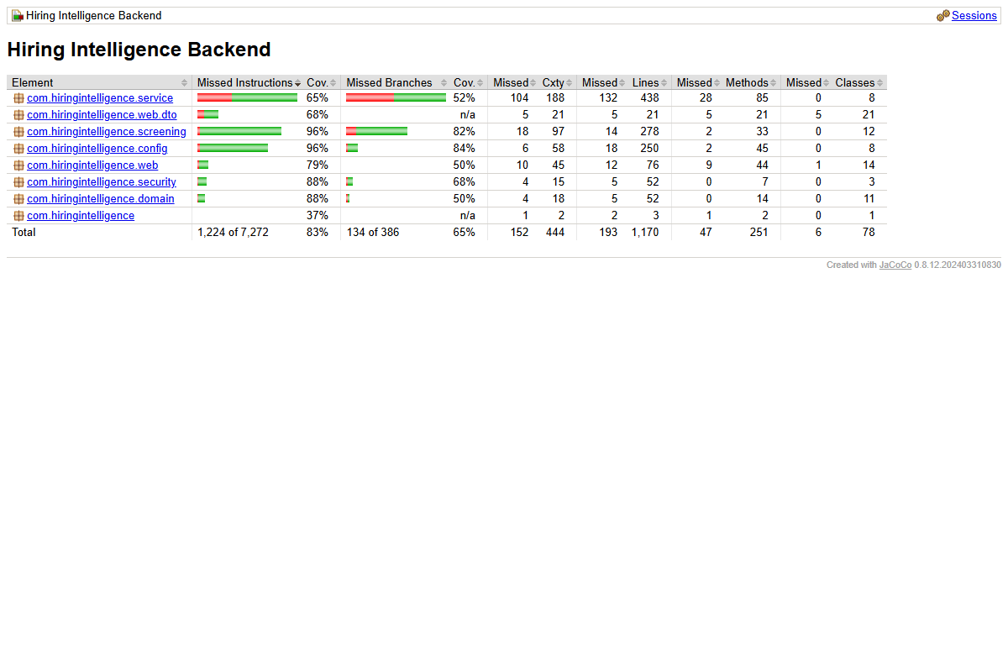
Figure 3. JaCoCo coverage report, whole backend
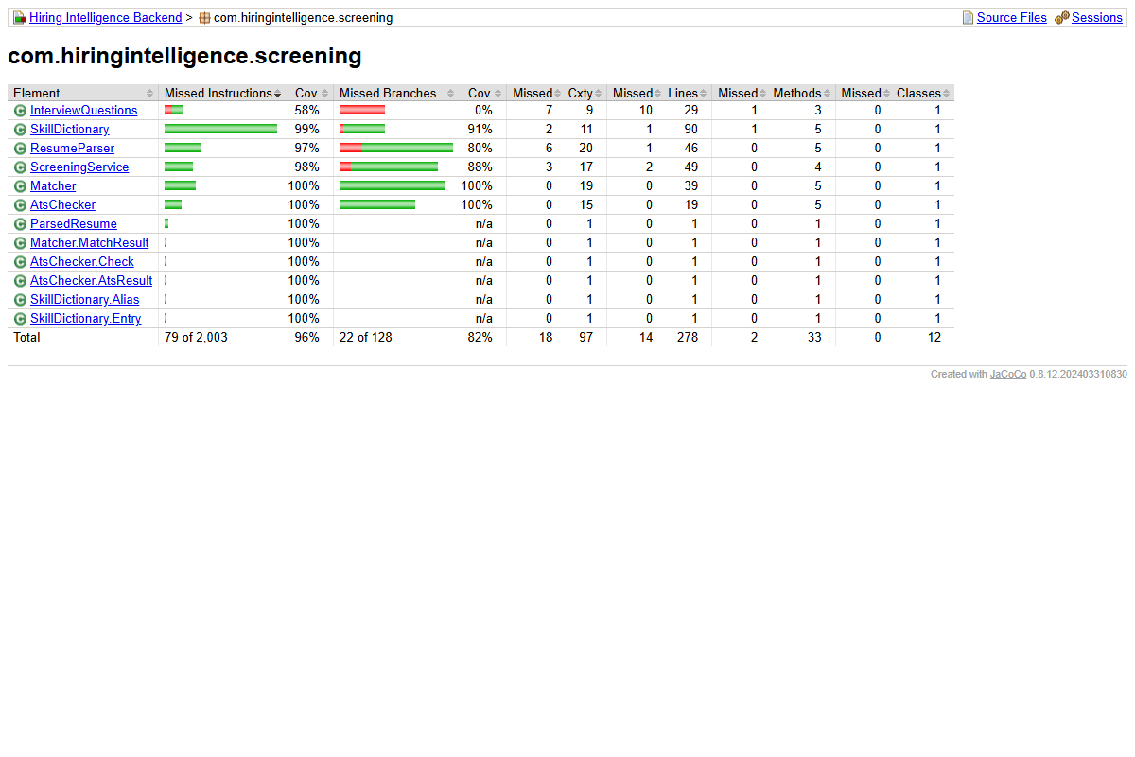
Figure 4. JaCoCo report for the screening package: Matcher and AtsChecker at 100% of lines and branches, InterviewQuestions at 0% of branches

5.4 Test cases and results
ID | Unit | Condition | Expected | Result
WB_01 | Matcher.experienceFit | Years equals minimum (4 in 4-8) | 1.0 | Pass
WB_02 | Matcher.experienceFit | Years equals maximum (8 in 4-8) | 1.0 | Pass
WB_03 | Matcher.experienceFit | One year below window (3 in 4-8) | 0.75 | Pass
WB_04 | Matcher.experienceFit | Zero years (0 in 4-8) | 0.0 (clamped) | Pass
WB_05 | Matcher.experienceFit | One year above window (9 in 4-8) | 0.875 | Pass
WB_06 | Matcher.experienceFit | Far above window (40 in 4-8) | 0.0 (clamped) | Pass
WB_07 | Matcher.experienceFit | Max = 0, so ceiling is min + 3 | 1.0 (6 in 3-6) | Pass
WB_08 | Matcher.experienceFit | Negative minimum treated as 0 | 1.0 | Pass
WB_09 | Matcher.match | Null skill lists on both sides | Score 30 (experience only) | Pass
WB_10 | Matcher.match | Case-insensitive skill comparison | Score 100 | Pass
WB_11 | Matcher.match | No skill overlap, under-experienced | Explanation: none found, below minimum | Pass
WB_12 | Matcher.match | Over-experienced candidate | Explanation mentions ceiling | Pass
WB_13 | AtsChecker | Each of six checks failed one at a time (8 tests) | Score drops by exactly the check weight | Pass
WB_14 | AtsChecker | Text length 199 vs 200 characters | 90 vs 100 | Pass
WB_15 | AtsChecker | Pass threshold: 60 passes, 50 fails | atsPassed true / false | Pass
WB_16 | AtsChecker | Empty candidate | Score 0, six flags | Pass
WB_17 | ResumeParser | Well-formed resume | Email, phone, skills, 5 yrs, name extracted | Pass
WB_18 | ResumeParser | Empty text | No exception, no skills | Pass
WB_19 | ResumeParser | Invalid email "not-an-email@" | Not accepted as email | Pass
WB_20 | JwtService | Issue then parse | userId, role, companyId preserved | Pass
WB_21 | JwtService | Admin token has no company | companyId null | Pass
WB_22 | JwtService | Tampered signature | JwtException | Pass
WB_23 | JwtService | Expired token | JwtException | Pass
WB_24 | JwtService | Token signed with a different key | JwtException | Pass
WB_25 | JwtService | Malformed token string | Exception | Pass
WB_26 | Screening (existing) | Skill extraction, fit decay, match score 83, ATS 100 (4 tests) | As asserted | Pass

Result: 35 unit tests (WB_01-26 group into 35 test methods) all passed.

6. Integration Testing
Integration testing checks that the parts work together. ApiBlackBoxTest starts the whole Spring context, so each request passes through the CORS filter, JWT filter, method security (@PreAuthorize), controller, validation, service, JPA repository and the H2 database. The seeder also runs at startup, so the tests use a realistic set of 3 companies, 8 jobs and 52 candidates.
Integration point | Tests that exercise it
Security filter chain + JWT service | TC_SEC_01-02, TC_AUTH_01-02
Method security + role in token | TC_SEC_03-07
Controller validation + exception handler | TC_AUTH_05-06, TC_JOB_02-05, TC_COMP_02, TC_ING_04
Ingestion + ResumeParser + Matcher + repositories | TC_ING_01-02, TC_JOB_06
Company scoping in JobService | TC_SEC_08
Neon PostgreSQL through Hibernate (live) | Section 7 and 9.4

7. System, Smoke and Regression Testing

7.1 System test on the live deployment
# | Step | Observed result | Result
1 | Open hiring-intelligence-eight.vercel.app/login | Login page loads; demo accounts listed | Pass
2 | Sign in as administrator | Redirected to /dashboard within the wait period | Pass
3 | Read dashboard tiles | 3 client companies, 8 open jobs, 52 candidates, 42 shortlisted, average match 32% | Pass
4 | Read recent job postings list | Machine Learning Engineer, Data Engineer, Android Engineer and others shown with skills and shortlisted counts | Pass
5 | Sidebar shows all admin pages | Overview, Client Companies, Resume Ingestion, Candidate Pool, All Jobs, Analytics | Pass
6 | Live API: 30 parallel GET /api/jobs | All 30 returned 200 in about 10 seconds total | Pass
7 | Wrong password on the login form | Red message "Invalid email or password", stays on login | Pass
8 | Sign in as recruiter; open an admin-only page | Own dashboard (2 jobs); /companies shows 403 Not authorized | Pass
9 | Open every admin screen in a browser (Appendix C) | All 10 screens render with data | Pass

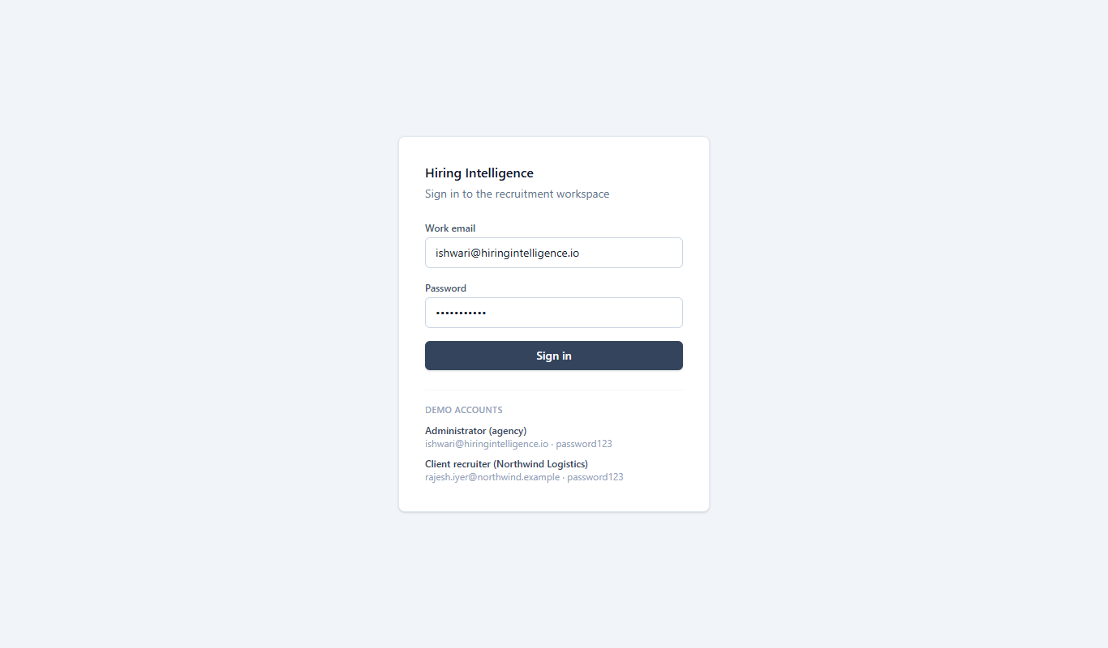
Figure 5. Login page of the live system
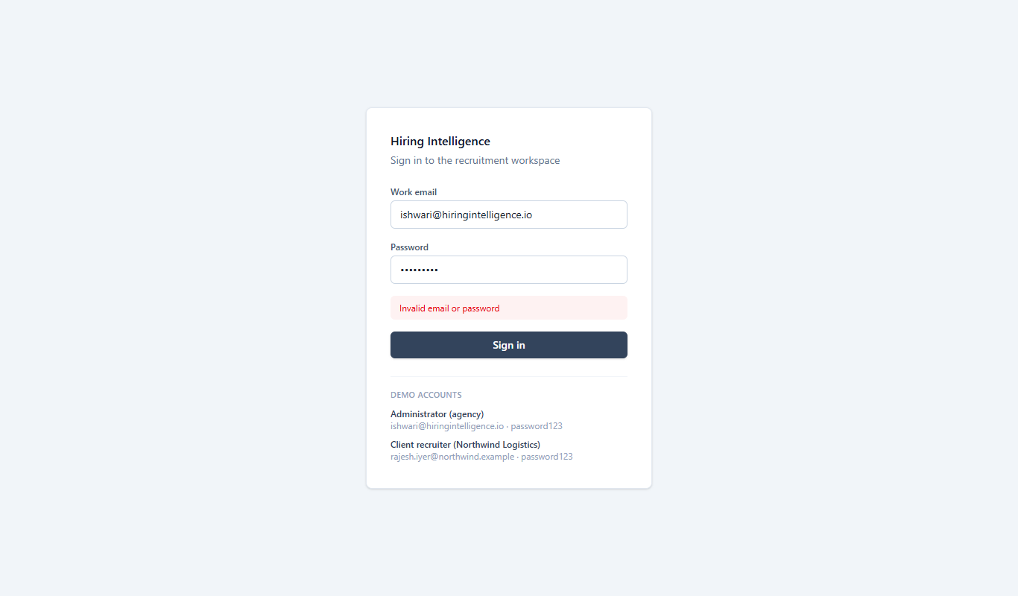
Figure 6. Wrong password: error message shown, user stays on the login page
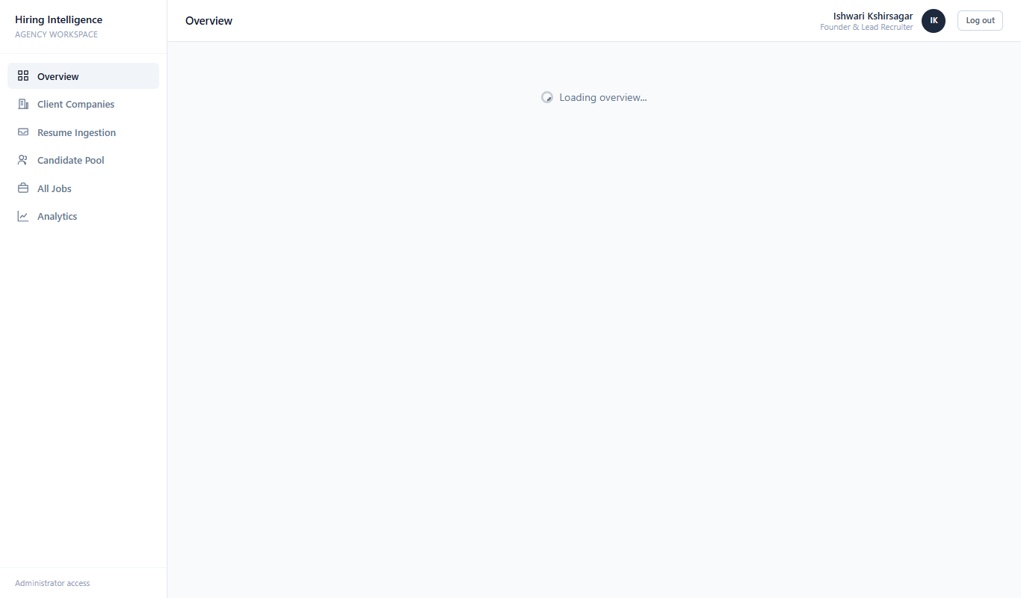
Figure 7. Administrator dashboard after login (live, Neon data)
Screenshots of all other screens are in Appendix C. They were taken from the live site with browser automation (Microsoft Edge).

7.2 Smoke and sanity
Smoke test after each deployment: the frontend returns 200 for /login, the backend answers 401 on a protected endpoint without a token, admin login returns 200 with a token, and the dashboard summary returns data. All four passed on the live system after the CORS fix. A sanity check after that fix confirmed that the Vercel origin now receives an Access-Control-Allow-Origin header.

7.3 Regression
The regression suite of 69 automated tests was run again after the last code change. Result: 69 run, 0 failed, 0 errors, 0 skipped. (The 6 probe tests in Section 10.1 are kept separate and disabled.) The suite is quick to run (about 20 seconds), so it can be run after every change. Adding it to a CI workflow on GitHub is recommended.
Test class | Tests | Failures | Type
ScreeningLogicTest | 4 | 0 | Unit, white-box
WhiteBoxBranchTest | 25 | 0 | Unit, white-box
JwtServiceTest | 6 | 0 | Unit, white-box
ApiBlackBoxTest | 34 | 0 | Integration, black-box
Total | 69 | 0
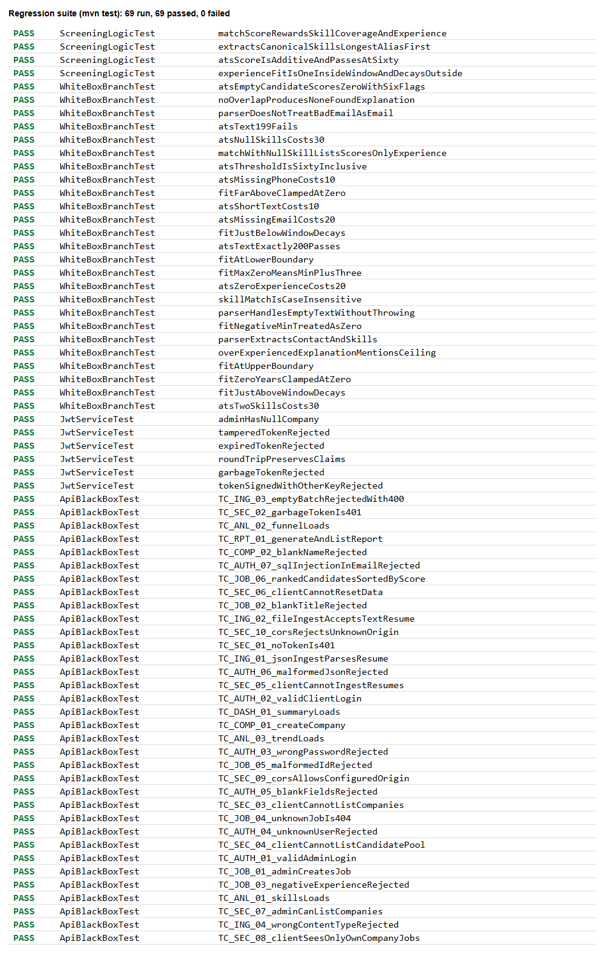
Figure 8. Result of every test in the regression suite (from the Maven surefire reports)

8. Acceptance Testing: Alpha and Beta

8.1 Alpha testing (executed)
Alpha testing is done by people inside the project, on a near-final build, to find problems before real users see it. It was carried out on the deployed system with the demo data, using the two demo accounts. The alpha tester acted as an administrator and as a client recruiter. Items marked "Not yet run" were not performed in this cycle.
# | Scenario | Expected | Status
A1 | Admin logs in and sees the agency-wide overview | Dashboard with 5 tiles and recent jobs | Executed: Pass
A2 | Wrong password shows an error, not a crash | Error message; stays on login | Executed: Pass (API level, TC_AUTH_03)
A3 | Recruiter cannot open admin-only pages | 403 from API | Executed: Pass (API level, TC_SEC_03-06)
A4 | Recruiter sees only their company jobs | Single company | Executed: Pass (API level, TC_SEC_08)
A5 | Admin adds a job and it appears in the list | Job created and listed | Executed: Pass (API level, TC_JOB_01)
A6 | Admin uploads a resume and the candidate is scored | Parsed fields and scores appear | Executed: Pass (API level, TC_ING_01-02)
A7 | Ranked shortlist for a job is in score order | Highest score first | Executed: Pass (TC_JOB_06)
A8 | Admin generates a report | Report listed | Executed: Pass (TC_RPT_01)
A9 | Click through Candidate Pool, Companies, Analytics, Jobs, Reports screens in the browser | Pages render with data | Executed: Pass (Appendix C)
A10 | Upload a real PDF and a real DOCX resume in the browser | Fields extracted | Not yet run
A11 | Use the app on a phone-size screen (390 px wide) | Layout usable | Executed: Fail (D-10)

8.2 Beta testing (planned, not executed)
Beta testing means real users outside the team try the software in their own setting and report what they find. That has not happened yet: no external user has used this system, so there are no beta results. The plan below is ready to run.
Item | Plan
Participants | 5 to 8 people: 2 or 3 working recruiters or HR students, 2 or 3 classmates acting as client recruiters, 1 or 2 non-technical users
Duration | 1 week, using the live site (hiring-intelligence-eight.vercel.app)
Tasks | Log in; add a job; upload 3 of their own sample resumes (personal data removed); read the ranked shortlist; generate a report
Data rule | Testers must not upload real resumes with personal data unless the candidate has agreed
Feedback method | The form below, plus a 10-minute call with each tester
Exit rule | Fix all issues reported by 2 or more testers; average ease-of-use score of at least 4 out of 5

Beta feedback form
Question | Answer
Name / role (optional)
Device and browser used
Could you log in and find your way around without help? (1-5)
Were the match scores and explanations easy to understand? (1-5)
Did the resume upload extract the right name, skills and years? (Yes / Partly / No)
Was any page slow? Which one?
What did you find confusing?
Any error message or wrong result? Steps to repeat it
What one feature would you add?

9. Non-Functional Testing

9.1 Performance and load
Method: 10 sequential authenticated requests per endpoint against the live Render backend, from a laptop in India, timed with curl. Then 30 requests in parallel to /api/jobs. This is a small, single-location sample and shows the order of magnitude, not a full load test.
Endpoint | Average (ms) | Slowest (ms)
GET /api/dashboard/summary | 3441 | 6892
GET /api/jobs | 3365 | 3671
GET /api/companies | 3020 | 3567
GET /api/candidates | 2097 | 3272
GET /api/analytics/funnel | 2133 | 2844
GET /api/analytics/skills | 1947 | 2105
GET /api/analytics/trend | 1974 | 2389
GET /api/reports | 1296 | 2161

- Parallel test: 30 concurrent requests, all returned 200; the whole batch finished in about 9.9 seconds.
- Target from the exit criteria was under 1 second. Every endpoint measured above that, so this target was not met (defect D-01).
- The Render free plan sleeps when idle, so the first request after a quiet period can take about 50 seconds. This is a hosting limit, not a code fault.
- Not measured: sustained load with hundreds of users, memory use, and long-running stability.

9.2 Security testing
Area | Check | Test ID | Result
Authentication | Wrong password, unknown user, blank credentials rejected | TC_AUTH_03-05 | Pass
Injection | SQL injection strings in login rejected (JPA parameterised queries) | TC_AUTH_07 | Pass
Session tokens | Tampered, expired, wrong-key and garbage tokens rejected | WB_22-25, TC_SEC_02 | Pass
Authorisation | Recruiter blocked from admin endpoints | TC_SEC_03-06 | Pass
Data isolation | Recruiter sees only own company jobs | TC_SEC_08 | Pass
CORS | Allowed origin accepted, unknown origin refused | TC_SEC_09-10 | Pass
Transport | Live frontend and backend served over HTTPS; Neon requires SSL | Manual | Pass
Secrets | Database URL kept in git-ignored .env.local; Render generates the JWT secret | Review | Pass
Object-level access | Recruiter cannot fetch another company job (PR_04) or a candidate (PR_06) by id; both return 404 | PR_04, PR_06 | Pass
File upload | Executable file accepted as a resume (200) | PR_05, D-07 | Fail
Brute force | No throttling of repeated failed logins | PR_02, D-09 | Fail
Weak defaults | Default dev JWT secret in application.yml; short secrets are padded, not rejected | PR_01, D-03 | Fail
Demo credentials | Shown on the login page | D-02 | Open (demo only)

A note on secrets: the Neon connection string, including the database password, was pasted into a chat during setup. The password should be reset in the Neon dashboard and the new value set on Render. This is a process risk, not a defect in the code.
Not covered: a full penetration test and dependency vulnerability scanning.

9.3 Usability, compatibility and accessibility
Area | What was checked or is planned | Status
Usability, first look | Clean layout; sidebar navigation clear; tiles readable; demo accounts help first-time users | Executed (owner review)
Usability with real users | Task-based test with 5 or more users (see beta plan) | Planned, not executed
Browsers | Microsoft Edge (Chromium) desktop: all screens work. Firefox and Safari not tested | Partly executed
Devices | Phone width (390 px): sidebar stays open, cards cut off (D-10). Tablet not tested | Executed: Fail
Accessibility | Keyboard-only use, screen reader labels, colour contrast (WCAG 2.1 AA) | Planned, not executed

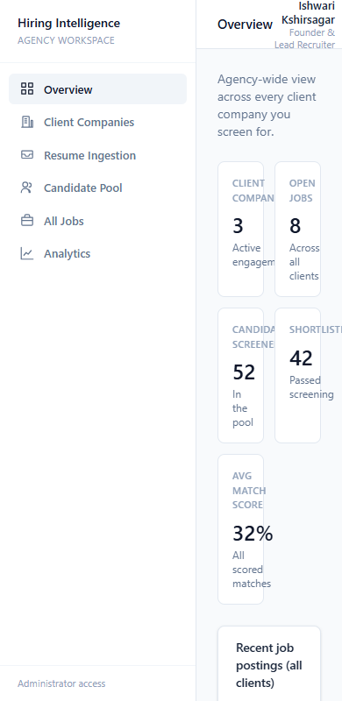
Figure 9. Phone width (390 px): sidebar does not collapse, card labels are cut off
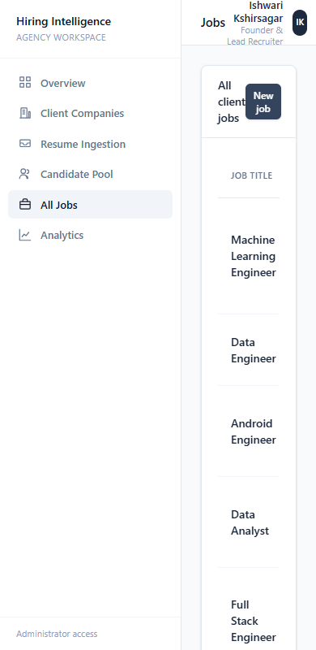
Figure 10. Phone width (390 px): jobs page

9.4 Database and data integrity
- Startup against Neon PostgreSQL: Hibernate created all tables with ddl-auto=update; connection pool started; application ready in about 18 seconds.
- Seeding is guarded: it runs only when tables are empty, so restarting does not duplicate data. Confirmed by the live counts (3 companies, 8 jobs) staying the same after redeploys.
- The same JPA code runs on H2 (tests) and PostgreSQL (live) with no changes; skill lists are stored as text through an AttributeConverter.
- Not tested: backup and restore, migration scripts (the project uses schema auto-update rather than Flyway or Liquibase), and concurrent writes to the same row.

9.5 Static analysis and build
Check | Result | Status
Frontend production build (vite build) | 702 modules transformed, built in about 8 seconds | Pass
Frontend lint (oxlint) | 0 errors, 2 warnings (D-05) | Pass with warnings
Backend compile and package | Compiles on Java 21; Docker build defined | Pass
Bundle size | Main JS chunk about 810 kB (243 kB gzipped); Vite warns above 500 kB | Warning

10. Failed Tests and Defect Log

10.1 Tests that failed
Seven checks failed during this cycle. All are reported here. One was a wrong expectation in a test; the rest show real weaknesses in the software.
Test | What it checks | Actual result | Verdict | Defect
TC_ING_03 (first run) | Empty resume batch should succeed (2xx) | 400 Bad Request: "No resume entries supplied" | Fail: test was wrong, fixed | D-06
PR_01 | A 5-character JWT secret is rejected at startup | No exception; secret padded silently | Fail | D-03
PR_02 | 15 wrong passwords are throttled (429) | Last response 401; no throttling | Fail | D-09
PR_03 | Job with min 10 yrs, max 2 yrs is rejected | 200 OK; job created | Fail | D-08
PR_05 | Executable file upload is rejected | 200 OK; accepted as a resume | Fail | D-07
Manual A11 | Layout usable on 390 px wide screen | Sidebar stays open; content clipped | Fail | D-10
Perf target | Typical response under 1 second | 1.3 to 3.4 seconds average | Fail | D-01

Two probe tests passed: PR_04 (a recruiter fetching another company's job by id gets 404) and PR_06 (a recruiter fetching a candidate by id gets 404). The six probe tests are in KnownDefectProbeTest.java. They are marked @Disabled so the regression suite stays green; remove the annotation from a test once its defect is fixed and it becomes a regression test.
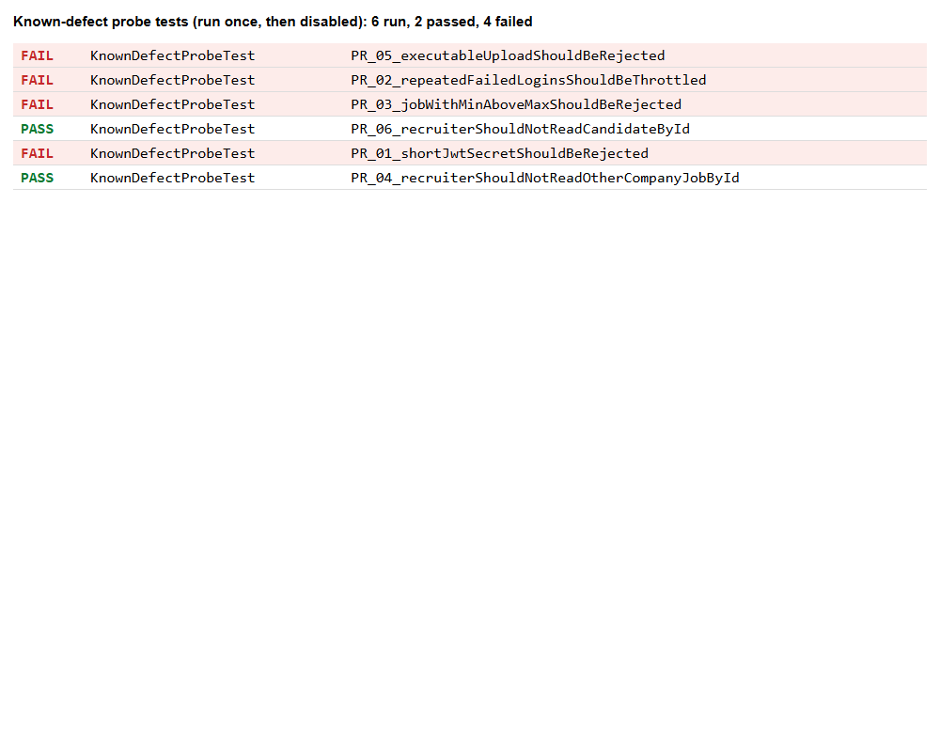
Figure 11. Result of the six probe tests when they were run: 4 failed, 2 passed

10.2 Defect log
Severity scale: Critical (system unusable or data exposed), High (major feature broken), Medium (feature works but badly), Low (minor or cosmetic), Info (observation).
ID | Severity | Description | Cause and recommendation | Status after cycle 2
D-01 | Medium | Slow API responses on the deployed system: 1.3 s to 3.4 s on average per request, worst case 6.9 s (dashboard summary). | Likely cause: the Render backend and Neon database are in different regions and each request makes several database round trips. Not yet confirmed. Fix: same region for both, use the pooled Neon URL, cache dashboard and analytics. | Partly fixed (Section 13.3)
D-02 | Low | Login page pre-fills the admin email and password and lists demo credentials on screen (Section 7.1 screenshots). | Acceptable for the demo. Remove before any real use. | Fixed: hidden by default, shown on the demo site by a setting
D-03 | Medium | A short JWT secret is padded instead of rejected, and application.yml ships a default dev secret. Probe PR_01 failed: no exception is raised for the secret "short". | Weak or default secret makes tokens forgeable. Fix: fail startup when APP_JWT_SECRET is missing or under 32 bytes. The Render deployment uses a generated strong secret, so live tokens are not affected. | Fixed (v2.0)
D-04 | Low | Branch coverage is 65.3%. InterviewQuestions has 0 of 12 branches covered; JwtService 5 of 8. | Add tests for interview question generation and JWT edge cases. | Fixed (v2.0): branch coverage 74.0%
D-05 | Info | oxlint reports 2 warnings in AuthContext.jsx (react-refresh/only-export-components). No errors. | Move the hook or constants to a separate file. | Fixed (v2.0): lint clean
D-06 | Info | TC_ING_03 failed on first run: POST /api/resumes with an empty array returns 400, the test expected success. | Judged correct behaviour ("No resume entries supplied"). Test corrected to expect 400. | Closed (test fixed)
D-07 | Medium | File upload accepts any file type. Probe PR_05 uploaded "malware.exe" (bytes MZ..) and the API returned 200 instead of 4xx. | The file is treated as a resume, so junk data can enter the candidate pool. Fix: allow only PDF, DOCX and TXT by extension and content type, and reject empty or unparsable files. | Fixed (v2.0)
D-08 | Low | Job validation does not compare minimum and maximum experience. Probe PR_03 created a job with min 10 and max 2 and got 200. | An inverted range gives every candidate a poor experience fit. Fix: add a cross-field check (min <= max) in JobRequest. | Fixed (v2.0)
D-09 | Medium | No brute-force protection on login. Probe PR_02 sent 15 wrong passwords and the last one still got 401, never 429. | Attacker can guess passwords without limit. Fix: rate limit or lock out after repeated failures (for example Bucket4j or a simple per-IP counter). | Fixed (v2.0)
D-10 | Medium | The layout is not responsive. On a 390 px wide phone screen the sidebar stays open and the content is squeezed: stat card labels are cut off ("CLIENT COMPANI", "SHORTLISTE"), Section 9.3 screenshots. | Fix: collapse the sidebar into a menu button below the tablet breakpoint and let cards stack in one column. | Fixed (v2.0)
D-11 | Medium | Found in cycle 2 by reading the code: PDF and DOCX uploads are accepted, but their text is not extracted. The candidate is created from the file name with the note "Resume text could not be extracted from this file". Only text-like files (TXT, MD, CSV, JSON) are really parsed. | Real resumes are mostly PDF or DOCX, so this limits real-world use. Fix: add a PDF and DOCX text extractor (for example Apache PDFBox and Apache POI) in IngestionService, with tests using sample files. | Open

Eleven defects are recorded: 0 Critical, 0 High, 6 Medium (D-01, D-03, D-07, D-09, D-10, D-11), 3 Low (D-02, D-04, D-08) and 2 Info (D-05, D-06). D-01 to D-10 were addressed in version 2.0 (Section 13); D-11 was found afterwards and is open.

11. Requirements Traceability
Req. | Requirement | Tests | Coverage
FR-01 | Secure login with roles (admin, recruiter) | TC_AUTH_01-07, TC_SEC_01-02, WB_20-25 | Covered
FR-02 | Recruiters see only their own company data | TC_SEC_03-06, TC_SEC_08 | Covered
FR-03 | Manage client companies | TC_COMP_01-02, TC_SEC_03/07 | Covered
FR-04 | Create and view jobs with validation | TC_JOB_01-05 | Covered
FR-05 | Ingest resumes (JSON and file) | TC_ING_01-04, WB_17-19 | Covered
FR-06 | ATS check of each resume | WB_13-16 | Covered
FR-07 | Match and rank candidates per job | TC_JOB_06, WB_01-12 | Covered
FR-08 | Dashboard, analytics and reports | TC_DASH_01, TC_ANL_01-03, TC_RPT_01 | Covered
NFR-01 | Security (auth, RBAC, CORS, injection) | TC_AUTH_07, TC_SEC_01-10 | Covered
NFR-02 | Performance | Section 9.1 measurements | Measured, target not met
NFR-03 | Usability and cross-browser | Alpha A9, A11; Section 9.3 screenshots; beta plan | Partly covered

12. Test Summary and Conclusion

12.1 Results at a glance
Measure | Result | Exit criterion
Automated tests run | 69
Passed / failed / skipped | 69 / 0 / 0 | All pass: Met
Black-box cases | 34 of 34 pass
White-box / unit cases | 35 of 35 pass
Line coverage | 83.5% | At least 80%: Met
Branch coverage | 65.3% | At least 70%: Not met
Open Critical or High defects | 0 | None: Met
Probe tests run / failed | 6 / 4 | See Section 10.1
Defects logged | 10 (5 Medium, 3 Low, 2 Info)
Requirements with at least one test | 11 of 11 | All traced: Met
Typical API response time | 1.3 to 3.4 seconds | Under 1 second: Not met

Sections 1 to 12 record test cycle 1, run on version v2.0-beta before any fixes. Section 13 records cycle 2, the re-test of version v2.0 after the fixes.

12.2 Conclusion
The functional behaviour of the system is sound in the main workflows. Login, role separation, company data isolation, job and company management, resume ingestion, scoring and ranking all behaved as specified in every test, and no High or Critical defect was found. Login, token checks, role checks and company isolation held up against the attacks tried. The negative tests did find real weaknesses: uploads are not restricted by file type, logins are not throttled, weak JWT secrets are accepted, inverted experience ranges are accepted, and the layout breaks on a phone screen.
Criteria not yet met or not yet tested: branch coverage is 65% against a 70% target, live response times are above one second, and beta, cross-browser and accessibility testing have not been carried out. The system is suitable for the project demonstration. It should not be used for real candidate data until the performance issue, the default-secret issue and the beta round are dealt with.

12.3 Recommendations
- Put the Render backend in the same region as the Neon database (or use Neon's pooled connection) and cache the dashboard and analytics queries. Re-measure.
- Add tests for InterviewQuestions and the JWT and filter error paths to reach 70% branch coverage.
- Restrict uploads to PDF, DOCX and TXT and reject other file types (D-07).
- Add login throttling (D-09) and a min-not-above-max check on jobs (D-08).
- Make the sidebar collapse on small screens and stack the cards (D-10).
- Make the backend refuse to start in production without a strong APP_JWT_SECRET.
- Remove pre-filled credentials from the login page for any real deployment.
- Reset the Neon password that was shared in chat.
- Run the beta round (Section 8.2) and the browser and accessibility checks (Section 9.3), then update this report.
- Add a GitHub Actions workflow that runs the 69 tests on every push.

13. Test Cycle 2: Re-Test After Fixes (version 2.0)
After cycle 1, the defects were fixed on the branch fix/defects, merged into v2 and main, and tagged v2.0. The six probe tests from Section 10.1 were turned into a permanent regression class (DefectFixRegressionTest) and 5 more were added. Everything was then re-tested locally and on the live system.

13.1 What was fixed and how it was verified
Defect | Fix | Verified by | Result
D-07 | Uploads limited to PDF, DOCX, TXT, MD, CSV, JSON; empty files refused | PR_05 (exe rejected), PR_07 (pdf accepted), PR_08 (empty rejected); live: exe upload returned 400 | Pass
D-08 | Reject min experience above max (max 0 still means no ceiling) | PR_03, PR_09; live: inverted range returned 400 | Pass
D-09 | Login throttle: 5 failures per client and email in 15 minutes, then 429 with a Retry-After header. A good login resets the count. | PR_02, PR_10, PR_11 and 6 unit tests; live: 429 returned after repeated failures | Pass
D-03 | Backend refuses to start with a JWT secret under 32 bytes | PR_01 and JwtServiceTest | Pass
D-10 | Sidebar becomes a slide-out menu on screens under 768 px; header compacts | Browser check at 390 px, local and live (Figures below) | Pass
D-02 | Demo accounts and pre-filled password only when VITE_SHOW_DEMO_ACCOUNTS=true. On for the demo site, off by default. | Login page without the flag (Figure below) | Pass
D-01 | Job list uses 3 queries instead of about 2 per job; ranking loads only the needed candidates; read endpoints cached and cleared on every write | Timings in Section 13.3 | Partly fixed
D-04 | 14 new unit tests: login limiter, cache, interview questions | JaCoCo report (Figures below) | Pass
D-05 | Auth hooks moved out of AuthContext.jsx | oxlint: 0 errors, 0 warnings | Pass

13.2 Results
Measure | Cycle 1 | Cycle 2 (v2.0)
Regression tests run | 69 | 94
Failed / errors | 0 / 0 | 0 / 0
Probe tests | 6 run, 4 failed | 11 in regression class, all pass
Line coverage | 83.5% | 88.2%
Branch coverage | 65.3% (target 70%: not met) | 74.0% (target 70%: met)
Lint | 0 errors, 2 warnings | 0 errors, 0 warnings
Open Medium defects | 5 | 1 (D-01 partly), plus new D-11

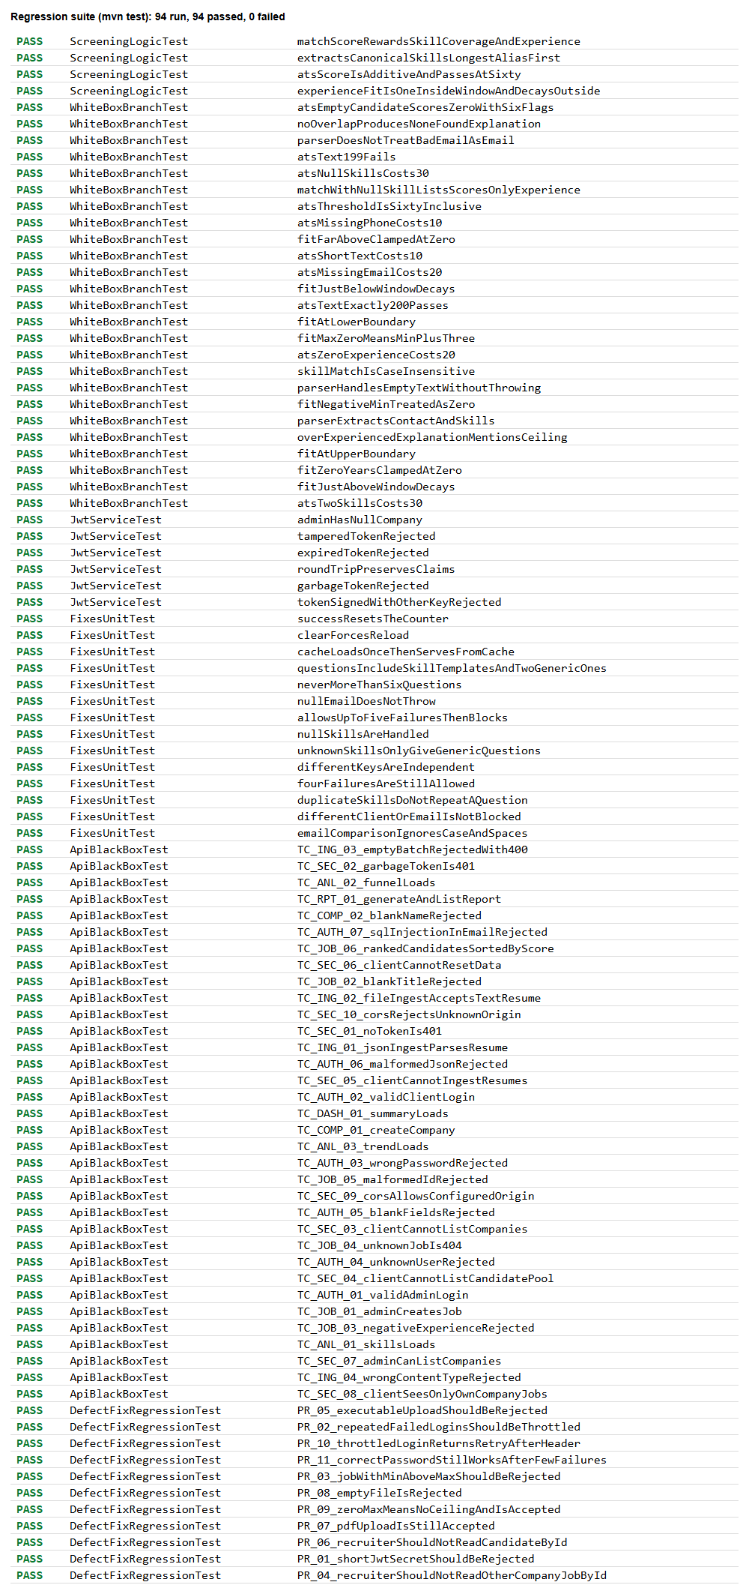
Figure 12. Cycle 2: result of every test in the regression suite (94 run, 0 failed)
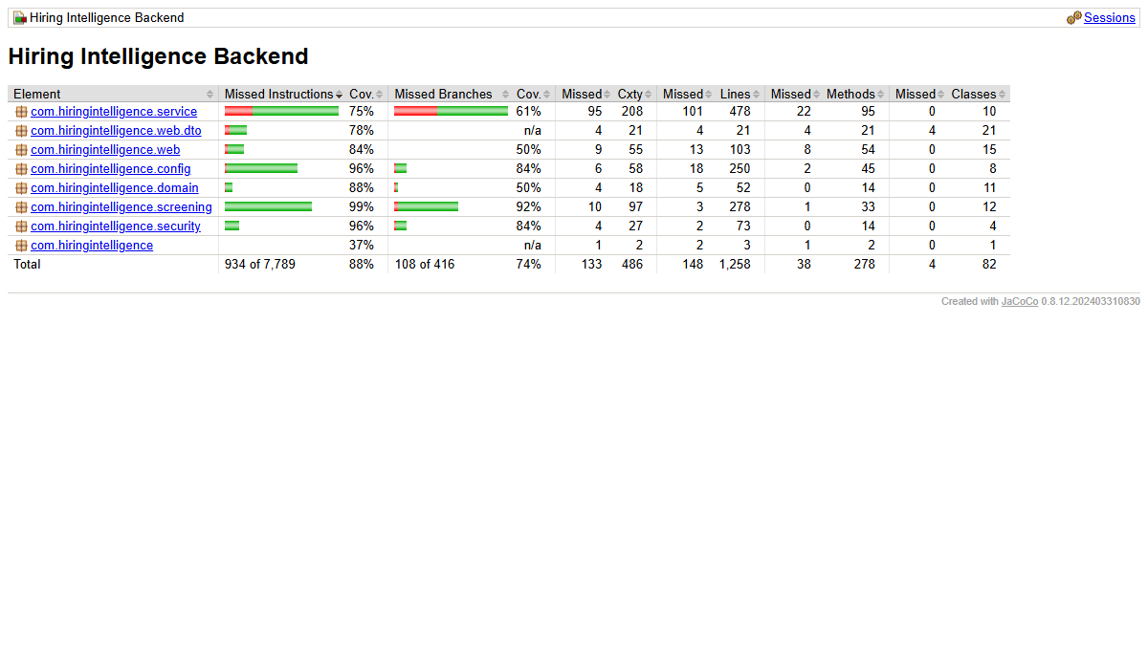
Figure 13. Cycle 2: JaCoCo coverage for the whole backend
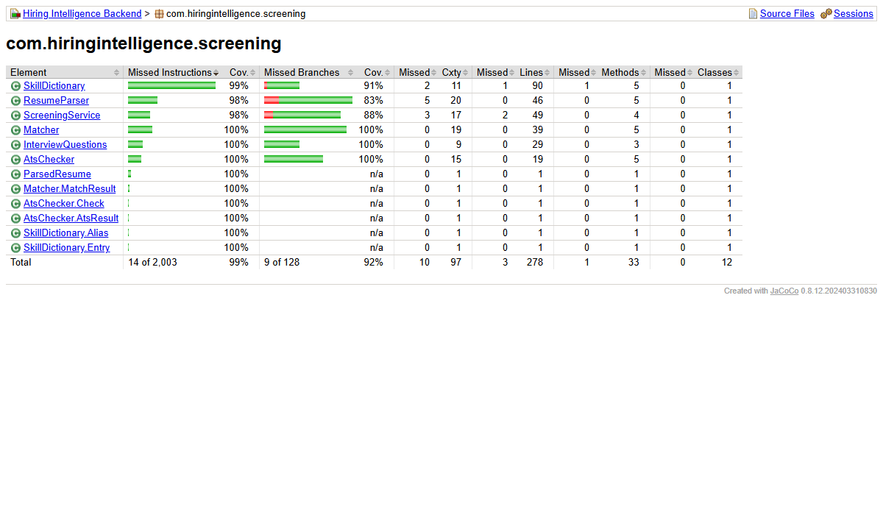
Figure 14. Cycle 2: JaCoCo coverage for the screening package (InterviewQuestions now covered)

13.3 Performance re-test (D-01)
Method as in Section 9.1: 10 sequential requests per endpoint against the live Render backend. "First" is the first call after the deployment, when the cache is empty; "Average" is over all 10 calls. Cycle 1 numbers are the averages from Section 9.1.
Endpoint | Cycle 1 average (ms) | Cycle 2 first (ms) | Cycle 2 average (ms) | Change in average
GET /api/dashboard/summary | 3441 | 3639 | 1186 | -66%
GET /api/jobs | 3365 | 2368 | 930 | -72%
GET /api/companies | 3020 | 716 | 690 | -77%
GET /api/candidates | 2097 | 2056 | 958 | -54%
GET /api/analytics/funnel | 2133 | 2371 | 885 | -59%
GET /api/analytics/skills | 1947 | 2502 | 860 | -56%
GET /api/analytics/trend | 1974 | 2276 | 904 | -54%
GET /api/reports | 1296 | 1260 | 1196 | -8%

- The average dropped by 54% to 77% for the cached endpoints. The first call after any change (a write, or 5 minutes without one) is still 2 to 3.6 seconds because it goes to the database.
- A cached response is still 0.7 to 1.2 seconds. Five calls to a protected endpoint that never touches the database (a 401 answer) took 0.5 to 0.8 seconds each from this laptop, so most of that time is network distance to Render's servers, not application work.
- A local run of the backend against Neon (removing the Render hop) before and after: average of 6 calls, jobs 2730 ms to 189 ms, dashboard 1891 ms to 308 ms, companies 2174 ms to 343 ms. First call to /api/jobs: 3065 ms to 1094 ms, which shows the effect of the query batching alone.
- The target of under 1 second is met for most cached calls but not for the first call after a change, so D-01 is marked partly fixed. The remaining fix is to move the Render service to the Singapore region, next to the Neon database. Render does not allow changing the region of an existing service, so this means creating the service again.

13.4 Live system re-check
Check on the live system | Result | Status
Admin login with the demo password | 200 with a token | Pass
Upload a file named malware.exe | 400 Bad Request | Pass
Create a job with min 10 and max 2 years | 400 Bad Request | Pass
Repeated wrong passwords for one email | 401 for each attempt, then 429 Too Many Requests | Pass
Phone width (390 px) after login | Menu button in header; sidebar opens as a drawer; cards fit | Pass
Demo accounts shown on the deployed login page | Yes, because the demo deployment sets the flag | Pass (by design)
Backend starts with the generated JWT secret | Yes: live logins work after the deployment | Pass

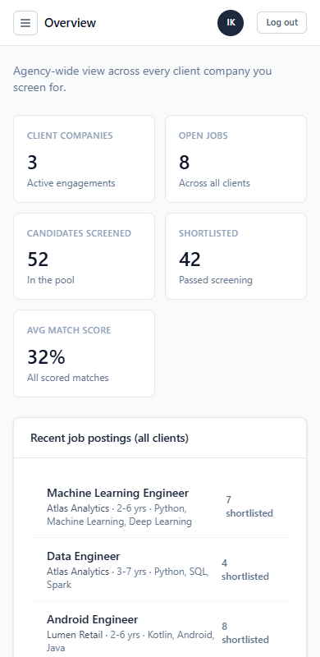
Figure 15. Live system at 390 px: overview with a menu button, cards fit the screen
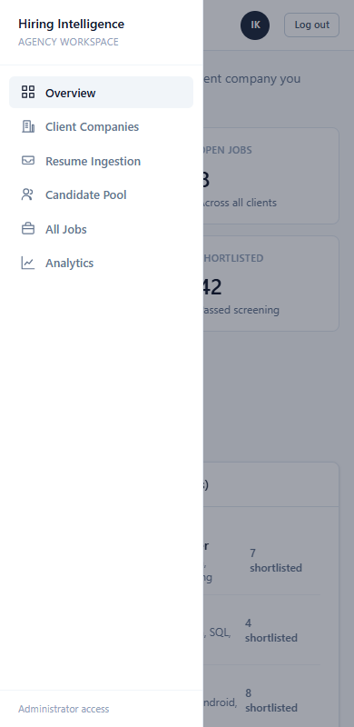
Figure 16. Live system at 390 px: the sidebar as a slide-out menu
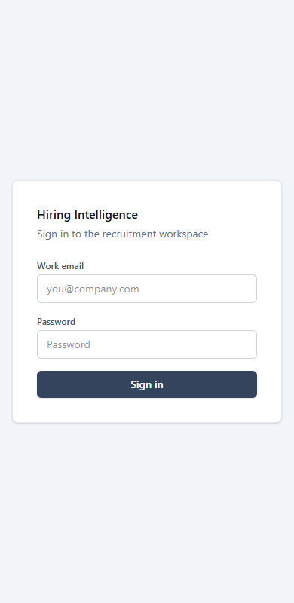
Figure 17. Login page with the demo flag off: empty fields, no demo accounts

13.5 Remaining work
- D-11: extract text from PDF and DOCX resumes. This is the most important open item for real use.
- D-01: move the Render service to the Singapore region.
- Run the beta round with real users (Section 8.2), and test Firefox, Safari, tablet size and accessibility (Section 9.3).
- Add a GitHub Actions workflow to run the 94 tests on every push.
- Reset the Neon database password that was shared in chat.

13.6 Release
Version 2.0 was released on 20 September 2026: branch fix/defects merged into v2 and main, tag v2.0. Version 1 (mock-data prototype) remains on branch v1 with tag v1.0, and the pre-fix build on tag v2.0-beta. Live frontend: hiring-intelligence-eight.vercel.app. Live backend: hiring-intelligence-api.onrender.com.

Appendix A. How to Re-Run the Tests
Purpose | Command (from the repository root)
Run all backend tests | cd backend && ./mvnw test
Run tests with coverage report | cd backend && ./mvnw org.jacoco:jacoco-maven-plugin:0.8.12:prepare-agent test org.jacoco:jacoco-maven-plugin:0.8.12:report  Report: backend/target/site/jacoco/index.html
Frontend lint | npm run lint
Frontend build | npm run build
Test source files | backend/src/test/java/com/hiringintelligence/ (screening, security, service, web)

Appendix B. Test Data
Item | Value
Administrator account | ishwari@hiringintelligence.io (demo password on the login page)
Recruiter account | rajesh.iyer@northwind.example (Northwind Logistics)
Seeded data | 3 client companies, 8 jobs, 52 synthetic candidates (deterministic seed 20260830)
Data note | All candidates are synthetic and generated by the seeder. No real personal data was used in testing.

Appendix C. Screenshot Evidence
All screenshots were taken on 20 September 2026 from the live system (hiring-intelligence-eight.vercel.app), logged in as the administrator, using browser automation in Microsoft Edge.
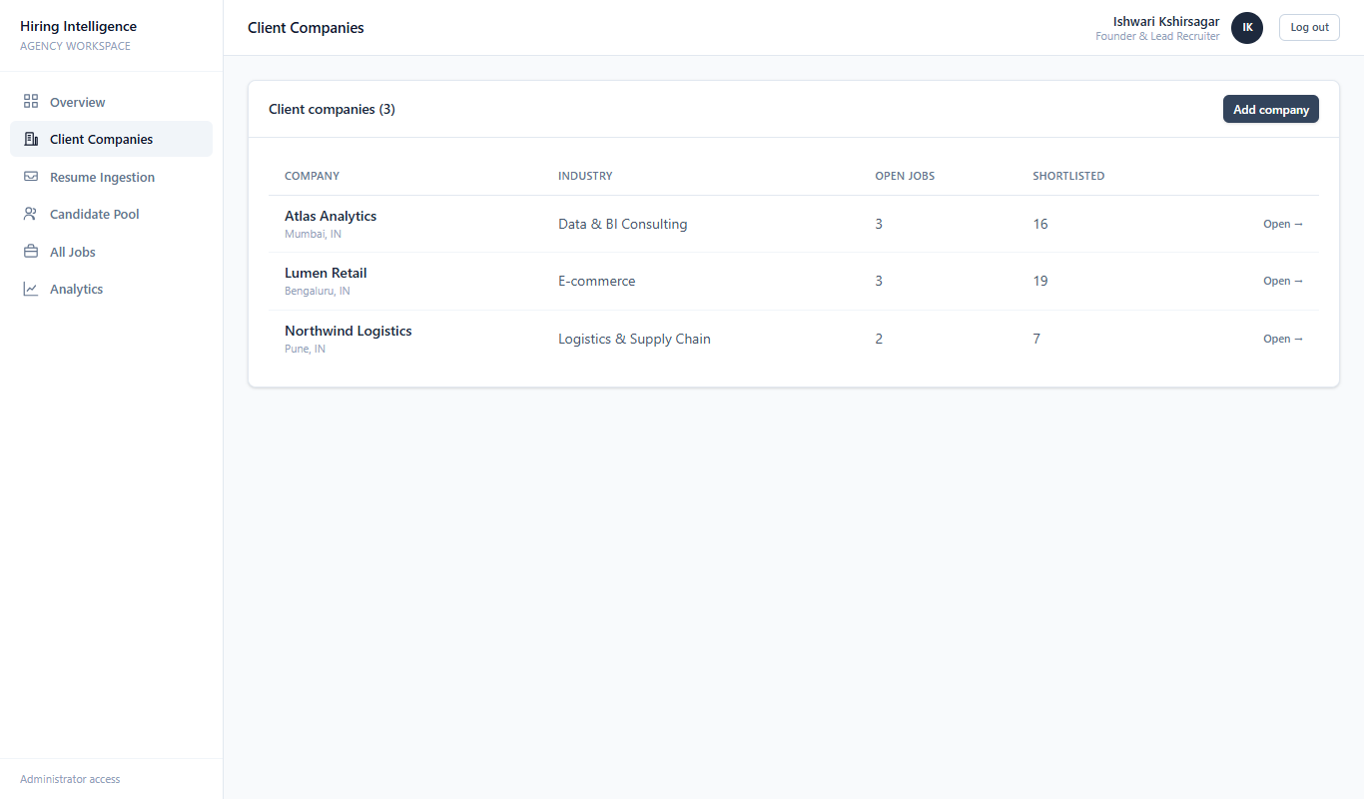
Figure 18. Client Companies
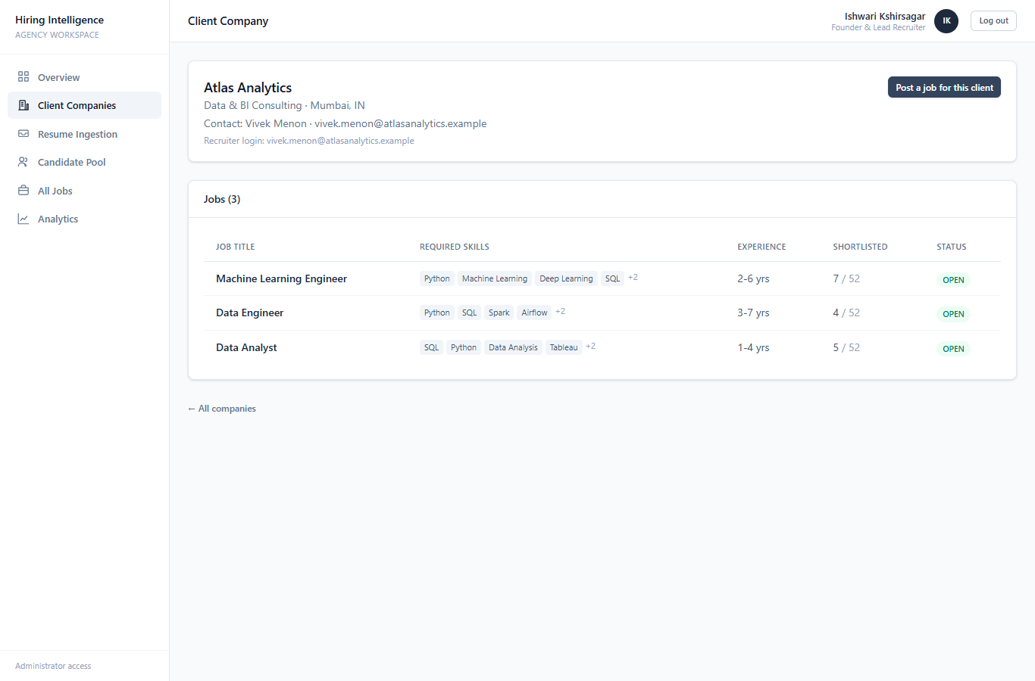
Figure 19. Client company detail
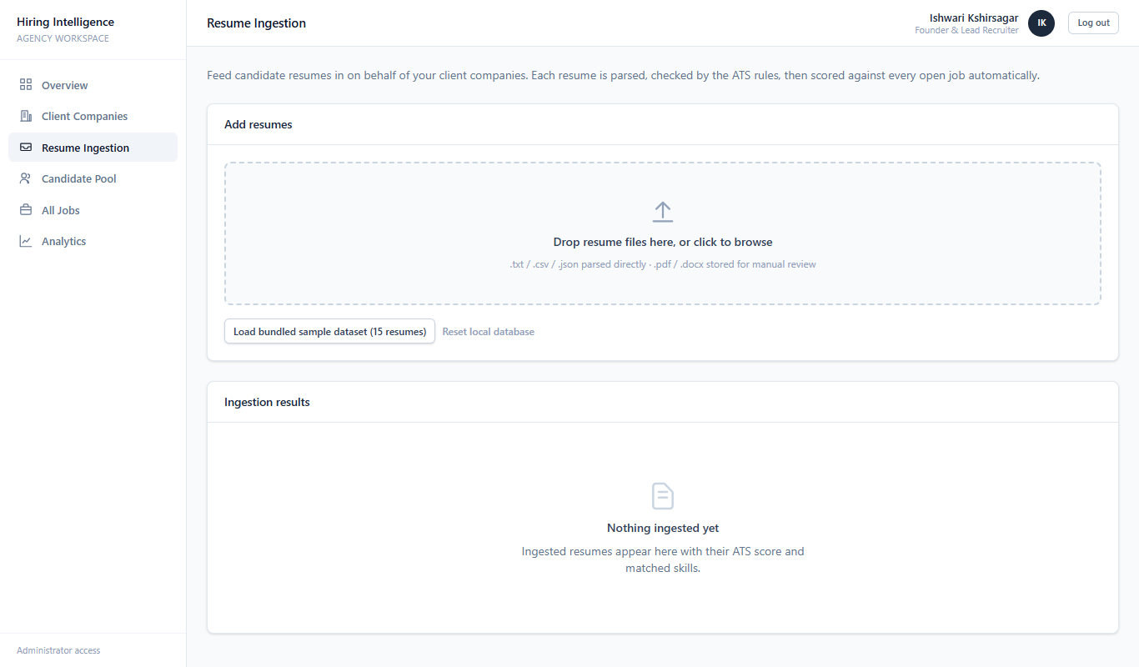
Figure 20. Resume Ingestion
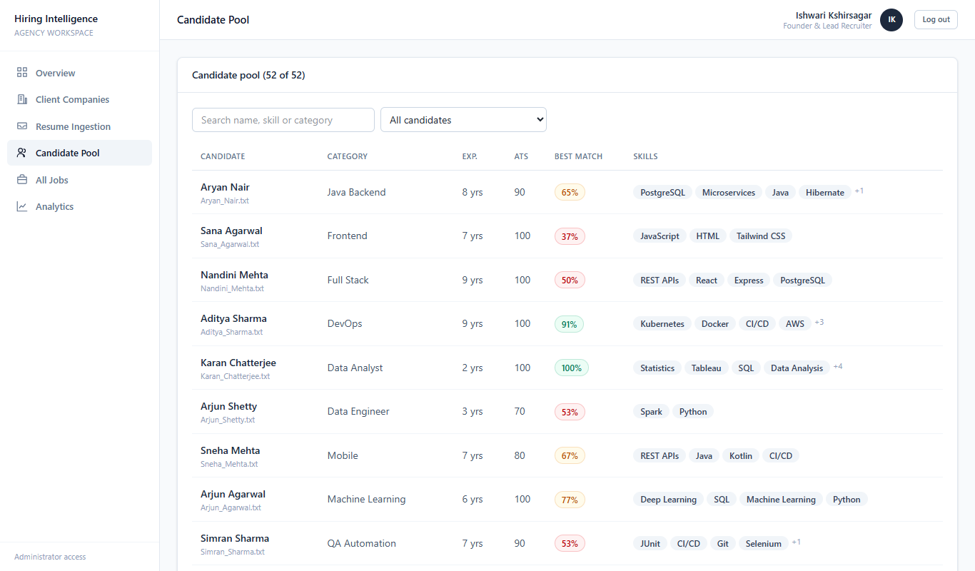
Figure 21. Candidate Pool
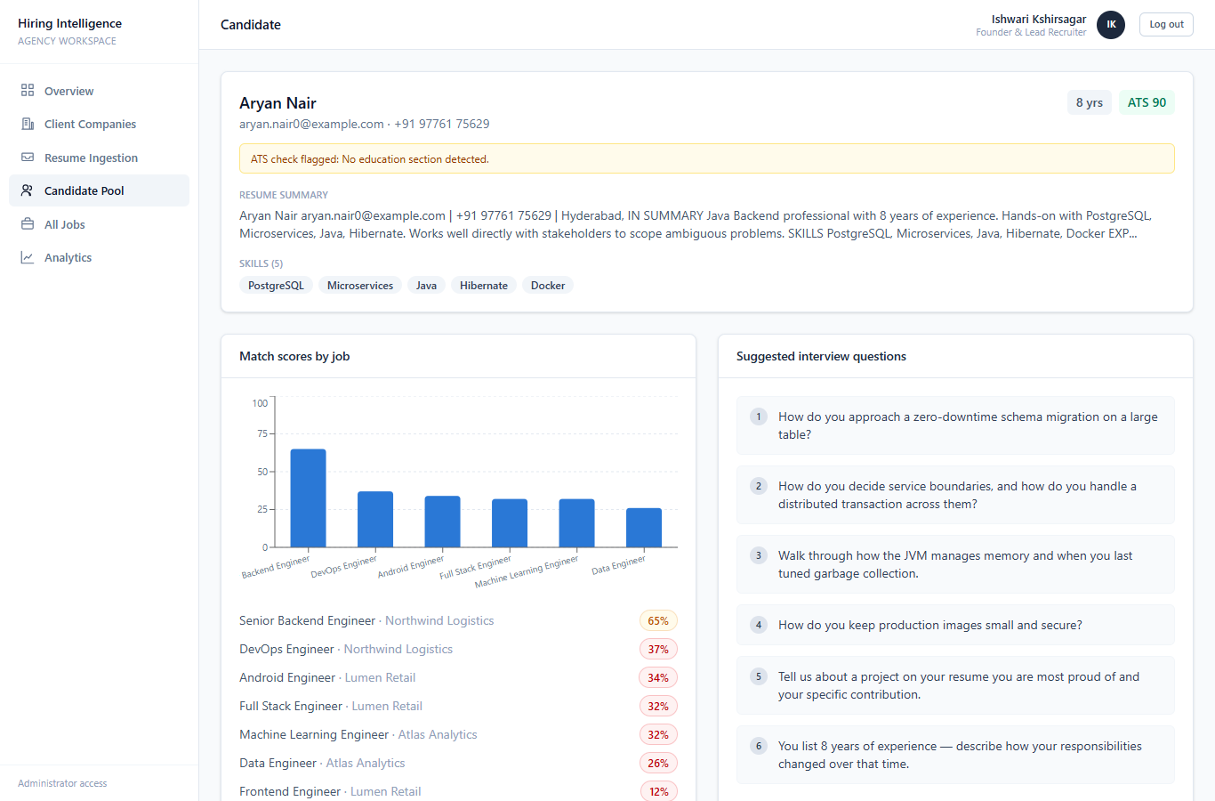
Figure 22. Candidate profile
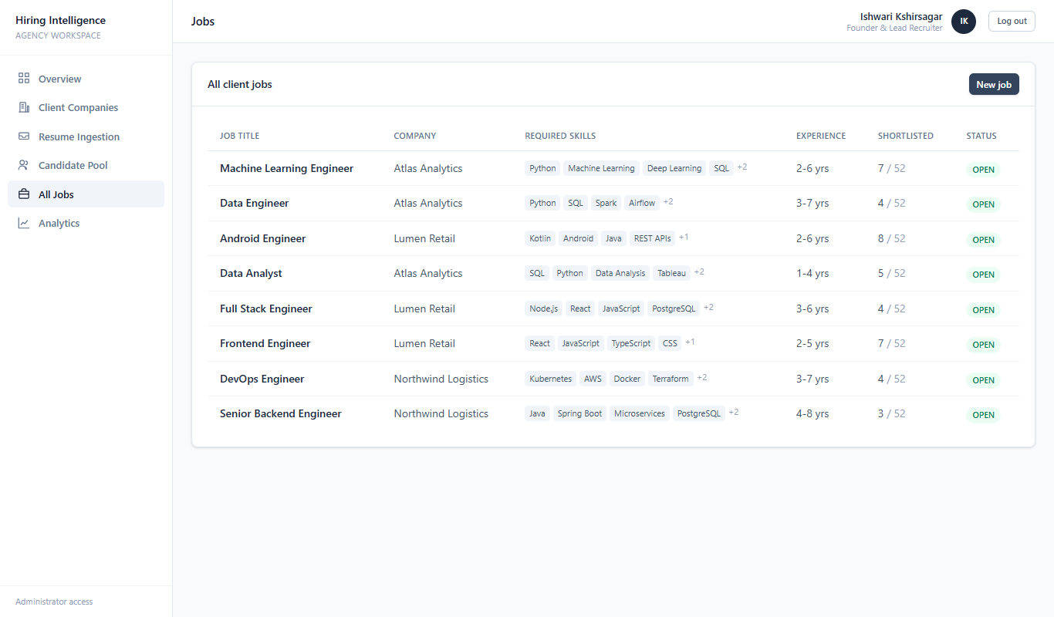
Figure 23. All Jobs
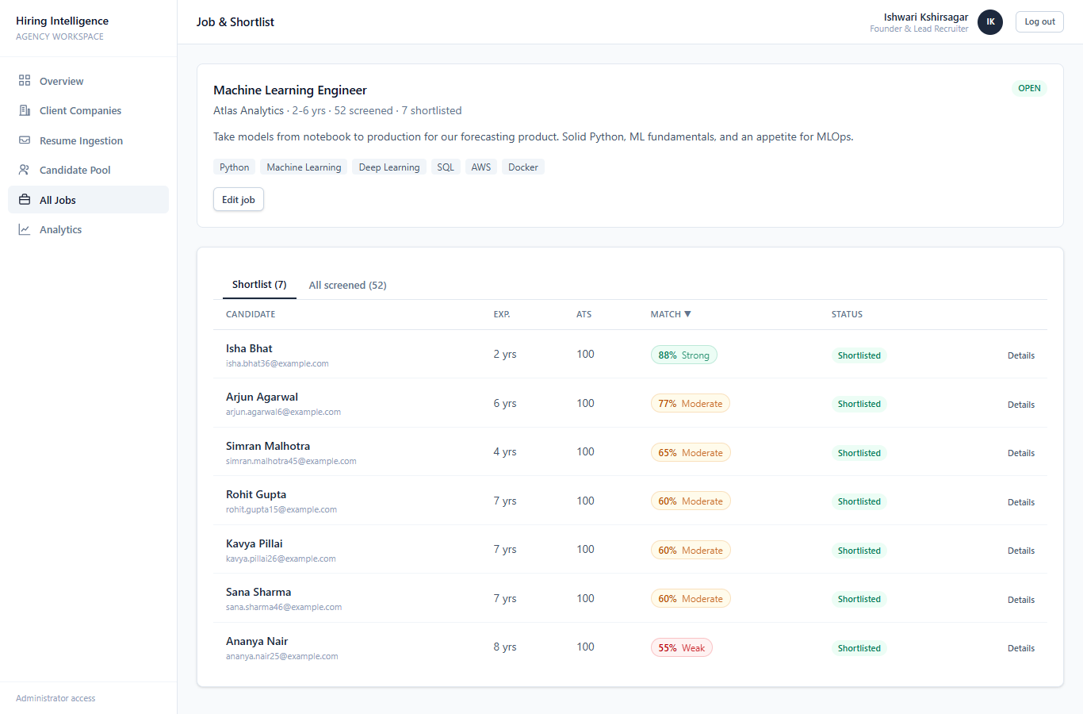
Figure 24. Job and ranked shortlist (Machine Learning Engineer), highest match score first
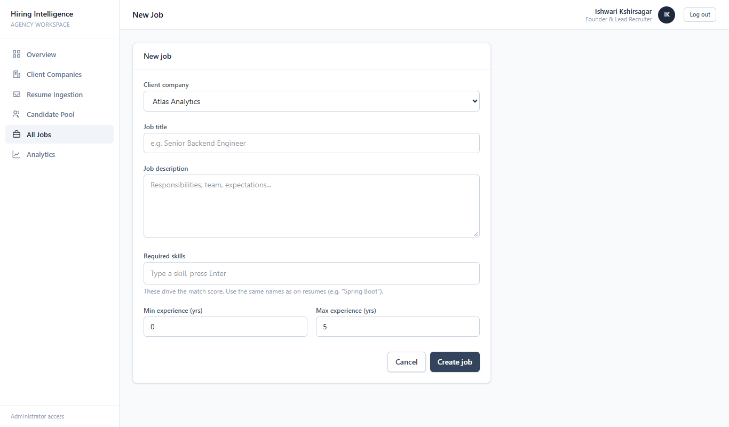
Figure 25. New job form
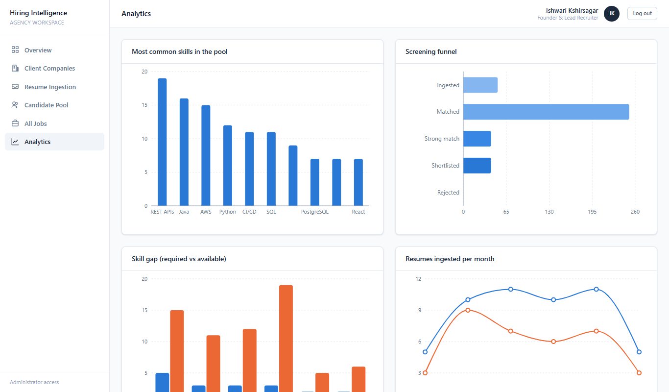
Figure 26. Analytics: skills, screening funnel, skill gap, resumes per month
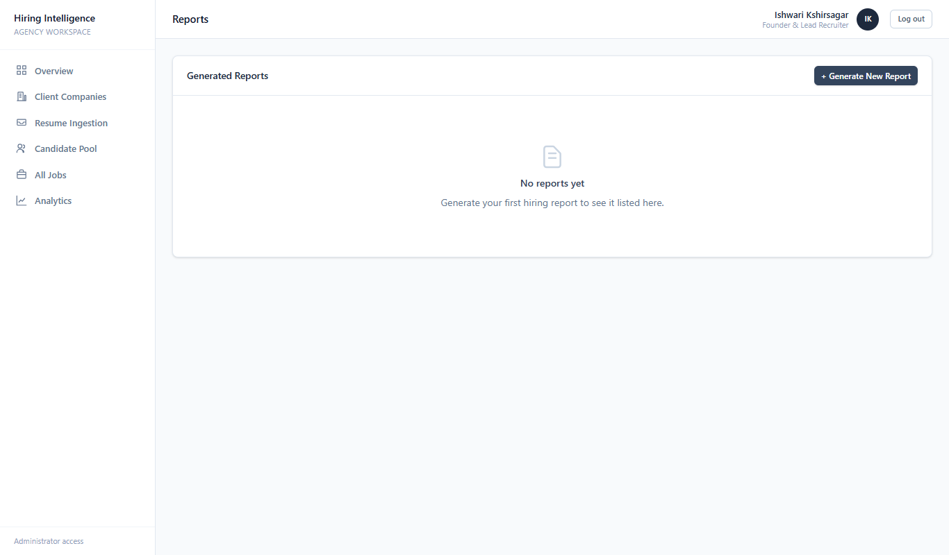
Figure 27. Reports

