PROJECT DOCUMENTATION
Hiring Intelligence Platform
A resume screening and candidate ranking system for recruitment agencies
Submitted by
No. | Name | ID
1 | Ishwari Kshirsagar | 53013240102
2 | Pratiksha Kunwar | 53013240104
3 | Shreya Pillai | 53013240088

Item | Detail
Project version | 2.0 (final release)
Project period | 27 August 2026 to 20 September 2026
Source code | https://github.com/ishwariksh06/Hiring_intelligence
Live application | https://hiring-intelligence-eight.vercel.app
Live API | https://hiring-intelligence-api.onrender.com
Table of Contents

Abstract
Recruitment agencies receive hundreds of resumes for every job they fill, and screening them by hand is slow and inconsistent. The Hiring Intelligence Platform automates the first screening step. An administrator adds client companies and their jobs, then uploads resumes. The system reads each resume, extracts the candidate's skills and years of experience, checks whether the resume is complete enough for applicant tracking systems (ATS), and scores every candidate against every job. Each job then shows a ranked shortlist with the matched skills, the missing skills and a plain-language explanation of the score. Recruiters from the client companies log in and see only their own jobs and shortlists.
The application has a React front end, a Spring Boot REST back end and a PostgreSQL database hosted on Neon. It is deployed on Vercel and Render. The project was planned with a work breakdown structure, activity network diagrams (AOA and AON), the critical path method and PERT, and designed with use case, class and entity-relationship diagrams. It was tested in two cycles with 94 automated tests, which found eleven defects. Ten of them were fixed in the final release, one of them partly.
Keywords: resume screening, candidate ranking, ATS score, Spring Boot, React, PostgreSQL, JWT, software project management.

1. Introduction

1.1 Background and problem
A recruitment agency works for several client companies at once. For each opening it must read many resumes, decide who fits, and explain the choice to the client. Doing this by hand takes hours per job, and two reviewers may rate the same resume differently. Resumes also vary in format, so some good candidates are missed because their key details are hard to find.

1.2 Objectives
- Read resumes automatically and extract name, contact details, skills, experience and education.
- Check each resume for the fields an applicant tracking system needs and give an ATS score.
- Score every candidate against every job with a rule that can be explained, and rank them.
- Give the agency a full view of all clients, and give each client a view limited to its own jobs.
- Show simple analytics: skill demand, screening funnel, skill gaps and intake over time.
- Run on the web, on desktop and phone, with data kept in a managed cloud database.
- Follow a planned, tested and documented software process.

1.3 Scope
In scope | Out of scope (this version)
Login with two roles (administrator, recruiter) | Reading text from scanned images (no OCR)
Companies, jobs, resume ingestion, candidate pool | Text extraction from PDF and DOCX files (files are accepted but only text-like files are fully parsed)
ATS check, match score, ranking, shortlist status | Email notifications to candidates
Dashboard, analytics, reports | Self-service sign-up and password reset
Cloud deployment (Vercel, Render, Neon) | Machine-learning ranking models

1.4 Users
User | What they do
Administrator (agency staff) | Adds client companies and jobs, uploads resumes, reviews the whole candidate pool, sees all analytics and reports
Recruiter (client company) | Logs in to see the jobs of their own company, reads the ranked shortlist, opens candidate profiles and moves candidates between Review, Shortlisted and Rejected

1.5 Glossary
Term | Meaning
ATS | Applicant tracking system, software companies use to collect and filter resumes
JWT | JSON Web Token, a signed token that proves who the user is on each request
REST API | A web interface where each URL and HTTP method does one thing (for example GET /api/jobs)
JPA / ORM | A way for Java code to read and write database tables as objects
WBS / CPM / PERT | Project planning methods described in Section 6

2. Technology Stack

2.1 Front end
Technology | Version | Used for
React | 19 | Building the single-page user interface from reusable components
Vite | 8 | Development server and production build
Tailwind CSS | 4 | Styling and the responsive layout (slide-out menu on phones)
React Router | 7 | Page routes and role-based route protection
React Hook Form | 7 | Forms and validation (login, job form)
Axios | 1.x | Calling the REST API with the login token attached
Recharts | 3 | Bar, funnel and line charts on the analytics page
oxlint | 1.x | Static analysis of the JavaScript code

2.2 Back end
Technology | Version | Used for
Java | 17 language level, run on 21 | Application language
Spring Boot | 3.3.4 | Web server, dependency injection, configuration
Spring Web (MVC) | 3.3.4 | REST controllers and JSON
Spring Security | 6 | Filter chain, method-level role checks, CORS, BCrypt passwords
Spring Data JPA / Hibernate | 3.3.4 | Saving and loading entities without hand-written SQL
Bean Validation | 3.x | Checking request bodies (@NotBlank, @PositiveOrZero)
jjwt | 0.12.6 | Creating and verifying signed login tokens
Lombok | managed by Spring Boot | Removing getter and setter boilerplate
Maven | 3.9.9 (wrapper) | Build and dependency management

2.3 Database
Technology | Used for
PostgreSQL on Neon | The production database: a managed, serverless PostgreSQL service. Tables are created automatically by Hibernate.
H2 (embedded) | A file database for local development and an in-memory database for automated tests. The same code runs on H2 and PostgreSQL.

2.4 Hosting, tools and process
Tool | Purpose
Vercel | Hosts the React front end and serves it over HTTPS
Render (Docker) | Runs the Spring Boot back end from a Dockerfile in the repository
Neon | Hosts the PostgreSQL database
GitHub | Source control, branches and tags for the versions
Jira | Task board and timeline for planning
JUnit 5, AssertJ, Spring MockMvc | Unit, white-box and black-box API tests
JaCoCo | Code coverage measurement
Playwright (Microsoft Edge) | Taking screenshots of the live system for the reports

3. System Requirements

3.1 Functional requirements
ID | Requirement | How it is met
FR-01 | Secure login with two roles | Password check with BCrypt, signed JWT valid for 12 hours, role and company inside the token
FR-02 | A recruiter sees only their own company's data | Company check in every job and shortlist request
FR-03 | Manage client companies | Companies page and API (administrator only)
FR-04 | Create and edit jobs with validation | Job form and API; title and description required, experience range checked
FR-05 | Ingest resumes | File upload (PDF, DOCX, TXT, MD, CSV, JSON) or JSON text; parsed and stored
FR-06 | ATS check for each resume | Six weighted checks giving a score out of 100, pass mark 60
FR-07 | Match and rank candidates for each job | Match score = skill coverage x 70 + experience fit x 30, sorted high to low
FR-08 | Dashboard, analytics and reports | Overview tiles, four charts, report generation

3.2 Non-functional requirements
ID | Requirement | Target and result
NFR-01 | Security | Token authentication, role checks, login throttling (5 failures in 15 minutes), upload type limits, CORS allow-list. Checked by more than 20 automated security tests.
NFR-02 | Performance | Target under 1 second. Cached calls now 0.7 to 1.2 s on the live system; the first call after a change takes 2 to 3.6 s (Section 9).
NFR-03 | Usability | Clean layout; works on phone width with a slide-out menu; demo accounts on the login page of the demo site
NFR-04 | Portability | Runs on Windows, Linux and in Docker; H2 or PostgreSQL by a setting
NFR-05 | Maintainability | Layered code, 94 automated tests, 88% line coverage

4. System Architecture
The system has three tiers. The browser runs a React single-page application. It calls a stateless Spring Boot REST API over HTTPS. The API reads and writes a PostgreSQL database. No page is generated on the server, and no session is kept on the server, so the back end can be restarted at any time without logging users out.
Tier | Where it runs | Main parts
Presentation | User's browser; files served by Vercel | Pages, layout with sidebar and top bar, route guard, API client, charts
Application | Render (Docker container, port 8090) | Controllers, services, screening engine, security filter, read cache
Data | Neon PostgreSQL (Singapore) | users, companies, jobs, candidates, matches, reports

4.1 Back-end packages
Package | Responsibility
web | REST controllers, request and response objects (DTOs), the global error handler
service | Business logic: authentication, jobs, companies, candidates, ingestion, analytics, reports, read cache
screening | ResumeParser, SkillDictionary, AtsChecker, Matcher, InterviewQuestions, ScreeningService
domain | Entity classes and enumerations that map to the database tables
repo | Spring Data repositories, one per entity
security | JWT creation and checking, request filter, login rate limiter
config | Security configuration, application properties, sample-data seeder

4.2 Front-end structure
Folder | Content
src/pages | 13 pages: Login, Dashboard, Companies, Company detail, Ingest, Candidate pool, Candidate profile, Jobs, Job detail, Job form, Analytics, Reports, Unauthorized
src/components | Layout (sidebar, top bar, route guard), charts, job and candidate tables, upload area, common buttons
src/api | One file per API area; a shared Axios client that adds the token
src/context | Login state (AuthProvider) and the useAuth hook

5. How the System Works
This section follows one piece of work through the system, from logging in to reading a ranked shortlist.

5.1 Logging in
- The user enters an email and password on the login page.
- The API looks up the user and compares the password with its BCrypt hash. Five wrong attempts for the same email from the same client within 15 minutes are blocked with a "too many attempts" message.
- On success the API returns a signed token (valid 12 hours) with the user's name, role and company. The browser keeps it and sends it with every later request.
- The front end sends an administrator to the agency dashboard and a recruiter to the company dashboard. Pages the role may not open show a "403 Not authorized" screen, and the API refuses the same requests.
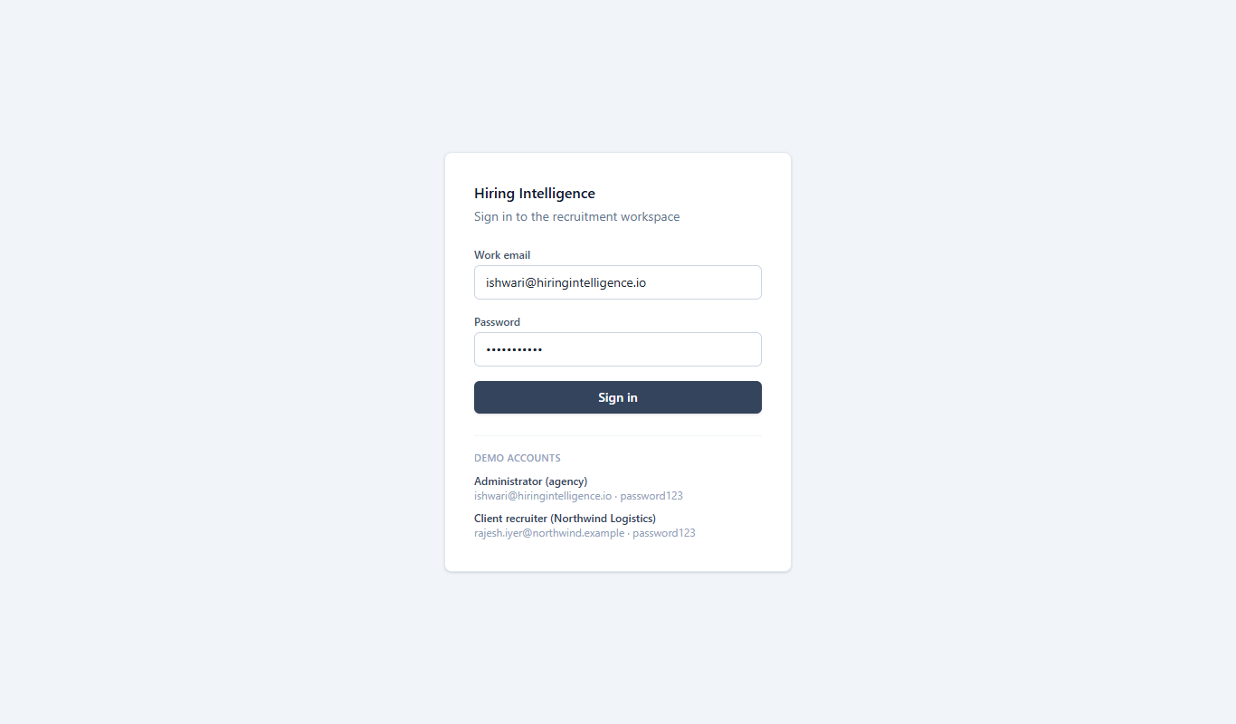
Figure 1. Login page (demo site shows the demo accounts)
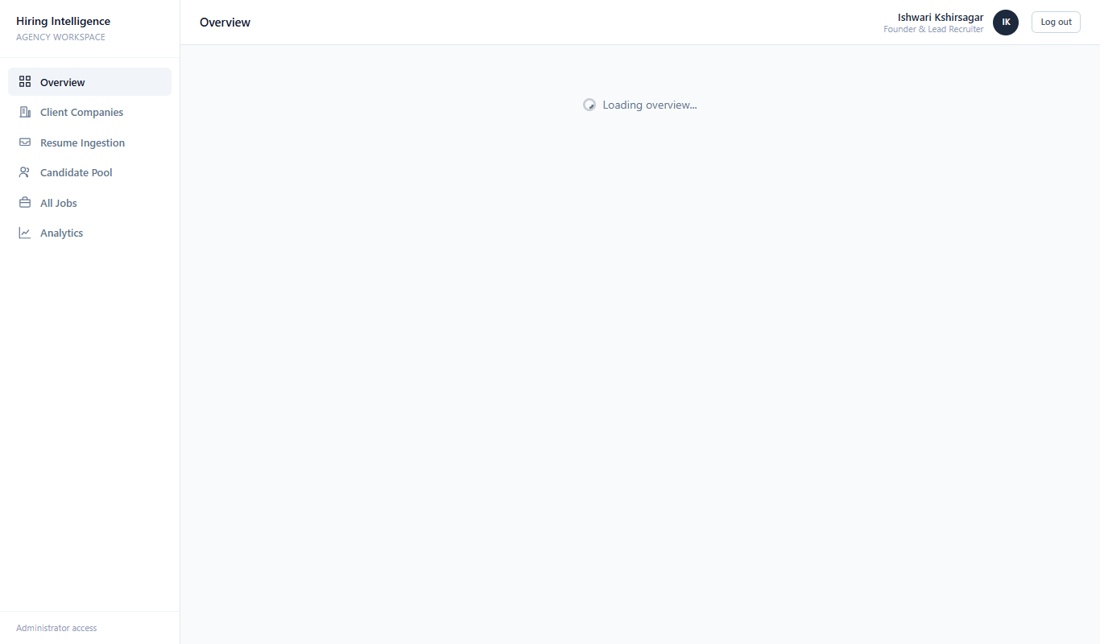
Figure 2. Administrator dashboard: totals across all client companies

5.2 Adding companies and jobs
The administrator adds a client company, then creates jobs for it. A job has a title, description, required skills, and an experience range in years. The minimum may not be above the maximum; a maximum of 0 means there is no upper limit. Saving a job immediately scores every candidate in the pool against it.
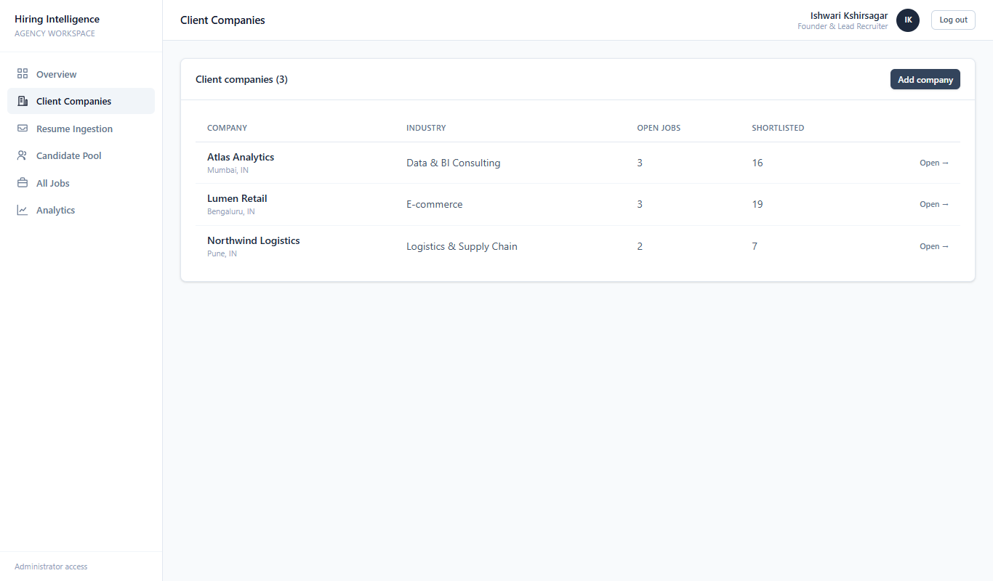
Figure 3. Client companies with job and shortlist counts
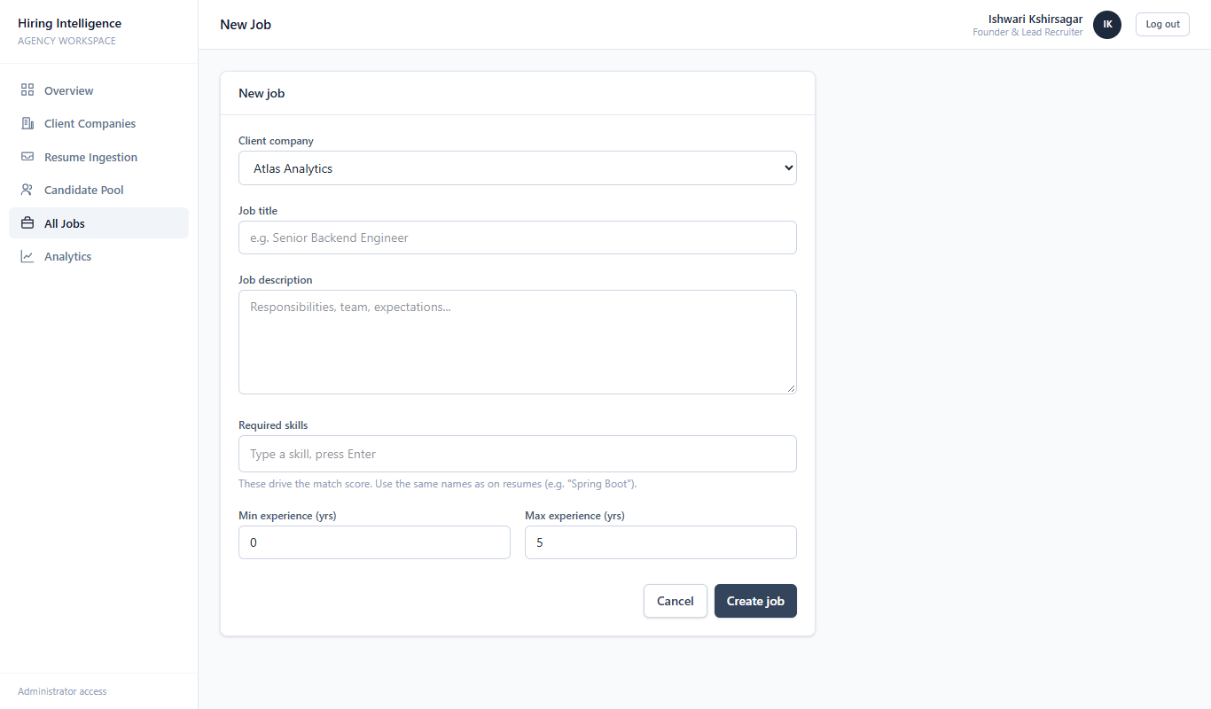
Figure 4. Job form

5.3 Ingesting resumes
On the Resume Ingestion page the administrator uploads files or pastes resume text as JSON. Only PDF, DOCX, TXT, MD, CSV and JSON files are accepted, and empty files are refused. For each resume the system does the following:
- ResumeParser finds the email address and phone number with pattern matching.
- It guesses the name from the first suitable line, reads the stated years of experience, and finds the education line.
- SkillDictionary matches the text against a list of skills and their aliases, longest name first, so "Spring Boot" is not read as just "Spring".
- AtsChecker gives the ATS score (Section 5.4).
- The candidate is saved, and all open jobs are re-scored.
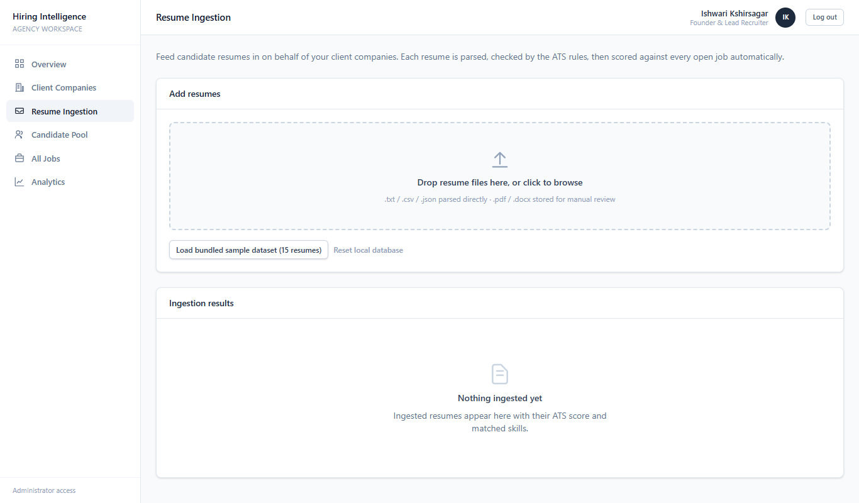
Figure 5. Resume ingestion page

5.4 The ATS score
The ATS score shows how complete a resume is. It is the sum of six checks. A score of 60 or more counts as passed, and every failed check is listed as a flag on the candidate's profile.
Check | Points | Flag when it fails
Email address found | 20 | No email address found
Phone number found | 10 | No phone number found
At least 3 recognised skills | 30 | Fewer than 3 recognised skills
Years of experience stated | 20 | Years of experience not stated
Education section detected | 10 | No education section detected
Resume text of at least 200 characters | 10 | Resume text unusually short

5.5 The match score and ranking
For each candidate and job, the match score is: round( skill coverage x 70 + experience fit x 30 ).
- Skill coverage is the number of the job's required skills found on the resume, divided by the number of required skills. Skills are compared without regard to upper or lower case.
- Experience fit is 1.0 when the candidate's years are inside the job's range. Below the minimum or above the maximum it falls towards 0 the further away the candidate is.
Worked example. A job needs Java, Spring Boot, PostgreSQL and Kafka, with 4 to 8 years of experience. A candidate has Java, Spring Boot and PostgreSQL and 5 years. Skill coverage is 3 of 4 = 0.75. The 5 years are inside the range, so the experience fit is 1.0. The score is 0.75 x 70 + 1.0 x 30 = 82.5, which rounds to 83. The explanation reads: covers 3 of 4 required skills, gap: Kafka, 5 years is inside the 4 to 8 year window.
Candidates are listed from the highest score to the lowest. A score of 80 or more is labelled Strong, 60 to 79 Moderate and below 60 Weak on the shortlist page. The recruiter can move any candidate to Shortlisted or Rejected; that manual choice is locked so re-scoring never overwrites it.
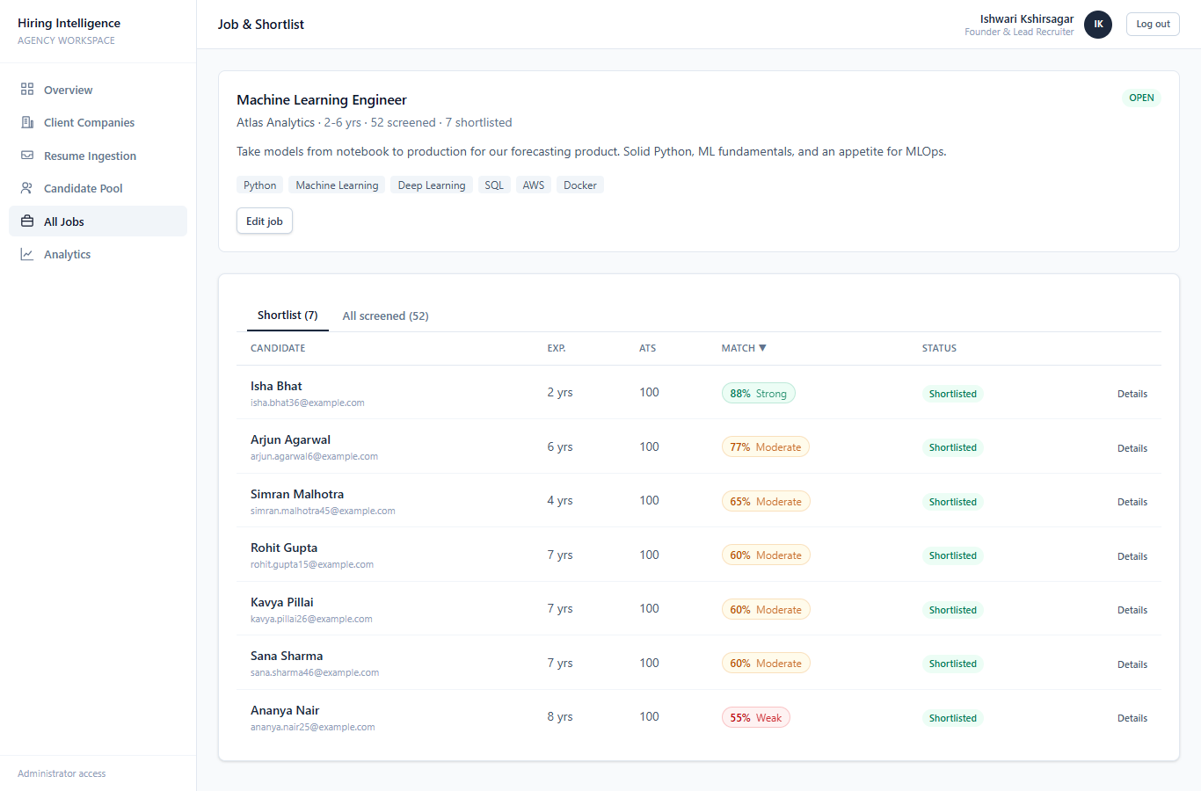
Figure 6. A job with its ranked shortlist, match scores and status
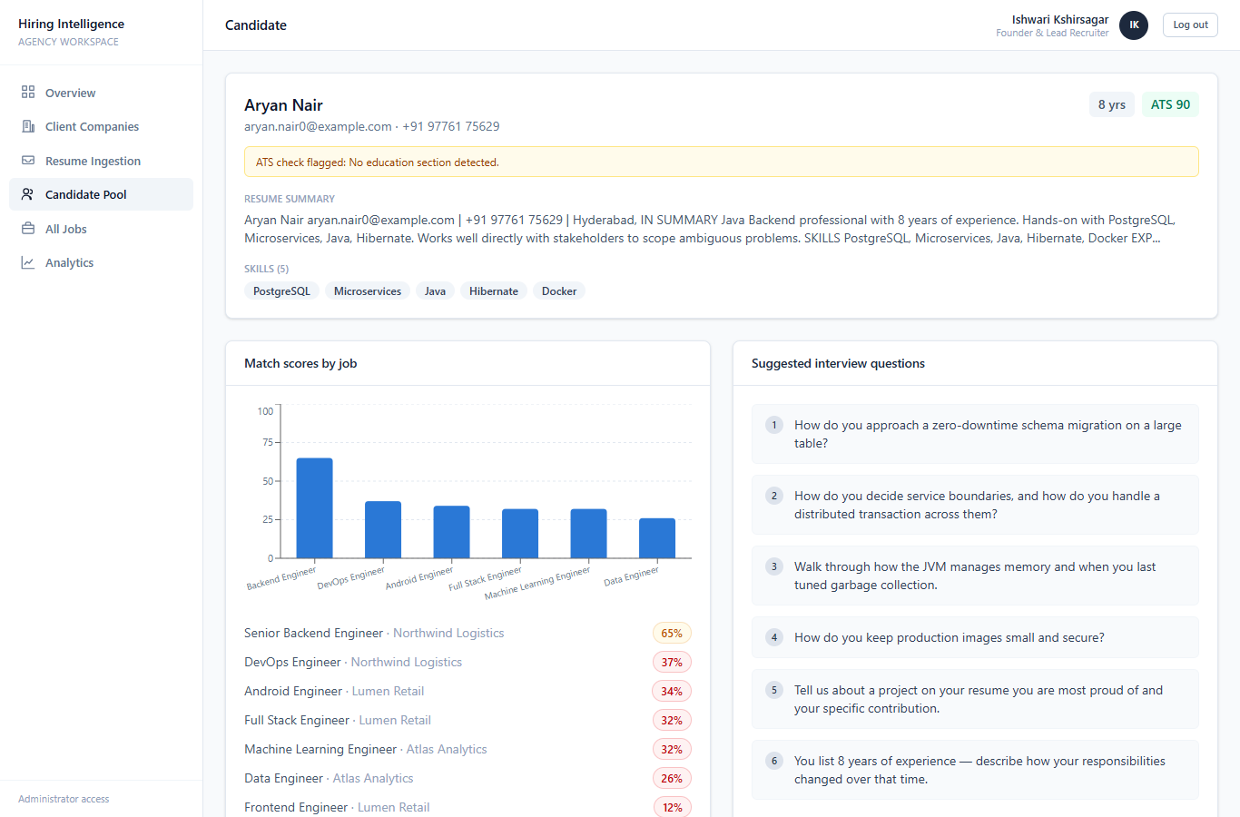
Figure 7. Candidate profile: skills, ATS flags, per-job scores and interview questions

5.6 Candidate pool, jobs and analytics
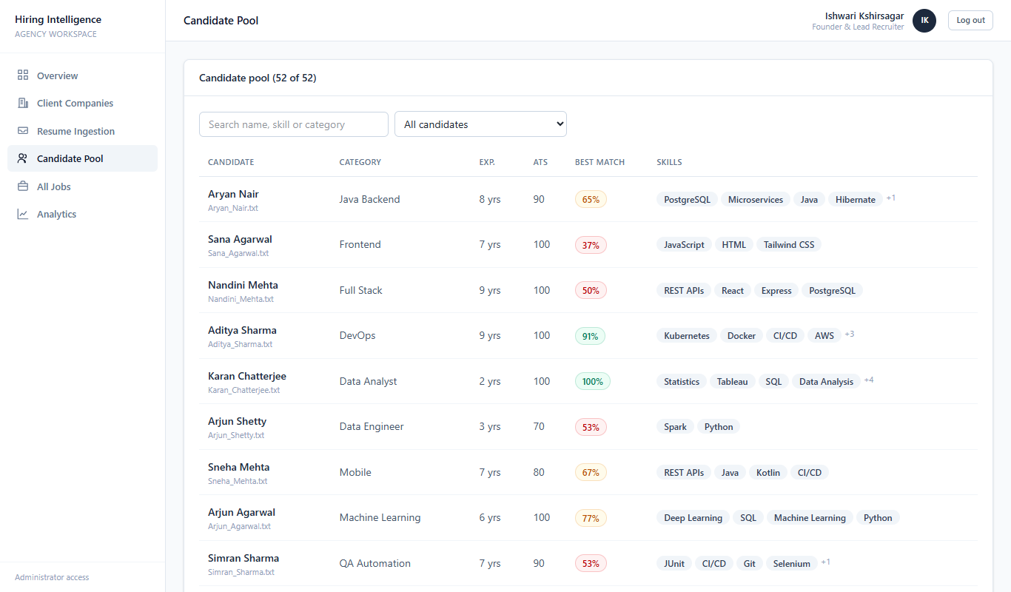
Figure 8. Candidate pool (administrator)
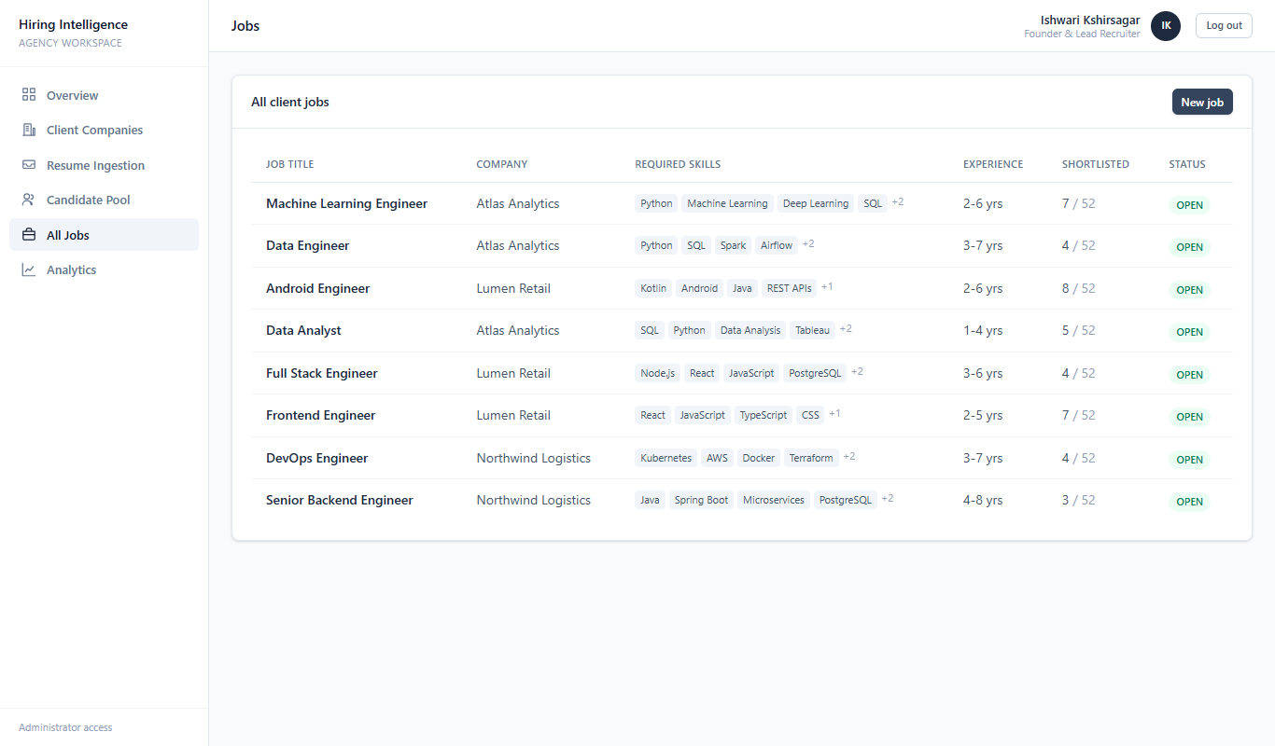
Figure 9. All jobs
The Analytics page has four charts: the most common skills in the pool, the screening funnel (ingested, matched, strong match, shortlisted, rejected), the skill gap (skills jobs ask for against skills candidates have) and the number of resumes ingested per month. The Reports page creates and lists reports.
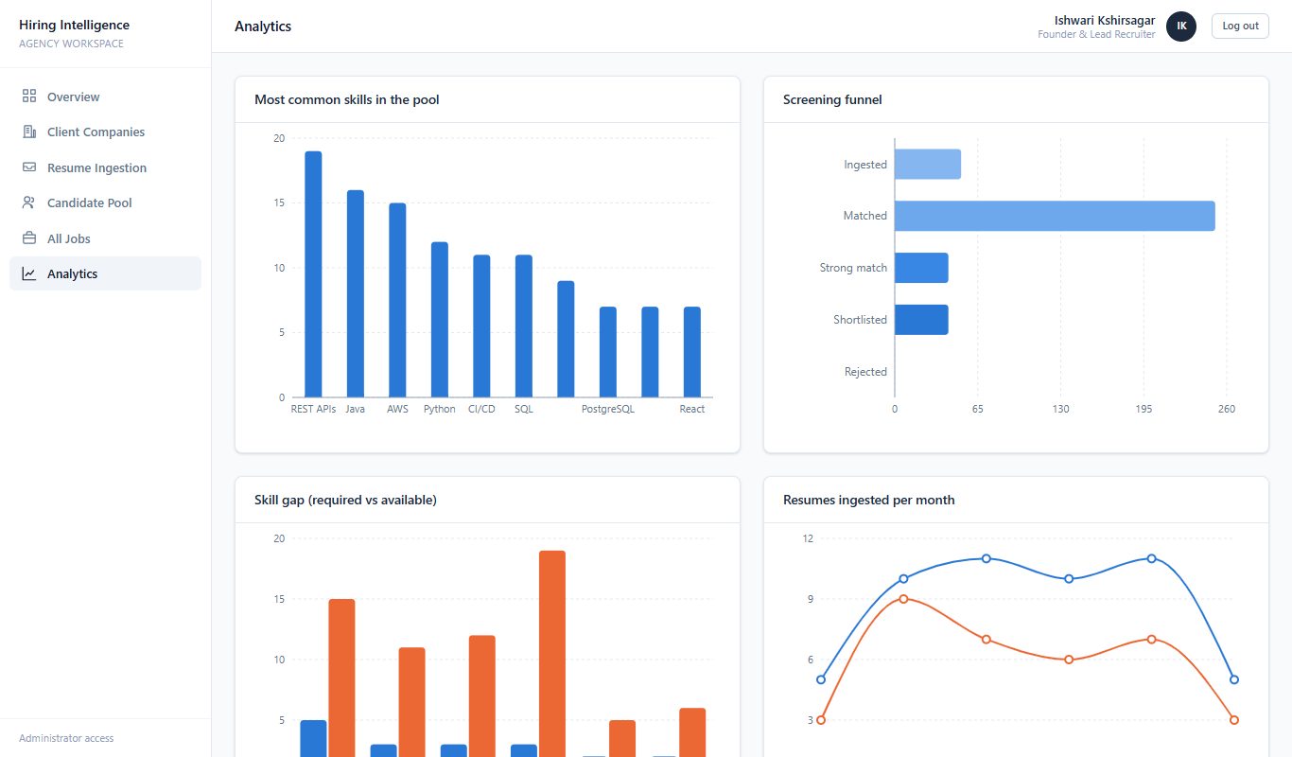
Figure 10. Analytics page

5.7 What a recruiter sees
A recruiter from a client company sees a smaller menu and only the data of their own company. In the example below, the Northwind Logistics recruiter sees two jobs. Opening an administrator page shows a 403 screen, and the same request made directly to the API is refused.
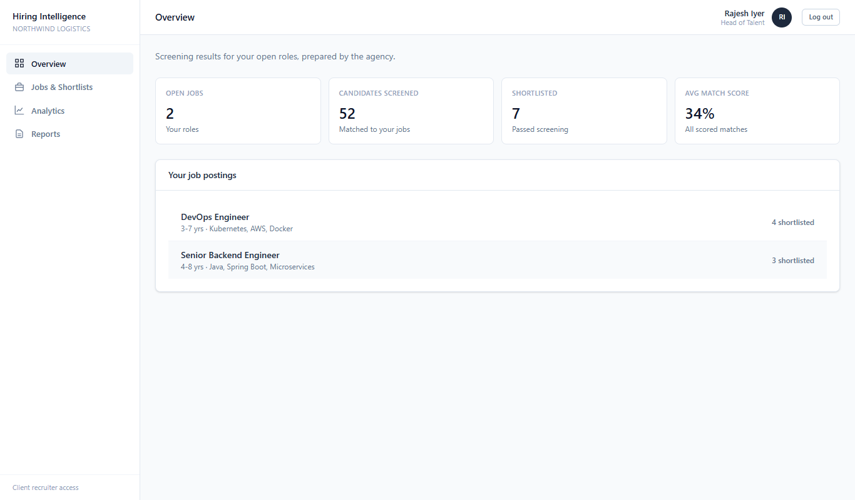
Figure 11. Recruiter dashboard (Northwind Logistics)
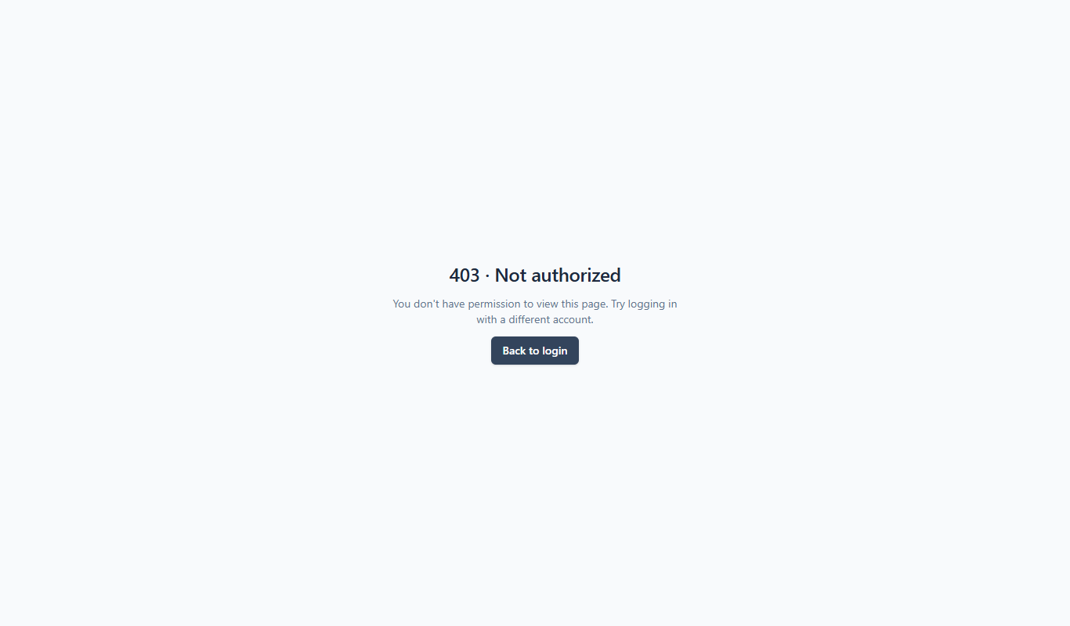
Figure 12. A recruiter opening an administrator page

5.8 Phone layout
Below 768 pixels wide, the sidebar becomes a slide-out menu opened by a button in the top bar, and the summary tiles fit the screen.
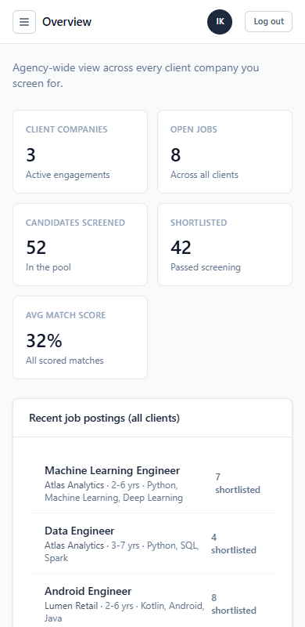
Figure 13. Overview on a phone-width screen
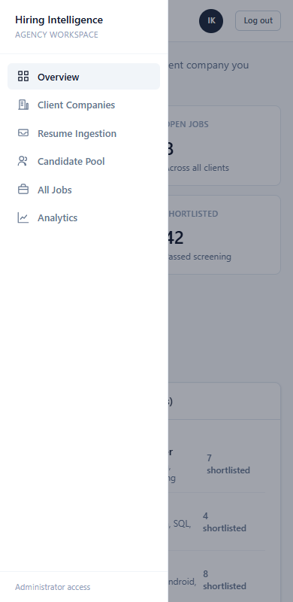
Figure 14. The menu opened on a phone

5.9 Speed: the read cache
Dashboard, analytics, job, company and candidate lists are stored in memory for up to five minutes and cleared whenever anyone adds or changes data. Job lists are also loaded with three queries instead of two per job. On the live system this cut the average response time of cached calls by 54% to 77%.

6. Diagrams Used in the Project
Two groups of diagrams were used. The project planning diagrams show how the work was organised and scheduled. The software design diagrams show what was built.
Diagram | Group | What it shows | Used for in this project
Work Breakdown Structure (WBS) | Planning | The project split into work packages and tasks | Seven packages, each task linked to a schedule activity
Activity-on-Node (AON) precedence diagram | Planning | Activities as boxes joined by dependency arrows | Order of the 12 activities
Activity-on-Arrow (AOA) network diagram | Planning | Activities as arrows between numbered events, with dummy activities | Event times and dependencies
Critical Path Method (CPM) diagram | Planning | Earliest and latest start and finish, slack, longest path | Critical path A-C-E-F-I-J-K-L, 23 days
PERT chart | Planning | Three-point time estimates, expected time, variance | Expected 24.5 days, 16% chance of 23
Use case diagram | Design | Actors and what they can do | Administrator and recruiter functions
Class diagram (2) | Design | Classes, fields, methods and relationships | Domain model; services and screening engine
Entity-Relationship (ER) diagram | Design | Tables, keys and relationships | Six database tables

Architecture, screen flow and data tables are described in words and tables in Sections 4, 5 and 7. Gantt charts, data flow diagrams, sequence diagrams and deployment diagrams were not drawn for this version.

6.1 Schedule basis
The project ran from 27 August to 20 September 2026. The work was split into twelve activities (A to L). Durations are planning estimates in days, sized to that real span. They are not recorded time-sheets.
ID | Activity | Predecessors | Duration (d) | ES | EF | LS | LF | Slack | Critical? | Linked WBS
A | Requirements & scope | - | 2 | 0 | 2 | 0 | 2 | 0 | Yes | 1.1, 1.2
B | Frontend prototype (v1) | A | 3 | 2 | 5 | 7 | 10 | 5 | No | 2.1, 3.1
C | Screening engine design | A | 3 | 2 | 5 | 2 | 5 | 0 | Yes | 2.2
D | Database / ER design | A | 2 | 2 | 4 | 3 | 5 | 1 | No | 2.3
E | Spring Boot backend + JPA | C, D | 5 | 5 | 10 | 5 | 10 | 0 | Yes | 3.2
G | Project documentation | B, C | 2 | 5 | 7 | 19 | 21 | 14 | No | 7.1, 7.3
F | Frontend-API integration | B, E | 3 | 10 | 13 | 10 | 13 | 0 | Yes | 3.3
H | Neon database setup | E | 2 | 10 | 12 | 11 | 13 | 1 | No | 4.1
I | Deploy (Vercel + Render) | F, H | 2 | 13 | 15 | 13 | 15 | 0 | Yes | 4.2
J | Test plan + test cycle 1 | I | 3 | 15 | 18 | 15 | 18 | 0 | Yes | 5.1, 5.2, 7.2
K | Defect fixing | J | 3 | 18 | 21 | 18 | 21 | 0 | Yes | 6.1
L | Re-test & release v2.0 | K, G | 2 | 21 | 23 | 21 | 23 | 0 | Yes | 5.3, 6.2
ES/EF = earliest start/finish, LS/LF = latest start/finish, slack = LS - ES. Shaded rows are on the critical path. Project duration: 23 days.

6.2 Work Breakdown Structure
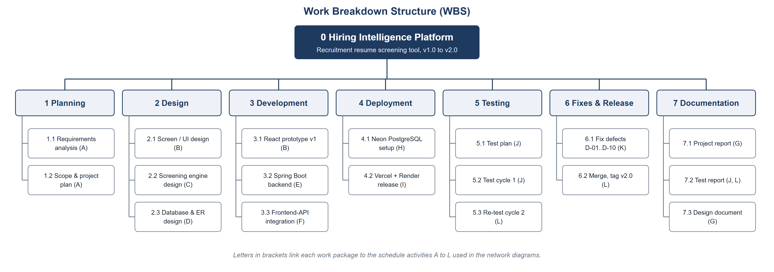
Figure 15. Work Breakdown Structure

6.3 Activity-on-Node precedence diagram
An arrow from X to Y means Y cannot start until X has finished. E waits for both C and D, and L waits for both K and G.
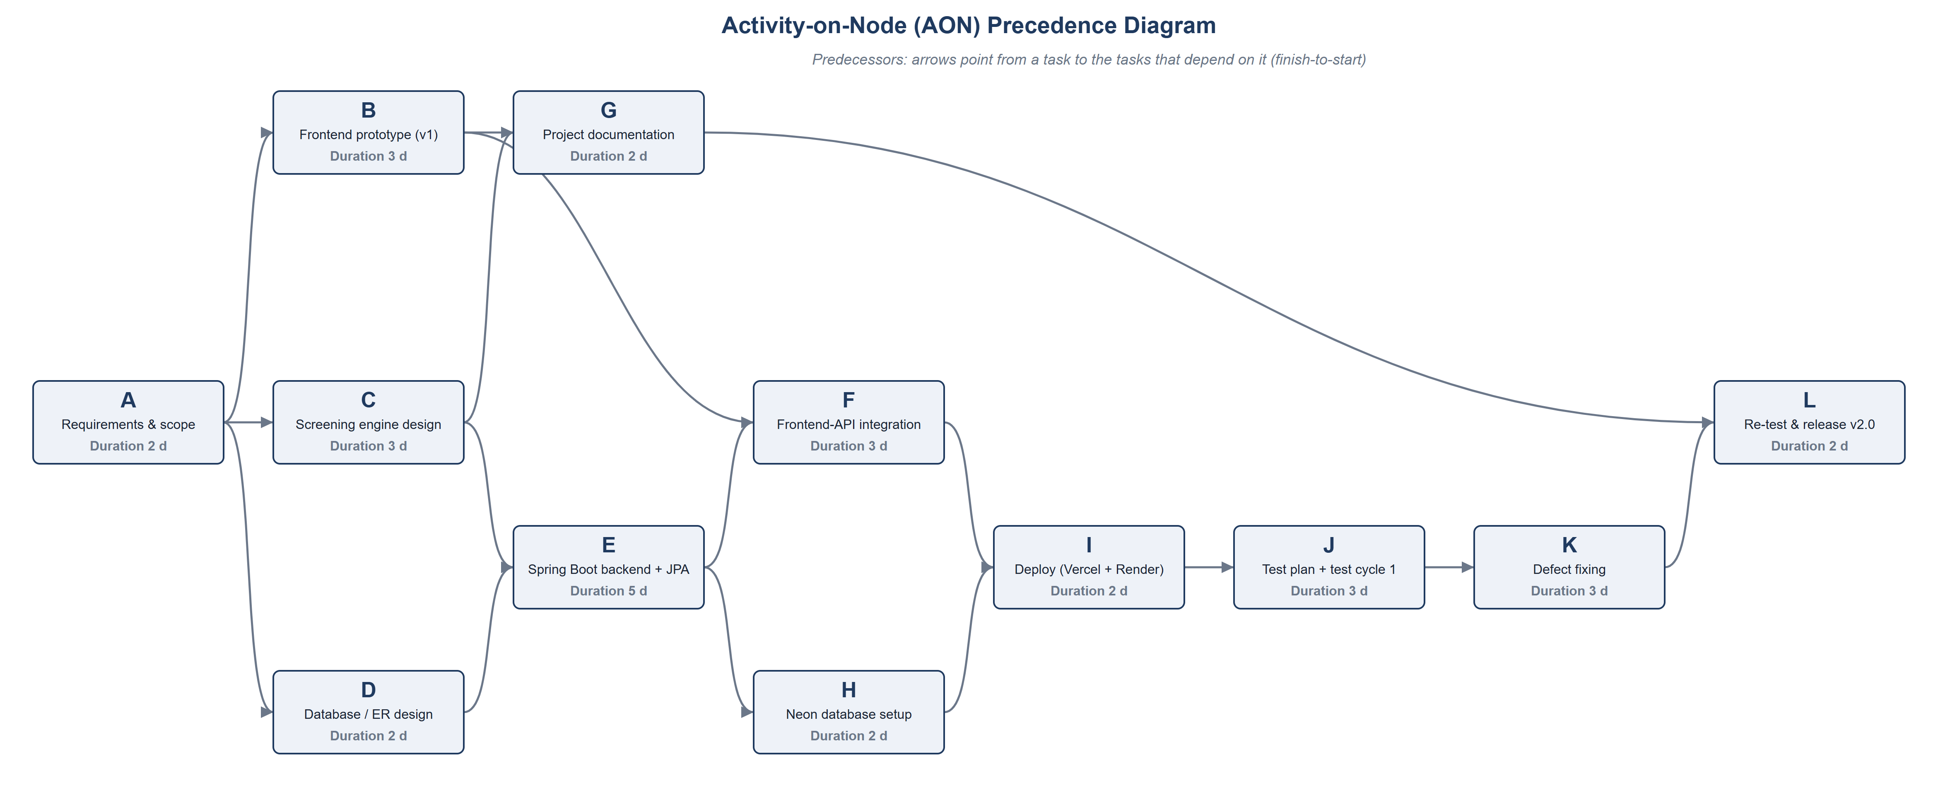
Figure 16. AON precedence diagram

6.4 Activity-on-Arrow network diagram
Circles are events, arrows are activities, dashed arrows are dummy activities of zero length. Under each event, green is the earliest time and red is the latest time.
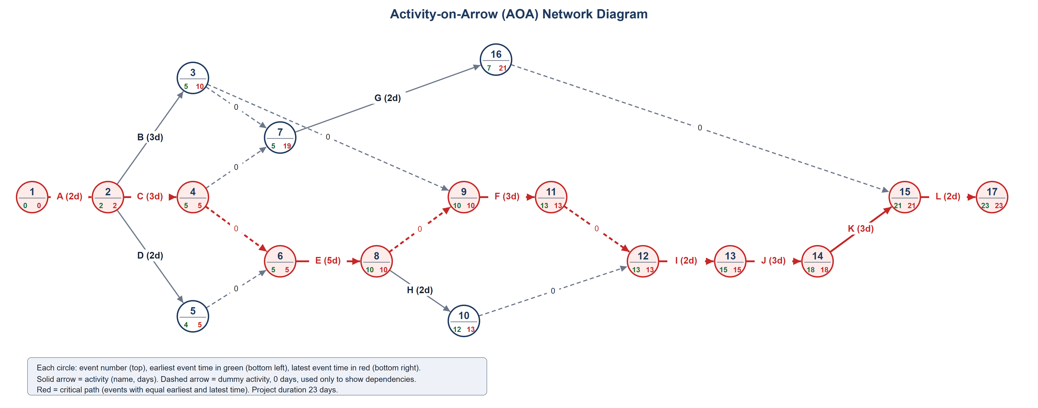
Figure 17. AOA network diagram; critical path in red

6.5 Critical Path Method
The critical path is A, C, E, F, I, J, K, L: 23 days. Activities D and H have one day of slack, B has five and G has fourteen. The backend (E, 5 days) is the longest activity on the critical path, so it carries the most schedule risk.
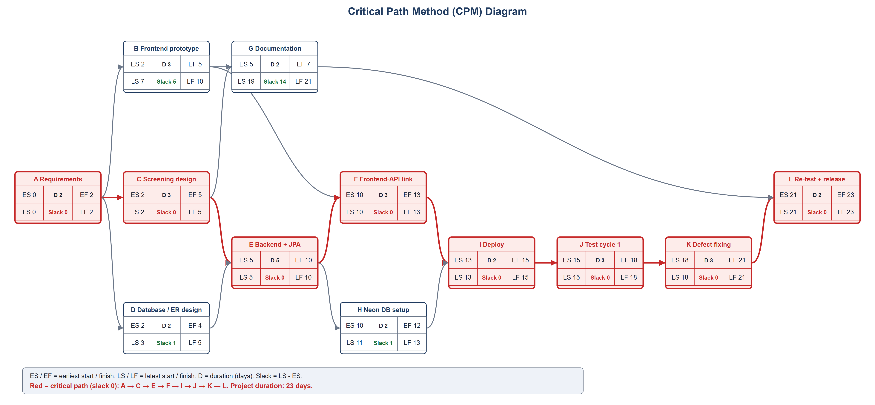
Figure 18. CPM diagram with slack and the critical path

6.6 PERT chart
Expected time te = (O + 4M + P) / 6. The expected duration is 24.5 days with a standard deviation of 1.5 days, so the chance of finishing within the planned 23 days is about 16%.
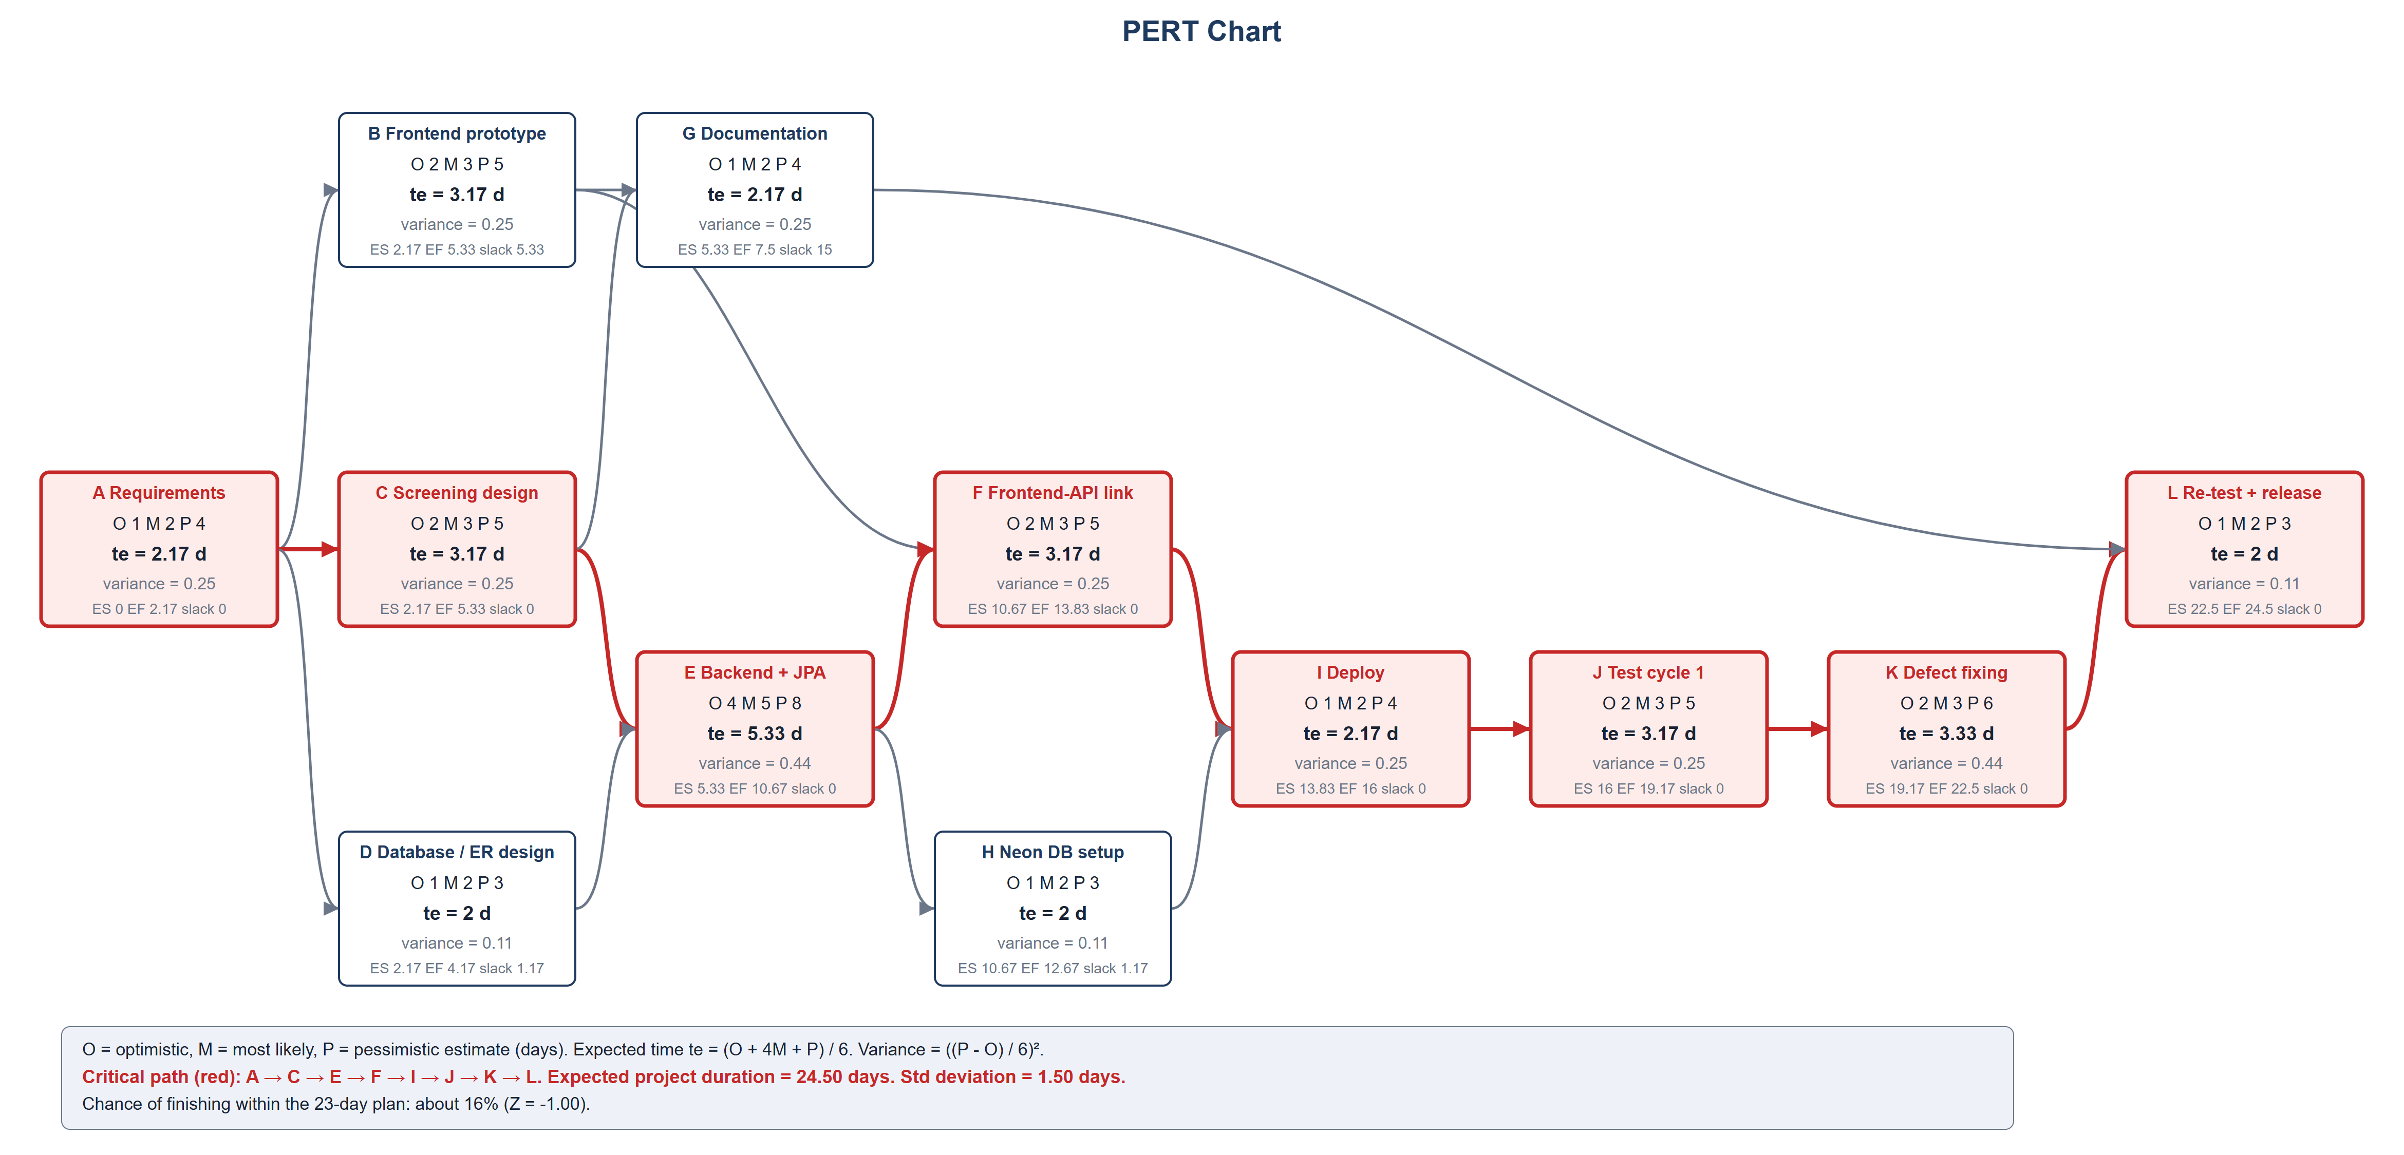
Figure 19. PERT chart
ID | Activity | O | M | P | Expected te | Variance | ES | EF | Critical?
A | Requirements & scope | 1 | 2 | 4 | 2.17 | 0.25 | 0 | 2.17 | Yes
B | Frontend prototype (v1) | 2 | 3 | 5 | 3.17 | 0.25 | 2.17 | 5.33 | No
C | Screening engine design | 2 | 3 | 5 | 3.17 | 0.25 | 2.17 | 5.33 | Yes
D | Database / ER design | 1 | 2 | 3 | 2 | 0.11 | 2.17 | 4.17 | No
E | Spring Boot backend + JPA | 4 | 5 | 8 | 5.33 | 0.44 | 5.33 | 10.67 | Yes
G | Project documentation | 1 | 2 | 4 | 2.17 | 0.25 | 5.33 | 7.5 | No
F | Frontend-API integration | 2 | 3 | 5 | 3.17 | 0.25 | 10.67 | 13.83 | Yes
H | Neon database setup | 1 | 2 | 3 | 2 | 0.11 | 10.67 | 12.67 | No
I | Deploy (Vercel + Render) | 1 | 2 | 4 | 2.17 | 0.25 | 13.83 | 16 | Yes
J | Test plan + test cycle 1 | 2 | 3 | 5 | 3.17 | 0.25 | 16 | 19.17 | Yes
K | Defect fixing | 2 | 3 | 6 | 3.33 | 0.44 | 19.17 | 22.5 | Yes
L | Re-test & release v2.0 | 1 | 2 | 3 | 2 | 0.11 | 22.5 | 24.5 | Yes

6.7 Use case diagram
Both actors log in, view dashboards and analytics, work with jobs and reports, and see ranked shortlists. Only the administrator manages companies, ingests resumes, sees the candidate pool and resets demo data. Viewing a shortlist includes scoring and ranking; ingesting resumes includes parsing and the ATS check.
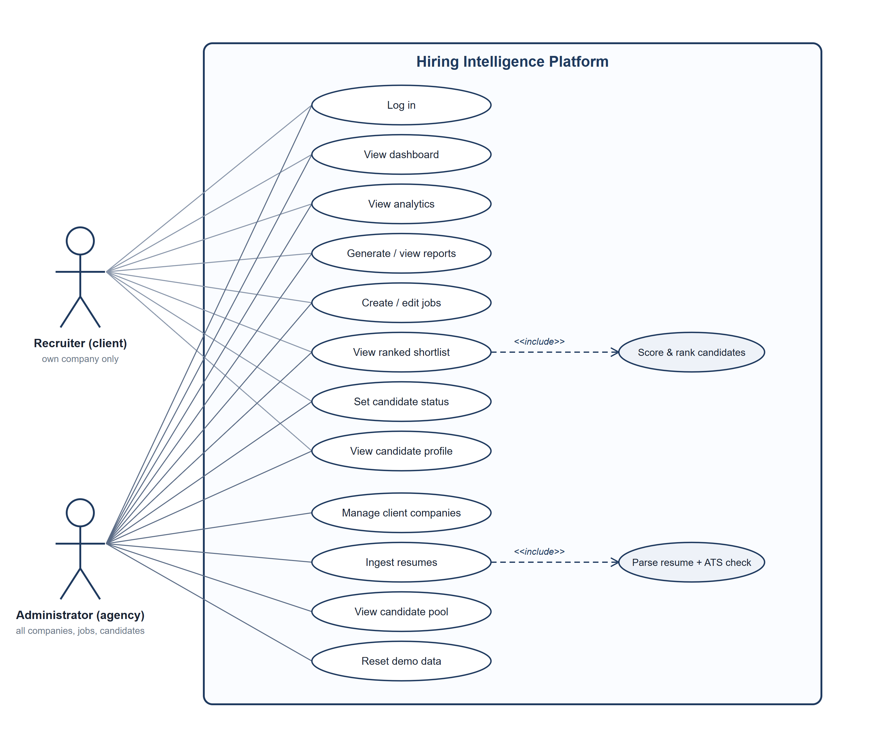
Figure 20. Use case diagram

6.8 Class diagrams
The domain model has six entities and three enumerations. Relationships are kept as UUID foreign keys.
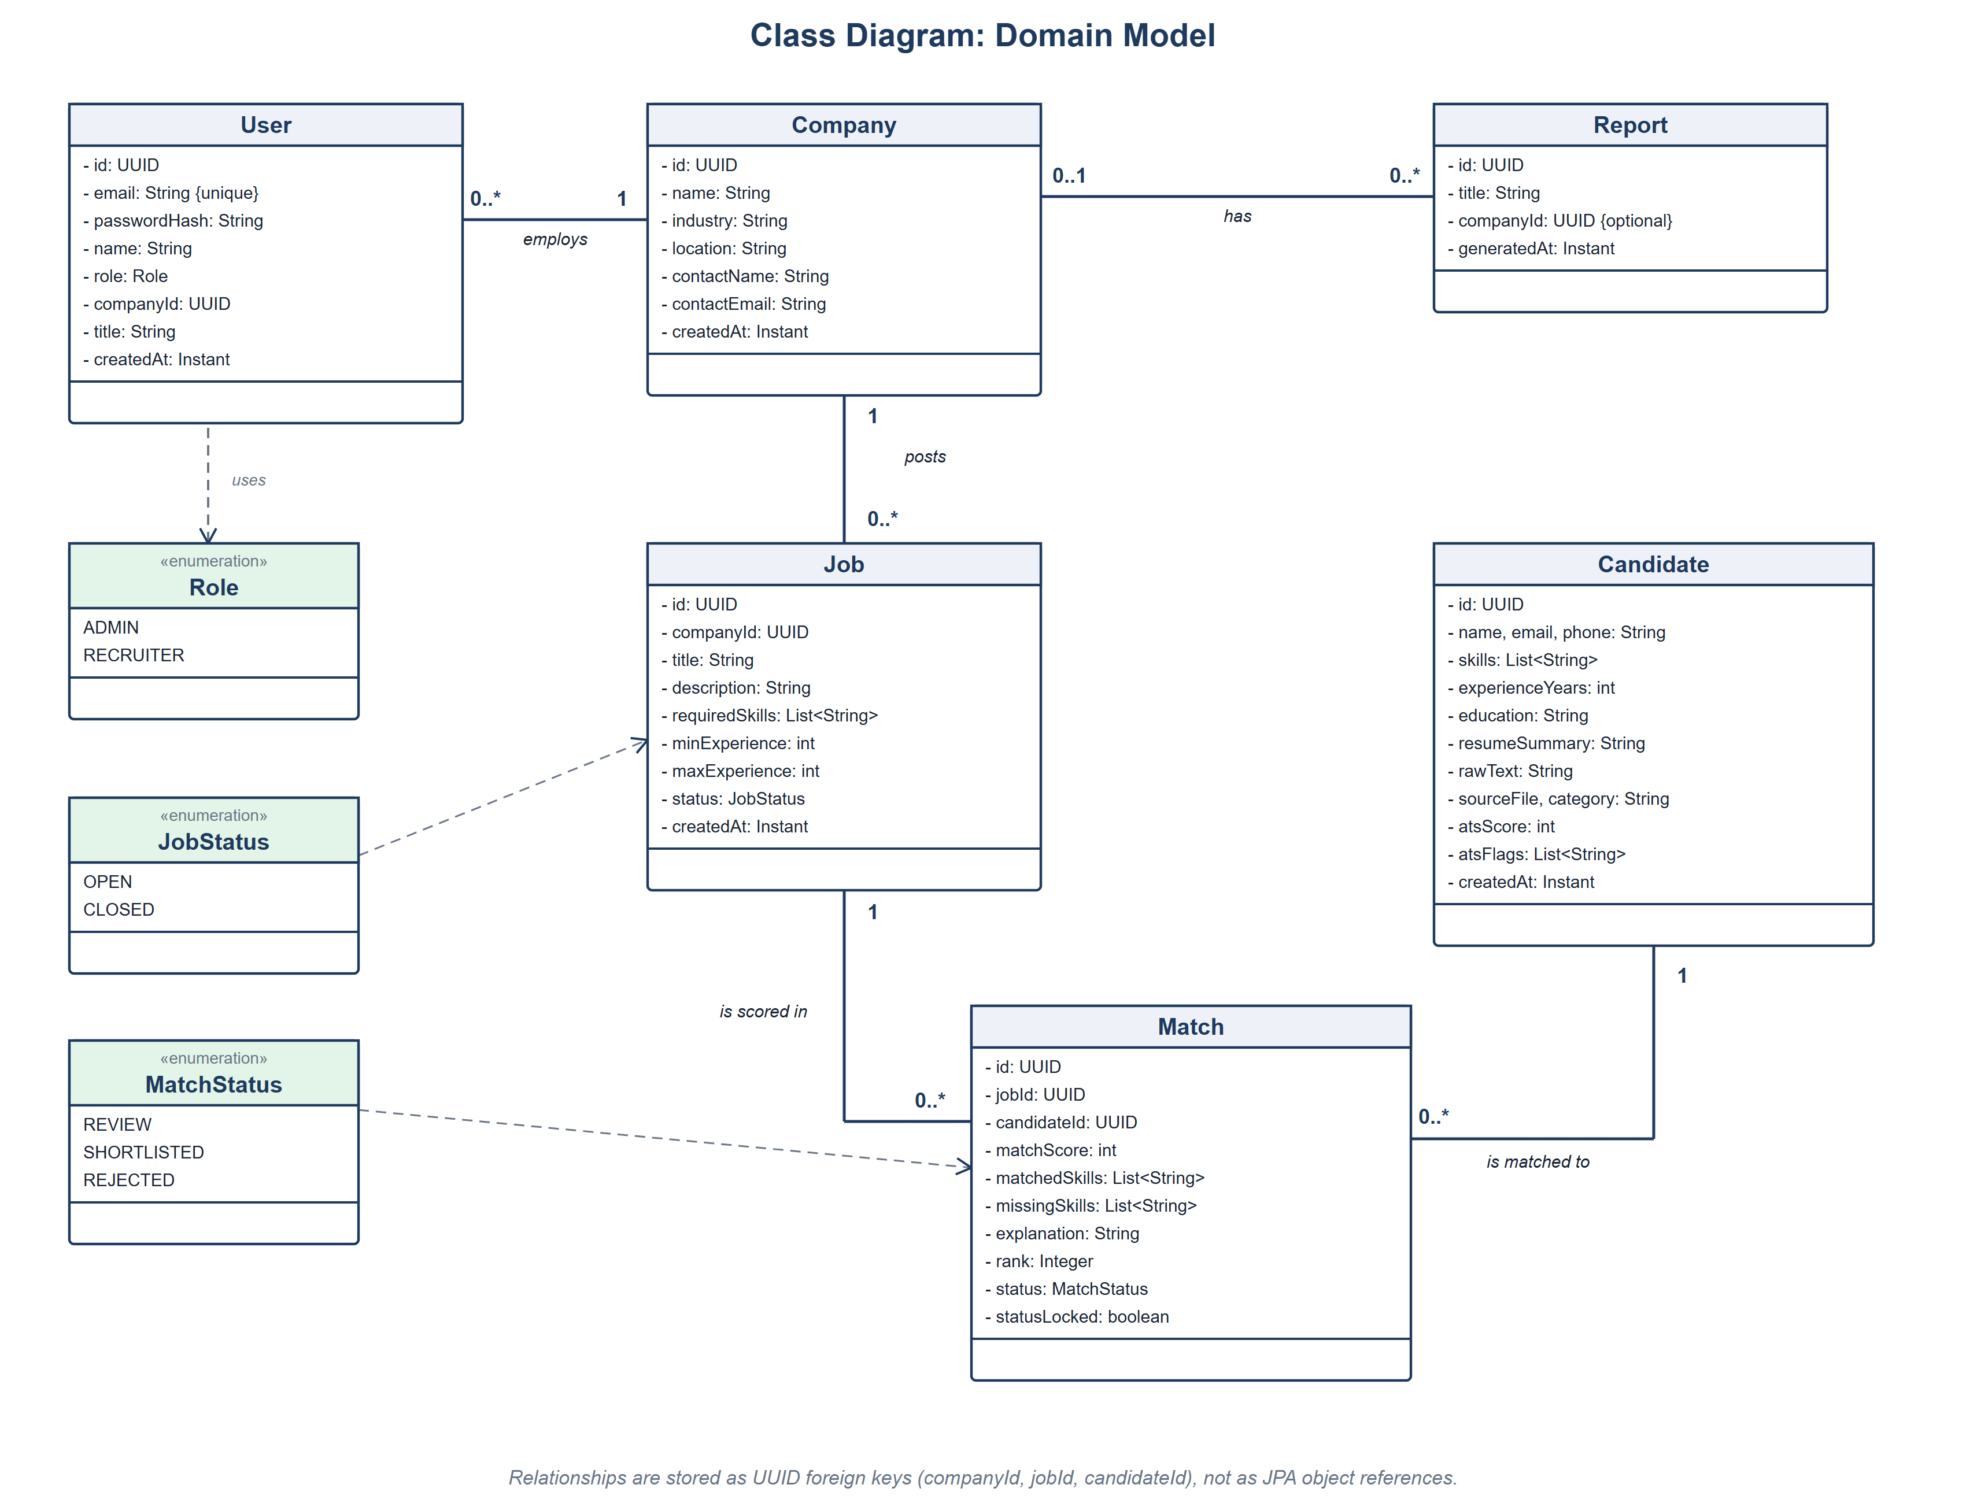
Figure 21. Class diagram: domain model

6.9 Class diagram: services and screening engine
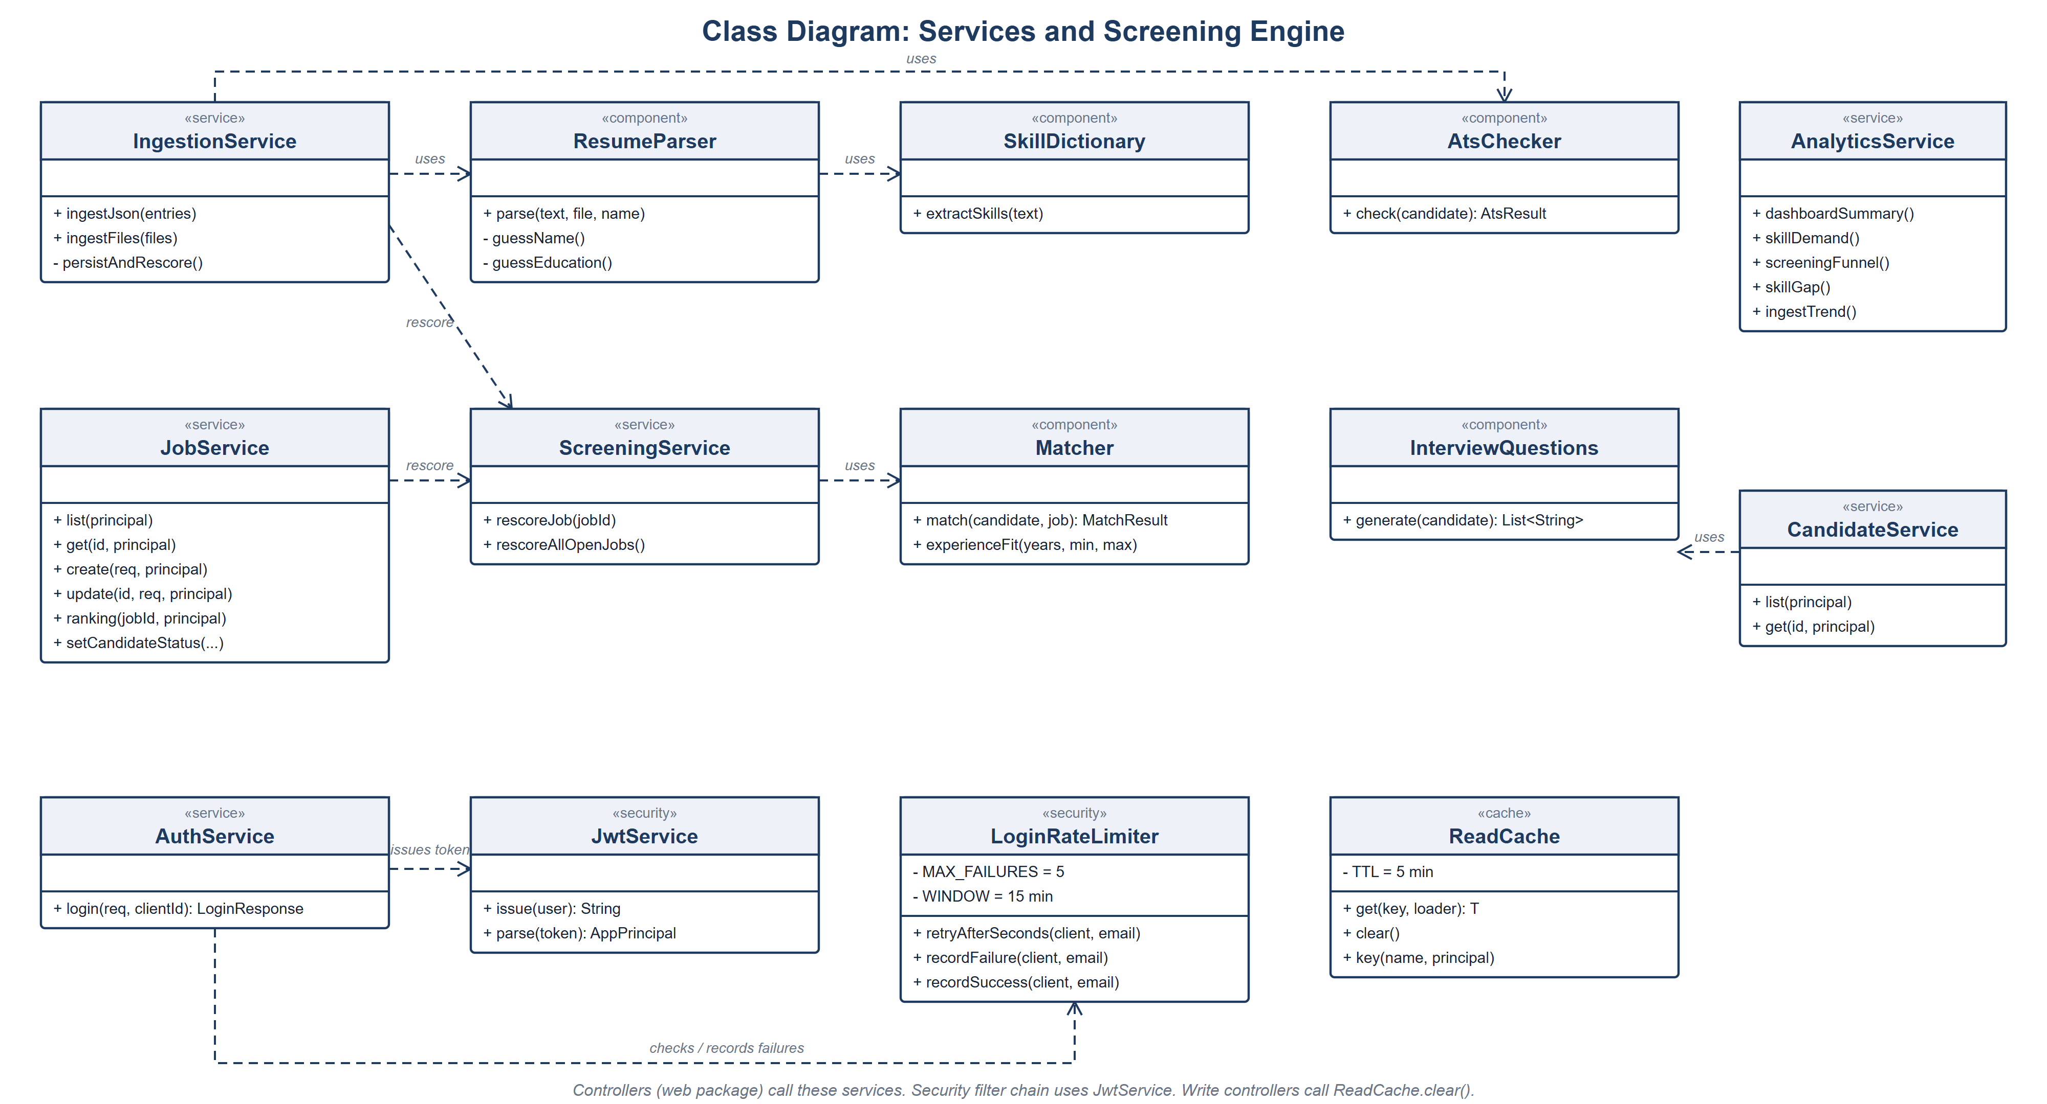
Figure 22. Class diagram: services, screening engine, security and cache

6.10 Entity-Relationship diagram
A company has many users, jobs and reports. Jobs and candidates are linked through the matches table, which is unique on (job_id, candidate_id).
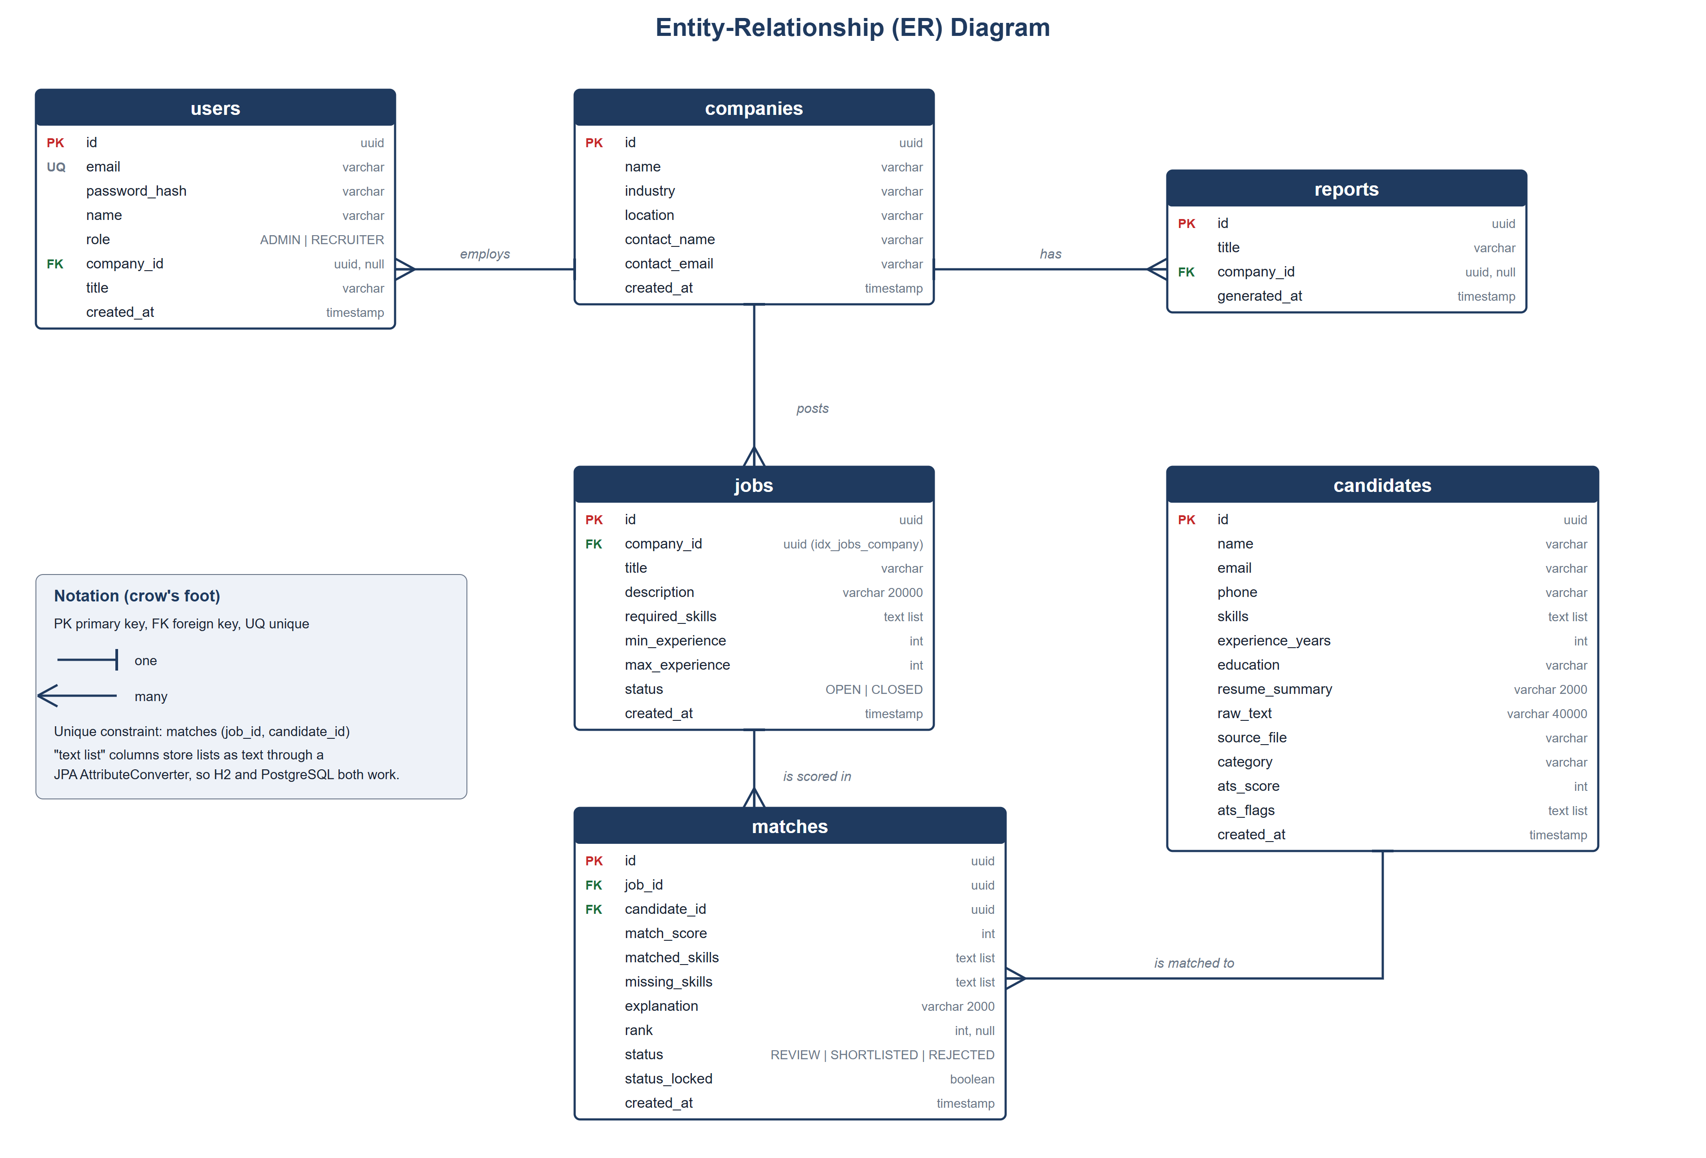
Figure 23. ER diagram

7. Database Design
The database has six tables. Hibernate creates them automatically. List-valued fields (skills, flags) are stored as text through a converter so that the same code runs on H2 and PostgreSQL.
Table | Key columns | Notes
users | id (PK), email (unique), password_hash, role, company_id (FK) | Roles ADMIN and RECRUITER. Administrators have no company.
companies | id (PK), name, industry, location, contact | Client companies of the agency
jobs | id (PK), company_id (FK, indexed), title, description, required_skills, min/max_experience, status | Status OPEN or CLOSED
candidates | id (PK), name, email, phone, skills, experience_years, education, raw_text, ats_score, ats_flags | One row per ingested resume
matches | id (PK), job_id (FK), candidate_id (FK), match_score, matched_skills, missing_skills, explanation, status, status_locked | Unique on (job_id, candidate_id). Status REVIEW, SHORTLISTED or REJECTED.
reports | id (PK), title, company_id (FK, optional), generated_at | Generated reports

8. Implementation Details

8.1 Repository layout
- backend/ : Spring Boot application (src/main/java, src/test/java, Dockerfile, pom.xml)
- src/ : React application (pages, components, api, context)
- docs/ : test plan and report, design document, screenshots and diagrams
- render.yaml, vercel.json, run-neon.ps1 : deployment and launch configuration

8.2 REST API
Method | Path | Who | Purpose
POST | /api/auth/login | Public | Log in
GET | /api/dashboard/summary | Both | Overview tiles and recent jobs
GET / POST | /api/companies | Admin | List or add companies
GET / POST | /api/jobs | Both | List (own company for recruiters) or create jobs
GET / PUT | /api/jobs/{id} | Both | View or edit a job
GET | /api/jobs/{id}/candidates | Both | Ranked shortlist
PATCH | /api/jobs/{id}/candidates/{candidateId} | Both | Set candidate status
GET | /api/candidates, /api/candidates/{id} | Admin / both | Pool and profile
POST | /api/resumes | Admin | Ingest resumes (JSON or files)
GET | /api/analytics/skills | funnel | skill-gap | trend | Both | Chart data
GET / POST | /api/reports, /api/reports/generate | Both | Reports
POST | /api/admin/reset | Admin | Reload demo data

8.3 Security measures
- BCrypt password hashes; signed tokens; the backend refuses to start with a JWT secret under 32 bytes.
- Method-level role checks plus company checks in the service layer.
- Login throttling: 5 failed attempts per client and email in 15 minutes give HTTP 429.
- Upload allow-list: PDF, DOCX, TXT, MD, CSV, JSON; empty files refused.
- CORS allow-list of front-end addresses; HTTPS on Vercel, Render and Neon.
- Secrets (database URL, JWT secret) are kept in environment variables and git-ignored files, not in the code.

8.4 Error handling
Status | When | Body
400 | Validation failed, bad file type, min above max, empty batch | JSON: timestamp, status, error, message
401 | No or bad token, wrong password | Same
403 | Role or company does not allow it | Same
404 | Unknown id | Same
429 | Too many failed logins | Same plus Retry-After header

9. Testing
Testing was done in two cycles. The complete plan, every test case, the results, screenshots and the defect log are in the separate document "Hiring Intelligence Test Plan and Report" (docs folder). This section summarises it.

9.1 Types of testing performed
Type | What was done | Status
Black-box (API) | 45 tests through HTTP only: 34 on login, roles, validation, injection, CORS, jobs, companies, ingestion, analytics and reports, plus 11 defect regression tests | Executed
White-box / unit | 49 tests on branches and boundaries of the matcher, ATS checker, resume parser, JWT service, login limiter, cache, interview questions | Executed
Integration | Whole Spring context with security filters, JPA and seeded H2 database | Executed
System | Login and all screens checked in a browser on the live site | Executed
Regression | Full suite re-run after every change (94 tests) | Executed
Smoke and sanity | Checks after each deployment | Executed
Security | Authentication, authorisation, injection, tokens, CORS, upload, brute force | Executed
Performance and load | Timed requests, 30 parallel requests | Executed (small scale)
Database | Startup on Neon, seeding, portability H2 to PostgreSQL | Executed
Static analysis | oxlint (0 warnings after fixes), production build | Executed
Alpha | Checklist run by the project team on the live system | Executed
Beta | Plan and feedback form prepared; no outside users yet | Planned, not executed
Usability, browsers, accessibility | Edge and phone width checked; Firefox, Safari, tablet, accessibility not tested | Partly executed

9.2 Results
Measure | Cycle 1 | Cycle 2 (final)
Automated tests | 69 | 94
Failed | 0 (plus 4 failing probe tests) | 0
Line coverage | 83.5% | 88.2%
Branch coverage | 65.3% | 74.0%
Lint warnings | 2 | 0
Defects logged | 10 | 11 in total; 10 addressed

9.3 Defects found and their status
ID | Defect | Severity | Status
D-01 | Slow API responses (1.3 to 3.4 s average) | Medium | Partly fixed: cached calls 0.7 to 1.2 s; first call 2 to 3.6 s
D-02 | Demo credentials shown and pre-filled on login page | Low | Fixed: shown only when a setting is on
D-03 | Short JWT secret accepted | Medium | Fixed
D-04 | Branch coverage below target | Low | Fixed (74.0%)
D-05 | Two lint warnings | Info | Fixed
D-06 | A test expected the wrong result for an empty batch | Info | Closed (test corrected)
D-07 | Any file type accepted as a resume | Medium | Fixed
D-08 | Minimum experience above maximum accepted | Low | Fixed
D-09 | No limit on failed login attempts | Medium | Fixed
D-10 | Layout broken on phone width | Medium | Fixed
D-11 | PDF and DOCX text is not extracted | Medium | Open

No Critical or High defects were found. All fixes were verified with automated regression tests and on the live system.

10. Deployment and Version Control

10.1 Environments
Part | Host | Address
Front end | Vercel | https://hiring-intelligence-eight.vercel.app
Back end | Render (Docker) | https://hiring-intelligence-api.onrender.com
Database | Neon PostgreSQL | Connection kept private in environment variables
The Render free plan sleeps when idle, so the first request after a quiet period can take about 50 seconds.

10.2 Versions in the repository
Branch / tag | Contents
v1 (tag v1.0) | Version 1: React prototype with mock data
tag v2.0-beta | Version 2 before the defect fixes (the build tested in cycle 1)
fix/defects | Branch where the defects were fixed
v2, main (tag v2.0) | Final release with all fixes, tests and documents

10.3 Running the project locally
Back end (uses the embedded H2 database, port 8090):
cd backend
./mvnw spring-boot:run
Front end (port 5173):
npm install
npm run dev
Tests:
cd backend && ./mvnw test

Setting | Meaning
SPRING_PROFILES_ACTIVE=postgres | Use PostgreSQL instead of H2
DB_URL, DB_USER, DB_PASSWORD | PostgreSQL connection (Neon)
APP_JWT_SECRET | Token signing key, at least 32 characters
APP_CORS_ORIGINS | Front-end addresses the API accepts
VITE_API_BASE_URL | Address of the API used by the front end
VITE_SHOW_DEMO_ACCOUNTS=true | Show demo accounts on the login page (demo site only)

Demo accounts (demo site only): administrator ishwari@hiringintelligence.io and client recruiter rajesh.iyer@northwind.example. Both use the demo password shown on the login page. All data in the demo is synthetic.

11. Results, Limitations and Future Scope

11.1 What was achieved
- A working, deployed web application for resume screening and ranking, used by two roles.
- Explainable scoring: every score comes with matched skills, missing skills and a sentence of explanation.
- Company-level data separation for recruiters, checked by automated tests.
- A 94-test automated suite with 88% line coverage and a documented two-cycle test process.
- Complete planning and design diagrams and documents, with three versions kept in the repository.

11.2 Limitations
- PDF and DOCX text is not extracted yet (defect D-11), so only text-like files are fully parsed.
- First requests after a change take 2 to 3.6 s because the Render service and the Neon database are in different regions.
- The read cache and the login throttle live in memory of one server instance.
- Skill matching uses a fixed dictionary, so a skill that is not in it is not recognised.
- Beta testing with real users, other browsers and accessibility checks are still to be done.

11.3 Future scope
- Add PDF and DOCX text extraction (for example Apache PDFBox and Apache POI).
- Move the back end to the same region as the database.
- Add a CI workflow on GitHub that runs the 94 tests on every push.
- Grow the skill dictionary and add synonyms; consider machine-learning ranking once real data exists.
- Email notifications, calendar links for interviews, and sign-up with password reset.
- Run the beta round with recruiters and act on their feedback.

12. Conclusion
The Hiring Intelligence Platform meets its main goal: it turns a pile of resumes into a ranked, explained shortlist for each job, and it keeps each client's data separate. The project was planned with WBS, network diagrams, CPM and PERT, designed with use case, class and ER diagrams, built as a React and Spring Boot application on a managed PostgreSQL database, tested in two cycles, and released as version 2.0. The testing found real weaknesses, and all but one were fixed before release. The remaining work is clear and small: read text from PDF and DOCX files, bring the back end closer to the database, and test with real users.

References
- React documentation: https://react.dev
- Vite documentation: https://vite.dev
- Tailwind CSS documentation: https://tailwindcss.com
- Spring Boot reference: https://docs.spring.io/spring-boot
- Spring Security reference: https://docs.spring.io/spring-security
- PostgreSQL documentation: https://www.postgresql.org/docs
- Neon documentation: https://neon.tech/docs
- Vercel documentation: https://vercel.com/docs
- Render documentation: https://render.com/docs
- JSON Web Token (RFC 7519): https://www.rfc-editor.org/rfc/rfc7519
- JUnit 5 user guide: https://junit.org/junit5
- JaCoCo: https://www.jacoco.org/jacoco

No. | Team member | ID
1 | Ishwari Kshirsagar | 53013240102
2 | Pratiksha Kunwar | 53013240104
3 | Shreya Pillai | 53013240088

