**STOCK MARKET CHARTING**

**MILESTONE-2**

**A.ISHWARYA**

**765521**

**ADD COMPANY**

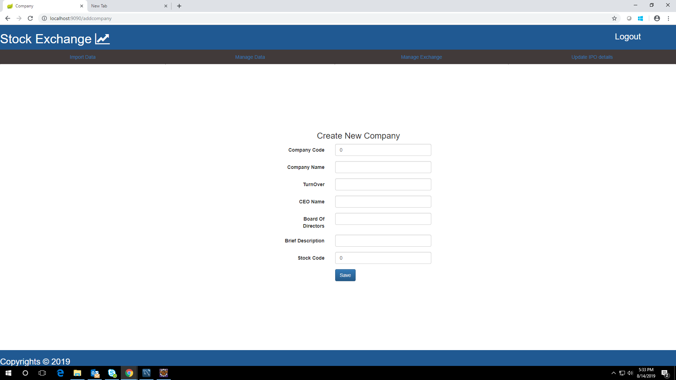

**List Company**

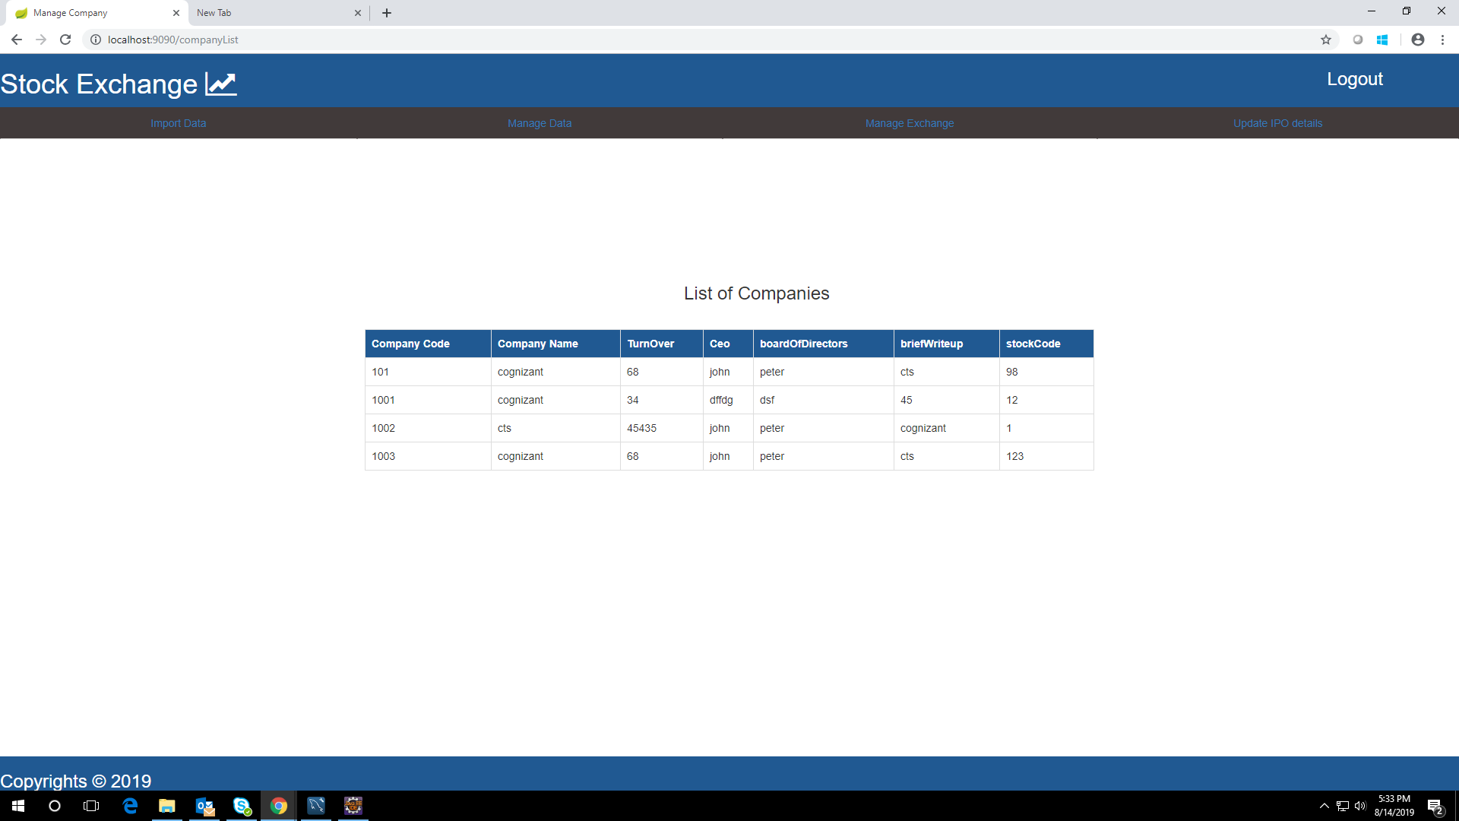

**Stock Exchange**

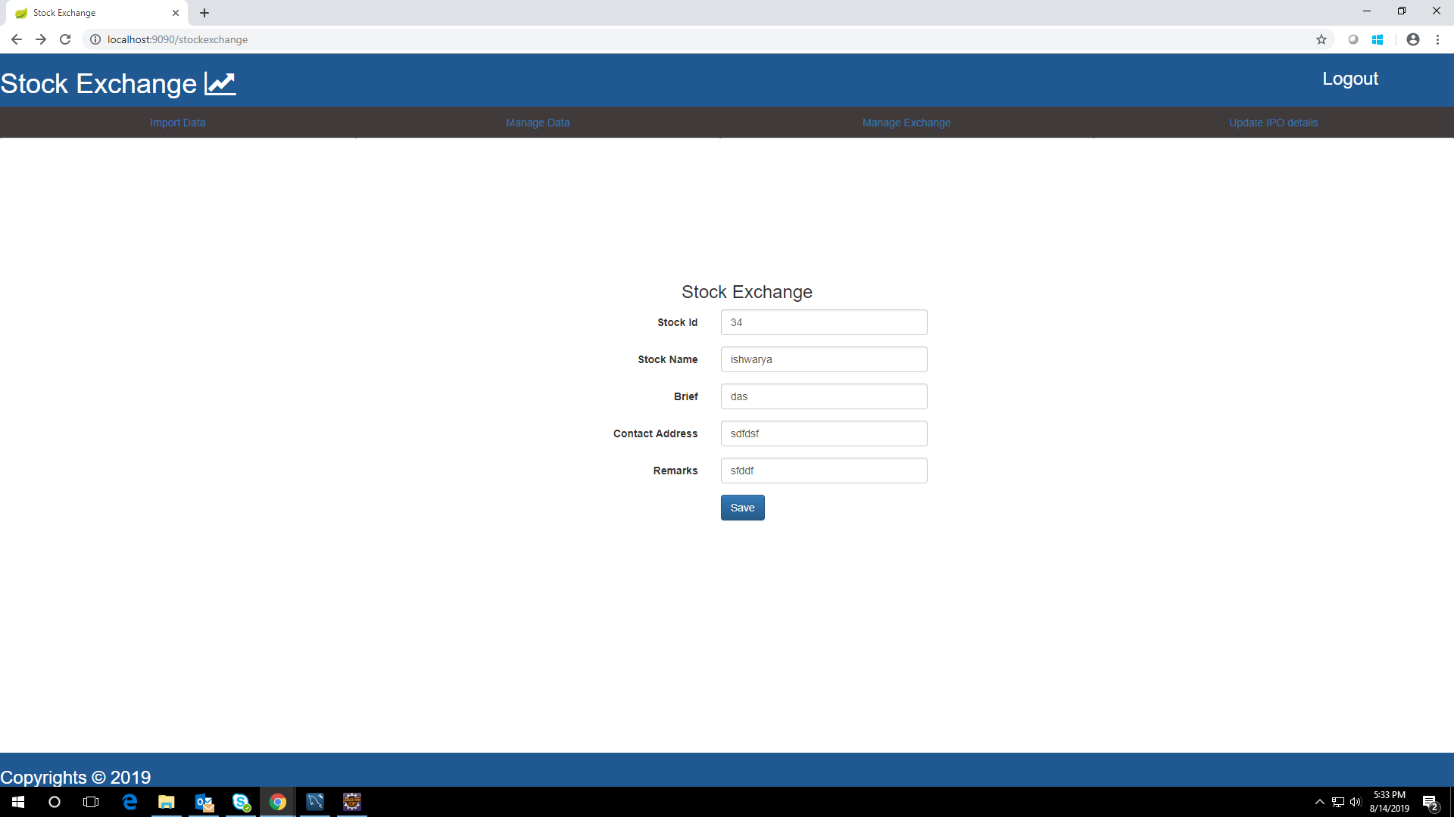

**List Stock Exchange**

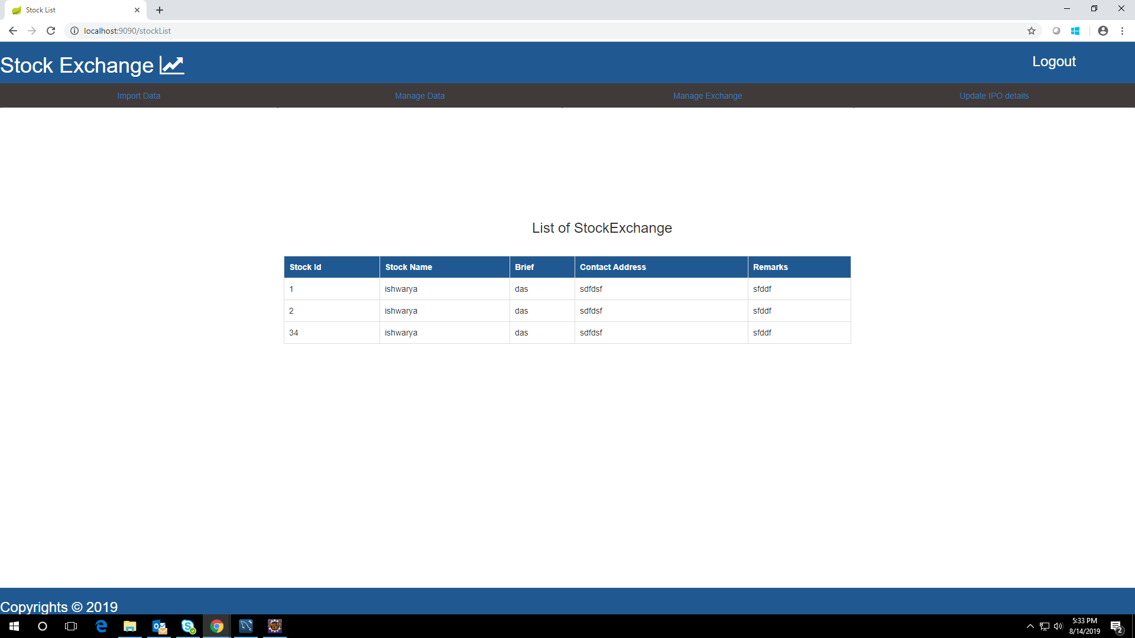

**SignUp**

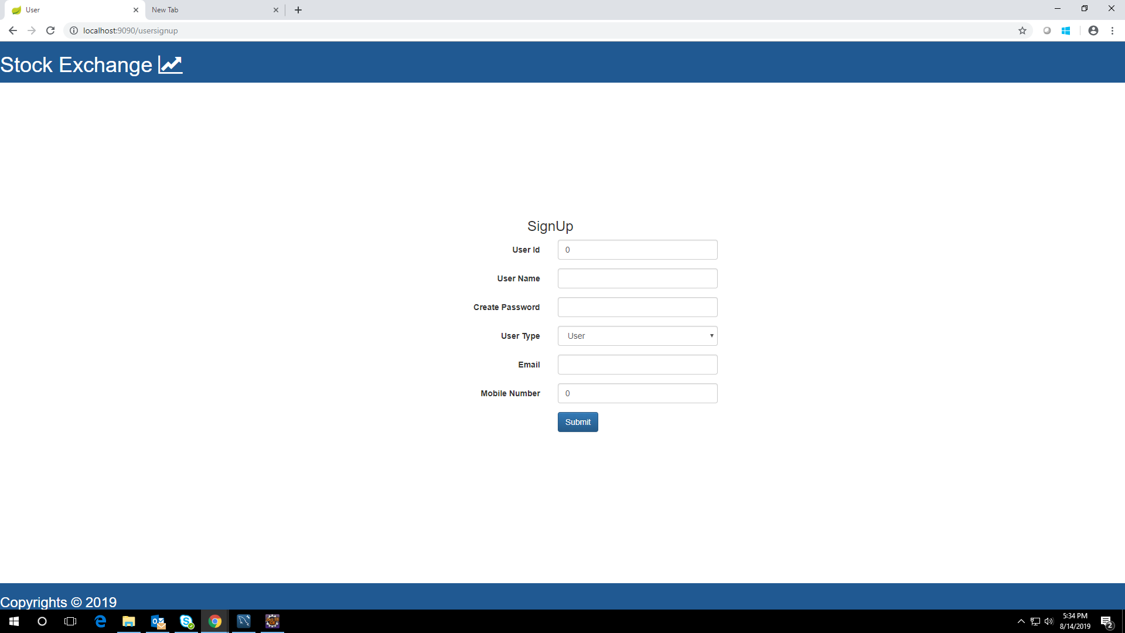

**Github link:**

**https://github.com/ishwarya12a/StockExchange-milestone2**