Retail Inventory Intelligence Dashboard
Preethi Wear: Women Fashion and Maternity Retail
Power BI Project Report
Sector: Retail
Business function: Inventory Management and Stock Management
Tool: Microsoft Power BI Desktop
Phase 1: Business understanding | Phase 2: Data set and cleaning | Phase 3: Solution | Phase 4: Data modelling, DAX and rough dashboard | Phase 5: Dashboard, insights and recommendations

Phase 1: Business Understanding

1. Sector: Retail
Retail is the direct selling of goods and services to the end customer for personal use. Retail businesses include convenience stores, specialty stores, supermarkets, discount stores, department stores, warehouse clubs and online retailers.

2. Business Type: Women Fashion and Maternity Retail
Preethi Wear (https://preethiwear.in) is a Tamil Nadu based women’s fashion brand that focuses on maternity wear and new mom wear. It offers more than 1,000 products across several categories:
- Maternity clothing: kurtis, loungewear, t-shirts, and t-shirt and pant sets.
- Non-maternity clothing: dresses, kurtis, ethnic wear and leggings.
The brand sells through an online store and through retail outlets in Chennai, Coimbatore and Madurai. Its business has reportedly grown from ₹1.2 crore in its first financial year to around ₹16.5 crore in the years that followed.

3. Business Function: Inventory Management and Stock Management
Inventory management means keeping track of everything in the business, from buying materials to selling products. It helps a business to have enough products for its customers without wasting money on extra stock. In short, it is about having the right amount of items at the right time.
Stock management means keeping track of only the finished products that are ready to sell.

4. Business Problem
In the retail industry, managing inventory is essential for profit and for running the business smoothly. Retailers often lack clear visibility of stock in warehouses, stores and distribution channels. This can lead to overstocking, stockouts and improper stock allocation.
- Overstocking means keeping more stock than needed. It increases storage cost, blocks working capital and can lead to wastage or outdated products.
- Stockouts happen when products are not available when customers need them. They cause lost sales, customer dissatisfaction and damage to the brand reputation.
Balancing supply and demand becomes harder when there are many products, many sales channels and changing customer needs. Inventory, sales and replenishment data may also be stored in different systems, which makes it difficult to track stock movement through the supply chain and to identify fast-selling products, slow-moving products and changes in demand.
Understanding historical trends is important for planning future stock. Without proper analytical tools it is hard to forecast demand, plan replenishment and distribute stock efficiently across locations, which leads to reactive instead of proactive inventory planning. Manual reporting is time-consuming, error-prone and hard to update, and stakeholders cannot easily drill down into product, category or regional performance.

Project Objective
This project develops an interactive Retail Inventory Intelligence Dashboard in Power BI. The dashboard brings data from multiple tables into one structured and centralised view to:
- improve inventory visibility and track stock movement
- support data-driven decisions
- help stakeholders understand inventory behaviour and identify stock management problems
- improve inventory planning and reduce operational costs
- improve product availability and supply chain efficiency

Phase 2: Data Set Creation and Data Cleaning
The data set was created with ChatGPT to represent the inventory operations of Preethi Wear. It was generated as three raw CSV files (Inventory_Transactions.csv, Product_Details.csv and Inventory_Locations.csv) and cleaned in Python with pandas and numpy. The cleaned data is saved as three CSV files that are loaded into Power BI.

Data Tables
Table | Role | Grain | Key columns
Inventory_Transactions_Cleaned | Fact table | One row per inventory record, product and date (6,000 rows) | transaction_id, inventory_id, product_id, date, opening_stock, stock_recieved, stock_transfer_in, stock_transfer_out, unit_sold, unit_returned, damaged_stock, unit_cost, sales_amount, closing_stock, stock_out, overstock, stock_issue
Inventory_Locations_Cleaned | Dimension | One row per inventory record (350 rows) across 12 locations | inventory_id, location_id, location_name, location_type, city, channel
Product_Details_Cleaned | Dimension | One row per product (85 products) | product_id, product_name, category, subcategory, size, color, season, supplier, unit_price, product_status

Python Data Cleaning Steps
The cleaning script performs the following steps in order. The full code is given at the end of this phase.
- Load the three raw CSV files and check their shapes and column names.
- Standardise column names: remove extra spaces, convert to lowercase and replace spaces with underscores.
- Check data types, missing values and duplicate rows in all three tables.
- Trim extra spaces in the ID columns and in the text columns of the product and location tables.
- Standardise the stock_out and overstock flags so that Y, YES and yes become Yes, and N, NO and no become No.
- Convert the date column to a proper date type (mixed formats, day first). Dates that cannot be read become blank.
- Convert the nine numeric columns to numbers (invalid values become blank), then check for negative opening stock, units sold and sales amount, and for product prices of zero or less.
- Review the unique values of category, subcategory, product status and the Yes/No flags.
- Remove duplicate transaction rows.
- Create a transaction_id for every row (TXN000001 onwards).
- Calculate closing_stock = opening stock + received + transfer in - transfer out - units sold - damaged stock + units returned.
- Create the stock_issue column: rows with closing stock below zero are marked Negative Stock, all others OK.
- Validate keys: every product_id and inventory_id in the transactions must exist in the product and location tables.
- Save the three cleaned tables as Inventory_Transactions_Cleaned.csv, Product_Details_Cleaned.csv and Inventory_Locations_Cleaned.csv.

Data Profile
- The transactions cover 23 September 2023 to 22 September 2026 (36 months).
- There are 85 products in two categories (Maternity Clothing and Non Maternity), 12 locations in three cities (Chennai, Coimbatore and Madurai), and 350 inventory records.
- Closing stock is calculated by the cleaning script from the movement columns (opening stock plus received plus transfer in, minus transfer out, minus units sold, minus damaged stock, plus units returned), so the stock balance holds on every row.

Data Preparation in Power BI
- Three transaction rows with a blank date were excluded, so the dashboard uses 5,997 transaction rows (18,974 units sold).
- Date types were set, and a Date table, a Month Label column and a Product Label column were created with DAX.
- Product names repeat across sizes (85 product IDs but 23 product names), so charts use a Product Label of name, size and ID.

Python Data Cleaning Script
The complete script used to clean the data set is given below.
import pandas as pd
import numpy as np
#Loaded a data
inventory = pd.read_csv("Inventory_Transactions.csv")
products = pd.read_csv("Product_Details.csv")
locations = pd.read_csv("Inventory_Locations.csv")
print("Data Loaded")
#Checked Shapes
print("\nInventory Shape:")
print(inventory.shape)
print("\nProduct Shape:")
print(products.shape)
print("\nLocation Shape:")
print(locations.shape)
#checked Columns
print("\nInventory Columns:")
print(inventory.columns)
print("\nProduct Columns:")
print(products.columns)
print("\nLocation Columns:")
print(locations.columns)
#cleaned column names
inventory.columns = (
inventory.columns
.str.strip()
.str.lower()
.str.replace(" ", "_")
)
products.columns = (
products.columns
.str.strip()
.str.lower()
.str.replace(" ", "_")
)
locations.columns = (
locations.columns
.str.strip()
.str.lower()
.str.replace(" ", "_")
)
print("Cleaned Column Names")
print("\nInventory Data Types:")
print(inventory.dtypes)
print("\nProduct Data Types:")
print(products.dtypes)
print("\nLocation Data Types:")
print(locations.dtypes)
print("\nMissing Values - Inventory")
print(inventory.isnull().sum())
print("\nMissing Values - Products")
print(products.isnull().sum())
print("\nMissing Values - Locations")
print(locations.isnull().sum())
print("\nDuplicate rows in Inventory:")
print(inventory.duplicated().sum())
print("\nDuplicate rows in Products:")
print(products.duplicated().sum())
print("\nDuplicate rows in Locations:")
print(locations.duplicated().sum())
inventory["inventory_id"] = (
inventory["inventory_id"]
.astype(str)
.str.strip()
)
inventory["product_id"] = (
inventory["product_id"]
.astype(str)
.str.strip()
)
inventory["stock_out"] = (
inventory["stock_out"]
.astype(str)
.str.strip()
)
inventory["overstock"] = (
inventory["overstock"]
.astype(str)
.str.strip()
)
print("Cleaned Inventory Text Columns")
text_columns_locations = [
"inventory_id",
"location_id",
"location_name",
"location_type",
"city",
"channel"
]
for column in text_columns_locations:
locations[column] = locations[column].astype(str).str.strip()
text_columns_products = [
"product_id",
"product_name",
"category",
"subcategory",
"size",
"color",
"season",
"supplier",
"product_status"
]
for column in text_columns_products:
products[column] = products[column].astype(str).str.strip()
print("Cleaned Product and Location Text Columns")
inventory["stock_out"] = (
inventory["stock_out"]
.replace({
"Y": "Yes",
"N": "No",
"YES": "Yes",
"NO": "No",
"yes": "Yes",
"no": "No"
})
)
inventory["overstock"] = (
inventory["overstock"]
.replace({
"Y": "Yes",
"N": "No",
"YES": "Yes",
"NO": "No",
"yes": "Yes",
"no": "No"
})
)
print("Standrized Yes and No Values")
inventory["date"] = pd.to_datetime(
inventory["date"],
format="mixed",
dayfirst=True,
errors="coerce"
)
print("\nInvalid / Missing Dates:")
print(inventory["date"].isnull().sum())
numeric_columns = [
"opening_stock",
"stock_recieved",
"stock_transfer_in",
"stock_transfer_out",
"unit_sold",
"unit_returned",
"damaged_stock",
"unit_cost",
"sales_amount"
]

for column in numeric_columns:
inventory[column] = pd.to_numeric(
inventory[column],
errors="coerce"
)
print("Checked Numeric Column")
#checking missing values after conversion
print("\nMissing values in transaction numeric columns:")

print(
inventory[numeric_columns]
.isnull()
.sum()
)
#checking negative values
print("\nNegative Opening Stock:")
print(
inventory[
inventory["opening_stock"] < 0
].shape[0]
)
print("\nNegative Units Sold:")
print(
inventory[
inventory["unit_sold"] < 0
].shape[0]
)
print("\nNegative Sales Amount:")
print(
inventory[
inventory["sales_amount"] < 0
].shape[0]
)
#check product price
print("\nProducts with invalid price:")
print(
products[
products["unit_price"] <= 0
]
)
print("\nProduct Categories:")
print(products["category"].unique())
print("\nSubcategories:")
print(products["subcategory"].unique())
print("\nProduct Status:")
print(products["product_status"].unique())
print("\nInventory Stock Out Values:")
print(inventory["stock_out"].unique())
print("\nInventory Overstock Values:")
print(inventory["overstock"].unique())
duplicate_count = inventory.duplicated().sum()
print("\nDuplicate inventory transaction rows:", duplicate_count)
inventory = inventory.drop_duplicates()
inventory.insert(
0,
"transaction_id",
["TXN" + str(i).zfill(6)
for i in range(1, len(inventory) + 1)]
)
inventory["closing_stock"] = (
inventory["opening_stock"]
+ inventory["stock_recieved"]
+ inventory["stock_transfer_in"]
- inventory["stock_transfer_out"]
- inventory["unit_sold"]
- inventory["damaged_stock"]
+ inventory["unit_returned"]
)
print("Created closing stock column")
negative_closing_stock = inventory[
inventory["closing_stock"] < 0
]
print("\nNegative Closing Stock Records:")
print(len(negative_closing_stock))
print(
negative_closing_stock[
[
"inventory_id",
"product_id",
"opening_stock",
"stock_recieved",
"stock_transfer_in",
"stock_transfer_out",
"unit_sold",
"damaged_stock",
"unit_returned",
"closing_stock"
]
].head()
)
inventory["stock_issue"] = np.where(
inventory["closing_stock"] < 0,
"Negative Stock",
"OK"
)
inventory["stock_issue"].value_counts()
#Displaying Negetive closing stock rows
negative_stock = inventory[
inventory["closing_stock"] < 0
]
negative_stock[
["inventory_id", "product_id", "date",
"opening_stock", "stock_recieved",
"stock_transfer_in", "stock_transfer_out",
"unit_sold", "unit_returned",
"damaged_stock", "closing_stock"]
]
print("\n====================================")
print("FINAL DATASET INFORMATION")
print("====================================")

print("\nInventory:")
print(inventory.shape)

print("\nProducts:")
print(products.shape)

print("\nLocations:")
print(locations.shape)

print("\nMissing Values - Inventory:")
print(inventory.isnull().sum())

print("\nCleaning Completed Successfully!")
#fact checking
invalid_product_ids = inventory[
~inventory["product_id"].isin(
products["product_id"]
)
]

print("\nInvalid Product IDs in Transactions:")
print(len(invalid_product_ids))

invalid_inventory_ids = inventory[
~inventory["inventory_id"].isin(
locations["inventory_id"]
)
]

print("\nInvalid Inventory IDs in Transactions:")
print(len(invalid_inventory_ids))
inventory.to_csv(
"Inventory_Transactions_Cleaned.csv",
index=False
)

products.to_csv(
"Product_Details_Cleaned.csv",
index=False
)
locations.to_csv(
"Inventory_Locations_Cleaned.csv",
index=False
)
print("File saved successfully")

Phase 3: Solution
The solution answers nine business questions. Each question is mapped to an analytics type and to the dashboard page that answers it.
# | Business question | Analytics type | How it is analyzed | Dashboard page
1 | Which products are fast moving and slow moving? | Product Analytics | Analyze units sold by product to classify product movement and improve inventory planning. Products that move quickly need more inventory; slow movers need less. | Page 2
2 | Which product categories and subcategories have high and low sales? | Sales Analytics | Summarize sales by category and subcategory to identify the highest and lowest contributors and prioritize stock availability and replenishment. | Page 2
3 | Which locations have the highest and lowest sales? | Geographic Analytics | Compare sales across locations to support location-wise inventory allocation and planning. | Page 3
4 | Which products are overstocked? | Inventory Analytics | Compare stock with sales to find products with excess inventory so holding costs can be reduced. | Page 5
5 | Which products have high demand but low stock? | Inventory Analytics | Examine demand against available stock to find products at risk of stockout and prioritize replenishment. | Page 5
6 | What are the historical sales trends and patterns? | Time Series Analytics | Analyze sales over time to find increasing, decreasing, seasonal or recurring patterns for future planning. | Page 1
7 | Which locations have overstock and stockout? | Inventory Analytics | Examine inventory conditions by location to find stock imbalances and improve allocation. | Page 3
8 | How much inventory value is tied up in each category and location? | Inventory Analytics | Measure the money held in stock by category and location to monitor working capital. | Page 1
9 | How much stock is received, transferred, sold, returned or damaged over time? | Inventory Analytics | Track stock flow through receiving, transfers, sales, returns and damages to understand inventory movement and operational patterns. | Page 4

Phase 4: Data Modelling, DAX and Rough Dashboard

4.1 Data Model
The model is a star schema with one fact table and three dimensions. All relationships are one-to-many with a single filter direction, flowing from the dimension to the fact table.
From (one side) | To (many side) | Column
Inventory Locations | Inventory Transactions | inventory_id
Product Details | Inventory Transactions | product_id
Date | Inventory Transactions | date

Two small helper tables, Priority List and Movement Type, are not connected to any other table. They only provide category names for charts, because a measure cannot be used as a chart category.

Data Quality Checks in the Model
- Rows with a blank date are excluded, and relationships are many-to-one with a single filter direction.
- Product Label separates products that share a name (85 product IDs but 23 names).
- Current Stock and Inventory Value use the latest snapshot only, to avoid double counting stock.
- Totals were reconciled across the dashboard pages and against the CSV files (sales ₹20.30 million, 18,974 units, 327,915 units in stock).

4.2 Calculated Tables and Columns

Date (table)
Provides a calendar so charts can group by month and year and the Year slicer works.
Date = VAR minD = MIN ( 'Inventory Transactions'[date] ) VAR maxD = MAX ( 'Inventory Transactions'[date] ) RETURN ADDCOLUMNS ( CALENDAR ( DATE ( YEAR ( minD ), 1, 1 ), DATE ( YEAR ( maxD ), 12, 31 ) ), "Year", YEAR ( [Date] ), "Month No", MONTH ( [Date] ), "Month", FORMAT ( [Date], "MMM" ), "Year-Month", FORMAT ( [Date], "yyyy-MM" ) )

Month Label (column)
Short month names such as Oct 23 so axis labels do not overlap.
Month Label = FORMAT ( 'Date'[Date], "MMM yy" )

YM Sort (column)
Sorts Month Label in date order.
YM Sort = YEAR ( 'Date'[Date] ) * 100 + MONTH ( 'Date'[Date] )

Product Label (column)
Separates products that share a name but differ in size.
Product Label = 'Product Details'[product_name] & " - " & 'Product Details'[size] & " (" & 'Product Details'[product_id] & ")"

Priority List (table)
Gives the Stock Health chart its four category names.
Priority List = DATATABLE ( "Priority", STRING, { { "Replenish now" }, { "Overstocked" }, { "Healthy" }, { "Watch" } } )

Movement Type (table)
Gives the Units Moved chart one bar per movement.
Movement Type = DATATABLE ( "Movement", STRING, "Order", INTEGER, { { "Received", 1 }, { "Transfer in", 2 }, { "Transfer out", 3 }, { "Sold", 4 }, { "Returned", 5 }, { "Damaged", 6 } } )

4.3 DAX Measures
All measures are stored in a measures table. Stock measures use only the latest snapshot of each inventory and product combination. Stock is a point-in-time quantity, so adding closing stock across all dates would overstate it (388,433 units instead of 327,915).

Total Sales (Sales)
Total rupee sales; the base for most charts.
Total Sales = SUM ( 'Inventory Transactions'[sales_amount] )

Total Units Sold (Sales)
Units sold; drives fast and slow movers and priority labels.
Total Units Sold = SUM ( 'Inventory Transactions'[unit_sold] )

Sales 3M Moving Avg (Sales)
Smooths monthly sales to show the real trend.
Sales 3M Moving Avg = VAR w = DATESINPERIOD ( 'Date'[Date], MAX ( 'Date'[Date] ), -3, MONTH ) RETURN AVERAGEX ( CALCULATETABLE ( VALUES ( 'Date'[Year-Month] ), ALL ( 'Date' ), w ), [Total Sales] )

Current Stock (Inventory)
Stock today (latest snapshot only).
Current Stock = SUMX ( SUMMARIZE ( 'Inventory Transactions', 'Inventory Transactions'[inventory_id], 'Inventory Transactions'[product_id] ), CALCULATE ( SUM ( 'Inventory Transactions'[closing_stock] ), LASTDATE ( 'Inventory Transactions'[date] ) ) )

Inventory Value (Inventory)
Money tied up in stock today, valued at unit cost.
Inventory Value = SUMX ( SUMMARIZE ( 'Inventory Transactions', 'Inventory Transactions'[inventory_id], 'Inventory Transactions'[product_id] ), CALCULATE ( SUMX ( 'Inventory Transactions', MAX ( 0, 'Inventory Transactions'[closing_stock] ) * 'Inventory Transactions'[unit_cost] ), LASTDATE ( 'Inventory Transactions'[date] ) ) )

Overstock Records (Inventory)
Count of current records flagged overstock.
Overstock Records = SUMX ( SUMMARIZE ( 'Inventory Transactions', 'Inventory Transactions'[inventory_id], 'Inventory Transactions'[product_id] ), CALCULATE ( COUNTROWS ( FILTER ( 'Inventory Transactions', 'Inventory Transactions'[overstock] = "Yes" ) ), LASTDATE ( 'Inventory Transactions'[date] ) ) )

Stockout Records (Inventory)
Count of current records flagged stock-out.
Stockout Records = SUMX ( SUMMARIZE ( 'Inventory Transactions', 'Inventory Transactions'[inventory_id], 'Inventory Transactions'[product_id] ), CALCULATE ( COUNTROWS ( FILTER ( 'Inventory Transactions', 'Inventory Transactions'[stock_out] = "Yes" ) ), LASTDATE ( 'Inventory Transactions'[date] ) ) )

Total Stock Received / Transfer In / Transfer Out / Returned / Damaged (Movement)
Building blocks for stock movement analysis.
Total Stock Received = SUM ( 'Inventory Transactions'[stock_recieved] )
Total Transfer In = SUM ( 'Inventory Transactions'[stock_transfer_in] )
Total Transfer Out = SUM ( 'Inventory Transactions'[stock_transfer_out] )
Total Returned = SUM ( 'Inventory Transactions'[unit_returned] )
Total Damaged = SUM ( 'Inventory Transactions'[damaged_stock] )

Damage Rate % (Movement)
Share of received stock that was damaged.
Damage Rate % = DIVIDE ( [Total Damaged], [Total Stock Received] )

Return Rate % (Movement)
Share of sold units that were returned.
Return Rate % = DIVIDE ( [Total Returned], [Total Units Sold] )

Net Units Sold (Movement)
Units sold after returns.
Net Units Sold = [Total Units Sold] - [Total Returned]

Negative Stock Records (Movement)
Records where stock went below zero.
Negative Stock Records = CALCULATE ( COUNTROWS ( 'Inventory Transactions' ), 'Inventory Transactions'[stock_issue] = "Negative Stock" )

Units Moved (Movement)
Feeds the Units moved chart, one bar per movement type.
Units Moved = SWITCH ( SELECTEDVALUE ( 'Movement Type'[Movement] ), "Received", [Total Stock Received], "Transfer in", [Total Transfer In], "Transfer out", [Total Transfer Out], "Sold", [Total Units Sold], "Returned", [Total Returned], "Damaged", [Total Damaged] )

Replenish Priority (Priority)
Labels each product by comparing its sales and stock with the average product: Replenish now, Overstocked, Healthy or Watch.
Replenish Priority = VAR avgUnits = AVERAGEX ( ALL ( 'Product Details' ), [Total Units Sold] ) VAR avgStock = AVERAGEX ( ALL ( 'Product Details' ), [Current Stock] ) RETURN SWITCH ( TRUE (), ISBLANK ( [Total Units Sold] ), BLANK (), [Total Units Sold] >= avgUnits && [Current Stock] < avgStock, "Replenish now", [Total Units Sold] < avgUnits && [Current Stock] >= avgStock, "Overstocked", [Total Units Sold] >= avgUnits && [Current Stock] >= avgStock, "Healthy", "Watch" )

Products by Priority (Priority)
Counts products for each priority label.
Products by Priority = VAR p = SELECTEDVALUE ( 'Priority List'[Priority] ) RETURN COUNTROWS ( FILTER ( ALLSELECTED ( 'Product Details'[product_id] ), [Replenish Priority] = p ) ) + 0

Priority Color (Priority)
Colours scatter chart dots by priority label.
Priority Color = SWITCH ( [Replenish Priority], "Replenish now", "#C8553D", "Overstocked", "#E9A23B", "Healthy", "#2A9D8F", "#BBBBBB" )

Highest / Lowest Sales Location (Location)
Cards showing the best and weakest location and its sales in lakh.
Highest Sales Location = VAR t = ADDCOLUMNS ( ALLSELECTED ( 'Inventory Locations'[location_name] ), "@s", [Total Sales] ) VAR r = TOPN ( 1, FILTER ( t, NOT ISBLANK ( [@s] ) ), [@s], DESC ) RETURN MAXX ( r, 'Inventory Locations'[location_name] ) & " - " & FORMAT ( MAXX ( r, [@s] ) / 100000, "0.0" ) & " L"
(Lowest Sales Location uses the same formula with ASC in TOPN.)

Active Locations (Location)
Number of locations with sales in the current selection.
Active Locations = COUNTROWS ( FILTER ( ALLSELECTED ( 'Inventory Locations'[location_name] ), NOT ISBLANK ( [Total Sales] ) ) )

Total Products (Product)
Number of products in the catalogue.
Total Products = DISTINCTCOUNT ( 'Product Details'[product_id] )

4.4 Rough Dashboard
Before building in Power BI, a rough dashboard was designed. All five pages share one layout: a left sidebar with the logo, page navigator, four dropdown slicers (Year, Channels, City, Category) and a Reset Filters button. Each chart box in the wireframe also names the fields it uses.
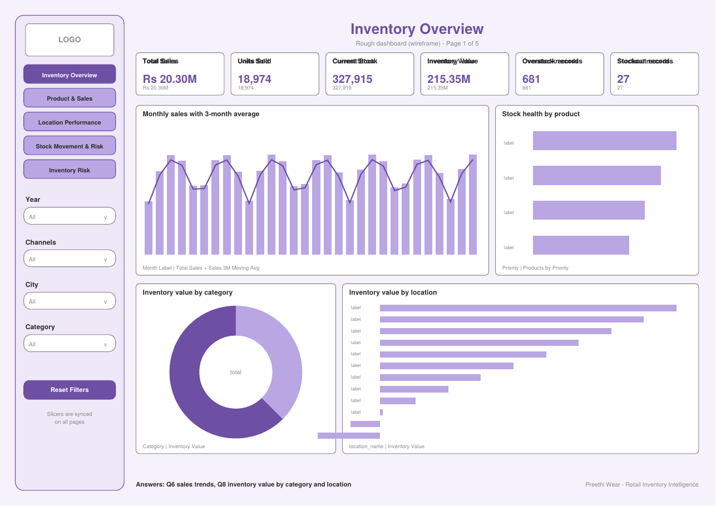
Rough dashboard, Page 1: Inventory Overview
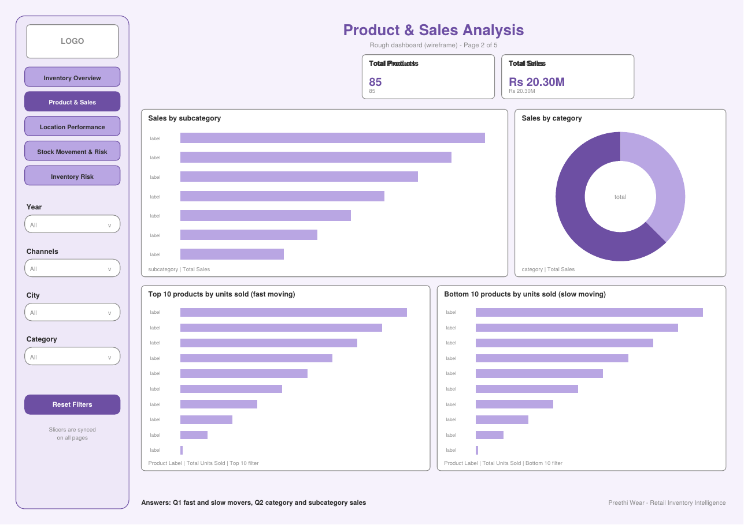
Rough dashboard, Page 2: Product and Sales Analysis
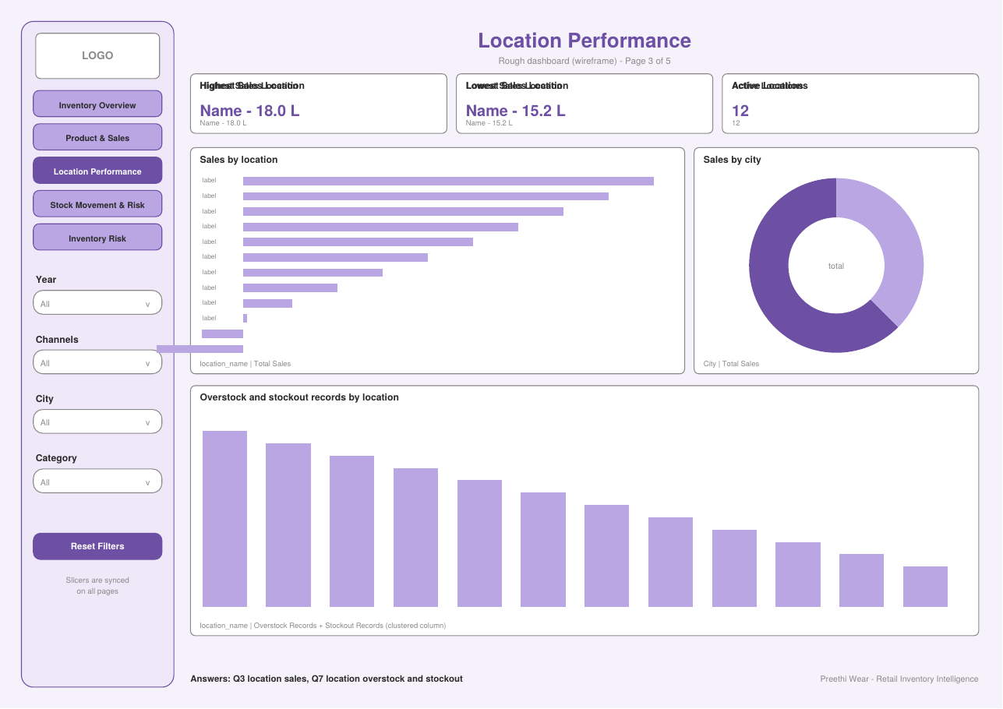
Rough dashboard, Page 3: Location Performance
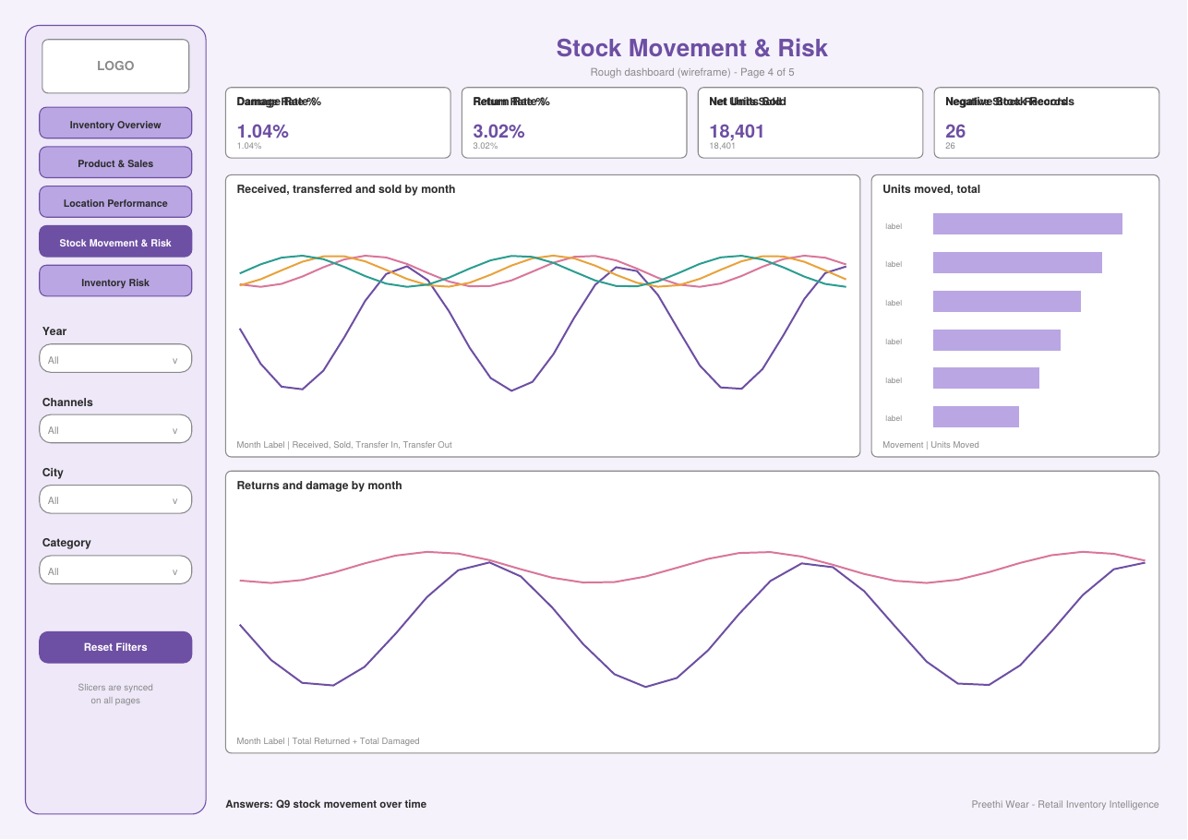
Rough dashboard, Page 4: Stock Movement and Risk
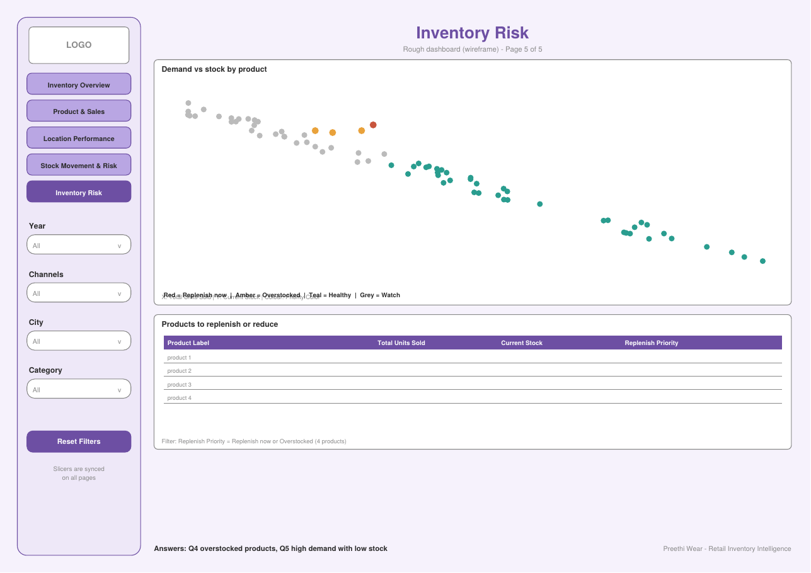
Rough dashboard, Page 5: Inventory Risk

Phase 5: Dashboard, Insights and Business Recommendations
The final report has five pages that share one sidebar and four synced slicers (Year, Channels, City, Category). Every figure below comes from the dashboard with no slicer selected, so it covers the full period from September 2023 to September 2026.

5.1 Page 1: Inventory Overview
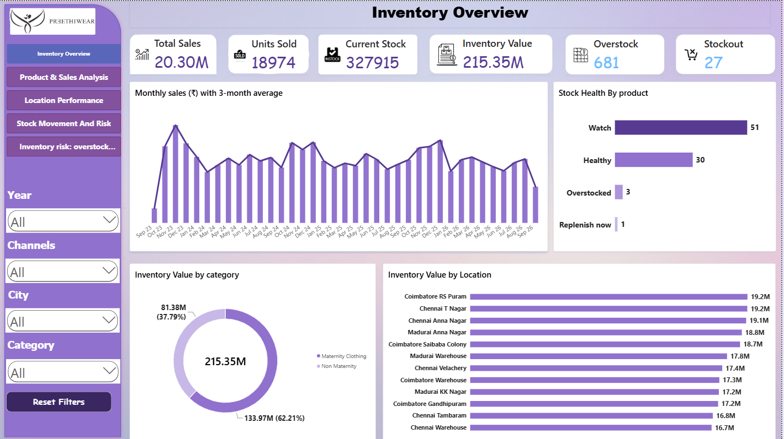
Page 1: Inventory Overview
Answers Q6 (historical sales trends) and Q8 (inventory value by category and location).
- Total sales are ₹20.30 million (about ₹2.03 crore) from 18,974 units sold. Current stock is 327,915 units, valued at ₹215.35 million.
- Monthly sales rise sharply in the first months, then stay fairly steady with repeating peaks around November to January each year. September 2023 and September 2026 are partial months, so their bars look low.
- Maternity Clothing holds ₹133.97 million of inventory (62.21%) and Non Maternity ₹81.38 million (37.79%).
- Inventory value is spread evenly across locations, from ₹16.7 million at Chennai Warehouse to ₹19.2 million at Coimbatore RS Puram and Chennai T Nagar.
- Stock health by product: 51 products are Watch, 30 Healthy, 3 Overstocked and 1 needs replenishment now.
- The cards show 681 overstock records and 27 stockout records.

5.2 Page 2: Product and Sales Analysis
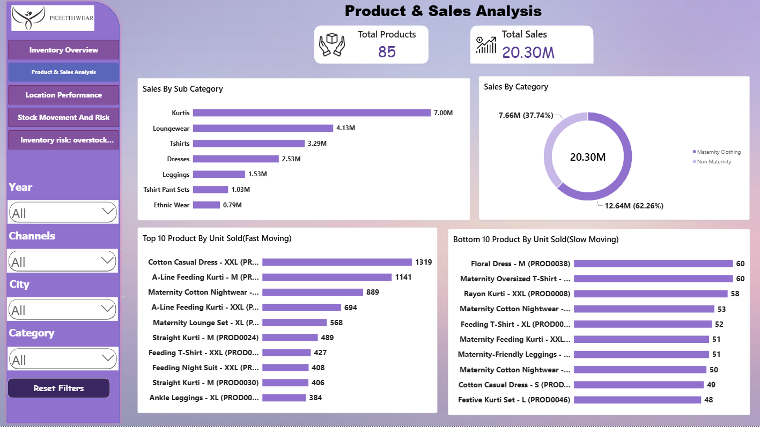
Page 2: Product and Sales Analysis
Answers Q1 (fast and slow movers) and Q2 (category and subcategory sales).
- Kurtis lead subcategory sales at ₹7.00 million, followed by Loungewear (₹4.13 million) and T-shirts (₹3.29 million). Ethnic Wear is the lowest at ₹0.79 million.
- Maternity Clothing contributes ₹12.64 million (62.26%) of sales and Non Maternity ₹7.66 million (37.74%).
- Fast movers: Cotton Casual Dress XXL (1,319 units), A-Line Feeding Kurti M (1,141) and Maternity Cotton Nightwear L (889).
- Slow movers: Festive Kurti Set L (48 units), Cotton Casual Dress S (49) and several maternity items at 50 to 60 units. The slowest products sell about one twenty-seventh of the units of the best seller.
- The catalogue has 85 products.

5.3 Page 3: Location Performance
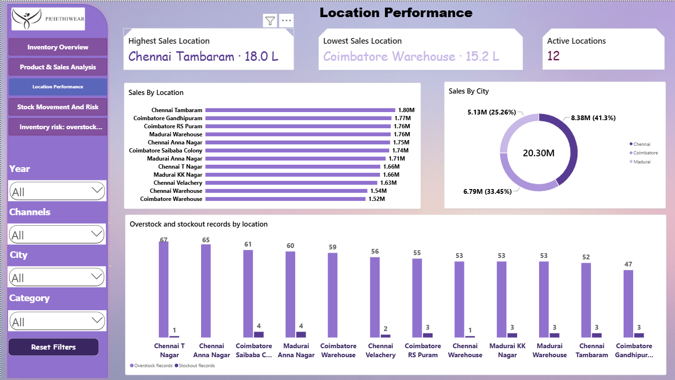
Page 3: Location Performance
Answers Q3 (location sales) and Q7 (location overstock and stockout).
- Chennai Tambaram is the top location (₹18.0 lakh) and Coimbatore Warehouse is the lowest (₹15.2 lakh), so the top location sells only about 18% more than the lowest and sales are spread evenly across the 12 locations.
- By city, Chennai contributes ₹8.38 million (41.3%), Coimbatore ₹6.79 million (33.45%) and Madurai ₹5.13 million (25.26%).
- Every location has far more overstock records (47 to 67) than stockout records (0 to 4). Chennai T Nagar has the most overstock (67) and Coimbatore Saibaba Colony and Madurai Anna Nagar have the most stockouts (4 each).

5.4 Page 4: Stock Movement and Risk
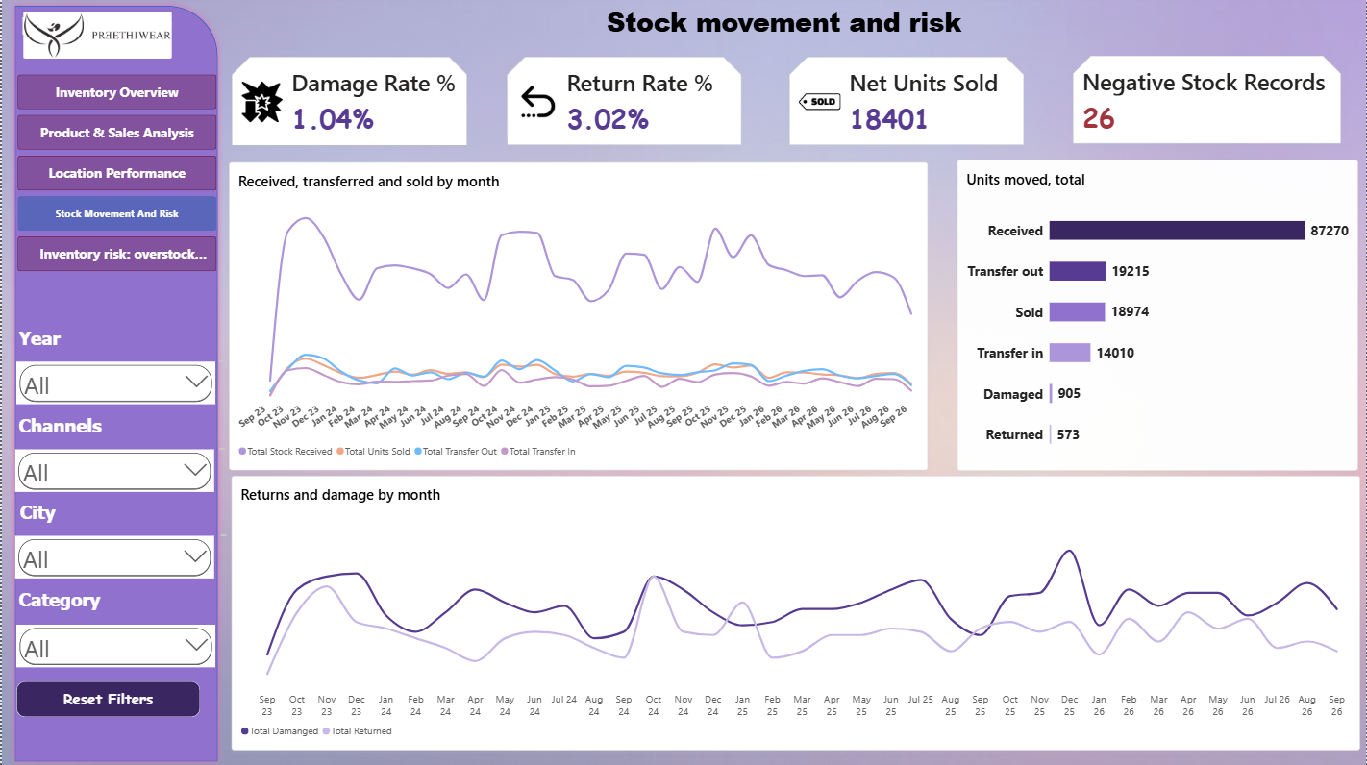
Page 4: Stock Movement and Risk
Answers Q9 (stock movement over time).
- Over the period 87,270 units were received, 19,215 transferred out, 14,010 transferred in, 18,974 sold, 905 damaged and 573 returned.
- Stock received is about 4.6 times the units sold, which is the main reason inventory keeps building up.
- The damage rate is 1.04% and the return rate is 3.02%. Net units sold after returns are 18,401.
- 26 records show negative stock, which indicates stock updates that are not recorded on time.

5.5 Page 5: Inventory Risk
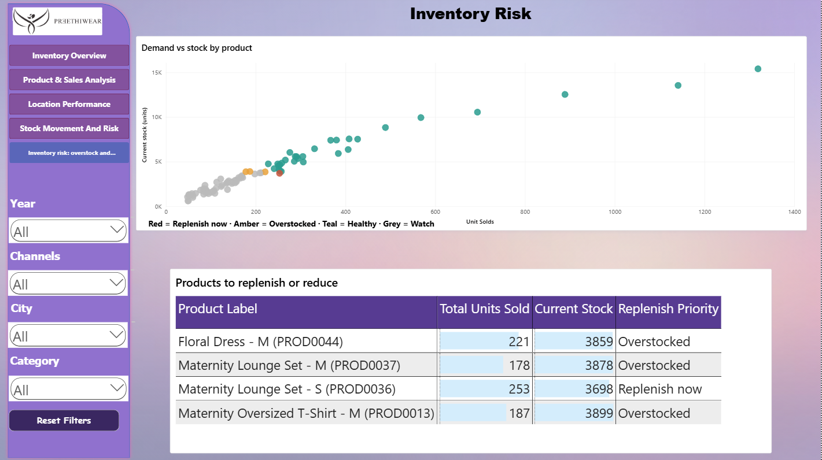
Page 5: Inventory Risk
Answers Q4 (overstocked products) and Q5 (high demand with low stock).
Product | Units sold | Current stock | Priority
Maternity Lounge Set - S | 253 | 3,698 | Replenish now
Floral Dress - M | 221 | 3,859 | Overstocked
Maternity Lounge Set - M | 178 | 3,878 | Overstocked
Maternity Oversized T-Shirt - M | 187 | 3,899 | Overstocked

The scatter chart shows stock rising almost in line with sales for most products. Only these four products stand out from the average product on both measures, which is why the dashboard classifies them as risks.

5.6 Overall Insights
- Stock is far above demand. Current inventory is valued at about ten times total sales over three years, and received stock is about 4.6 times units sold.
- Overstock is the main risk, not stockout. There are 681 overstock records against 27 stockout records, and every location has more overstock than stockout.
- Maternity Clothing is the core business. It accounts for about 62% of both sales and inventory value, and Kurtis are the strongest subcategory.
- Demand follows a seasonal pattern with peaks around November to January each year.
- Location performance is balanced, with the best and worst locations about 18% apart, so stock allocation should be even rather than concentrated.
- Operational losses are low: 1.04% damage and 3.02% returns. The larger issue is data quality, with 26 negative stock records.

5.7 Business Recommendations
- Replenish urgent items. Reorder Maternity Lounge Set (S) first, since it sells above the average and holds below-average stock.
- Stop buying overstocked items. Pause reorders of Floral Dress (M), Maternity Lounge Set (M) and Maternity Oversized T-Shirt (M), and use offers or bundles to clear them.
- Align purchasing with demand. Inbound stock is far larger than sales. Set reorder levels from monthly sales and the 3-month average instead of fixed quantities.
- Reduce working capital in stock. About ₹21.5 crore is held in stock. Prioritise reducing stock in Maternity Clothing and the highest-value locations.
- Rebalance stock between locations. Use stock transfers to move excess from locations with the most overstock (Chennai T Nagar, Chennai Anna Nagar) to locations with stockouts (Coimbatore Saibaba Colony, Madurai Anna Nagar).
- Prepare for the peak season. Build stock of the best sellers (Cotton Casual Dress XXL, A-Line Feeding Kurti M, Maternity Cotton Nightwear L) before November, and avoid over-ordering afterwards.
- Review slow movers. Reduce range or run promotions on products that sell fewer than about 60 units in three years, such as Festive Kurti Set L and Cotton Casual Dress S.
- Fix stock data accuracy. Investigate the 26 negative stock records and update stock on time at each location, so that dashboard figures can be trusted.
- Keep monitoring returns and damage. The rates are low, but track size-related returns in maternity wear and damage during transfers.
- Support Madurai. Madurai has the smallest share of sales (25.26%). Review marketing and range there before adding stock.
5.8Data Quality Management and Validation
Data quality was managed at three stages: in the Python cleaning script, in the Power BI model, and on the dashboard itself. The script applies the following checks.
Quality check | What the script does | Where in the script
Structure | Checks shapes and column names, then standardises names (trim, lowercase, underscores) | Load and column-name steps
Completeness | Counts missing values in all three tables, before and after type conversion | isnull().sum() steps
Uniqueness | Counts duplicate rows, removes duplicate transactions and creates a unique transaction_id | duplicated(), drop_duplicates(), TXN000001
Consistency | Trims spaces in IDs and text, and converts Y, YES, yes to Yes and N, NO, no to No | Text cleaning and Yes/No standardising
Validity (type) | Converts dates and numeric columns; bad values become blanks (errors set to coerce) | to_datetime, to_numeric
Validity (range) | Checks for negative opening stock, units sold and sales amount, and for product prices of zero or less | Negative-value and price checks
Validity (domain) | Lists unique categories, subcategories, product status and flag values | unique() steps
Accuracy | Calculates closing_stock from the movement columns | Closing stock formula
Anomaly flagging | Creates stock_issue (Negative Stock or OK) for rows with closing stock below zero | np.where step
Referential integrity | Checks that every product_id and inventory_id in the transactions exists in the product and location tables | Fact checking section
Final summary | Prints final shapes and remaining missing values, then saves the cleaned files | Final dataset information

Quality Checks in Power BI and on the Dashboard
- Rows with a blank date (created when the script could not parse a date) are excluded, so the dashboard uses 5,997 rows.
- Relationships enforce the links between the fact table and the dimension tables.
- Stock measures use the latest snapshot, which prevents double counting (327,915 units instead of 388,433).
- Totals were reconciled across pages: sales of ₹20.30 million and 18,974 units sold match everywhere, and the four stock health groups add up to the 85 products.
- The Negative Stock Records card (26) acts as a data quality monitor on the dashboard.

5.9 Conclusion
The Retail Inventory Intelligence Dashboard gives Preethi Wear one centralised view of sales, stock, locations and stock movement. It answers all nine business questions, shows that overstock rather than stockout is the main problem, and identifies the specific products that need action. With the recommendations above, the business can move from reactive to proactive inventory planning, reduce the cash tied up in stock and keep its best-selling products available.

