DSA0311-Natural Language Processing
Exp-17
Aim: To access WordNet using NLTK and retrieve synsets, definitions, and examples of a word.
Procedure:
- Install the NLTK library.
- Download the WordNet database.
- Enter a word.
- Retrieve its synsets.
- Display the meanings and examples.
Code:
import nltk
from nltk.corpus import wordnet as wn
nltk.download("wordnet", quiet=True)
nltk.download("omw-1.4", quiet=True)
word = "book"
synsets = wn.synsets(word)
for syn in synsets[:5]:
print("Synset:", syn.name())
print("Meaning:", syn.definition())
print()
Output:
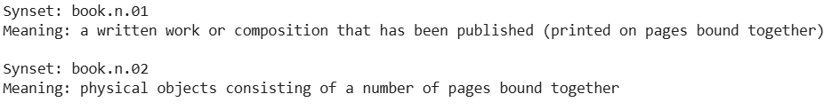
Result:
The program retrieves word meanings and synsets from WordNet.

