DSA0311-Natural Language Processing
Exp-20
Aim: To implement an information retrieval system using TF-IDF to rank documents according to their relevance to a query.
Procedure:
- Create a collection of documents.
- Convert the documents into TF-IDF vectors.
- Enter a search query.
- Calculate cosine similarity between the query and each document.
- Rank the documents by similarity score.
Code:
from sklearn.feature_extraction.text import TfidfVectorizer
from sklearn.metrics.pairwise import cosine_similarity
documents = [
"Python is a programming language",
"Python is used in machine learning",
"Natural language processing uses machine learning",
"Cooking requires fresh vegetables"
]
query = "Python machine learning"
vectorizer = TfidfVectorizer()
tfidf_matrix = vectorizer.fit_transform(documents)
query_vector = vectorizer.transform([query])
scores = cosine_similarity(query_vector, tfidf_matrix)[0]
ranked = sorted(
enumerate(scores, start=1),
key=lambda item: item[1],
reverse=True
)

print("Search query:", query)
print("Ranked documents:")
for doc_id, score in ranked:
print(
f"Document {doc_id}: "
f"{documents[doc_id - 1]} "
f"(Score: {score:.4f})"
)
Output:
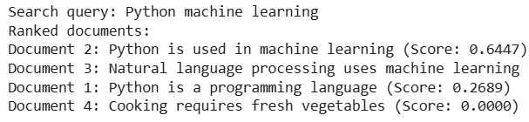
Result:
The TF-IDF-based information retrieval system ranks documents according to their cosine similarity with the search query.

