## Aggregate Operations

1. Find the latest arrival time for each airline.

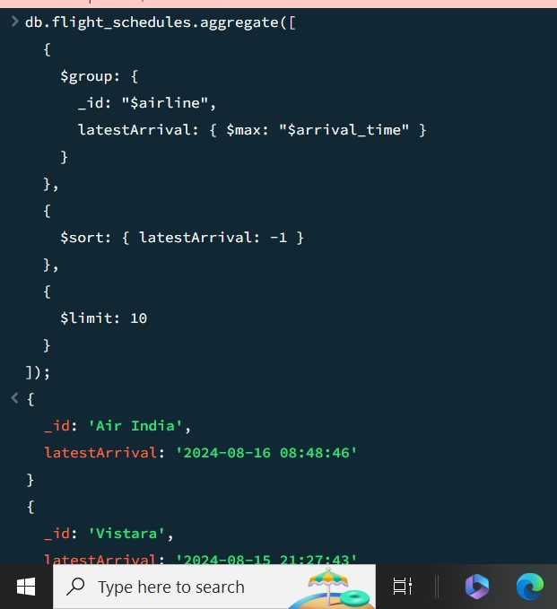

1. Find the earliest departure time for each origin airport.

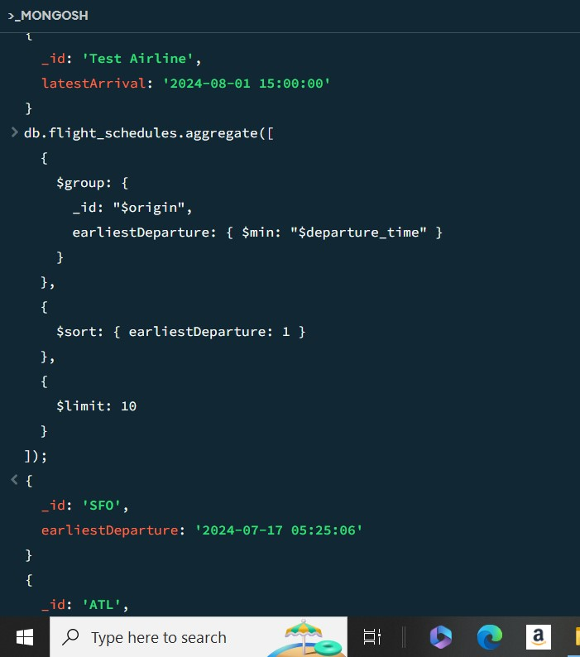

1. Count the total number of flights for each destination airport.

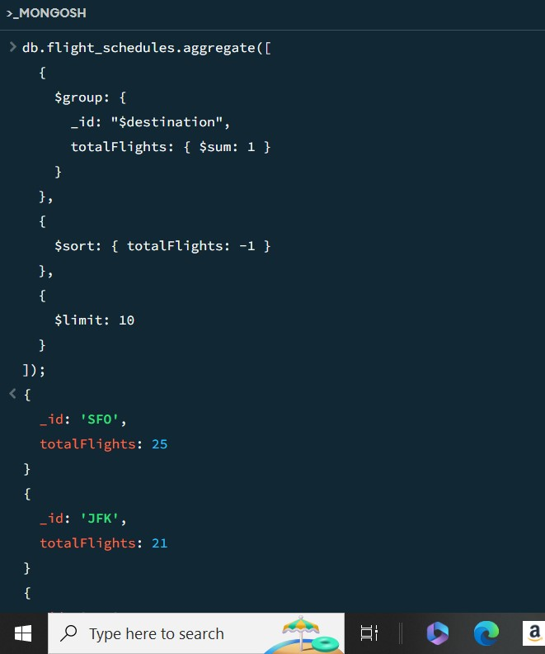

1. Calculate the average flight duration for each airline. Flight duration is calculated as the difference between arrival time and departure time.

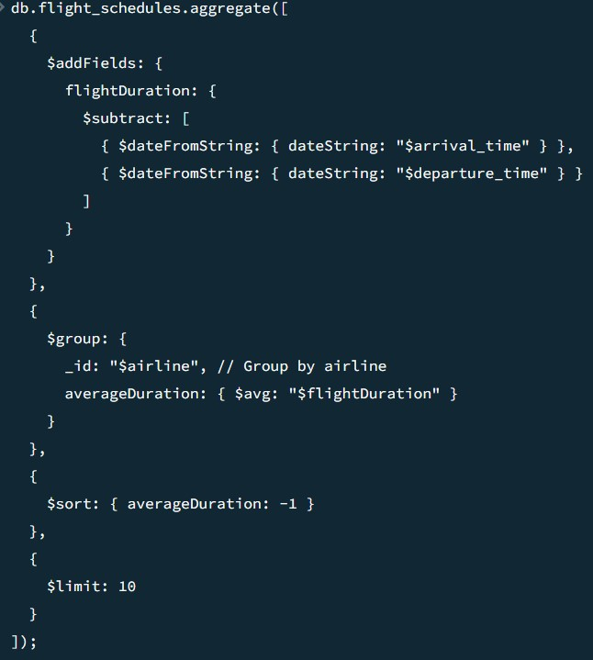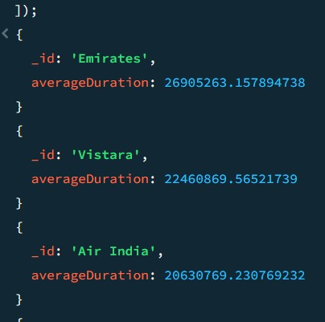

1. Group by origin airport and perform multiple calculations: max, min, sum, and average of flight durations.

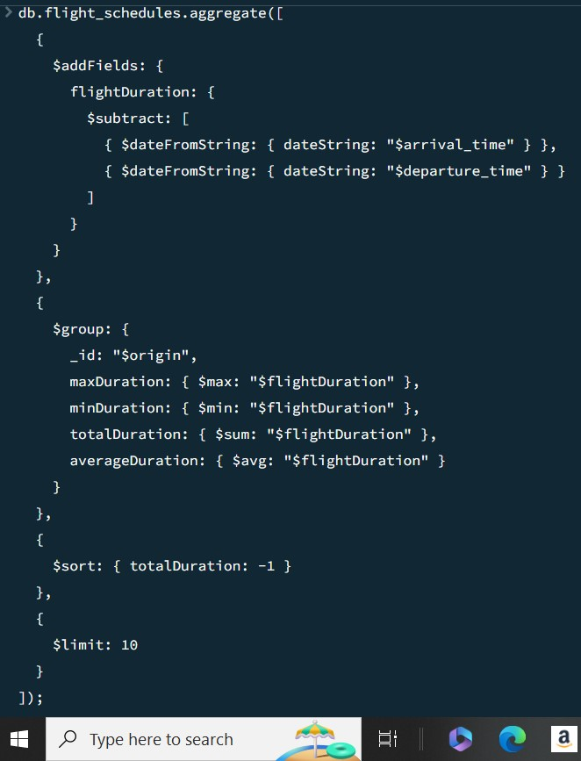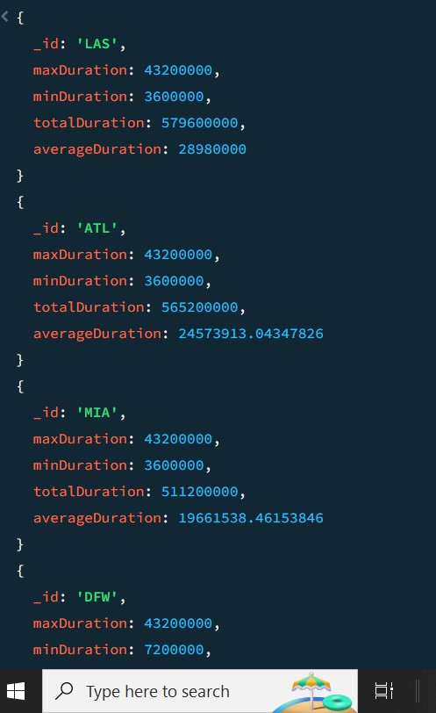

## Filter Operations

1. Find flights from 'JFK' or 'LAX' airports

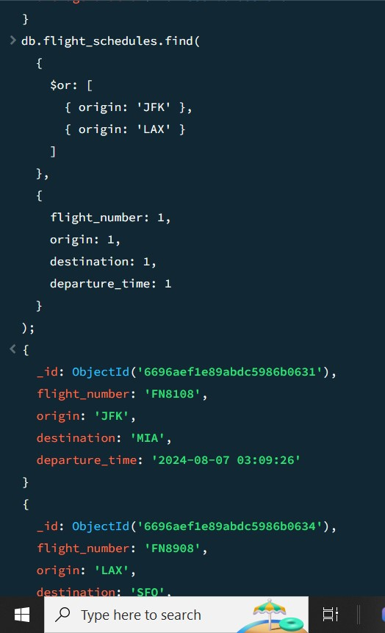

1. Find flights operated by 'Air India' and status is 'On Time'

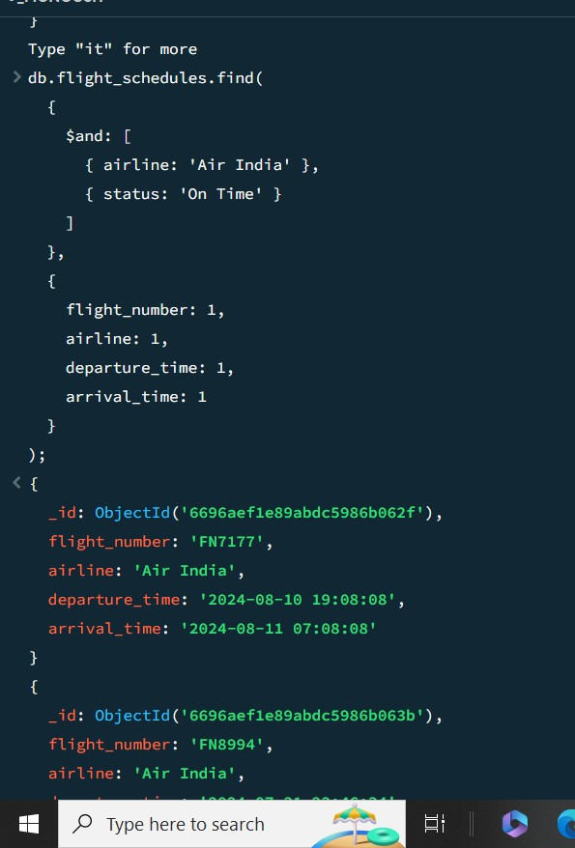

1. Find flights with departure time equal to a specific datetime

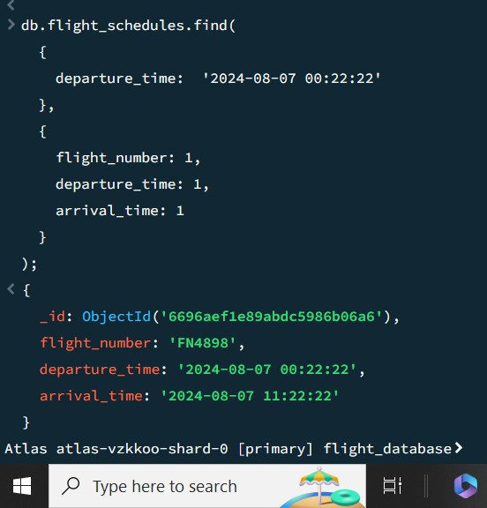

1. Find flights where the destination is not 'DFW'

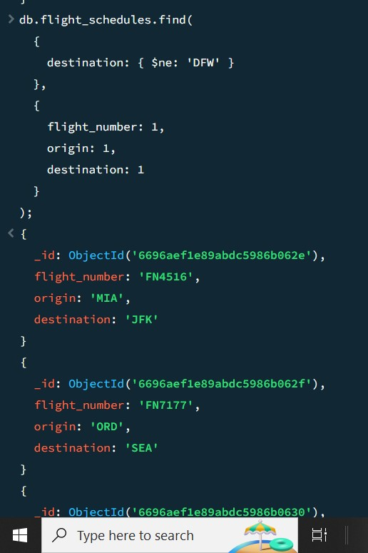

1. Find flights from 'JFK' and arriving before a specific time

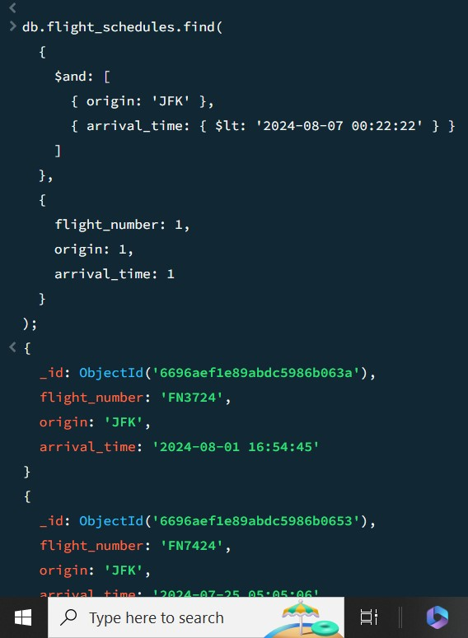

11.Find flights operated by 'Vistara' or have status 'Cancelled'

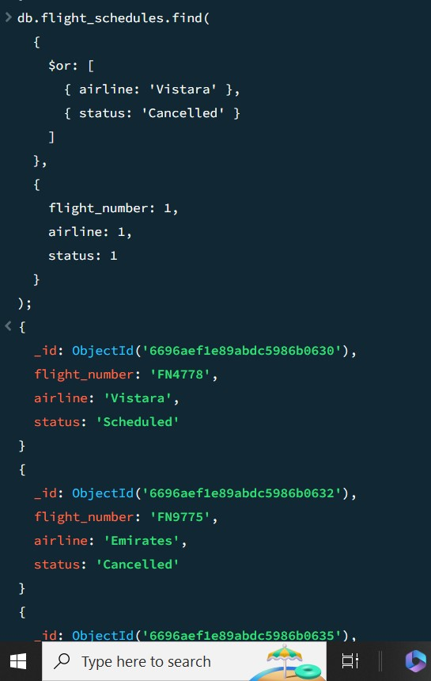

12. Find flights departing after '2024-07-19 08:00:00' and before '2024-0719 20:00:00'

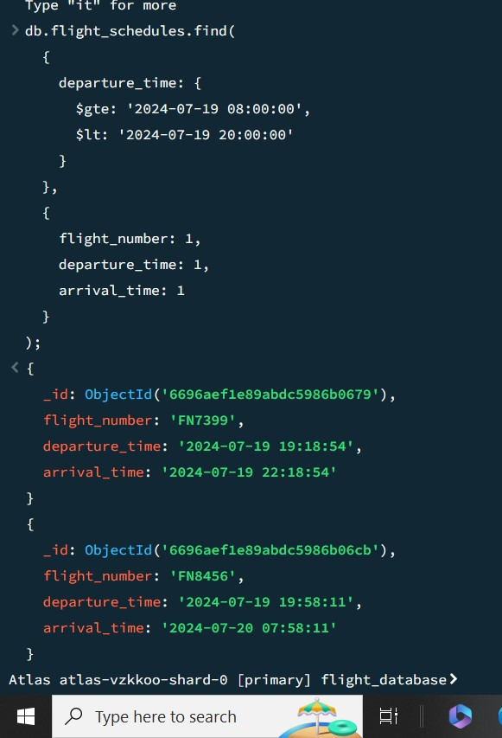

13.Find flights with status not equal to 'Scheduled'

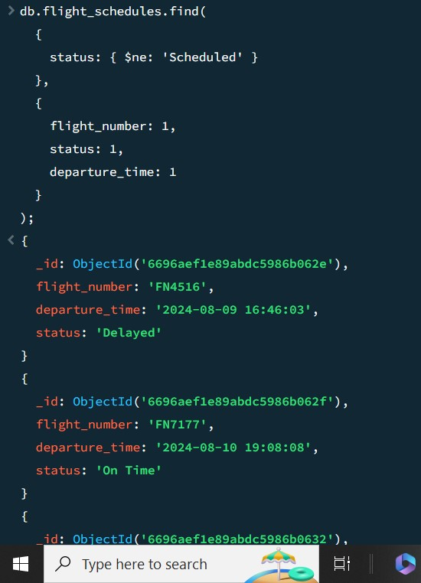

14. Find flights where origin is 'ORD' and destination is 'SFO'

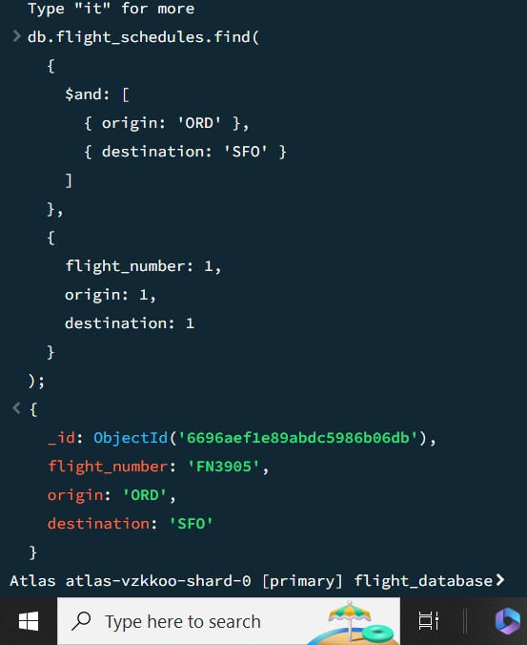

15.Find flights with an arrival time equal to a specific datetime

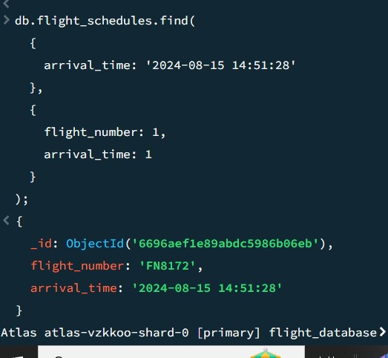

16. Find flights where status is either 'On Time' or 'Delayed'

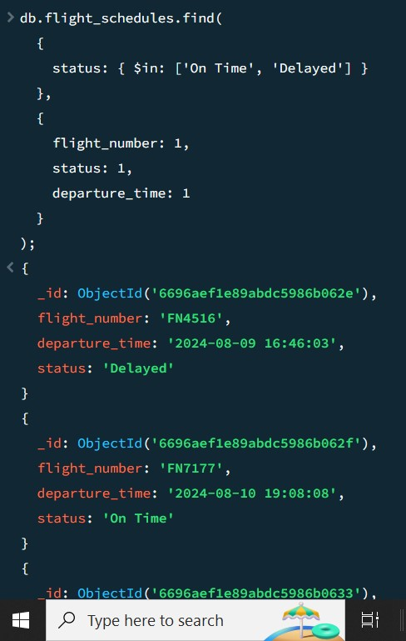

17.Find flights with a departure time greater than or equal to '2024-07-20'

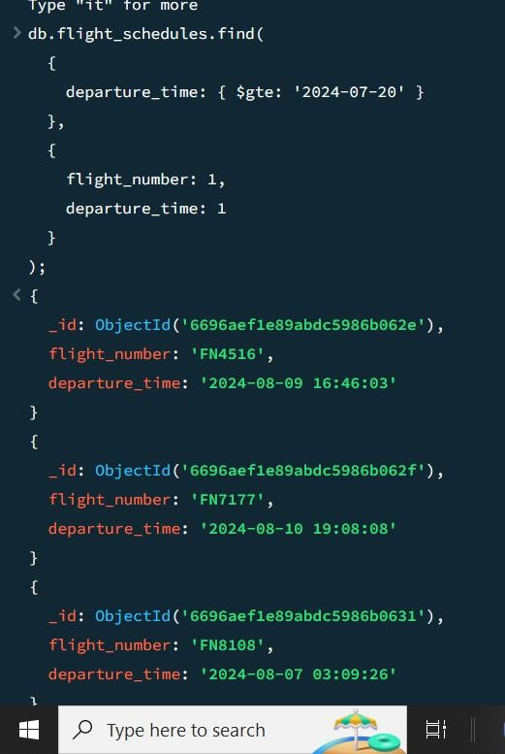

18. Find flights where origin is not 'MIA'

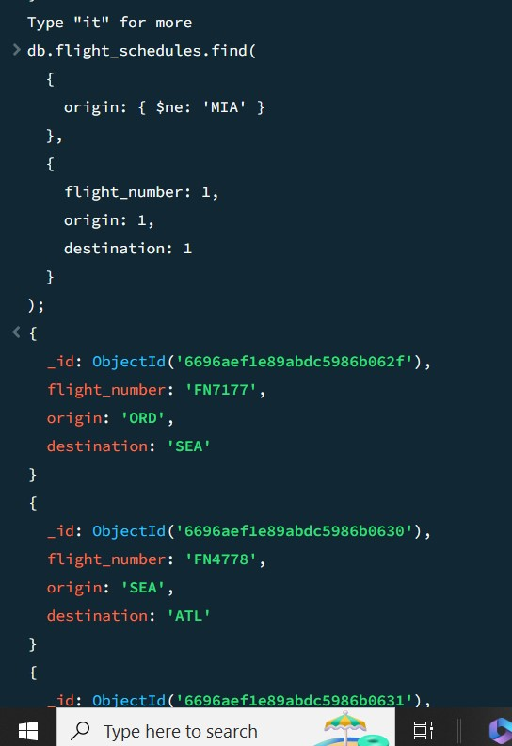

19.Find flights where airline is 'Emirates' or the arrival time is after '202407-21'

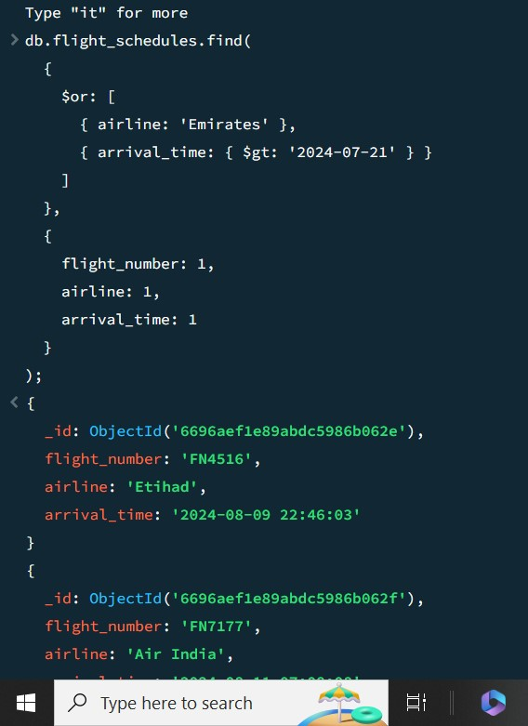

20. Find flights with departure time before '2024-07-22' and status is

'Delayed'

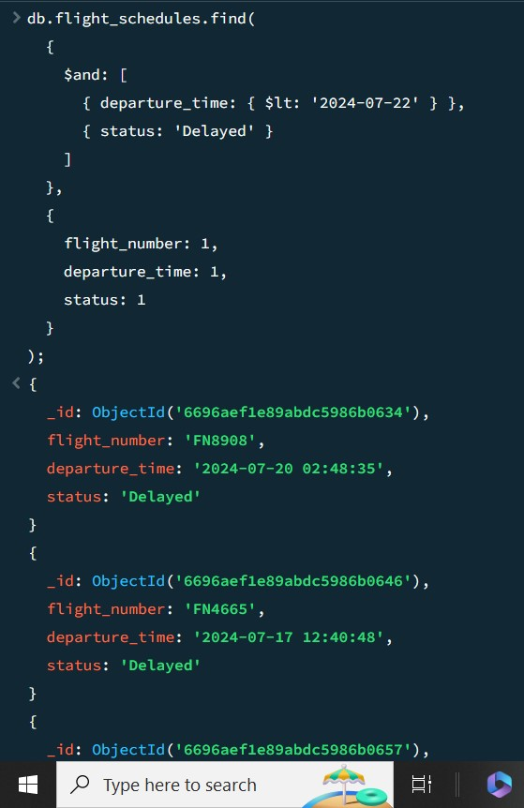

## Update Operations

1. Update the status of a specific flight and adjust its arrival time. This query finds a flight by its flight number and updates both its status and arrival time.

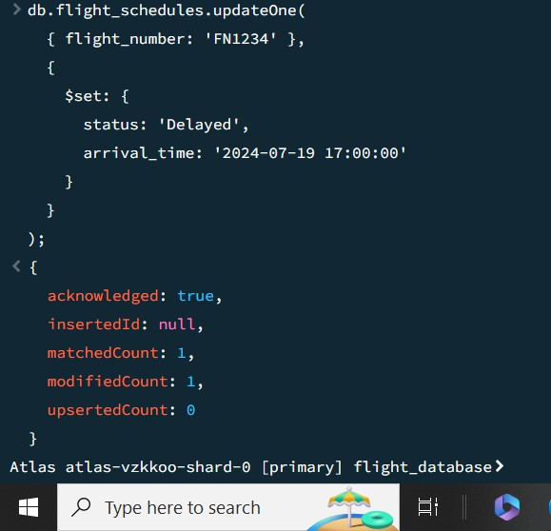

1. Increment Flight Duration and Update Aircraft Type

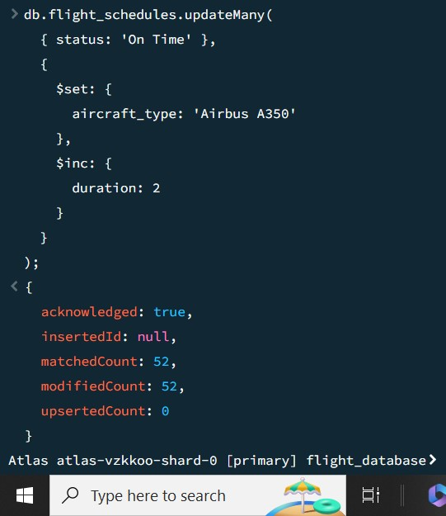

1. Update the status and departure time for all flights from a specific airline

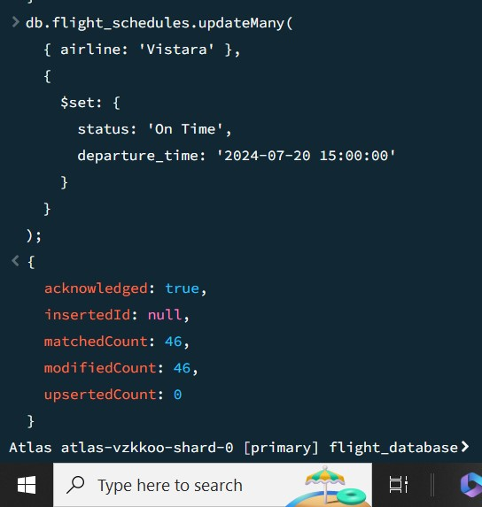

## Delete Operations

1. Delete a flight document based on a specific flight number

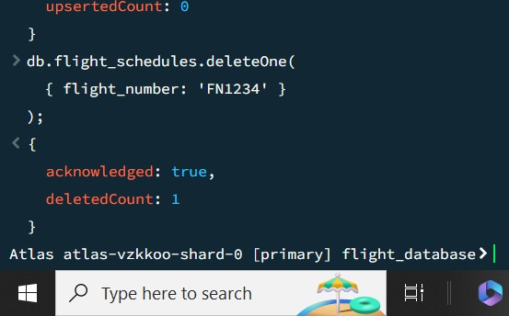

1. Delete all flight documents where the status is 'Cancelled'

