**What is Computer Vision?**

* In a **nutshell,** another buzzword for something we can eventually understand.
* Also, Computer Vision (CV) is a subfield of artificial intelligence (AI) that focuses on teaching computers to see and interpret the world as humans do. It is inspired by our understanding of biological vision systems in animals.

**How Computer Vision started:**

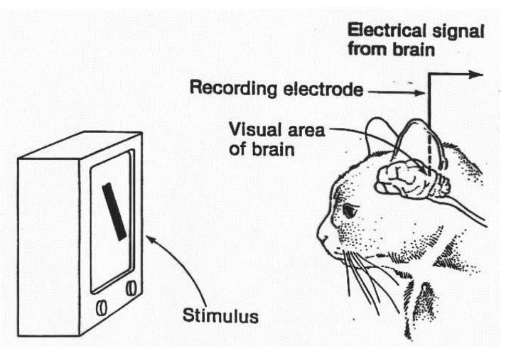

With a cat.

In 1959 two scientists, Hubel and Wiesel conducted an experiment with a cat by placing it In a harness and inserting an electrode into its primary visual cortex. Then, they showed it some images on a screen. The cat's visual cortex did not respond to any of the images. But the EUREKA moment came later, as they turn off the screen, the cat’s neurons responded to a simple horizontal line of light appeared.

This investigation set up the basics for Computer Vision and to understand animal vision, as it suggested that we perceive the world as a combination of **lines** and **edges** which ultimately form more complex shapes.

**How Human vision works:**

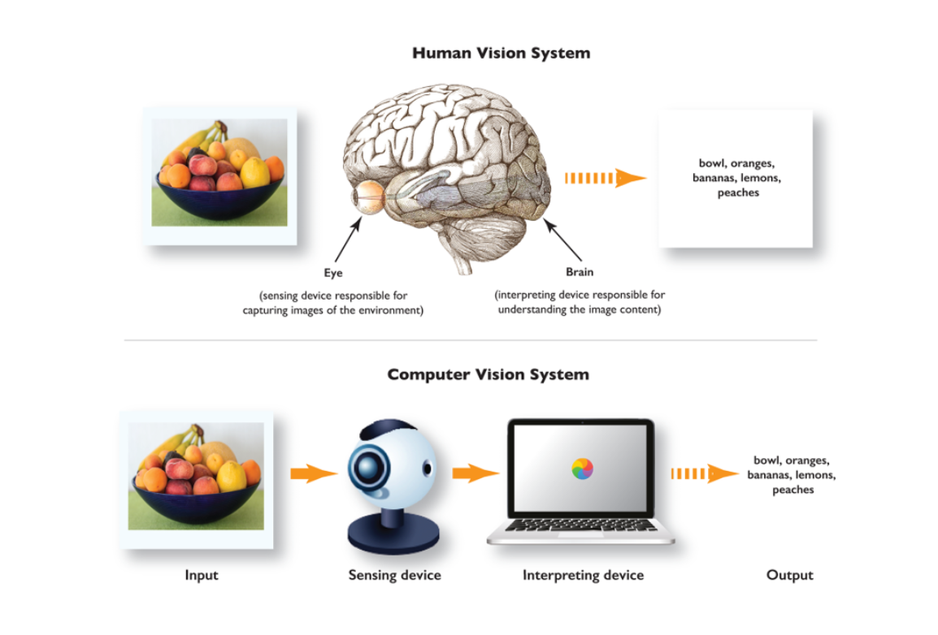

Human vision relies on **eyes** and the **brain** → We capture images of our surroundings, and our brainworks to interpret and understand these images.

The human **eye** captures light and focuses it onto the retina, which contains **light-sensitive cells** called **rods** and **cones.**

* **Rods:**  Responsible for low-light vision.
* **Cones:** Processes colour vision and details.

The retina converts light into **electrical signals** through these cells, and those electric pulses travel through the optic nerve and finally are transmitted to the **brain**.

The **brain** processes this signal in our **primary visual cortex**, located in the **occipital lobe**, which is responsible for basic **shape** and **edge detection.**

Other parts of human visual processing occurs in other regions of the brain to recognize objects, faces, shapes, and more complex visual information.

**How Machine Vision works:**



The **“eye”** of **Machine Vision** works by converting digital images into numerical representations that can be processed and analysed.

* Any digital image can be converted to a NumPy array, which translates the image as a matrix of pixels, with each pixel containing the intensity values of three basic colour channels: red, green, and blue.
* To simplify processing and reduce computational requirements, the image is often converted to grayscale. The grayscale pixel values represent intensity levels ranging from 0 (black) to 255 (white).

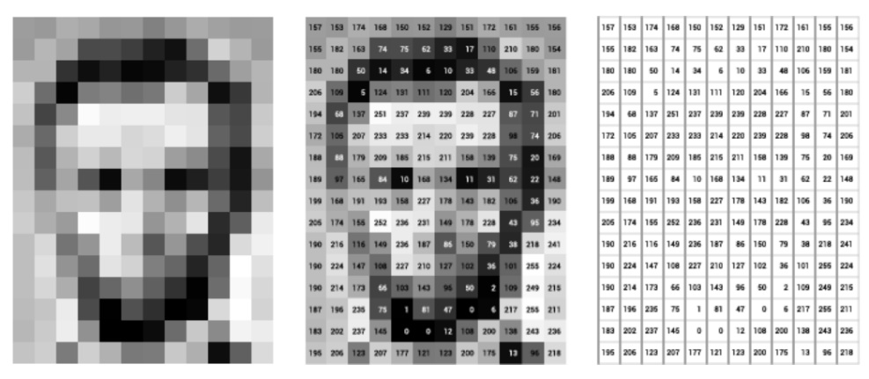

The **“brain”** of Machine Visionworks by using **Convolutional Neural Networks** (CNNs) and Deep Learning techniques (DL), both of which are deeply rooted in how we compute information with our own brain.

CNNs aim to replicate the hierarchical structure of the brain by processing the images in a series of layers and using weights to adjust the importance of the input features. During the training process, each layer focuses on specific features like edges and lines. Weights are then updated in each loop, adding complexity to the process of finding patterns and features from the input-images.

CNNs are commonly used for human-like tasks like **image classification, object detection** and **segmentation** (medical imaging, facial recognition, autonomous motion).

**How to Start with it (an easy approach):**

1. **Define the problem and determine what you want to achieve with the image.**
2. Acquire the image (webcam, photography, recording…).
3. Process the image using techniques like resizing, cropping, rotating, or converting to grayscale (depending on what you want to **achieve)**.
4. Have fun. Feed the processed image into a CV model to interpret objects, features, and patterns.

For beginners, OpenCV and scikit-image are excellent libraries to start with due to their versatility and the availability of extensive options. Let’s walk through it → Open the notebook.