DASH User Guide 9/2021

This document provides a short overview to creating and running DASH[1] agents. DASH agents are intended to simulate human behavior in a variety of situations in DETER and other environments where group decision-making is mediated by computers. For example, they have been used to model observed behavior in:

* Managing passwords on multiple accounts
* Launching a coordinated SQL injection attack
* Making inferences and decisions while controlling a power plant.

In situations like these, human behavior might differ from the optimal, as may be defined by decision-theoretic measures or accepted best practice, and these differences impact the behavior of systems under test. This may happen because the typical user of a system has an incorrect or incomplete model of the system’s behavior or of its security, or because humans inevitably make mistakes, particularly when their attention is taken with other tasks.

DASH agents model this behavior using a dual-process cognitive architecture.

* The **rational behavior** module contains sub-modules for reactive planning and for projection using mental models.
* The **instinctive behavior** module models instinctive reactions and other reasoning that humans are typically not aware of

The combination of these two modules can account for effects of cognitive load, time pressure, or fatigue on human performance, that have been documented in many different domains. The combination can also duplicate some well-known human biases in reasoning, such as confirmation bias. The DASH platform includes support for teams of agents that communicate with each other and a GUI to control agent parameters and view the state of both modules as the agent executes.

It can be time consuming to program agent behaviors, and a typical cyber security test scenario may include a number of relatively standard agents, with some alterations to a few key players. Therefore DASH provides a library of agents that can be used in a range of situations and extended as required, covering end user behavior as well as attackers and defenders, though the latter are currently more limited.

**Overview**:

* First we go through an example of a DASH agent, showing its execution and how to interrogate the state.
* Next we show more detail on the representation used for the rational and instinctive modules and show how to program new agents that combine these behaviors.
* Finally we provide an overview of the library, and examples of using library agents and combining behaviors from the library within agents.

For comments or questions about DASH and to obtain a copy for research purposes, please contact Jim Blythe at [blythe@isi.edu](mailto:blythe@isi.edu), or 310-448-8251.

1. Installation 3

2. An example mail reading agent 3

3. High-level modules in DASH 4

4. The Rational Module and top-level agent behavior. 5

5. Goal-driven reactive behavior 6

5.1 Programming goal-driven agents 7

Underlying Python definition 7

5.2 Mental models 8

6. Inter-Agent Communication 8

7. The Instinctive Module 9

8. Discrete event simulation 10

9. DASH architecture and API 11

# 1. Installation

DASH agents are written in python 3.7, so first you will need to download python, if it is not already installed on your system. In order to do so:

* Go to <https://www.python.org/downloads/>
* Choose python3 and Mac, Linux, Windows, or another version compatible with your computer

In order to get the code, go to GitHub:

* <https://github.com/isi-usc-edu/dash>
* If you do not already have a GitHub account, you will need to create one

To run the code:

* Go to a command line interface such as linux or terminal.
* Once you clone the git repository, move to the directory that contains DASH2
* Type: python ‘name of file’ and it should start to run
* In many of the examples that follow, one or more agents are communicating via a hub. In this case you will need to start the hub running in a separate terminal window before you start an agent. In the examples below we specify which hub is needed.
* Pycharm or another python IDE can also be used if desired.

# 2. An example mail reading agent

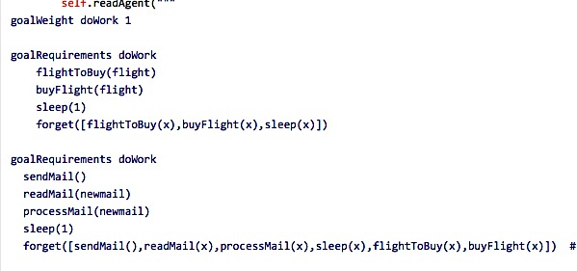We introduce DASH and illustrate some of its capabilities using an agent that reads email and buys airline tickets that are requested by other agents. Here, please use ‘Dash2/tutorial/mailReader03.py’ as the definition of the mailReader agent. When processing mail, the agent "reads" the message for a flight request, driven by a deliberative goal decomposition process.

This agent has two ways to achieve its top-level goal called ‘doWork’ (see the figure to the right):

* Buying a flight, if one has been requested
* Reading, sending, and processing mail

Notice that the last indented line in each goalRequirements clause is a ‘forget’ predicate. This causes the agent to forget what has already been done, so that, when it picks a new action, it will continue to check whether there are flights available and buy a different one.

Below is an example trace of the code running in PyCharm. Initially, there is no requested flight and no mail has been sent, so the agent successfully reads an empty list of mail. In the next iteration, mail has been sent to the hub from the mailSender agent and is picked up by the agent and processed, leading to a known request for a ticket to New York. In the next iteration, the agent buys the ticket.

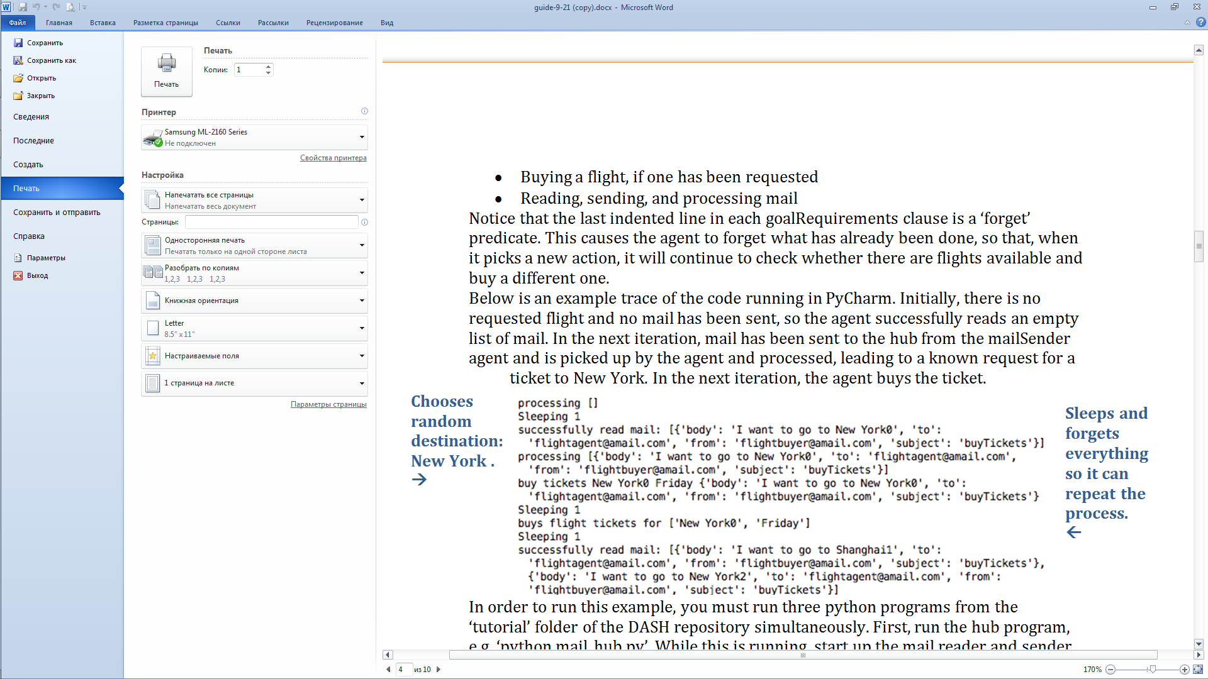

In order to run this example, you must run three python programs from the ‘tutorial’ folder of the DASH repository simultaneously. First, run the hub program, e.g. ‘python mail_hub.py’. While this is running, start up the mail reader and sender agents in either order, e.g. ‘python mailReader03.py’ and ‘python mailSender.py’. The two agents will interact via the hub in an infinite loop. In order to shut the agent system down, first kill the two agent programs and then kill the hub.

# 3. High-level modules in DASH

As mentioned, the mail reading agent makes use of reactive goal decomposition, one of several modules of DASH which are introduced and explained in more detail in subsequent sections. These include the rational module, reactive goal decomposition and the mental models library within the rational module, the instinctive module and inter-agent communication.

At the heart of the DASH architecture is a dual-process model, consisting of the rational and instinctive modules. In this approach, both modules may be engaged in deciding which action to choose, and may collaborate or compete. In normal operation, the instinctive module produces a suggested action, stored in working memory, that the rational module usually accepts. This reflects human behavior since, most of the time, humans are not thinking deeply about the actions they choose but are following habit. Sometimes a surprising observation or request breaks the agent out of habitual action. In DASH, this can happen in two ways:

* First, the instinctive system may have low confidence in its chosen action – in this example, an email might look suspicious – in which case it will signal to the rational module that it should provide a second opinion.
* Second, the rational module might be triggered to override the suggestion of the instinctive module for a number of reasons, and will begin more detailed processing even though the confidence of the instinctive module’s selection has not reduced.

In general, the balance between the two modules in terms of the final action decision can be changed in a number of ways, including models of physiological changes that may lead the rational system to be more active, or, for example, changes in cognitive load caused by other tasks – high cognitive load may suppress the rational module.

In the rest of this guide, we describe the instinctive model and the rational module in more detail so the reader can understand how the agent’s knowledge is

represented and how to modify it.

* Section 4 gives an overview of the rational module.
* Section 5 covers goal-driven behavior in the rational module, which can follow workflows while responding to changes in the environment if needed, even when they may lead to changes in the workflow or its being dropped entirely.
* Section 6 addresses inter-agent communication and the use of a hub
* Section 7 covers the instinctive module
* Section 8 covers the discrete event simulation support in DASH
* Section 9 provides class diagrams and API overview of the Core module of DASH.

# 4. The Rational Module and top-level agent behavior.

The rational module deals with decision-making that humans perform consciously and deliberatively, including planning and assessing alternative actions. In the next sections we describe support in DASH for goal-driven behavior, including following workflows, and we describe support for mental models in the following section. Here we focus on how the rational and instinctive modules combine to make decisions about actions.

Figure 3 below shows the overall architecture of the agent. On each cycle, the agent takes in new inputs and chooses an action to perform, or it may choose not to perform any action.

* The instinctive module first applies rules to the new information and updates the items in working memory with new items that have high activation.
* The rational module then picks a recommended action.

It may choose a suggested action placed in working memory by the instinctive module, or it may decide on further deliberation. By default, this is determined by an activation strength threshold: if the suggested action with highest activation is too low, deliberation will occur.

When the rational module engages in deliberation, it enters a planning process automatically, reasoning based on its working memory about its most important goals and about actions that can achieve them. As part of this process, it may reason about the results of alternative actions according to its own mental model, which may be different from the agent’s actual environment or from that of the instinctive module. The framework to support this reasoning is described in the next two sections, but here we note that the framework or the rational process can easily be customized by providing general python clauses to describe action selection, goal elaboration, or mental models.

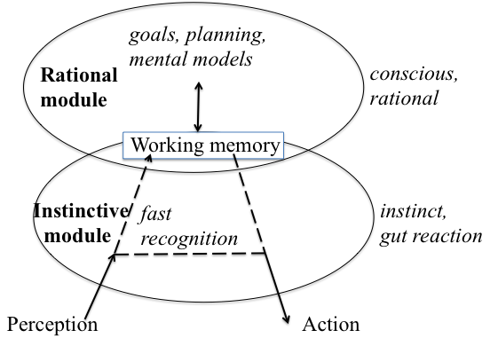

Figure 3. The instinctive module and rational module combine to make action decisions, and share information that is posted in working memory by either module.

# 5. Goal-driven reactive behavior

Much of the time, human online behavior is influenced by *workflows*, for example when performing group tasks within an organization such as purchasing equipment or performing individual tasks such as taking pictures at an event, uploading and distributing them. While following workflows, we are aware of events in our environment that might cause us to change our plans.

To support this behavior, DASH provides a framework of goals and sub-goals that are used to achieve them, with an elaboration process that bottoms out into primitive actions that may be chosen as the next agent action. The agent can perform coherent goal-driven activity by maintaining a top-level goal over time and working towards it. However the framework effectively re-computes the goal and actions on each decision cycle, giving the agent a chance to respond to changes that might require a change in plans and to combine its plans with other less plan-driven activity such as taking a break.

## 5.1 Programming goal-driven agents

### Underlying Python definition

Within python, a series of goals and sub-goals, written as primitive actions, are used to establish the goal of the agent as a whole, in this case a mail reading agent. Below is an example of these goals:

goalWeight doWork 1

goalRequirements doWork

flightToBuy(flight)

buyFlight(flight)

sleep(1)

forget([flightToBuy(x), buyFlight(x), sleep(x)])

goalRequirements doWork

readMail(newmail)

processMail(newmail)

sleep(1)

forget([readMail(x), processMail(x), sleep(x), flightToBuy(x)])

transient doWork # Agent will forget goal’s achievement or failure as soon

as it happens

The goal, doWork, has a goal weight of 1. In this case, there are two ways to achieve that goal. Either the agent can buy a flight or send mail. First, the agent checks if there is a flight available, if there is not it will switch to sending mail in order to complete its goal requirements. Alternatively, goals can also be implemented by other goal requirements clauses.

If there is no goalRequirements clause, then the goal activity is ‘primitive’ and must be associated with a python method on the agent class. In order to associate the code, you can either use primitive actions call to establish the code that will be run, or name the method to correspond to the goal, converting camel case to lower case with underscores, e.g. flightToBuy -> flight_to_buy.

Here is an example, in which the primitive action method can be called with a variable or constant. Given a variable, it proves a list of possible bindings based on the current open flight requests. The planner will try each in turn on backtracking. Given a constant, it checks that the constant matches an open flight request and returns success (the null bindings list) if so, otherwise returning failure (an empty list of bindings).

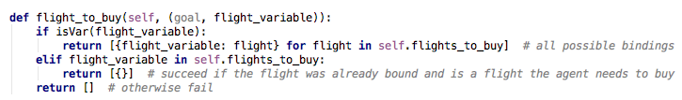

# 5.2 Mental models

DASH includes infrastructure to support an agent deciding its course of action by projecting the believed consequences of its alternatives forwards and comparing the alternative resulting end states. These projections are made using the agent’s internal models of how its environment will respond to its actions, which may or may not be correct, which we call mental models based on work in the cognitive science literature. Please see ‘legacy/securityUser.py’ and ‘nurse/bcma.py’ for examples. For more on the motivation and background on the implementation of mental models in DASH, see Blythe & Camp, ‘Implementing Mental Models’, IEEE S&P Workshops 2012 (<https://ieeexplore.ieee.org/document/6227689>)

# 6. Inter-Agent Communication

The mailReader agent, that responds to email messages and buys flight tickets, in the examples above, is designed to respond to email messages sent to it by the corresponding mailSender agent, that that sends ticket requests. The messages are passed through a communications hub, a Python object that accepts connections from several agents, routes communications between them and implements a simple shared state through its member variables. This section briefly describes the process and API for agent communication and shared state.

In order for agents to communicate,

* The hub program must be started before the agent programs. This is done by starting the appropriate hub class, in the example a mailHub object, before starting the mailReader and mailSender agents.
* An agent that seeks to communicate with a hub includes a ‘register’ command in its start-up code, which registers it with a hub using a unique id number. This number is the value of the ‘id’ instance variable inherited from the ‘DASHAgent’ class. In both mailReader.py and mailSender.py, the id number is set to be a constant.
* Once registered with the hub, the sendAction command is used by agents to send information about an action to the hub and receive in return a status (success or failure) and a tuple of simulated sensor data An example can be found in the read_mail method of the MailReader agent.

# 7. The Instinctive Module

The dual-process model of human behavior includes two distinct systems of reasoning: one that makes fast, instinctive decisions based on its perception of the world and one that performs slower, more conscious and deliberative reasoning. According to this theory, humans are generally aware only of the rational system, while the instinctive system is constantly suggesting decisions and is more frequently involved in our outward behavior. In the psychological literature, these systems are often called respectively “system 1” and “system 2”, in order to reduce any prejudice from their naming as to which is more likely to offer correct decisions or has general control [Stanovich & West 00]. Here, we will refer to them as the “instinctive” module and “rational” module for ease of reference.

In DASH, the instinctive module is represented with a set of nodes in a graph, each of which represents some statement about the world, an activation level and a set of neighbor nodes. Some of these nodes represent the desire to perform an action. On each time step, all such nodes with an activation level above a threshold are viewed by the agent as potential actions to take. The agent will then choose whether to perform one of these actions or engage in system 2 reasoning to select an alternative action. The choice can be customized for each agent and depends on threshold levels that represent the preference for instinctive over deliberative action as well as the relative strengths of the choices. This threshold can be varied, modeling the way the agent’s preference for instinctive over deliberative action may vary with cognitive load or fatigue.

On each decision cycle, activation levels for the nodes are computed as follows:

statements about the world that have activation levels, and a set of if-then rules that act to change the activation level of statements on the right-hand side of the rule based on the levels of statements on the left-hand side. When these rules are chained together, the result is a form of spreading activation [Anderson 00].

For an example of using both the rational and instinctive parts of the agent to make decisions at different times, see the Python mailReader agent that is *not* in the Tutorial folder.

*NB: What follows pertains to the old version of DASH and is not currently supported in the python version. It has been left in the manual for comparison, in case users would prefer this approach.*

*Here, for example, are some of the rules in use in the mailReader agent:*

***if*** *url(ID,Url) and short(Url)*

***then*** *ok(followLink(Url,ID))* ***at*** *0.4*

***if*** *doNotReply(ID)* ***then*** *ok(followLink(Url,ID))* ***at*** *-0.6.*

***if*** *url(ID,_)* ***then*** *ok(followLink(Url,ID))* ***at*** *-0.5.*

*Each rule begins with “if” and has three pieces, separated by the words “then” and “at”. The first piece, before “then” is the rule precondition, which uses variables and logical connectives to specify a pattern that might match many facts in the instinctive module’s memory. For example, the first rule will match any Url that is short found in an email message, binding the variable ID to the email message and Url to the Url. The definition of “short” is given elsewhere. For matches to this pattern, the rule changes the activation strength of its consequent, in this case ok(followLink(ID)), specified between the words then and at in the rule. Semantically, this can be interpreted as a suggestion that the agent follow the link.*

*The final number after the word at, 0.4 in this case, is its activation modifier. All facts in the instinctive modules knowledge base have an activation strength, where a strength of 0 implies a neutral attitude and increasingly positive or negative numbers imply an increasingly positive of negative attitude, respectively. When a rule is applied, it increments the activity level of its consequent by the product of its activation modifier and the activation strength of its precondition. When the precondition is an atomic fact, this is the activation strength of the fact. The activation strength of a conjunction is the minimum of the strengths of its components, and the activation strength of a disjunct is the maximum of its components. The facts with the highest absolute value of activation strength are placed in the working memory buffer where the rational module can access and act on them.*

*The three rules shown above contribute to the strength of the fact ok(followLink(1,1)), where the first argument to followLink represents the first url seen in the email message, and the second argument is the Id of the message.*

# 8. Discrete event simulation

DASH also supports discrete event simulation models. Examples of discrete event simulation (DES) agents can be found here: ‘Dash2/tutorial/example_agents.py’

Use case #2 in this scripts shows an example of DES agent:

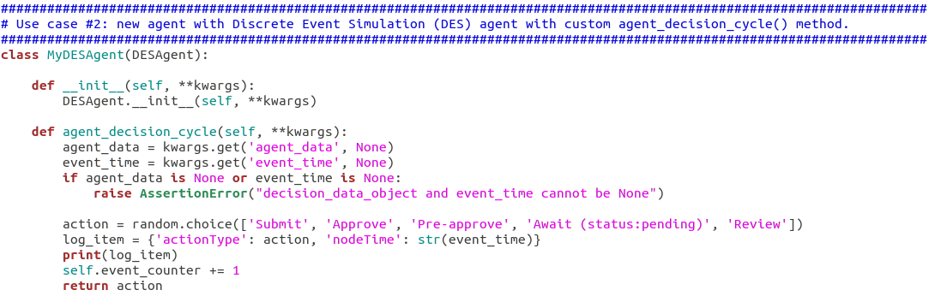

In this example, agent makes a random choice of type of action to perform. Action logic of any domain specific agent should be implemented in *agent_decision_cycle()* method of descendants of *DESAgent* class (e.g. ‘Dash2/posam/github_probabilistic_agent.py’ for an Enron email user agent).

DESAgents activation time is scheduled on the central queue which is handled by the class ‘Dash2/core/des_work_processor.py:LocalWorkProcessor’. This class is responsible for placing agents in the queue and calling each agent’s decision loop when it reaches the front of the queue and is activated.

Experiments with DESAgents are usually parameterized and run in batches via experiment.py scripts (see example for Enron email user agent here: ‘Dash2/core/ experiment.py’ )

# 9. DASH architecture and API

The diagram below show key interfaces of DASH framework. Every Agent should implement Agent interface. WorkProcessor is only needed for discrete event simulation, since this process handles the event queue.

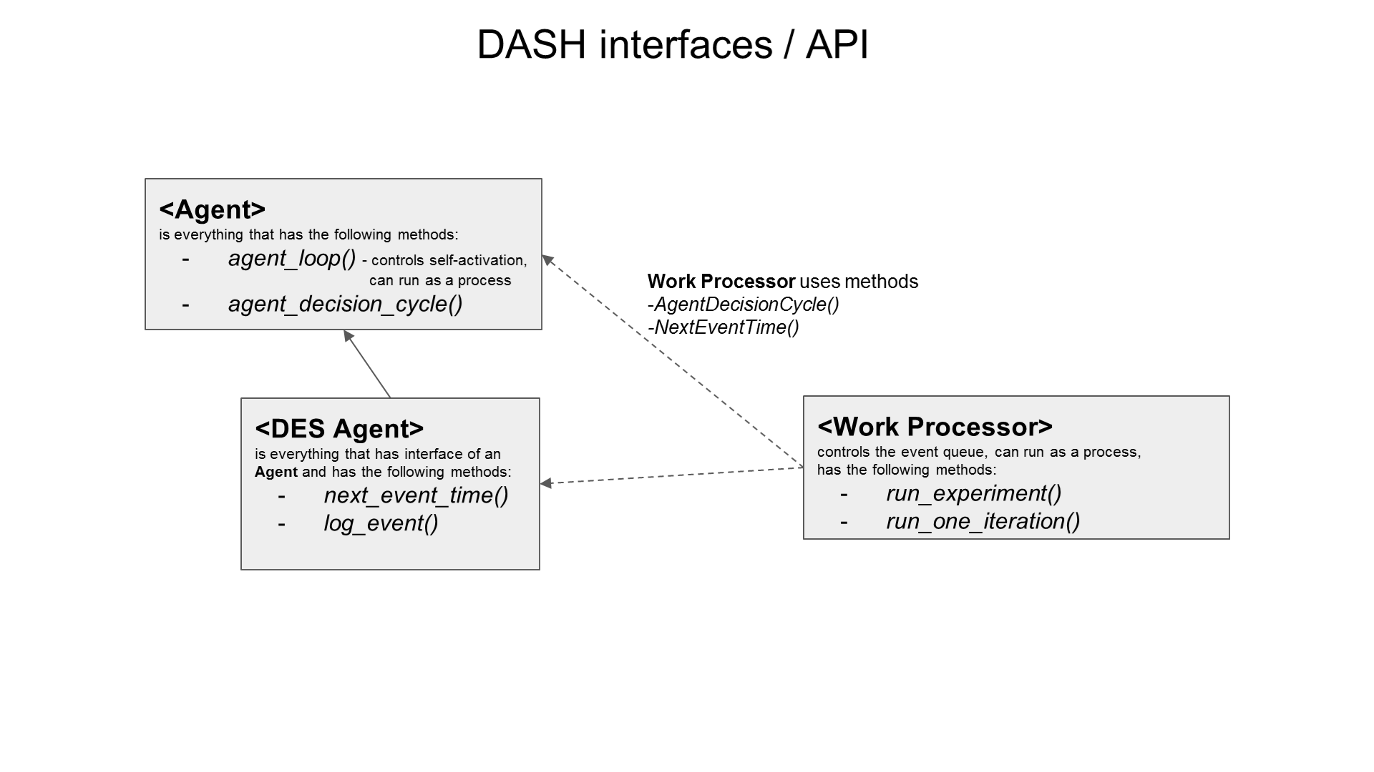

The diagram below shows key classes and their interfaces in core module. The green boxes below show examples of sub-classes in the tutorial and various projects.

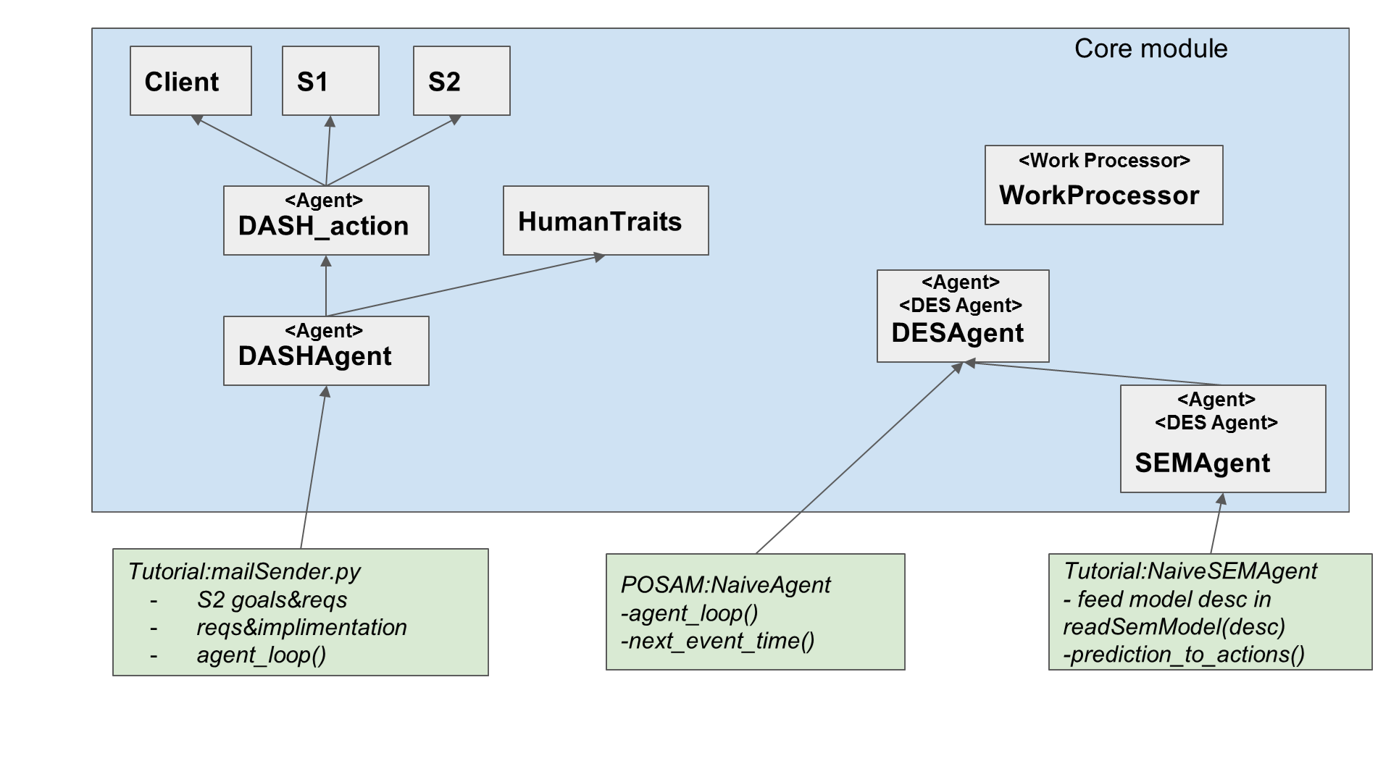

1. Deter Agents Simulating Humans