Web Portfolio
Final Practical Work Report
Author: Isse Ibrahim
Type of assignment: Practical Work
Course: Basics of Web Development (TT00CD79)
Return date: 3 November 2026
Student identifier: AI2867
Name of Field: Information and Communications Technology (ICT)
Final Practical Work includes project synopsis, wireframe, testing, development resources and self-evaluation.

Contents
1 Introduction and synopsis 2
1.1 Published Website and Source Code 2
2 Website structure 2
3 Layout design and wireframe 4
4 Implementation and testing 5
4.1 Tools and implementation 5
4.2 Debugging and validation 5
5 Resources and time spent 5
6 Reflection and self evaluation 6
References 7
Appendices 8
Appendix 1. Testing and Deployment Evidence 8

Figures
Figure 1. Original website hierarchy from the first synopsis. 3
Figure 2. Portfolio wireframe 4
Figure 3. W3C HTML validation results 8
Figure 4. Netlify deployment history 9

Tables
Table 1. Final single page website structure 3
Table 2. Development timeline and estimated work hours. 5

Introduction and synopsis
I created a personal web portfolio for my Basics of Web Development practical work. The main audience is people working in ICT companies, including recruiters, team leaders, developers and internship coordinators. The website presents my projects, skills, education and contact information. I built it using HTML5, CSS, Sass and JavaScript without ready templates or frameworks. It is responsive and published on JAMK LabraNet, GitHub Pages and Netlify. I plan to update it as I gain new skills and experience.

Published Website and Source Code
I published my portfolio on JAMK LabraNet, GitHub Pages and Netlify. I used GitHub for version control and automatic deployment to Netlify. The website and source code can be accessed through the following links.
JAMK LabraNet: https://student.labranet.jamk.fi/~ai2867/jamk_portfolio/
GitHub Pages: https://isibrahiim.github.io/isse-portfolio/
Netlify: https://ai2867.netlify.app/
GitHub Repository: https://github.com/isibrahiim/isse-portfolio

Website structure
My first synopsis described six separate pages. During development, I decided to use one page with navigation links to the main sections. This made the website easier to browse and kept important information in one place. The original plan is shown in Figure 1. The final structure is shown in Table 1.
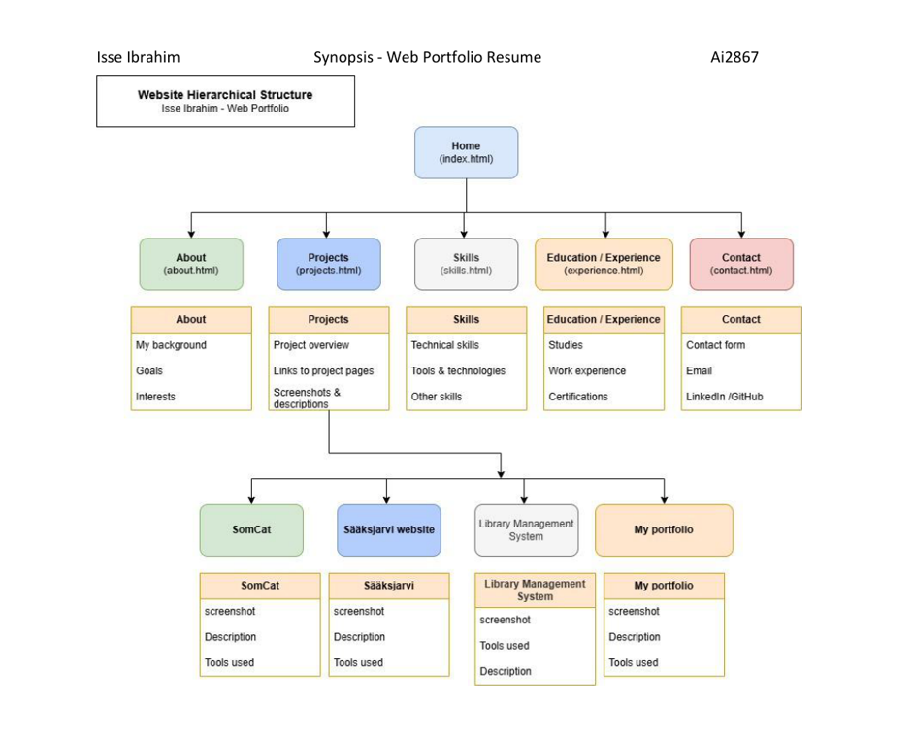
Figure 1. Original website hierarchy from the first synopsis.

Table 1. Final single page website structure
Page or section | What visitors can find
Home | Introduction and links to projects and contact
Projects | HOOYO, Python projects, Cat Lovers and Little Lemon
Skills and Tools | Programming languages, tools and skills
Experience | Education, training and relevant experience
Contact | Contact form and contact information

Layout design and wireframe
I planned the layout before finishing the website. The wireframe helped me decide where to put the navigation, introduction, projects, skills, experience and contact form. The final design follows the same general order, with some changes made during development.
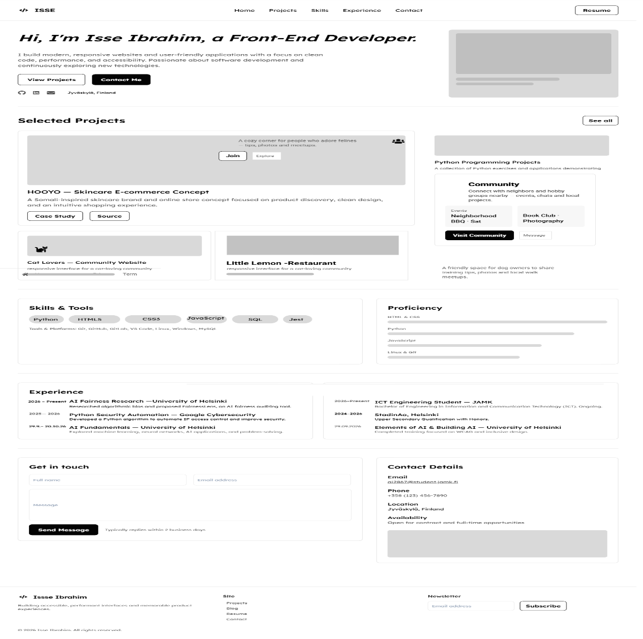
Figure 2. Portfolio wireframe

Implementation and testing

Tools and implementation
I built the website using HTML5, Sass, CSS and JavaScript, with semantic HTML and external stylesheets. It includes project cards, navigation, skills, experience and a contact form. I used Git and GitHub for version control and published the website on GitHub Pages, Netlify and JAMK LabraNet using WinSCP.

Debugging and validation
On 27 October, I improved the contact form, fixed accessibility and HTML issues, and removed nonstandard markup. On 1 November, I updated the design and sample CV and completed further checks.
I tested the website on different screen sizes, including mobile phones, laptops and a TV. I also tested it in Google Chrome, Mozilla Firefox and Microsoft Edge. The website worked correctly in all three browsers. The local HTML, GitHub Pages and JAMK LabraNet versions passed W3C validation with zero errors and warnings. Netlify showed two messages caused by its injected script.

Resources and time spent
I worked on the portfolio over several weeks. These times are estimates because I did not keep a detailed time log.
Date or period | Work completed | Estimated time
13 September 2026 | Initial planning and synopsis | 2 to 3 hours
9 to 19 October 2026 | Project preparation and selecting content | 3 to 5 hours
20 to 26 October 2026 | Wireframe and layout planning | 3 to 5 hours
October 2026 | Website implementation | 12 to 18 hours
October 2026 | Responsive design and testing | 4 to 6 hours
27 October 2026 | Contact form debugging | 2 to 3 hours
27 October 2026 | HTML and accessibility fixes | 2 to 4 hours
1 November 2026 | Final design, publishing and validation | 3 to 4 hours
Total | Approximate work time | 31 to 48 hours
Table 2. Development timeline and estimated work hours.

Reflection and self evaluation
I believe my project deserves a grade of 5 out of 5. I completed all the course exercises and prepared the synopsis, website hierarchy and wireframe. I built the portfolio using HTML5, Sass, CSS and JavaScript without using ready templates or frameworks.
I tested the website on different screen sizes, including mobile phones, laptops and a TV. I fixed HTML errors using the W3C HTML Checker and improved the contact form. I published the website on JAMK LabraNet and GitHub Pages. I also connected GitHub to Netlify for automatic deployment and created a working contact form using Netlify.
I also prepared a 10 page final report using the JAMK report template. The report includes my planning, design, development, testing, screenshots and time spent on the project.
This project helped me improve my coding, design, testing and debugging skills. I believe my work meets the course requirements for a grade of 5 out of 5. I plan to keep improving the portfolio as I learn new skills and complete more projects.

References
JAMK University of Applied Sciences. (n.d.). JUAS reporting model [Video]. Panopto. https://jamk.cloud.panopto.eu/Panopto/Pages/Viewer.aspx?id=c76bf798-c962-4210-9346-ad1a0099455e
Niemi, K. (2026). Basics of Web Development: Practical Work (Web Portfolio Resume). JAMK University of Applied Sciences. https://student.labranet.jamk.fi/~nikar/materiaali/tt00cd79eng/index.html
WHATWG. (n.d.). Nu HTML Checker. https://validator.w3.org/nu/

Appendices

Appendix 1. Testing and Deployment Evidence
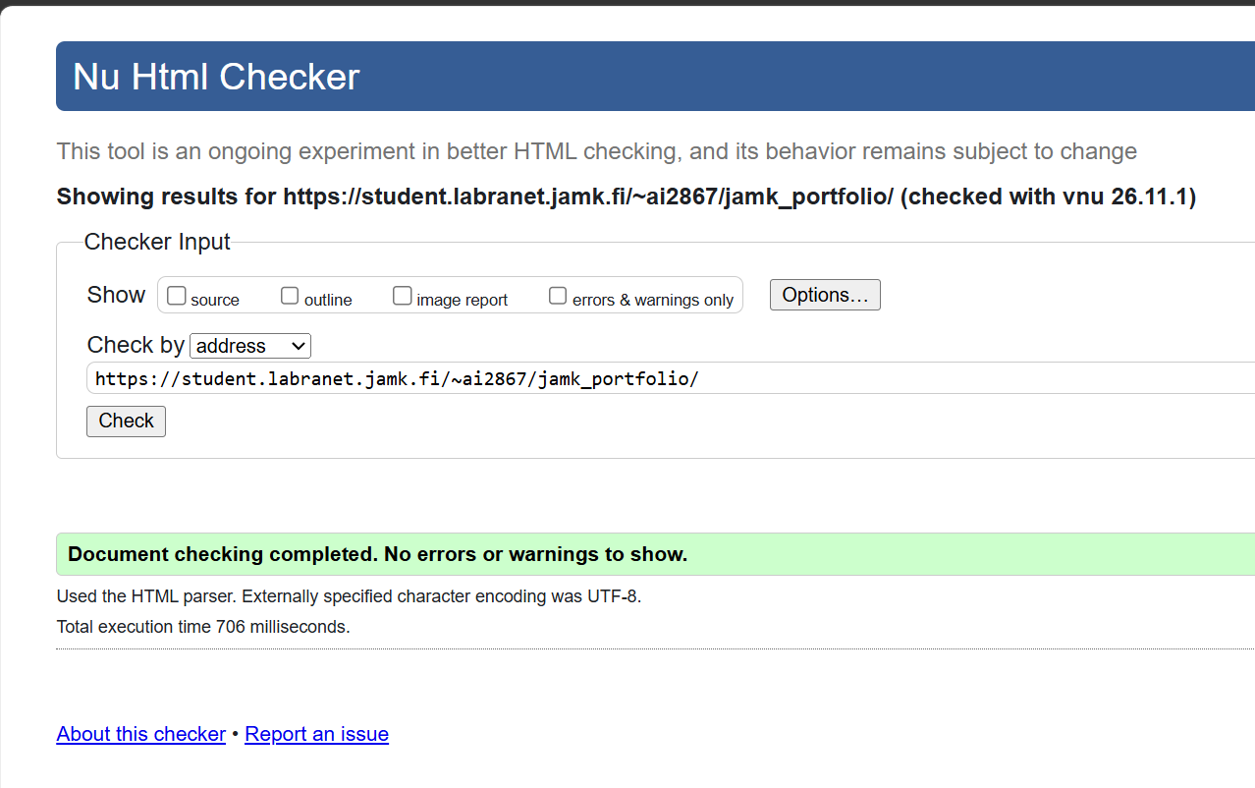
Figure 3. W3C HTML validation results

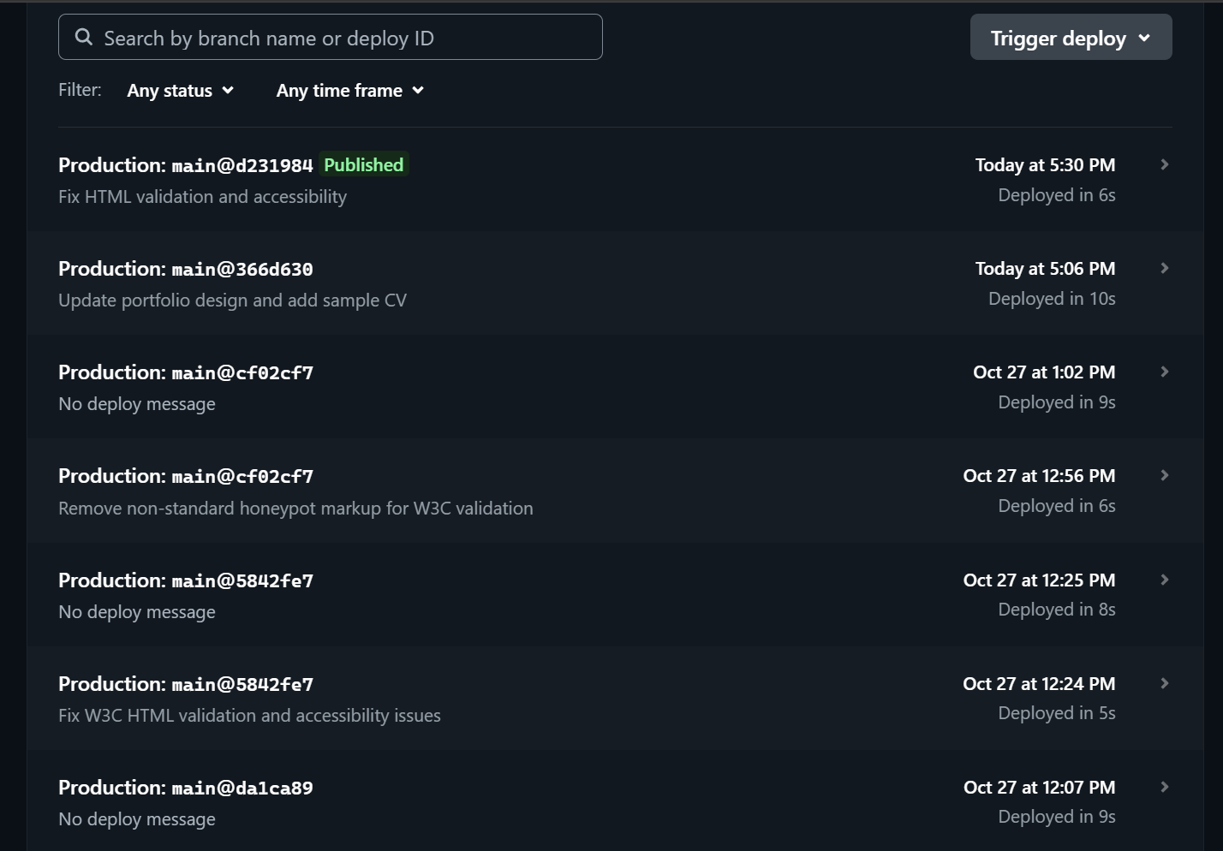
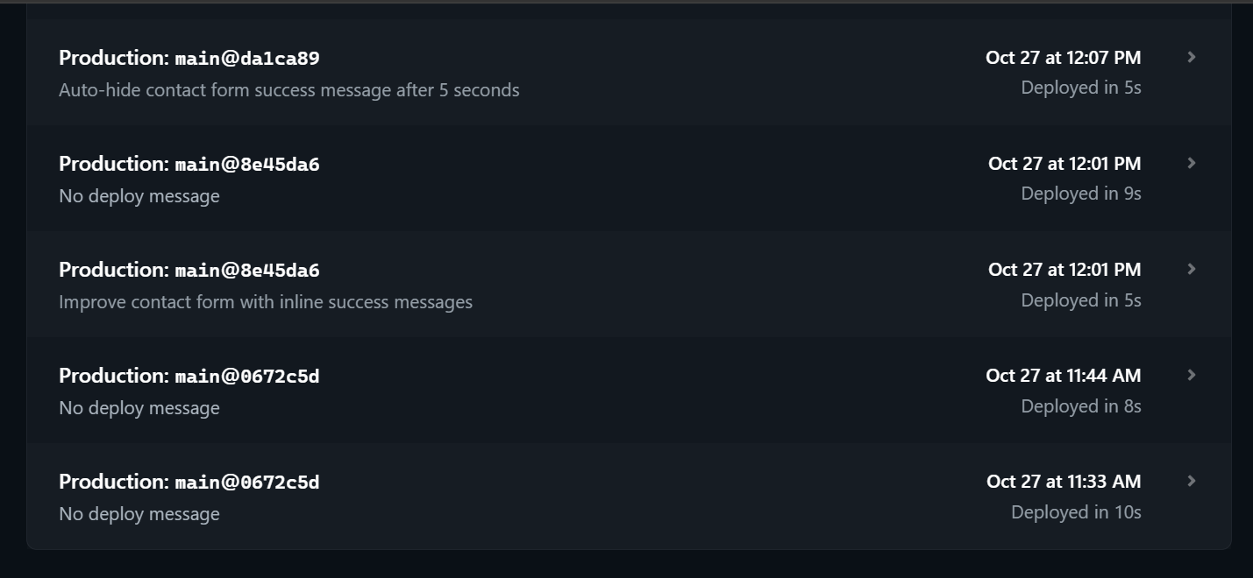
Figure 4. Netlify deployment history

