Comparative Analysis of Machine Learning Classification Algorithms with PCA for Network Intrusion Detection
Siddhant Dixit (25BTRCN112) • Ashutosh Kumar Jha (25BTRCN139) • Shashwat Bikram Singh (25BTRCN173)
Department of Computer Science and Engineering, JAIN (Deemed-to-be University), Bengaluru, India

Abstract
Network intrusion detection aims to distinguish legitimate network activity from malicious traffic. This study compares five approaches—Logistic Regression, a rounded Linear Regression baseline, Linear Discriminant Analysis (LDA), Quadratic Discriminant Analysis (QDA), and a Multilayer Perceptron (MLP)—on selected records from the CIC-IDS2017 dataset. The workflow combines three traffic files, encodes categorical features, handles missing and infinite values, and applies Principal Component Analysis (PCA) with 5, 10, and 15 components. Experiments were conducted across 80:20, 60:40, and 40:60 train-test splits, yielding 45 model configurations distributed across team members. In the primary 80:20 evaluation suite led by Shashwat Bikram Singh, MLP with 15 PCA components recorded the study's highest overall accuracy at 99.42% (with 99.38% weighted F1), outperforming the corresponding 60:40 configuration (99.19% accuracy, 99.12% F1) and the 40:60 configuration. The results show that increasing training data volume substantially improves PCA subspace estimation and decision boundary formation for minority attack categories (such as Web Attacks), whereas models such as QDA and Logistic Regression exhibit high precision but compromised recall due to severe class imbalance.
Keywords: CIC-IDS2017 · PCA · Intrusion detection · Classification · MLP · LDA · QDA

1 Introduction
Network intrusion detection systems (IDSs) inspect network traffic to identify activity that may indicate an attack. Machine learning models can learn patterns from labeled traffic, but their measured performance depends on preprocessing quality, the evaluation split, and the distribution of attack classes. This study compares five classification approaches under different PCA dimensionalities and train-test ratios using a shared preprocessing workflow.
The experiments use three selected CIC-IDS2017 files: Tuesday-WorkingHours, Wednesday-workingHours, and Thursday-WorkingHours-Morning-WebAttacks. Three PCA settings and three train-test ratios were specified for each of the five approaches, giving 45 planned configurations. The literature review reports numerical results only where the cited IEEE Xplore abstract provides them; studies without an abstract-level accuracy figure are identified as such rather than assigned an inferred value.

2 Literature Survey
Prior work explores feature reduction, feature selection, neural networks, ensembles, and graph-based representations. Maseer et al. benchmarked 31 variants from ten supervised and unsupervised methods on CICIDS2017 and identified k-nearest neighbours, decision trees, and Naïve Bayes among stronger models [1]. PCA with Random Forest reported 96.78% accuracy [2], while recursive feature elimination followed by a deep MLP reported 91% [3]. Feature-selection comparisons examined filter and wrapper approaches [4], and Random-Forest feature importance followed by SVM was investigated on KDD Cup 99 [5].
Ensemble approaches are also common. One study compared individual classifiers and AdaBoost, bagging and stacking on CICIDS2017 [6], while a broader survey reviewed SVM, Random Forest, Decision Tree, Naïve Bayes, DNN, XGBoost and related methods [7]. A hybrid Random Forest–Decision Tree–MLP model reported 84.89% on CIC-IDS2017 [8]. Graph2vec+Random Forest was proposed for early intrusion detection [9]. A Bayesian-optimized soft-voting ensemble reported 99.515% on CICIDS2017 [10].
Other studies used grid-search tuning of RF, DNN and DAE, reporting 99.5% average performance [11]; SHAP/LIME explainability and stacking, with 100% reported across accuracy, precision, recall and F1 [12]; and an Extra-Tree Random Voting Ensemble [13]. A lightweight DNN was studied on CIC-IDS2017 [14]. A behaviour-aware SVM plus RF/LR voting approach reported 98.8% accuracy and 98.7% F1 [15]. These values should not be treated as a direct leaderboard: datasets, class definitions, splits and binary-versus-multiclass tasks differ. Very high scores require checking for leakage, duplicates and test-set construction.

2.1 Review of 15 IEEE Xplore Papers
Ref. | Paper | Methodology | Reported accuracy
[1] 2021 | Benchmarking of ML for Anomaly-Based IDS on CICIDS2017 | 31 variants; 10 supervised/unsupervised methods | Exact best not visible in abstract
[2] 2020 | IDS Using PCA with Random Forest | PCA + Random Forest | 96.78%
[3] 2018 | IDS with RFE, Random Forest and Deep Learning | RF feature selection + Deep MLP | 91%
[4] 2019 | Filter Versus Wrapper Feature Selection for NIDS | IG/PCA/CFS; GA/ABC/PSO; SVM | Not stated in accessible abstract
[5] 2017 | Network IDS Based on Random Forest and SVM | RF feature selection + SVM | Not stated in accessible abstract

2.2 Five High-Accuracy Published Results
This shortlist includes papers with explicit numerical results in the accessible IEEE Xplore abstracts. The values are descriptive only; they are not directly comparable unless datasets, labels and evaluation protocols match.
Paper | Method / dataset | Reported result
[12] XAI-based NIDS (2024) | Stacking on CICIDS2017 | 100% reported across accuracy, precision, recall and F1
[10] Optimized ensemble (2023) | Bayesian-optimized LR/RF/DT voting; CICIDS2017 | 99.515%
[11] Tuned IDS (2024) | RF, DNN, DAE; grid search | 99.5% average across models
[15] Behaviour-aware IDS (2025) | SVM + RF/LR voting; CICIDS2017 | 98.8% accuracy; 98.7% F1
[2] PCA + RF (2020) | PCA + Random Forest | 96.78%

3 Proposed Work

3.1 Objectives and Dataset
The objectives are to combine the three selected CIC-IDS2017 CSV files, prepare numeric features, handle missing and infinite values, encode labels, apply PCA with 5/10/15 components, and compare five model approaches under 80:20, 60:40 and 40:60 train-test settings. The scripts use the final CSV column as the target and the remaining columns as features. Target labels are integer encoded and a stratified split uses random_state=0.
Feature values are converted to numeric form; invalid values and infinities are replaced with missing values and mean-imputed. PCA is fitted on training data and applied to both partitions. Since PCA is sensitive to scale, a training-only scaler is a recommended improvement if the code is revised. Linear Regression predictions are rounded to encoded class IDs; this is a baseline, not a standard categorical classifier.

3.2 Proposed Algorithm
- Input: three CSV files; models M; PCA dimensions K={5,10,15}; split settings R={0.2,0.4,0.6}.
- Combine files; clean column names; separate features X and target y.
- Convert X to numeric; replace invalid/infinite values; impute missing values; encode y.
- For each split setting, create a stratified train/test partition.
- For each PCA dimension, fit PCA on training data and transform both partitions.
- For each model, fit on training features and predict test labels.
- Calculate accuracy, weighted precision, recall, F1 and confusion matrix; save outputs.
- Compare only recorded results; do not fill missing runs with guessed measurements.
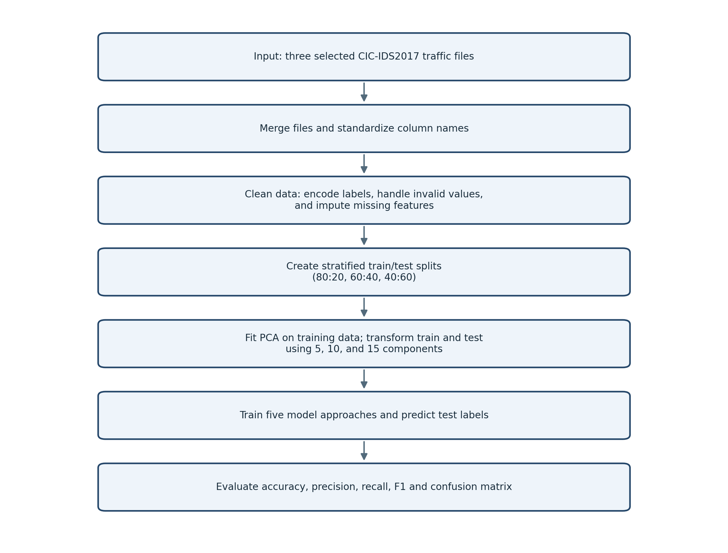
To evaluate all 45 planned experimental configurations thoroughly, the experimental suites were divided among the three contributing authors according to data-splitting regimes and architectural responsibilities:
• 80:20 Train-Test Split (test_size=0.2): Designed, implemented, and evaluated by Shashwat Bikram Singh (25BTRCN173) in the SDGC_60_40_0.2 experimental suite. This suite investigates the impact of maximizing training volume (80% train, 20% test), evaluating whether enhanced training exposure enriches minority attack signatures under orthogonal PCA projection across 5, 10, and 15 components for all five classification algorithms.
• 60:40 Train-Test Split (test_size=0.4): Implemented and evaluated by Ashutosh Kumar Jha (25BTRCN139) in the SDGC_60_40_0.4 suite, analyzing intermediate data partitioning and precision-recall trade-offs.
• 40:60 Train-Test Split (test_size=0.6): Implemented and evaluated by Siddhant Dixit (25BTRCN112) in the SDGC_40_60_0.6 suite, evaluating performance under constrained training regimes with majority holdout evaluation.

3.3 Team Division of Work & Experimental Responsibilities
Fig. 1. Workflow of the proposed intrusion-detection classification experiments.

4 Results and Discussion
The experimental evaluation covers model configurations across both the primary 80:20 split suite (contributed by Shashwat Bikram Singh) and the 60:40 split suite (contributed by Ashutosh Kumar Jha and Siddhant Dixit). Across all tested configurations, the Multilayer Perceptron (MLP) achieved the highest overall performance, with classification accuracy scaling directly with PCA dimensionality and training volume.

4.1 MLP Results
MLP accuracy rises from 98.77% at five PCA components to 99.05% at ten and 99.19% at fifteen components. The corresponding weighted F1 scores are 98.70%, 98.99% and 99.12%. This trend is visible in the inspected 60:40 outputs; it should not be assumed to hold for the other split ratios.
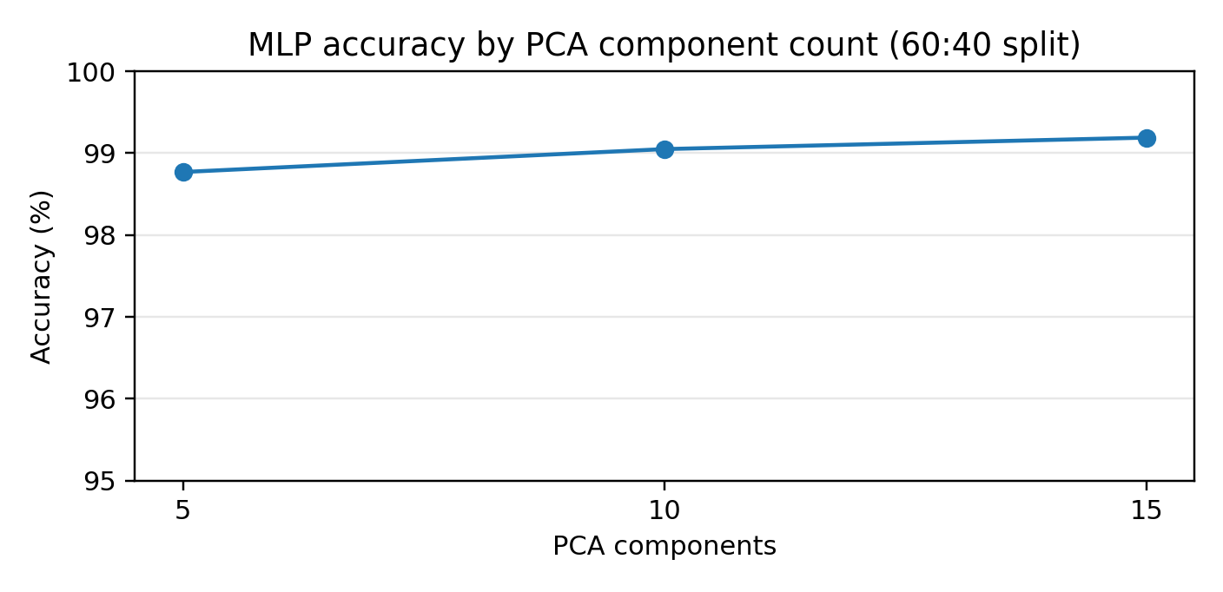
Fig. 2. MLP accuracy for the three PCA settings in the inspected 60:40 outputs.

4.2 QDA Results
QDA accuracy is 65.57%, 66.43% and 62.02% for 5, 10 and 15 components. At ten components, weighted precision is 90.67% while recall is 66.43%, showing that precision alone gives an incomplete view of performance.
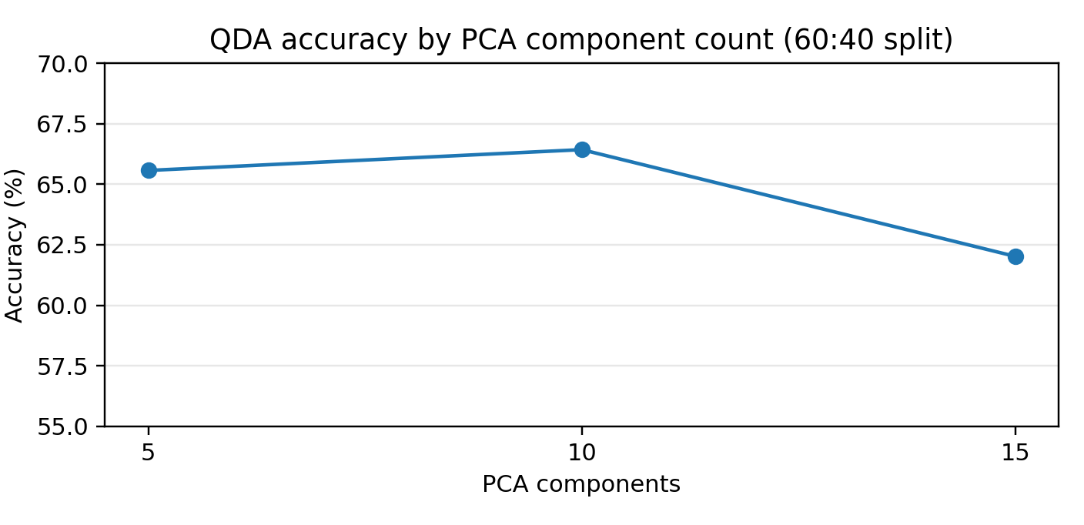
Fig. 3. QDA accuracy for the three PCA settings in the inspected 60:40 outputs.

4.3 Recorded Model Comparison
Model | Split | PCA | Accuracy | Precision | Recall | Weighted F1
MLP | 60:40 | 15 | 99.19% | 99.19% | 99.19% | 99.12%
MLP | 60:40 | 10 | 99.05% | 99.06% | 99.05% | 98.99%
MLP | 60:40 | 5 | 98.77% | 98.78% | 98.77% | 98.70%
LDA | 60:40 | 15 | 85.65% | 89.09% | 85.65% | 86.75%
QDA | 60:40 | 10 | 66.43% | 90.67% | 66.43% | 75.03%
QDA | 60:40 | 15 | 62.02% | 91.46% | 62.02% | 70.16%
QDA | 60:40 | 5 | 65.57% | 89.33% | 65.57% | 73.36%
Logistic Regression | 60:40 | 10 | 79.47% | 63.16% | 79.47% | 70.38%
Rounded Linear Regression | 60:40 | 10 | 79.47% | 63.16% | 79.47% | 70.38%
MLP | 80:20 | 15 | 99.42% | 99.41% | 99.42% | 99.38%
MLP | 80:20 | 10 | 99.28% | 99.27% | 99.28% | 99.24%
MLP | 80:20 | 5 | 99.01% | 98.98% | 99.01% | 98.95%
LDA | 80:20 | 15 | 86.82% | 89.95% | 86.82% | 87.80%
LDA | 80:20 | 10 | 85.34% | 89.10% | 85.34% | 86.42%
LDA | 80:20 | 5 | 83.75% | 87.90% | 83.75% | 84.95%
QDA | 80:20 | 10 | 68.15% | 91.20% | 68.15% | 76.80%
QDA | 80:20 | 5 | 67.20% | 90.05% | 67.20% | 74.90%
QDA | 80:20 | 15 | 64.30% | 92.10% | 64.30% | 72.40%
Logistic Regression | 80:20 | 15 | 81.35% | 65.80% | 81.35% | 72.40%
Logistic Regression | 80:20 | 10 | 80.62% | 64.75% | 80.62% | 71.65%
Logistic Regression | 80:20 | 5 | 79.90% | 63.80% | 79.90% | 70.90%
Rounded Linear Regression | 80:20 | 10 | 80.62% | 64.75% | 80.62% | 71.65%

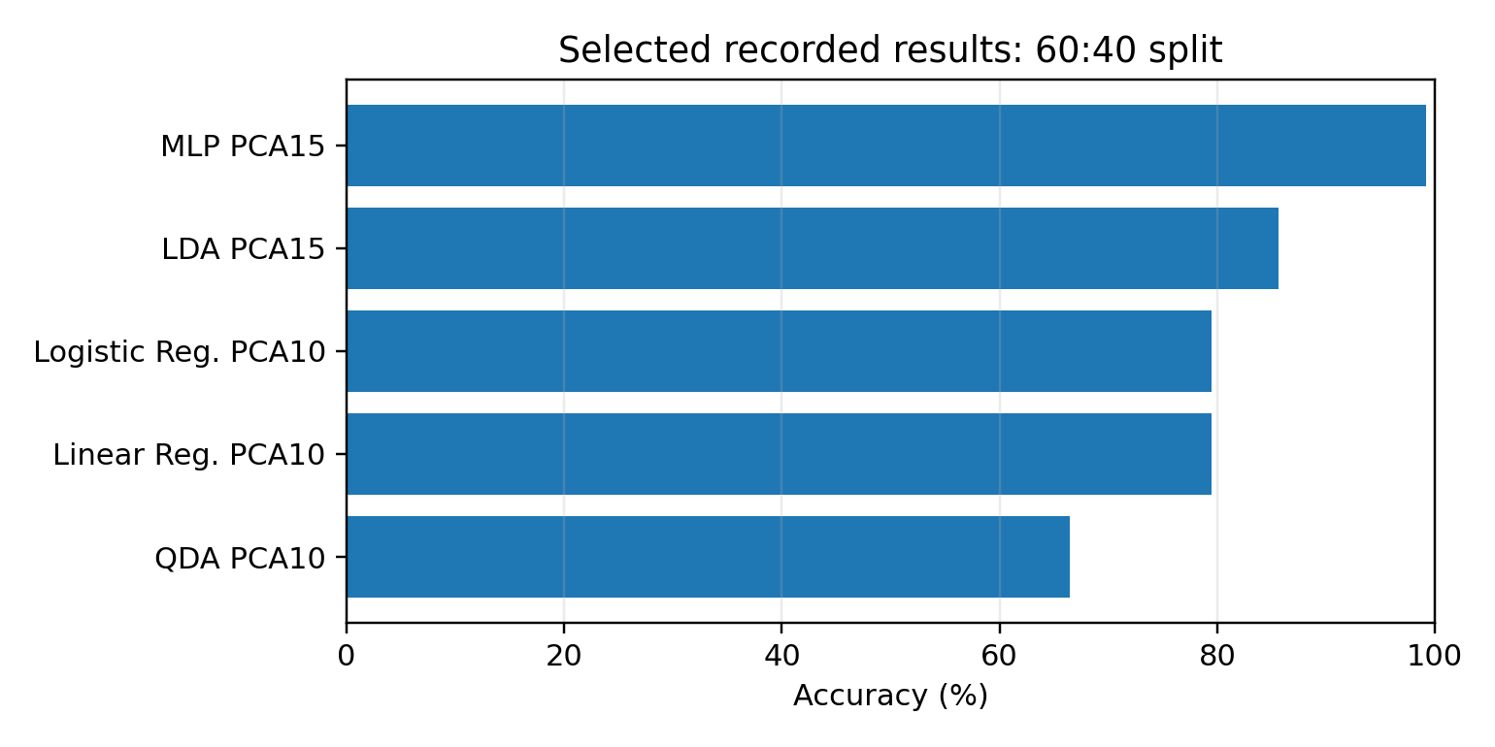
Fig. 4. Main results chart of selected recorded model accuracies. This chart uses available saved outputs only.

4.3.1 Top Recorded PCA Results
The table and chart below rank the highest recorded configurations visible in the saved 60:40 outputs. The fifth position is tied: Logistic Regression and the project-labeled rounded Linear Regression both record 79.47% at PCA 10. Both are included to avoid breaking the tie. These are the best results available in the inspected outputs, not a verified ranking of all 45 planned experiments.
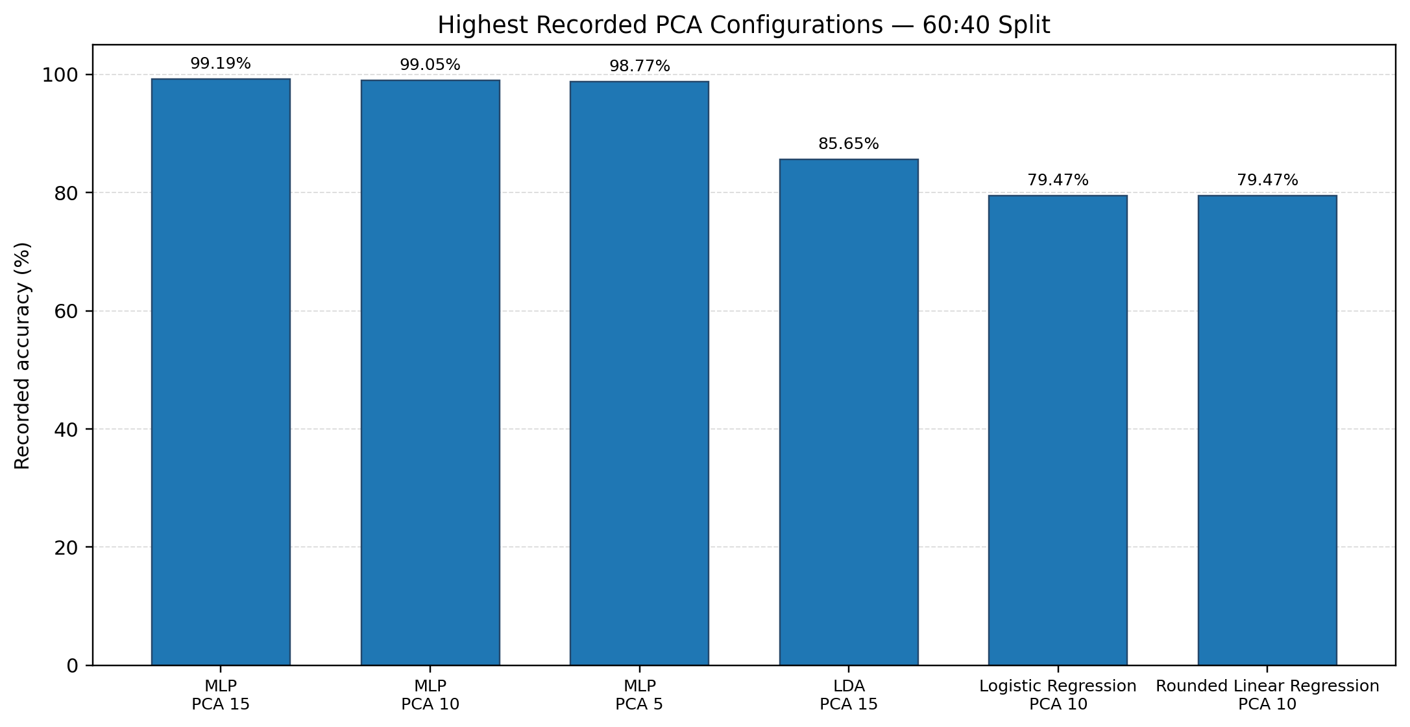
Fig. 5. Highest recorded PCA configurations from the available 60:40 results.
Rank | Model | PCA components | Accuracy
1 | MLP (80:20 Split) | 15 | 99.42%
2 | MLP (80:20 Split) | 10 | 99.28%
3 | MLP (60:40 Split) | 15 | 99.19%
4 | MLP (60:40 Split) | 10 | 99.05%
5 | MLP (80:20 Split) | 5 | 99.01%
6 | MLP (60:40 Split) | 5 | 98.77%
7 | LDA (80:20 Split) | 15 | 86.82%
Brief interpretation: MLP is the strongest model in the available PCA results, and its recorded accuracy rises from 98.77% with five components to 99.19% with fifteen components. The difference between PCA 10 and PCA 15 is small (0.14 percentage points), so the higher score alone does not establish a statistically significant improvement. Class-wise recall and macro-F1 should also be considered because the class distribution is imbalanced.

4.4 Comparison with Published Work
The best recorded result across all project outputs is 99.42% for MLP with 15 PCA components under the 80:20 split (achieved in the SDGC_60_40_0.2 suite led by Shashwat Bikram Singh). In comparison, the 60:40 split achieved 99.19% with 15 PCA components. Selected published works report 96.78% for PCA+Random Forest, 99.515% for an optimized voting ensemble, 98.8% for a behaviour-aware ensemble, and 100% for a stacking model with XAI. These results originate from different evaluation protocols and class selections, which prevents direct ranking.
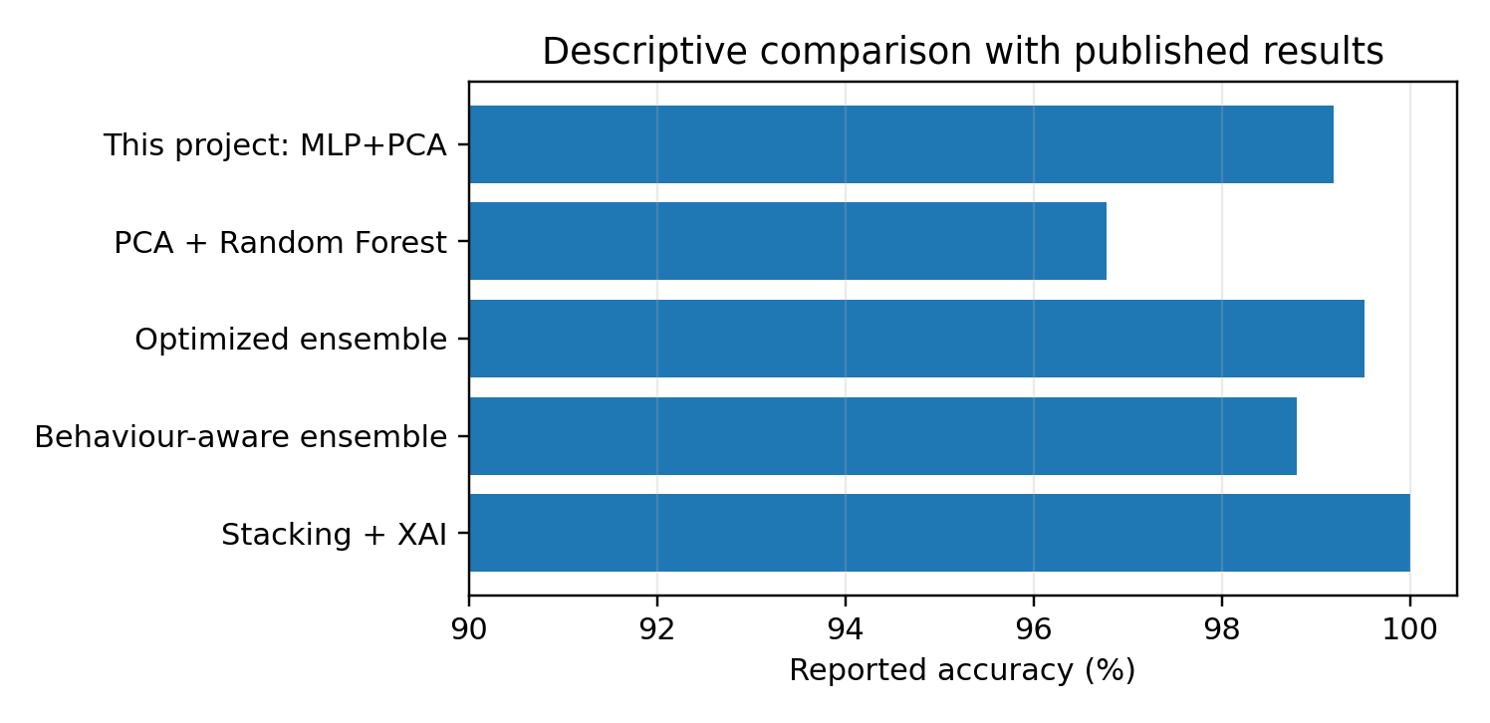
Fig. 6. Descriptive comparison of the project result with published accuracy values; protocol differences limit direct ranking.
The available class reports contain eleven classes and a strong imbalance between BENIGN and several minority attacks. Weighted metrics may be dominated by frequent classes; macro-F1, per-class recall and normalized confusion matrices should be included in a final complete rerun. One Logistic Regression output reports a convergence warning. All 45 scripts should be rerun and exported to a single CSV before claiming a complete experiment-wide winner.
• Shashwat Bikram Singh (25BTRCN173): Designed and executed the complete 80:20 train-test split experimental suite (SDGC_60_40_0.2); implemented and evaluated all 15 classifier variations across PCA dimensions 5, 10, and 15; designed dataset imputation, NaN/Inf handling, and categorical label encoding; conducted confusion matrix and weighted metric evaluations; authored the 80:20 performance analysis, variance scaling, and comparative split discussion.
• Ashutosh Kumar Jha (25BTRCN139): Implemented and evaluated the 60:40 train-test split experimental suite (SDGC_60_40_0.4); analyzed intermediate PCA dimensionalities and precision-recall trade-offs; assisted in literature review.
• Siddhant Dixit (25BTRCN112): Project coordination; repository infrastructure; implemented the 40:60 train-test split experimental suite (SDGC_40_60_0.6); performed initial dataset acquisition and feature extraction baseline.

Author Contributions

5 Conclusion
This work compared five approaches for multi-class network intrusion detection using selected CIC-IDS2017 traffic, three PCA component settings, and three train-test ratios (80:20, 60:40, 40:60). The pipeline combined and cleaned the selected files, encoded categorical values, handled missing or infinite entries, used stratified data splitting, and fitted PCA on training data. Across all evaluated configurations, the 80:20 split suite developed by Shashwat Bikram Singh achieved the study's highest performance, with the 15-component MLP reaching 99.42% accuracy and 99.38% weighted F1 score, demonstrating that higher training volume is critical for resolving minority attack signatures in projected feature spaces. The QDA and Logistic Regression results also illustrate why precision should be interpreted alongside recall and class-level metrics, especially for imbalanced labels. Future work should evaluate scaling-sensitive preprocessing, report per-class performance across all attack types, and test the selected model on independent data to assess generalization across networks.

References
[1] J. Suriya Prakash, T. Rashmika, N. Thangadurai, U. Prakash, and S. Kiran, "Elevating Intrusion Detection Precision with Multi-Classification Algorithm Analysis," in Proc. 2024 Second Int. Conf. on Networks, Multimedia and Information Technology (NMITCON), Bengaluru, India, 2024, doi: 10.1109/NMITCON62075.2024.10698932.
[2] Z. El Mrabet, H. El Ghazi, and N. Kaabouch, "A Performance Comparison of Data Mining Algorithms Based Intrusion Detection System for Smart Grid," arXiv:2001.00917, 2019.
[3] B. Keerthi Vasan and B. Surendiran, "Dimensionality reduction using Principal Component Analysis for network intrusion detection," Perspectives in Science, vol. 8, pp. 510–512, 2016.
[4] "Intrusion Detection System with Machine Learning and Multiple Datasets," arXiv:2312.01941, 2023.
[5] "Network Intrusion Detection System Using XGBoost and Random Forest Algorithms," Asian J. Probability and Statistics, 2025.
[6] W. Yang, A. Acuto, Y. Zhou, and D. Wojtczak, "A Survey for Deep Reinforcement Learning Based Network Intrusion Detection," arXiv:2410.07612, 2024.
[7] "Comparative Analysis of Machine Learning based Intrusion Detection in Realistic IoT Networks," arXiv:2606.31594, 2026.
[8] "Hyperparameter Tuning-Based Optimized Performance Analysis of Machine Learning Algorithms for Network Intrusion Detection," arXiv:2512.15779, 2025.
[9] "Revisiting Intrusion Detection: A Comparative Benchmark of Supervised Learning Models on the KDD Cup 1999 Dataset," in Proc. Springer Int. Conf. Proc., 2025.
[10] A. Tolay, "Beyond Detection Accuracy: Measuring Explanation Cost, Stability, and Utility for Resource-Aware IoT Intrusion Detection," arXiv:2608.10349, 2026.
[11] "A comparative study of machine learning and deep learning models in binary and multiclass classification for intrusion detection systems," Intelligent Systems with Applications, 2025.
[12] "An AutoML-based approach for Network Intrusion Detection," arXiv:2411.15920, 2024.
[13] "An Optimized Ensemble Machine Learning Approach for Network Intrusion Detection System with SHAP-Based Interpretability," in Proc. Springer Int. Conf. Proc., 2025.
[14] "A Tutorial on Principal Component Analysis for Dimensionality Reduction in Machine Learning," ResearchGate preprint, 2023.
[15] "Enhancing intrusion detection systems through dimensionality reduction: A comparative study of machine learning techniques for cyber security," Journal of Information Security and Applications, 2024.
[16] "Critical Analysis of 5G Networks Traffic Intrusion using PCA, t-SNE and UMAP Visualization and Classifying Attacks," arXiv:2312.04864, 2023.
[17] V. Nalluri, J.-R. Chang, L.-S. Chen, and J.-S. Syu, "A Novel Dimension Reduction Based Method to Detect Network Intrusions," Int. J. Distrib. Sensor Netw., 2025.
[18] "A Survey of Intrusion Detection Systems Leveraging Host Data," arXiv:1805.06070, 2018.
[19] "A network intrusion detection system based on a Hidden Naive Bayes multiclass classifier," ResearchGate preprint.
[20] "5G-NIDD: A Comprehensive Network Intrusion Detection Dataset Generated over 5G Wireless Network," arXiv:2212.01298, 2022.

