Embedded Systems Final Report

Melih Işık 14411823172

In this Project, I am supposed to use a HC-06 bluetooth module, to establish a connection between the host and the launchpad. I will use the bluetooth module to send messages text from the computer using Termite. Once you receive these messages on the lauchpad, I will send those messages to the Internet server with time information in front of the message.

When receiving data from the bluetooth module at the beginning of the project, usually seen from baudrate mismatch; I got corrupted data. I solved this problem by setting Baudrate to 38400 in COM settings from Device manager.

HC-06 Connection

Then I set the Baudrate to 9600 on Termite. I set the data bits to 8. I made RX TX connections to PA2 and PA3 pins using UART3.

PROTOCOL

When bluetooth sent ‘0’ message then launchpad sent “LED ON” message both to seri port and server with instant time information.

Message ‘0’ -> ‘‘LED ON’’

Message ‘1’ -> ‘‘LED OFF’’

Message ‘2’ -> ‘‘LED ON’’

Message ‘3’ -> ‘‘LED OFF’’

Message ‘4’ -> ‘‘LED TOG’’

Message ‘5’ -> ‘‘LED TOG’’

TERMİNOLOGY

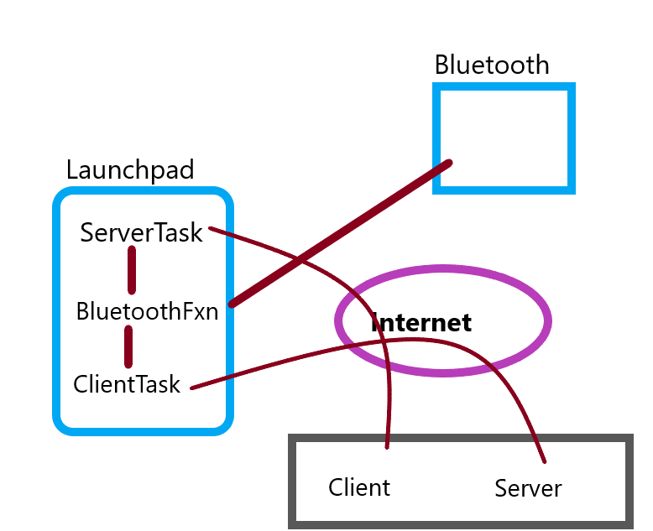

PROGRAM OUTPUT

metin içeren bir resim

Açıklama otomatik olarak oluşturuldu

Commands I send with Termite.

metin içeren bir resim

Açıklama otomatik olarak oluşturuldu

Answers I got from the server.