DOI: [assigned by editorial team]
UDC 004.932:004.94:796.352

Diagnostic Evaluation of a Markerless Golf-Club Motion-Analysis Workflow: Reference-Based 2D Agreement and Perturbation Sensitivity

Ivan M. Syniuk¹⁾
ORCID: https://orcid.org/0009-0000-4141-0135; i.syniuk@gmail.com
Maksym V. Maksymov¹⁾
ORCID: https://orcid.org/0000-0002-7536-2570; prof.maksimov@gmail.com. Scopus Author ID: 7005088554
Oleksii M. Maksymov¹⁾
ORCID: https://orcid.org/0000-0003-2504-0853; oleksii.maksymov@op.edu.ua. Scopus Author ID: 57220057510
Karthik Iyer²⁾
ORCID: https://orcid.org/0009-0003-2520-1810; ki2406@columbia.edu
¹⁾ Odesa Polytechnic National University, 1, Shevchenko Ave. Odesa, 65044, Ukraine
²⁾ Columbia University, 116th and Broadway. New York, 10027, USA
ABSTRACT
Markerless video analysis could broaden access to golf-swing measurement, but visual plausibility does not establish measurement validity, and a single annotator cannot show how precise a manual reference is. This study assessed the agreement and perturbation sensitivity of a monocular golf-club motion-analysis workflow against a multi-rater visual reference whose own uncertainty was quantified first. A subset of 25 sessions was selected from 71 heterogeneous processed recordings using viewpoint, capture-speed class, and video-quality strata. Two annotators independently marked address, top of backswing, downswing transition, and impact in all 25 sessions, and both clicked the clubhead on a shared plan of 150 frames; the first annotator repeated 10 sessions to give an intra-rater round. Annotators were blinded from automatic overlays and from each other's coordinates. A disclosed mean rule combined the two rounds into a consensus reference used for all algorithm comparisons. Between annotators, event frames agreed to a median of 4 frames, or 80 ms, with 13% exact agreement and limits of agreement from -13.1 to +12.9 frames, while the repeat round of one annotator agreed to a median of 2 frames. Clubhead clicks agreed far less closely: the median disagreement was 77.1 pixels, or 4.03% of the image diagonal, between annotators and 78.5 pixels within one annotator, so the reference itself resolves clubhead position only to a few per cent of the frame. The automatic transition output was the same proxy for both manually defined transition events and therefore did not constitute two detectors; the annotators separated those two events by a median of only 3 frames. Against the consensus, automatic events fired a median 38 to 40 frames, or 780 to 940 ms, early, with mean biases from -1699 to -1824 ms - roughly ten times the human disagreement, and far larger than the 67 ms maximum timestamp discrepancy over the common frame grid. The median of session-specific clubhead discrepancies was 2.54% of the image diagonal (95% confidence interval 1.98-2.88%), or 46.2 pixels (41.4-51.9 pixels), which is below the reference's own inter-rater disagreement; 22 of 150 points exceeded 100 pixels and 3 exceeded 500 pixels. Path efficiency and smoothness index showed the lowest perturbation response, with median absolute symmetric changes of 5.9% and 6.2% and no high-response scenario among twelve, whereas swing tempo, backswing peak speed, and curvature RMS changed by 39.6% to 74.4%. Production-stage ablation, run after a process-noise correction to the Rauch-Tung-Striebel smoother, showed that the smoothed output still lies a median 141.4 cm from the observed path, that despiking changed no points, and that bounded reconstruction restores geometry while returning root-mean-square jerk to 11 835 m/s³. The contribution of the study is therefore a diagnostic evaluation framework that combines reference-precision measurement, time-base auditing, perturbation stress testing, and production-stage ablation to identify evidence boundaries and failure modes in an implemented markerless workflow. The results establish a reproducible diagnostic baseline for subsequent redesign; they do not claim external biomechanical validity, athlete test-retest reliability, cross-athlete comparability, or application-level adequacy for coaching and virtual-reality feedback.
Keywords: markerless motion analysis; golf swing; clubhead tracking; inter-rater agreement; perturbation analysis; measurement agreement

For citation: Syniuk I. M., Maksymov M. V., Maksymov O. M., Iyer K. "Diagnostic evaluation of a markerless golf-club motion-analysis workflow: reference-based 2D agreement and perturbation sensitivity". Herald of Advanced Information Technology. - [Year]. - Vol. [..]. - No. [..]. - Pp. [..-..]. DOI: [assigned by editorial team]
© Syniuk I. M., Maksymov M. V., Maksymov O. M., Iyer K., 2026
This is an open access article under the CC BY license (http://creativecommons.org/licenses/by/4.0/deed.en)
INTRODUCTION
Quantitative golf-swing assessment supports technique research, coaching, and the development of interactive training systems. Laboratory optical motion capture can resolve segment and club kinematics with controlled calibration, but it requires synchronized cameras, markers, and specialist operation [1], [2]. Golf biomechanics has therefore been studied through laboratory kinematics, clubhead-speed and power analysis, and segment sequencing [8], [9], [10], [11], [23]. These methods establish what can be measured under controlled conditions but do not by themselves solve the problem of low-cost field acquisition.
Portable inertial measurement units and ordinary video lower the acquisition burden. Golf-specific inertial systems have been compared with three-dimensional motion capture, while single-camera studies have combined pose estimation and object detection to examine golfer posture and clubhead trajectories [24], [31]. General pose-estimation frameworks such as OpenPose, BlazePose, and MediaPipe make markerless processing accessible [3], [4], [5]. Nevertheless, accessibility is not equivalent to accuracy, and a visually smooth trajectory can remain temporally misaligned, geometrically biased, or unstable under small changes in the input.
Validation literature distinguishes agreement with an explicit reference from reliability across repeated measurements, and it also requires that the reference itself be characterized. Markerless estimates are affected by viewpoint, occlusion, motion blur, training-domain mismatch, and monocular projection [12], [13], [25], [26], [27], [28]. Golf-specific evidence is especially cautionary: monocular three-dimensional pose models that look convincing after reprojection can still be unsuitable for kinematic analysis when compared with synchronized marker-based data [30]. Derivatives amplify coordinate noise, and impact-like, non-stationary motion creates additional filtering problems [6], [7], [19].
The workflow evaluated here was introduced in a companion methodological manuscript and combines median pre-filtering, confidence-aware Kalman tracking, Rauch-Tung-Striebel smoothing, trajectory despiking, bounded polynomial reconstruction, and dynamic scaling [32]. The present work asks a narrower question: what agreement and numerical sensitivity can be demonstrated with the available data, once the precision of the manual reference is measured rather than assumed? The evidence is deliberately limited to manual two-dimensional annotations from two annotators, decoded video timing, synthetic perturbations, and production-stage ablation. Figure 1 summarizes the study design and its evidence boundary.
The implemented production workflow, rather than an idealized or post-retuned version, is intentionally treated as the object of evaluation. This choice is methodologically important because a visually plausible end-to-end trajectory can conceal compensating or inactive internal stages. Evaluating the production configuration therefore allows the study to determine not only how closely the final output agrees with the available reference, but also where the workflow loses evidential support and which internal behaviours require redesign. In this study, a negative stage-level result is consequently treated as diagnostic evidence produced by the evaluation protocol, not as a reason to exclude that stage from the analysis.
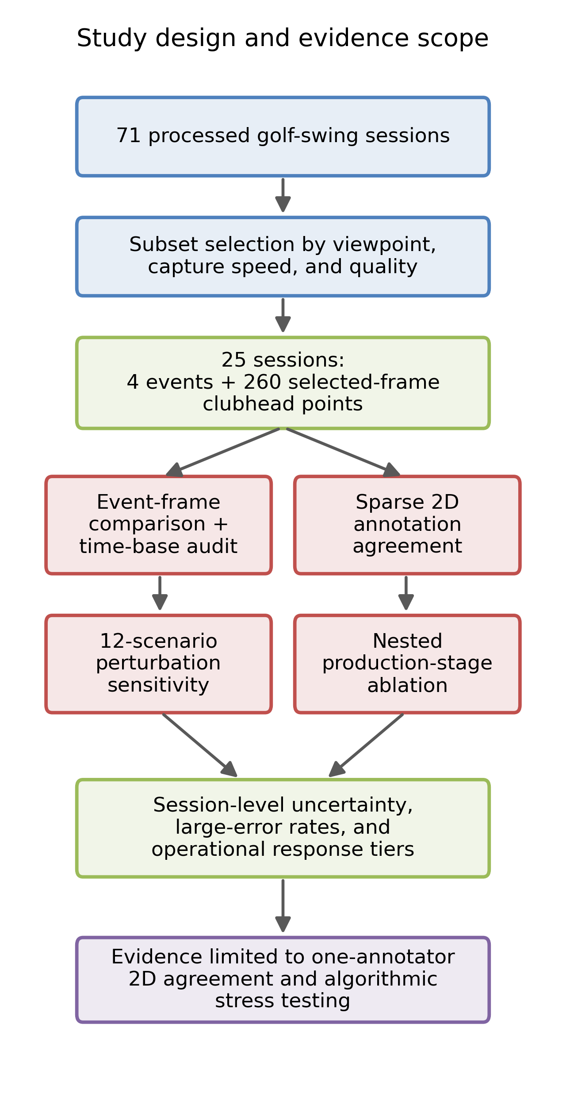
Fig. 1. Study design and evidence scope
Source: compiled by the authors
LITERATURE REVIEW AND PROBLEM STATEMENT
Markerless sports analysis spans general human-pose estimation, sport-specific movement recognition, and task-specific object tracking [3], [4], [5], [29]. In golf, Yamamoto et al. used a single sagittal camera, human-pose estimation, and DeepLabCut clubhead tracking to study proficiency and individual swing characteristics [31]. Ingwersen et al. compared monocular pose models with synchronized marker-based golf data and found substantial quantitative error despite plausible visual reconstructions [30]. Together these studies show that golf-specific validation must report the reference standard, camera geometry, event definitions, and failure tails rather than relying on representative images.
Signal conditioning changes both geometry and derived metrics. Median filters suppress isolated outliers [14]; Kalman filtering combines a dynamic model with noisy measurements [15], [16]; Rauch-Tung-Striebel smoothing uses later observations to refine earlier states [17]; and local polynomial methods can reduce noise while preserving trajectory shape [18]. For rapidly changing motion, however, the filter that best suppresses coordinate noise may attenuate true motion or create endpoint and derivative artefacts [7]. Smoothness measures based on jerk are consequently sensitive to the derivative definition and to the time interval used across missing samples [19].
Measurement terminology is also consequential. Test-retest reliability, intraclass correlation, standard error of measurement, and minimal detectable change require repeated observations with an identifiable grouping structure [20], [21]. Between-session dispersion in a heterogeneous corpus does not meet that definition. Bland-Altman bias and limits of agreement describe paired differences, and they apply equally to two human annotators and to an algorithm compared with a human consensus [22]. Robust summaries such as medians are useful for skewed error distributions [14], but they must be accompanied by uncertainty and failure-tail reporting.
Three gaps motivate this study. First, the available workflow had not been compared with manually selected clubhead positions and visually defined events, and the manual reference had never been repeated by a second observer, so its own precision was unknown. Second, the alignment of video frames, landmark indices, and annotation times had not been audited before interpreting large timing errors. Third, previous sensitivity and ablation summaries used unstable random seeds, percentage changes unsuitable near zero, a non-production smoothing variant, and cross-session coefficients of variation mislabeled as reliability. The problem addressed here is to correct those design and reporting weaknesses without claiming evidence that the dataset cannot provide.
Accordingly, the scientific problem addressed here is not how to certify a finished markerless system, but how to evaluate an implemented workflow without allowing plausible final output to mask uncertainty in the reference, time-base disagreement, numerical sensitivity, or stage-specific failure. A useful evaluation must therefore separate reference precision, algorithm-reference agreement, perturbation response, and internal production-stage behaviour. This separation provides an evidence boundary for the current implementation and a reproducible baseline against which later algorithmic redesign can be judged.
RESEARCH AIM AND OBJECTIVES
The aim is to diagnostically evaluate an implemented markerless video-based golf-club motion-analysis workflow under heterogeneous recording conditions by quantifying manual-reference precision, algorithm-reference agreement, time-base consistency, perturbation sensitivity, and production-stage behaviour, and thereby to establish the evidence boundary and redesign targets of the current configuration.
The research objectives are:
1. To define a blinded multi-rater selected-frame annotation protocol and to quantify inter-rater and intra-rater agreement before any algorithm comparison.
2. To construct a consensus reference from the raw rater rounds under a rule disclosed in advance, keeping the raw rounds immutable.
3. To audit video presentation timestamps, landmark times, frame counts, and event-definition mapping before interpreting event disagreement.
4. To estimate session-level clubhead localization agreement with the consensus in pixels and image-diagonal-normalized units, to quantify large-error tails, and to compare the result with the precision of the reference itself.
5. To characterize metric response to 12 controlled perturbation scenarios using deterministic simulation and symmetric relative change.
6. To compare the actual nested production stages and identify inactive, unstable, or compensating stages whose behaviour may be masked by the final reconstructed output.
7. To distinguish demonstrated findings from untested biomechanical validity, reliability, and application-level usefulness.
The scientific contribution is a diagnostic evaluation structure that explicitly separates four evidence layers: the precision of the visual reference, agreement of the implemented algorithm with that reference, sensitivity of derived outputs to controlled perturbations, and behaviour of the nested production stages. This structure makes it possible to identify cases in which an apparently acceptable final trajectory is produced despite unacceptable or inactive internal-stage behaviour. The study therefore contributes a reproducible way to locate evidence boundaries and failure modes before external biomechanical validation, rather than a claim that the current workflow is a finalized measurement instrument.
MATERIALS AND METHODS
Dataset, sampling, and available metadata
The corpus contained 71 processed golf-swing sessions. Frame rates ranged from 23.98 to 60.00 frames/s, and nine distinct resolutions ranged from 480 x 706 to 1920 x 1080 pixels. Viewpoint was predominantly down-the-line (59 sessions), with 10 face-on and 2 other views; club type was driver in 32 sessions, iron in 23, and unknown in 16. The selection algorithm formed strata from viewpoint, capture-speed class, and quality grade, then sampled 25 sessions with a fixed seed. Frame-rate and resolution distributions were summarized after selection but were not sampling strata. The selected set contained 21 down-the-line, 3 face-on, and 1 other view (Table 1). The export did not encode participant identity, number of sessions per participant, age, skill, device, camera distance or height, shutter speed, lighting, codec settings, or whether slow-motion interpolation had been applied. These omissions prevent participant-level generalization and test-retest analysis.

Table 1. Dataset and reference-subset characteristics
Characteristic | Full dataset | Annotated subset
Sessions, n | 71 | 25
Camera viewpoint | down-the-line: 59; face-on: 10; other: 2 | down-the-line: 21; face-on: 3; other: 1
Capture speed class | regular: 47; slow: 23; super slow motion: 1 | regular: 17; slow: 8
Frame-rate bucket, fps | 31–60: 41; ≤30: 30 | 31–60: 18; ≤30: 7
Resolution bucket | ≥1080 p: 43; <720 p: 14; 720–1080 p: 14 | ≥1080 p: 17; 720–1080 p: 5; <720 p: 3
Quality grade | medium: 47; good: 12; difficult: 12 | medium: 17; difficult: 4; good: 4
Club type | driver: 32; iron: 23; unknown: 16 | driver: 12; iron: 7; unknown: 6
Clubhead control points, n | - | 150 (in 25 sessions)
Source: compiled by the authors

Ethics, consent, and data provenance
No ethics-committee approval was required for this study. The analysed recordings are anonymized public demonstration footage used for algorithmic evaluation; they do not constitute identifiable human-participant research data for the purposes reported here. Session folders were stored locally and identified by universally unique identifiers. No participant image is reproduced in the article. The schematic in Fig. 2 is retained for annotation-definition illustration rather than as a subject photograph.
Manual annotation protocol and rater design
Two annotators contributed independent rounds. Ivan Syniuk (annotator A) completed all 25 sessions, recording four events and 8-14 clubhead points per session, for 100 event labels and 260 points. Daria Plokhotniuk (annotator B), a different person, independently completed all 25 sessions, recording the same four events and one clubhead click on each frame of a shared plan of 150 frames, giving 100 event labels and 150 points. The plan assigned six frames per session, chosen deterministically and spread over annotator A's ordered control frames so that difficult mid-swing frames were included rather than only early ones; it exported session and frame indices only, never coordinates. Annotator A then repeated 10 of the 25 sessions as a second round, selected by a stored deterministic plan stratified as far as possible by viewpoint, frame-rate group, resolution, capture speed, and quality, giving 40 event labels and 60 points for intra-rater analysis. The interval between annotator A's two rounds is not recorded in the export and is therefore not reported.
The annotation interface displayed decoded video frames without automatic event markers or processed clubhead coordinates, and no annotator saw another annotator's event frames or coordinates, or their own earlier round, before all raw rounds were locked. Clicks were captured at full resolution in original video pixel coordinates. Operational definitions are given in Table 2 and illustrated schematically in Fig. 2. Control points were deliberately placed along visible portions of the swing arc; consequently, the sample favours frames where a visual click was possible and cannot estimate whole-video tracking availability. The reference is therefore a sparsely sampled, two-dimensional visual reference from two observers, not a continuous or external biomechanical ground truth.

Table 2. Operational definitions of manually annotated events
Event | Visual criterion | Role
Address | Last stable frame before takeaway | Time-origin diagnostic
Top of backswing | Maximal backswing extent before reversal | Compared with transition proxy
Downswing transition | First sustained motion toward impact | Compared with transition proxy
Impact | Closest visible clubhead-ball contact | Compared with impact detector
Source: compiled by the authors

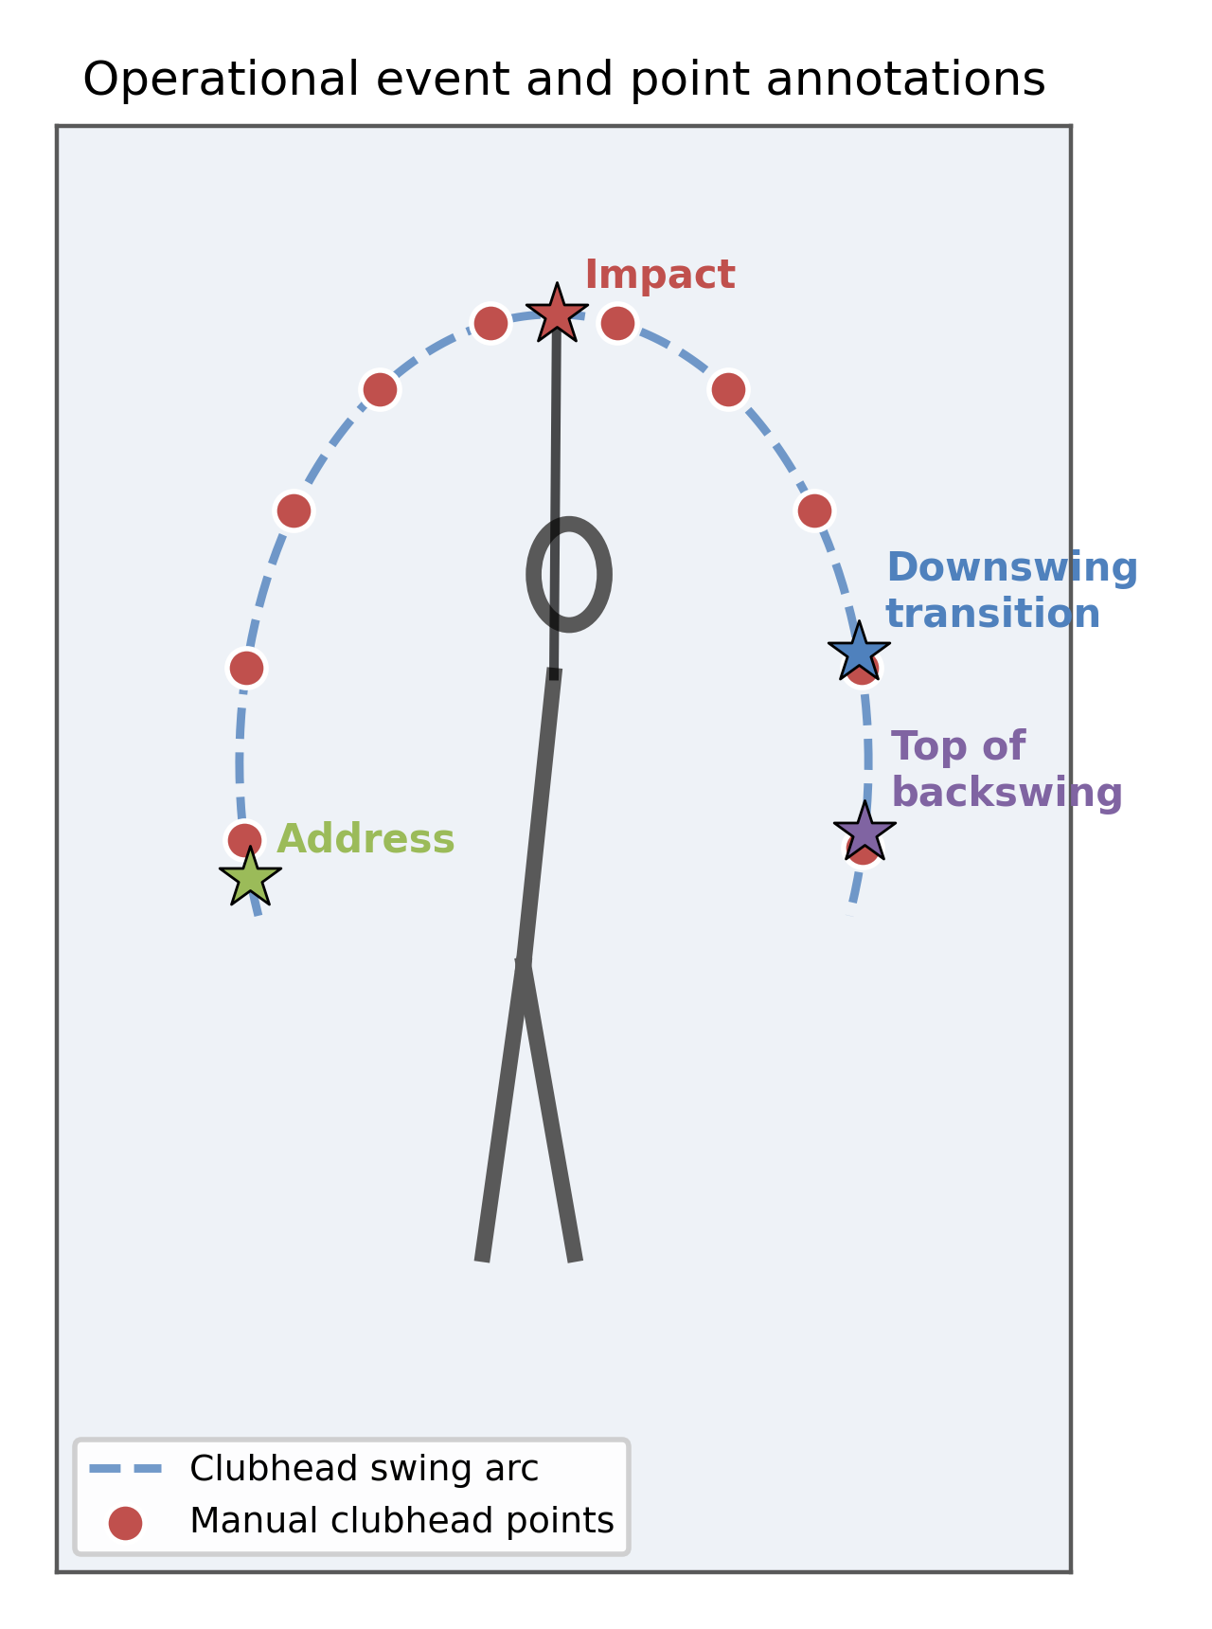
Fig. 2. Operational event and selected-frame clubhead annotations
Source: compiled by the authors
Consensus reference construction
Raw rater rows were preserved unchanged and merged into a multi-rater archive; a merge check rejected duplicate rows for the same rater, round, session, event, or planned point frame. Every position where the two round-1 annotators differed was listed, and each was resolved by a single rule fixed before adjudication and disclosed here: the consensus event frame is the midpoint of the two annotators' frames, and the consensus clubhead position is the pixel mean of the two annotators' clicks. All 250 adjudication records - 100 events and 150 points - were resolved by that mean rule, and each consensus row carries the adjudication identifier, decision, and reason. The consensus reference therefore contains 25 sessions, 100 event rows, and 150 clubhead points. Because a mean is not an expert re-adjudication, the consensus inherits the annotators' disagreement rather than removing it, and the size of that inherited uncertainty is reported alongside the algorithm results. All algorithm comparisons in this article use the consensus reference only; raw rater rounds are used only for annotation agreement.
Automatic workflow
Normalized landmark coordinates were converted to pixels. A running median preceded a confidence-aware constant-velocity Kalman filter with physical gating and adaptive measurement noise. Stored forward states were passed to the production Rauch-Tung-Striebel smoother, then to trajectory despiking and bounded polynomial/Laplacian reconstruction with blending and a maximum deviation from raw coordinates. During this revision a defect was corrected in the production smoother, whose predicted covariance had omitted the process-noise term used by the forward filter; the smoother now propagates the same process noise, and synthetic constant-velocity and missing-sample tests were added. No Kalman or despiking parameter was retuned. A running median of detected shaft length supplied the pixel-to-metre factor using an assumed physical club length of 1.0 m. The evaluated output was generated with the scientific profile described in the companion workflow [32].
Time-base and event audit
Every selected processed video was decoded with presentation timestamps. For each session, decoded frame count, timestamp intervals, the landmark-array time field, and manual reference_frame/reference_time_s pairs were compared. An event scatter plot used manual and automatic frame indices with an identity line. The workflow exports one impact index and one transition index. The transition index was compared separately with the consensus top of backswing and the consensus downswing transition only as a definition diagnostic; the two rows share the same automatic output and are not independent detectors.
Annotation agreement measures
Human-human agreement was computed from raw rater rows only, with no automatic input. For events, paired signed and absolute frame differences were summarized per event and overall by median, mean, standard deviation, 95th percentile, minimum, and maximum; by exact-frame, within-one-frame, and within-two-frame agreement; and by Bland-Altman bias and limits in frames and milliseconds [22]. Whether the two annotators could distinguish top of backswing from downswing transition was examined separately as the same-session absolute gap between those two labels for each annotator. For the shared 150 frames, click disagreement was the Euclidean pixel distance between the two annotators' coordinates, also expressed as a percentage of the image diagonal, summarized within each session and then across sessions with session-bootstrap intervals, together with counts above 10, 25, and 50 pixels. Inter-rater results and annotator A's intra-rater results are reported separately and are never pooled. No intraclass correlation is reported, because the design has no athlete or trial grouping; between-session dispersion of the corpus is not called reliability anywhere in this article.
Event agreement measures
For session i and consensus definition e, signed frame error was E_frame(i,e) = frame_auto(i,e) - frame_consensus(i,e). Negative values indicate an early automatic output. Presentation-time error was E_time(i,e) = time_auto(i,e) - time_consensus(i,e) and was reported in milliseconds. Absolute error was the magnitude of the signed error. For each comparison, the median signed error, median absolute error, mean bias, standard deviation of paired differences, 95th percentile absolute error, and Bland-Altman limits bias +/- 1.96 x SD were calculated [22]. Session bootstrap intervals resampled the 25 paired sessions 10 000 times.
Clubhead localization agreement
At every annotated frame, the Euclidean pixel discrepancy was D_px = sqrt[(x_auto - x_consensus)^2 + (y_auto - y_consensus)^2]. The primary resolution-normalized measure was D_diag = D_px / sqrt(width^2 + height^2). A secondary physical estimate used D_m = D_px x L_assumed / length_px, where L_assumed = 1.0 m and length_px was the workflow's running detected club length. Because this scale is generated by the evaluated workflow and actual club length is unavailable for 16 sessions, centimetre values are model-dependent and are not treated as independently calibrated accuracy. Points were assigned to phases from consensus events. To respect clustering, the median was first calculated within each session and phase; medians and 95% bootstrap intervals were then calculated across sessions. Point-level 95th percentiles, maxima, and counts above 100, 250, and 500 pixels describe the heavy tail. Because the consensus is a mean of two disagreeing observers, the resulting discrepancy is interpreted against the inter-rater disagreement measured on the same 150 frames, and a sensitivity check recomputed the same statistic against annotator A's round-1 clicks alone.
Perturbation sensitivity
All 71 sessions were reprocessed under 12 scenarios: frame thinning by factors of 2 and 3; club-landmark dropout of 5%, 10%, and 20%; independent coordinate jitter with normalized standard deviations 0.004 and 0.008; scale changes of -10%, -5%, +5%, and +10%; and a combined case comprising twofold thinning, 10% dropout, and 0.004 jitter. Depending on frame size, the jitter doses correspond approximately to 2-8 and 5-15 pixels per coordinate. These are study-specific stress-test doses, not empirically estimated prevalence levels. Dropout and jitter used a process-independent seed derived from the session identifier and recorded with every run; one realization per session and dose was evaluated, so the reported spread reflects between-session variation rather than Monte Carlo uncertainty.
For baseline value m0 and perturbed value mp, absolute symmetric change was Delta_sym = 200 x |mp - m0| / (|mp| + |m0|). This bounded measure avoids the unbounded denominator problem of ordinary percentage change, although interpretation remains difficult near zero and for an index with an arbitrary origin. Spearman rank correlation quantified preservation of session ordering. Session bootstrap intervals used 2000 resamples for median change and 1000 for rank correlation. Each metric is summarized per scenario, and the tabulated figure is the median of the 12 scenario-level medians, not a pooled median over runs. For descriptive summaries only, scenario medians below 10%, from 10% to below 25%, and at least 25% were labelled low, moderate, and high response, and metrics were ordered by their median across scenarios; no composite score and no coefficient of variation enters this ordering. These author-defined operational bands are not coaching tolerances or measurement-validity thresholds. Phase-duration metrics were excluded because the event segmentation was not valid, and downswing peak speed was excluded because it duplicated maximum speed in these runs.
Production-stage ablation and metric definitions
The nested ablation exposed the actual arrays produced after raw landmark extraction, median filtering, forward Kalman filtering, production Rauch-Tung-Striebel smoothing, despiking, and final bounded reconstruction. No corrected textbook smoother was substituted for the production implementation, so the variants differ by one production stage at a time. For every stage, the number of points changed relative to the preceding stage was counted before rounding. A common derivative calculation used the actual elapsed interval across missing samples. Scalar speed was displacement magnitude divided by elapsed time; scalar acceleration was the first difference of speed; scalar jerk was the first difference of acceleration; and RMS_jerk = sqrt[mean(jerk^2)]. The smoothness index was S = -log10[mean(jerk^2) + 10^-9], so larger values indicate lower RMS jerk only within this definition. Path efficiency was endpoint displacement divided by cumulative path length. Maximum angular velocity was the maximum absolute first difference of shaft angle per unit time, and curvature RMS was the root mean square of three-point planar curvature. Stability of these computed quantities does not establish that they measure swing quality.
Statistical analysis
Sessions, rather than individual control points, were the resampling unit. Bootstrap confidence intervals used the percentile method with a fixed seed. Point-level distributions are additionally shown to expose rare failures, but no p-values are reported for the small and imbalanced viewpoint, frame-rate, resolution, quality, capture-speed, or club subgroups. Between-session coefficients of variation, repeatability coefficients, standard errors of measurement, minimal detectable changes, and intraclass correlations were not calculated, because athlete/trial repeated-measure grouping was unavailable [20], [21]. Results are reported only for methods explicitly shown in the tables, figures, or supplementary comma-separated files.
RESEARCH RESULTS
Reference subset and annotation completeness
The 25-session subset retained multiple frame-rate, resolution, capture-speed, club, and quality categories but remained dominated by down-the-line recordings (Table 1). Both round-1 annotators supplied four event labels in every session, and both clicked every frame of the shared 150-frame plan; annotator A's second round covered all four events and six planned frames in each of its 10 sessions. After adjudication, the consensus contained 100 event rows and 150 clubhead points. The consensus points were not uniformly distributed by phase: 60 fell in backswing, 8 in transition, 26 in downswing, 23 near impact, and 33 in follow-through, so the transition estimate is descriptive only.
Annotation agreement between and within annotators
Event frames agreed moderately between annotators and better within one annotator (Table 3; Fig. 3). Across all 100 paired event labels the median absolute difference was 4 frames, or 80 ms, with a session-level median of 4 frames (95% CI 3.0-5.5). Exact agreement was reached for 13% of labels, 24% agreed within one frame, and 36% within two frames; the Bland-Altman bias was -0.08 frames with limits of agreement from -13.1 to +12.9 frames. Address was the most reproducible event (median 2 frames, 20% exact) and top of backswing the least (median 5 frames, 8% exact, bias +2.0 frames). Annotator A's repeat round agreed to a median of 2 frames, or 40 ms, with 60% of labels within two frames and limits from -8.6 to +7.4 frames, so about half of the between-annotator event disagreement is attributable to within-observer variability rather than to differing interpretations.
The two transition-related events were not clearly separable in the human data: the same-session gap between top of backswing and downswing transition had a median of 3 frames for both annotators, and it was two frames or less in 48% and 40% of sessions respectively. Comparing one automatic transition output with both definitions is therefore a definition diagnostic rather than two independent validations.
Clubhead clicks agreed much less closely than event frames. Over the 150 shared frames the median between-annotator disagreement was 77.1 pixels, or 4.03% of the image diagonal, with a 95th percentile of 183.3 pixels and a maximum of 219.4 pixels; the median of session medians was 73.3 pixels (95% CI 69.0-81.3). Every one of the 150 pairs differed by more than 10 pixels, 145 by more than 25 pixels, and 104 by more than 50 pixels. Annotator A's repeat round was no more precise, with a median of 78.5 pixels, or 3.85% of the diagonal, and 43 of 60 pairs above 50 pixels. Because within-observer repetition is as dispersed as between-observer comparison, the limiting factor is the operational definition of the clubhead point on blurred, fast-moving frames rather than observer disagreement about the swing. The manual reference consequently localizes the clubhead only to a few per cent of the image diagonal, and no geometric conclusion in this study can be finer than that.

Table 3. Annotation agreement between and within annotators
Comparison and measure | n | Median (95% CI) | P95 / max | Exact, % | Within 2, % | Bias (95% LoA)
Between annotators: address, frames | 25 | 2 (1-4) | 8.8 / 12 | 20 | 52 | -0.44 (-9.9 to 9)
Between annotators: top of backswing, frames | 25 | 5 (4-8) | 12.6 / 23 | 8 | 16 | 2 (-13.2 to 17.2)
Between annotators: downswing transition, frames | 25 | 4 (2-7) | 10 / 26 | 0 | 32 | -2.2 (-16.3 to 11.9)
Between annotators: impact, frames | 25 | 4 (1-5) | 11.6 / 19 | 24 | 44 | 0.32 (-11.7 to 12.3)
Between annotators: all events, frames | 100 | 4 (3-5.5) | 12 / 26 | 13 | 36 | -0.08 (-13.1 to 12.9)
Within annotator, repeat round: all events, frames | 40 | 2 (1.5-3) | 9 / 11 | 12 | 60 | -0.6 (-8.6 to 7.4)
Between annotators: clubhead clicks, px | 150 | 73.3 (69-81.3) | 183.3 / 219.4 | - | - | 104 pairs > 50 px
Within annotator, repeat round: clubhead clicks, px | 60 | 72.6 (65.8-86.3) | 186.3 / 211.2 | - | - | 43 pairs > 50 px
Source: compiled by the authors; human annotation only; confidence intervals resample sessions

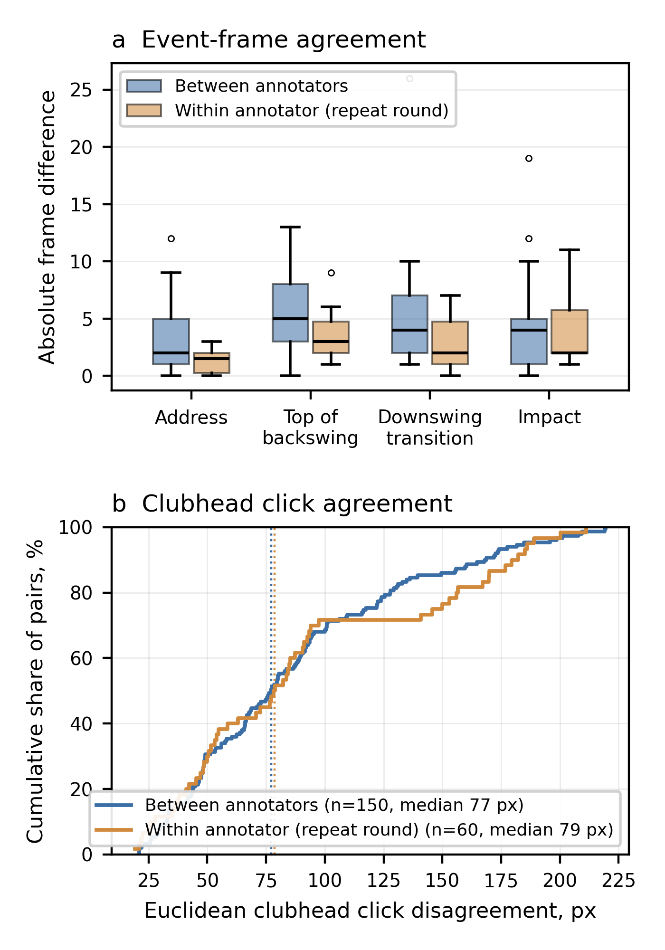
Fig. 3. Human annotation agreement between and within annotators
Source: compiled by the authors
Time-base audit and event disagreement
Decoded video and landmark frame counts matched in 24 of 25 sessions; the remaining session differed by one frame. Twelve videos had non-uniform presentation intervals, and no session contained a non-monotonic timestamp step. Manual annotation times differed from decoded presentation times by at most 19.6 ms, and the landmark-time grid differed from the decoded grid by at most 66.7 ms over common frames. These discrepancies are two orders of magnitude smaller than the observed event disagreement, although frame-based reporting remains primary and source-to-processed-video alignment could not be audited without the original source files.
The transition proxy fired a median 38 frames early relative to the consensus top of backswing and 40 frames early relative to the consensus downswing transition; the impact output fired a median 40 frames early (Table 4; Fig. 4). Median absolute errors were 780 ms (95% CI 700-1635 ms), 940 ms (660-1919 ms), and 800 ms (660-1022 ms), respectively. Mean biases were -1699, -1824, and -1728 ms, with standard deviations near 2000 ms, 95th percentile absolute errors between 4698 and 5217 ms, and limits of agreement spanning roughly -6100 to +2700 ms. Of the 75 comparisons, 73 were early and 2 late; the smallest absolute error was 14 frames, the median 39 frames, and the largest 531 frames. Figure 4 shows that most outputs lie far below the identity line. This disagreement is about ten times the inter-rater event disagreement of 4 frames and cannot be attributed to reference uncertainty or to time-base misalignment; it is an end-to-end disagreement of the current processed output with the consensus definitions, and it does not by itself localize the fault to a single detector component.

Table 4. Event-frame agreement with the consensus reference
Auto / manual | n | Median |error|, frames | Median |error|, ms (95% CI)
Transition / top | 25 | 38 | 780 (700–1635)
Transition / transition | 25 | 40 | 940 (660–1919)
Impact / impact | 25 | 40 | 800 (660–1022)
Source: compiled by the authors

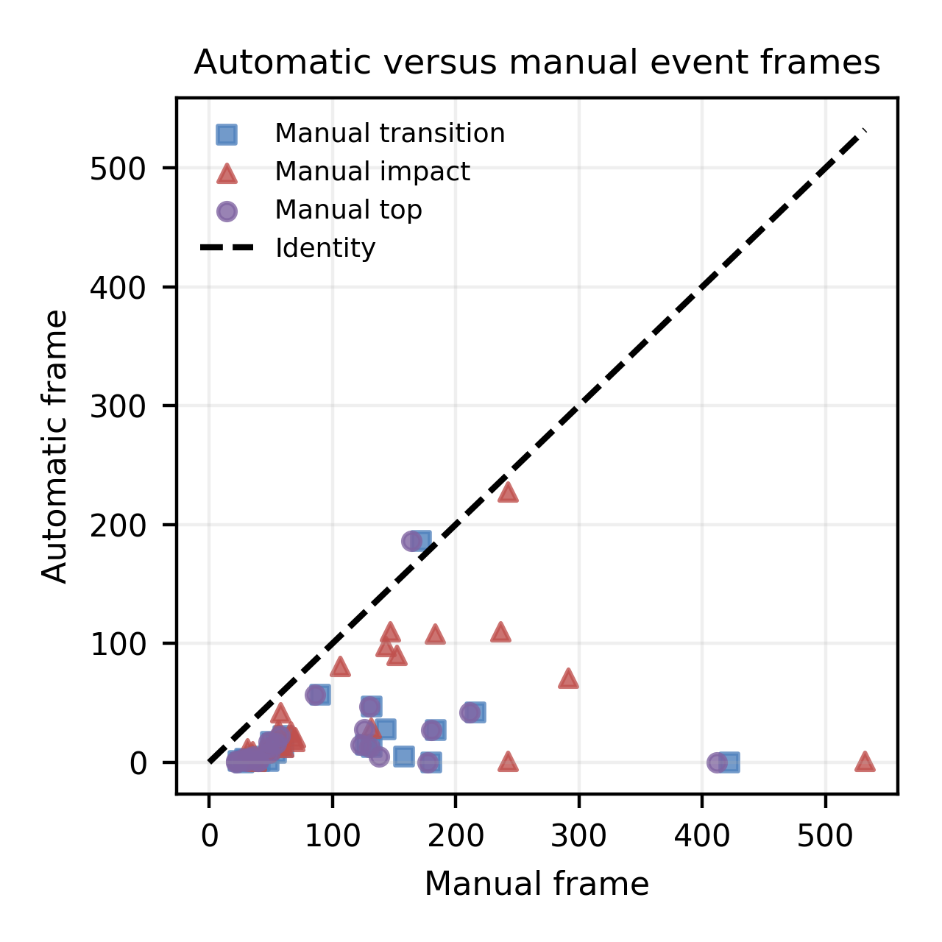
Fig. 4. Automatic versus manual consensus event frames
Source: compiled by the authors
Clubhead localization agreement and failure tail
Across 25 session-specific medians, the clubhead discrepancy with the consensus was 46.2 pixels (95% CI 41.4-51.9 pixels), or 2.54% of the image diagonal (1.98-2.88%). The corresponding model-dependent physical estimate was 13.6 cm. Session-median normalized discrepancy was 1.94% in backswing, 3.25% in transition, 3.32% in downswing, 2.70% near impact, and 2.66% in follow-through (Table 5; Fig. 5). Only eight sessions contributed a transition point, yielding a wide interval.
This discrepancy is smaller than the reference's own precision: the median algorithm-consensus distance of 44.4 pixels at point level is below the 77.1-pixel median disagreement between the two annotators on the same frames. A sensitivity check against annotator A's round-1 clicks alone gave a session-level median of 14.8 pixels, or 0.78% of the diagonal, and the consensus lies a median 38.6 pixels from those clicks - approximately half the inter-rater disagreement, as the mean rule implies. The choice of reference therefore changes the reported magnitude by a factor of about three, which is why the consensus rule is disclosed and why these values are reported as agreement bounded by reference precision rather than as tracker accuracy.
The point-level distribution was right-skewed. Its 95th percentile was 169.1 pixels and its maximum 2492.9 pixels. Twenty-two of 150 points (14.7%) exceeded 100 pixels across 13 sessions; 5 points (3.3%) exceeded 250 pixels across 4 sessions; and 3 points (2.0%) exceeded 500 pixels across 2 sessions. The largest failures were concentrated after impact: follow-through and impact-region point-level 95th percentiles were 498.3 and 361.8 pixels, against 89.8 pixels in backswing. The workflow returned a coordinate at all 150 selected frames, but coordinate availability did not guarantee correct localization. Because frames were selected where the clubhead was visually annotatable, these counts cannot be interpreted as whole-video tracking-success rates.
Exploratory subgroup summaries suggested larger session-median normalized errors at no more than 30 frames/s than at 31-60 frames/s (3.31% versus 2.05%) and below 720 p than at 1080 p or higher (3.70% versus 2.00%). The difficult-quality group had a median of 3.30%, but its four-session confidence interval reached 7.54%. Face-on results were based on only three sessions. These patterns are hypothesis-generating and do not support adjusted or causal comparisons.

Table 5. Clubhead localization agreement with the consensus by swing phase
Phase | n_s / n_p | Median, % diag. (95% CI) | P95 / max, px
Backswing | 25/60 | 1.94 (1.69–2.26) | 89.8 / 120.8
Transition | 8/8 | 3.25 (2.08–4.53) | 94.7 / 98.9
Downswing | 17/26 | 3.32 (2.20–3.92) | 105.3 / 397.3
Impact region | 16/23 | 2.70 (1.68–6.38) | 361.8 / 2103.0
Follow-through | 22/33 | 2.66 (1.61–3.76) | 498.3 / 2492.9
All phases | 25/150 | 2.54 (1.98–2.88) | 169.1 / 2492.9
Source: compiled by the authors; n_s - sessions; n_p - points

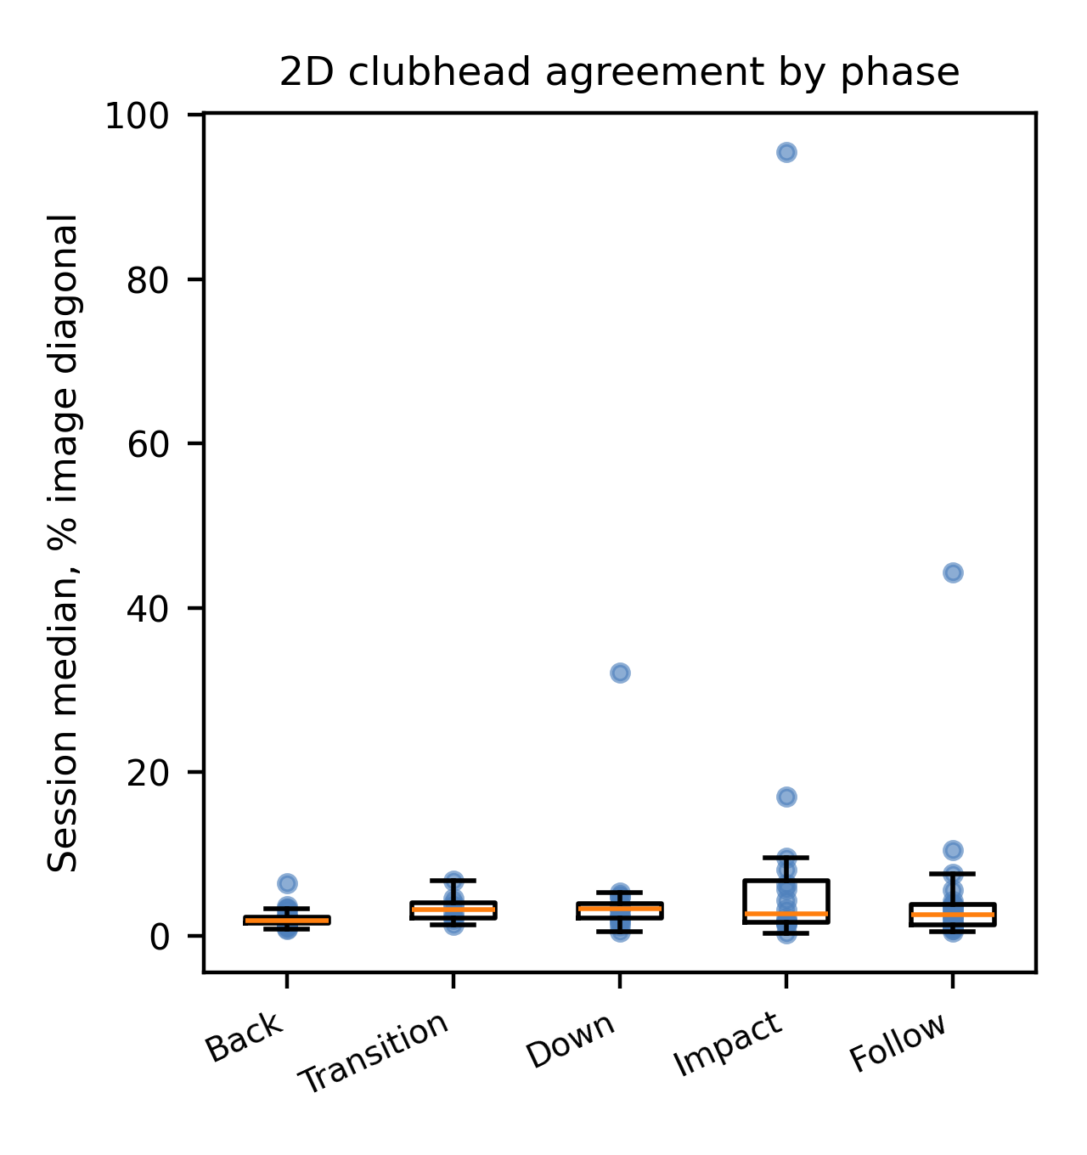
Fig. 5. Session-level clubhead agreement by swing phase
Source: compiled by the authors
Perturbation sensitivity
All 71 sessions were reprocessed in all 12 scenarios; individual metrics were undefined in up to three sessions per scenario, so scenario-level counts range from 68 to 71. Path efficiency and smoothness index had the lowest overall response, with medians across scenarios of 5.9% and 6.2% and worst scenarios of 24.8% under the larger jitter dose and 15.1% under combined degradation; both had 7 low-response and 5 moderate-response scenarios and no high-response scenario (Table 6; Fig. 6). Maximum angular velocity and maximum speed followed at 17.0% and 18.7%, each with six high-response scenarios, and maximum acceleration at 26.0%. Curvature RMS, backswing peak speed, and swing tempo were the most responsive, with medians of 39.6%, 53.6%, and 74.4% and worst scenarios of 157.4%, 179.8%, and 160.7%.
Magnitude response and rank preservation were not interchangeable. Curvature RMS and maximum angular velocity retained median Spearman correlations of 0.93 and 0.81 despite the largest magnitude changes, whereas path efficiency and smoothness index, the least responsive metrics in magnitude, had median correlations of 0.64 and 0.73. Swing tempo and backswing peak speed were unstable on both criteria, with median correlations of 0.34 and 0.44. Scale perturbations produced the smallest responses for scale-free quantities, while thinning, jitter, and combined degradation dominated most derivative metrics. The complete 12-scenario table, including confidence intervals, is retained as supplementary comma-separated output.

Table 6. Perturbation response and rank preservation of exported metrics
Metric | Median change, % | Worst, % | Median ρ | Low/mod./high | Interpretation
Path efficiency | 5.9 | 24.8 | 0.63 | 7/5/0 | Candidate only
Smoothness index | 6.2 | 15.1 | 0.73 | 7/5/0 | Candidate only
Maximum angular velocity | 17.0 | 89.9 | 0.81 | 6/0/6 | High perturbation sensitivity
Maximum speed | 18.7 | 60.8 | 0.56 | 5/1/6 | High perturbation sensitivity
Maximum acceleration | 26.0 | 93.5 | 0.46 | 4/2/6 | High perturbation sensitivity
Curvature RMS | 39.6 | 157.4 | 0.93 | 4/1/7 | High perturbation sensitivity
Backswing peak speed | 53.6 | 179.8 | 0.44 | 4/1/7 | High perturbation sensitivity
Swing tempo | 74.4 | 160.7 | 0.34 | 4/0/8 | High perturbation sensitivity
Source: compiled by the authors; response bands are study-specific descriptive labels, not measurement tolerances

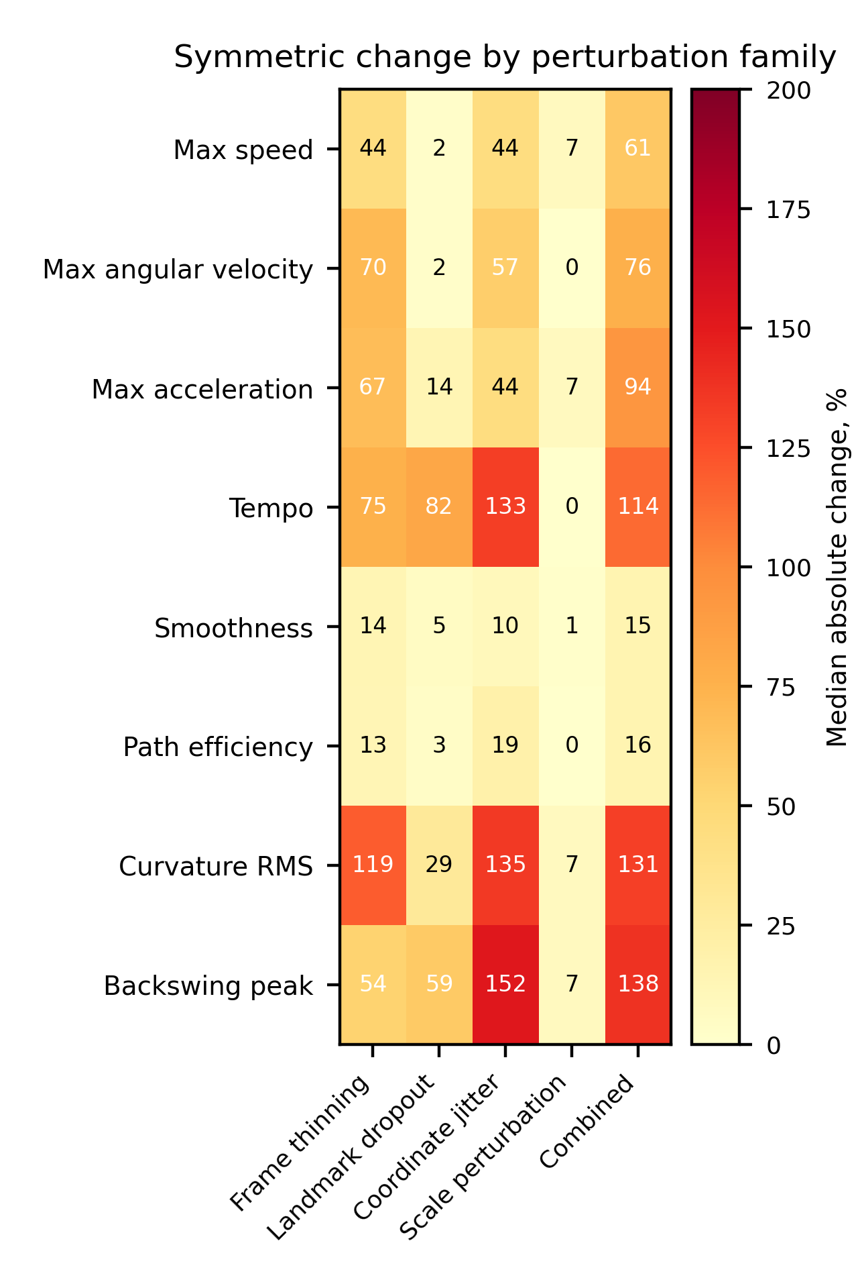
Fig. 6. Metric response by perturbation family
Source: compiled by the authors
Production-stage ablation
The corrected ablation did not show monotonic improvement (Table 7; Fig. 7). Median RMS jerk decreased from 17 334 m/s³ for raw landmarks to 14 448 after the median stage and 881 after the production Kalman stage, at which point half the sessions retained only 66 valid samples because innovation gating rejected measurements, so that variant is not directly comparable with the others. The production Rauch-Tung-Striebel stage reduced RMS jerk further to 181 m/s³ but moved a median 141.4 cm from the raw path, with a median 95th-percentile deviation of 280.7 cm, and reduced median maximum speed to 1.27 m/s. Restoring the process-noise term to the smoother's predicted covariance reduced but did not remove this behaviour, so the smoothed output still departs from the observed path far more than measurement noise would justify.
Despiking changed zero points in every one of the 71 sessions, so no contribution can be attributed to that stage under the current thresholds, and its row is numerically identical to the preceding one. Final bounded reconstruction changed a median 162 points and returned mean deviation to 1.9 cm, the closest of any stage to the observed path, but RMS jerk rose to 11 835 m/s³. The final stage therefore restores proximity to the observed path while reintroducing derivative variation. These findings identify implementation and parameter issues; they do not validate the causal benefit of each pipeline stage.

Table 7. Nested ablation of actual production stages
Stage | Δpoints, n | Δraw, cm | RMS jerk, m/s³
Raw landmarks | 0 | 0.0 | 17334
Median only | 143 | 15.3 | 14448
Kalman only | 157 | 9.4 | 881
Kalman + RTS | 162 | 141.4 | 181
Kalman + RTS + despiking | 0 | 141.4 | 181
Full pipeline | 162 | 1.9 | 11835
Source: compiled by the authors

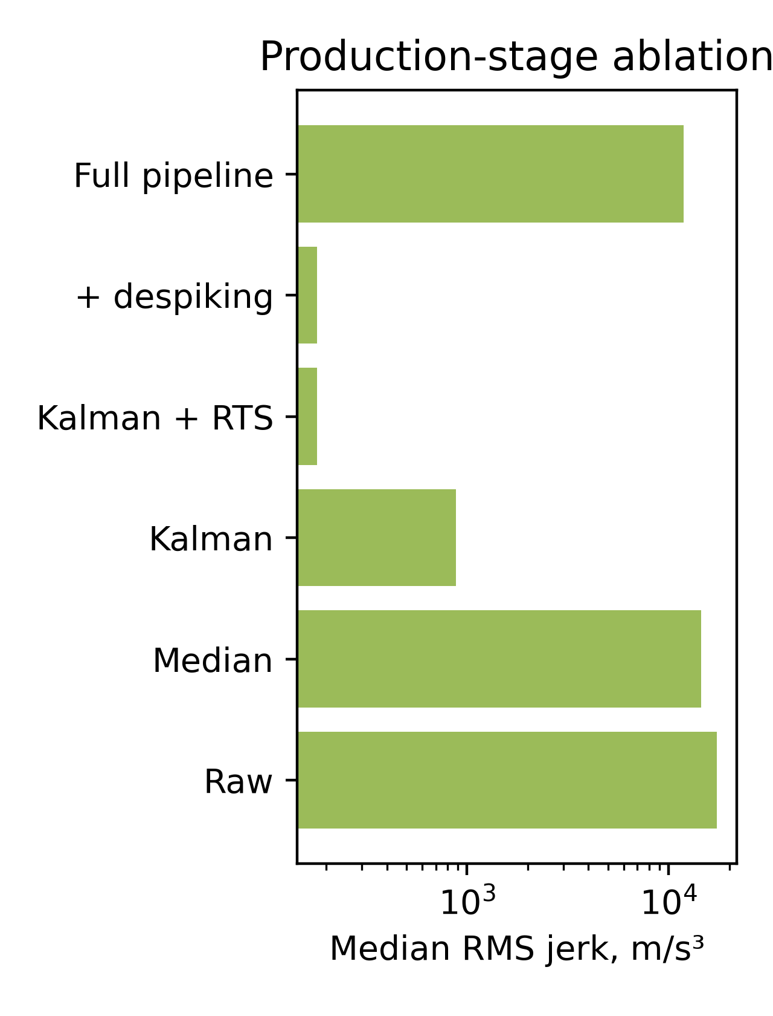
Fig. 7. Root-mean-square jerk across production stages
Source: compiled by the authors
DISCUSSION OF RESULTS
The central result is bounded by the reference rather than by the algorithm. Selected-frame clubhead positions agreed with the two-annotator consensus to a session-level median of 2.54% of the image diagonal, and the point-level discrepancy was smaller than the disagreement between the two annotators on the same frames. That ordering is the key interpretive fact: with a reference whose own median disagreement is 4.03% of the diagonal, and whose within-observer repetition is no tighter, this design cannot demonstrate tracker accuracy below a few per cent of the frame. Reporting a single number without that comparison would overstate what a sparse visual reference can support, and the threefold change in magnitude between the consensus and a single-annotator reference makes the same point quantitatively. The centimetre estimate remains secondary because the evaluated workflow supplied its own scale and actual club lengths were not available.
Adding a second annotator and a repeat round therefore did more than satisfy a reviewer requirement: it changed the conclusion. The intra-rater round shows that the dispersion is not a disagreement between people about swing mechanics, since one observer repeating the same frames scattered as widely as two observers did. What limits precision is the operational definition of a clubhead point on blurred, fast-moving frames, and improving it - for example by annotating a geometrically defined landmark such as the shaft-head junction, or by restricting annotation to frames with a resolvable head - is a prerequisite for any tighter geometric claim.
The timing audit materially changes interpretation of the event result. Presentation-time and landmark-grid discrepancies were at most tens of milliseconds and the inter-rater event disagreement was 4 frames, whereas the automatic event disagreement was 38 to 40 frames, or 780 to 940 ms. The large early bias therefore survives both a processed-video time-base check and an explicit measurement of reference uncertainty, which is what distinguishes it from the trajectory result. The transition comparison additionally exposed a definition problem: one automatic transition output had been presented as if it independently detected top of backswing and downswing transition. The revised analysis treats these as two comparisons of one proxy, and the human data support that treatment, because the annotators themselves separated the two events by a median of only 3 frames. Source-video trimming and preprocessing history remain unverified.
The perturbation study supports a relative statement, not a validity claim. Path efficiency and smoothness index responded less than the other tested outputs and reached no high-response scenario, but neither has been validated against expertise, shot outcome, coach judgement, or user benefit, and path efficiency still changed by 24.8% under the larger jitter dose. Rank preservation ran in the opposite direction to magnitude stability, with curvature RMS and maximum angular velocity retaining session ordering better than the two least responsive metrics, which shows why a single "robust" label is inadequate. Numerical stability is one property of an implementation; construct validity and application tolerance are separate questions.
The production-stage ablation is a central diagnostic result of the study. Correcting the smoother's predicted covariance was necessary for the production and ablation paths to describe the same algorithm, but the corrected stage still moved the trajectory more than a metre from the observed path. Despiking did not activate under the current thresholds, whereas bounded reconstruction returned the trajectory toward the observations while increasing derivative variation. These findings show that the visually acceptable final output is partly produced by compensating behaviour between stages rather than by monotonic improvement through the processing chain.
This stage-level behaviour is precisely why evaluation of the implemented production configuration is informative. The purpose of the present study is not to certify every pipeline component as successful, but to determine whether the available evidence supports the final output and to expose internal failure modes that would remain hidden if only visually plausible trajectories were inspected. The smoother, despiking, and reconstruction findings therefore define explicit redesign targets and establish a diagnostic baseline for the next development stage. Their presence does not weaken the logic of the evaluation; it demonstrates the need for production-stage ablation as part of a rigorous markerless-motion assessment.
The present article should therefore be read as a diagnostic baseline study of the current production workflow. Retuning the smoother, changing the inactive despiking thresholds, or redesigning the reconstruction stage would create a new algorithmic configuration and should be evaluated against this baseline in a subsequent development cycle. Keeping the current configuration as the evaluated object preserves the causal interpretability of the reported failure modes and prevents post hoc optimization from being conflated with independent assessment.
The study has substantial limitations. The reference is sparse, two-dimensional, and imprecise at the scale discussed above, and it covers frames chosen because a click was possible, which creates verification bias. Two annotators and one repeat round support agreement statistics but no intraclass correlation, standard error of measurement, or minimal detectable change, because participant identities and repeated athlete trials are unavailable. Points are clustered within sessions and viewpoint groups are imbalanced. The consensus mean rule is disclosed but arbitrary; an expert re-adjudication of each disagreement would give a different reference. The perturbations are author-defined stress tests with one stochastic realization per session. Monocular two-dimensional coordinates cannot resolve depth, perspective, or foreshortening. Participant identities and detailed acquisition metadata are unavailable in the export. These limitations affect the strength of the conclusions and are not dismissed as inconsequential.
For application, the observed agreement may be compatible with coarse trajectory visualization in some settings, but application-specific acceptability thresholds have not been established, and the event output is not usable for phase-based feedback. The data do not justify biomechanical impact analysis, athlete-to-athlete comparison, real-time reliability claims, or unqualified coaching and virtual-reality feedback. Such uses require an independently calibrated reference, verified provenance, repeated athlete trials, a tighter annotation definition, and a user- or task-specific tolerance study.
CONCLUSIONS
The study demonstrates that the current workflow disagrees substantially with a two-annotator consensus on event frames, firing a median 38 to 40 frames, or 780 to 940 ms, early. That disagreement is about ten times the inter-rater event disagreement of 4 frames and two orders of magnitude larger than the 67 ms maximum time-base discrepancy, so it reflects detector behaviour rather than reference noise or synchronization error. One automatic transition output had additionally been compared with two manual definitions that the annotators themselves separated by a median of only 3 frames.
For selected clubhead frames, the median of session-specific discrepancies with the consensus was 2.54% of the image diagonal, or 46.2 pixels, with 14.7% of points above 100 pixels and 2.0% above 500 pixels. Because the two annotators disagreed by a median of 4.03% of the diagonal, and because one annotator repeating the same frames was no more consistent, this result establishes agreement at the resolution the reference can support and does not establish tracker accuracy below that level.
Path efficiency and smoothness index showed the lowest response to the 12 study-specific perturbations, with no high-response scenario, while derivative metrics showed larger magnitude responses but sometimes better rank preservation. These results describe numerical sensitivity only. They do not establish that any metric validly measures swing quality or is suitable for cross-athlete comparison.
The production-stage ablation identified three concrete redesign targets in the current configuration: excessive departure of the Rauch-Tung-Striebel smoothed trajectory from the observed path, no activation of despiking under the tested thresholds, and renewed derivative variation after final bounded reconstruction. These stage-level findings are part of the study's contribution because they explain how a visually plausible final trajectory can coexist with problematic internal behaviour. The current results therefore establish a reproducible diagnostic baseline against which a retuned or redesigned pipeline can subsequently be evaluated. The contribution of this article is a multi-rater reference protocol, an explicit measurement of reference precision, a bounded 2D algorithm-reference agreement analysis, and a production-level stress-test and failure-mode characterization; it does not claim full external biomechanical validation or athlete-level reliability.
ACKNOWLEDGMENTS
The authors thank Daria Plokhotniuk for independent reference annotation, and the research supervisor and collaborators who reviewed the manuscript and the motion-analysis workflow. Responsibility for the data, analysis, interpretation, and final text remains with the authors.
Use of generative AI tools: AI-assisted language revision, consistency checking, and code review were performed with GPT-5.6 Sol, Claude Opus 5, and Cursor Grok 4.6 in Cursor during manuscript preparation in 2026. The authors reviewed the resulting text and remain responsible for the data, methods, interpretation, references, and final manuscript.

REFERENCES
1. Winter, D. A. “Biomechanics and Motor Control of Human Movement”. 4th ed. Hoboken, NJ, USA: Wiley, 2009.
2. Bartlett, R. “Introduction to Sports Biomechanics: Analysing Human Movement Patterns”. 2nd ed. London, UK: Routledge, 2007. DOI: https://doi.org/10.4324/9780203462027.
3. Cao, Z., Hidalgo, G., Simon, T., Wei, S. E. & Sheikh, Y. “OpenPose: Realtime multi-person 2D pose estimation using part affinity fields”. IEEE Transactions on Pattern Analysis and Machine Intelligence. 2021; Vol. 43, No. 1: 172–186. https://www.scopus.com/record/display.uri?eid=2-s2.0-85070219994. DOI: https://doi.org/10.1109/TPAMI.2019.2929257.
4. Bazarevsky, V., Grishchenko, I., Raveendran, K., Zhu, T., Zhang, F. & Grundmann, M. “BlazePose: On-device real-time body pose tracking”. Proceedings of the CVPR Workshop on Computer Vision for Augmented and Virtual Reality. Seattle, WA, USA. June 2020. DOI: https://doi.org/10.48550/arXiv.2006.10204.
5. Lugaresi, C., Tang, J., Nash, H., McClanahan, C., Uboweja, E., Hays, M., Zhang, F., Chang, C. L., Yong, M. G., Lee, J., Chang, W. T., Hua, W., Georg, M. & Grundmann, M. “MediaPipe: A framework for building perception pipelines”. arXiv preprint. 2019. DOI: https://doi.org/10.48550/arXiv.1906.08172.
6. Robertson, D. G. E., Caldwell, G. E., Hamill, J., Kamen, G. & Whittlesey, S. N. “Research Methods in Biomechanics”. 2nd ed. Champaign, IL, USA: Human Kinetics, 2014. DOI: https://doi.org/10.5040/9781492595809.
7. Davis, D. J. & Challis, J. H. “Automatic segment filtering procedure for processing non-stationary signals”. Journal of Biomechanics. 2020; Vol. 101: 109619. DOI: https://doi.org/10.1016/j.jbiomech.2020.109619.
8. Hume, P. A., Keogh, J. & Reid, D. “The role of biomechanics in maximising distance and accuracy of golf shots”. Sports Medicine. 2005; Vol. 35, No. 5: 429–449. https://www.scopus.com/record/display.uri?eid=2-s2.0-18244376551. DOI: https://doi.org/10.2165/00007256-200535050-00005.
9. Nesbit, S. M. & Serrano, M. “Work and power analysis of the golf swing”. Journal of Sports Science and Medicine. 2005; Vol. 4, No. 4: 520–533. https://www.scopus.com/record/display.uri?eid=2-s2.0-33747125283.
10. McLaughlin, J. J. & Best, R. J. “Three-dimensional kinematic analysis of the golf swing”. In: Cochran, A. J. & Farrally, M. R. (Eds.). Science and Golf II. London, UK: E & FN Spon, 1994. p. 91–96.
11. Tinmark, F., Hellström, J., Halvorsen, K. & Thorstensson, A. “Elite golfers' kinematic sequence in full-swing and partial-swing shots”. Sports Biomechanics. 2010; Vol. 9, No. 4: 236–244. https://www.scopus.com/record/display.uri?eid=2-s2.0-79551491419. DOI: https://doi.org/10.1080/14763141.2010.535842.
12. van der Kruk, E. & Reijne, M. M. “Accuracy of human motion capture systems for sport applications: state-of-the-art review”. European Journal of Sport Science. 2018; Vol. 18, No. 6: 806–819. https://www.scopus.com/record/display.uri?eid=2-s2.0-85045751825. DOI: https://doi.org/10.1080/17461391.2018.1463397.
13. Ota, M., Tateuchi, H., Hashiguchi, T. & Ichihashi, N. “Verification of reliability and validity of motion analysis systems during bilateral squat using human pose tracking algorithm”. Gait & Posture. 2020; Vol. 80: 62–67. https://www.scopus.com/record/display.uri?eid=2-s2.0-85085754655. DOI: https://doi.org/10.1016/j.gaitpost.2020.05.027.
14. Tukey, J. W. “Exploratory Data Analysis”. Reading, MA, USA: Addison-Wesley, 1977.
15. Kalman, R. E. “A new approach to linear filtering and prediction problems”. Journal of Basic Engineering. 1960; Vol. 82, No. 1: 35–45. DOI: https://doi.org/10.1115/1.3662552.
16. Welch, G. & Bishop, G. “An introduction to the Kalman filter”. Technical Report TR 95-041. Chapel Hill, NC, USA: University of North Carolina at Chapel Hill, 2006. [Online]. – Available from: https://www.cs.unc.edu/~welch/media/pdf/kalman_intro.pdf – [Accessed: Apr. 29, 2026].
17. Rauch, H. E., Tung, F. & Striebel, C. T. “Maximum likelihood estimates of linear dynamic systems”. AIAA Journal. 1965; Vol. 3, No. 8: 1445–1450. https://www.scopus.com/record/display.uri?eid=2-s2.0-84945697750. DOI: https://doi.org/10.2514/3.3166.
18. Savitzky, A. & Golay, M. J. E. “Smoothing and differentiation of data by simplified least squares procedures”. Analytical Chemistry. 1964; Vol. 36, No. 8: 1627–1639. https://www.scopus.com/record/display.uri?eid=2-s2.0-33947453419. DOI: https://doi.org/10.1021/ac60214a047.
19. Balasubramanian, S., Melendez-Calderon, A., Roby-Brami, A. & Burdet, E. “On the analysis of movement smoothness”. Journal of NeuroEngineering and Rehabilitation. 2015; Vol. 12: 112. https://www.scopus.com/record/display.uri?eid=2-s2.0-84953214858. DOI: https://doi.org/10.1186/s12984-015-0090-9.
20. Atkinson, G. & Nevill, A. M. “Statistical methods for assessing measurement error (reliability) in variables relevant to sports medicine”. Sports Medicine. 1998; Vol. 26, No. 4: 217–238. https://www.scopus.com/record/display.uri?eid=2-s2.0-0031740657. DOI: https://doi.org/10.2165/00007256-199826040-00002.
21. Koo, T. K. & Li, M. Y. “A guideline of selecting and reporting intraclass correlation coefficients for reliability research”. Journal of Chiropractic Medicine. 2016; Vol. 15, No. 2: 155–163. https://www.scopus.com/record/display.uri?eid=2-s2.0-84963540533. DOI: https://doi.org/10.1016/j.jcm.2016.02.012.
22. Bland, J. M. & Altman, D. G. “Statistical methods for assessing agreement between two methods of clinical measurement”. The Lancet. 1986; Vol. 327, No. 8476: 307–310. https://www.scopus.com/record/display.uri?eid=2-s2.0-0022571143. DOI: https://doi.org/10.1016/S0140-6736(86)90837-8.
23. Mo, S. & Chow, D. H. K. “Segmental sequencing in golf swing and its relation to clubhead speed”. Sports Biomechanics. 2018; Vol. 17, No. 3: 429–441. https://www.scopus.com/record/display.uri?eid=2-s2.0-85029525987. DOI: https://doi.org/10.1080/14763141.2017.1371213.
24. Kim, S. E., Burket Koltsov, J. C., Richards, A. W., Zhou, J., Schadl, K., Ladd, A. L. & Rose, J. “Validation of inertial measurement units for analyzing golf swing rotational biomechanics”. Sensors. 2023; Vol. 23, No. 20: 8433. DOI: https://doi.org/10.3390/s23208433.
25. Colyer, S. L., Evans, M., Cosker, D. P. & Salo, A. I. T. “A review of the evolution of vision-based motion analysis and the integration of advanced computer vision methods towards developing a markerless system”. Sports Medicine – Open. 2018; Vol. 4: 24. https://www.scopus.com/record/display.uri?eid=2-s2.0-85048302366. DOI: https://doi.org/10.1186/s40798-018-0139-y.
26. Wade, L., Needham, L., McGuigan, P. & Bilzon, J. “Applications and limitations of current markerless motion capture methods for clinical gait biomechanics”. PeerJ. 2022; Vol. 10: e12995. https://www.scopus.com/record/display.uri?eid=2-s2.0-85125709321. DOI: https://doi.org/10.7717/peerj.12995.
27. Needham, L., Evans, M., Cosker, D. P., Wade, L., McGuigan, P. M., Bilzon, J. L. & Colyer, S. L. “The accuracy of several pose estimation methods for 3D joint centre localisation”. Scientific Reports. 2021; Vol. 11, No. 1: 20673. https://www.scopus.com/record/display.uri?eid=2-s2.0-85117132097. DOI: https://doi.org/10.1038/s41598-021-00212-x.
28. Stenum, J., Rossi, C. & Roemmich, R. T. “Two-dimensional video-based analysis of human gait using pose estimation”. PLOS Computational Biology. 2021; Vol. 17, No. 4: e1008935. https://www.scopus.com/record/display.uri?eid=2-s2.0-85104998893. DOI: https://doi.org/10.1371/journal.pcbi.1008935.
29. Cust, E. E., Sweeting, A. J., Ball, K. & Robertson, S. “Machine and deep learning for sport-specific movement recognition: a systematic review of model development and performance”. Journal of Sports Sciences. 2019; Vol. 37, No. 5: 568–600. https://www.scopus.com/record/display.uri?eid=2-s2.0-85053196097. DOI: https://doi.org/10.1080/02640414.2018.1521769.
30. Ingwersen, C. K., Nørtoft Jensen, J., Rieger Hannemose, M. & Bjorholm Dahl, A. “Evaluating current state of monocular 3D pose models for golf”. Proceedings of the Northern Lights Deep Learning Workshop. 2023; Vol. 4. DOI: https://doi.org/10.7557/18.6793.
31. Yamamoto, K., Hasegawa, Y., Suzuki, T., Suzuki, H., Tanabe, H. & Fujii, K. “Extracting proficiency differences and individual characteristics in golfers' swing using single-video markerless motion analysis”. Frontiers in Sports and Active Living. 2023; Vol. 5: 1272038. DOI: https://doi.org/10.3389/fspor.2023.1272038.
32. Syniuk, I. M., Maksymov, M. V., Maksymov, O. M. & Iyer, K. “Markerless video-based golf-stick motion analysis using Kalman filtering and RTS smoothing”. Unpublished manuscript. 2026.
Conflicts of Interest: The authors declare that there is no conflict of interest regarding this study, including financial, personal, authorship, or other interests that could influence the research and its results presented in this article.
Funding: This research was conducted without external financial support.
Ethics and consent: No ethics-committee approval was required. The analysed recordings are anonymized public demonstration footage used for algorithmic evaluation; they do not constitute identifiable human-participant research data for the purposes reported here. No participant image is reproduced.
Data availability: Analysis code, derived aggregate tables, and de-identified session-level outputs can be made available on request. Source demonstration videos are not separately released as a public dataset in this submission.
Received [completed by editorial office]. Received after revision [completed by editorial office]. Accepted [completed by editorial office].
УДК 004.932:004.94:796.352

Діагностичне оцінювання безмаркерного відеоаналізу руху ключки для гольфу: еталонна двовимірна узгодженість і чутливість до збурень

Синюк Іван Миколайович¹⁾
ORCID: https://orcid.org/0009-0000-4141-0135; i.syniuk@gmail.com
Максимов Максим Віталійович¹⁾
ORCID: https://orcid.org/0000-0002-7536-2570; prof.maksimov@gmail.com. Scopus Author ID: 7005088554
Максимов Олексій Максимович¹⁾
ORCID: https://orcid.org/0000-0003-2504-0853; oleksii.maksymov@op.edu.ua. Scopus Author ID: 57220057510
Айєр Картік²⁾
ORCID: https://orcid.org/0009-0003-2520-1810; ki2406@columbia.edu
¹⁾ Національний університет «Одеська політехніка», просп. Шевченка, 1. Одеса, 65044, Україна
²⁾ Колумбійський університет, 116-та вулиця та Бродвей. Нью-Йорк, 10027, США
АНОТАЦІЯ
Безмаркерний відеоаналіз може розширити доступ до вимірювання гольф-свінгу, однак візуальна правдоподібність не доводить валідності вимірювань, а один анотатор не дає змоги оцінити точність самого еталона. У дослідженні оцінено узгодженість і чутливість до збурень монокулярного пайплайну аналізу руху ключки для гольфу щодо багатоекспертного візуального еталона, власну невизначеність якого визначено попередньо. Із 71 неоднорідного опрацьованого запису за стратами ракурсу, класу швидкості зйомки та якості відео відібрано 25 сесій. Два анотатори незалежно позначили вихідне положення, вершину замаху, перехід до даунсвінгу та удар у всіх 25 сесіях, а також позначили головку ключки на спільному плані з 150 кадрів; перший анотатор повторив 10 сесій для внутрішньоекспертного раунду. Анотатори не бачили автоматичних накладень і координат один одного. Розкрите правило середнього об'єднало раунди у консенсусний еталон, який використано для всіх порівнянь з алгоритмом. Між анотаторами кадри подій узгоджувалися з медіаною 4 кадри, або 80 мс, за 13% точних збігів і межами узгодженості від -13,1 до +12,9 кадру, тоді як повторний раунд одного анотатора дав медіану 2 кадри. Позначення головки ключки узгоджувалися значно гірше: медіанна розбіжність становила 77,1 пікселя, або 4,03% діагоналі кадру, між анотаторами та 78,5 пікселя в межах одного анотатора, тому сам еталон визначає положення головки лише з точністю кількох відсотків кадру. Один автоматичний вихід переходу використовувався як проксі для двох ручних подій і не був двома незалежними детекторами; анотатори розділяли ці події медіаною лише 3 кадри. Щодо консенсусу автоматичні події спрацьовували на 38-40 кадрів, або 780-940 мс, раніше, із середнім зміщенням від -1699 до -1824 мс, що приблизно вдесятеро перевищує людську розбіжність і значно перевищує максимальну розбіжність часової сітки 67 мс. Медіана сесійних медіан розбіжності головки ключки становила 2,54% діагоналі кадру (95% довірчий інтервал 1,98-2,88%), або 46,2 пікселя (41,4-51,9), що нижче міжекспертної розбіжності самого еталона; похибка 22 із 150 точок перевищувала 100 пікселів, а 3 точок - 500 пікселів. Ефективність траєкторії та індекс плавності мали найменшу реакцію на збурення з медіанними абсолютними симетричними змінами 5,9% і 6,2% без сценаріїв високої реакції серед дванадцяти, тоді як темп свінгу, пікова швидкість бек-свінгу та середньоквадратична кривина змінювалися на 39,6-74,4%. Абляція виробничих етапів, виконана після внесення шуму процесу у згладжувач Рауха-Тунга-Штрібеля, показала, що згладжений результат усе ще відходить від спостережуваного шляху на медіанні 141,4 см, що видалення викидів не змінило жодної точки, а фінальна обмежена реконструкція відновлює геометрію, повертаючи середньоквадратичний ривок до 11 835 м/с³. Отже, внеском дослідження є діагностична структура оцінювання, що поєднує вимірювання точності еталона, аудит часової прив'язки, стрес-тестування чутливості до збурень і абляцію виробничих етапів для виявлення меж доказовості та режимів відмови реалізованого безмаркерного робочого процесу. Результати встановлюють відтворювану діагностичну базову лінію для подальшого перепроектування; вони не заявляють зовнішньої біомеханічної валідності, надійності повторних вимірювань спортсмена, порівнюваності між спортсменами чи прикладної придатності для тренерського зворотного зв'язку та віртуальної реальності.
Ключові слова: безмаркерний аналіз руху; гольф-свінг; відстеження головки ключки; міжекспертна узгодженість; аналіз збурень; узгодженість вимірювань
Для цитування: Синюк І. М., Максимов М. В., Максимов О. М., Айєр К. «Діагностичне оцінювання безмаркерного відеоаналізу руху ключки для гольфу: еталонна двовимірна узгодженість і чутливість до збурень». Herald of Advanced Information Technology. - [Рік]. - Т. [..]. - № [..]. - С. [..-..]. DOI: [призначається редакцією]
ABOUT THE AUTHORS
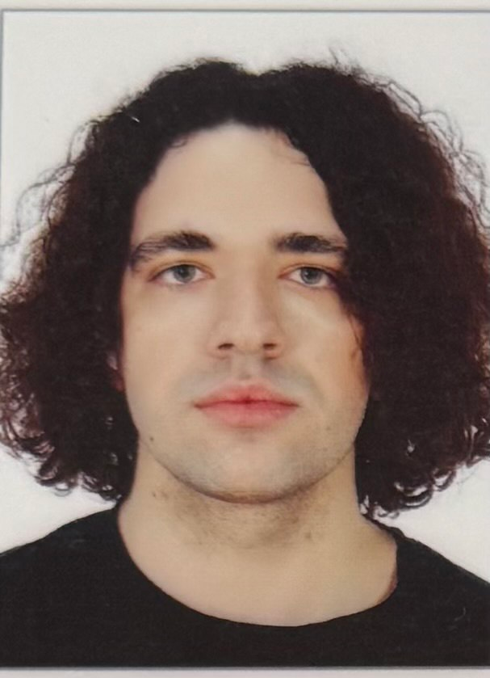 | Ivan M. Syniuk – PhD student, Department of Computer Intelligent Systems and Networks, Odesa Polytechnic National University, 1, Shevchenko Ave. Odesa, 65044, Ukraine. Author of scientific publications on markerless motion analysis, computer vision pipelines and applied biomechanics. Current PhD research focuses on the development of reproducible video-based measurement workflows for sport biomechanics and virtual-reality training applications, including signal filtering, trajectory smoothing and kinematic feature extraction.  ORCID: https://orcid.org/0009-0000-4141-0135; i.syniuk@gmail.com  Research field: markerless motion analysis; computer vision; Kalman filtering and trajectory smoothing; sport biomechanics; virtual-reality training systems  Синюк Іван Миколайович – аспірант кафедри комп’ютерних інтелектуальних систем і мереж, Національний університет «Одеська політехніка», просп. Шевченка, 1. Одеса, 65044, Україна. Сфера наукових інтересів охоплює безмаркерний відеоаналіз рухів людини та спортивного інвентарю, фільтрацію Калмана, згладжування траєкторій, кінематичні індикатори техніки виконання та застосування відеоаналітики у системах віртуальної реальності.
 | Maksym V. Maksymov – Doctor of Technical Sciences, Professor, Head of Department, Department of Computer Intelligent Systems and Networks, Odesa Polytechnic National University, 1, Shevchenko Ave. Odesa, 65044, Ukraine. Author and co-author of more than two hundred scientific publications, monographs, patents and study guides on automated control systems, intelligent measurement systems and applied data analysis. Supervises doctoral and PhD research on intelligent information systems and computer modelling of complex technical objects.  ORCID: https://orcid.org/0000-0002-7536-2570; prof.maksimov@gmail.com; Scopus Author ID: 7005088554  Research field: automation and control systems; intelligent measurement systems; data analysis and processing; computer modelling of complex technical objects; decision-support systems  Максимов Максим Віталійович – доктор технічних наук, професор, завідувач кафедри комп’ютерних інтелектуальних систем і мереж, Національний університет «Одеська політехніка», просп. Шевченка, 1. Одеса, 65044, Україна. Автор і співавтор понад двохсот наукових публікацій, монографій, патентів та навчально-методичних видань у галузі автоматизованих систем управління, інтелектуальних вимірювальних систем та аналізу даних.
Oleksii M. Maksymov – PhD in Engineering, Associate Professor, Department of Computer Intelligent Systems and Networks, Odesa Polytechnic National University, 1, Shevchenko Ave. Odesa, 65044, Ukraine. Author of scientific publications in the field of computer vision, applied signal processing and intelligent information systems. Participates in research and educational projects related to image processing, software engineering and the development of analytical pipelines for heterogeneous measurement data.
ORCID: https://orcid.org/0000-0003-2504-0853; oleksii.maksymov@op.edu.ua; Scopus Author ID: 57220057510
Research field: computer vision; digital signal and image processing; intelligent information systems; software engineering; applied machine learning
Максимов Олексій Максимович – кандидат технічних наук, доцент кафедри комп’ютерних інтелектуальних систем і мереж, Національний університет «Одеська політехніка», просп. Шевченка, 1. Одеса, 65044, Україна. Автор наукових публікацій у галузі комп’ютерного зору, цифрової обробки сигналів і зображень, інтелектуальних інформаційних систем та програмної інженерії.
Karthik Iyer – Researcher, Columbia University, 116th Street and Broadway. New York, NY 10027, USA. Conducts research on computer vision, applied machine learning and biomedical engineering, with particular interest in image-based measurement of human motion, sport biomechanics and assistive technologies. Co-author of publications on motion analysis and applied signal processing in healthcare and sport-related domains.
ORCID: https://orcid.org/0009-0003-2520-1810; ki2406@columbia.edu
Research field: computer vision; applied machine learning; biomedical engineering; image-based motion measurement; sport and rehabilitation technologies
Айєр Картік – дослідник, Колумбійський університет, 116-та вулиця та Бродвей. Нью-Йорк, 10027, США. Сфера наукових інтересів включає комп’ютерний зір, прикладне машинне навчання, біомедичну інженерію, відеоаналіз рухів людини у спортивних і реабілітаційних застосуваннях.

