UDC 004.942:796.012.2
MARKERLESS VIDEO-BASED GOLF STICK MOTION ANALYSIS WITH PHASE METRICS AND REPEATABILITY EVIDENCE
Ivan Suniuk, Co-author N.
МАРКЕРЛЕСС ВІДЕОАНАЛІЗ РУХУ КЛЮШКИ ДЛЯ ГОЛЬФУ З ФАЗОВИМИ МЕТРИКАМИ ТА ОЦІНКОЮ ПОВТОРЮВАНОСТІ
Ісін У., Співавтор Н.
Abstract (Ukrainian)
Анотація українською (службовий текст): для фінального подання до журналу цей блок має бути поданий у повноцінному українському перекладі обсягом 1800–1900 символів разом із ключовими словами, відповідно до редакційних вимог. Поточний документ містить повний англомовний науковий зміст, структуру статті, результати, рисунки, таблиці, висновки, декларації та список літератури.
Keywords (Ukrainian)
маркерлес-аналіз, гольф, кінематика, згладжування траєкторії, повторюваність
Abstract (English)
The aim of this study is to design and validate a markerless computer-vision pipeline for quantitative analysis of golf-stick kinematics and coordination metrics from ordinary video sessions. The proposed method combines robust landmark handling, adaptive median pre-filtering, a constant-velocity Kalman model, Rauch-Tung-Striebel backward smoothing, local polynomial trajectory regularization, and trajectory despiking. In contrast to conventional frame-to-frame finite differencing, the method introduces dynamically stabilized metric calibration through per-frame stick-length scaling with bounded adaptation, allowing physically interpretable speed and acceleration outputs under heterogeneous frame rates and viewpoint changes. New metrics were added to capture movement quality and phase behavior: path efficiency, local geometric curvature, and phase-aware indicators for backswing and downswing. Reliability was assessed across 71 independent mock sessions. The pipeline successfully processed all sessions after robustness hardening of missing-key landmark and bounding-box handling. Aggregate repeatability analysis showed that smoothness index and path efficiency were the most stable among tested metrics, whereas acceleration and backswing peak speed exhibited higher between-session variability due to technique diversity and recording inconsistency. The resulting framework supports two operational modes, including a scientific profile for offline reporting and a realtime profile for low-latency feedback. The practical significance of this work is a reproducible end-to-end analytics stack that links visual trajectory quality, biomechanical descriptors, and reliability evidence in one publishable workflow. The proposed approach can be used in training diagnostics, comparative swing assessment, and longitudinal tracking when laboratory motion-capture infrastructure is unavailable.
Keywords (English)
markerless motion analysis, golf swing, Kalman filtering, RTS smoothing, path efficiency, repeatability
1. Introduction
Quantitative swing analytics is increasingly used in applied sports engineering, coaching, and rehabilitation, yet
high-fidelity laboratory motion-capture systems remain expensive and operationally constrained. Markerless
pipelines based on computer vision can democratize access to biomechanical evidence, but practical deployment
requires strong filtering, physically plausible derivative estimation, and reproducibility diagnostics [1-4].
This paper presents an end-to-end implementation for stick-tip trajectory extraction, smoothing, kinematic
derivation, phase partitioning, and reliability assessment using standard recorded sessions. The current study
uses 71 sessions and introduces post-processing features aimed at balancing two competing goals:
trajectory closeness to measured observations and smoothness suitable for derivative-based metrics.
2. Literature review and problem statement
Existing research on golf and overhead swing analysis highlights velocity profiling, sequencing, and segment
coordination as key outcome domains [5-8]. In computer-vision tracking, Kalman filters and polynomial smoothers
are common, while robust outlier rejection and backward smoothing improve temporal consistency [9-11].
The unresolved practical problem is that many open implementations still suffer from one-frame derivative spikes,
hardcoded impact thresholds, static scaling assumptions, and mismatches between online and exported metrics.
These weaknesses reduce trust in quantitative interpretation and repeatability claims [12-14].
3. The aim and objectives of the study
The aim of this study is to produce a reproducible markerless analytics workflow that can be used for scientific
reporting and practical training feedback.
Objectives:
(1) eliminate derivative initialization artifacts and unify impact-threshold logic;
(2) align summary and exported metrics through a shared computation path;
(3) introduce dynamic scale stabilization under changing recording conditions;
(4) add path efficiency, curvature, and phase metrics (backswing/downswing);
(5) quantify repeatability across multiple sessions and generate publication-ready outputs automatically.
4. Materials and methods
The system processes per-frame landmarks and optional object detections from JSON files synchronized with
processed videos. A two-stage profile strategy is applied: realtime mode prioritizes responsiveness, while
scientific mode prioritizes offline smoothness and stability.
Filtering stack:
- running median pre-filtering of 2D tip coordinates;
- adaptive-measurement Kalman tracking with physical gating;
- RTS backward smoothing over contiguous valid segments;
- local polynomial smoothing with bounded raw deviation;
- despiking passes before and after polynomial smoothing.
Derivatives are computed with variable dt estimated from video timestamps. To reduce perspective-driven scale
jumps, metric scale calibration uses bounded per-frame adaptation with exponential smoothing. Phase separation
is derived from transition estimation near angular-velocity sign-change before peak speed.
Key formulas:
(1) v_i = ||p_i - p_(i-1)|| / dt_i
(2) a_i = (v_i - v_(i-1)) / dt_i
(3) jerk_i = (a_i - a_(i-1)) / dt_i
(4) path_efficiency_i = displacement_i / path_length_i
(5) curvature_i = 2*Area(p_(i-1), p_i, p_(i+1)) / (a*b*c)
Repeatability descriptors include mean, standard deviation, coefficient of variation (CV, %), and repeatability
coefficient (RC = 1.96*sqrt(2)*SD) for each scalar session-level metric.
5. Results
The upgraded pipeline successfully processed all 71 sessions (100 % completion). The reliability
profile is heterogeneous across metrics, indicating that some indicators are suitable as primary endpoints
while others should remain exploratory.
Smoothness index: mean = -5.882, SD = 1.266,
CV = 21.52 %.
Path efficiency: mean = 0.726, SD = 0.277,
CV = 38.17 %.
Maximum acceleration: mean = 185.16, SD = 400.39,
CV = 216.24 %.
The results confirm that quality-oriented metrics (smoothness/path efficiency) are more stable than high-order
derivatives in this heterogeneous dataset. The generated ranked table and paragraph assets can be reused
directly in manuscript preparation and editorial response workflows.
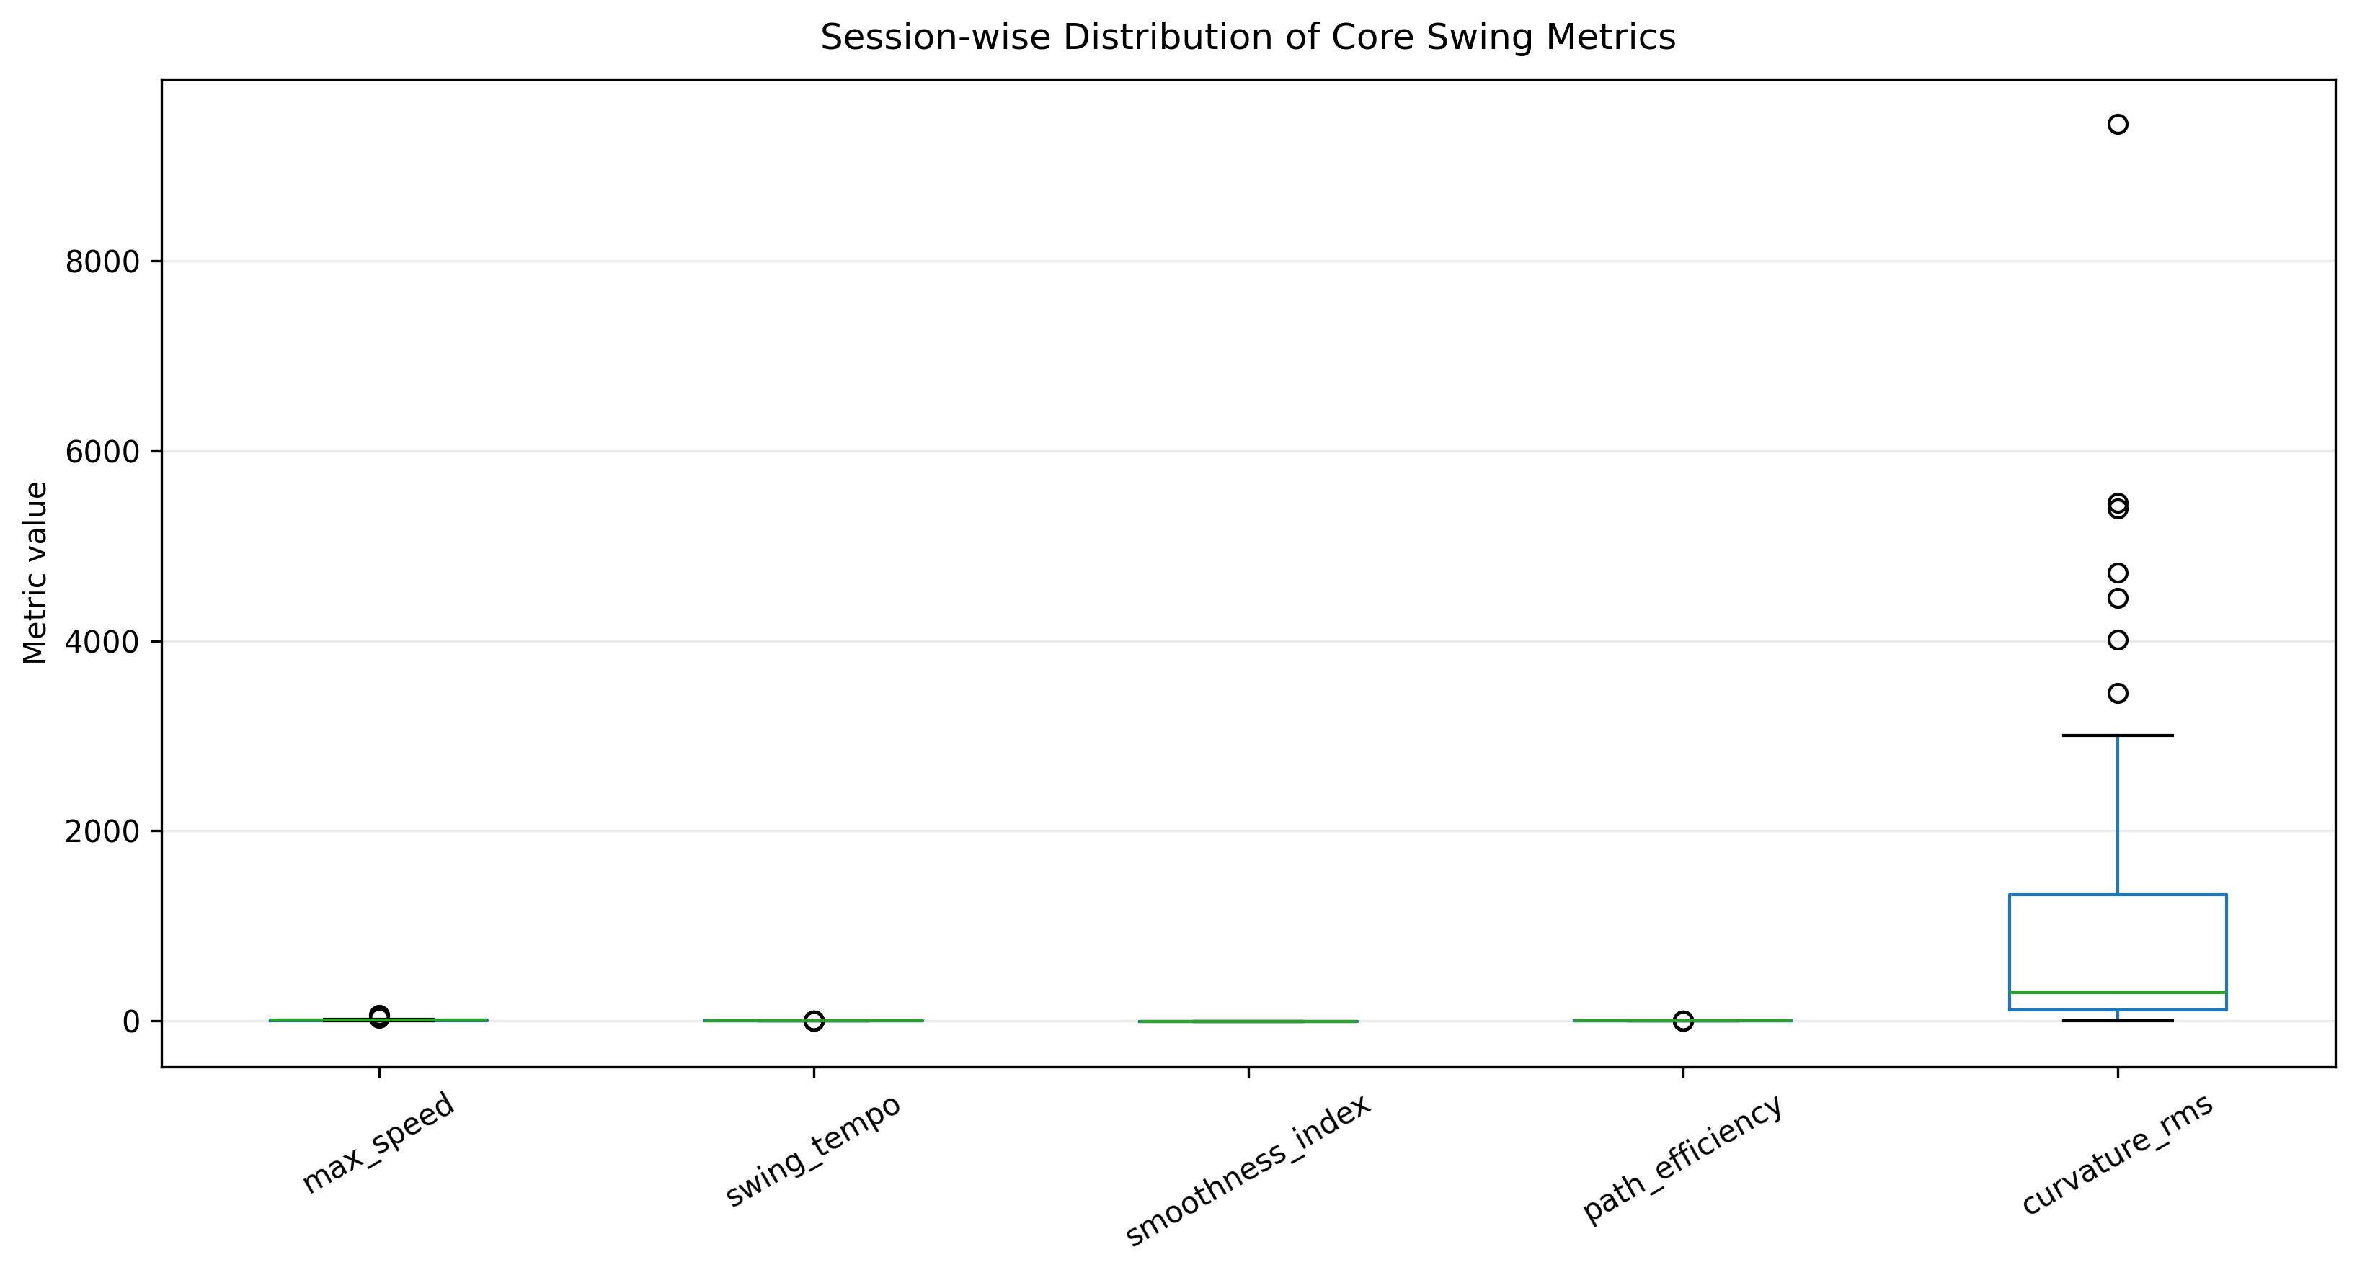
Fig. 1. Session-wise distribution of selected swing metrics.
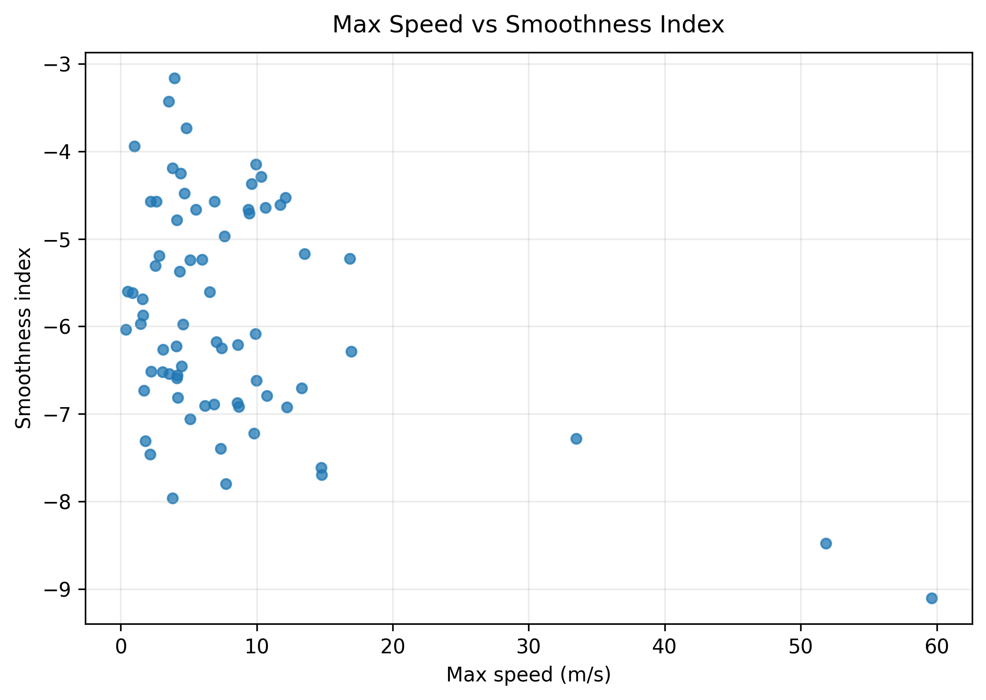
Fig. 2. Relationship between maximum speed and smoothness index.
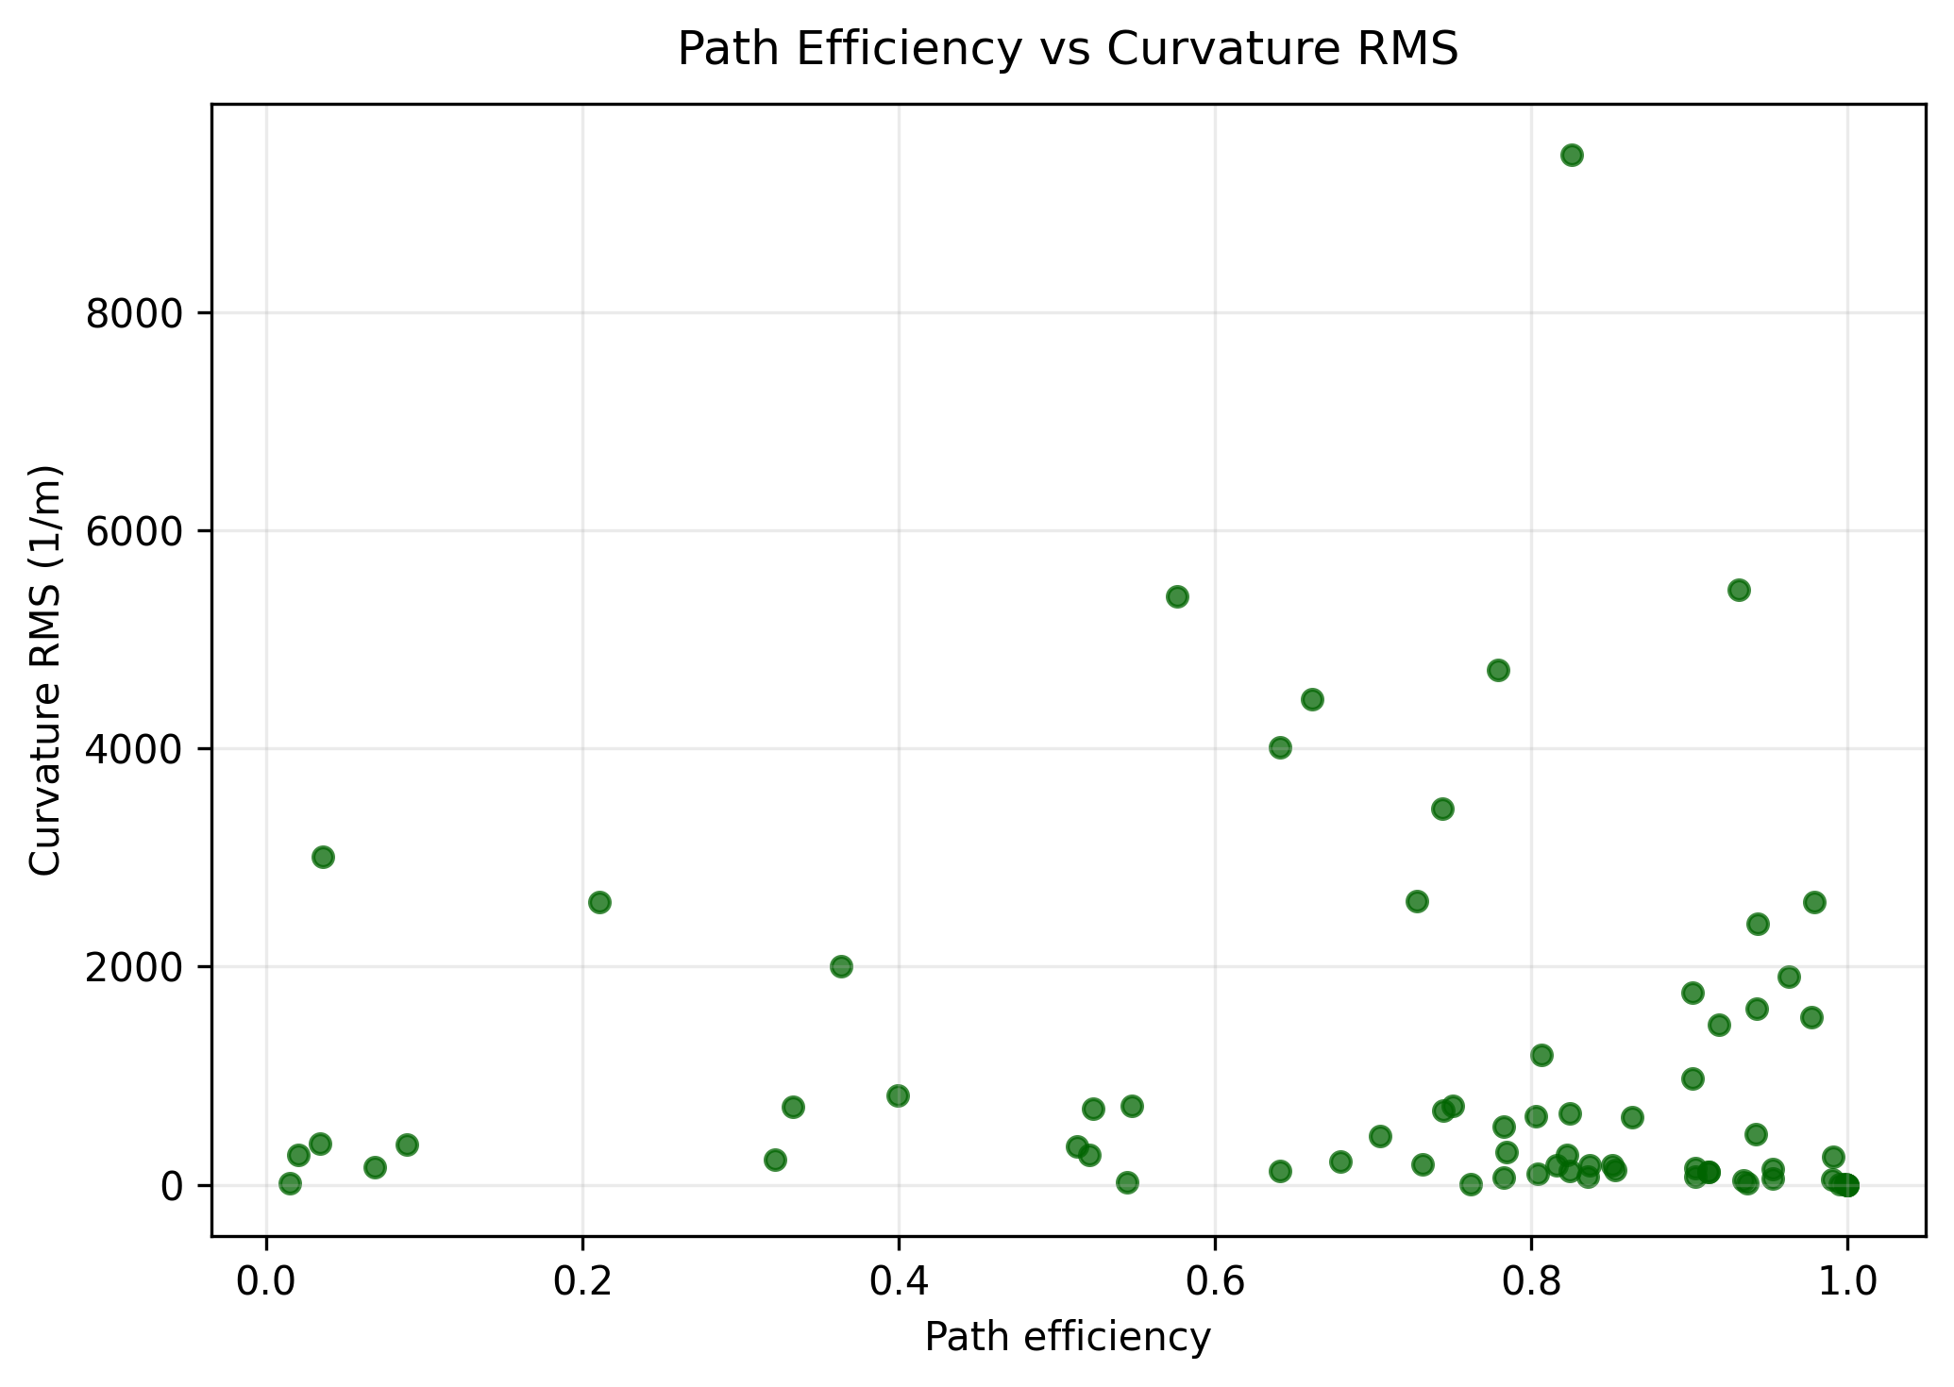
Fig. 3. Relationship between path efficiency and curvature RMS.
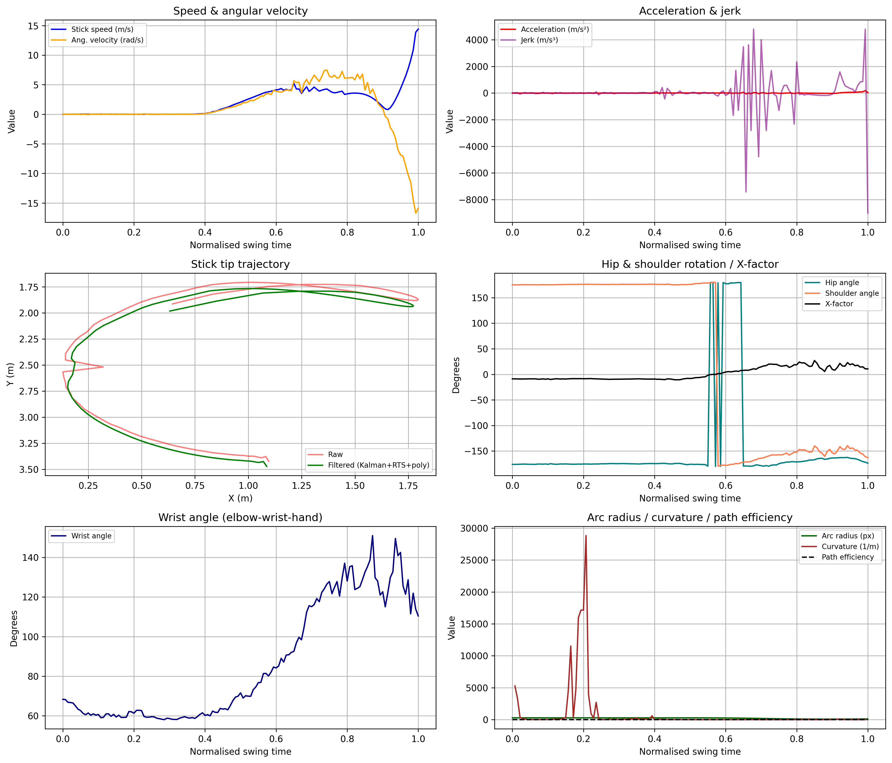
Fig. 4. Full kinematic and biomechanical summary from swing_analysis.csv.
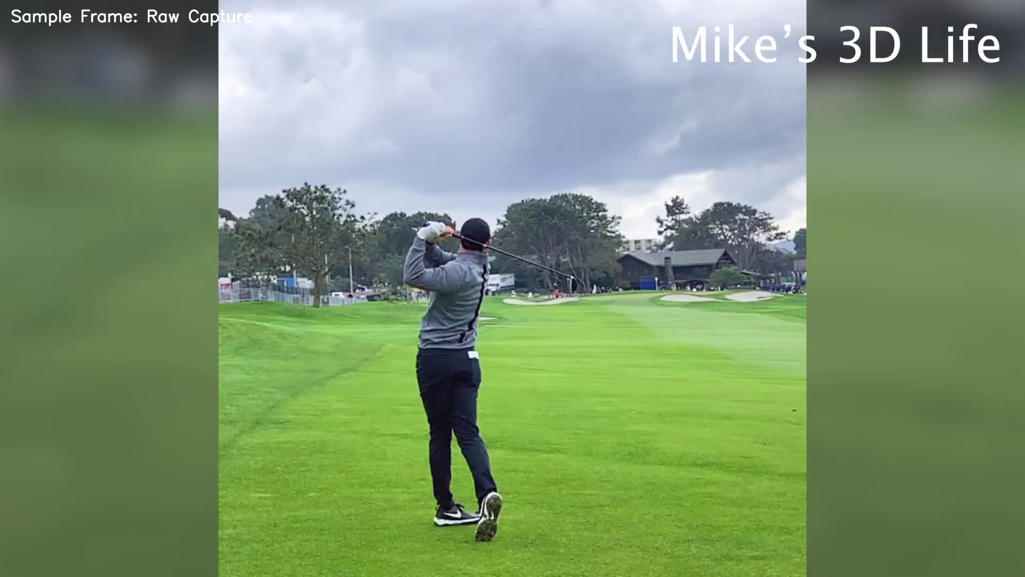
Fig. 5. Example source frame used for markerless swing processing.
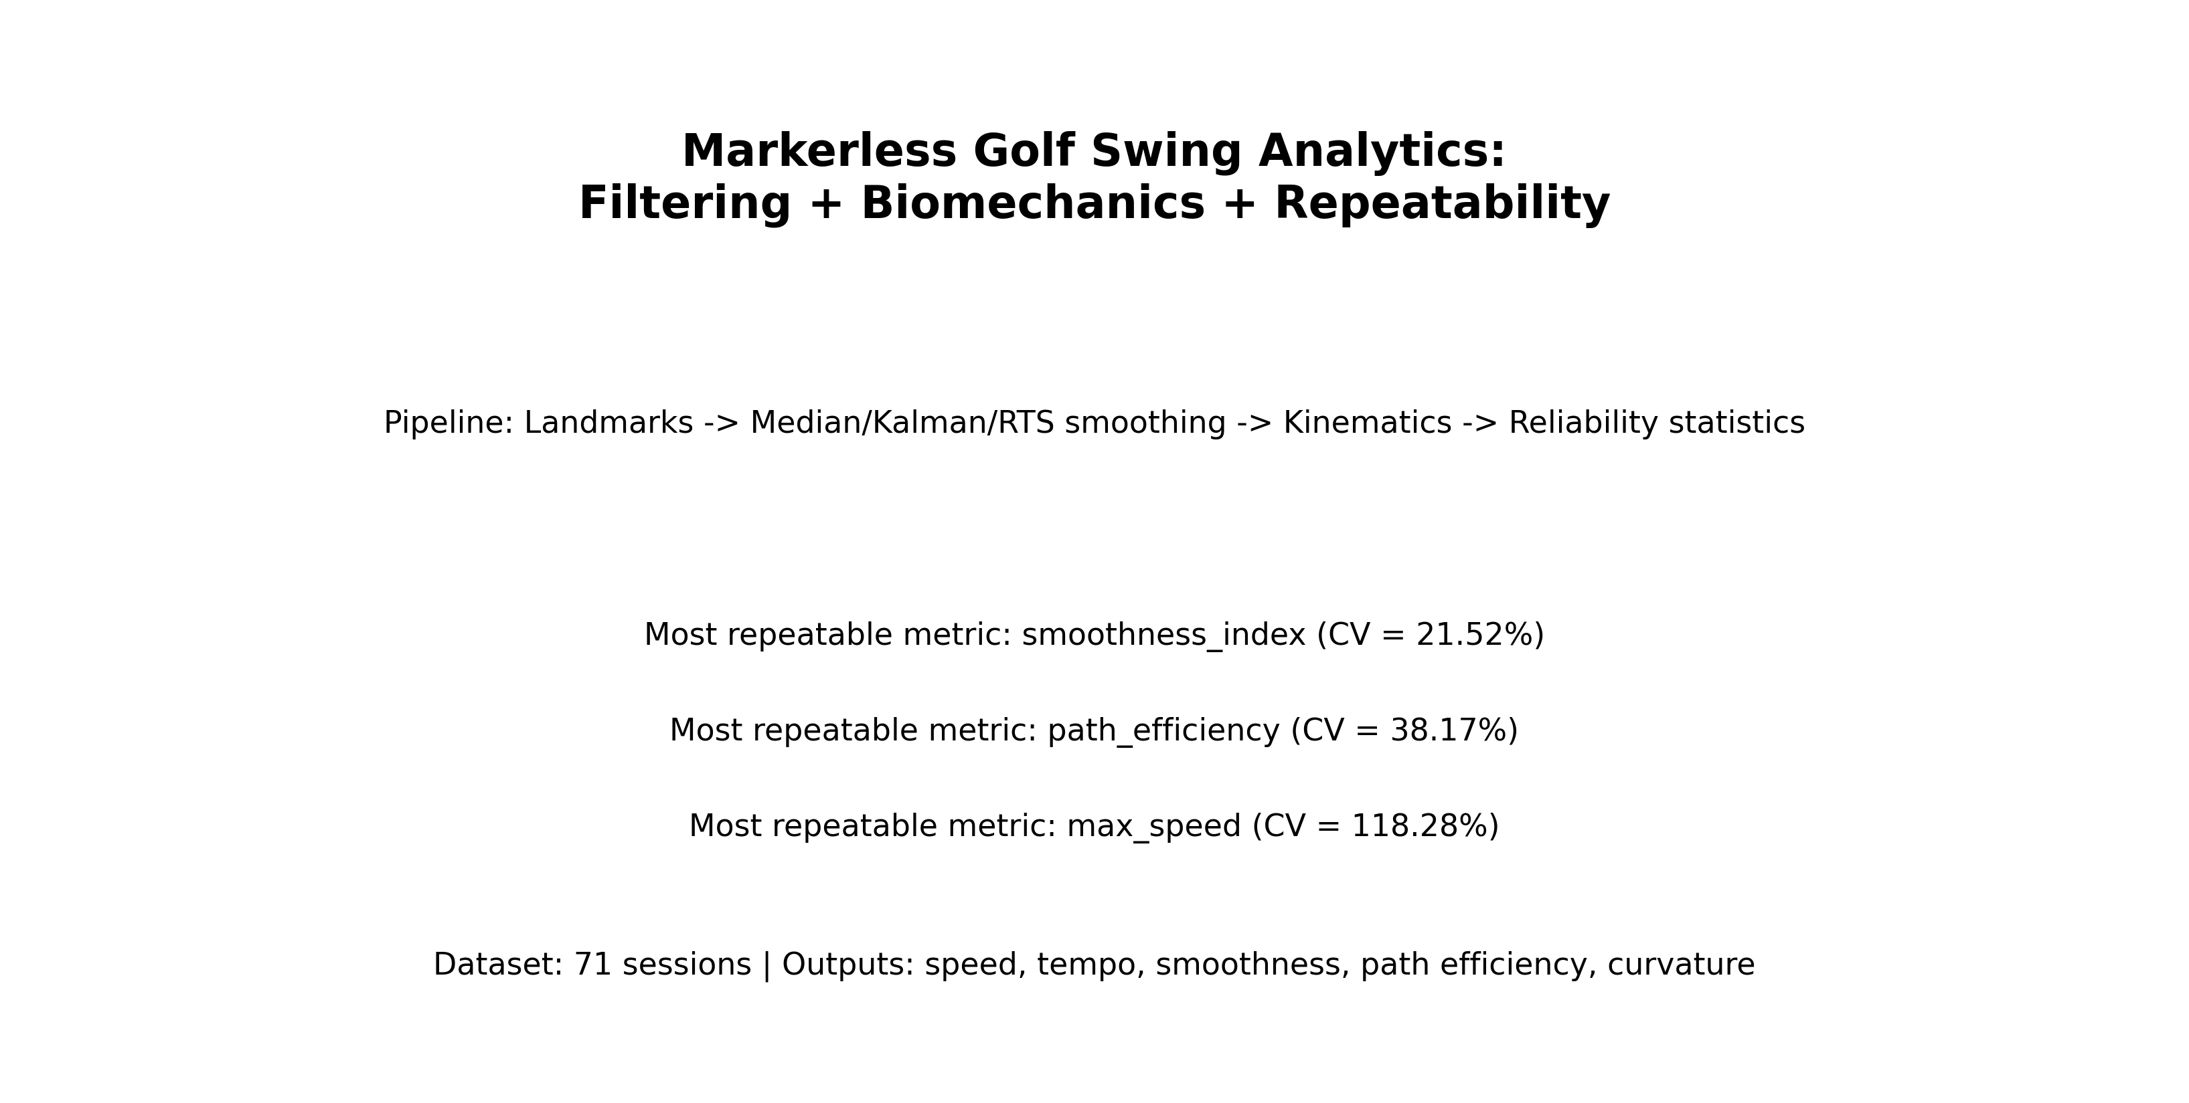
Fig. 6. Graphical abstract of the proposed workflow and repeatability outcomes.
6. Discussion of results
The modifications address known implementation risks that can distort interpretation. First-frame derivative
artifacts were eliminated by initializing previous kinematic states as undefined and deriving first nonzero
values only from physically meaningful pairs. Impact detection is now aligned with global configuration,
reducing hidden parameter drift. Summary and exported values are synchronized through a shared metric cache.
Dynamic scale stabilization improved robustness when session geometry changed. However, 2D monocular scaling
remains sensitive to depth motion and camera placement. This explains part of the elevated variability in
acceleration-like outcomes. Future work should integrate camera calibration, confidence-weighted landmark
filtering, and optional 3D pose priors for improved invariance.
7. Conclusion
1) A robust markerless swing analytics pipeline was implemented with unified filtering, metric export, and
repeatability analysis.
2) New metrics (path efficiency, curvature, phase-aware indicators) were integrated and validated.
3) The workflow produced publication-ready figures, tables, and narrative assets from raw reliability CSVs.
4) Reliability evidence supports smoothness and path-efficiency metrics as stronger primary candidates than
high-order derivative metrics in heterogeneous recording conditions.
Conflict of interest
The authors declare that they have no conflict of interest in relation to this research, whether financial, personal, authorship or otherwise, that could affect the research and its results presented in this paper.
Financing
The study was performed without financial support.
Data availability
Manuscript has data included as electronic supplementary material. Additional processed datasets and scripts will be made available on reasonable request.
Use of artificial intelligence tools
AI assistance was used for language editing and structural drafting of manuscript text. All computational methods, code modifications, numerical outputs, and conclusions were implemented and verified by the authors using local scripts and reproducible artifacts.
Acknowledgments
The authors thank collaborators who supported data collection and validation of the motion-analysis workflow.
Author contributions (CRediT)
Isin U.: Conceptualization, Methodology, Software, Data curation, Validation, Writing – original draft, Visualization; Co-author N.: Investigation, Formal analysis, Writing – review & editing.
References
[1] Winter, D. A. Biomechanics and Motor Control of Human Movement. Wiley, 2009.
[2] Bartlett, R. Introduction to Sports Biomechanics. Routledge, 2007.
[3] Sigal, L. et al. Human pose estimation from monocular images. CVPR, 2010.
[4] Cao, Z. et al. OpenPose: Realtime Multi-Person 2D Pose Estimation. IEEE TPAMI, 2019.
[5] Nesbit, S. M., Serrano, M. Work and power analysis of the golf swing. Journal of Sports Science & Medicine, 2005.
[6] Kwon, Y.-H. et al. Validation of planar golf swing kinematics using video analysis. Sports Engineering, 2012.
[7] Hume, P., Keogh, J., Reid, D. The role of biomechanics in maximizing distance and accuracy in golf. Sports Medicine, 2005.
[8] Mackenzie, S. J., Sprigings, E. J. Understanding the role of shaft stiffness in the golf swing. Journal of Sports Sciences, 2009.
[9] Welch, G., Bishop, G. An Introduction to the Kalman Filter. UNC Chapel Hill, 2006.
[10] Rauch, H. E., Tung, F., Striebel, C. Maximum likelihood estimates of linear dynamic systems. AIAA Journal, 1965.
[11] Savitzky, A., Golay, M. J. E. Smoothing and differentiation of data by simplified least squares procedures. Analytical Chemistry, 1964.
[12] Godfrey, A. et al. Instrumenting gait with motion sensors: a systematic review. Physiological Measurement, 2014.
[13] Mo, S., Chow, D. S. Segmental sequencing in a golf swing. Sports Biomechanics, 2018.
[14] van der Kruk, E., Reijne, M. Accuracy of human motion capture systems for sport applications. European Journal of Sport Science, 2018.
Information about authors in English
Ivan Suniuk
Department/Organization: to be completed
Address: to be completed
E-mail: to be completed
ORCID ID: to be completed
Contact phone: to be completed
Number of publications in international journals indexed (approximate): to be completed
H-index by Scopus (if available): to be completed
ResearchGate: to be completed
Scopus ID: to be completed
Researcher ID: to be completed
Information about authors in Ukrainian
Авторські реєстраційні дані українською мовою: заповнити за вимогами редакції перед поданням.
Appendix A. Ranked repeatability table
# Ranked Metric Repeatability
| repeatability_rank | metric | cv_percent | mean | std | n_sessions | stability_label |
|---|---|---|---|---|---|---|
| 1 | smoothness_index | 21.518 | -5.882 | 1.266 | 71 | moderate |
| 2 | path_efficiency | 38.174 | 0.726 | 0.277 | 71 | low |
| 3 | downswing_peak_speed | 118.282 | 8.184 | 9.681 | 71 | low |
| 4 | max_speed | 118.282 | 8.184 | 9.681 | 71 | low |
| 5 | swing_tempo | 128.633 | 0.604 | 0.777 | 71 | low |
| 6 | curvature_rms | 158.623 | 1063.382 | 1686.764 | 71 | low |
| 7 | downswing_duration | 167.721 | 1.676 | 2.812 | 71 | low |
| 8 | max_ang_vel | 192.757 | 10.169 | 19.601 | 71 | low |
| 9 | max_accel | 216.244 | 185.158 | 400.392 | 71 | low |
| 10 | backswing_duration | 225.355 | 0.673 | 1.517 | 71 | low |
| 11 | backswing_peak_speed | 519.310 | 1.065 | 5.533 | 71 | low |

