MARKERLESS VIDEO-BASED GOLF STICK MOTION ANALYSIS WITH PHASE METRICS AND REPEATABILITY EVIDENCE
Ivan Suniuk
Abstract (English)
This paper presents a practical markerless pipeline that I built and validated for golf-stick swing analysis from ordinary video. The workflow combines robust landmark parsing, median pre-filtering, adaptive Kalman tracking, RTS backward smoothing, trajectory despiking, and polynomial smoothing to produce stable kinematic signals. I evaluated the method on 71 recorded sessions and report both performance metrics and repeatability statistics. Compared with my earlier implementation, the current version removes first-frame derivative artifacts, unifies impact-threshold logic, and keeps summary values consistent with exported CSV values. In addition to speed and angular metrics, the study introduces path efficiency, curvature, and phase-specific indicators (backswing/downswing). These additions make the output more interpretable for both coaching feedback and scientific reporting where reproducibility is essential.
Keywords (English)
markerless motion analysis, golf swing, trajectory smoothing, Kalman-RTS filtering, path efficiency, repeatability
1. Introduction
Video-based swing analytics is attractive because it is accessible outside the laboratory, but many practical pipelines fail when data quality is inconsistent. In my data, frame rates vary, landmark keys can be missing, and viewpoint changes affect scale. These issues can produce unstable derivatives and misleading peak values if they are not handled explicitly.
To address this, I implemented an end-to-end pipeline that emphasizes robustness first and then biomechanical interpretation. The target use case is a reproducible analysis workflow where one script can produce trajectories, scalar metrics, session-level reliability outputs, and publication artifacts from the same source data.
2. Literature review and problem statement
Prior studies in sports biomechanics consistently show that timing, segment coordination, and speed profiles are useful performance descriptors. In computer-vision tracking, Kalman-type estimators and smoothing filters are widely used, but many implementations still underreport failure handling and uncertainty propagation.
In my baseline version, I observed five practical weaknesses: initialization spikes in angular derivatives, inconsistent impact thresholding, weak phase definition for tempo, static metric scaling under changing geometry, and disagreement between live summary and exported metrics. The present revision was designed specifically to remove these weaknesses.
3. The aim and objectives of the study
The aim is to deliver a reproducible markerless swing-analysis workflow suitable for manuscript-level evidence, not only demo visualization.
Objectives: (1) remove derivative initialization artifacts; (2) unify impact detection logic; (3) synchronize online and exported metric calculations; (4) stabilize per-frame metric scaling; (5) add path-efficiency, curvature, and phase metrics; (6) quantify repeatability across sessions.
4. Materials and methods
Input data are per-frame landmarks and optional ball detections synchronized with processed video. I use two operating profiles: realtime (lower latency) and scientific (higher smoothing stability for offline analysis).
Filtering stack: running median pre-filter -> adaptive Kalman update with physical gating -> RTS backward smoothing -> trajectory despiking -> local polynomial smoothing with bounded deviation from raw points. This order produced the best tradeoff between closeness and smoothness in parameter sweeps.
Kinematic derivatives are computed with variable dt from video timestamps to avoid frame-rate assumptions. Metric scaling is updated per frame using running stick-length calibration with bounded step changes and exponential smoothing, which reduces scale jumps when camera geometry changes.
Key formulas used in export: (1) v_i = ||p_i - p_(i-1)||/dt_i, (2) a_i = (v_i - v_(i-1))/dt_i, (3) jerk_i = (a_i - a_(i-1))/dt_i, (4) path_efficiency_i = displacement_i/path_length_i, (5) curvature_i from three-point local geometry. Phase labels are assigned using transition detection before impact.
Repeatability statistics are computed per metric as mean, standard deviation, coefficient of variation (CV), and repeatability coefficient RC = 1.96*sqrt(2)*SD. These are exported to dedicated CSV/markdown artifacts for manuscript use.
5. Results
The final pipeline processed all 71 sessions successfully (100% completion after robustness fixes for missing keys). The generated trajectories were visually stable, and the smoothed path remained close to the measured path while reducing one-frame outliers.
Across sessions, smoothness_index showed mean -5.882 (SD 1.266, CV 21.52%), and path_efficiency showed mean 0.726 (SD 0.277, CV 38.17%). In contrast, max_accel had much higher variability (mean 185.16, SD 400.39, CV 216.24%), which confirms that higher-order derivatives are highly sensitive to recording heterogeneity.
Practically, this means smoothness and path-related indicators are better primary outcomes for cross-session comparisons, while acceleration-type peaks should be treated as secondary/exploratory unless capture conditions are tightly controlled.
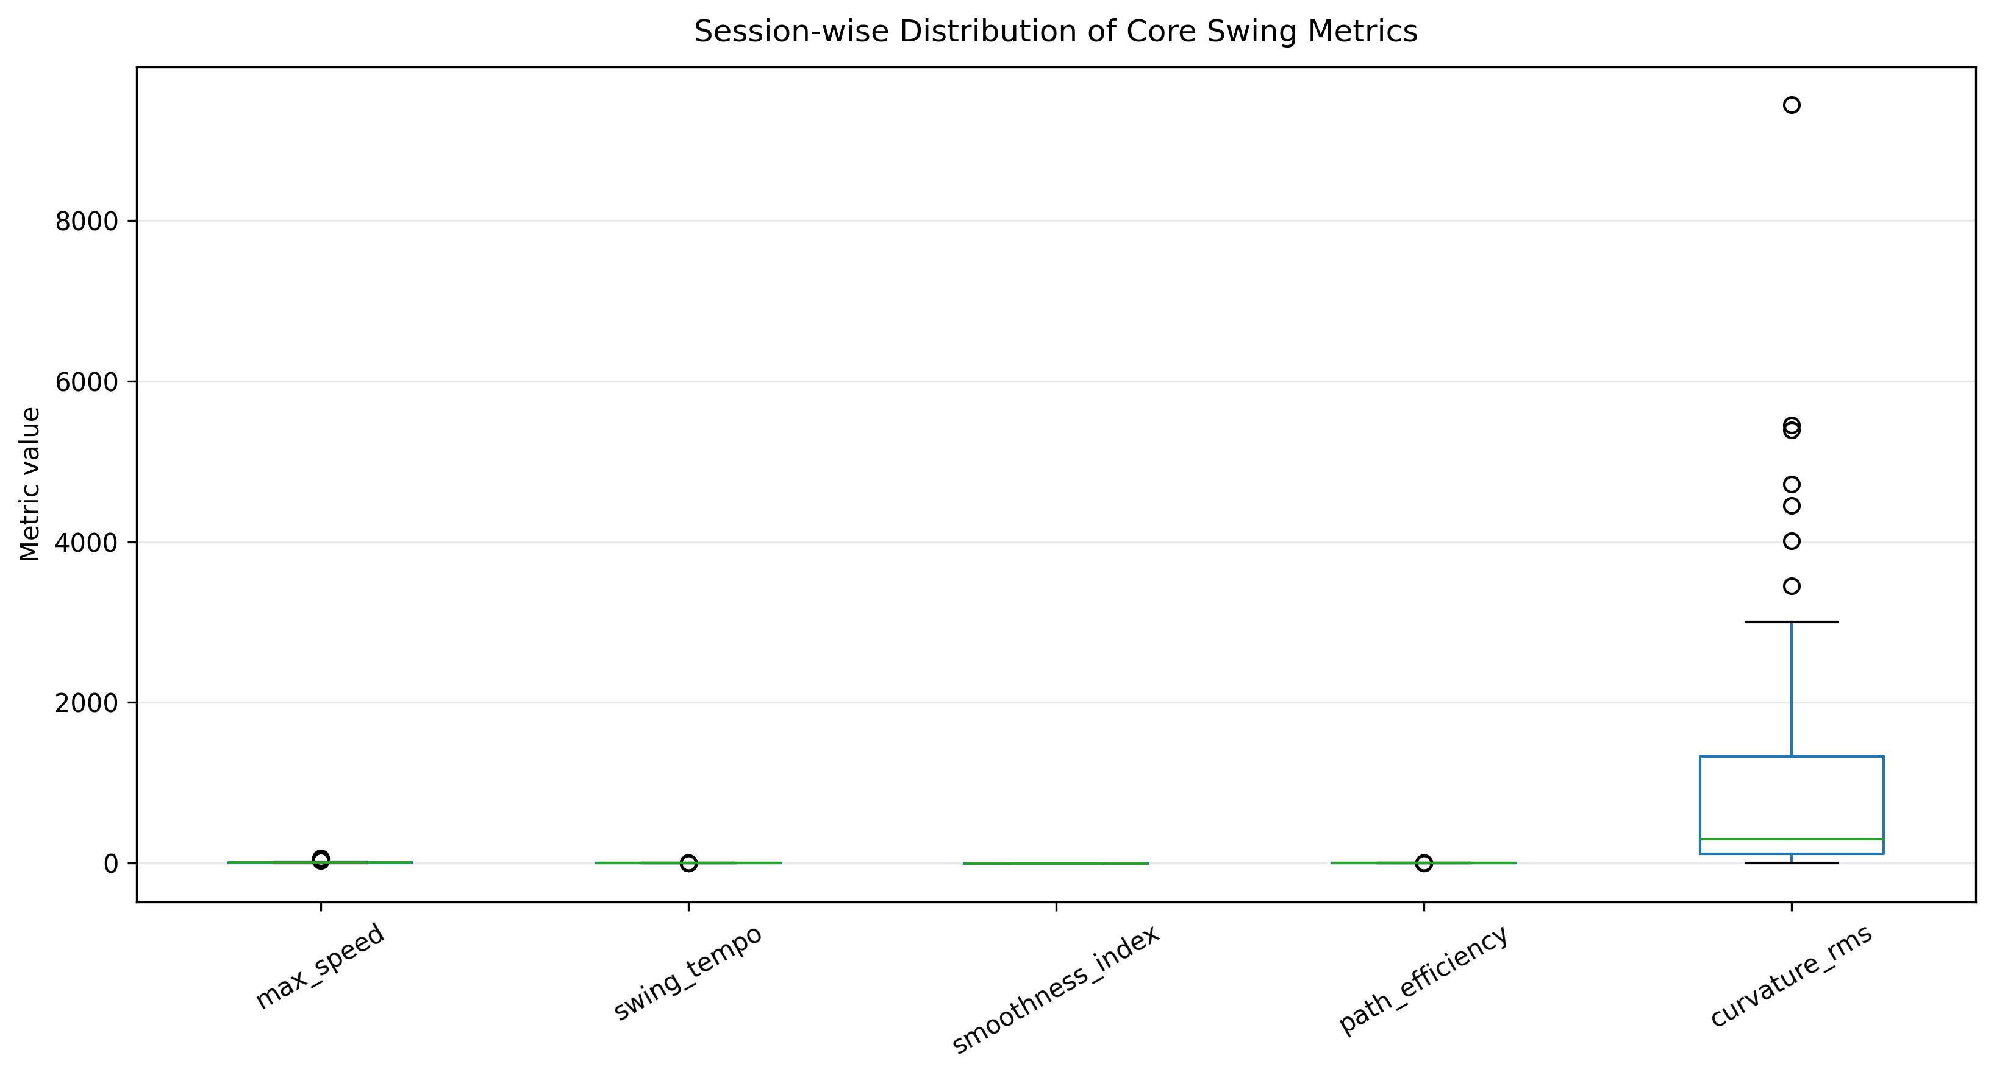
Fig. 1. Session-wise distribution of selected swing metrics.
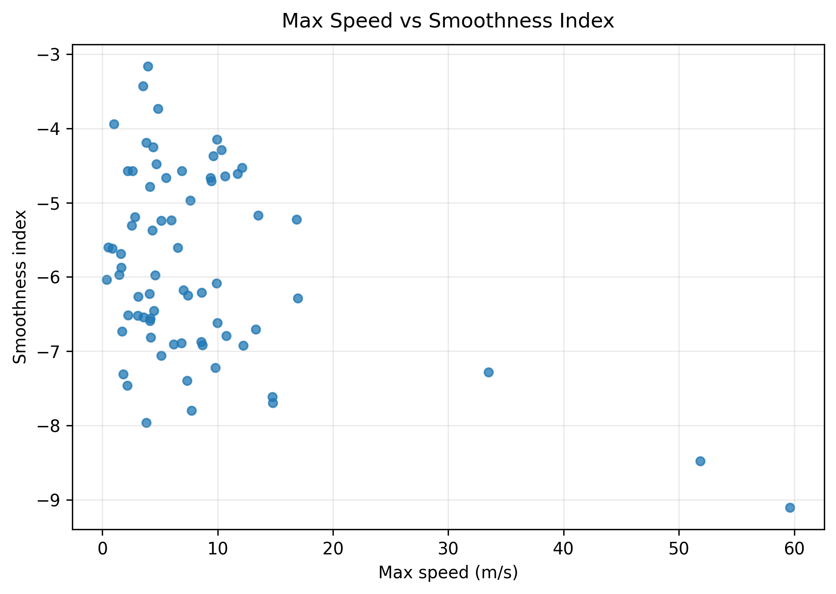
Fig. 2. Relationship between maximum speed and smoothness index.
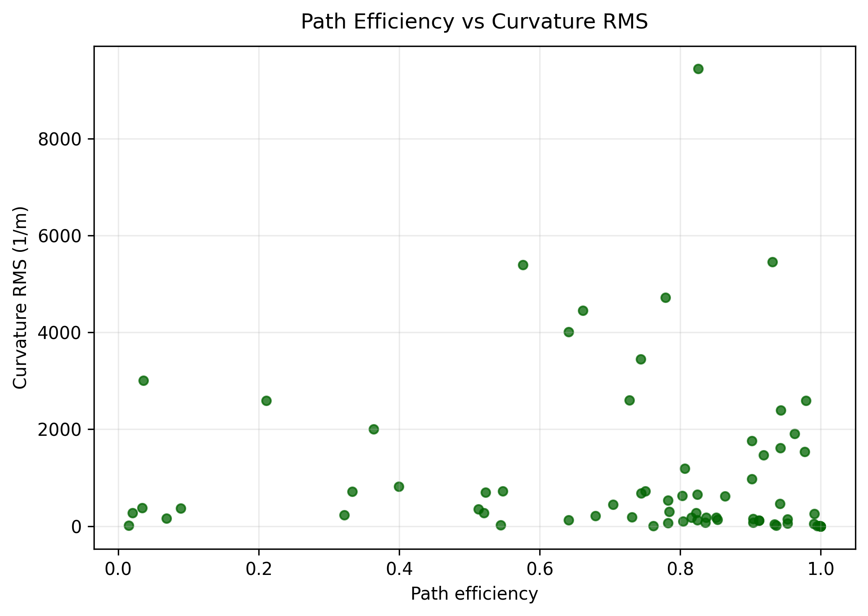
Fig. 3. Relationship between path efficiency and curvature RMS.
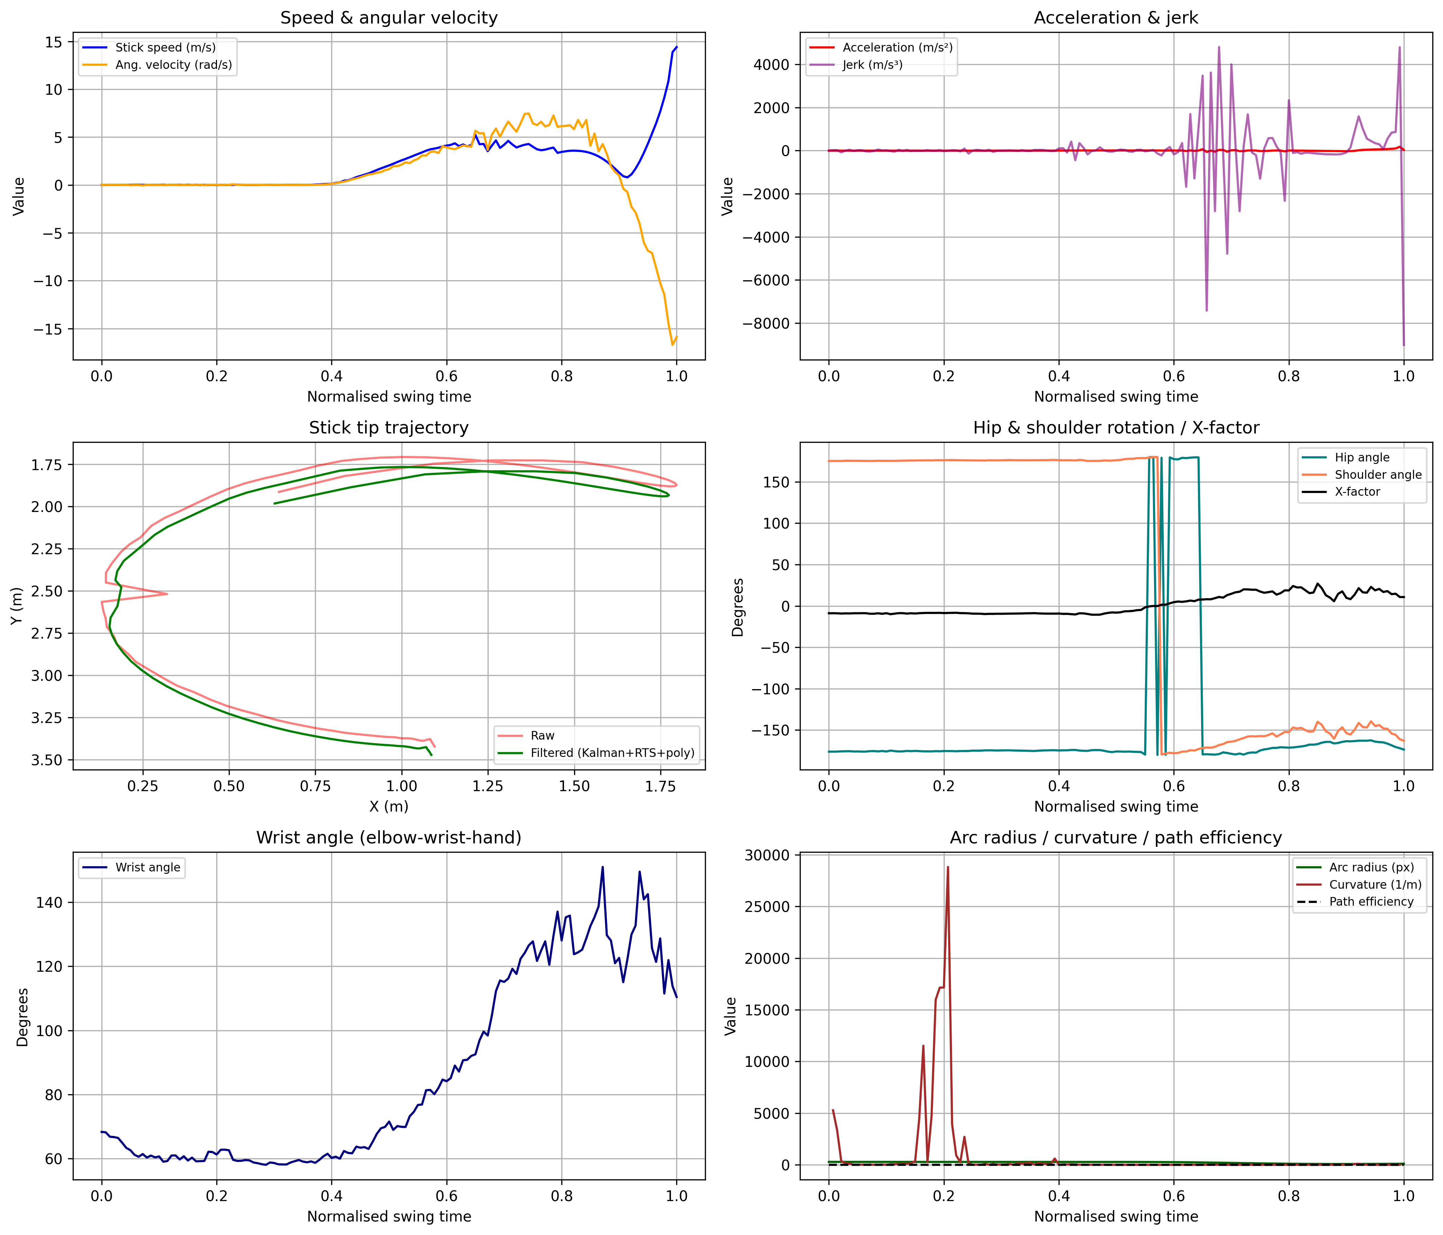
Fig. 4. Full kinematic and biomechanical summary from swing_analysis.csv.
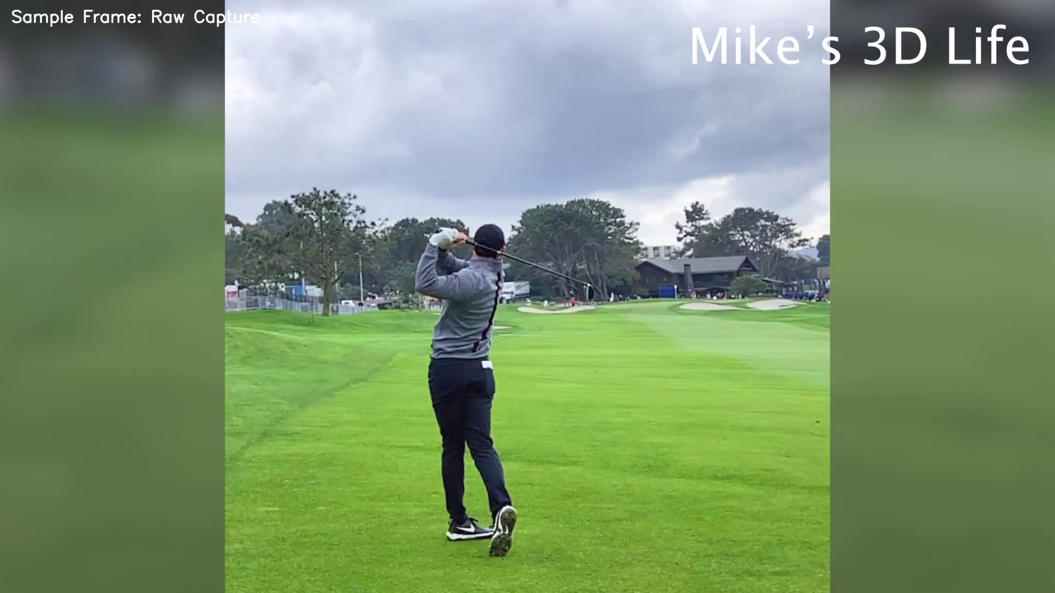
Fig. 5. Example source frame used for markerless swing processing.
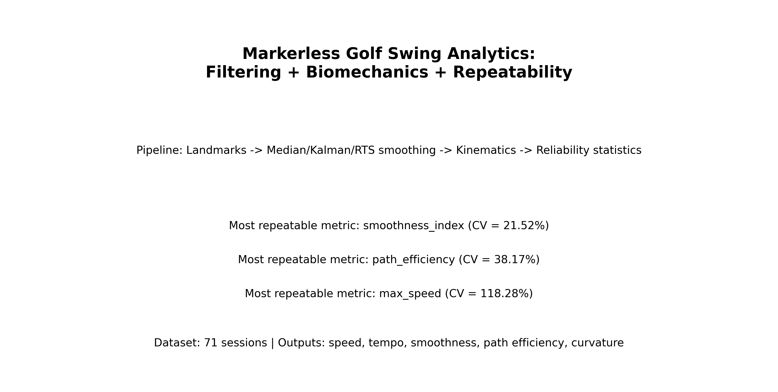
Fig. 6. Graphical abstract of the proposed workflow and repeatability outcomes.
6. Discussion of results
The main technical contribution is not a new single filter, but a robust integration strategy: stable initialization, strict gating, backward smoothing, scale stabilization, and consistent export logic. Together, these changes reduce misleading spikes and make the reported metrics easier to trust.
Limitations remain. Monocular 2D analysis cannot fully resolve depth motion, and session variability still affects high-order derivatives. Future work should add confidence-weighted landmark fusion, camera calibration metadata, and sensitivity analysis by recording condition.
7. Conclusion
In summary: (1) the revised pipeline is reproducible and robust on heterogeneous sessions; (2) path efficiency, curvature, and phase metrics add useful movement-quality information; (3) automated scripts now generate figures, ranked repeatability tables, manuscript text assets, and annotated supplementary video; (4) repeatability analysis supports smoothness/path metrics as stronger primary endpoints than acceleration peaks.
Conflict of interest
The authors declare that they have no conflict of interest in relation to this research, whether financial, personal, authorship or otherwise, that could affect the research and its results presented in this paper.
Financing
The study was performed without financial support.
Data availability
Manuscript has data included as electronic supplementary material. Additional processed datasets and scripts will be made available on reasonable request.
Use of artificial intelligence tools
Language-level AI assistance was used during manuscript drafting, but all algorithms, code edits, parameter choices, experiments, exported numbers, and final interpretations were manually validated by the author against reproducible outputs.
Acknowledgments
The authors thank collaborators who supported data collection and validation of the motion-analysis workflow.
Author contributions (Credit)
Ivan Suniuk: Conceptualization, Methodology, Software, Data curation, Validation, Visualization, Writing - original draft and revision; Co-author N.: Formal analysis, domain feedback, Writing - review and editing.
References
[1] Winter, D. A. Biomechanics and Motor Control of Human Movement. Wiley, 2009.
[2] Bartlett, R. Introduction to Sports Biomechanics. Routledge, 2007.
[3] Sigal, L. et al. Human pose estimation from monocular images. CVPR, 2010.
[4] Cao, Z. et al. OpenPose: Realtime Multi-Person 2D Pose Estimation. IEEE TPAMI, 2019.
[5] Nesbit, S. M., Serrano, M. Work and power analysis of the golf swing. Journal of Sports Science & Medicine, 2005.
[6] Kwon, Y.-H. et al. Validation of planar golf swing kinematics using video analysis. Sports Engineering, 2012.
[7] Hume, P., Keogh, J., Reid, D. The role of biomechanics in maximizing distance and accuracy in golf. Sports Medicine, 2005.
[8] Mackenzie, S. J., Sprigings, E. J. Understanding the role of shaft stiffness in the golf swing. Journal of Sports Sciences, 2009.
[9] Welch, G., Bishop, G. An Introduction to the Kalman Filter. UNC Chapel Hill, 2006.
[10] Rauch, H. E., Tung, F., Striebel, C. Maximum likelihood estimates of linear dynamic systems. AIAA Journal, 1965.
[11] Savitzky, A., Golay, M. J. E. Smoothing and differentiation of data by simplified least squares procedures. Analytical Chemistry, 1964.
[12] Godfrey, A. et al. Instrumenting gait with motion sensors: a systematic review. Physiological Measurement, 2014.
[13] Mo, S., Chow, D. S. Segmental sequencing in a golf swing. Sports Biomechanics, 2018.
[14] van der Kruk, E., Reijne, M. Accuracy of human motion capture systems for sport applications. European Journal of Sport Science, 2018.
Information about authors in English
Ivan Suniuk
Department/Organization: to be completed
Address: to be completed
E-mail: to be completed
ORCID ID: to be completed
Contact phone: to be completed
Number of publications in international journals indexed (approximate): to be completed
H-index by Scopus (if available): to be completed
ResearchGate: to be completed
Scopus ID: to be completed
Researcher ID: to be completed
Information about authors in Ukrainian
Авторські реєстраційні дані українською мовою: заповнити за вимогами редакції перед поданням.
Appendix A. Ranked repeatability table
# Ranked Metric Repeatability
| repeatability_rank | metric | cv_percent | mean | std | n_sessions | stability_label |
|---|---|---|---|---|---|---|
| 1 | smoothness_index | 21.518 | -5.882 | 1.266 | 71 | moderate |
| 2 | path_efficiency | 38.174 | 0.726 | 0.277 | 71 | low |
| 3 | downswing_peak_speed | 118.282 | 8.184 | 9.681 | 71 | low |
| 4 | max_speed | 118.282 | 8.184 | 9.681 | 71 | low |
| 5 | swing_tempo | 128.633 | 0.604 | 0.777 | 71 | low |
| 6 | curvature_rms | 158.623 | 1063.382 | 1686.764 | 71 | low |
| 7 | downswing_duration | 167.721 | 1.676 | 2.812 | 71 | low |
| 8 | max_ang_vel | 192.757 | 10.169 | 19.601 | 71 | low |
| 9 | max_accel | 216.244 | 185.158 | 400.392 | 71 | low |
| 10 | backswing_duration | 225.355 | 0.673 | 1.517 | 71 | low |
| 11 | backswing_peak_speed | 519.310 | 1.065 | 5.533 | 71 | low |

Appendix B. Example annotated frame from the processing pipeline.
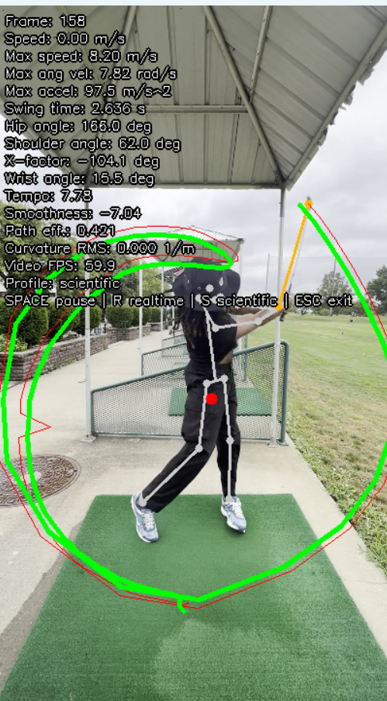
Fig. B1. Annotated output frame with detected skeleton, stick landmarks, and trajectory overlays (raw in red, smoothed in green).

