（一）点餐程序设计FoodMenu：
布局文件：
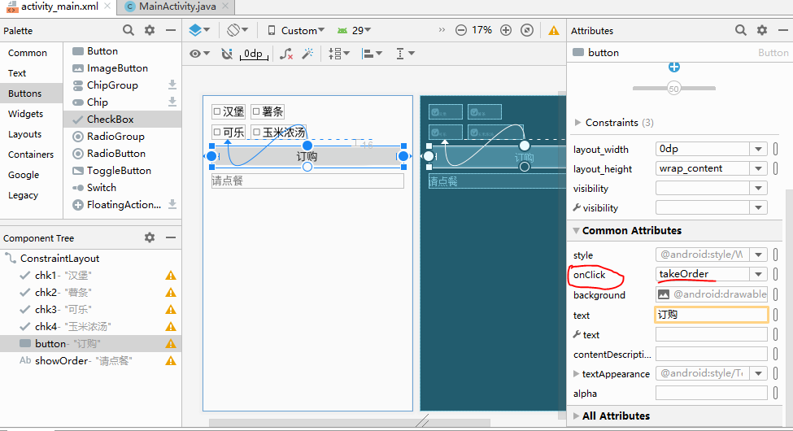
<?xml version="1.0" encoding="utf-8"?>
<androidx.constraintlayout.widget.ConstraintLayout xmlns:android="http://schemas.android.com/apk/res/android"
xmlns:app="http://schemas.android.com/apk/res-auto"
xmlns:tools="http://schemas.android.com/tools"
android:layout_width="match_parent"
android:layout_height="match_parent"
tools:context=".MainActivity">
<CheckBox
android:id="@+id/chk1"
android:layout_width="wrap_content"
android:layout_height="wrap_content"
android:text="汉堡"
android:textSize="30sp"
android:checked="false"
tools:layout_constraintRight_creator="1"
app:layout_constraintRight_toRightOf="@+id/chk3"
app:layout_constraintBaseline_toBaselineOf="@+id/chk2"
tools:layout_constraintBaseline_creator="1"
tools:layout_constraintLeft_creator="1"
app:layout_constraintLeft_toLeftOf="@+id/chk3" />
<CheckBox
android:id="@+id/chk2"
android:layout_width="wrap_content"
android:layout_height="wrap_content"
android:text="薯条"
android:textSize="30sp"
android:checked="false"
tools:layout_constraintTop_creator="1"
android:layout_marginStart="16dp"
android:layout_marginTop="24dp"
tools:layout_constraintLeft_creator="1"
app:layout_constraintTop_toTopOf="parent"
app:layout_constraintLeft_toRightOf="@+id/chk1"
android:layout_marginLeft="16dp" />
<CheckBox
android:id="@+id/chk3"
android:layout_width="wrap_content"
android:layout_height="wrap_content"
android:text="可乐"
android:textSize="30sp"
android:checked="false"
tools:layout_constraintTop_creator="1"
android:layout_marginStart="24dp"
android:layout_marginTop="16dp"
app:layout_constraintTop_toBottomOf="@+id/chk1"
tools:layout_constraintLeft_creator="1"
app:layout_constraintLeft_toLeftOf="parent"
android:layout_marginLeft="24dp" />
<CheckBox
android:id="@+id/chk4"
android:layout_width="wrap_content"
android:layout_height="wrap_content"
android:text="玉米浓汤"
android:textSize="30sp"
android:checked="false"
android:layout_marginStart="1dp"
app:layout_constraintBaseline_toBaselineOf="@+id/chk3"
tools:layout_constraintBaseline_creator="1"
tools:layout_constraintLeft_creator="1"
app:layout_constraintLeft_toLeftOf="@+id/chk2"
android:layout_marginLeft="1dp" />
<Button
android:layout_width="0dp"
android:layout_height="wrap_content"
android:id="@+id/button"
android:text="订购"
android:onClick="takeOrder"
android:textSize="30sp"
tools:layout_constraintTop_creator="1"
android:layout_marginStart="24dp"
android:layout_marginTop="16dp"
app:layout_constraintTop_toBottomOf="@+id/chk3"
tools:layout_constraintLeft_creator="1"
app:layout_constraintLeft_toLeftOf="parent"
android:layout_marginLeft="24dp"
android:layout_marginEnd="24dp"
app:layout_constraintRight_toRightOf="parent"
android:layout_marginRight="24dp" />
<TextView
android:layout_width="0dp"
android:layout_height="wrap_content"
android:text="请点餐"
android:id="@+id/showOrder"
android:textSize="30sp"
tools:layout_constraintTop_creator="1"
android:layout_marginStart="24dp"
android:layout_marginTop="16dp"
app:layout_constraintTop_toBottomOf="@+id/button"
tools:layout_constraintLeft_creator="1"
app:layout_constraintLeft_toLeftOf="parent"
android:layout_marginLeft="24dp"
app:layout_constraintRight_toRightOf="@+id/button" />
</androidx.constraintlayout.widget.ConstraintLayout>

源码：

运行结果：
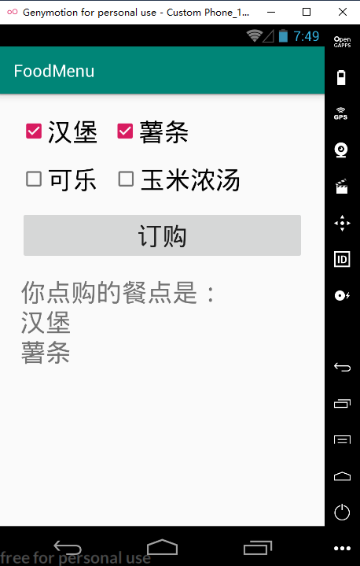

（二）带有图片的点餐实例：FoodImgMenu
先准备好图片：
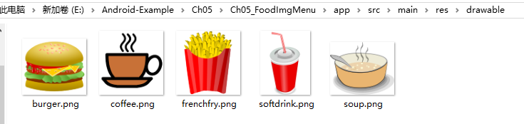
布局文件：
<?xml version="1.0" encoding="utf-8"?>
<androidx.constraintlayout.widget.ConstraintLayout xmlns:android="http://schemas.android.com/apk/res/android"
xmlns:app="http://schemas.android.com/apk/res-auto"
xmlns:tools="http://schemas.android.com/tools"
android:layout_width="match_parent"
android:layout_height="match_parent"
tools:context=".MainActivity">
<CheckBox
android:id="@+id/chk1"
android:layout_width="wrap_content"
android:layout_height="wrap_content"
android:text="汉堡"
android:textSize="25sp"
android:checked="false"
tools:layout_constraintTop_creator="1"
android:layout_marginStart="16dp"
android:layout_marginTop="24dp"
tools:layout_constraintLeft_creator="1"
app:layout_constraintLeft_toLeftOf="parent"
app:layout_constraintTop_toTopOf="parent"
android:layout_marginLeft="16dp" />
<CheckBox
android:id="@+id/chk2"
android:layout_width="wrap_content"
android:layout_height="wrap_content"
android:text="薯条"
android:textSize="25sp"
android:checked="false"
tools:layout_constraintTop_creator="1"
android:layout_marginStart="16dp"
android:layout_marginTop="23dp"
tools:layout_constraintLeft_creator="1"
app:layout_constraintTop_toTopOf="parent"
app:layout_constraintLeft_toRightOf="@+id/img1"
android:layout_marginLeft="16dp" />
<CheckBox
android:id="@+id/chk3"
android:layout_width="wrap_content"
android:layout_height="wrap_content"
android:text="可乐"
android:textSize="25sp"
android:checked="false"
tools:layout_constraintTop_creator="1"
android:layout_marginStart="16dp"
android:layout_marginTop="22dp"
app:layout_constraintTop_toBottomOf="@+id/chk1"
tools:layout_constraintLeft_creator="1"
app:layout_constraintLeft_toLeftOf="parent"
android:layout_marginLeft="16dp" />
<CheckBox
android:id="@+id/chk4"
android:layout_width="wrap_content"
android:layout_height="wrap_content"
android:text="玉米浓汤"
android:textSize="25sp"
android:checked="false"
tools:layout_constraintTop_creator="1"
android:layout_marginStart="16dp"
android:layout_marginTop="21dp"
app:layout_constraintTop_toBottomOf="@+id/chk2"
tools:layout_constraintLeft_creator="1"
app:layout_constraintLeft_toRightOf="@+id/img3"
android:layout_marginLeft="16dp" />
<ImageView
android:layout_width="30dp"
android:layout_height="0dp"
app:srcCompat="@drawable/burger"
android:id="@+id/img1"
app:layout_constraintBottom_toBottomOf="@+id/chk1"
app:layout_constraintTop_toTopOf="@+id/chk1"
app:layout_constraintLeft_toRightOf="@+id/chk1"
tools:layout_constraintTop_creator="1"
tools:layout_constraintBottom_creator="1"
android:layout_marginTop="3dp"
android:layout_marginBottom="3dp" />
<ImageView
android:layout_width="30dp"
android:layout_height="0dp"
app:srcCompat="@drawable/frenchfry"
android:id="@+id/img2"
app:layout_constraintBottom_toBottomOf="@+id/chk2"
app:layout_constraintTop_toTopOf="@+id/chk2"
app:layout_constraintLeft_toRightOf="@+id/chk2"
tools:layout_constraintTop_creator="1"
tools:layout_constraintBottom_creator="1"
android:layout_marginTop="3dp"
android:layout_marginBottom="3dp" />
<ImageView
android:layout_width="30dp"
android:layout_height="0dp"
app:srcCompat="@drawable/softdrink"
android:id="@+id/img3"
app:layout_constraintBottom_toBottomOf="@+id/chk3"
app:layout_constraintTop_toTopOf="@+id/chk3"
app:layout_constraintLeft_toRightOf="@+id/chk3"
tools:layout_constraintTop_creator="1"
tools:layout_constraintBottom_creator="1"
android:layout_marginTop="3dp"
android:layout_marginBottom="3dp" />
<ImageView
android:layout_width="30dp"
android:layout_height="0dp"
app:srcCompat="@drawable/soup"
android:id="@+id/img4"
app:layout_constraintBottom_toBottomOf="@+id/chk4"
app:layout_constraintTop_toTopOf="@+id/chk4"
app:layout_constraintLeft_toRightOf="@+id/chk4"
tools:layout_constraintTop_creator="1"
tools:layout_constraintBottom_creator="1"
android:layout_marginTop="3dp"
android:layout_marginBottom="3dp" />
<TextView
android:layout_width="0dp"
android:layout_height="wrap_content"
android:text="请点餐"
android:id="@+id/showOrder"
android:textSize="30sp"
tools:layout_constraintTop_creator="1"
tools:layout_constraintRight_creator="1"
android:layout_marginStart="16dp"
android:layout_marginEnd="16dp"
app:layout_constraintRight_toRightOf="parent"
android:layout_marginTop="20dp"
app:layout_constraintTop_toBottomOf="@+id/chk3"
tools:layout_constraintLeft_creator="1"
app:layout_constraintLeft_toLeftOf="parent"
android:layout_marginLeft="16dp"
android:layout_marginRight="16dp" />
<LinearLayout
android:orientation="horizontal"
android:layout_width="wrap_content"
android:layout_height="wrap_content"
tools:layout_constraintTop_creator="1"
android:layout_marginStart="16dp"
android:layout_marginTop="24dp"
app:layout_constraintTop_toBottomOf="@+id/showOrder"
tools:layout_constraintLeft_creator="1"
app:layout_constraintLeft_toLeftOf="parent"
android:layout_marginLeft="16dp">
<ImageView
android:layout_width="60dp"
android:layout_height="60dp"
app:srcCompat="@drawable/burger"
android:id="@+id/output1"
tools:layout_editor_absoluteY="197dp"
tools:layout_editor_absoluteX="16dp"
android:layout_weight="1"
android:visibility="gone" />
<ImageView
android:layout_width="60dp"
android:layout_height="60dp"
app:srcCompat="@drawable/frenchfry"
android:id="@+id/output2"
tools:layout_editor_absoluteY="197dp"
tools:layout_editor_absoluteX="76dp"
android:layout_weight="1"
android:visibility="gone" />
<ImageView
android:layout_width="60dp"
android:layout_height="60dp"
app:srcCompat="@drawable/softdrink"
android:id="@+id/output3"
tools:layout_editor_absoluteY="197dp"
tools:layout_editor_absoluteX="136dp"
android:layout_weight="1"
android:visibility="gone" />
<ImageView
android:layout_width="60dp"
android:layout_height="60dp"
app:srcCompat="@drawable/soup"
android:id="@+id/output4"
tools:layout_editor_absoluteY="197dp"
tools:layout_editor_absoluteX="196dp"
android:layout_weight="1"
android:visibility="gone" />
</LinearLayout>
</androidx.constraintlayout.widget.ConstraintLayout>

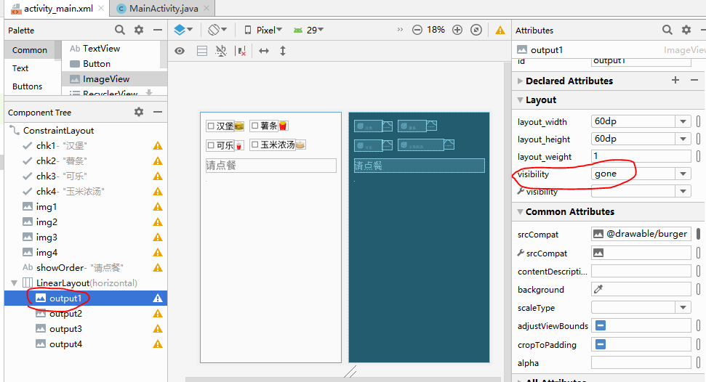

源码原理：
（CompoundButton是CheckBox的父类）
源码：
运行结果：
