**ListView列表显示点餐菜单：**

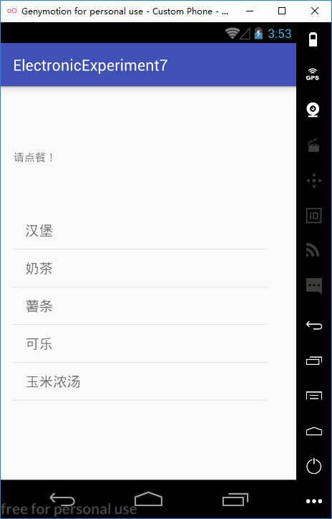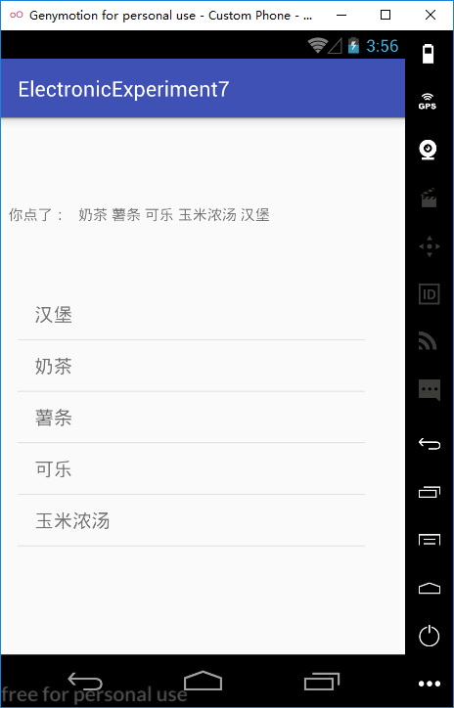

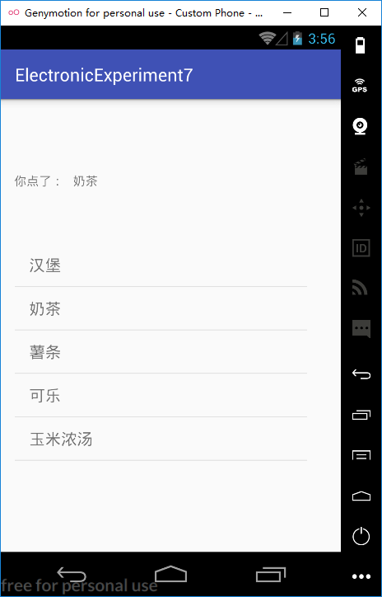

**strings.xml**

<resources>  
 <string name="app_name">ElectronicExperiment7</string>  
 <string name="txv">请点餐！</string>  
 <string-array name="menuItems">  
 <item>汉堡</item>  
 <item>奶茶</item>  
 <item>薯条</item>  
 <item>可乐</item>  
 <item>玉米浓汤</item>  
 </string-array>  
</resources>

**ListView的属性：**

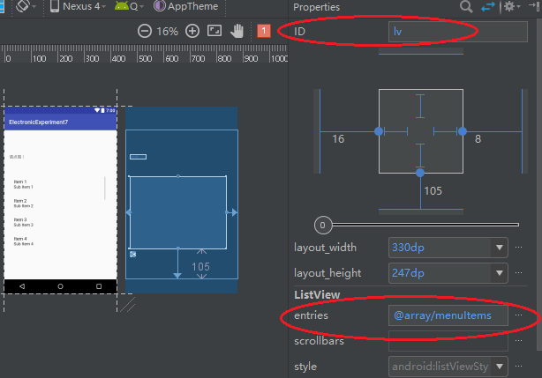

# 注释：listView无需适配器添加数据，ListView通过android:entries指定

**MainActivity.java**

**public class MainActivity extends AppCompatActivity implements AdapterView.OnItemClickListener {**

**@Override**

**protected void onCreate(Bundle savedInstanceState) {**

**super.onCreate(savedInstanceState);**

**setContentView(R.layout.activity_main);**

**ListView lv = (ListView) findViewById(R.id.lv);**

**lv.setOnItemClickListener(this);**

**}**

**ArrayList<String> selected = new ArrayList<>();**

**@Override**

**public void onItemClick(AdapterView<?> parent, View view, int position, long id){**

**TextView txv = (TextView) view;**

**String item = txv.getText().toString();**

**if(selected.contains(item))**

**selected.remove(item);**

**else**

**selected.add(item);**

**String msg;**

**if(selected.size()>0){**

**msg = "你点了： ";**

**for(String str:selected)**

**msg += " " + str;**

**}**

**else**

**msg = "请点餐！";**

**TextView msgTxv = (TextView) findViewById(R.id.txv_showorder);**

**msgTxv.setText(msg);**

**}**

**}**