**Spinner下拉菜单订票：**

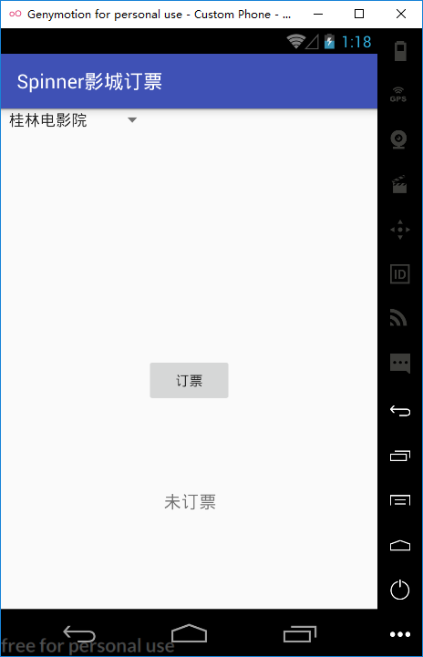

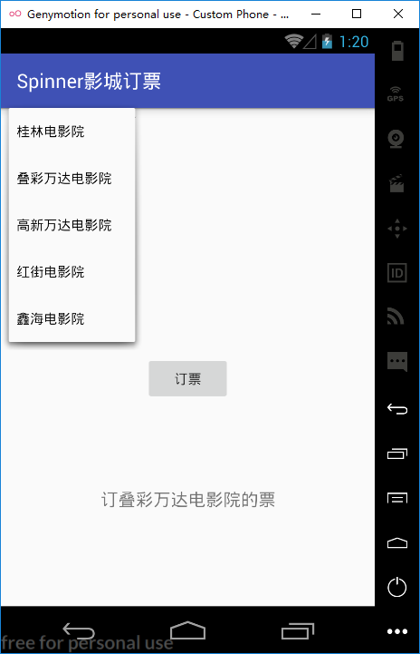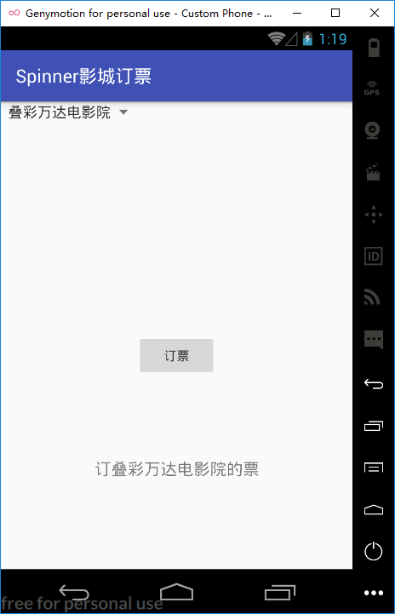

**Strings.xml文件：**

**<resources>**

**<string name="app_name">Spinner影城订票</string>**

**<string name="btn_booking">订票</string>**

**<string-array name="cinemas">**

**<item>桂林电影院</item>**

**<item>叠彩万达电影院</item>**

**<item>高新万达电影院</item>**

**<item>红街电影院</item>**

**<item>鑫海电影院</item>**

**</string-array>**

**<string name="txv">未订票</string>**

**</resources>**

**MainActivity.java文件：**

**public class MainActivity extends AppCompatActivity {**

**TextView txv;**

**Spinner cinema; // 戏院列表对象**

**@Override**

**protected void onCreate(Bundle savedInstanceState) {**

**super.onCreate(savedInstanceState);**

**setContentView(R.layout.activity_main);**

**txv = (TextView) findViewById(R.id.textView);**

**cinema = (Spinner) findViewById(R.id.cinema);**

**}**

**public void order(View v) {**

**String[] cinemas =**

**getResources(). getStringArray(R.array.cinemas);**

**// 获取字符串资源中的字符串数组**

**int index = cinema.getSelectedItemPosition(); // 获取被选取的项目**

**txv.setText("订" + cinemas[index] + "的票"); // 显示选取的项目**

**}**

**}**