**简单CheckBox展示。**

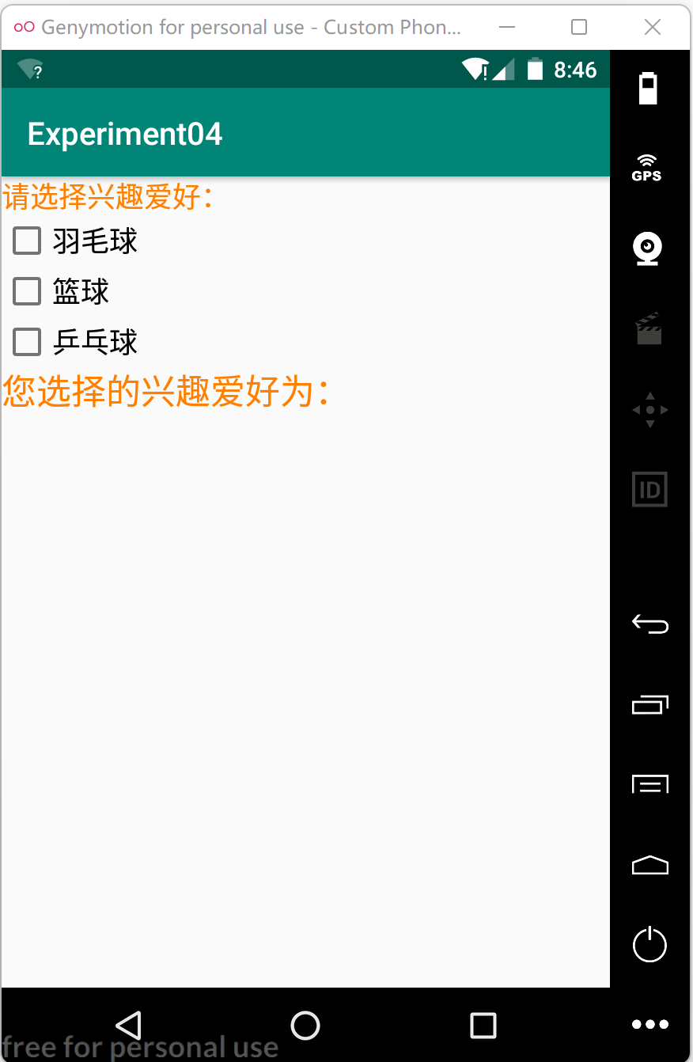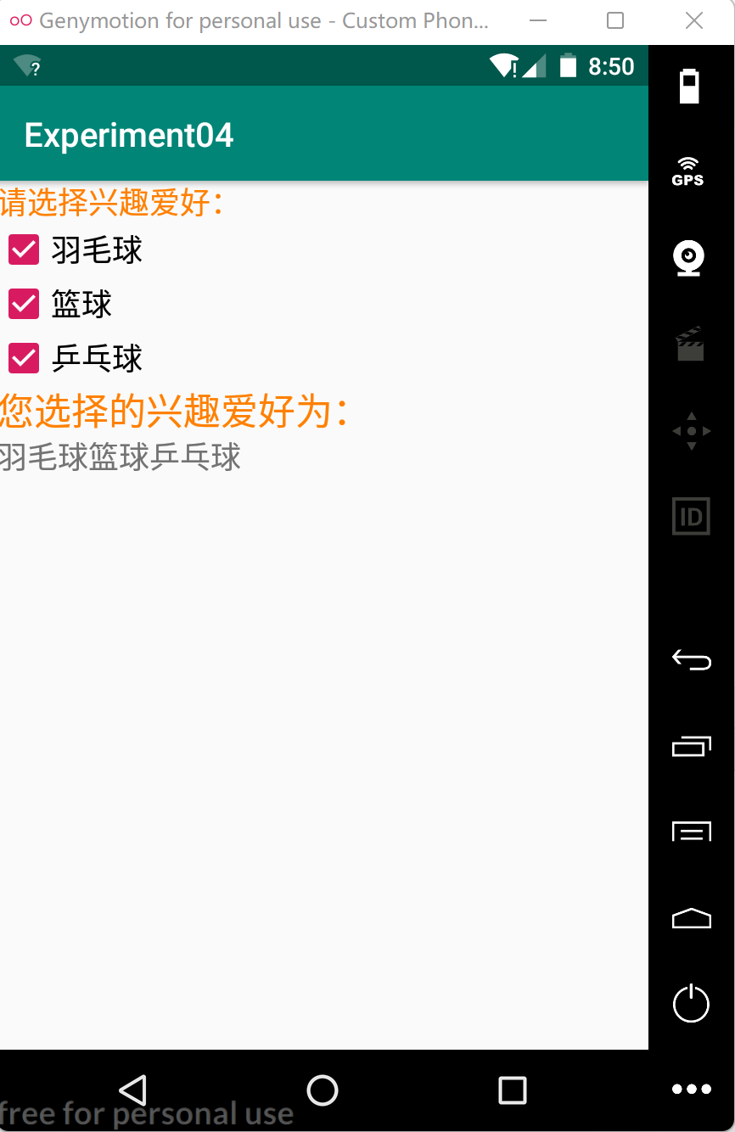

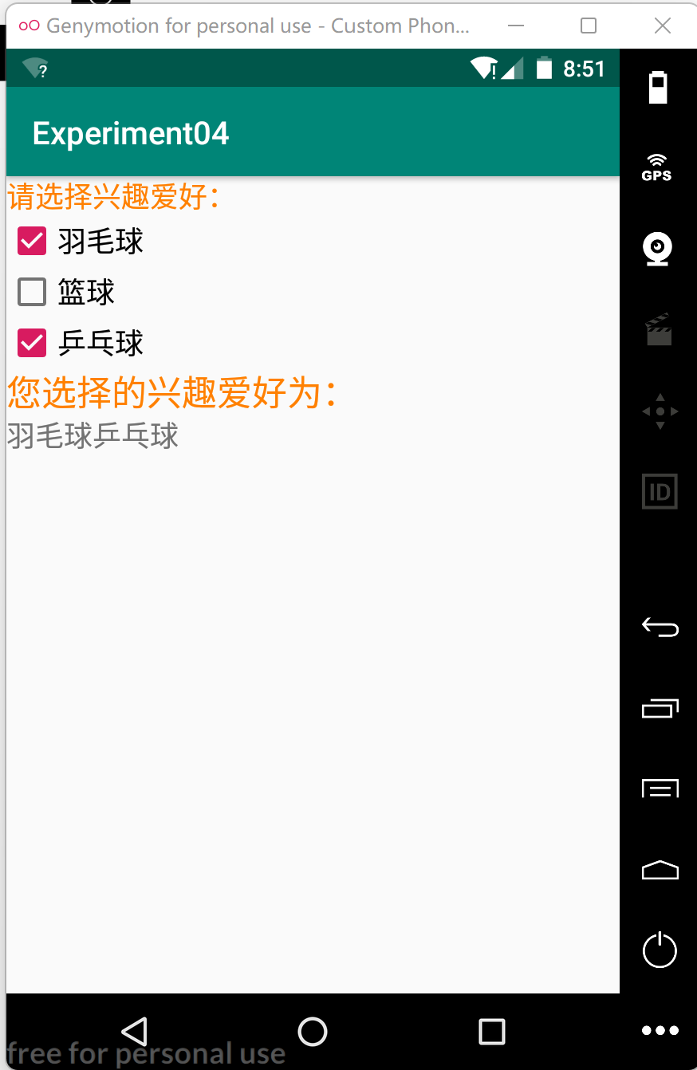

**activity_main.xml文件代码：**

*<?***xml version="1.0" encoding="utf-8"***?>*<**LinearLayout xmlns:android="http://schemas.android.com/apk/res/android"  
 xmlns:tools="http://schemas.android.com/tools"  
 android:layout_width="match_parent"  
 android:layout_height="match_parent"  
 tools:context=".MainActivity"  
 android:orientation="vertical"**>  
 <**TextView  
 android:layout_width="wrap_content"  
 android:layout_height="wrap_content"  
 android:text="请选择兴趣爱好："  
 android:textColor="#FF8000"  
 android:textSize="18sp"** />  
 <**CheckBox  
 android:id="@+id/like_shuttlecock"  
 android:layout_width="wrap_content"  
 android:layout_height="wrap_content"  
 android:text="羽毛球"  
 android:textSize="18sp"** />  
 <**CheckBox  
 android:id="@+id/like_basketball"  
 android:layout_width="wrap_content"  
 android:layout_height="wrap_content"  
 android:text="篮球"  
 android:textSize="18sp"** />  
 <**CheckBox  
 android:id="@+id/like_pingpong"  
 android:layout_width="wrap_content"  
 android:layout_height="wrap_content"  
 android:text="乒乓球"  
 android:textSize="18sp"** />  
 <**TextView  
 android:layout_width="wrap_content"  
 android:layout_height="wrap_content"  
 android:text="您选择的兴趣爱好为："  
 android:textColor="#FF8000"  
 android:textSize="22sp"** />  
 <**TextView  
 android:id="@+id/hobby"  
 android:layout_width="wrap_content"  
 android:layout_height="wrap_content"  
 android:textSize="18sp"** />  
</**LinearLayout**>

**MainAcitivity.java文件代码：**  
**package** com.example.experiment04;  
**import** android.os.Bundle;  
**import** android.widget.CheckBox;  
**import** android.widget.CompoundButton;  
**import** android.widget.TextView;  
**import** androidx.appcompat.app.AppCompatActivity;  
  
**public class** MainActivity **extends** AppCompatActivity **implements** CompoundButton.OnCheckedChangeListener {  
 **private** TextView **hobby**;  
 **private** String **hobbys**;  
 @Override  
 **protected void** onCreate(Bundle savedInstanceState) {  
 **super**.onCreate(savedInstanceState);  
 setContentView(R.layout.***activity_main***);  
 *//初始化CheckBox控件* CheckBox shuttlecock = findViewById(R.id.***like_shuttlecock***);  
 CheckBox basketball = findViewById(R.id.***like_basketball***);  
 CheckBox pingpong = findViewById(R.id.***like_pingpong***);  
 shuttlecock.setOnCheckedChangeListener(**this**);  
 basketball.setOnCheckedChangeListener(**this**);  
 pingpong.setOnCheckedChangeListener(**this**);  
 **hobby** = findViewById(R.id.***hobby***);  
 **hobbys** = **new** String();*//存放选中的CheckBox的文本信息* }  
 @Override  
 **public void** onCheckedChanged(CompoundButton buttonView, **boolean** isChecked) {  
 String motion = buttonView.getText().toString();  
 **if**(isChecked){  
 **if**(!**hobbys**.contains(motion)){  
 **hobbys** = **hobbys** + motion;  
 **hobby**.setText(**hobbys**);  
 }  
 }**else** {  
 **if** (**hobbys**.contains(motion)) {  
 **hobbys** = **hobbys**.replace(motion, **""**);  
 **hobby**.setText(**hobbys**);  
 }  
 }  
 }  
}