实验六要求：

实现登陆注册界面的类似功能，点击注册按钮向注册界面的跳转。图左为注册界面，当点击注册按钮时，执行startActivity(new Intent(this, *.class))指令，跳转到注册成功界面并显示注册相关信息，关闭注册成功界面时，在前一页返回及时消息Toast。

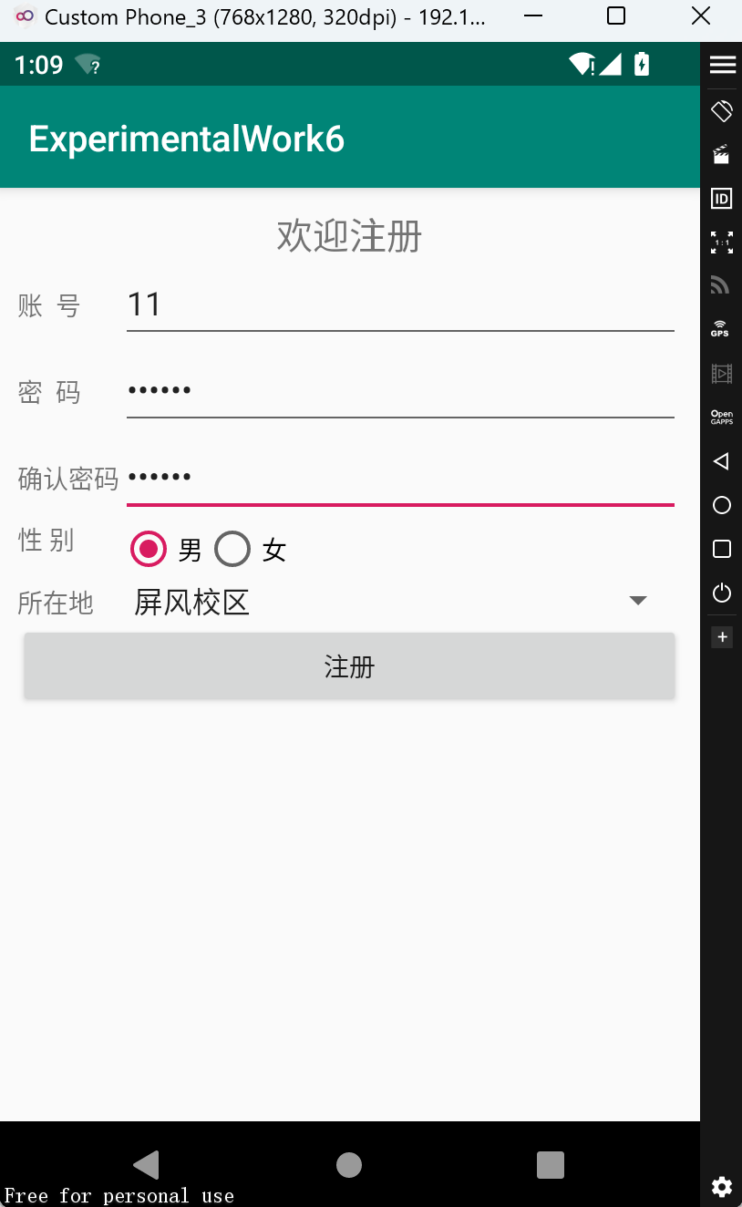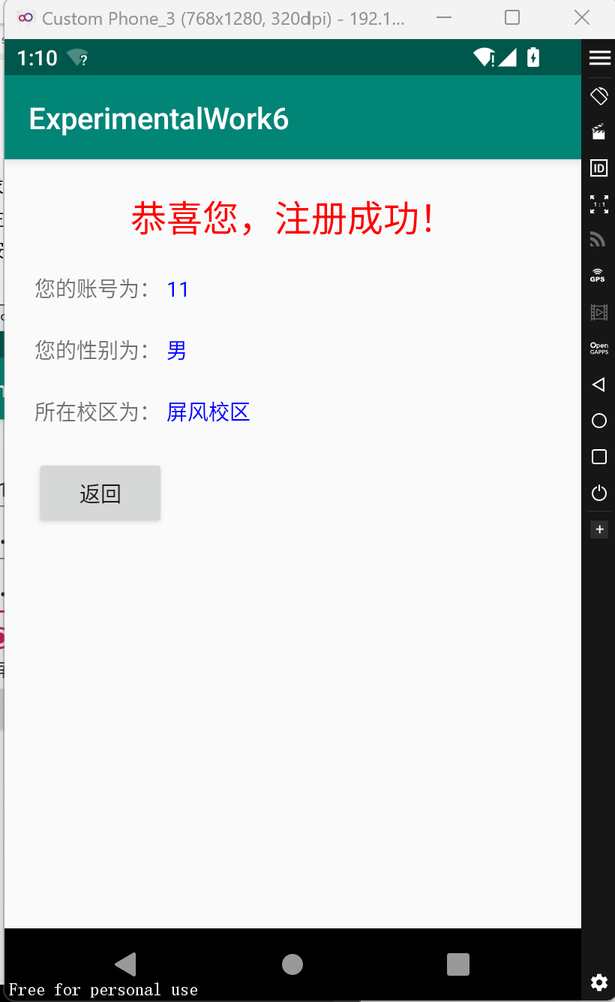

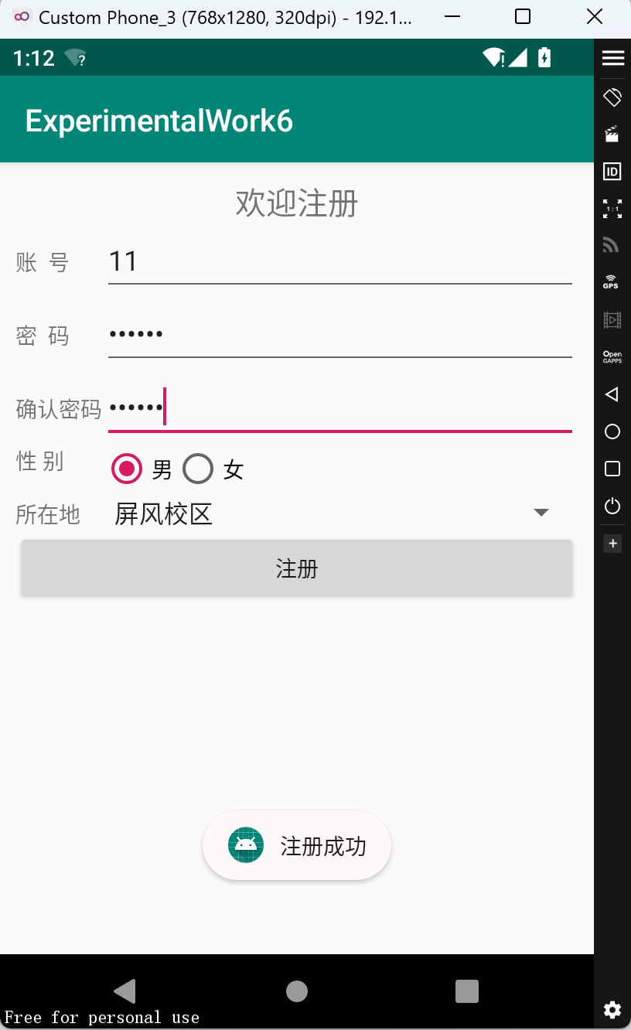

**源代码：**

**activity_main.xml文件：**

*<?***xml version="1.0" encoding="utf-8"***?>*<**TableLayout xmlns:android="http://schemas.android.com/apk/res/android"  
 xmlns:tools="http://schemas.android.com/tools"  
 android:layout_width="match_parent"  
 android:layout_height="match_parent"  
 android:padding="10dp"  
 android:stretchColumns="1"**>  
 <**TextView  
 android:gravity="center"  
 android:text="欢迎注册"  
 android:textSize="20sp"** />  
 <**TableRow**>  
 <**TextView android:text="账 号"** />  
 <**EditText  
 android:id="@+id/name"  
 android:hint="用户名不能为空"**/>  
 </**TableRow**>  
 <**TableRow**>  
 <**TextView android:text="密 码"** />  
 <**EditText  
 android:id="@+id/psd"  
 android:hint="6-15位之间"  
 android:inputType="textPassword"**/>  
 </**TableRow**>  
 <**TableRow**>  
 <**TextView android:text="确认密码"** />  
 <**EditText  
 android:id="@+id/repsd"  
 android:hint="两次密码必须一致"  
 android:inputType="textPassword"**/>  
 </**TableRow**>  
 <**TableRow**>  
 <**TextView android:text="性 别"** />  
 <**RadioGroup android:orientation="horizontal"**>  
 <**RadioButton  
 android:id="@+id/male"  
 android:layout_width="wrap_content"  
 android:layout_height="wrap_content"  
 android:checked="true"  
 android:text="男"** />  
 <**RadioButton  
 android:id="@+id/female"  
 android:layout_width="wrap_content"  
 android:layout_height="wrap_content"  
 android:text="女"** />  
 </**RadioGroup**>  
 </**TableRow**>  
 <**TableRow**>  
 <**TextView  
 android:id="@+id/location"  
 android:layout_width="wrap_content"  
 android:layout_height="wrap_content"  
 android:text="所在地"** />  
 <**Spinner  
 android:id="@+id/campusoption"  
 android:entries = "@array/campus_group"  
 android:layout_width="match_parent"  
 android:layout_height="wrap_content"** />  
 </**TableRow**>  
 <**Button  
 android:onClick="register"  
 android:text="注册"** />  
</**TableLayout**>

**ResultActivity.java文件：**

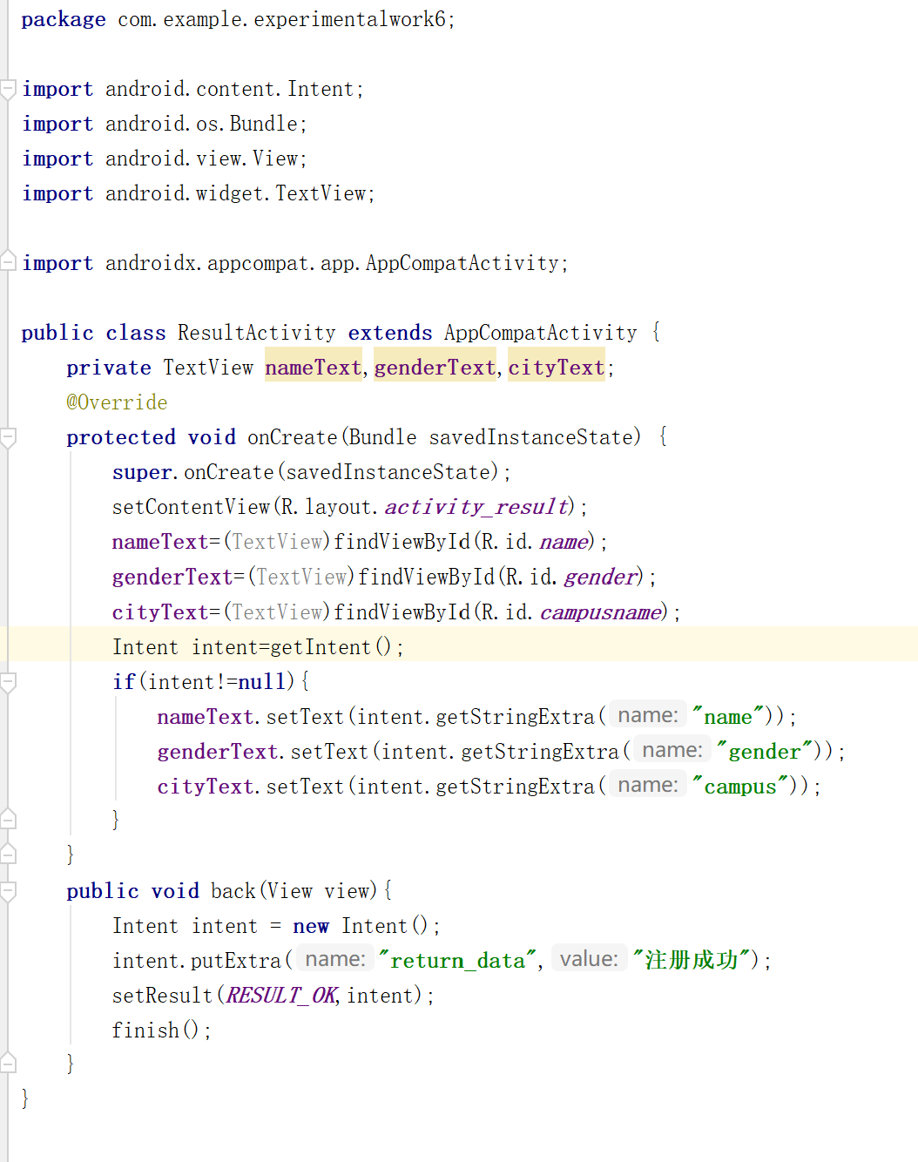

**MainActivity.java文件：**

**package** com.example.experimentalwork6;  
**import** android.app.AlertDialog;  
**import** android.content.Intent;  
**import** android.os.Bundle;  
**import** android.view.View;  
**import** android.widget.EditText;  
**import** android.widget.RadioButton;  
**import** android.widget.Spinner;  
**import** android.widget.Toast;  
**import** androidx.appcompat.app.AppCompatActivity;  
  
**public class** MainActivity **extends** AppCompatActivity {  
 **private** EditText **nameText**,**psdText**,**repsdText**;  
 **private** RadioButton **maleBtn**;  
 **private** Spinner **campusName**;  
 @Override  
 **protected void** onCreate(Bundle savedInstanceState) {  
 **super**.onCreate(savedInstanceState);  
 setContentView(R.layout.***activity_main***);  
 **nameText**=(EditText)findViewById(R.id.***name***);  
 **psdText**=(EditText)findViewById(R.id.***psd***);  
 **repsdText**=(EditText)findViewById(R.id.***repsd***);  
 **maleBtn**=(RadioButton)findViewById(R.id.***male***);  
 **campusName**=(Spinner)findViewById(R.id.***campusoption***);  
 }

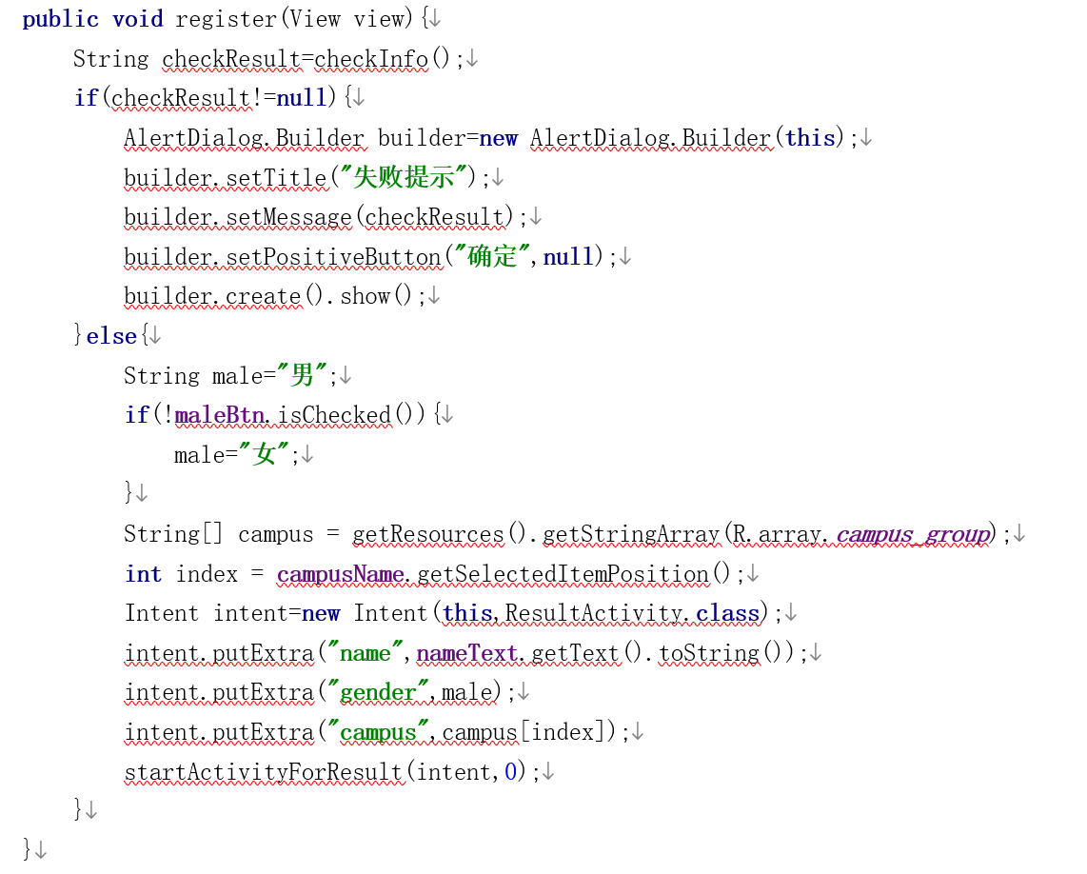  
 **public** String checkInfo(){  
 String name=**nameText**.getText().toString();  
 **if**(name==**null**||**""**.equals(name)){  
 **return "用户名不能为空！"**;  
 }  
 String psd=**psdText**.getText().toString();  
 **if**(psd.length()<6||psd.length()>15){  
 **return "密码位数应在6-15位之间"**;  
 }  
 String repsd=**repsdText**.getText().toString();  
 **if**(!psd.equals(repsd)){  
 **return "两次密码必须一致"**;  
 }  
 **return null**;  
 }  
 @Override  
 **protected void** onActivityResult(**int** requestCode, **int** resultCode, Intent data) {  
 **switch** (requestCode){  
 **case** 0:  
 **if**(data!=**null**){  
 **if**(resultCode==***RESULT_OK***){  
 Toast.*makeText*(**this**,data.getStringExtra(**"return_data"**),Toast.***LENGTH_LONG***).show();  
 }  
 }  
 **break**;  
 **default**:  
 }  
 }  
}

**AndroidManifest.xml文件：**

