Extra virgin olive oil

Our special extra virgin olive oil comes from sunny orchards where olives grow. It's made by pressing the olives without using heat, keeping all the good flavors in. You can use it for making salads tastier, dipping bread, or adding a healthy richness to your cooking. our extra virgin olive oil elevates every meal with its exquisite taste and healthful benefits. Get our extra virgin olive oil and enjoy a delicious meal.

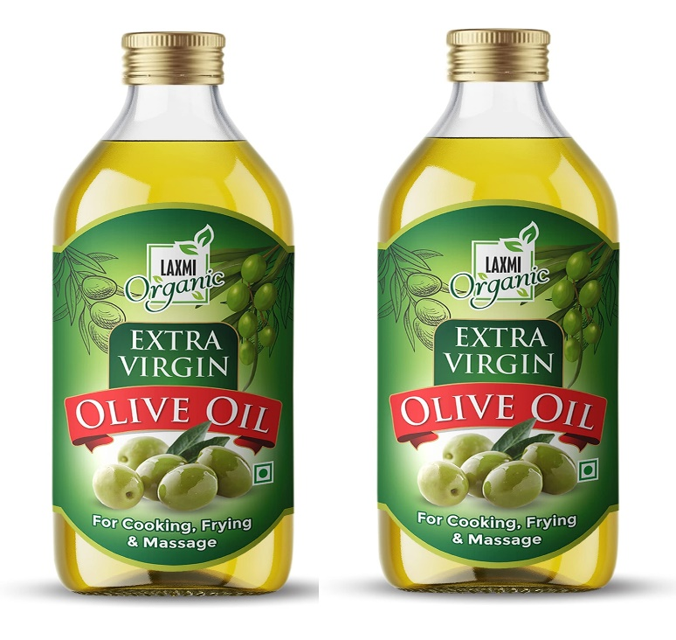

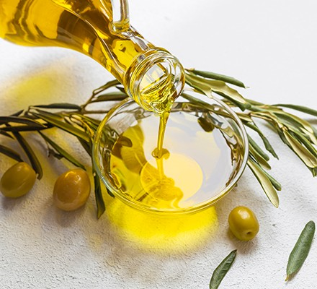

Exotic mango

Our exotic mangoes with a yummy honey like taste are super juicy and has a vibrant sweet flavor. Each mango is picked after its perfectly ripe, so it has a delicious taste. You can eat them just by slicing them up, blend them into smoothies or add them to salads to make them sweeter. These exotic mangoes are not just fruits; they're an embodiment of pure, unadulterated indulgence.

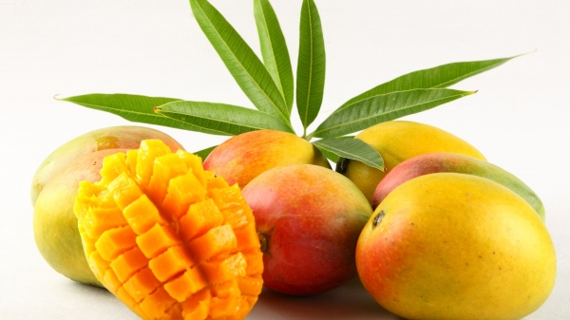

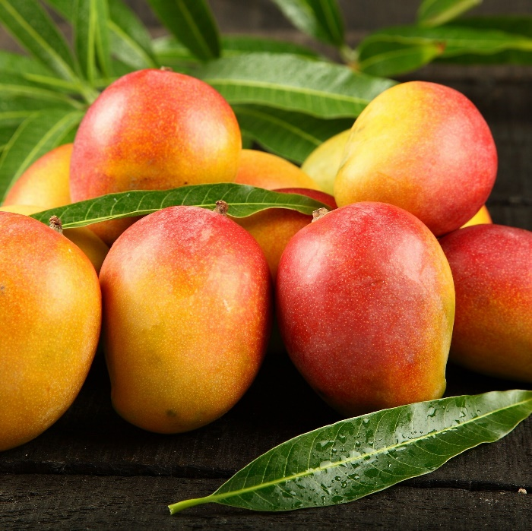

Organic baby spinach

Introducing our organic baby spinach which is really pure and fresh is super healthy and full of good stuff that helps you stay energetic and healthy. It is grown with sustainable farming, without chemicals and harmful pesticides and full of vitamins like A C and K and minerals such as iron and calcium. You can put it in salads, blend it into smoothies or cook it lightly in a pan and make your food nutritious.

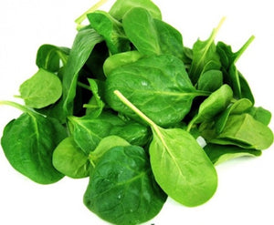

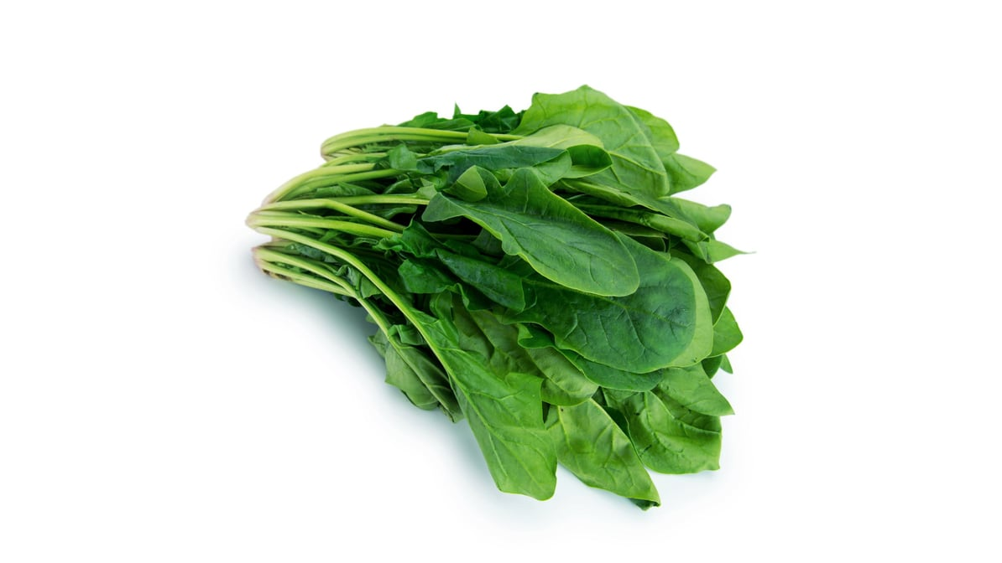

Exotic Dragon fruit

Try our exotic dragon fruit that tastes sweet and a bit like flowers, which makes it different from other fruits. You can eat it cold and sliced, mix it into smoothies, blend it into your favorite smoothie recipes or add it to fruit salads. The specialty of this fruit is Its unique color, taste and appearance create a feast for both eye and tongue.

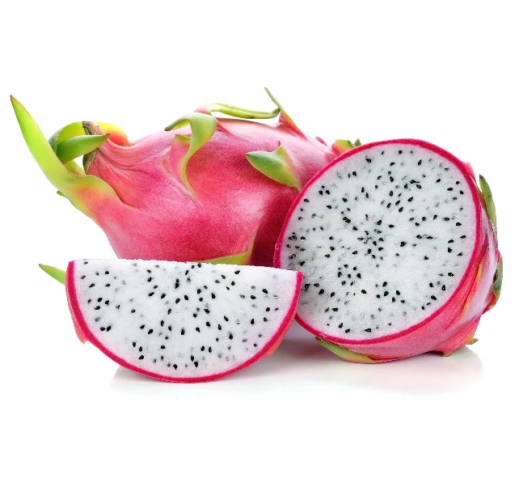

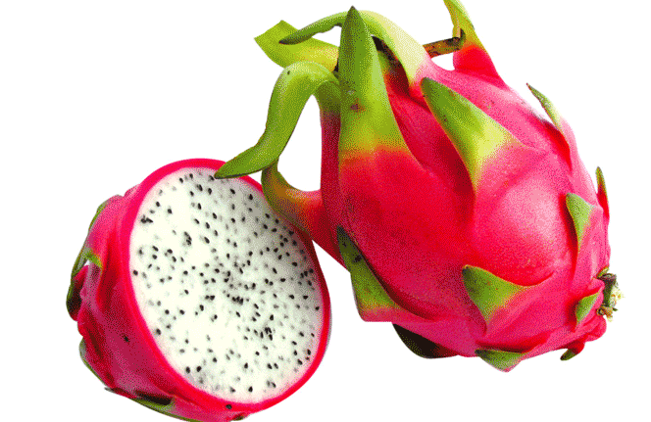

Organic Tomatoes

Introducing our special organic tomatoes grown without any chemicals or harmful pesticides which is super fresh and healthy. These tomatoes are super versatile as You can make yummy sauces, toss them in salads, or put them on your favorite dishes and These tomatoes are super versatile. offering not only a burst of flavor but also an array of health benefits.

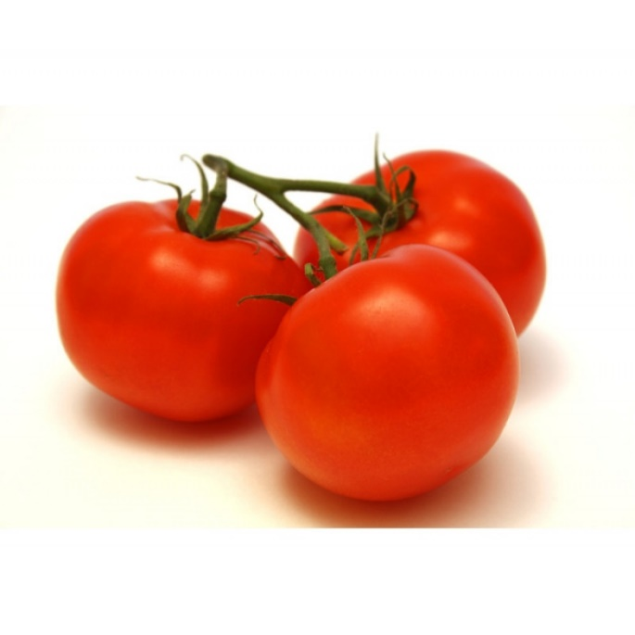

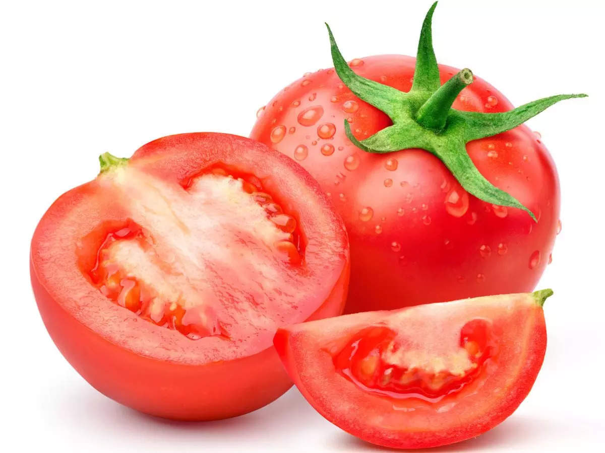

Organic Bell Peppers

Taste our super fresh organic bell peppers grown without chemicals and any other harmful pesticides. You can chop them for salads, stuff and bake them, or cook them in a pan for yummy fajitas. You can get them in colors like red, green and yellow. They are packed with vitamins and nutrients and these organic bell peppers make your meals tastier and healthy.

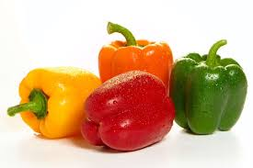

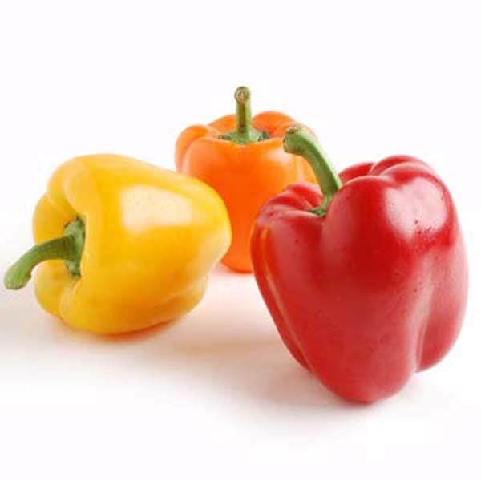

Organic Beet

Try our organic beet Grown naturally and free from any harmful chemicals. You can cook them by roasting for a sweet flavor, chop them up for salads, or even blend them into smoothies. They’ll make your meal healthy as they are rich in vitamins and minerals like iron, fiber, manganese, potassium, vitamin B9 and vitamin C

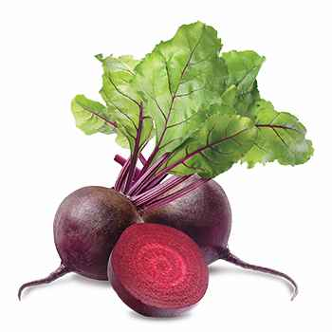

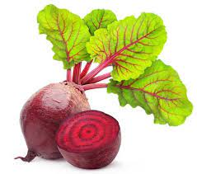

Green Beans

Try our green beans which are really crispy and come straight from our farms without any harmful chemicals. You can steam them gently for a simple and tasty side dish that keeps their crunchiness, fry them with your favorite spices and can include them in salads too. They're full of vitamins like vitamin A, C, K, iron, calcium and folate that make your meals healthy.

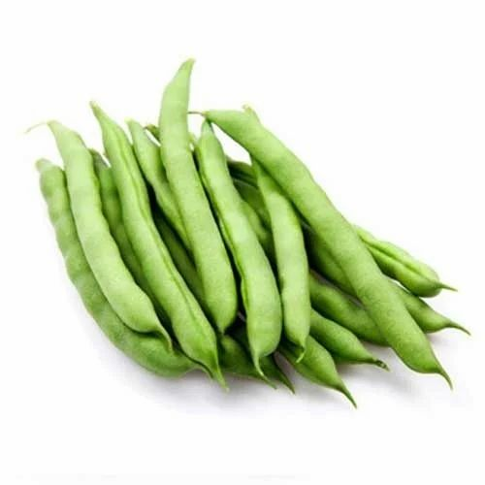

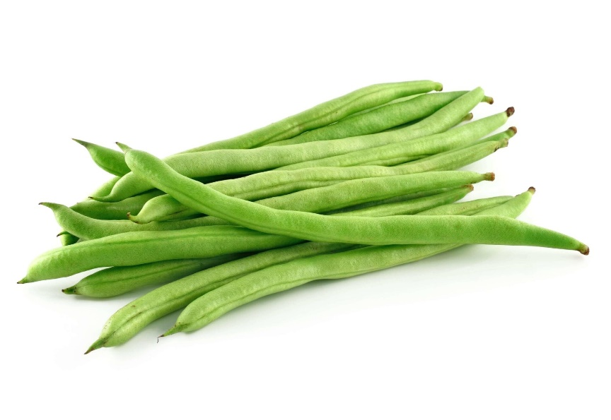

Organic Carrots

Try our organic carrots which comes in different colors and naturally grown without harmful chemicals. You can eat these carrots which are super yummy by munching on them for a crunchy snack, cook them in the oven for a sweet taste or shred them into salads. They are rich in vitamins and minerals like vitamin B and B6.

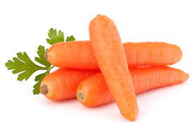

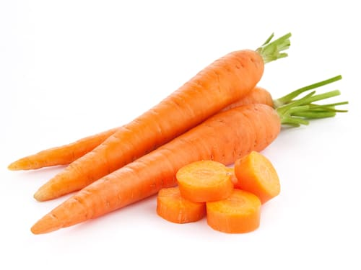

Organic Red Grapes

Try our organic red grapes which are deep red in color and really sweet in taste. They are grown without any chemicals or harmful pesticides. They are rich in vitamins like vitamin K and copper. You can eat them right off the bunch for a tasty snack or add them to fruit salads for extra sweetness and beauty.

