Requirements for Switzerland GUI

API

Notes for all API definitions
The calls that get data should return data in a structured format such as XML, JSON, or delimited. (If it's web.py code making these API calls, it might make more sense for the return types to be python data structures. Then the web.py code can produce web 1.0 type output for the browser. If certain features seem to work much better in javascript, we should look at ways to efficiently transform the output )
NOTE: We could do a global search-and-replace from all instances of the word “ Alice” to “Client”

ClientConfig()
Parameters:
none
Returns:
Returns an xAliceConfig object, which contains the following:
- tweakable_options : a list of config options which can be changed at any time
- immutable_options : a list of config options which require a connection restart in order to be changed
  - each option is a tuple of (name, type), where name is a string and type is one of:

str | int | float | ”IP” | ”hostname” | “path” | bool | portno

Question is that the right form for type?

- set_option(option_name, value) : set the new value for option_name
  - May raise:
    - TypeError – if value is the wrong type for this option
    - AliceAPI.ConfigError – if value failed some other reuirement, such as a directory path which neither exists nor is creatable
    - KeyError – if option_name is not a valid variable
- get_option(option_name) : can we also get away with just referring to the .option_name attribute of the xAliceConfig object? Probably...

connectServer(xAlice_config)
Parameters:
an xAliceConfig object as returned by APIAliceConfigxAliceConfig()
Returns:
An xAlice object

xAlice objects have the following methods:

.disconnect() disconnect from the server

.get_server_info() returns a dictionary of server information entries, including at least the following entries:
“hostname” : may be an ip address
“ip” : definitely an ip address
“connection time” : seconds
“message count” : a tuple of (sent, received)
“last message” : seconds since last communication

.get_client_info() returns a dictionary of client status information, including at least the following entries:
“public ip”
“private ip”
“network interface”
“ntp method”
“clock dispersion” (estimated clock accuracy)

.get_peers() returns a list of xPeer objects (based on switzerland.client.FlowManger.Peer, but also with flow-related attributes?)

xPeer objects have the following attributes:
- firewalled : True if the xPeer is connected from behind a NAT firewall (note: this should be a constant; if a xPeer disconnects and then reconnects, such that this might change, there should be a new xPeer object).
- traceroute(): return a string representing the route that our packets take to this xPeer
- active_flows() : return a list of xFlow objects
- old_flows(): return a list of xFlow objects

Important question: if a flow becomes inactive (no packets for x amount of time) is a new flow object created, or does the old one spring back to life?

xFlow objects will have the following attributes:

- flow_tuple: (source_ip, source_port, dest_ip, dest_port, protocol) – specify which binary format this will use... probably best to make it as human readable as possible (eg, ips are “1.2.13.214” rather than 4 bytes, and the protocol is “tcp” rather than a protocol number if we succeeded in looking it up)
- These methods do not have a “since time t” parameter, since it seems more efficient to calculate these as deltas
  - get_new_packet_count(): returns total packets sent/recd (at our end) since the last call to this function
  - get_new_byte_count(): returns total bytes sent/recd since the last call to this function
- get_pair(): returns another flow object in the opposite direction, or None if there isn't one
- maybe query_packet(hash) : return the raw packet(s) from this flow which had a particular hash
- is_active(): returns true or false
- get_new_dropped(): returns a list of (timestamp, packet) for packets that have been identified as dropped since the last call to this function.
- get_new_injected(): returns a list of (timestamp, packet) for packet that have been identified as spoofed/injected/forged since the last call to this function
- get_new_modified(): returns a list of (sent, recd, delta) for packets that appear to have been modified since the last call to this function

Packets have the following attributes:

getPacketInfo(packetID)
Parameters:
packetID is a unique packet identifier

Returns:
Structured data (XML, JSON, delimited?) consisting of
Actual pcap output
Summary data
Target IP ID
Target TCP seq
List of modifications
Modification field
Original value
Modified value

GUI

Notes
GUI is currently planned to be written in python with web.py.

Summary status screen.
This screen is updated periodically (every second? every 5 seconds?) with incoming data. The graph is updated and the list of peers is updated. The user can start and stop the client from this screen.
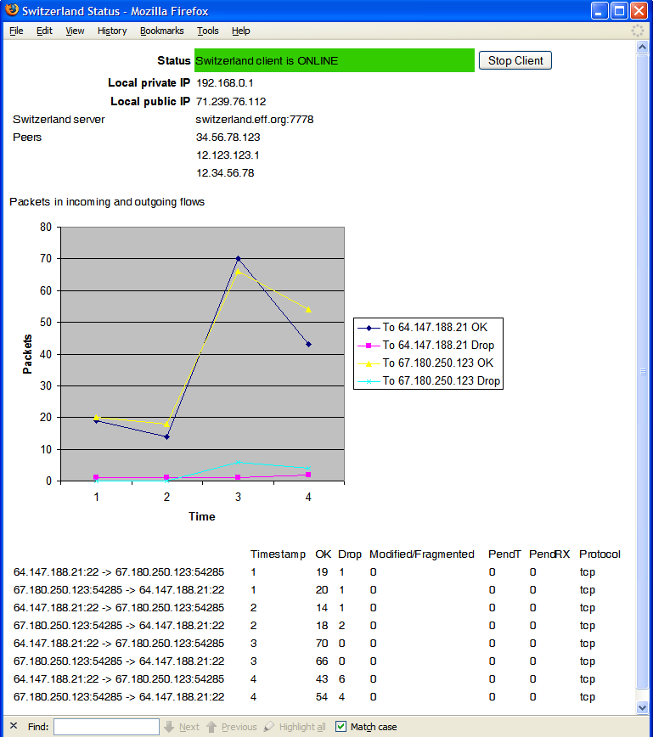

Packet Detail Screen
The user might be able to get to a packet detail screen by clicking on the numbers in the Summary Screen columns that say “dropped” or “modified” packets.
