**THE HIPP CHRONOSCOPE1**

*Dr. Thomas Schraven*

Krefeld (Germany)

TABLE OF CONTENTS

1. A FEW WORDS AT THE BEGINNING 2
2. THE YEARS 1840-1859: HIPP IN REUTLINGEN AND BERN 3
3. THE YEARS 1860-1875: HIPP IN NEUCHÂTEL 13
4. THE YEARS 1875-1889: HIPP’S IMPROVED CHRONOSCOPE 18
5. THE YEARS 1889-1908: PEYER AND FAVARGER 24
6. THE YEARS 1908-1927: FAVARGER & CIE 27
7. THE YEARS 1927-CA. 1975: FAVAG 29
8. THE HIPP STYLE CHRONOSCOPE MADE BY OTHERS 34
9. SUMMARY 44
10. HEARTLY THANKS TO... 47
11. LITERATURE 48

1 This paper is based on a talk given at a meeting of the Electrical Group of the Antiquarian Horological Society at the Science Museum, London, on November 23, 2003.

1. A FEW WORDS AT THE BEGINNING

To *protect* all the old chronoscopes mentioned in my report, the information about the location has been shortened to a minimum in most cases. All scientists, psychologists, historians, and other persons who wish more detailled information for their research should get in touch with Rand Evans, Henning Schmidgen, or myself.

This was my first research with help of the Internet [141]. I would even say that it was possible with support of the Internet only. After a short time I recognized that the Hipp chronoscope is well known, but the knowledge about its development and history is more fragmentary. Only a handful of scientists in the field of psychology and history of science are familiar with this instrument. I want to refer to the excellent works of Rand Evans [48, 49], Andrea Gaeta [66], Horst Gundlach [75, 76, 77], and Henning Schmidgen [137].

After two years my research has spanned the globe like a net of a spider. I have found helpful hands all over the world. Over the last three years, almost 400 mails came in from Australia, America, Canada, Japan, and Europe. Kind persons have patiently answered my questions and added new pieces to the never-ending chronoscope jigsawpuzzle.

This has made it possible to register 102 chronoscopes of the Hipp style. I would like to thank all nice persons who have given me friendly support. I want to express my special gratitude to a couple of scientists who have given friendship and help and encouraged me not to give up and to finish this research:

David Baker Akron, Archives of the History of American Psychology Paolo Brenni Florence, Institute for the History of Science

Rand Evans Greenville, East Carolina University, Department of

Psychology

Horst Gundlach Passau, University, Institute for the History of Psychology Hans Jochen Kummer Ludwigshafen

Tom Perera Montclair, retired now

Ute Saccardi Stuttgart, Library of Stuttgart

Henning Schmidgen Berlin, Max Planck Institute for the History of Science,

Berlin

Steven Turner Washington DC, Smithonian Institute

My friend Rand Evans has corrected this paper. I would like to thank him very much for his friendly support. My friend Henning Schmidgen has prepared the Internet presentation of this paper. I would like to thank him for his help and assistance. He has accompanied my research since our first contact in 2000.

1. THE YEARS 1840-1859: HIPP IN REUTLINGEN AND BERN

A suitable starting point for the historical investigation of Hipp’s chronoscope is a paper written by Robert Weber. Like Matthäus Hipp, Weber lived in Neuchâtel. He worked for the Institute for Physics at the Academy of Neuchâtel. After Hipp’s death he published an obituary plus an addition in the *Elektrotechnische Zeitschrift* of 1893 [169].

His text contains lots of very private details from Hipp’s life and work. I assume that Weber was personally acquainted with Hipp. The Weber publication was the base for all later papers dealing with the clockmaker Hipp [05, 06,17].

In Weber’s biography you’ll find a few details on the development of the chronoscope. Weber says that Professor Wilhelm Eisenlohr (1799-1872) purchased a chronoscope from the well known English physicist Charles Wheatstone (1802-1875). Eisenlohr worked as a teacher for mathematics and physics at the high school of Karlsruhe and simultaneous as a teacher for physics at the Polytechnic School [157]. Eisenlohr was a dedicated scientist and had close contacts to other scientists like Faraday, Tyndall, and Liebig [166, 167].

Eisenlohr was very interested in horology and designed the German cuckoo clock.

Eisenlohr made several journeys to England. It is probable that he returned with the Wheatstone chronoscope from one of these journeys. Wheatstone developed his chronoscope to measure the velocity of projectiles [171].

There is not much information about the Wheatstone chronoscope. However, a short description was published in Eisenlohr’s text book [45]:

“The main part of the Wheatstone chronoscope is a horizontal cylinder with a rope and a weight. This cylinder has a thread which moves a small wheel and the clockwork, which moves the hand with high velocity after the electric current is closed. An electromagnet stops movement and hands. This allows the exact measurement of 1/100 sec”.

Eisenlohr tried to prove Newton’s Law of falling bodies with help of this chronoscope:

s=1/2 g t2

[s = falling height, g = gravity 9.81 m/sec2 , t = falling time]

Eisenlohr measured the time it took for a metal ball to fall from a precisely given height. The comparison of the measured time with the theoretical time showed the success of this method, but Eisenlohr’s measurements did not agree with the formula.

An explanation is easy. The Wheatstone chronsocope has a mechanical movement driven by a weight. After you close the electric contact clockwork and recording dial are started. The mechanical movement has its own inertia and needs a certain time to reach a constant velocity. This means that the acceleration of the movement is part of the time measurement: for a proper measurement you need a velocity of the movement which is constant.

Let’s travel to Reutlingen in Germany now. After his apprenticeship a clockmaker named Matthäus Hipp (1813-1893) took up residence in this town. In July 1840, he opened a

clockmaking shop. During a very short time Mr. Hipp’s ingenious inventions in the field of clockmaking and the application of electricity became known to the scientific world.

Prof. Kahlert has published a detailed description of Hipp’s live and work [92, 93]

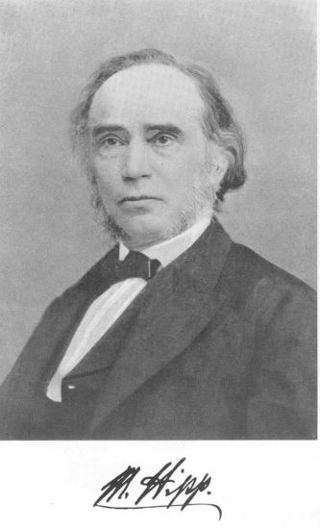

*Figure 2:* Matthäus Hipp [94]

Purely by chance Hipp travelled to Karlsruhe near by to visit Eisenlohr. During this visit Hipp was able to see and to examine the chronoscope made by Wheatstone. Hipp discovered the source of the problem. Shortly after he created his own chronoscope based on Wheatsone’s ideas.

This new chronoscope was tested in the same experiment and the results were impressive. The difference between measured and calculated time was only a few hundredths of a second and Newton’s law was verified by experiment [121].

My attempt to find traces to this early Hipp chronoscope in the old inventory lists (1840- 1867) of the University of Karlsruhe was not successful. Neither the Hipp chronoscope nor the Wheatsone chronoscope are listed.

Weber’s publication gives the information that Hipp sold his first instrument to Professor Eduard Reusch (1821-1891). Reusch worked as a teacher at the University of Stuttgart [162] and bought several chronoscopes from Hipp. To buy the improved one, Reusch sold the older one.

We have to answer the question: “when did Hipp develop his first chronoscope?” The date given in Weber’s biography is not very exact.

You’ll find an answer in the article “The Wheatstone Hipp chronoscope, its adjustments, accuracy and control” published by the English psychologists Edgell and Symes in 1906 [43]. This report says that Eisenlohr got the chronoscope from Wheatstone in 1842 and Hipp sold

his first instrument in 1843. Edgell and Symes declared that these data have been specified by Hipp’s successors Peyer, Favarger & Cie. I have my doubts about this statement.

Eisenlohr published eleven editions of his *Lehrbuch der Physik zum Gebrauche bei Vorlesungen und zum Selbstunterrichte*. The 4th edition of 1844 [47] does not mention a chronoscope. The 5th edition of 1849 [46] gives a short description of Wheatstone’s chronoscope only and the Hipp chronoscope appears in the later editions of 1852 [45] and 1869 [44]. If Eisenlohr knew of Hipp’s chronoscope in 1843 he would have published it in the 4th or 5th edition.

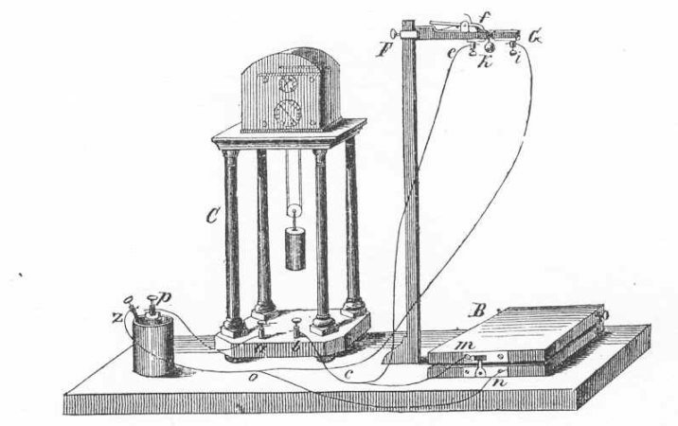

*Figure 2:* Chronoscope in Eisenlohr’s physics text book (6th ed., 1852) [45]

Another argument is that the knowledge about such an important instrument like the Hipp chronoscope would have left traces in the scientific literature of the time. But the first written details about the Hipp chronoscope were published five years later, in 1848.

The author of this 1848 article [121] was Wilhelm Oelschläger (1816-1901) from Reutlingen. From 1849 to 1863 Oelschläger was the headmaster of the high school. He also had a special interest in clocks and clockmaking. His horological interests brought him together with the clockmaker Hipp who lived in the same town. During his free time Oelschläger created his own clocks. Mentioned is a high precision pendulum clock which Oelschläger made for the examination of earthquakes at the school of Reutlingen [14, 15, 62].

Oelschlägers article “Das Wheatstonsche Chronoskop verbessert vom Uhrmacher Hipp in Reutlingen” very briefly describes the Wheatstone chronoscope and quotes the incorrect results of shorttime measurement. Subsequently the Hipp chronoscope is introduced, followed by a report about the exact results of time measurement.

I have found other historical traces to the early days of the Hipp chronoscope. An extraordinary event was the discovery of a chronoscope signed “Hipp in Reutlingen.” In early 1849, this instrument was delivered to the Physical Institute of Utrecht University (Netherlands). Along with the instrument are a handwritten letter with instructions and a drop apparatus for the control and adjustment of the chronoscope [85].

The letter is dated the March 5, 1849. The signature says “M. Hipp, mechanic,” not ‘clockmaker.’

Hipp’s letter gives information about the battery needed. It also says that the chronoscope is able to measure the 500th part of a sec. In addition, Hipp offers a description of how to use the levers when starting and stopping the clock. He underscores that before starting the measurment the clock movement should run for a few seconds. He then adds some results of tests concerning the gravity law he had conducted with Oelschläger. The letter lists the times for three different heights of fall. At the end, Hipp asks the customer to recommend the chronoscope and to pay to a bank in Frankfurt.

This early chronoscope located in Utrecht is extraordinary and very important. It is the oldest known Hipp chronoscope today.

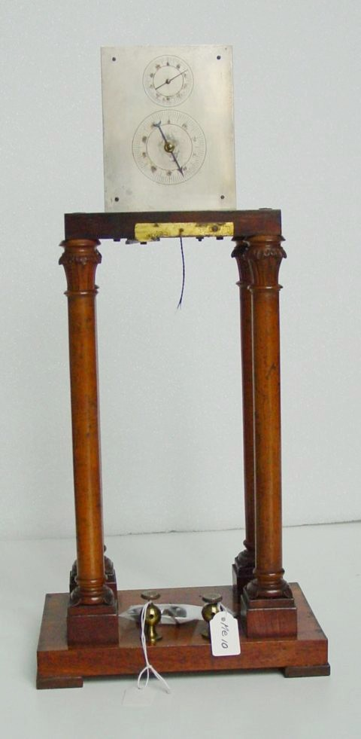

*Figure 3 (a):* Chronoscope signed “M. Hipp in Reutlingen” (1849) Utrecht University Museum, Inventory No. ME-30 (Photograph by Jan Deimann)

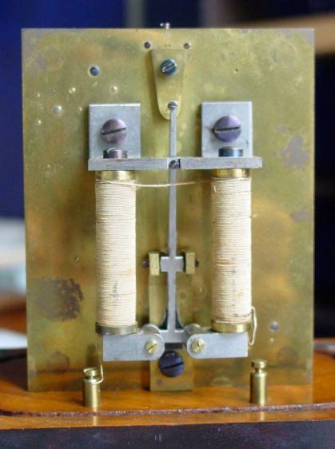

*Figure 3 (b):* Chronoscope (clockwork: backside) signed “M. Hipp in Reutlingen” (1849) Utrecht University Museum, Inventory No. ME-30 (Photograph by Jan Deimann)

In the late 1840s and early 1850s, there was a major interest in scientific questions and experiments and instruments were demonstrated to the public in special scientific shows. Hipp wished to impart knowledge in natural science to the public and he arranged special lectures in the “Reutlinger Leseverein.” This periodical event took place in Reutlingen from 1847 onwards [13]. Written papers of these lectures do not exist, but I assume that Hipp demonstrated his chronoscope during these lessons, too.

I was able to prove the assumption that these scientific events left traces in the local newspapers. In the *Schwäbische Kronik* of October 1849 [07] I found a note saying that the mechanic and clockmaker Matthäus Hipp made very interesting experiments with a new chronoscope in Reutlingen. The new instrument allows the registration of milliseconds. During this experiments the time of a dropped ball and the velocity of projectiles was measured with high accuracy.

These results were the occasion for Hipp’s friend Oelschläger to publish a second article about the chronoscope in 1849 [22, 120, 122]. In “Das Hippsche Chronoskop zur Messung der Fallzeit eines Körpers und zu Versuchen über die Geschwindigkeit der Flintenkugeln” Oelschläger gives a detailed description of the chronoscope. He mentions that Hipp improved his first chronoscope and describes an additional instrument, a drop apparatus for the control and adjustment of the chronoscope.

|  |  |  |  |
| --- | --- | --- | --- |
| **Chronoscope** | Wheatstone | Hipp | Hipp |
| Oelschläger | 1848 | 1848 | 1849 |
| price in Florins | 144.- | 66.- | 88.- incl. drop apparatus [139] |
| measurement in sec | 1/100 | 1/500 | 1/1000 |

According to Oelschläger, Hipp delivered chronoscopes allowing for exact time measurement and at the same being less expensive than the Wheatstone chronoscope.

A detailed explanation of the instrument will follow later, but I want to reproduce here the drawings published by Oelschläger in 1849:

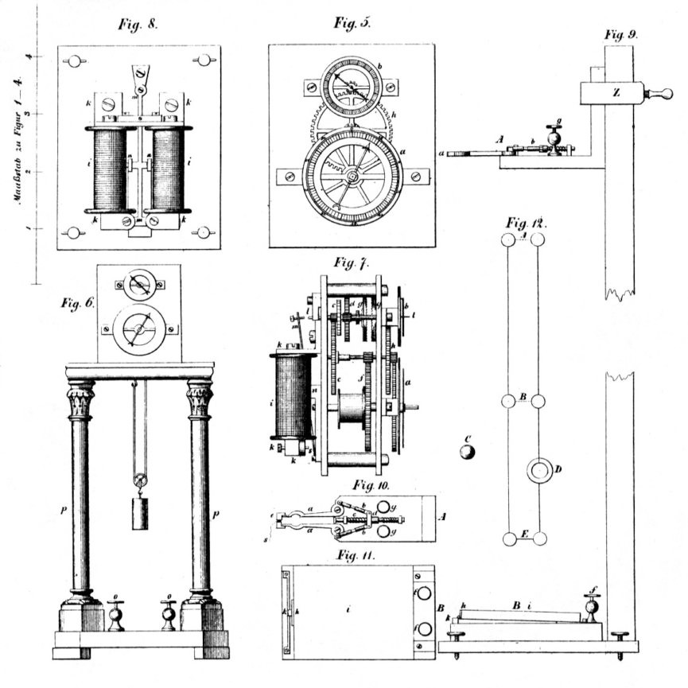

*Figure 4:* Construction of the Hipp Chronoscope, Oelschläger 1849 [120]

Two years later, in 1851, Hipp made a journey through Germany and Austria for a public presentation of his new instruments, a telegraph and the new chronoscope. Hipp visited Vienna, Munich and Regensburg. Hipp’s demonstration was announced in the *Regensburger Tageblatt* of September 9, 1851 [11].

“On Friday the 26. September 1851 Mr. M. Hipp from Reutlingen will demonstrate and explain his electromagnetic telegraph and his chronoscope, the newest invention, in the lecture hall of the royal high school door 72. The chronoscope indicates the velocity of a falling ball or shot bullets with the accuracy of 1000 parts of the second. In addition, electricity will be demonstrated as used for medicine and the explanation of the instruments.

These instruments, shown in a few towns (Munich and Vienna) only, have met with a great approval and will be of special interest for the ladies too. The admission fee is 12 Kr. One half of the proceeds will be used for charity”.

Three days later a detailed report about Hipp’s scientific show was published in the same newspaper [10, 12]. The accuracy of the measurements was praised. Of special interest is the statement that Hipp sold chronoscopes to physical institutes in England, Scotland, Germany, and Switzerland.

Hipp’s telegraph met with great approval too. On September 18, 1851, Carl August Steinheil honoured Hipp’s telegraph in Vienna. On Steinheil’s recommendation Hipp was appointed as the leader of the Telegraph works of Switzerland in Bern. In 1852, Hipp left Reutlingen and became civil servant in Switzerland (March 23, 1852).

The chronoscope presented by Hipp in Regensburg was a modification of the instrument described in Oelschlägers article. Today, a chronoscope showing this modification is located at the University of Heidelberg:

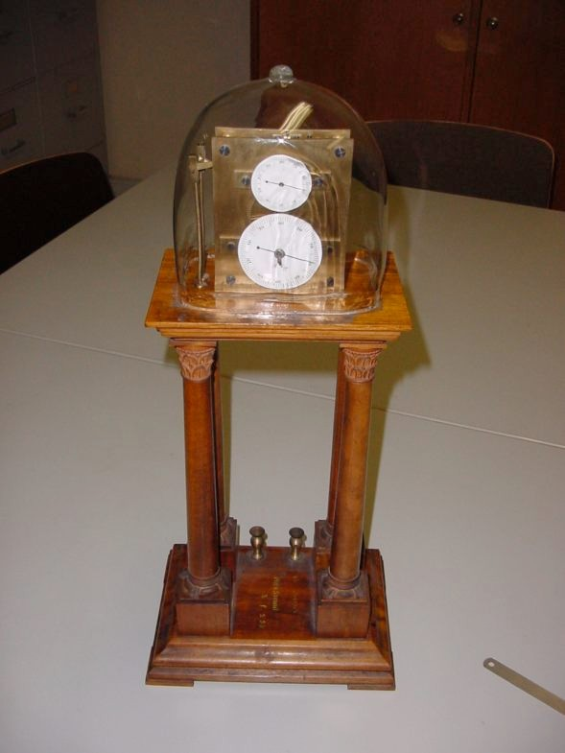

*Figure 5 (a):* Chronoscope signed “M. Hipp,” Heidelberg, Inventory No. Xf25*

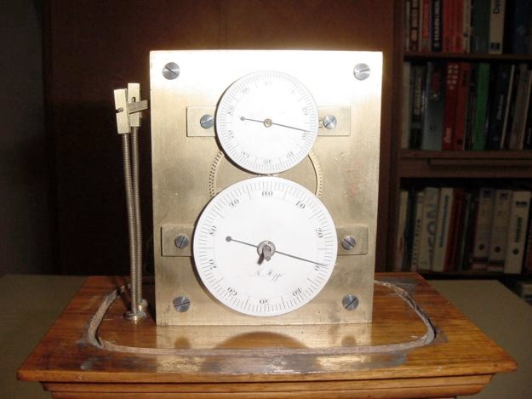

*Figure 5 (b):* Chronoscope signed M. Hipp, Heidelberg, Inventory No. Xf25* (detail)

The movement is started and stopped with help of 2 levers. The levers are connected with a rod and a spiral spring for the reset of the lever. The single metal dial has been replaced by two enamelled dials. The accuracy is like before 1/1000 sec.

This chronoscope is not dated. I have tried to find it in the old inventory index of the University. Philipp Lennard created this list in 1913 [108]. Fortunately, Lennard did not change the numbers of the older instruments.

The list covers hundreds of pages. I was not able to find the chronoscope “Xf25” in a reasonable time. But other entries allow the assumption that the Heidelberg chronoscope was purchased between 1850 and 1852.

|  |  |  |  |
| --- | --- | --- | --- |
| **Inventory No. Xf-** | **Date** | **Instrument** | **Detail** |
| 16 | 1848 | Electromagnet |  |
| 19 | no entry | Electromagnet |  |
| 22 | no entry | Wheatstone Telegraph |  |
| 24 | 1850 | model of Morse Telegraph |  |
| 25 | date wanted | ? | not found |
| 28 | no entry | Tangentenbousole |  |
| 31 | 1852 | Galvanometer |  |
| 32 | no entry | Galvanometer |  |
| 33 | 1843 | Galvanometer | type mismatch ? 1853? |
| 34 | 1859 | Galvanometer |  |
| 35 | 1863 | Galvanometer |  |

In the list I found another Hipp chronoscope (“IX 23”) which was bought in 1854. Nothing is known about this instrument today but it proves that the civil servant Hipp fabricated his own chronoscopes in Bern.

Another early instrument of this type is exhibited at the University of Pisa. The University says that this instrument was made before 1860. There is also an unsigned chronoscope in the collection of the Science Museum, London. This instrument came from King’s College. Apparently, it belonged to Charles Wheatstone [164]. I think that this instrument was also made by Hipp.

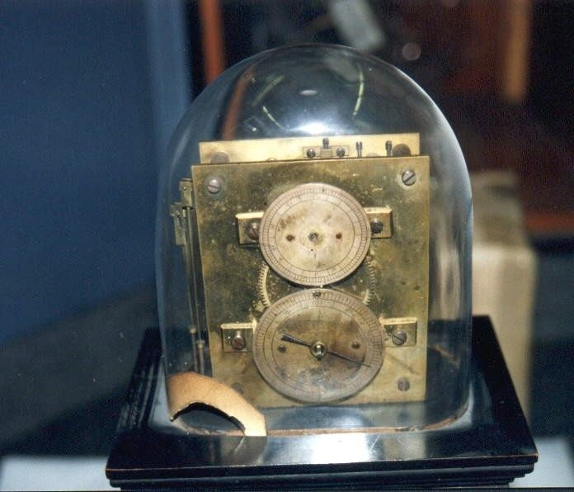

*Figure 6 (a):* Chronoscope without signature (front)

London, Science Museum, Inventory No. 1949-0302 (Photograph by Rand Evans)

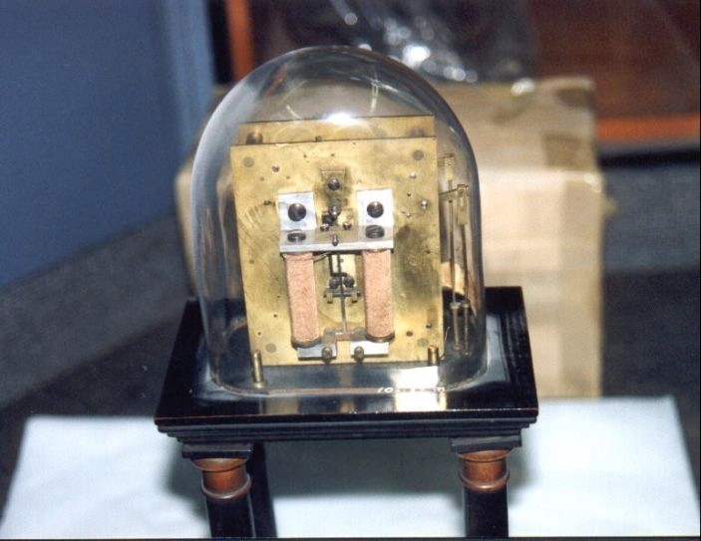

*Figure 6 (b):* Chronoscope without signature (back)

London, Science Museum, Inventory No. 1949-0302 (Photograph by Rand Evans)

Between 1850 and 1859 several other publications about the Hipp chronoscope appeared in scientific journals. The authors, Decher (1852) [34], Poppe (1853; 1854) [133] and Kuhn (1855) [100], discuss the use and the adjustment of the Hipp chronoscope.

Other descriptions are found in text books on physics and electricity:

Eisenlohr (1852), *Lehrbuch der Physik zum Gebrauche bei Vorlesungen und zum Selbstunterrichte* [45]

Du Moncel (1853), *Exposé des applications de l’électricité* [41] Harzer (1854), *Magnetelectricität als motorische Kraft* [78]

The main fields of application were physics and ballistics. Matthäus Hipp himself used the chronoscope to examine the telegraph lines in Switzerland [78].

1. THE YEARS 1860-1875: HIPP IN NEUCHÂTEL

In 1860, Hipp left the Telegraph works of Bern and founded his own factory in Neuchâtel called “Fabrique de Télégraphes et Apparails électriques.” Products of the Hipp works were electric clocks, electric telegraphs, and scientific instruments. It is certain that chronoscopes were produced too.

Old trade catalogues of this firm have survived and other information on the development of the chronoscope. In general, Hipp’s trade catalogues were divided in four sections, with the chronoscope ranged in section B under the heading “scientific instruments.” The catalogue from 1869 [82, 83] contains the following image:

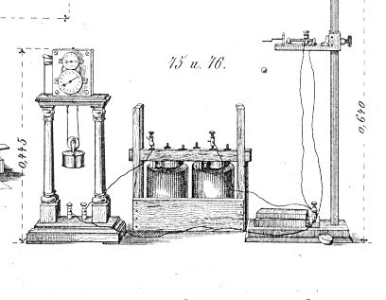

*Figure 7*: Hipp chronoscope, “model 75,” trade catalogue of 1869

The catalogue mentions a paper by Hirsch that was published in the physiological journal edited by Jacob Moleschott in 1865 [87, 118].

This paper is based on a lecture of Hipps friend Adolphe Hirsch (1830-1901). At a meeting of the Society of Neuchâtel Naturalists, Hirsch lectured about „Chronoskopische Versuche über die Geschwindigkeit der verschiedenen Sinneseindrücke und der Nervenleitung“ in 1861.

Hirsch was an astronomer and the director of the observatory of Neuchâtel. He was familiar with the problem of the personal equatation. He tried to explain it and was looking for ways of correction.

For his experiments, Hirsch had borrowed two chronocopes from Hipp. Hirsch measured reaction times for different impressions of the senses, like seeing, feeling and hearing. The reaction time was different for each kind of sense impression and varied from individual to

individual. Eminent Neuchâtel citizens such as Hipp, Guillaume, and Garnier were experimental subjects in his experiments.

Hirsch urged psychologists to continue this examination and to use the Hipp chronoscope for the experiments. Hirsch was the first scientist who applied the chronoscope for psychological measurements. In 1863, he published another article on the personal equatation and its correction [86].

A detailed description of the chronoscope was added to Hirsch’s paper of 1865. I want to show the drawings and to explain the chronoscope now:

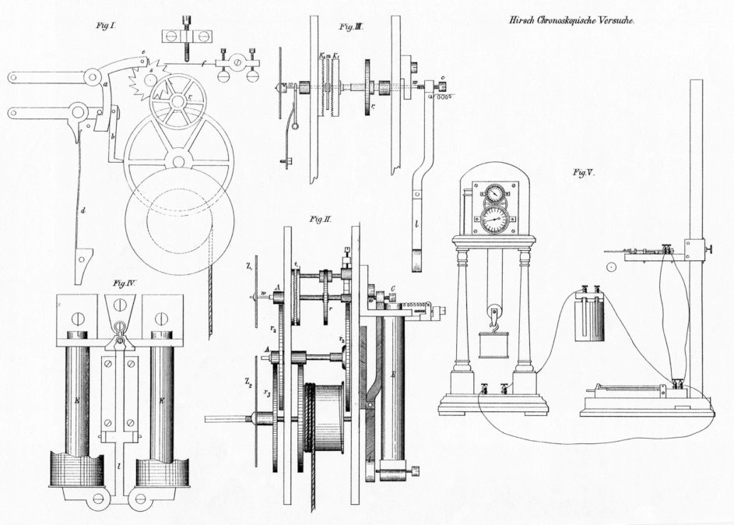

*Figure 8 (a):* Construction of Hipp’s chronoscope, “model 75” (Hirsch 1865)

Like Wheatstone, Hipp used a mechanical clock movement driven by a weight and combined with an electromechanical unit, which starts the time measurement. Wheatstone did not consider the inertia of the mechanical movement. Hipp’s solution was elegantly simple: he separated the clock movement from the movement for the dial. At first, the movement of the clock was started. Only after it had reached its constant working speed, the measurement began by engaging the dial.

*Escapement*

Hipps clock has an ingenious escapement shown in part I of figure 8 (a) (see also figure 8 [b]). The main parts of it are a steel lamella *f* fixed at one side and an escapewheel *s* with 20 teeth. The reed is known as Hipp lamella or sirens lamella. Hipp used it in his telegraphs too [17].

Robert Weber’s paper says that Hipp made long series of experiments to find out the best material and dimensions for the lamella. The best results came up with a reed made from

casted and not tempered steel with a solid fixing device and with a unity dimension over the length.

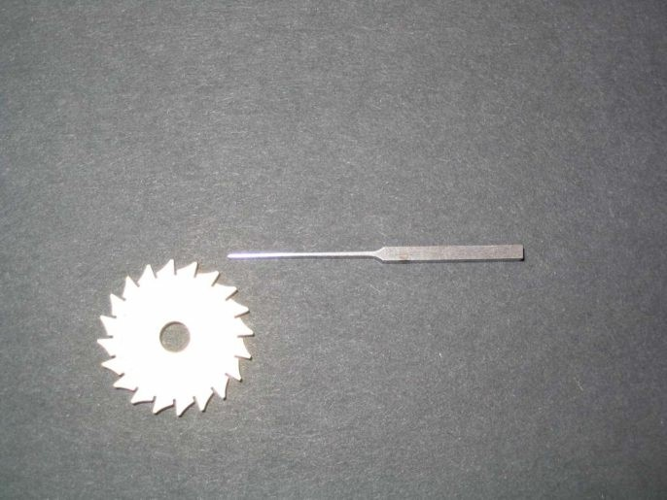

*Figure 8 (b):* Construction of Hipp’s chronoscope: lamella and escapewheel

When the lamella starts to move, it makes 1000 vibrations per second. The characteristic noise of the working instrument corresponds to 1000 Hertz. The escape wheel makes 91 turns in 1 sec. Persons who are able to adjust pianos are able to calibrate the chronoscope.

*Movement*

The movement is started and stopped by hand with the help of two threads fixed at the levers. The lever above (part I of fig. 8, above) is used to start the movement. The pin *e* removes the escape wheel *s* and moves the catch *b*. The catch *b* transmits the energy of the tighten spring *d* to the movement and escape wheel *s*. In this way the lamella is accelerated rapidly and able to make its 1000 vibrations.

*Dial*

The train for the hands is separated from the clockwork and has two dials, divided in one hundred parts. The hand of the lower dial makes one turn in ten seconds, thus indicating 1/10 sec. The hand of the upper dial needs 1/10 sec for one turn and indicates 1/1000 sec.

Part III of figure 8 (see above) shows that the hand of the upper dial is fixed at the shaft *w*, which could be moved horizontally through the hollow shaft of the crown wheel *K1* and the wheel *R1*. The shaft *w* has a pin *m*. This pin *m* is able to contact the moveable crown wheel *K1* or the fixed crown wheel *K2*. Every crown wheel has 100 teeth.

If the pin *m* moves into the crown wheel *K1*, the shaft *w* and the hands will move. If the pin *m*

has contact with crown wheel *K2* the shaft *w* is motionless and the hands too.

Shaft *w* and pin *m* are moved with help of lever *l* which is switched by the electromagnet.

If the electromagnet is active, shaft *w* will be pressed to the right side and pin *m* is in contact with crown wheel *K2*. The hands do not move.

In the case of an interruption of the current, the lever *l* does not press the shaft *w* and the pin *m* is able to be in contact with the turning crown wheel *K1*. The motion of crown wheel *K1* is transferred to the hands.

The chronoscopes of “model 75” were fabricated between 1860 and 1875. Six of them still exist today. All these instruments are of the same type and have the signature “M. Hipp, Neuchâtel, Suisse,” plus a serial number:

|  |  |  |  |  |
| --- | --- | --- | --- | --- |
| **C-** | **Location** | **Signature** | **detail** | **dated** |
| **55** | I-Palermo | No. 2505 M. Hipp Neuchâtel Suisse |  | Dec. 1865 |
| **11** | CH-Le Locle | No. 2506 M. Hipp Neuchâtel Suisse |  |  |
| **14** | D-private | No. 2889 M. Hipp Neuchâtel Suisse |  |  |
| **96** | NL-Leiden | No. 5370 M. Hipp Neuchâtel Suisse |  | 1871 |
| **22** | Unknown | No. 5751 M. Hipp Neuchâtel Suisse | Auction 1983  not sold [186] |  |
| **104** | CD-Yale | No. 7001 M. Hipp Neuchâtel Suisse |  |  |

The chronoscope “model 75” looks very similar to the older chronocopes, but if you examine the instrument carefully you will discover a modification of the start and stop unit. The rods were replaced with strings ending in a button made of bone.

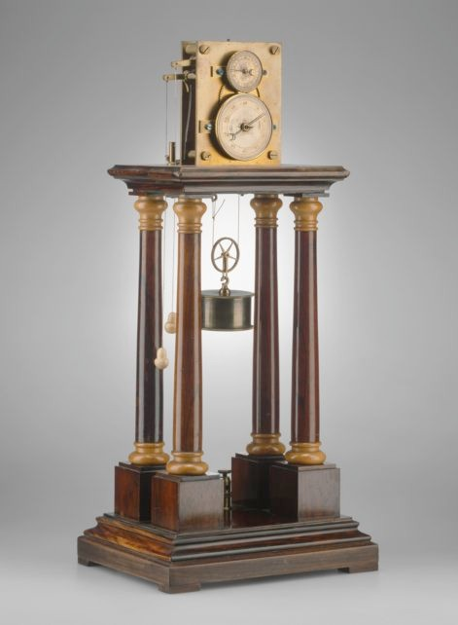

*Figure 9:* Hipp Chronoscope, “model 75” (private collection) Photograph: Landesmuseum Mannheim, Klaus Luginsland

The silvered dials have been replaced by enamelled dials. The accuracy of this instrument is again a few milliseconds.

More descriptions of the chronoscope were published in the scientific literature of this time:

Loir (1860), “Chronoscopes et chronographes” [113]

Dub (1863), *Die Anwendung des Elektromagnetismus mit besonderer Berücksichtigung der Telegraphie* [40]

Kuhn (1866), *Handbuch der angewandten Elektrizitätslehre* [101]

Daguin (1867), *Traité élémentaire de physique theorétique et expérimentale* [33] Du Moncel (1872), *Exposé des applications de l’électricté* (vol. 4) [42]

Here are two chronoscope images taken from Dub’s book on applied electromagnetism:

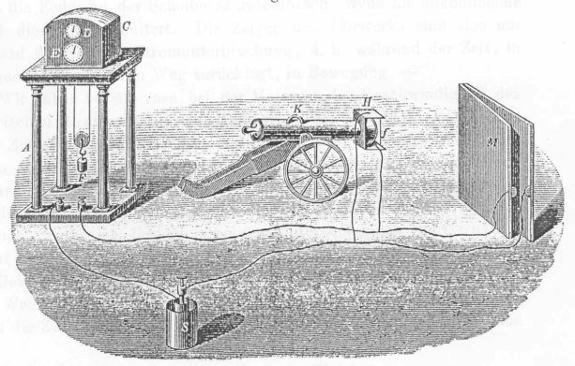

*Figure 10:* Ballistic experiment with chronosocope (Dub, 1863) [40]

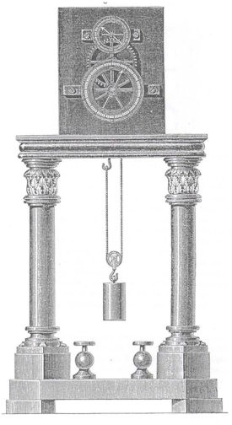

*Figure 11:* Hipp chronoscope (Dub, 1863) [40]

1. THE YEARS 1875-1889: HIPP’S IMPROVED CHRONOSCOPE

The chronoscope “type 75” was fabricated without any visible modification from 1860 to 1875. In 1875, Heinrich Schneebeli from Neuchâtel published the first article on the new and improved chronoscope. In „Über die Anziehungs- und Abreißungszeit der Elektromagneten“ Schneebeli [138] says that he possesses a new version of the Hipp chronoscope. He recommends it highly. He writes that the chronoscope is well known and that nearly every physical laboratory has one. Schneebeli adds a detailed description of the instrument.

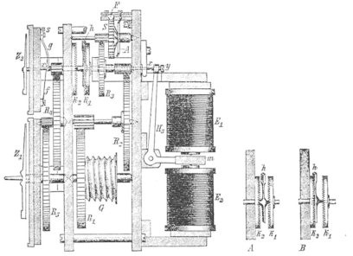

*Figure 12 (a):* Construction of the improved chronoscope (clock work and electromagnets)

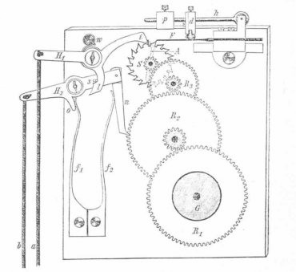

*Figure 12 (b):* Construction of the improved chronoscope (start and stop mechanism) Hipp had changed the escapement and the electric part of his chronoscope.

*Escapement*

The simple screw to adjust the Hipp lamella is replaced by an additional unit to calibrate it. Part of this unit is a lever *h* with a little weight *p* and a damper *d*, to prevent self resonance.

The plate of the movement in the front is smaller then the other.

*The electric unit*

Visible is the modification at the backside of the chronoscope. All older chronoscopes had only one electromagnet (2 coils), the improved model has two electromagnets (4 coils). Between the pairs of coils a metal armature *m* is placed. The position of this armature *m* could be adjusted with help of two levers and springs.

The construction of the older chronoscopes allowed measurements only when the circuit was interrupted. The new arrangement of the electromagnets enabled for measurements with opened and closed circuits.

|  |  |  |
| --- | --- | --- |
| I | II | III |
| Interruption | impulse | impulse |
| magnet E active | magnet E active | magnet F active |
| spring C under tension | spring C under tension | spring O under tension |

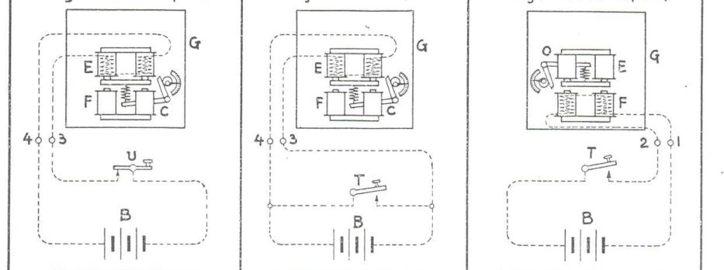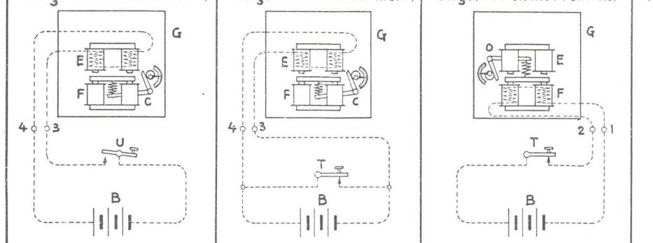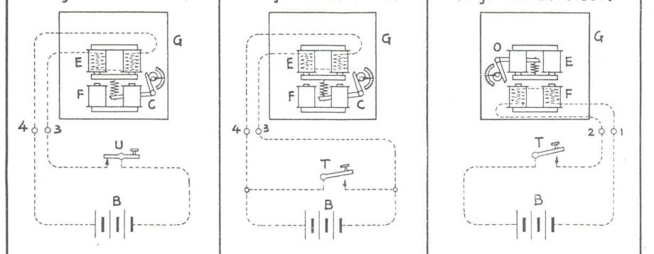

hands in motion

hands stopped

*Figure 13:* Possibilities of time measurement with the improved chronoscope Drawings taken from Favarger, 1924 [61]

The improved chronoscope figured also in Hipp’s trade catalogues [84]. In the late 1870s, it was listed as item “88:”

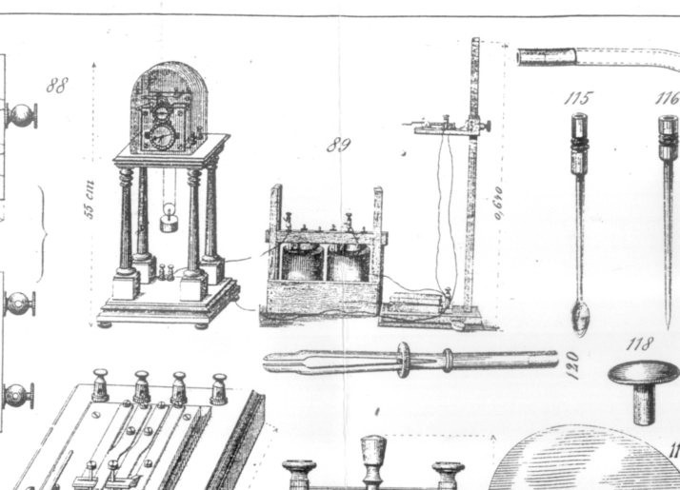

*Figure 14:* Hipp Chronoscope, “type 88,” undated trade catalogue [84] The following list shows 18 instruments of “type 88” which are known today.

|  |  |  |  |  |
| --- | --- | --- | --- | --- |
| **No** | **location** | **Signature** | **detail** | **dated** |
| **69** | I-Cremona | M. Hipp Neuchâtel Suisse No. 25347 | Ganelli Ernesto[68] | April  1877 |
| **28** | CH-La Chaux-de-Fonds  MIH | M. Hipp Neuchâtel No 7741 |  |  |
| **59** | D-Berlin | M. Hipp Neuchâtel No. 8319 | dial for reset to 0 |  |
| **85** | CH-Winterthur | M. Hipp Neuchâtel Suisse No. 9252 | stand modified |  |
| **1** | D-München  Deutsches Museum | M. Hipp Neuchâtel Suisse No. 9255 |  |  |
| **30** | USA-WashingtonDC | M. Hipp Neuchâtel Suisse No. 10107 |  |  |
| **39** | D-private | Michael Sendtner München | No. 11037 = Hipp |  |
| **90** | D-Passau | M. Hipp Neuchâtel Suisse No. 11480 | from Innsbruck |  |
| **99** | USA-Washington DC | M. Hipp Neuchâtel Suisse No. 12283 |  |  |
| **100** | I-Palermo | M. Hipp Neuchâtel Suisse No. 12576 |  |  |
| **86** | DK-Kopenhagen | M. Hipp Neuchâtel Suisse No. 12805 | [02, 65,106] | 1887 |
| **40** | D-Göttingen | M. Hipp Neuchâtel Suisse No. 12955 | stand with 3 legs |  |
| **61** | I-Palermo | M. Hipp Neuchâtel Suisse No. 12956 |  |  |
| **8** | GB-London  Science Museum | M. Hipp Neuchtael Suisse No. 13074 |  | 1889 |
| **47** | USA-Providence | M. Hipp Neuchâtel Suisse No. 13079 |  |  |
| **23** | USA- Worchester | M. Hipp Neuchâtel Suisse No. 13082 |  |  |
| **66** | F-Paris | M. Hipp Neuchâtel Suisse No. 13140 |  | 1889 |
| **31** | USA-Washington DC | M. Hipp Neuchâtel Suisse No. 13184 |  |  |

Almost all listed instruments have an identical construction. They bear Hipp’s signature and a serial number.

Only few of them show particularities.

The chronoscope No. 59 from Berlin has a modified dial. The dial is moveable to enable a reset to the zero point. I think this modification was made later.

The chronoscope No. 40 from Göttingen shows a modified stand.

A little bit strange is the serial number of the instrument in Cermona and I’m not able to explain this.

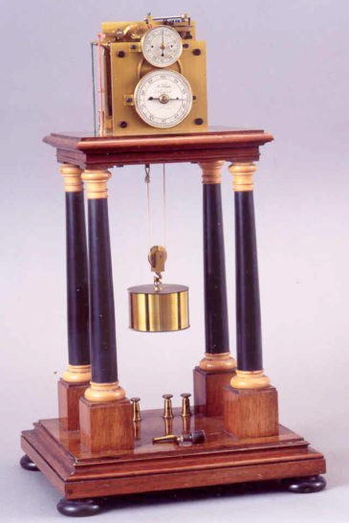

*Figure 15 (a):* Chronoscope, “model 88,” signed “M. Hipp, Neuchâtel, No. 7741” La Chaux de Fonds, MIH, Inventory No. IV-298

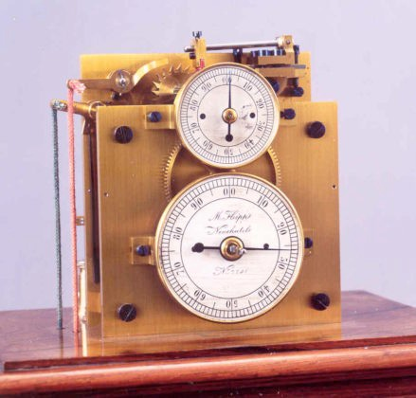

*Figure 15 (b):* Chronoscope, “model 88,” signed “M. Hipp, Neuchâtel, No. 7741” (detail) La Chaux de Fonds, MIH, Inventory No. IV-298

Lovely is the following chronoscope signed “Michael Sendtner, München:”

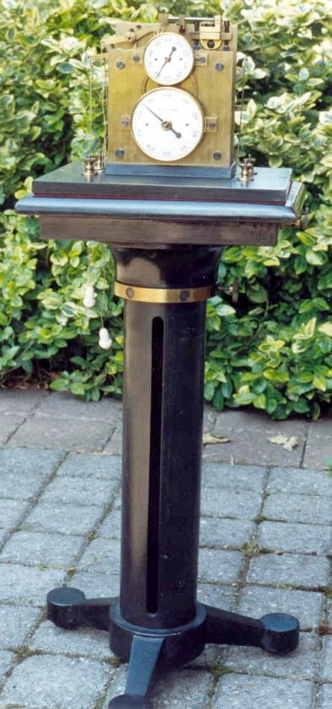

*Figure 16:* Chronoscope, signed “Michael Sendtner Müchen” (private collection)

Michael Sendtner was a mechanic and manufacturer of scientific instruments. Sendtner founded his factory in Munich in 1879. He produced geological and astronomical instruments [187].

Not easy to discover is a small number “11037” stamped in one of the plates. No doubt that this number indicates that the movement is a product of the Hipp works in Neuchâtel. Sendtner bought the movement and added his own stand that allowed for extended running time.

A great number of chronoscopes is located at psychological institutes and I’ll try to explain this situation now.

In the middle of the 19th century several scientists made attempts to examine nerves and senses of animals and humans with the aim to explain and understand cognitive processes.

In 1848/49 Emil du Bois-Reymond (1818-1896), in his *Untersuchungen über thierische Elektrictät,* argued that the activity of nerves is an electrical phenomenon.

In 1850, the Königsberg physiologist Hermann von Helmholtz (1821-1894) gave a lecture about „Die Methoden, kleinste Zeittheile zu messen und ihre Anwendung für physiologische Zwecke“ [81]. Helmholtz was able to demonstrate by way of experiments that nervous stimulation required time to cause responses in the brain.

The experiments of Hirsch I have mentioned also refer to this context.

In the second half of the 19th century, the physician and philosopher Wilhelm Wundt (1832- 1920) introduced experimental methods into the field of psychology. Wundt studied the mental processes. Of special interest was the human reaction time [74, 64]. For the experimental examination of reaction times Wundt mostly relied on the Hipp chronoscope [172, 173].

Wundt’s scientific work met with great approval and became public as experimental psychology. In 1875, he was appointed to a position at the University of Leipzig where he collected a set of apparatus for studying the mental process. In 1879, he founded the first laboratory of experimental psychology. The Leipzig students spread Wundt’s science of the experimental psychology over the world. In the following years, many institutes for experimental psychology were founded: in Göttingen (1881), at Johns Hopkins (1883), in Copenhagen (1886), etc. In 1889, the year of Hipp’s death, fourteen institutes were founded. Ten years later fifty institutes and laboratories existed [119]

Wundt used the Hipp chronoscope and his students used it too. This situation led to a great need in chronoscopes. An industry emerged to meet the demand in scientific instruments.

The following image shows a typical experiment with chronoscope for psychological purposes:

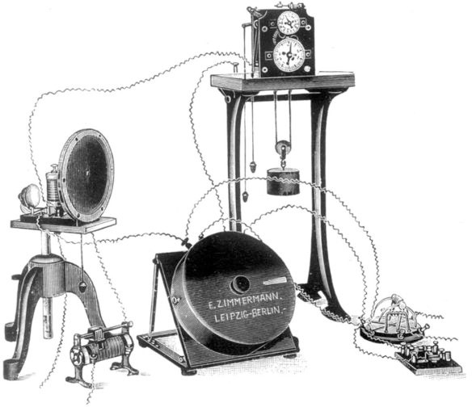

*Figure 17:* Experiment for testing perception, association, and memory with

Ranschburg apparatus

From trade catalogue E. Zimmermann, Liste 50 (1928) [178]

1. THE YEARS 1889-1908: PEYER AND FAVARGER

On February 15, 1889, Matthäus Hipp entrusted two engineers, Peyer and Favarger, with the management of the Hipp Works. The state of his health was not the best and Hipp and his wife moved to Zürich a few days later. On May 3, 1893, Hipp died at the age of 80.

The instruments and apparatus of the following period were signed “Peyer, Favarger & Cie, Successeurs de Hipp, Neuchâtel, Suisse, [serial number].”

Peyer and Favarger continued the fabrication of the Hipp chronoscope. A detailed description of the chronoscope is published in Albert Favarger’s book, *Die Electricität und ihre Verwerthung zur Zeitmessung* [60].

In addition to the standard type, two new models were offered.

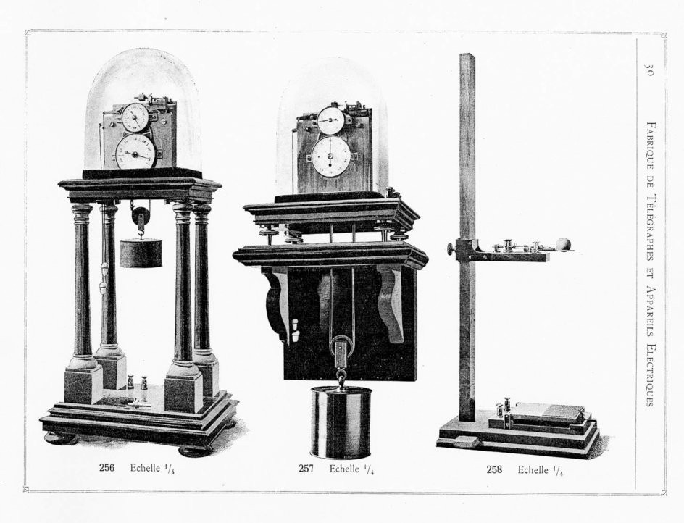

*Figure 18:* Chronoscope, “model 256” and “257”, as shown in the trade catalogue

of Peyer, Favarger & Cie 1902 [131]

“Model 256” was the same as the earlier “model 88” produced by Hipp. A novelty was “model 257.” The movement was fixed on a wooden board and the running time was six minutes. A heavy weight drove the movement. This instrument was able to measure milliseconds. A characteristic feature was the position of the square shaft below the dial for the winding key.

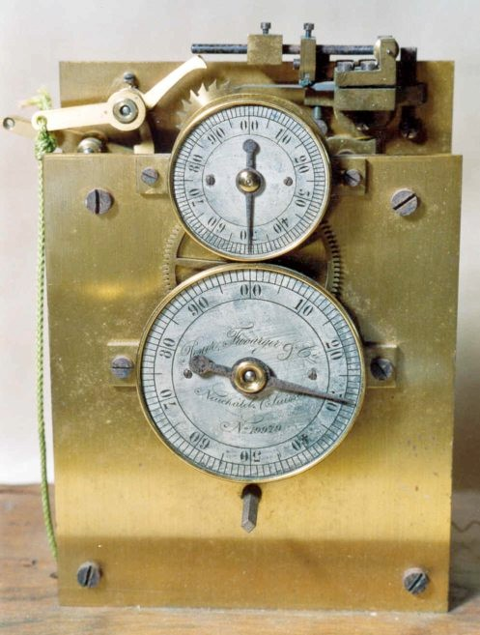

*Figure 19:* Chronoscope, “model 257,” (private collection, Jaime Wyss)

The other new model is “257B” which has three dials and a running time of nearly one hour. The movement is driven by a heavy weight fixed at a chain. The accuracy is 1/100 sec. An illustration of “257B” is not published in the 1902 catalogue, but the instrument is shown in the 1913 trade catalogue of Favarger & Cie.

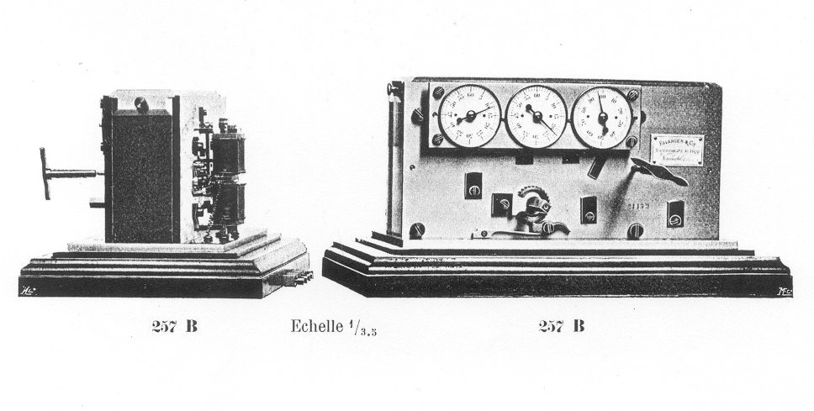

*Figure 20:* Chronoscope, “model 257 B,” trade catalogue Favarger & Cie (1913) [59]

Today, we know of 17 Chronoscopes made by Peyer, Favarger & Cie.

|  |  |  |  |  |
| --- | --- | --- | --- | --- |
| **C-** | **Location** | **Signature** | **detail** | **dated** |
| **32** | USA- Washington DC | Peyer, Favarger &Cie No. 13482 | 256 |  |
| **09** | CD-Toronto | Peyer, Favarger &Cie No. 13919 | 256 Clay & Torbenson | 1890/  1891 |
| **04** | USA- Cambridge | Peyer, Favarger &Cie No. 14453 | 256 |  |
| **48** | USA-Povidence | Peyer, Favarger &Cie No. 14879 | 256 |  |
| **75** | USA-Akron/Ohio | Peyer, Favarger &Cie No. 16261 | 256 |  |
| **80** | USA-Washington DC | Peyer, Favarger &Cie No. 16402 | 256 |  |
| **62** | F-Rennes | Peyer, Favarger &Cie No. 16404 | 256 |  |
| **58** | D-Berlin | Peyer, Favarger &Cie No. 16331 | 256, dial moveable[116] |  |
| **16** | USA- Lincoln | Max Kohl Chemnitz | 256 serial No 16897 |  |
| **72** | F-Strasbourg | Peyer, Favarger &Cie No. 17157 | 256 [03, 152] | 1898 |
| **89** | D-private collection | Peyer, Favarger &Cie No. 175?? | 256 |  |
| **57** | Literature [28] | Peyer, Favarger &Cie No. 19385 | 256 |  |
| **13** | CH-private collection | Peyer. Favarger &Cie No. 19979 | 257 |  |
| **02** | D-München  Deutsches Museum | Peyer, Favarger &Cie No. 20260 | 256 present of Peyer-F. | 1906 |
| **76** | USA-private collection | Peyer, Favarger &Cie No. 20658 | 256 |  |
| **10** | USA- Montclair | Peyer, Favarger &Cie No. 20659 | 256 [127] |  |
| **77** | USA-unknown, private | Max Kohl Chemnitz | no No. = model 256 |  |

The Observatory of Strasbourg in France ordered a chronsocope in 1889. Peyer and Favarger delivered the wanted instrument in March 1898. This instrument is listed in the inventory index of the Observatory [152]. The price of the chronoscope (“model 256”) and the drop apparatus was 345 Marks.

The famous German Museum for Technology in Munich was also interested in acquiring a chronoscope. In November 1905 the director of the museum wrote a letter to Peyer and Favarger to ask for a Hipp chronoscope for the scientific instrument collection. The answer arrived on December 6, 1905. Peyer replied that no chronoscopes were available at the moment, because a lot of orders had come in. But he promised to send a chronoscope plus a few other items in the near future.

In a second letter dated June 13, 1906, Peyer wrote that a chronoscope, “modèle courant,” a new electric master clock with 1/1 sec pendulum and a few slave clocks will be exhibited in Mailand. After the exhibtion these devices would be send to Munich. [128, 129]

In other words, the chronoscope shown in the permanent collection of the Munich museum is a present of Peyer, Favarger & Cie.

1. THE YEARS 1908-1927: FAVARGER & CIE

In 1908, Peyer, Favarger & Cie was taken over by the limited partnership Favarger & Cie which then was transformed into a limited company in 1923.

The clocks and instruments of this period were signed “Favarger & Cie, Successeurs de Hipp, Neuchâtel, Suisse [a serial number].

The chronoscope seemed to be very important for science during these years: the 1913 trade catalogue shows eight additional models of the chronsocope [59].

Favarger modified running time and design without changings in the main construction. For every field of application a special chronoscope was offered.

|  |  |  |  |  |  |
| --- | --- | --- | --- | --- | --- |
| **model** | **driven**  **by** | **Type** | **Measurement**  **Sec** | **running**  **time** | **price**  **sfr.** |
| 256 | small  weight | „Modèle courant“ wooden table | 1/1000 | 1 min | 400.- |
| 256 A | sring | like 256 wooden board | 1/1000 | 1 min | 375.- |
| 256 B | spring | Metal, glas  „Münsterberg Chronoskop“ | 1/1000 | 1 min | 425.- |
| 257 | heavy weight | Grand modèle   1. wooden board 2. wooden tabel | 1/1000 | 6 min | 600.-  650.- |
| 257 A | weight  Gall chain | Grand modèle à 3 cadrans wooden board | 1/10 | 30 min | 750.- |
| 257 B | spring | Grand modèle à 3 cadrans  wooden board | 1/10 | 15 min | 700.- |
| 257 C | spring  Gall chain | 257A with 4 dials case | 1/1000 | 30 min | 900.- |
| 257 D | spring | 257B with 4 dials  case | 1/1000 | 15 min | 850.- |
| 257 E | weight Gall chain | Nouveau modèle 1 dial 30 cm   1. without reset 0 2. with reset 0 | 1/50 |  | 800.-  950.- |

Nine chronoscopes made by Favarger & Cie between 1908 and 1927 are still existing. A few of them bear strange signatures:

|  |  |  |  |  |
| --- | --- | --- | --- | --- |
| **C-** | **Location** | **Signature** | **Detail** | **date** |
| **88** | NL-Groningen | Spindler & Hoyer Werkstatt für  Präzisions-mechanik Göttingen | 257A [39]  serial No. 21 132 |  |
| **102** | I-Rom | no signature | 256, serial No. 22066 |  |
| **81** | AUS-Crawley | Spindler & Hoyer Göttingen | 256 serial No. 22250 |  |
| **45** | D-Passau | Favarger &Cie  Neuchâtel Suisse No. 22 728 | 257 stand new |  |
| **27** | CH-La Chaux-de-Fonds  MIH | Favarger &Cie Successeur de Hipp  Neuchâtel Suisse No. 22853 | 257D |  |
| **5** | USA-Akron | Favarger &Cie  Neuchâtel Suisse No. 22903 | 256B, Münsterberg  chronoscope |  |
| **93** | NL-Groningen | Favarger & Cie  Neuchâtel Suisse No. 23223 | 257A [39] |  |
| **41** | D-Passau | Favarger &Cie  Neuchâtel Suisse No. 23224 | 257A |  |
| **46** | CH-Le Locle | Favarger &Cie  Neuchâtel Suisse No. 23469 |  |  |
| **97** | AUS-Sydney | no signature, no serial number | 256B Favarger & Cie? |  |

The first example is a chronoscope signed “Spindler & Hoyer, Göttingen,” but the serial number “21132” proves that, in fact, this instrument was made by Favarger & Cie.

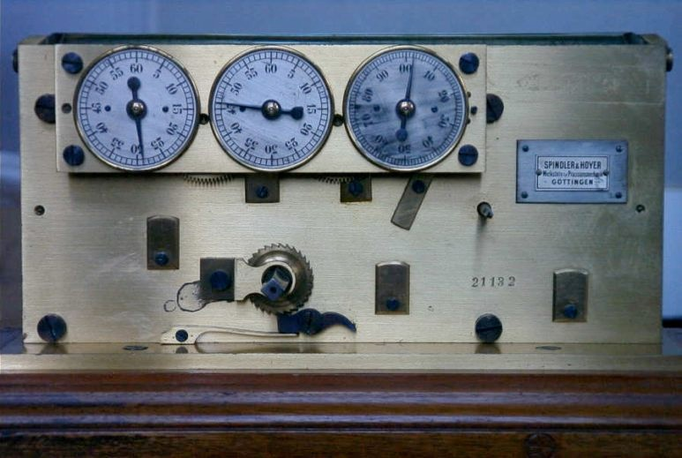

*Figure 21:* Chronoscope, “model 257A,” signed “Spindler & Hoyer, No 21132” Groningen, Inventory No. 1966/13.4

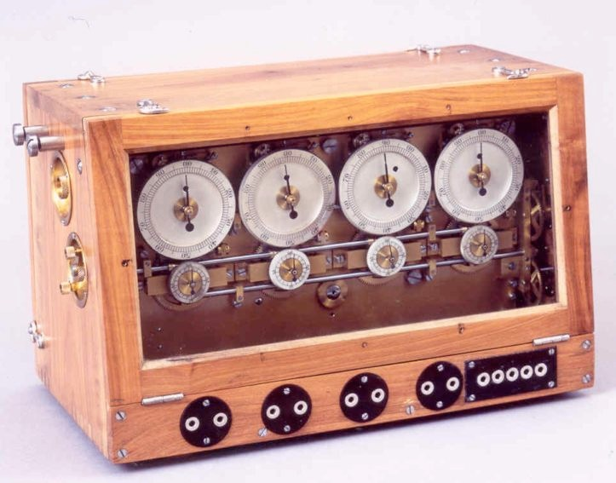

*Figure 22:* Chronoscope, “model 257D,” with four dials made by Favarger & Cie La Chaux-de-Fonds, MIH, Inventory No. V-226

1. THE YEARS 1927- CA. 1975: FAVAG

In 1927, Favarger AG was renamed FAVAG, i.e. “Fabrik elektrischer Apparate AG.” In 1932, the FAVAG was taken over by Hasler.

Part of the production were again chronoscopes, but FAVAG reduced the delivery programme. From 1928 to 1936, FAVAG offered the following types of chronoscopes [16, 51, 52, 53, 54, 58, 105].

|  |  |  |  |  |  |  |
| --- | --- | --- | --- | --- | --- | --- |
| **model** | **driven by** | **Type** | **Measurement** | **running**  **time** | **price**  **sfr.** | **Catalogue** |
|  | spring | like 256 A | 1/1000 | 1 min |  | 4/1928 |
| 201 | weight | Laboratory, table  without reset to 0 | 1/1000 | 1 min | 800 | 1928, 1933 |
| 202 | weight | Laboratory, table, reset to 0 | 1/1000 | 1 min | 900 | 1928, 1933 |
| 206 | spring | Standard,Glass/Metal  without reset to 0 | 1/1000 | 1 min | 825 | 1928, 1933 |
| 207 | spring | Standard glass/metal  with reset to 0 | 1/1000 | 1 min | 925 | 1928, 1933 |
| 211 | weight | wooden board  without reset to 0 | 1/1000 | 6 min | 1300 | 1928, 1933 |
| 212 | weight | wooden board, reset to 0 | 1/1000 | 6 min | 1400 | 1928, 1933 |
|  | spring | Longtime, 3 dials | 1/100 | 60 min |  | 1933, 1936 |

FAVAG chronoscopes of this time depend in their main construction on the old electromechanical pattern devised by Hipp some 80 years earlier. New is an arrangement for the reset of the hands, which is offered at a higher price.

The wonderful stand made from high quality wood was replaced by simple geometric forms made from cheaper wood.

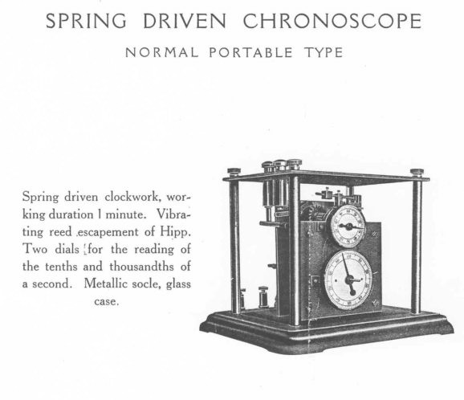

*Figure 23:* FAVAG, Chronoscope, “model 202”

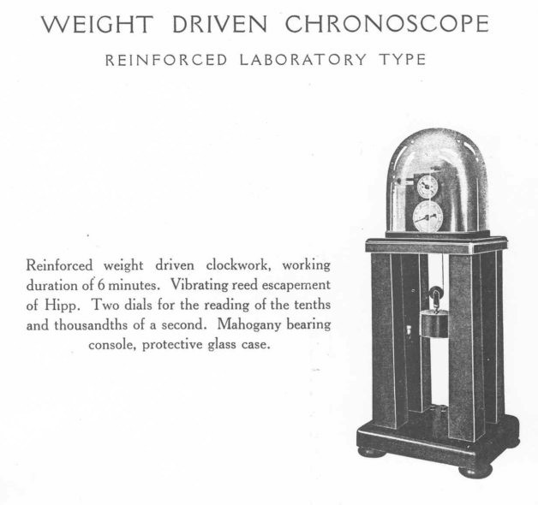

*Figure 23:* FAVAG, Chronoscope, “model 207”

In this period, clocks and Instruments were signed “FAVAG, S.A.” In other words, the system of serial numbers which was in use from 1860 to 1928 changed.

The quantity of existing instruments is very small. I was able to find only two FAVAG chronoscopes. One chronoscope of type “202” is located at the University of Oxford [123] with a photo on the Internet. The other one, a Münsterberg chronoscope, is part of the psychological instrument collection at the University of Sydney.

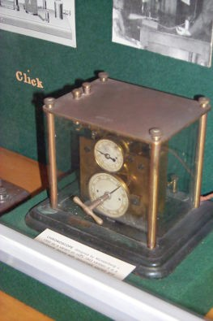

*Figure 24:* Münsterberg chronoscope with reset to 0, bearing no signature or serial number University of Sydney

A few words about the time after 1945. The first reference to the next type of chronoscope I have found is a paper published by FAVAG in 1946 [57]. Mentioned is a chronoscope “type

M 400” with a synchronous motor for psychological time measurement. Unfortunately, no other traces leading to his chronoscope have appeared during my research.

In the 1950s the FAVAG marketed an improved type of this chronoscope, which was named “M 430” [55, 182, 184]. A synchronous motor drives this instrument too. The 110 or 220 Volt motor replaced the Hipp escapement with the lamella, the mechanical movement and the driving weight. In accordance with the old pattern, the driving unit and the movement for the hands are separated. The measurement is started electrically. The connection is made with the help of the two crown wheels just as Hipp had used them in his first chronoscope. The accuracy is again a few milliseconds.

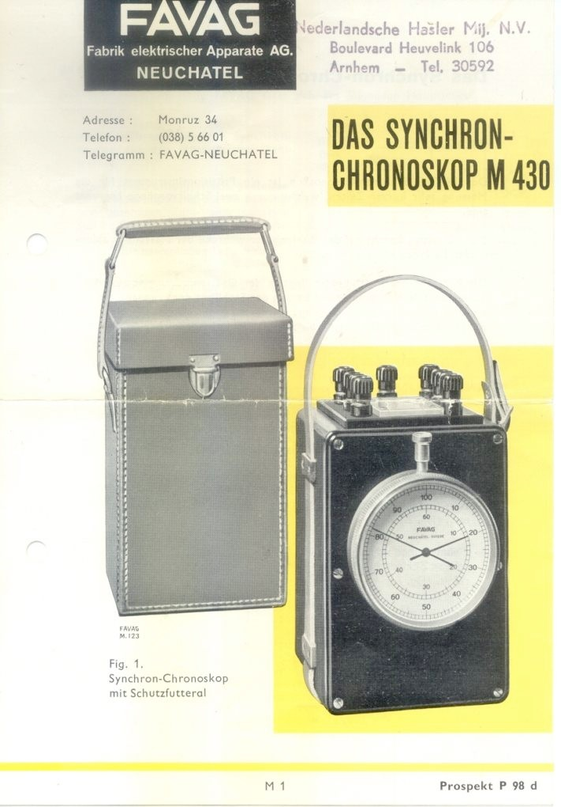

*Figure 25:* Prospectus of the “M 430” chronoscope with synchronous motor

Almost twenty years later, “type M 430” was modified again. The improved model was named “M 500.” A characteristic feature is the case made from plastic [56].

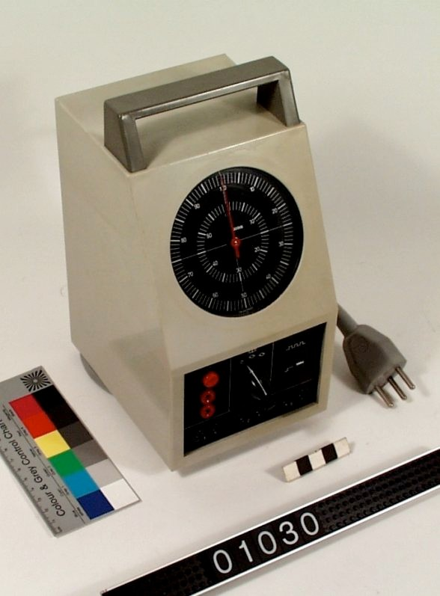

*Figure 26:* Chronoscope with synchronous motor, “model M 500,” dated 1969 Passau, Inventory No. 01030

Seven chronoscopes of “type M 430” and two of “type M 500” are known today, but I assume that more of them are still around.

|  |  |  |  |  |
| --- | --- | --- | --- | --- |
| **C-** | **Town** | **Type** | **serial No.** | **date** |
| **73** | D-Passau | M430 | 501987 | 1950 |
| **107** | NL-Arnheim | M430 | 560634 | 1956 |
| **71** | D-private collection [183] | M430 | 591974 | 1959 |
| **98** | CH-private collection | M430 | 622715 | 1962 |
| **106** | technical papers to a M430 [185] | M430 | 620632 | 1962 |
| **103** | D-private collection | M430 | 642510 | 1964 |
| **67** | CH-private collection Jaime Wyss | M430 | 662512 | 1966 |
| **95** | D-Passau | M500 | 691622 | 1969 |
| **94** | D-Passau | M500 | 712855 | 1971 |

The modern type of the chronoscope has no ancient appearance and so the collector has no special interest in it. I suspect that a lot of these chronsocopes have been thrown away during the last years.

One “M 430” chronoscope was sold at Ebay. Landis & Gyr used this instrument to adjust the burners of heating systems. The department in Zug disappeared a few years ago. All instruments were to be scraped, but one worker saved this chronoscope. Ten years later, he offered it at Ebay.

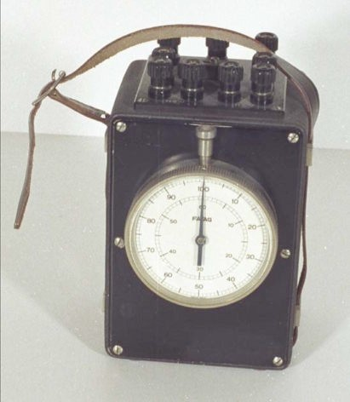

*Figure 27:* Chronoscope, “modell M 430,” dated 1959 (private collection)

In 1983/84, Hasler merged with Autophon and the firm Ascom was established. FAVAG was renamed Ascom FAVAG. The Ascom FAVAG was sold to the Bosshard (Moser-Baer) Company in November 1989 and the production was closed. In July 2002, the Bosshard Company was renamed Mobatime.

1. THE HIPP STYLE CHRONOSCOPE MADE BY OTHERS

The Hipp chronoscope was a very valuable and quite expensive instrument with great importance for the sciences. Its handling was easy and resulted in direct indication of the measured time.

The trade with this instrument was very profitable. At first the Hipp Works was the only supplier, but others appeared from 1890 onwards.

The following list shows the names of firms that offered chronoscopes. In most cases, historical trade catalogues have been my source.

|  |  |  |  |  |
| --- | --- | --- | --- | --- |
| **Supplier** | **Town** | **catalogue** | **chronoscope**  **purchased from** | **sum** |
| Clay & Torbensen | Philadelphia | invoice | Peyer, Favarger | 1 |
| Diel Heinrich, Präzisionsmechaniker | Leipzig | 1911 [36, 37, 38] |  | 0 |
| Fischer Constantin, Fabrikation  wissenschaftlicher Apparate | Leipzig | 1924 [63] |  | 0 |
| Gerhardt,C. – Marquardts Lager  chemischer Utensilien | Bonn | 1902 [69] |  | 0 |
| James Jaquet AG  Fabrik für wiss.Chronometrie | Basel | ca. 1927 [88, 89,  90] | FAVAG | 0 |
| Kohl Max Werkstätten für Präzisions-  mechanik und Elektrotechnik | Chemnitz | 1905 – 1925  [97, 98,99] | Peyer, Favarger | 2 |
| Krille, Karl Werkstatt für  wissenschaftliche Instr. | Leipzig | 1893 [172] | Peyer, Favarger  Wundt | 0 |
| Lepin & Masche  Fabrik wissenschaftlicher Instrumente | Berlin | ca. 1915 [107] |  | 0 |
| Leybold, E. Nfg | Köln | ca. 1911 [109] |  | 0 |
| Löbner, F.L., Uhrenfabrik | Berlin | ca. 1900  [32, 110, 111,] | Strasser & Rohde | 2 |
| Palmer, C.F. Ltd. Myographic Works | London | 1934 [124] | FAVAG | 1 |
| Sendtner Michael | München | < 1889 | Hipp | 1 |
| Spindler & Hoyer, Mechanische und  optische Werkstätten | Göttingen | 1908 – 1921  [18, 150, 151] | Peyer, Favarger | 2 |
| Stoelting, C.H. Co., Manufacturer – Importer – Exporter – Publisher | Chicago | 1930 [135, 153] | FAVAG |  |
| Strasser & Rohde, Uhrenfabrik | Glashütte | [102, 103, 154, 155,  156] | Hersteller |  |
| Volckmar. & Staakmann | Leipzig | 1914 [165] | Zimmermann | 0 |
| Zimmermann, Ernst  Wissenschaftliche Apparate | Leipzig,  Berlin | 1894 – 1937  [174 - 180] | ???? |  |

The history of the listed firms has to be examined in order to find out whether or not these firms manufactured chronoscopes by themselves. Only in a few cases, direct traces lead to the chronoscopes in question.

It is stated in the literature that the Leipzig-based mechanic Krille bought chronoscopes from the Hipp Works in Neuchâtel. In Göttingen, Spindler & Hoyer made no chronoscopes, but only special parts for them. In all other cases existing instruments and old trade catalogues are the only sources available for historical study.

The analysis of this material allows the statement that nearly all of the mentioned firms were dealers, not manufacturers. Sometimes the instruments show the signature of a dealer or a modified stand or additional parts and other little changes. But in most cases the origin of the movements was the factory in Neuchâtel.

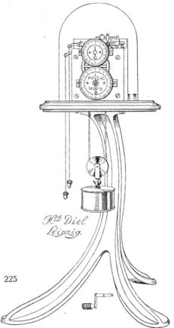

*Figure 28:* Chronoscope in the trade catalogue of Heinrich Diel 1911 [38]

A good example is the chronoscope of the Institute for Physics and Astronomy at Nebraska University. This instrument was discovered in 1999. It is signed “Max Kohl, Chemnitz.” The part of the dial with the Hipp signature has been cut out and Max Kohl carved his own signature in the plate of the movement behind the dial. Two years later, we examined the instrument again and discovered a small serial number which indicates that this movement is a product of Peyer, Favarger & Cie.

Back to the list now. It is possible that three of the listed firms produced their own chronoscopes and I want to discuss this:

*F.L. Löbner, Berlin*

Löbner was a well known wholesale store for all types of clocks. The Löbner firm was a main supplier for clocks and instruments to the German army. The quantity of self produced clocks was very small. A few references to Löbner and the chronoscopes have been found. Two different types of chronoscopes are known. “Type 1” has an extended running time:

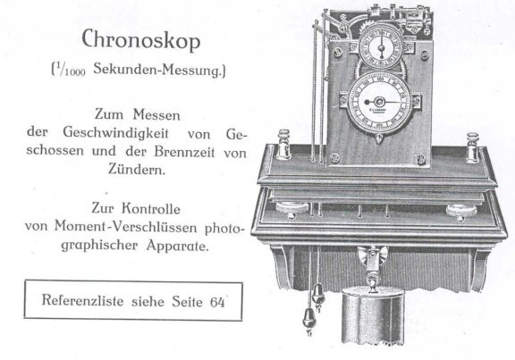

*Figure 29:* Löbner chronoscope, taken from the 1913catalogue

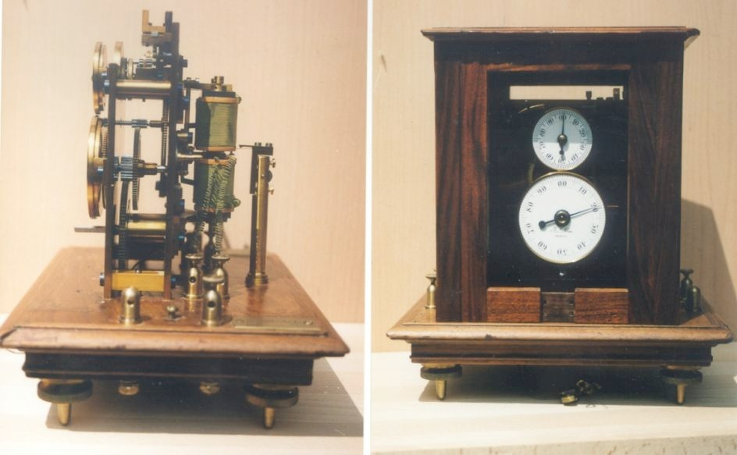

*Figure 30:* Löbner chronoscope, private collection,

with special unit for measuring the times of the electromagnet

I know of two “type 1” chronoscopes. Both instruments are signed “F. L. Löbner, Berlin.” They are very similar to “model 257” made by Peyer, Favarger & Cie. Both instruments have a running time of six minutes, no serial number and the special device for the electromagnet.

The other type seems to be more recent and probably was made around 1925:

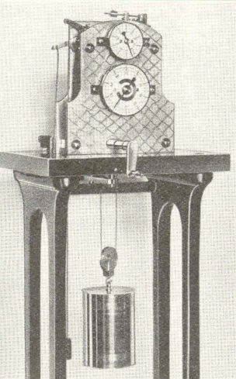

*Figure 31:* Löbner Chronoscope, more recent type (Kaltenbach, 1938) [95]

*Strasser & Rohde, Glashütte*

The case of this firm shows similar patterns. Strasser & Rohde in Glashütte was a well known manufacturer of high precision clocks and instruments. It is evident that Strasser & Rohde have produced their own chronoscopes during the 1930s. Their chronoscope was based on Hipp’s, but it was of their own construction. The differences are visible:

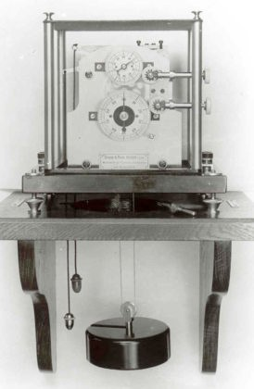

*Figure 32:* Chronoscope made by Strasser & Rohde

The Strasser & Rohde chronoscope is very similar to the more recent Löbner type shown above.

A discovery of high importance was a wooden box coming from the workshop of Strasser & Rohde. In this box we have found an unfinished chronoscope, special tools, three unused dials, some Hipp lamellas and escape wheels, one complete unit for the fine adjustment of the electromagnets, wooden bodies for the coils, a winding key and other parts in little paper bags and boxes.

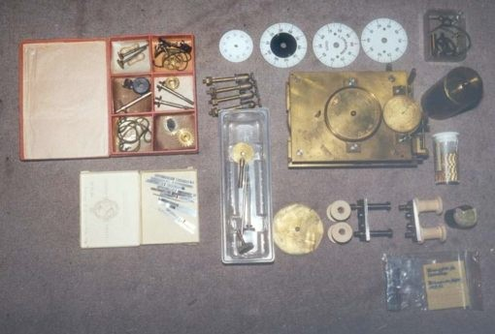

*Figure 33:* Strasse & Rohde box with chronoscope parts (private collection)

This chronoscope has a running time of 6 min. It has the same additional device for the electromagnets as the Löbner chronoscope. Hans Jochen Kummer and I have examined this movement and the movement of a Löbner chronoscope very carefully.

We think that both chronoscopes have been produced in the same workshop and this means that Löbner bought the chronoscopes from Strassser & Rohde. This makes sense, because Löbner also traded Strasser pendulum clocks under his own name.

Let’s have a look at the third firm now

*E. Zimmermann, Leipzig*

This firm was founded in 1887. Zimmermann delivered psychological instruments to clients all over the world. The factory was in Leipzig. Initially, the headquarter of the firm was located in Leipzig, then in Berlin (1907). The name Zimmermann is closely connected to Wundt and his Institute for experimental psychology at Leipzig University.

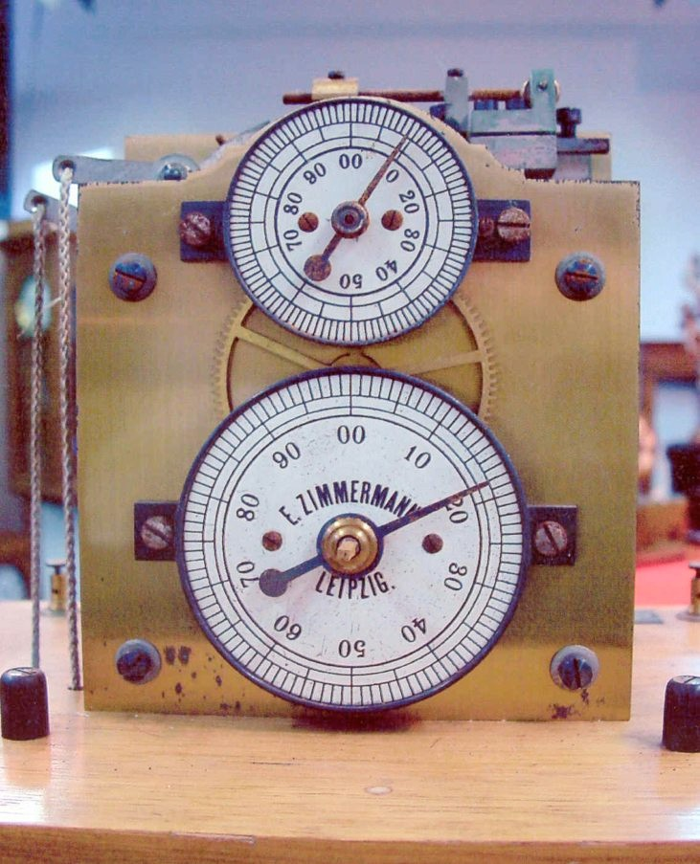

*Figure 34:* Chronoscope sold by Zimmermann, with additional contact as invented by Külpe (Private collection, Jaime Wyss)

Many of Zimmermann’s trade catalogues still exist today. In the period between 1894 and 1937, Zimmermann offered different models of chronoscopes. He changed the design and the movement.

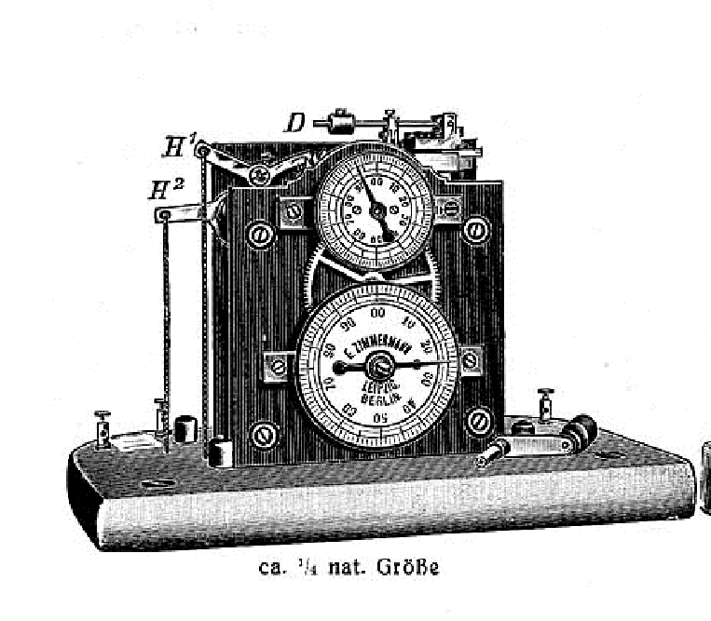The differences between Hipp and Zimmermann chronoscopes are shown here:

*Figure 35:* Differences between Hipp and Zimmermann chronoscope Adjustment: the weight is a cylinder, Hipp used a cubic weight

Signature: all instruments are signed Zimmermann

Movement: Zimmermann used lots of different designs for the plates;

plates were connected with screws and washers, Hipp used screws only; sometimes the plates have a special grinding, Hipp used polished plates only;

often the gear wheels are punched, Hipp used gear wheels with legs only Serial No.: Zimmermann = 2-3 digits, Hipp = 4-6 digits

My conclusion is that Zimmermann did *not* purchase the movements from the Telegraph Works in Neuchâtel. As a consequence, the question remains to be answered “who has produced the movements for the Zimmermann chronoscopes?”

One argument for in-house production by Zimmermann is the impressive quantity of 31 still existing chronoscopes – the largest group of electromechanical instruments driven by a clockwork. Another piece of evidence is the chronoscope as improved by Rudolf Schulze from Leipzig in 1909 [143, 144, 145]. Schulze’s improved chronoscope was patented in Germany as “DRP 209151.” The Zimmermann firm was the only supplier of this instrument.

However, the Zimmermann chronoscope looks very similar to the chronoscopes made by Strasser & Rohde. In the wooden box from the Strasser & Rohde workshop we have found an unused dial signed “E. Zimmermann , Leipzig” and a small bag with the label “vibrating reeds for Zimmermann chronoscope, 11. 7. 1942.”

The following figure shows a chronoscope signed “E. Zimmermann, Leipzig” which is very similar to the Strasser & Rohde chronoscopes.

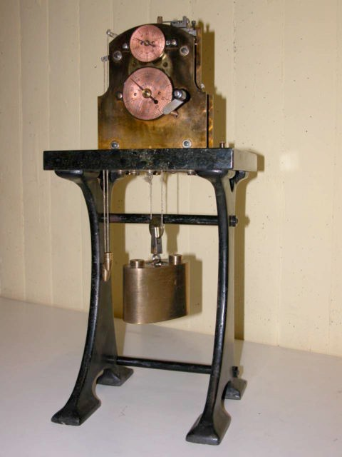

*Figure 36:* The chronoscope of the University of Bonn (Inventory No. HIS-001)

This chronoscope has an impressive story: it was stolen at at an exhibit in May 1998! The police of Bonn tried to find the stolen instrument without success. The police report is published on the Internet [132].

The University of Bonn was my first contact. I am familiar with all details of the instrument and with the theft since 1999. During all these years of research I was optimistic to find some trace leading to the stolen instrument. Eventually, the instrument turned up at Ebay where it was offered as a “chronometer.” My hope is that the police will catch the thief and bring the instrument back to Bonn.

As to the origin of the Zimmermann chronoscopes I have some further thoughts. Perhaps Zimmermann bought special parts like wheels and escapements from the Glashütte factory of and the factory in Leipzig assembled the movements later. This allowed Zimmermann to use his own design for the plates of the movements

Several attempts have been made to find the origin of the Zimmermann chronoscopes, but without success. It will be the task of the future to examine the history of this very interesting firm. This firm is of special interest for the electric horologist, because Zimmermann produced lots of electromechanical instruments for scientific use.

|  |  |  |  |  |
| --- | --- | --- | --- | --- |
| **C-** | **location** | **Signature** | **deatail** | **dated** |
| **3** | USA-Cambridge | E. Zimmermann Leipzig |  |  |
| **6** | USA-Akron/Ohio | E. Zimmermann Leipzig |  |  |
| **12** | CH-private collection | E. Zimmermann Leipzig |  |  |
| **17** | YU-Belgrad | E. Zimmermann Leipzig – Berlin | 371, DRP 209 151 |  |
| **19** | D-Bonn | E. Zimmermann Leipzig – Berlin | Glashütte? Stolen [132] |  |
| **24** | USA-Austin | E. Zimmermann Leipzig |  |  |
| **25** | J-Tohoku | E. Zimmermann Leipzig – Berlin | DRP 209 151, 692Yen | 8.7.1925 |
| **26** | USA-Brunswick | E. Zimmermann Leipzig |  | 1904/1905 |
| **33** | J-Tokyo | E. Zimmermann Leipzig – Berlin | 253, long time | >1919 |
| **34** | D-Leipzig | E. Zimmermann | DRP 209 151 | >1909 |
| **35** | D-Leipzig | E. Zimmermann Leipzig |  |  |
| **36** | D-Leipzig | E. Zimmermann |  |  |
| **37** | CZ-Prag | E. Zimmermann ? | DRP 209 151 |  |
| **38** | CZ-Prag | E. Zimmermann |  |  |
| **42** | D-Passau | E. Zimmermann |  |  |
| **43** | D-Passau | E. Zimmermann Leipzig Berlin |  |  |
| **44** | D-Passau | E. Zimmermann Leipzig Berlin | 180 DRP 209 151 | >1909 |
| **51** | D-private collection | E. Zimmermann Leipzig – Berlin |  |  |
| **54** | I-Firenze | E. Zimmermann Leipzig | [163] |  |
| **64** | J-Kyoto | E. Zimmermann Leipzig | 34 Yen | 1906 |
| **68** | D-Passau | E. Zimmermann Leipzig | 1 dial 40 cm |  |
| **70** | J-Tokyo | E. Zimmermann | 132.33 Yen | 1901 |
| **74** | D-Berlin | E. Zimmermann Leipzig – Berlin | 940 [91],  DRP 209 151, reset 0 |  |
| **78** | D-Würzburg | E. Zimmermann |  |  |
| **82** | NL-Utrecht | E. Zimmermann Leipzig | long running time |  |
| **83** | NL-Utrecht | E. Zimmermann Leipzig |  |  |
| **84** | AUS-Melbourne | E. Zimmermann Leipzig – Berlin | 176 [140]  DRP 209 151 |  |
| **87** | NL-Groningen | E. Zimmermann Leipzig | [39] |  |
| **91** | I-Vicenza | E. Zimmermann Leipzig | [21] |  |
| **92** | IR-Dublin | E. Zimmermann Leipzig | 109 [117] |  |
| **101** | D-private collection | E. Zimmermann Leipzig – Berlin | 961  DRP 209 151 |  |
| **105** | AR-Buenos Aires | Unknown | Zimmermann |  |

Now a few examples of Zimmermann chronoscopes:

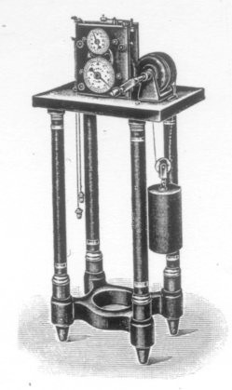

*Figure 37:* Chronoscope offered by Zimmermann with extended running time [08]

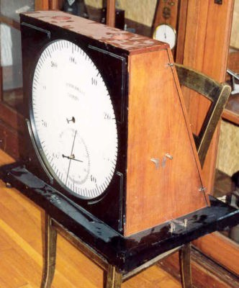

*Figure 38 (a):* Zimmermann demonstration chronoscope (front), Passau (Inv. No. 02034)

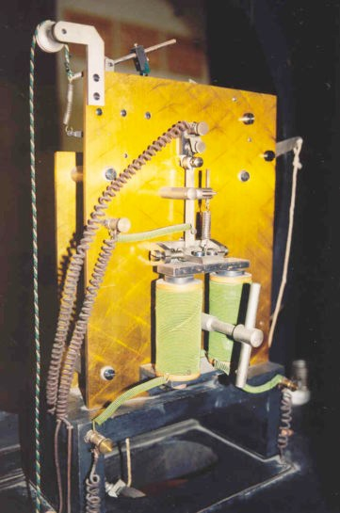

*Figure 38 (b):* Zimmermann demonstration chronoscope (back), Passau (Inv. No. 02034)

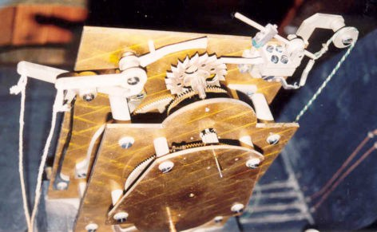

*Figure 38 (c):* Zimmermann demonstration chronoscope (detail), Passau (Inv. No. 02034)

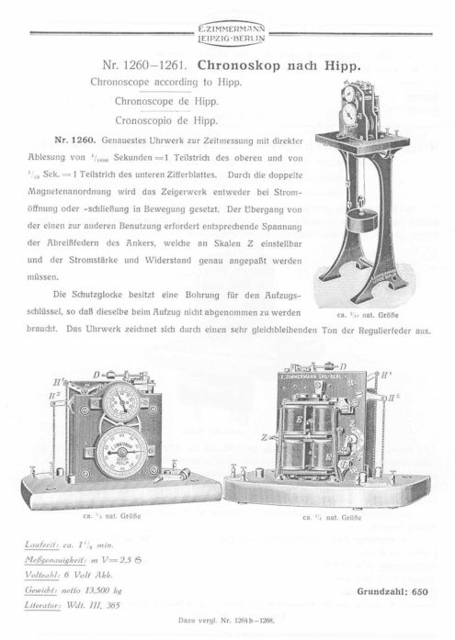

*Figure 39:* Chronoscope in Zimmermann trade catalogue “Liste 50” (1928)

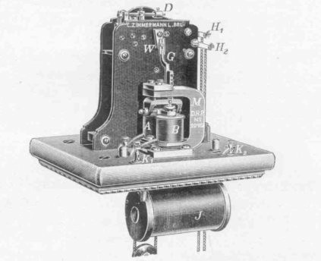

*Figure 40:* Chronoscope as improved by Rudolf Schulze, Leipzig (DRP 209 151)

1. SUMMARY

In total, 107 chronoscopes of the Hipp type have been found. Five of these are only mentioned in the literature. Nobody knows if they still exist today. But Signature, serial number, and/or description prove that these instruments were real.

This means that probably 112 instruments have survived. 17 of them are in private collections. The majority of Hipp chronoscopes is located in collections and museums of psychological institutes. In the collections of clock museums chronoscopes are rarely found. Sorted by country and maker these instrument are distributed as follows:

|  |  |  |  |
| --- | --- | --- | --- |
| **Country** | **pcs.** | **Manufacturer** | **pcs.** |
| America | 19 |  |  |
| Argentinia | 1 | E. Zimmermann | 31 |
| Australia | 3 |  |  |
| Canada | 2 | Hipp Reutlingen | 1 |
| Danmark | 1 | Hipp Bern | 2 |
| Germany | 37 | Hipp Neuchâtel | 24 |
| England | 3 | Peyer, Favarger & Cie | 17 |
| France | 3 | Favarger & Cie | 9 |
| Irland | 1 | FAVAG SA | 10 |
| Italy | 8 |  |  |
| Japan | 4 | Strasser & Rohe | 5 |
| Netherlands | 8 |  |  |
| Switzerland | 9 |  |  |
| Serbia | 1 | self made | 3 |
| Tschechia | 2 | Unknown | 2 |
| + literature | 5 |  |  |

The Hipp Works manufactured 62 of the instruments I have identified. Serial number and signature allow us to date the Hipp instruments more precisely than before.

Hipp made his first chronoscope in 1848. Over the years, Hipp made several efforts to improve the chronoscope. The concluding figures summarize the single steps of this development.

The chronoscope was a most ingenious invention by Matthäus Hipp. It was in use for nearly 130 years. The dimensions of the plates of a few clock movements have been measured and the results indicate that each chronoscope has been made individually.

|  |  |  |  |
| --- | --- | --- | --- |
| **?** | **?** | **1848 -**  **1849** | **1/500 sec**  **Literature only** |
|  |  | **1849** | **1/1000 sec 1 Magnet**  **1 lever**  **M. Hipp Reutlingen**  **Utrecht** |
|  |  | **1850 -** | **1/1000 sec 1 Magnet**  **2 levers with spring**  **M. Hipp**  **Heidelberg Pisa London** |
|  |  | **1860**  **– 1875** | **1/1000 sec 1 Magnet**  **2 levers with string**  **M. Hipp Neuchâtel**  **Krefeld, Palermo, Leiden, Le Locle,**  **Yale** |

*Figure 41 (a):* Development of the Hipp chronoscope: 1848-1875

|  |  |  |  |
| --- | --- | --- | --- |
|  |  | **1875** | **1/1000 sec** |
| **–** | **2 Magnets** |
| **ca.** |  |
| **1927** |  |
|  | **M. Hipp** |
|  | **Peyer, Favarger & Cie** |
|  | **Favarger & Cie** |
|  | **Neuchâtel** |
|  |  | **ca.** | **1/1000 sec** |
| **1927** | **2 Magnets** |
| **-** |  |
| **ca.** |  |
| **1945?** | **Favag SA** |
|  |  | **ca.** | **synchronous motor** |
| **1950** | **1/1000 sec** |
| **-** |  |
| **ca.** | **Favag SA** |
| **1970** |  |
|  |  | **ca.** | **synchronous motor** |
| **1969** | **1/1000 sec** |
| **-** |  |
| **ca.** |  |
| **1975** | **Favag SA** |

*Figure 41 (b):* Development of the Hipp chronoscope: 1875-1975

1. HEARTLY THANKS TO...

Antiquariat Heinzelmann (Stuttgart); Francesco Badalotti (Cremona); David Baker (Akron); Jean Marc Barrelet, (Neuchâtel), Barth (Mannheim); Heinz Bauer (Frankfurt); Norbert Becker (Stuttgart); Erwin Berger (Bad Grund); Berliner Antiquariat (Berlin); Bock (Karlsruhe); Christian Borck (Dreieich); Paolo Brenni (Florenz); Randall Brooks (Ottawa); Ann Brothers (Melbourne); Neil Brown (London); Roberto Cafferelli (Pisa); Lissi Monica and Toni Cantarin (Firenze); Ileana Chinnici (Palermo); Volkhardt Cremer (Berlin); Dale Beeks (USA); Jan Deiman (Utrecht); Herbert Dittrich (Münster); Sue Dixon (Crawley); Sven Ebisch (Berlin); Edgar Erdfelder (Bonn); Rand Evans (Greenville); Elenor Faller (Yale); Giuseppe Ferraro (Palermo); Fleischer (Freiburg); Giorgia Foderà (Palermo); Alfred Fuchs (Bowdoin); Joachim Funke (Heidelberg); Bjarne Funch (Kopenhagen); Wilhelm Füßl (München); Andrea Gaeta (Rom); Martina Gedlich (Dresden); Gemeinhardt (Reutlingen); Corinne Gerling (Strasbourg); Christopher Green (Toronto); Dorothy Gruich (Akron); Horst Gundlach (Passau); Willem Hackman (Oxford); Laura Hamilton (Strathclyde); Günther (Regensburg); Hatayama Toshiteru (Tohotu); Ed Haupt (Montclair); Alan Hawk (Washington DC); Hennig (Hartha); Kurt Herkner (Dormagen); Andreas Hidding (Raesfeld); George Holden (Austin); Julian Holland (Sydney); Hans Hooymayers (Leiden); Vaclav Horejsi (Prag); Birgit Horn (Leipzig); Jan Huismann (Groningen); Ileana Chinnici (Palermo); Jake Kling (Providence); Richard Knerr (München); Krajewski (Bochum); Kuhl (Koblenz); Hans-Jochen Kummer (Ludwigshafen); Linn Mott (Worchester); Löffelmeier (München); Till Lottermann (Mannheim); Gerd Lueer (Göttingen); Klaus Luginsland (Mannheim); Niklaus Maag (Rorbas); Mark McElyea (USA); Christoph Meinel (Regensburg); Annerose Meischner- Metge (Leipzig); Caspar Mierau (Weimar); Alison Morrison-Low; Charles Mollan (Dublin); Eva Moser (München); Neuhoff (Herne); Gerhard Neumeier (Karlsruhe); Clare Newman (London); Serge Nicolas (Paris); James Nye (London); Naoyuki Osaka (Kyoto); Tadasu Oyama (Tokyo); Dave Pantalony (Toronto); Tom Perera (Montclair); Christian Pfeiffer-Belli (Ulm); Wade Pickren (Washington, DC); Jens Plecher (Leipzig); Peter Proctor (Australia); Christophe Quaireau (Rennes); Jean Pierre Rieb (Strasbourg); Eugene Rudd (Lincoln); Ute Saccardi (Stuttgart); Rainer Scheibel (Dresden); Beate Schleicher (St. Augustin); Werner Schmid (Stuttgart); Henning Schmidgen (Berlin); Marion Schneider (Dresden); Karsten Sichel (Leipzig); Rene Stoneham (Melbourne); Sue Dixon (Crawley); Beatrice Techen (Hamburg); Dejan Todorovic (Belgrad und Toronto); Wolfgang Trost (Heidelberg); Steven Turner (Washington, DC); Wolfgang Uhlmann (Chemnitz); Viertel (Chemnitz); Michel Viredaz (Epalinges); Brigitte Vinzens (Winterthur); Erika Voigt (Ilmenau); Geoffrey Walsh (Edinburgh); Jaime Wyss (Dübendorf); Armin Zenner (Dormagen); Roland Zeifang (Dätzingen); Zentralantiquariat Leipzig (Leipzig).

1. LITERATURE

This last part lists all the literature I have found during my research. Not all items listed were used in the paper.

1. Ach, N. *Über die Willenstätigkeit und das Denken. Eine experimentelle Untersuchung. Mit einem Anhange über das Hippsche Chronoskop* (S. 250-294). Göttingen 1905.{detailed report on calibrating the chronoscope}
2. Andersen, H., *Historic scientific instruments in Denmark*. Kopenhagen 1995{pp. 180-181, on chronoscope No. 86}
3. AMUSS (Asociation pour les musées des sciences de Strasbourg), *Objets de sciences*. Exhibition catalog. Strasbourg n.d. {on chronoscope No. 72}
4. Anonymousous, “Chronoskop und Chronograph,” *Uhrmacher Zeitschrift*, 8 (1943): 112-113.
5. Anonymous, “Zur Erinnerung an Matthäus Hipp,” *Schwäbische Kronik*, 25.10.1913 {centenary of Hipp’s birthday}
6. Anonymous, “Dr. Matthäus Hipp” Schwäbische Kronik, 6.5.1893 {obituary on Hipp}
7. Anonymous, “Reutlingen am 2. Oktober 1849,“ *Schwäbische Kronik*, 4.10.1849 {report on Hipp’s chronoscope and chronoscope experiments}
8. Anonymous, [image of chronoscope and tuning fork by Zimmermann], Leipzig o.J. {Archive of the History of American Psychology, University of Akron; chronoscope with extended running time, depicted in Zimmermann’s *Liste 38: Zeitmessinstrumente, Kontrollapparate*, Leipzig/Berlin, 1923}
9. Anonymous, “Wheatstone’s Apparat zum Messen der Geschwindigkeit der Kanonen und Flintenkugeln, des Schalles, der Dauer des Blitzes etc., ” ? (1845) 56 {reproduced from *Comptes Rendus*, 22(1845)}
10. Anonymous, “Regensburg 26. September 1851, “ *Schwäbischer Merkur* (1851), 1336 {report on public demonstration of the Hipp chronoscope}
11. Anonymous, “Ankündigung, dass Hipp einen Telegraphen und ein Chronoskop im Lyceum vorführen wird,” *Regensburger Tageblatt,* Nr. 265, 26.09.1851
12. Anonymous, “Regenburg 26. September 1851,” *Regensburger Tageblatt*, Nr. 269 vom 30. 09.1851

{report on demonstration of Hipp’s instruments}

1. Anonymous, “Lese-Verein, ” *Reutlinger und Mezinger Courier*, 20.1.1847 {announcement of a lecture by Hipp on natural philosophy}
2. Anonymous, “Oberstudienrat a. D. v. Oelschläger ,” *Schwäbische Kronik*, 10. 12.1901
3. Anonymous, “Aus den Lehr- und Wanderjahren Wilhelm v. Oelschlägers,” Schwäbische Kronik, 15.02.1902
4. ATM (Archiv für technisches Messen), “Kurzzeit-Messer”, *Firmenmitteilung J 154-3*, Berlin 1933

{catalog on FAVAG chronoscopes and stop watches}

1. Bauder, K., “Matthäus Hipp der größte Erfinder auf dem Gebiet der Uhrmacherkunst in Verbindung mit der Elektrotechnik”, *Dienstags-Beilage der Süddeutschen Zeitung* 21.10.1913; also in: *Polytechnisches Journal* (1913): 724-727
2. Behrendsen, O., *Die mechanischen Werkstätten der Stadt Göttingen*. Leipzig 1900 {history of the firm Spindler & Hoyer}
3. Benshop, R. & Draaisma, D., “In pursuit of precision: The calibration of minds and maschines in late 19th century psychology,” *Annals of Science* 57(2000): 1-25
4. Bock, H., “Vom Fünftel bis zum Milliardstel der Sekunde,” *Deutscher Uhrmacherkalender* (1938): 83- 109 {general article on short time measurements}
5. Brenni, P., *Orologi e strumenti della collezione Beltrame*. 1996. {pp. 156-157, on chronoscope No. 91}
6. Brown, I., *Erfindungen und Verbesserungen in der Uhrmacherkunst*. Quedlinburg, Leipzig 1854. {pp. 336-338, resume of Oelschläger’s article}
7. Buccola, G., *La legge del tempo dei fenomeni del pensiero*. Milano 1883. {pp. 38-41, 1 plate}
8. Bud, R. & Warner, D. J., *Instruments of Science, an historical encyclopedia*. London, New York: Science Museum, Museum of American History/Smithonian Institute 1998{pp. 110-116, general article on chronoscopes}
9. Cattell, J., “Chronoskop und Chronograph,” *Philosophische Studien* 9(1894): 307-310.
10. Chaponniere, H., *Le Chronographe et ses applications*. Bienne, Besancon 1924. {pp. 14-16; 27-39, general article on short time measurements and all kinds of instruments including chronoscopes}
11. Chew, V.K., “A chronoscopic conundrum,” *AHS Electrical Horological Group, London*, Paper 6 (1971).
12. Cranz, C., *Lehrbuch der Ballistik*. 2. Aufl. Berlin 1927{pp. 129-150; 399, on chronoscope No. 57}
13. Cranz, C., “Vermischte ballistische Notizen,” *Zeitschrift für das gesamte Schieß- und Sprengstoffwesen*

(1908): 7-10

1. Cranz, C., “Über die Hippsche Uhr, eine Erwiderung,” *Zeitschrift für das gesamte Schieß- und Sprengstoffwesen* (1909): 251-253.
2. Cranz, C. & Ritter, F., “Erwiderung,” *Zeitschrift für das gesamte Schieß- und Sprengstoffwesen* (1910): 110-111 {discussion and debate about the Hipp chronoscope}
3. Cremer, V., “Uhrenfabrik L. Löbner, Berlin,” *AU* 2(1990): 35-41 {on the history of the Löbner firm, Berlin; this firm sold chronoscopes as well}
4. Daguin, P. A., *Traité élémentaire de physique théorique et expérimentale*. Toulouse, Paris 1867 {pp. 838- 839}.
5. Decher, G., “Über die Bestimmung der Constanten des Hippschen Chronoskops,” *Polytechnisches Journal* 125 (1852): 12-18.
6. Decher, G., “Über ein neues Relais von M. Hipp, Vorsteher der eidgenössischen Telegraphenwerkstätte in Bern,” *Polytechnisches Journal* (1852)
7. Diel, H., *Psychologische & physiologische Apparate*. Leipzig o.J. {image of chronoscope}
8. Diel, H., *Psychotechnik, Apparateverzeichnis Liste 11*. Leipzig o.J. {in this list a chronoscope is shown, without any further details}
9. Diel, H., *Physiologische und psychologische Apparate*. Leipzig 1911. {pp. 75-77, two models of the chronoscopes are offered}
10. Draaisma, D., *Een laboratorium voor de ziel*. Groningen 1992 {catalog on psychological instruments linked to the laboratory of Gerard Heymans; on chronoscope No. 87, No. 88 and No. 93}
11. Dub, J., *Die Anwendung des Elektromagnetismus mit besonderer Berücksichtigung der Telegraphie*. Berlin 1863. {pp. 548-562, brief chaper on chronoscopes}
12. Du Moncel, Th., Exposé des applications de l’électricté. Paris 1853. {pp. 147-161}
13. Du Moncel, Th., *Exposé des applications de l’électricté, Band IV*. Paris 1872. {pp. 183-302 and plate VI}
14. Edgell, B. & Symes, W., “The Wheatstone-Hipp chronoscope, its adjustments, accuracy and control,”

*Journal of Psychology*, II, pt. I (1906): 59- {the authors state that Hipp sold his first chronoscope in 1843}

1. Eisenlohr, W., *Lehrbuch der Physik zum Gebrauche bei Vorlesungen und zum Selbstunterrichte*. 7. Auflage. Stuttgart 1860. {pp. 646-648, mentions chronoscopes by Hipp und Wheatstone}
2. Eisenlohr, W., Lehrbuch der Physik zum Gebrauche bei Vorlesungen und zum Selbstunterrichte. 6. Auflage. Stuttgart 1852. {pp. 623-625, mentions chronoscopes by Hipp und Wheatstone}
3. Eisenlohr, W., *Lehrbuch der Physik zum Gebrauche bei Vorlesungen und zum Selbstunterrichte*. 5. Auflage. Stuttgart 1849. {pp. 665-666, mentions chronoscopes by Wheatstone}
4. Eisenlohr, W., *Lehrbuch der Physik zum Gebrauche bei Vorlesungen und zum Selbstunterrichte*. 4. Auflage. Stuttgart 1844. {no reference to chronoscopes}
5. Evans, R., *Measuring the mind: scientific instruments in psychology before the electronic age, Sample instrument descriptions*. Greenville 2000 {draft of a book by Rand Evans}
6. Evans, R., “Psychological Instruments at the turn of the century,” *American Psychologist* (2000): 322-325
7. Fairfid, C.M., “The developing technology of apparatus in psychology’s early laboratories,” *Annals of the New York Accademy of sciences*
8. FAVAG, *Präzisions Zeit-Mess-Apparate*. Neuchâtel 1929 {chronoscopes, chronographs, and other devices for short time measurements}
9. FAVAG, *Precision time measuring apparatus*. Neuchâtel 1928 {english version of catalog on chronoscopes, chronographs, and other devices for short time measurements}
10. FAVAG, *Electrical Works Ltd*. Neuchâtel 1931 {english catalog on clocks, chronoscopes, chronographs, and other devices for short time measurements}
11. FAVAG, *FAVAG manufacturers of electric apparatus*. Neuchâtel 1928 {english catalog on clocks, chronoscopes, chronographs, and other devices for short time measurements, with letter by FAVAG}
12. FAVAG, *Das Synchron Chronoskop M430, Beschreibung*. Neuchâtel 1952 {Prospectus P98d}
13. FAVAG, *Chronoscope synchron M 500*. Neuchâtel 1968 {description and product information}
14. FAVAG, *Ergänzung des Synchron Chronoskops M 400 für psychotechnische Prüfungen*. Neuchâtel 1946.
15. FAVAG, *75-jährige Erfahrung*. Neuchâtel 1936 {catalog on clocks, chronoscopes, and scientific apparatuses}
16. Favarger & Cie, *Prix courant illustre de la fabrique de telegraphes et appareils electriques, Catalogue B*. Neuchâtel 1913 {catalog on clocks, chronoscopes, and scientific apparatuses}
17. Favarger, A., Die Elektrizität und ihre Verwerthung zur Zeitmessung. Bautzen 1894. {pp. 220-224}
18. Favarger, A., *Electricite et ses applications a la chronometrie*. Neuchâtel 1924. {pp. 502-507, appendix and plate. VII with many details on the different models of the chronoscope}
19. Finckh, T., *Jubiläumsschrift der Oberrealschule Reutlingen*. Reutlingen 1926. {pp. 66-70, short biography W. Oelschläger}
20. Fischer , C., *Fabrikation wissenschaftlicher Apparate*. Leipzig 1924 {image of chronoscope with no further details}
21. Föderverein Wundt Stiftung, *Von Neckarau bis Großbothen*. Bonn 1994. {pp. 33, photography showing

W. Wundt with chronoscope}

1. Funch, B., *Alfred Lehmann’s Psykofysiske Laboratorium 1886 – 1921*. Kopenhagen 1986
2. Gaeta, A., *Il cronoscopio di Hipp*. Rom 2002.
3. Garden City Model Works, *List of apparatus for the psychological laboratory designed by Jastrow*. Chicago 1894 {description of a wooden case protecting the chronoscope}
4. Ganelli Ernesto, *Fab. D’Orologi per Torri*. Lieferschein. Cremona 1877 {delivery note concerning chronoscope No. 69}
5. Gerhardt, C., Preis-Verzeichnis über physikalische Apparate, Instrumente und Gerätschaften. Bonn 1902.

{p. 99}

1. Gerland, E., *Die Anwendung der Electricität bei registrierenden Apparaten*. 1887 (=Elektrotechnische Bibliothek; Bd. XXXVI).
2. Green, C., *Psychological laboratory of Havard University*. York University, Toronto 2000 {Internet: classics in the history of psychology}
3. Green, C., *Facilities in experimental psychology in the colleges of the United States*. York University, Toronto 2000.
4. Gscheidlen, R., *Physiologische Methodik*. Braunschweig 1876. {pp. 104-122, general chapter on time measurement in physiology}
5. Gundlach, H., “Wundt, Wilhelm,” in *Deutsche Biographische Enzyklopedie*, S. 598-599. München 1999.{short biography}
6. Gundlach, H., “Rationalität und Symbolik: Eine Studie zur Geschichte der Apparate in der Psychologie,”

*Teorie & Modelli* (1997): 75-93.

1. Gundlach, H., “The Hipp chronoscope as totem pole and the formation of a new tribe applied psychology: Psychotechics and rationality,” *Teorie & Modelli* (1996): 65-85.
2. Gundlach, H., “Time measuring apparatus in psychology,” in *A pictorial history of psychology* (S. 111- 116). Chicago, Berlin, London, Tokyo, Sao Paulo 1997.
3. Harzer, F., *Magnetelektrizität als motorische Kraft*. Weimar 1854. {pp. 190-199, chronoscope experiments conducted by Hipp on telegraph lines}
4. Haupt, E. J., “The controvery between G.E. Müller and Wilhelm Wundt over the proper measurement of reaction time,” *Montclair University* {Internet 1999}
5. Haupt, E. J., “The firm and 1903 catalogue of E. Zimmermann,” *Montclair University* {Internet 1999; history of the Zimmermann firm}
6. Helmholtz, H., “Über die Methoden kleinste Zeitteile zu messen und ihre Anwendung für physiologische Zwecke, Vortrag in Königsberg 13.12.1850,” *Königsberger naturwiss. Unterhaltungen II* (1854): 169- 189.
7. Hipp, M., *Prix courant illustre de la fabrique de telegraphes et appareils electriques a Neuchâtel*. Neuchâtel 1869 {french edition, chronoscope “model 75”}
8. Hipp, M., *Illustrierter Katalog der elektrischen Apparate Neuenburger Telegraphenfabrik*. Neuenburg 1869 {german edition, chronoscope “model 75”}
9. Hipp, M., *Prix courant illustre de la fabrique de telegraphes et appareils electriques a Neuchâtel, Section*

*B*. Neuchâtel o. J.[1875-1889] {chronoscope “model 88”}

1. Hipp, M., *Anleitung zum Chronoskop. Reutlingen 5. März 1849* {handwritten instructions concerning chronoscope No. 79 at Utrecht University Museum}
2. Hirsch, A., “Ueber persönliche Gleichung und Correction bei chronographischen Durchgangsbeobachtungen, Vortrag im Februar 1863,” *Untersuchungen zur Naturlehre des Menschen und der Tiere* 9 (1865): 200-208
3. Hirsch, A., “Chronoskopische Versuche über die Geschwindigkeit der verschiedenen Sinneseindrücke und der Nervenleitung, Vortrag am 8.11.1861,” *Untersuchungen zur Naturlehre des Menschen und der Tiere*, 9 (1865): 183-199, 1 plate
4. James Jaquet AG, *Katalog wissenschaftliche Instrumente*. Basel o.J. {offering a FAVAG chronoscope}
5. James Jaquet AG, *75 Jahre Jaquet 1889 – 1964*. Basel 1964 {*Festschrift*}
6. James Jaquet AG, *Enregistruers de temps*. Basel 1961 {catalog on stop watches and short time measurement devices}
7. Johannes-Müller Institut, *Historische Instrumentensammlung*. Berlin o.J. {catalog on instruments kept in the collection of the Institute for physiology; on chronoscope No. 74}
8. Kahlert, H., “Matthäus Hipp in Reutlingen, Entwicklungsjahre eines großen Erfinders (1813-1893),” *Zeitschrift für Württembergische Landesgeschichte* (1989): 291-303. {also as EHG Paper No. 57 (english version, abriged)}
9. Kahlert, H., “Lorenz Bob und Matthäus Hipp,” *Alte Uhren* 4 (1987): 22-30.
10. Keller, W. & Schmid, H. R., “Matthias Hipp,” *Schweizer Pioniere der Wirtschaft und Technik,* 12 (1961): 9-39.
11. Kaltenbach, P., *Die Kurzzeitmesser in Wissenschaft und Praxis*. Berlin 1938. (=Schriftenreihe der Gesellschaft für Zeitmesskunde und Uhrenkunde; Bd. 9) {pp. 19-44, on chronoscope No. 65}
12. Kistner, A., *Die historische Uhrensammlung Furtwangen*. Furtwangen 1925. {p. 96, catalog item 251, on chronoscope No. 20}
13. Kohl, M., *Preisliste 21: Physikalische Apparate*. Chemnitz 1905. {p. 327}
14. Kohl, M., *Preisliste 50, Band II: Physikalische Apparate*. Chemnitz ca. 1925. {p. 1391}
15. Kohl, M., *Preisliste 50, Band IV: Physikalische Apparate*. Chemnitz ca. 1925 {p. 1391, two chronoscopes with iron frame}
16. Kuhn, C., “Über ein Verfahren, um für Feuerwaffen von geringer Tragweite mit Anwendung des Hipp’schen elektromagnetischen Chronoskops die Geschwindigkeit des Geschosses zu bestimmen,” Polytechnisches Journal 136 (1855): 161-168 {including figures}
17. Kuhn, C., *Handbuch der angewandten Elektrizitätslehre, Bd II*. Leipzig 1866. {pp. 1171-1191, extended report on the chronoscope and its development}
18. Kummer, H. J., “Ein Chronoskop von Strasser und Rohde,” *Schriften der FAU,* 33 (1994): 17-19 {on chronoscope No. 63 by Strasser & Rohde}
19. Kummer, H. J., *Ludwig Strasser*. München 1994. {pp. 18-19, on chronoscope No. 63 by Strasser & Rohde}
20. Lang, V., “Bestimmung der Tonhöhe einer Stimmgabel mit dem Hipp`schem Chronoskop,” *Annalen der Physik und Chemie*, 1886
21. Lecoultre, F., “Die Anwendung der Elektrizität bei der Präzisionsmessung von Zeitabschnitten,” in:

*Komplizierte Taschenuhren*. Biel 1985 {FAVAG chronoscopes }

1. Lehmann, A., “Antrag auf Bewilligung von Geldmitteln für die Anschaffung eines Hippschen Chronoskops für das psychologische Laboratorium,” Kopenhagen 22. 1. 1887 {on chronoscope No. 86, furnished by Krille, Leipzig}
2. Lepin & Masche, *Liste D 31 Physik*. Berlin o.J. (ca. 1915) {p. 9, also offers a chronoscope}
3. Lenard, P., *Inventarverzeichnis des physikalischen Institutes der Universität Heidelberg*. Heidelberg 1913.
4. Leybold’s Nachfolger, *Einrichtungen und Apparate für den physikalischen Unterricht*. Köln ca. 1911 {pp. 60-61, offers a chronoscope}
5. Löbner, *Löbner-Chronoskop nach Hipp-Wheatstone Modell 21*. Berlin o.J.
6. Löbner, F. L., *Katalog*. Berlin ca. 1912 {inventory of all available clocks and chronoscopes}
7. Löbner, F. L., *Prospekt Tertienuhren, Chronoskope*. Berlin ca. 1900
8. Loir, M., “Etude des Chronoscopes et chronographes electrobalistiques,” *Annales* (1860): 284-300, 497- 525 + 1 Tafel {general article on chronoscopes, but the Hipp chronoscope did not play any significant role in France}
9. Meinel, C., Hg., *Instrument-Experiment: Historische Studien*. Berlin, Bassum 2000 {articles on historical instruments of all kinds; contains Henning Schmidgen’s study on the genealogy of reaction time experiments}
10. Meyers, *Conservationslexikon,* 1889 {pp. 153-156, “Chronoskop”}.
11. Mierau, C., “Matthias Hipp und das Hippsche Chronoskop,” Bauhaus Universität Weimar 2002

{undergraduate dissertation, seminary directed by Henning Schmidgen, MPIWG, Berlin}

1. Mollan, C., *An inventory of historic scientific instruments in institutional collections*. Dublin 1990. {p. 160, on chronoscope No. 92 made by Zimmermann}
2. Nicolas, S., “On the speed of different senses and nerve transmission by Hirsch, 1862,” Psychological Research (1997): 261-268 {english translation of Hirsch’s french article }
3. Nicolas, S., “Benjamin Bourdon (1860-1943),” in: *1896 – 1996 Centaire du laboratoire de psychologie experiementale*. Rennes 1996. {pp. 23-56, list with dates concering the foundation of psychological laboratories}
4. Oelschläger, W., “Das Hippsche Chronoskop zur Messung der Fallzeit eines Körpers und zu Versuchen über die Geschwindigkeit der Flintenkugeln,” *Polytechnisches Journal* 114 (1849): 255 + 1 Tafel {second article, gives results of experiments and describes the instrument}
5. Oelschläger, W., “Das Wheatstonsche Chronoskop verbessert von Uhrmacher Hipp in Reutlingen,”

*Polytechnisches Journal* 110 (1848): 184-187 {first article with short report on results of experiments}

1. Oelschläger, W., “Über das Hipp’sche Chronoskop zur Messung kleiner Zeiträume,” *PCB* (1850): 289- 291, 1 plate.
2. Oxford Museum of history and science, *New Acquisition: Experimental psychology instruments*. Oxford 2000 {Internet: chronoscope No. 56 made by FAVAG, additional information on the C. F. Palmer firm}
3. Palmer, C.F., *Research and students apparatus for physiology, pharmacology, psychology...* London 1934

{p. 146: offers chronoscopes made by FAVAG}

1. Parot, F., “Les instrumentes d’expérience à l’aube de la psychologie éxperimentale in 1896-1996,” In:

*Centaire du laboratoire de psychologie expérimntale*. Rennes 1996

1. Perera, T., *Reaction timing instrumentation*. Montclair University, Department of Psychology 1999.
2. Perera, T., *The Barnard College Psychology Department, History of psychology collection*. New York City 2000 {Internet, information on the collection of historical instruments, on chronoscope No. 10}
3. Peyer, Favarger & Cie, “Letter to the Deutsche Museum Munich, dated: Neuchâtel, 5.12.1905” {on chronoscope No. 2}
4. Peyer, Favarger & Cie, “Letter to the Deutsche Museum Munich, dated: Neuchâtel, 15.3.1906” {on chronoscope No. 2}
5. Peyer, Favarger & Cie, *Peyer, Favarger & Cie a la exposition universelle de 1900 a Paris. Notice pour messieurs les membres du Jury des classes 21, 27, 32*. Neuchâtel 1900
6. Peyer, Favarger & Cie, *Catalogue B: Appareils scientifiques*. Neuchâtel 1902.
7. Polizei Bonn, *Pressemitteilung vom 8.5.1998 zum Diebstahl des Chronoskops der Bonner Universität* {on chronoscope No. 19}
8. Poppe, A., “Über die Anwendung des electromagnetischen Chronoskops zur Ermittlung der Geschwindigkeit von Geschossen,” *Jahresbericht des physikalischen Vereins 1852 – 1853*, Frankfurt/M. (1853) 15, 31-41; *Polytechnisches Journal* 132 (1854): 259, 1 plate.
9. Popplestone, J., *An illustrated history of american psychology. The university of Akron* (o.J.). {p. 20, description of two chronoscopes}
10. Popplestone, J., *The great catalog of the C.H. Stoelting Company 1930-1937*. Reprint. New York (o.J.)

{pp. 84-85}

1. Ritter, F., “Über die Hippsche Uhr,” *Zeitschrift für das gesamte Schieß- und Sprengstoffwesen* (1909): 161-164; 185-190. {detailed description of and instructions concerning the Hipp chronoscope made by Löbner}
2. Schmidgen, H., “Zur Genealogie der Reaktionsversuche in der experimentellen Psychologie,” In Christoph Meinel (ed.), *Instrument-Experiment: Historische Studien* (pp. 168-179). Berlin, Diepholz: Verlag für Geschichte der Naturwissenschaften und der Technik, 2000.
3. Schneebeli, H., “Ueber die Anziehungs- und Abreißungszeit der Elektromagneten,” *Annalen der Physik und Chemie* 155 (1875): 156-164; 615-624 + 1 Tafel {improved Hipp chronoscope for the first time mentioned in the literature}
4. Schneebeli, H., “Einige Bemerkungen über den Hippschen Fallapparat,” *Annalen der Physik und Chemie*

135 (1874): 466-499.

1. Schraven, T., *Chronoscope at University of Melbourne, Medical History Museum*. Krefeld 2002 {chapter for exhibition catalog, on chronoscope No. 84 by Zimmermann}
2. Schraven, T., “Chronoskop, Chronoscope, Cronoscopio – Eine Spurensuche im Internet”, *Uhrenhanse,*

2001 {report on research done in the Internet}

1. Schreiber, A., “Das Prüflaboratorium für Berufseignung bei den Königlich Sächsischen Staatseisenbahnen,” *VDI Zeitschrift* (1918): 446-451.
2. Schulze, R., *Aus der Werkstatt der experimentellen Psychologie und Pädagogik mit besonderer Berücksichtigung der Methoden und Apparate*. Leipzig 1909. {pp. 136-138; 212-214, appendix I: a fabolous book on instruments in experimental psychology}
3. Schulze, R., *Aus der Werkstatt der experimentellen Psychologie und Pädagogik*. 3. Auflage. Leipzig 1913. {pp. 171-176; 266-272}
4. Schulze, R., “Chronoskop nach Hipp,” *DRP 209 151* (19099 {improvement of the Hipp chronoscope}
5. Sokal, M., “A national inventory of historical psychological apparatus,” *Journal of the history of the behavioral sciences*, 11 (1975): 284-286.
6. Sokal, M., “Laboratory instruments in the history of psychology,” *Journal of the history of the behavioral sciences* 12(1976): 59-64.
7. Sommer, R., “Die Messung der Zeit bei psychologischen Versuchen,” in: *Ergebnisse der Psychologie*

(pp. 671-698). Wiesbaden 1903,

1. Sommer, R., *Experimental-psychologische Apparate und Methoden. Die Ausstellung bei dem Kongreß für experimentelle Psychologie, Gießen 1904*. Leipzig 1904 and Reprint Passau 1984
2. Spindler & Hoyer, *Apparate für psychologische Untersuchungen, Preisliste XXI*. Göttingen 1921. {pp. 1- 15}
3. Spindler & Hoyer, *Apparate für psychologische Untersuchungen, Preisliste XXI*. Göttingen 1908. {p. 5}
4. Sternwarte Strasbourg, *Inventarverzeichnis*. Strasbourg o.J., {note on chronoscope und drop apparatus; on chronoscope No. 72}
5. Stoelting, C. H. Co., *Apparatus, tests and supplies, for psychology, psychometry*. Chicago 1930. {pp. 84- 85: offers the “Münsterberg Chronoscope”}
6. Strasser & Rohde, *Foto eines Chronoskops, Wandmodell*. Glashütte o. J. {photography received by Prof. Dittrich, on chronoscope No. 60}
7. Strasser & Rohde, *Geschäftsbuch*. Glashütte 1941 –1942 {from H. J. Kummer, two notes on chronoscopes}
8. Strasser & Rohde, *Zeitmessanordnung mit dem Hippschen Chronokop*. Glashütte o.J. {one page form a more extended prospectus}
9. Strobel, E., “Wilhelm Eisenlohr,” *Soweit der Turmberg grüßt* 11 (1950): 33-34 {on Eisenlohr}
10. Titchener, E., *Experimental Psychology: A manual of laboratory practice*. New York, London 1905. Reprint{pp. 326-351}
11. Titchner, E., *Photograph Album on psychological instruments*. 1895. {pp. 22; 30; 40, various photographs of chronoscopes}
12. Universität Passau, *Short time measurement in early experimental psychology*. Passau (2000) {prospectus on the exhibit in Kloster Irsee, 17.-22.7.2000}
13. Universität Passau, *Reaction Time Measurement*. Passau 2000 {very nice poster with experimental set up for reaction time measurement}
14. Universität Stuttgart, *Festschrift zum 150jährigen Bestehen der Universität Stuttgart*. Stuttgart 1979. {pp. 62-65; 196-19; 202-205; 226-227; 242-243; 248-251, on Eduard Reusch}
15. Universität Firenze, *Misua d’uomo, strumenti, teorie e practice dell’antrometria e della psicologia sperimentale tra 800 e 900*. Firenze o.J. {p. 104: exhibition catalog published by the psychological institute; on chronoscope No. 54 made by E. Zimmermann}
16. Vaughan, D., “A note on the tuning fork;” *Bulletin of the Scientific Instrument Soc*. 18 (1988): 18-19.
17. Volckmar, F. & Staakmann, L., *Lehrmittelnettokatalog*. Leipzig, Berlin, Stuttgart (1914) {pp. 92-94: offers chronoscope (on the stand: “E. Zimmermann”)}
18. Döll, J. C., *Badische Biographien Band 1*. Karlsruhe 1881. {pp. 223-226, on Wilhelm Eisenlohr}
19. Von Weech, F., *Geschichte der Stadt Karlsruhe und ihrer Verwaltung*. Karlsruhe 1895. {pp. 114-115, on the telegraphic installation made by Wilhelm Eisenlohr}
20. Wächter, F., *Anwendung der Elektrizität für militärische Zwecke*. Wien, Leipzig 1904

{=Elektrotechnische Bibliothek; Bd. 15).

1. Weber, R., “Kleine Mitteilungen: M. Hipp †”, *ETZ* (1893): 323-325, 715 {Robert Weber was professor of physics in Neuchâtel from 1879 to 1907}
2. Wenzel, J., “Ältere Uhren und Geräte zum Messen von Sekundenbruchteilen,” *Klassik Uhren* 2 (1995): 39 {general article on short time measurements}
3. Wheatstone, C., “Über das elektromagnetische Chronoskop,” *Annalen der Physik* 65 (1845): 451;

*Polytechnisches Journal* 97 (1845): 186-192.

1. Wundt, W., “Chronoskop und Chronograph,” *Philosophische Studien* 8 (1893): 653-654 {on the chronoscope delivered to the Leipzig Institute. As supplier figures the form of Krille at Leipzig}
2. Wundt, W., *Grundzüge der physiologischen Psychologie*. 6. Auflage. Leipzig 1911. {pp. 365-377: detailed description of the chronoscope}
3. Zimmermann, E., *Preisverzeichnis über Apparate zu psychologischen und physiologischen Experimenten*. Leipzig 1894 {p. 7: offers a demonstration chronoscope}
4. Zimmermann, E., *XVIII. Preisliste über psychologische und physiologische Apparate*. Leipzig 1903. {p. 32}
5. Zimmermann, E., *Psychologische und physiologische Apparate, Liste 20*. Leipzig 1908. {p. 76-81}
6. Zimmermann, E., *Psychologische und physiologische Apparate, Liste 25*. Leipzig, Berlin 1912. {p. 80- 83}
7. Zimmermann, E., *Psychologische und physiologische Apparate, Liste 50*. Leipzig, Berlin 1928. {p. 110- 113}
8. Zimmermann, E., *Psychotechnische Apparate, Liste 51*. Leipzig, Berlin 1929.
9. Zimmermann, E., Liste *200, psychologische und physiologische Apparate*. Leipzig 1937. {p. 17}
10. Zöllner, W., *Chemnitz am Ende des 19. Jahrhunderts*. Chemnitz 1900. {pp. 233-239, on the history of the Max Kohl firm}
11. FAVAG, *Das Synchron Chronoskop M430, Anwendungen*. Neuchâtel 1952 {Prospectus P99d}
12. FAVAG, *Synchron Chronoskop M430, Gangzeugnis für 591974*. Neuchâtel 1959 {on chronoscope No. 71}
13. FAVAG, *Das Synchron Chronoskop M430, Unterhaltsvorschriften*. Neuchâtel 1958.
14. FAVAG, *Synchron Chronoskop M430, Gangzeugnis für 620632*. Neuchâtel 1962 {on Chronoskop No. 106}
15. Klöter Auktionshaus, *Katalog zur Auktion am 8.10.1983* {p. 35, No. 377}
16. *Mitteilung des Deutschen Museums*, Mai 2000.
17. Zimmermann, E., *Liste 33 Psychotechnik*. Leipzig, Berlin 1923. {pp. 29-33; 75-76}
18. Zimmermann, E., *Liste 38 Zeitmessinstrumente Kontrollapparate*. Leipzig, Berlin 1923). {pp. 7-14}