Matching Spirits Supply to Demand in Iowa
  - Decision support for the Iowa Alcoholic Beverages Division. ADS End-Term Project, Final Report
Group 1: Darshita Yadav (240981) · Raghav Yadav (240598) · Rayna Manchanda (240601) · Prerit Shrivastava (240593)
November 2026
Contents
Executive summary 2
1. Problem definition (BADIR: Business question) 3
1.1 What changed from the pre-submission, and why 3
2. Research questions and hypotheses 4
3. Data (BADIR: Data) 5
3.1 Sources and provenance 5
3.2 Integration: the single source of truth 5
3.3 Data quality: problems found and how each was treated 5
4. Exploratory analysis: observation → inference → decision 7
5. Methods (BADIR: Analysis plan) 8
6. Hypothesis results (BADIR: Insights) 9
6.1 H1: cross-border leakage 9
6.2 H2: regional mix 10
6.3 H3: new licences mostly redistribute sales 10
6.4 Association vs causation 11
6.5 Twenty exploratory hypotheses (H4–H23) 11
7. The decision-support solution: next-month forecast (BADIR: Recommendation engine) 14
7.1 Set-up 14
7.2 Approaches compared and why the final one was chosen 14
7.3 Calibrated uncertainty 15
7.4 Business value and service-level planning 15
8. Recommendations 16
9. Production and Responsible AI 17
10. Impact, limitations and assumptions 18
11. Implementation roadmap 18
12. Surprise scenarios 19
Appendix: reproducibility 19

Executive summary
Stakeholder and decision. The Iowa Alcoholic Beverages Division (ABD) is the state’s only wholesaler of spirits. It buys from suppliers, holds the stock in one central warehouse, delivers to about 2,240 licensed retailers and issues their licences. Each month it must decide how many liters of each spirits family to buy and truck to each region before stores order. The simple rule a planner can use today, plan from the same month last year, ignores where and why demand differs, and in 2026 it over-plans in a market that is shrinking by about 3% a year.
Data. A single source of truth of 4,518,330 order lines × 76 variables. It integrates the Iowa Data Hub spirits sales for 2025 and Jan–Oct 2026, US Census ACS 2020–24 county profiles, Census county adjacency and Gazetteer files, and the Tax Foundation’s 2026 state spirits-tax table. These are five official sources from four independent publishers.
What the evidence shows (hypotheses pre-registered before any 2026 outcome was examined; 2026 used as an out-of-time confirmation sample):
- H1, cross-border leakage: supported. Counties bordering Missouri, where spirits are taxed at $2.00/gal against Iowa’s implied $15.14, buy ~44% fewer liters per adult than comparable counties (95% CI 25–58%). The shortfall fades with distance from the border. It replicated exactly from 2025 to 2026 and survived permutation tests, trimming, population weighting and measurement in dollars. The sales at stake are about $5.9M a year (≈$2.0M of ABD margin), an association-based upper bound.
- H2, regional mix: supported. Agave share rises with the Hispanic share of a county, out-of-time.
- H3, new licences mostly move sales rather than create them: supported (difference-in-differences). Existing stores lose ~13% of their volume when a genuinely new store opens nearby. Small incumbents lose ~21%. About 60% of the newcomer’s volume is diverted from them.
- Forecast. An ensemble of a tuned gradient-boosting model and a calendar-adjusted seasonal naive cuts planning error by 20% (county level) to 27% (warehouse level) against the status quo on an untouched Jul–Oct 2026 test. Bias is +2% (status quo +6.5%) and the prediction intervals are calibrated. For the same 95% service level that means ~25% less warehouse safety stock (≈$0.7M of working capital) and an end to the status quo’s systematic over-buying (≈84,000 L a month).
- Twenty exploratory hypotheses (H4–H23): 10 supported, 3 partial, 7 rejected (§6.5). The most useful for planning: orders after a state price cut arrive the month after the cut (+49%), not during it; about 40–50% of a new outlet’s volume is new demand, matching H3 from an independent method; a shop that changes owner keeps 92% of its volume; a new store’s opening order is 1.86× its normal level; and the “old counties drink Canadian whisky” pattern is really rurality, not age.
Recommendations (§8): plan with the forecast at service levels set by cost, stocking promotions for the month after a price cut; plan by delivery days and the occasion calendar; drop per-capita norms in a ~30-mile southern band; forecast new licensees from peer stores and ownership changes from their predecessor; report the border revenue gap and the net-new demand of new outlets; set regional mix from local drivers; fix publisher data defects; and roll out through a randomised regional pilot with monthly monitoring.

1. Problem definition (BADIR: Business question)
Stakeholder | Iowa ABD supply-chain and planning team (primary); ABD licensing; the legislature (revenue, H1)
Problem | Stock and delivery capacity are committed before stores order; demand varies sharply by county, store format, season and calendar; the market is drifting down
Decision | Liters per spirits family per county (and store) next month; how to treat border counties and new licensees
Objective | Fewer stock-outs and less dead stock, without promoting consumption (ABD is also the regulator)
KPI | WAPE at county × family ≥10% lower than the status quo, with absolute bias ≤3% (pre-registered); safety stock and working capital
Constraints | Public data only; one state price (ABD cannot price by region); county-level census data; 22 months of history

1.1 What changed from the pre-submission, and why
Pre-submission | Problem found | Final project
ABD sets a “stocking profile” for each county or store | ABD does not stock stores: licensees order what they want. ABD’s real decisions are procurement, delivery capacity and licensing. | Reframed around those three decisions
H1: bigger counties buy more per adult | Sales are recorded where the store is; the lowest-buying counties all border Missouri | H1 now tests the mechanism (cross-border leakage)
H3 income → premium, H4 young adults → RTD | Rejected or confounded in our own pre-submission notebook | Dropped and reported as negative findings
14 data-mined candidates, “confirmed” on the other half of the same year | A pattern seen in the full year is by construction visible in each half; the brief asks for 2–3 hypotheses | 3 pre-registered hypotheses, confirmed on new 2026 data
K-means county clusters | Not in the course handout, and segments do not answer a quantity decision | Replaced by a forecast with SHAP explanations
Recommendation 3: flag high-volume counties for public-health review | High per-adult volume mostly marks hubs and tourism (Dickinson, the lakes), not heavy drinking | Replaced by the H3 licensing evidence
Truncated liters in Nov–Dec 2025 | Also Jan 2026, and dollars and prices too; multi-pack minis recorded as single 50 ml bottles; 55 “new” stores that are ownership changes | All detected, fixed or flagged (§3.3)
99-row county regressions compared with random forests | n = 99 cannot support ML, and the comparison did not inform a decision | Panel forecast on 409,000 store × family × month rows

2. Research questions and hypotheses
RQ1. Why does per-adult spirits buying differ so much between counties, and should ABD plan with per-capita norms? RQ2. Do licensing decisions change total demand or only redistribute it? RQ3. Can ABD plan next month’s volumes materially better than “same month last year”?
The hypotheses, tests and decision rules were written in reports/pre_registration.md before any 2026 outcome was computed. 2025 is the discovery sample and Jan–Oct 2026 the confirmation sample.
- H1, cross-border leakage. H1a: Missouri-border counties buy fewer liters per adult, controlling for population, income, age and education. H1b: the larger the tax gap to the cheapest neighbour, the fewer liters per adult. H1c: the shortfall concentrates in 1.75 L “stock-up” bottles. H1d: counties next to a much bigger Iowa county buy less.
- H2, mix. A larger Hispanic share goes with a larger agave (tequila/mezcal) share.
- H3, entry. When a genuinely new store opens in a city, incumbents order less, so the city grows by less than the newcomer’s volume.
Decision rule (H1/H2): HC3 and permutation p < 0.05 on 2026, and the sign holds after removing influential counties and with population weights. H3: negative post-entry effect (p < 0.05), jointly insignificant pre-entry coefficients, and a placebo.
Exploratory hypotheses H4–H23. After the pre-registered tests, we tested twenty further hypotheses in four themes: geography and culture, the cultural calendar, prices and economics, and market structure and store behaviour. They are exploratory, not pre-registered. Each states its direction before its test; county patterns count as supported only if they hold in both Jan–Oct 2025 and Jan–Oct 2026; and a Holm-corrected p-value is reported for multiple testing. Results are in §6.5.

3. Data (BADIR: Data)

3.1 Sources and provenance
Source | Publisher | Coverage | Size | Role
Iowa Liquor Sales 2025 (dataset 1262) | Iowa Data Hub, Alcohol & Tax Operations | Jan–Dec 2025 | 2,490,620 rows | orders, discovery
Iowa Liquor Sales 2026 (dataset 1263) | same | Jan 1–Oct 30 2026 | 2,029,764 rows | orders, confirmation and test
ACS 5-year 2020–24, 16 tables | US Census Bureau | 99 counties | 22 variables | demographics
County adjacency + Gazetteer 2024 | US Census Bureau | 99 counties | 15 variables | borders, area, distance
State spirits excise, Jan 2026 | Tax Foundation (cross-check FTA) | IA + 6 neighbours | 7 rows | tax gap
Every download link, date and licence is listed in data/links.txt. Row counts were checked against the publisher’s API (numRows): both years match exactly.

3.2 Integration: the single source of truth
scripts/01_build_ssot.py rebuilds the SSOT from the raw files in about a minute. Census and geography are joined on the 5-digit county FIPS code (many-to-one, validated, 100% matched); store attributes are joined on store_no, which is stable across both years (2,078 stores appear in both). Units are liters and US dollars. The result is 4,518,330 rows × 76 columns: 35 sales fields (published, derived and QA), 22 census, 15 geography and tax, and 4 store attributes. It is stored as Parquet and loads in seconds.

3.3 Data quality: problems found and how each was treated
Issue | Size | Treatment
2025 download contained a duplicated fifth part | 429,989 rows | excluded; parts 1–4 equal the publisher count
Exact duplicate rows within the published data | 21 rows | removed
Blank county | 4,135 rows | 2,102 filled from the store’s only county; 2,033 dropped (0.05%)
Liters truncated to whole numbers in Nov–Dec 2025 and Jan 2026 | −3.4% in those months | liters recomputed as bottles × bottle size (matches the source in 100% of clean-month rows)
Dollars and prices truncated in the same months | −0.4% | rebuilt from each item’s price in the nearest clean month; validated on Oct-25 from Sep-25 prices: −0.08% error
Multi-pack minis: one “bottle” = a sleeve, dispenser or bucket of 50 ml minis | 313 items, 4% of dollars; ~2% of liters understated | flagged, kept at recorded liters (ABD’s own convention), excluded from price metrics; H1 re-tested in dollars
New licence at an existing address | 55 stores | classified as ownership changes, not entry (critical for H3)
Category names renamed between years | 4 categories | keyword-based family mapping; tracked as schema drift
Blank cost/retail price Jan–Jun 2025; invoice-ID grain change Sep 2025 | 1.2M rows | price derived from dollars ÷ liters; invoice ID never used as a key
Wholesale cost truncated to whole dollars in Nov 2025–Jan 2026 (e.g. 6.74 → 6.00) | ~900 items look “on sale” | price-change tests (H13, H14) use only clean-price months (Jul–Oct 2025, Feb–Oct 2026)
Returns (negative bottles) | 4,019 rows | kept as negative volume; excluded from prices; forecast target clipped at 0
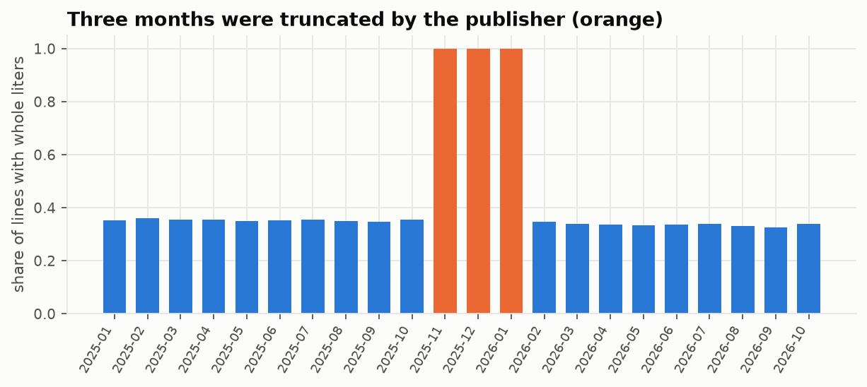
The publisher truncated liters in three months (orange); liters are recomputed.
Representativeness. Rows are retailers’ purchases from ABD, recorded where the store is. County figures therefore combine residents’ demand with cross-county and cross-border shopping (the subject of H1). The census profile is a 2020–24 average applied to 2025–26.

4. Exploratory analysis: observation → inference → decision
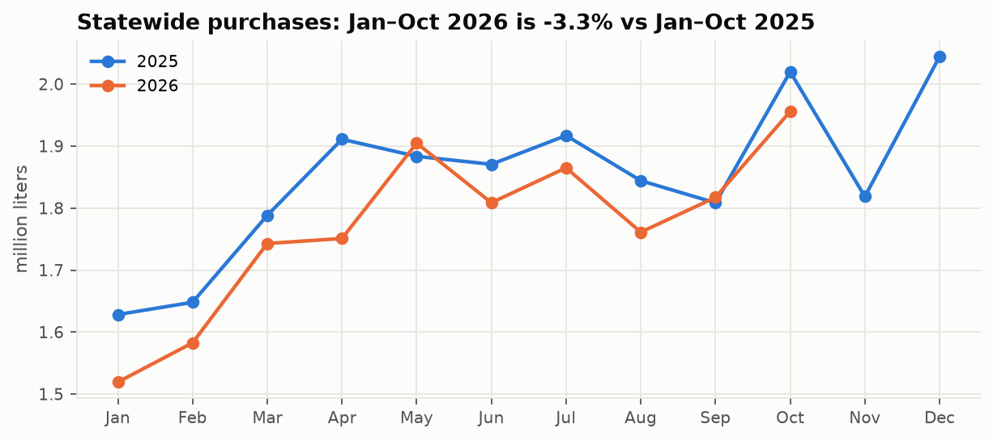
Statewide purchases, 2026 vs 2025.
Market drift. Jan–Oct 2026 is about 3% below 2025, and lower in 8 of the 10 months. Inference: a plan copied from last year over-buys. Decision: this is the status quo to beat and a drift to monitor.
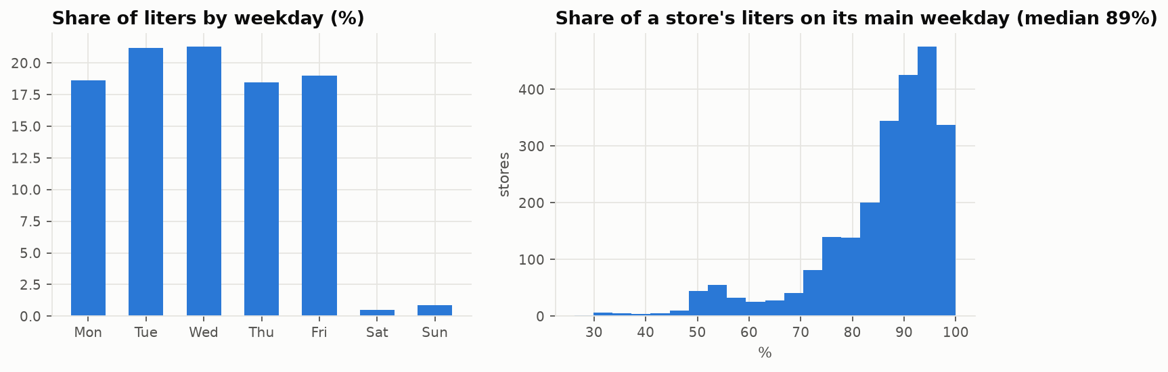
Weekday ordering.
Calendar. The median store places 89% of its liters on one weekday. Inference: a month with five of a store’s order days carries about 25% more volume than one with four, so much of the monthly “noise” is calendar. Decision: plan capacity by delivery days; the calendar becomes a forecasting feature.
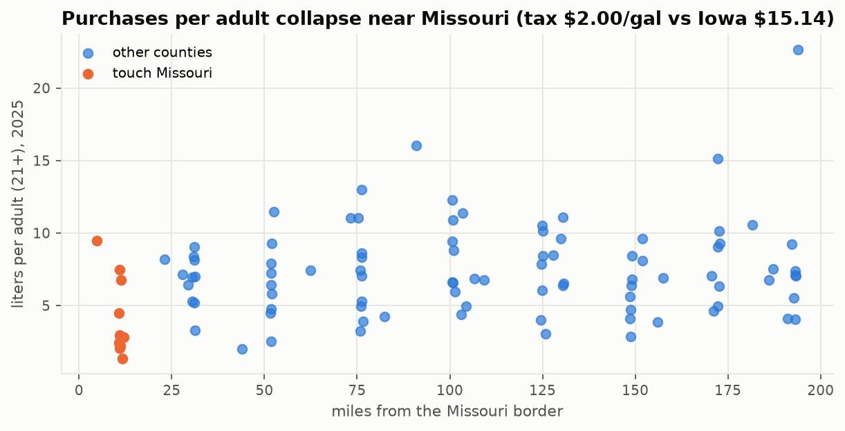
Liters per adult vs distance from Missouri (2025).
Border. The ten Missouri-border counties buy about half as much per adult. Inference: cross-border shopping into a state with a far lower spirits tax. Decision: per-capita norms are wrong for the southern tier (→ H1).
Entry. About 15 genuinely new stores start ordering every month, plus 55 ownership changes over the period (→ H3). Mix. Agave share rises with the Hispanic share of the county (→ H2).

5. Methods (BADIR: Analysis plan)
Course unit (handout) | Used for | Where
Problem framing, KPI and metric design | decision, KPI, WAPE and bias, value translation | §1, §7
Hypothesis testing | OLS with HC3 errors, Freedman–Lane permutation tests, bootstrap CIs, influence and weighting checks, out-of-time replication | §6, notebook 02
Causal inference: difference-in-differences | stacked event study for store entry, pre-trend test, placebo, cluster bootstrap | §6.3
Hypothesis testing (exploratory) | Moran’s I, hinge regression, Wilcoxon and Mann–Whitney tests, item × month fixed effects, rarefaction, Zipf fit, Jensen–Shannon distance, AUC, Holm correction | §6.5, notebook 05
Data engineering: ETL, warehousing | reproducible ETL, SSOT, Parquet, data-quality gates | §3, scripts/
Advanced ML | feature engineering (lags, calendar, competition), ensemble learning, gradient boosting (XGBoost, Tweedie), random-search HPO, interval calibration | §7, notebook 03
Decision intelligence: optimisation | newsvendor service-level planning | §7.4
MLOps | MLflow tracking (43 runs), FastAPI service, Dockerfile, PSI drift and error monitoring, retrain rule | §9, notebook 04
Responsible and explainable AI | SHAP, fairness audit by county group, sensitive-feature decision, privacy review | §9, notebook 04
Considered and not used, and why (the brief: do not force a method). Spark: the data fit in memory; it is the scale-up path if ABD’s full 2012– history (~30M rows) is used. A/B testing: no intervention was under our control, so it is proposed for the roll-out instead (§8). Propensity matching, regression discontinuity, uplift: no suitable treatment or cut-off (a border discontinuity would need Missouri-side data). Deep learning and transformers: monthly tabular data, nothing to gain. Reinforcement learning: no sequential control problem. K-means: not in the handout. LIME: TreeSHAP is exact for tree models.

6. Hypothesis results (BADIR: Insights)

6.1 H1: cross-border leakage
Test (2026, unseen) | Effect | HC3 p | Permutation p | Trimmed p | Weighted p | Verdict
H1a Missouri border → log L/adult | −0.585 (−44%) | <0.001 | <0.001 | <0.001 | 0.001 | Supported
H1a in dollars per adult | −0.512 (−40%) | <0.001 | <0.001 | <0.001 | 0.001 | robust
H1b tax gap → log L/adult | −0.022 per $ | 0.005 | 0.003 | 0.009 | 0.21 | Inconclusive
H1c fewer 1.75 L handles | −7.2 pts | 0.045 | 0.007 | <0.001 | 0.23 | Inconclusive
H1d bigger Iowa neighbour | −0.060 | 0.10 | 0.10 | 0.04 | 0.05 | Not supported
The 2025 estimate was −0.559, almost identical. The ordering of border groups follows the tax gap: median liters per adult in 2026 is MO 2.6, NE 5.5, SD 5.9, WI 6.2, MN 7.1, IL 7.5 (interior 6.4). H1b and H1c pass three of four checks but fail the population-weighted fit, which a few large counties dominate, so they are reported as inconclusive, as the rule requires.
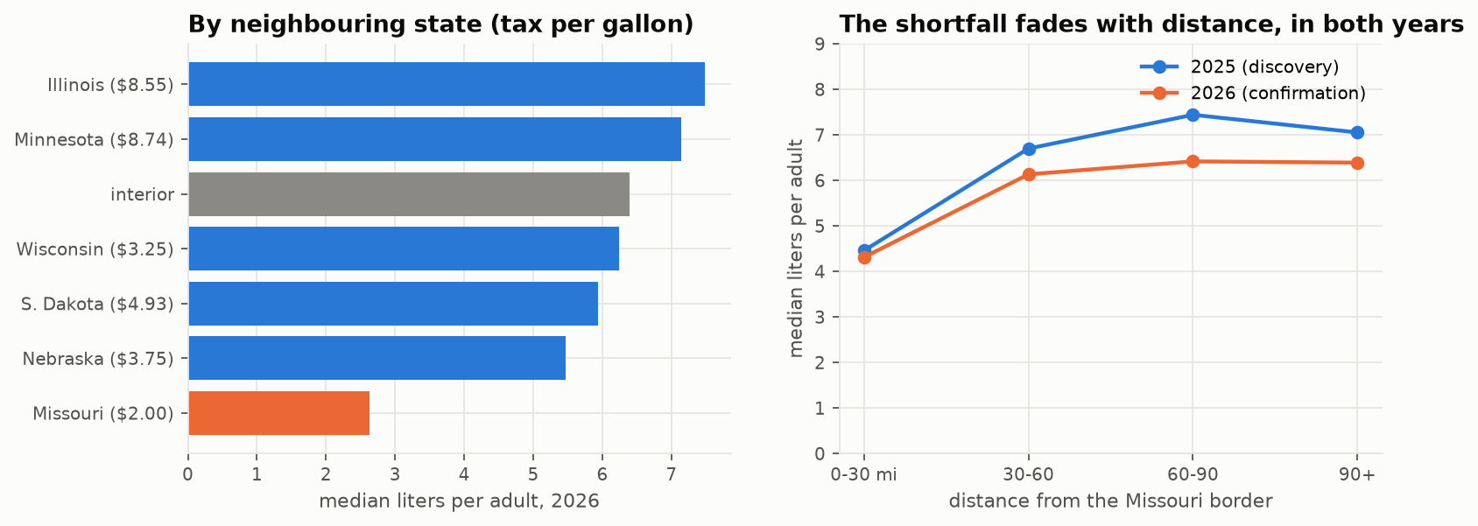
H1: border groups (left) and distance gradient (right).
What is at stake. If the ten Missouri-border counties bought at the rate predicted for comparable counties, Iowa stores would sell ~319,000 more liters a year: $5.9M at state retail price (95% CI $2.5–10.5M), about $2.0M of ABD gross margin (margin 33.4%, from 2026 cost vs retail prices). This is an upper bound: part of the gap may be lower consumption rather than purchases in Missouri.

6.2 H2: regional mix
Agave share rises by 0.8 percentage points per 10 points of Hispanic population (2026; mean agave share 3.6%), passing all four checks in both years. The effect is moderate, and the two most Hispanic counties sit below the line, so it should inform regional assortment, not targeting.

6.3 H3: new licences mostly redistribute sales
Stacked difference-in-differences over 116 treated cities (1,136 incumbent stores) and 475 city clusters. Fixed effects are store × stack and month × stack; standard errors are clustered by city. Incumbents are defined from pre-entry data only, and predecessor stores at the same address are excluded.
Outcome | ATT | 95% CI | p | Pre-trend p
Incumbent liters ÷ own pre-entry mean | −13.2% | −23.3% to −3.2% | 0.010 | 0.97
log(1 + liters) (pre-registered) | −23.2% | −30.3% to −16.1% | <0.001 | 0.11
Liters (pre-registered) | +6.9 L | −14.7 to +28.5 | 0.53 | 0.94
Placebo: ownership change (normalised) | −2.1% | −7.2% to +3.0% | 0.41 | <0.001
City incumbents, % of city pre-entry volume | −21.8% |  | 0.008 | 0.19
City total incl. entrant | +15.5% |  | 0.13
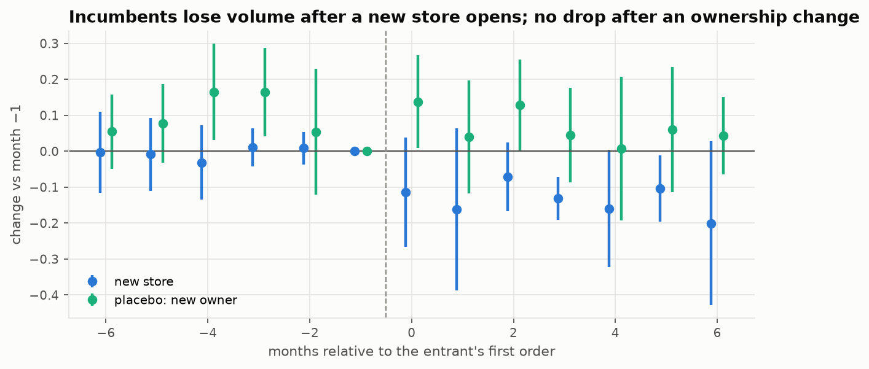
H3 event study: incumbents vs placebo.
Diversion ratio ≈ 60% (cluster-bootstrap 95% CI 28–129%). At least about a quarter, and quite possibly all, of a new store’s volume comes from existing stores in the same city. Small incumbents lose ≈21% against ≈4% for large ones. Disclosed deviation: the raw-liters outcome is not significant because a few very large stores dominate its variance, so the normalised outcome is the headline. The placebo shows no post-change effect, but its pre-period is not flat (20 cities, consistent with old owners winding down), so it supports the design without proving it.

6.4 Association vs causation
H1 and H2 are robust associations: a confounder correlated with the southern border cannot be excluded, and a geographic regression discontinuity would need Missouri-side store data. H3 is a causal design under parallel trends, supported by flat pre-entry coefficients. If entrants choose growing locations, the bias runs towards zero, so the measured diversion is conservative.

6.5 Twenty exploratory hypotheses (H4–H23)
Beyond H1–H3 we tested twenty hypotheses designed to find patterns a planner would not expect. Rules: each direction was stated before its test; county patterns (OLS with HC3 errors and a Freedman–Lane permutation test, controlling for population, income, age and education) count only if they hold in both Jan–Oct 2025 and Jan–Oct 2026; and because twenty tests are run, a Holm-corrected p-value is reported. Rejections are reported as findings. Code: scripts/05_twenty_hypotheses.py; walkthrough: notebook 05; detail: reports/twenty_hypotheses.md.
# | Hypothesis | Test | Result | Verdict
H4 | Wisconsin’s brandy culture crosses the Mississippi | brandy share ~ closeness to WI + controls | 2.7% vs 1.6% brandy share on the WI border (1.7×) | Supported
H5 | Neighbouring counties drink alike beyond demographics | Moran’s I of residuals | whiskey (I = 0.14) and rum (0.17) cluster; agave, gin do not | Supported (2 families)
H6 | Missouri’s pull has a travel-cost horizon | hinge regression | ~30-mile break in 2026; linear in 2025 | Partial
H7 | Dutch-Reformed Sioux County buys far less than predicted | studentised residual | rank 40 of 99 (−7%); outliers are Louisa, Keokuk | Rejected
H8 | St Patrick’s Day lifts Irish whiskey orders | paired Wilcoxon; Scotch as placebo | +29% Irish share in Feb–Mar (2026), +24% (2025); Scotch +4% | Supported
H9 | The Cinco de Mayo agave bump is larger in Hispanic counties | county uplift ~ % Hispanic | bump is real (+16%) but statewide | Rejected
H10 | College towns empty out in summer | county summer/autumn ratio ranks | Ames −37%, Iowa City −25%; 2nd and 4th lowest of 99 | Supported
H11 | Holiday premiumisation is a rich-county effect | Δ premium share ~ income | premium share 24.8% → 27.1% at every income level | Rejected
H12 | The palate rotates with the seasons | paired Wilcoxon, summer vs winter | 7 of 8 as predicted (RTD +48% in summer); rum is a winter spirit | Supported (7/8)
H13 | Price cuts make stores stock up, then under-order | item × month fixed effects | orders +14% in the cut month, +49% the month after; no dip | Rejected (reversed)
H14 | Tariffs raised imported spirits’ costs | same-item cost change; Mann–Whitney | every origin within ±1% | Rejected
H15 | Inequality builds a price “barbell” | price spread ~ Gini | spread widens, but average price rises too | Partial
H16 | The 50 ml mini share tracks poverty | county and within-store-type regressions | no county effect; +3.3 pts per +10 pts poverty within store type | Partial
H17 | More outlets, more drinking, but under 1:1 | log L/adult ~ log stores per adult | elasticity 0.39–0.52 (population-weighted) vs 0.40 implied by H3 | Supported
H18 | The long tail lives in cities | rarefaction (equal 892-line samples) | 547 vs 322 distinct products, densest vs sparsest decile | Supported
H19 | Product volume follows Zipf’s law | log-log rank regression | slope −1.10; top 1% of 4,792 products = 38% of liters | Supported
H20 | New stores have an opening “honeymoon” | Wilcoxon vs months 3–5 | opening order 1.86× steady state, then 0.79× | Supported
H21 | Stores fade slowly before closing | pre-exit decline; AUC | only −6%; early-warning AUC 0.53 | Rejected
H22 | Customers belong to the address, not the owner | Jensen–Shannon distance; Mann–Whitney | successor’s mix 2× closer to predecessor’s; 92% of volume kept | Supported
H23 | Iowa’s whiskey divide is generational | Canadian/bourbon share ~ age + controls | age effect reverses with controls; density (r = −0.69) and education drive it | Rejected
Scorecard: 10 supported, 3 partial, 7 rejected. Six results survive the Holm correction (H6, H12, H18, H20, H21, H22). H4, H8, H10 and H17 do not on their own, but each replicates in two independent years.
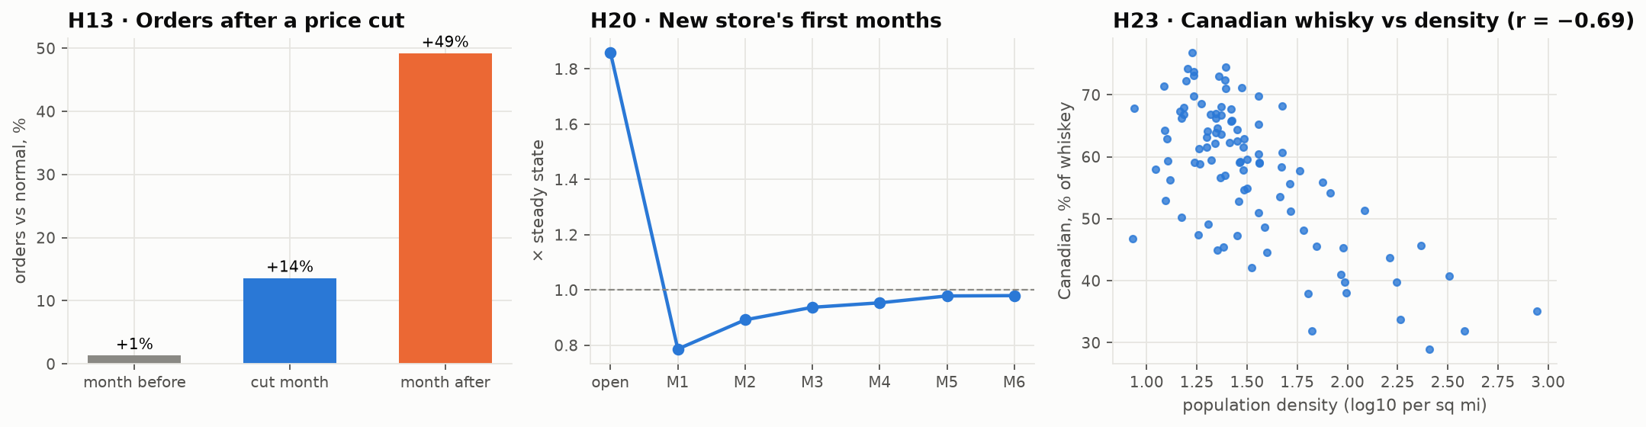
Three exploratory findings: price-cut timing (H13), the new-store honeymoon (H20), and the whiskey confounder (H23).
What they add to the decision.
- Price cuts work with a lag (H13). We expected forward buying. Instead orders barely move during a temporary cost cut and jump about 49% the month after it ends, most likely because stores pass the cut to shoppers, sell through, and restock at full price. Promotion stock belongs in month t + 1.
- Two methods, one answer on outlets (H17 + H3). Across counties, liters per adult rise with store density with an elasticity of ~0.4–0.5; the difference-in-differences of H3 implies 0.40. Roughly 40–50% of a new outlet’s volume is new demand, and the rest is taken from existing stores.
- The store life cycle is lumpy (H20, H21, H22). A new store’s opening order is 1.86× its normal level and is followed by a dip; closures come suddenly, with no warning in order data; and an ownership change keeps 92% of the shop’s volume, so it should be forecast from its predecessor, not as a new store.
- Regional taste has local drivers (H4, H5, H23). Brandy follows the Wisconsin border; whiskey and rum cluster between neighbouring counties beyond what demographics explain; and Canadian whisky follows rurality, not age. That last result is a textbook confounder: age looked important only because older counties are more rural.
- The calendar runs ahead of the occasion (H8, H10, H12). Irish whiskey peaks in February, college towns empty in summer, and the family mix rotates with the seasons. Because these are store orders, restocking leads each occasion by weeks.
Caveats. These are exploratory associations, apart from the designs that give more leverage (the placebo in H8, fixed effects in H13, rarefaction in H18). Thresholds (a 5% price cut, equal-size rarefaction samples, 3-month windows) were fixed before the results were seen; sensitivity to them is not reported.

7. The decision-support solution: next-month forecast (BADIR: Recommendation engine)

7.1 Set-up
The unit is store × spirits family × month (19,994 series), aggregated to county (delivery regions) and state (procurement). All features for month t use data up to t − 1. The split is time-ordered: train Apr-25–Mar-26, validation Apr–Jun-26 (model choice, hyperparameters, ensemble weight, intervals), test Jul–Oct-26, used once.
Metric: WAPE (Σ|error| ÷ Σ actual). It is volume-weighted, works with zeros (MAPE fails), and reads directly as “share of liters mis-planned”. Bias is reported alongside because over- and under-forecasting cost ABD different things.
Features. Own history (lags 1–12, rolling means and volatility); store context (format parsed from the name, age, totals); a store-specific order-day calendar; local competition (new entrants in the city, from H3); statewide family trend; county profile.

7.2 Approaches compared and why the final one was chosen
Model (test, Jul–Oct 2026) | County WAPE | State WAPE | Store WAPE | Bias
Status quo: same month last year | 17.3% | 7.0% | 48.5% | +6.5%
Calendar-adjusted seasonal naive | 16.5% | 6.0% | 47.7% | +5.5%
Last month / 3-month average | 22.7% / 18.2% | 11.3% / 9.4% | 50.4% / 41.6% | −2.0% / −0.8%
Ridge regression (log) | 18.5% | 10.7% | 41.7% | −2.5%
Random forest | 15.1% | 8.1% | 36.9% | −2.0%
Tuned XGBoost (Tweedie) alone | 14.6% | 6.8% | 36.6% | −0.9%
Final: ensemble (0.55 XGBoost + 0.45 seasonal naive) | 13.8% | 5.2% | 39.0% | +2.0%
Why this design. With only one seasonal cycle of history, learned models under-reacted to seasonal swings: on validation they under-forecast by 8–22%, most of it in the largest series, which trees cannot extrapolate beyond. The seasonal naive over-forecasts because it carries last year’s higher level. The two errors point in opposite directions, so an ensemble cancels part of both. Its weight was chosen on validation as the lowest county WAPE with |bias| ≤ 3%. Tweedie loss suits non-negative, zero-inflated, skewed volumes; least squares on log liters under-predicted totals by 19–22%. Hyperparameter search (20 random trials, MLflow-logged) moved validation WAPE only between 14.3% and 14.8%, and the defaults were as good. The gain comes from features and the ensemble, not tuning. Honest caveat: on the test months XGBoost alone was almost unbiased and is better at store level (36.6% vs 39.0%). The ensemble wins at the county and state levels, which are where ABD plans.
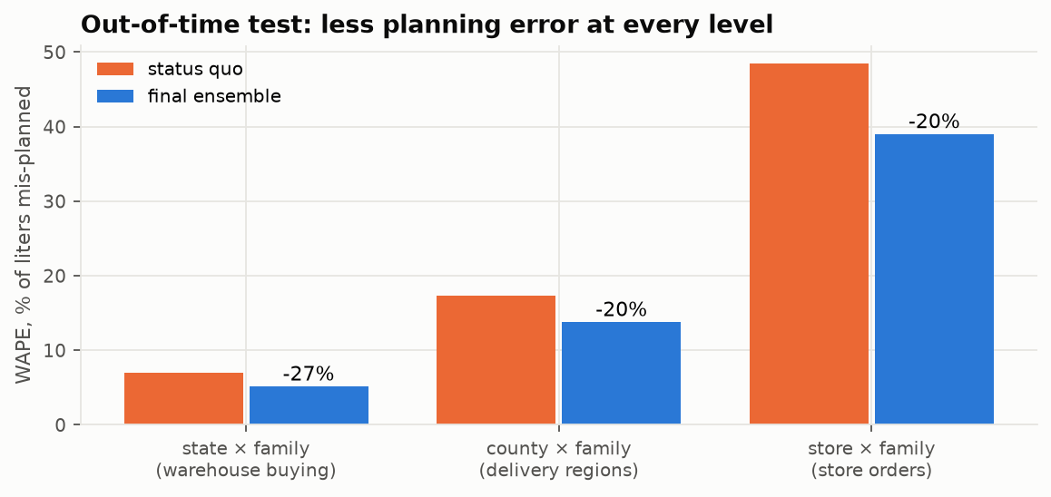
Out-of-time test by planning level.
What the errors mean. At county × family level roughly one liter in seven is mis-planned, against one in six today, and without the status quo’s systematic over-buying. The ensemble beats the status quo in every test month (by 16–26%). At warehouse level the error is ~5%. Store-level forecasts are guidance only (an order can slip by a week). Reliable enough for monthly procurement and regional capacity; not for individual store orders or brand-new stores.

7.3 Calibrated uncertainty
Intervals are empirical: quantiles of actual ÷ forecast by log-spaced size band, fitted on validation and checked on test. A nominal 80% band covers 77.5% of county × family outcomes, and 92.4% fall below the county P90 (nominal 90%). The store-level band is slightly conservative (86%).

7.4 Business value and service-level planning
Assumptions: safety stock = z × RMSE of the monthly error; one-month replenishment; 95% service (z = 1.645); stock valued at ABD’s 2026 cost of $12.25/L; holding cost 20% a year (sensitivity 10–30%).
Level | Safety stock, status quo | Safety stock, final | Reduction | Capital freed | Holding saving / yr
Warehouse (state × family) | 241,000 L | 182,000 L | −25% | $0.73M | $0.15M
Delivery regions (county × family) | 627,000 L | 507,000 L | −19% | $1.46M | $0.29M
The larger and more certain gain is that the status quo plans ≈84,000 L a month more than the forecast in a shrinking market (≈$1.0M of stock at cost each month), unless a planner corrects it by hand. These are planning estimates under stated assumptions, not audited savings.
From forecast to order quantity. Plan quantity = the service-level quantile of the calibrated forecast (newsvendor rule: service level = stock-out cost ÷ (stock-out cost + holding cost)). For Polk County in November 2026 (forecast ≈416,000 L), moving from 90% to 95% service adds ≈37,000 L of stock. That trade-off is the slider in the demo.

8. Recommendations
# | Recommendation | Evidence | KPI
1 | Plan monthly procurement and regional capacity with the ensemble forecast, not “same month last year”; stock price-cut items for the month after the cut. | −20% county / −27% state WAPE out-of-time; bias +2% vs +6.5%; H13: +49% the month after a cut | county WAPE ≤ 14%, |bias| ≤ 3%
2 | Set stock by service level, chosen per family from stock-out vs holding cost; under budget pressure, lower it for low-margin families first. | calibrated intervals; ~25% less warehouse safety stock at 95% | fill rate, inventory days
3 | Plan capacity by delivery days, not months, and stock occasions and college terms weeks ahead. | median store: 89% of liters on one weekday; H8, H10, H12 | truck utilisation
4 | Stop per-capita planning norms in a ~30-mile southern band; plan those counties on their own history. | H1a: −44% L/adult at the Missouri border, replicated; H6: ~30-mile horizon | border-county bias ≤ 5%
5 | Brief the ABD board and the legislature on the Missouri border gap (≈$5.9M sales, ≈$2.0M margin a year, upper bound) as an input to pricing and markup policy. Treat any Missouri tax change as a natural experiment. | H1, Tax Foundation 2026 | revenue tracked in border counties
6 | Forecast new licensees from peer stores, not their oversized opening order, and ownership changes from their predecessor; plan new stores at high service for 6 months and trim nearby incumbents. | H3: −13% for incumbents, ~60% diversion; H20: opening order 1.86×; H22: 92% of volume kept; new stores under-forecast by 24% | new-store stock-outs; incumbent overstock
7 | In licensing reviews, report the expected impact on existing (especially small) stores and the ~45% net-new demand a new outlet brings. | H3: small incumbents −21%; H17: elasticity ≈ 0.4–0.5 | —
8 | Set regional mix from local drivers (agave share, Wisconsin-border brandy, rural Canadian whisky), reviewed quarterly; keep ethnicity out of the operational model. | H2, H4, H23; ethnicity adds no forecast value | stock-outs by region and family
9 | Ask the Iowa Data Hub to fix the truncated months and blank 2025 costs, and to record pack counts for multi-pack minis; keep the ETL quality gates. | §3.3; H13 | zero failed gates
10 | Roll out through a randomised pilot: randomise delivery regions to forecast-based vs current plans for 3 months, then scale. | an A/B design gives causal evidence of the operational benefit before full adoption | fill rate, inventory days, write-offs

9. Production and Responsible AI
Working demo. A FastAPI service (app/) serves /forecast/county/{fips} and /forecast/store/{id} (forecast, P10–P90, planning quantity at any service level, both ensemble components, SHAP drivers), plus /predict, /monitoring, /model (model card) and a dashboard at /. It is containerised (Dockerfile), and every experiment is tracked in MLflow (43 runs). The November 2026 forecast is 1.92M liters statewide.
Explainability. XGBoost TreeSHAP: own history ≈78% of mean |SHAP|, store context ≈11%, statewide trend ≈6%, order calendar ≈3%, county demographics ≈1%. Demographics explain level differences between counties (H1/H2), which a store’s own history already contains.
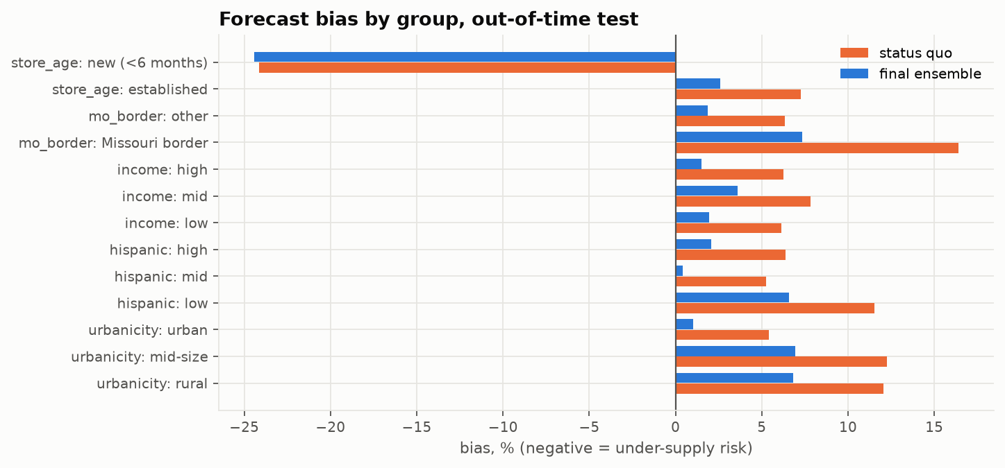
Forecast bias by county group: final vs status quo.
Fairness. The final model beats the status quo in every group: urban/rural, income and Hispanic tertiles, Missouri border, every store format. Residual bias is uneven, though: about +7% in rural and Missouri-border counties against +1% in urban ones (overstock risk, half the status quo’s). New stores are under-forecast by ~24% (stock-out risk). Mitigations: a group bias correction, the monthly audit, and recommendation 6.
Sensitive attribute. Keeping % Hispanic required a pre-stated >1% gain in validation WAPE. It gave 0.5%, so the production model excludes it. Removing all census features changes test WAPE by <0.1 points.
Privacy and ethics. There is no personal data: rows are business-to-government orders published under CC BY. Ecological fallacy: county statistics are never read as individual behaviour. Public health: the objective is matching supply, not raising sales.
Monitoring. PSI drift (features that shift by construction, such as calendar and store age, are reported but cannot trigger a retrain), monthly error tracking and schema-drift checks run in scripts/04_monitor.py. Retrain monthly, and at once if a watched feature’s PSI exceeds 0.25, live WAPE is >20% worse than at validation, or the model stops beating the status quo. Two lessons were caught. (1) A “major” drift alarm on active_share6 was an artefact of rolling windows not yet full; it was fixed by starting the reference window in July 2025. (2) A model frozen in Dec 2025 is worse than the status quo only in January, a month it never saw. That is why the ensemble keeps a seasonal half and the model is refitted monthly.

10. Impact, limitations and assumptions
- History. 22 months gives one seasonal cycle. Holidays and price changes are only partly captured.
- Location vs residence. Sales are recorded at the store, and the census profile (2020–24) is applied to 2025–26. The analysis is ecological.
- H1 is an association; the revenue figure is an upper bound. H3 relies on parallel trends; the diversion CI is wide; one outcome deviated from the pre-registration (disclosed).
- Liters. Multi-pack minis are understated by ~2% of liters (flagged, not imputed). Truncated months are repaired from rebuilt values.
- Value. Value estimates assume one-month replenishment and 20% holding cost, and ignore case-pack rounding and supplier minimums.
- Exploratory hypotheses. H4–H23 were not pre-registered; six survive a correction for twenty tests, and the rest rely on replication across two years. They are associations unless the design says otherwise.
- Deployment. Not yet run inside ABD systems; the pilot (recommendation 10) is the next step.

11. Implementation roadmap
Phase | When | Owner | Actions | Success measure
1 Shadow mode | Months 0–2 | ABD supply-chain analytics | run monthly forecasts beside the current plan; planner override log | county WAPE ≤ 14%, |bias| ≤ 3% live
2 Randomised pilot | Months 2–5 | ABD planning + operations | half the delivery regions plan with forecast and service levels | fill rate ≥ current; inventory days −10%
3 Statewide roll-out | Months 5–8 | ABD supply chain | procurement by service level; delivery-day capacity plan | safety stock −20% at equal fill rate
4 Policy use | Months 3–9 | ABD licensing; ABD board | H3 impact note in licence reviews; border-gap briefing | briefing delivered; reviews include incumbent impact
5 Run and improve | ongoing | analytics | monthly refit, drift and fairness audit; publisher data fixes; extend history to 2012– | no group |bias| > 5%; zero failed data gates

12. Surprise scenarios
- Reduced budget: lower service levels on low-margin families; skip HPO (no measurable gain).
- Changed error costs: move the service-level quantile; the point forecast and its bias target are unchanged.
- Data drift: PSI and error monitors, monthly refit, schema checks (e.g. new categories, another truncated month).
- Fairness concern: the group audit, sensitive feature removed, group bias correction.
- Missouri raises its spirits tax: expect border counties to recover volume (H1 bounds the size); lags adapt within 1–2 months.
- Licensing wave: plan entrants net of ~60% diversion and expect opening orders near 1.86× normal (H20); competition features already in the model.
- ABD runs a price promotion: stock for the month after the cut, when orders arrive (H13).

Appendix: reproducibility
scripts/01_build_ssot.py → 02_build_tables.py → 03_train_forecast.py → 04_monitor.py → 05_twenty_hypotheses.py, then notebooks/_build/build.py. Notebooks: 01 data and EDA · 02 hypotheses · 03 forecast and decision · 04 responsible AI and monitoring · 05 twenty exploratory hypotheses. Environment: pyproject.toml (Python 3.11). Raw sales files are linked in data/links.txt.

