ESMA Stress Simulation for Investment Funds

# Sample Data Description

## Fund Description

**AXA FRANCE OPPORTUNITIES (Equity fund):** open end fund registered in France. Its objective is to achieve long term capital appreciation through investment in French stocks by taking advantage of market opportunities. The fund invests at least 75% of its assets in French stock and other securities eligible for PEA.

## Input Data

Daily NAV and Fund Total Assets were extracted from Bloomberg. Period of observation is from July 5th, 2014 to July 5th, 2018.

### Data visualization

Below is the NAV and FTA data, as a graph and histogram

NAV: Net Asset Value

FTA: Fund Total Asset

|  |  |  |
| --- | --- | --- |
|  | NAV | FTA |
| Plot |  |  |
| Histogram |  |  |

### Outlier detection

We use the pandas dataframe.mad() function which returns the mean absolute deviation of the values (average distance between each data point and the mean). We remove every point which absolute value is above the threshold.

|  |  |  |
| --- | --- | --- |
| Variable | FTA | NAV |
| #outliers | 48 | 0 |

Below are all the outliers from FTA.



However, October and November dates correspond to some stock split, and dividend distribution by the firm.

Hence those dates are taken again into account in the data, only the other outliers are removed:

|  |  |  |  |  |
| --- | --- | --- | --- | --- |
| Outliers: | 20150105 | 20150106 | 20150107 | 20150109 |

We only removed outliers after verifying they were actual outliers.

# Liability Stress Test: redemption shocks

## Redemption and Subscription visualization

Plot and histogram of FTA return and NAV return

Nav return = NAV[t=i] – NAV[t=i-1]

Both ‘Fund total assets return’ graph and ‘Net Asset Value return’ graph have curved distributions centered approximatively around 100.

|  |  |  |
| --- | --- | --- |
|  | Plot | Histogram |
| FTA |  |  |
| NAV |  |  |

Plot and Histogram of R/S, R and S return

For the R (rachat), every value is negative, we transformed every value into a positive value, for an easier analysis.

Both R and S histograms are exponential-like distributions. R/S is the sum of R and S and is a curved distribution.

|  |  |  |
| --- | --- | --- |
|  | Plot | Histogram |
| R/S |  |  |
| R |  |  |
| S |  |  |

## Statistical analysis

For every yield, we analyse the distribution, to get a better look at the possible outliers, le skewness of the curve of the distribution and the kurtosis, for eventual thick queues.

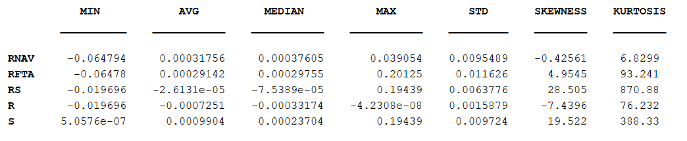

## Stationarity Test

### Autocorrelation

We analyse the stationarity of the different distributions. To do so, we use the autocorrelation: if the autocorrelation decreases rapidly towards 0 (if not equal to 0 at a certain point), then there is no correlation in the data, hence it is stationary.

At every moment i, we analyse the correlation between Yield[t] and Yield[t-i].

Below are the autocorrelation graphs for every yield : RNAV, RFTA, R, S, R/S

|  |  |
| --- | --- |
|  | Autocorrélation |
| RNAV |  |
| RFTA |  |
| R/S |  |
| R |  |
| S |  |

## Test égalité volatilité

On fait la différence des variances entre le premier tiers des données et le dernier tiers des données

|  |  |
| --- | --- |
|  | Différence de variance (pourcentage) |
| R/S | 0.08% |
| R | 0.04% |
| S | 0.01% |

Différence de variance négligeable 🡪 stationnarité

## Augmented Dickey-Fuller

Augmented Dickey-Fuller unit root test.

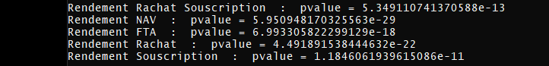

p-value <= 0.05: we reject the null hypothesis (H0), the data does not have a unit root and is **stationary**.

R/S, S et R sont bien stationnaires

## Ljung Box Test

For this test, if the Q is inferior to the critical value of the Khi2 distribution, then the distribution is a white noise.

We choose a lag of 5.

When the test becomes 1, it means the distribution associated is a white noise, the test is positive.

***Ljung Box test :***

**H0**: The data are independently distributed

**Ha:** The data are not independently distributed; they exhibit serial correlation.

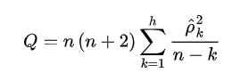

Under {\displaystyle H_{0}} **H0** the statistic Q asymptotically follows a Khi_2.{\displaystyle \chi _{(h)}^{2}}

Si la statistique Q est inférieure à la valeur critique associée à Khi_2(k), alors on ne peut pas rejeter l’hypothèse nulle que le processus est bruit blanc et normalement distribué.

Test bruit blanc

|  |  |  |  |  |  |  |  |  |  |  |
| --- | --- | --- | --- | --- | --- | --- | --- | --- | --- | --- |
| Q_RNAV | Q_RFTA | Q_RS | Q_R | Q_S | Valeurs critiques | Test_RNAV | Test_RFTA | Test_RS | Test_R | Test_S |
| 1.568 | 0.102 | 0.183 | 25.027 | 0.007 | 3.841 | 0 | 0 | 0 | 1 | 0 |
| 4.518 | 0.105 | 0.208 | 25.033 | 0.020 | 5.991 | 0 | 0 | 0 | 1 | 0 |
| 4.862 | 0.488 | 0.305 | 26.731 | 0.021 | 7.815 | 0 | 0 | 0 | 1 | 0 |
| 9.790 | 10.755 | 0.308 | 26.817 | 0.021 | 9.488 | 1 | 1 | 0 | 1 | 0 |
| 17.330 | 16.344 | 0.345 | 27.122 | 0.030 | 11.070 | 1 | 1 | 0 | 1 | 0 |

Here, only R/S and S series have negative Ljung Box results and therefore are “bruit blanc”. R distribution is not a bruit blanc, meaning Y[t] depends on Y[t-1].

## Distribution fitting

Here below are the different distribution and the model which fits the most. For each set of data, we consider all possible distribution with changing parameters and estimate the quadratic error using the “maximum de vraisemblance”. The distribution with the smallest SSE error is the one we keep and draw (in red) on the set of data (in blue).

***R/S : rendements rachats - souscriptions***

|  |
| --- |
|  |
| Nct (non-central student) |
| Student’s t-distribution has the probability density function given by:    For this fitting, we have: **v=1.40** |
| * mu = 5.02e-03 * sigma = 0.031 * nc=0.38 * location =-0.01 * scale (standard deviation) =0.03 * Error (SME) = 9.21 |

***R : rendements rachats***

|  |
| --- |
|  |
| Burr (log logistic) |
| The probability density function for burr is:    For this fitting, we have: **c= 1.47**, **d= 0.74** |
| * mu = 3.65e-05 * sigma = 0.029 * location = 0 * scale = 0.03 * Error (SME) = 17.33 |

***S : Rendements souscriptions***

|  |
| --- |
|  |
| Burr (log logistic) |
| The probability density function for burr is:    For this fitting, we have: **c= 1.79**, **d= 0.49** |
| * mu = 4.24e-06 * sigma = 0.064 * loc = 0 * scale = 0.06 * Error = 1784.28 |

## Simulation and shock definition

R/S : Simulation sur 1 semaine puis sur 1 mois du pire scénario

R : Simulation sur 1 semaine du pire scénario

|  |  |
| --- | --- |
| **R/S** |  |
|  | Vert – Mean R/S  Bleu - 90% value  Noir - 95%value  En 4 jour on atteint déjà à 80% |
|  | 1 month |

RACHAT

|  |  |
| --- | --- |
| **R** |  |
|  |  |

**Rachats - Souscriptions**

|  |  |  |  |  |  |
| --- | --- | --- | --- | --- | --- |
| **Dates** | **W1** | **W2** | **W3** | **W4** | **W5** |
| Mean R/S | 71,85% | 13,92% | 2,72% | 0,54% | 0,10% |
| 95% value | 48,36% | 94,67% | 99,30% | 99,90% | 99,99% |
| 90% value | 49,50% | 96,20% | 99,53% | 99,94% | 99,99% |

**Rachats**

|  |  |  |  |  |  |  |
| --- | --- | --- | --- | --- | --- | --- |
| **Dates** | **J1** | **J2** | **J3** | **J4** | **J5** | **W1** |
| Mean Rachat | 10,95% | 1,08% | 0,08% | 0,01% | 0,00% | 0,00% |
| 95% value | 99,11% | 99,98% | 100,00% | 100,00% | 100,00% | 100,00% |
| 90% value | 99,60% | 99,99% | 100,00% | 100,00% | 100,00% | 100,00% |