
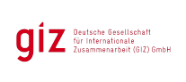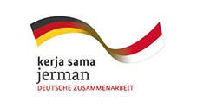

Internal Announcement

The Deutsche Gesellschaft fuer Internationale Zusammenarbeit (GIZ) GmbH is a German international cooperation enterprise for sustainable development with worldwide operations. PAKLIM, a Program advising and supporting the national government, local governments and industries with climate change mitigation and adaptation initiatives, is looking for

Admin Intern

Tasks
The intern assists PAKLIM administration team to do following jobs:
- Collecting, filing and following up the vouchers
- Filing properly procurement and contract documents
- Managing and ensuring sufficient supporting documents are fulfilled

Qualifications
- Having knowledge about general administration matter
- Having knowledge of filing system
- Good level of English knowledge
- Having knowledge about basic accounting system
- Good level of excel software

Period of assignment
1st March 2015 to 31st May 2015 (3 months)

Duty Station
Jakarta

Interested candidate should submit the application letter, CV with latest photograph and list of references to recruitment@paklim.org before 29th January 2015. Please indicate your application by putting the following code in the subject line: AI

GIZ Office Jakarta – HR Department
Menara BCA, 46th Floor, Jl. MH Thamrin No. 1, Jakarta 10310, Indonesia
www.giz.de

