Pen & paper

By: Iskander Sauma, 940325–1854

2.1

S1: House(Bob) = red

S2: Drink(Alice) = snaps

S3: Fear(Ted) = elevators

S4: Roommates(Ted, Carol)

S5: , Fear(x) = elevators => House(x) = blue

S6: , House(x) = red => Fear(x) = spiders

S7: , Drink(x) = snaps => House(x) = red

S8: , Neighbour(Bob, x) => Drink(x) = Beer

S9: , Roommate(x, y) Fear(y) = elevators => Fear(x) = spiders

S10: , Neighbour(x, y) Drink(y) = milk => Band(x) = Beatles

S11: , Roommates(Alice, x) Fear(x) = spiders => Drink(x) = milk

S12: , Roommates(x, y) Drink(y) = snaps => Band(x) = Beatles¨

S13: , Neighbour(Ted, x) Drink(x) = snaps Fear(x) = spiders => Band(x) = ABBA

2.2

2.3

C1: House(Bob) = red

C2: Drink(Alice) = snaps

C3: Fear(Ted) = elevators

C4: Roommates(Ted, Carol)

C5:

C6:

C7:

C8:

C9:

C10:

C11:

C12:

C13:

2.4

* C14: if person x and person y are not roommates or person x’s house is not house x or person y’s house is house z

C15: if person x’s house is not house z or person y’s house is not house z or (person x and person y) are roommates

C16: if (person x and person y) are not roommates or if (person y and person x) are roommates

C17: if person x’s house is not red or person y’s house not blur or if (person x and person y) are neighbours

C18: if (person x and person y) are not neighbours or if (person y and person x) are neighbours

2.5 For example, we can use C4 and C8 to get two different outcomes as used in previous assignment.

3.1

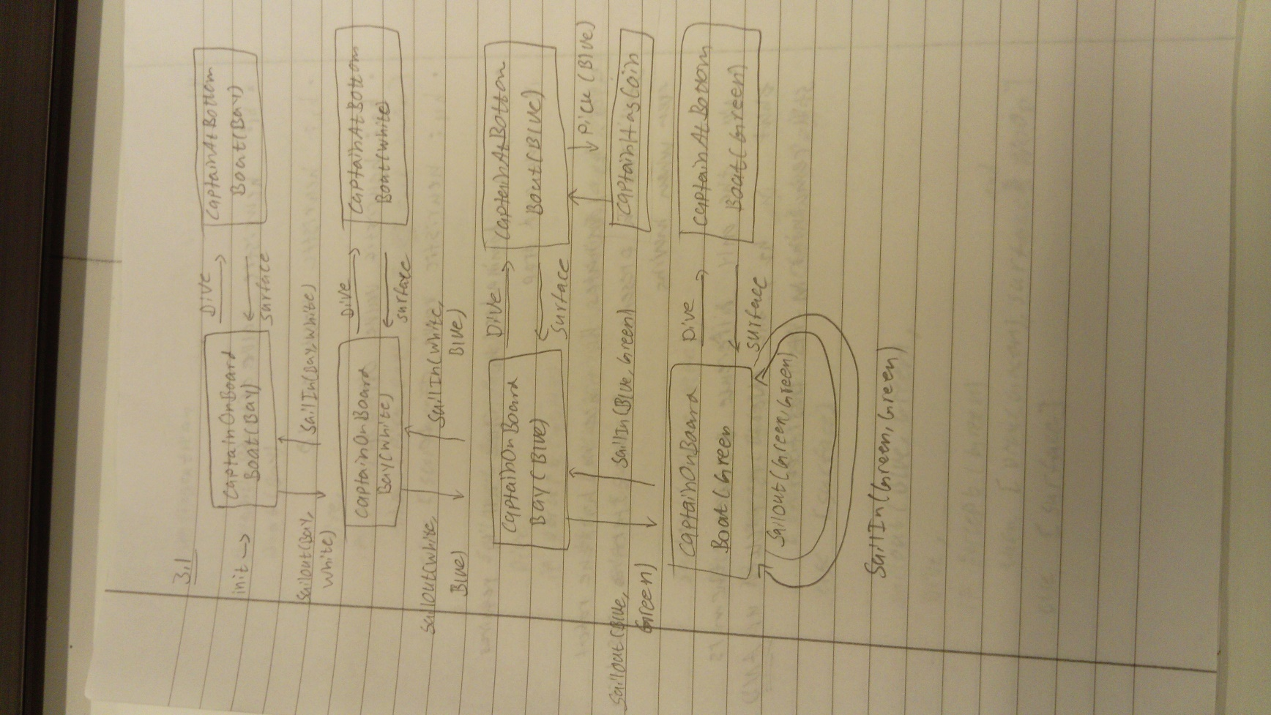

3.2

* Since we have Next(Green, Green) we have a loop that allows an infinite amount of action plans to exist. Moreover, there is no stopping the possibility for travelling between two destinations indefinitely. Giving infinite amount of action plans
* If Next(Green, Green) does not exist, the number of plans is limited. Every destination except Blue gives two possible action plans that still can lead to the satisfaction of the goal state. Blue only gives one possible action plans because a set of steps must be taken to pick up the coin. The amount is

6\*2 + 1 = 13 action plans

* 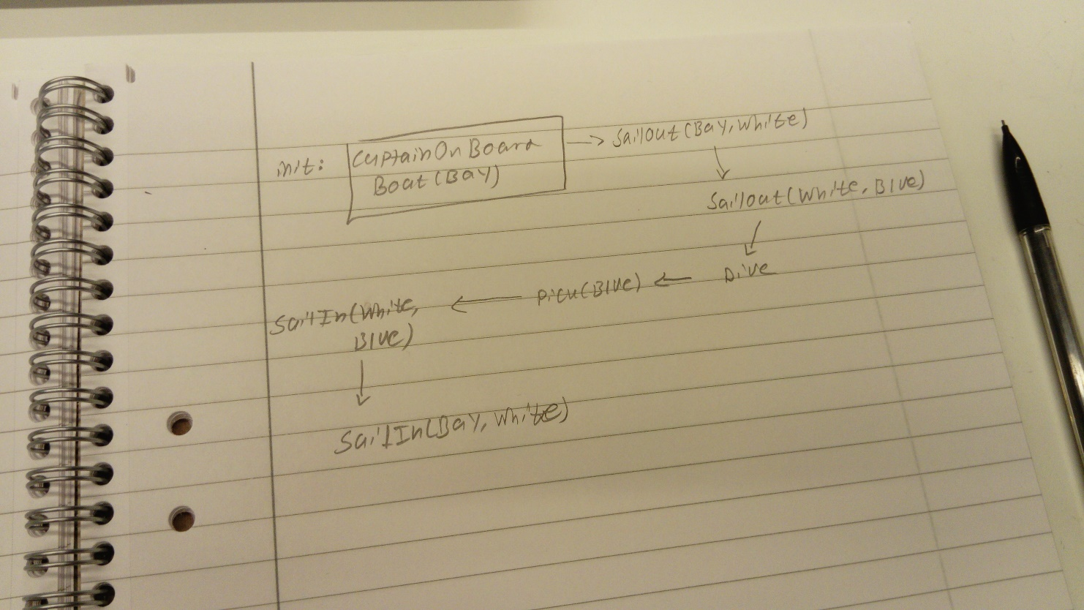The lowest number of steps required is 7

3.3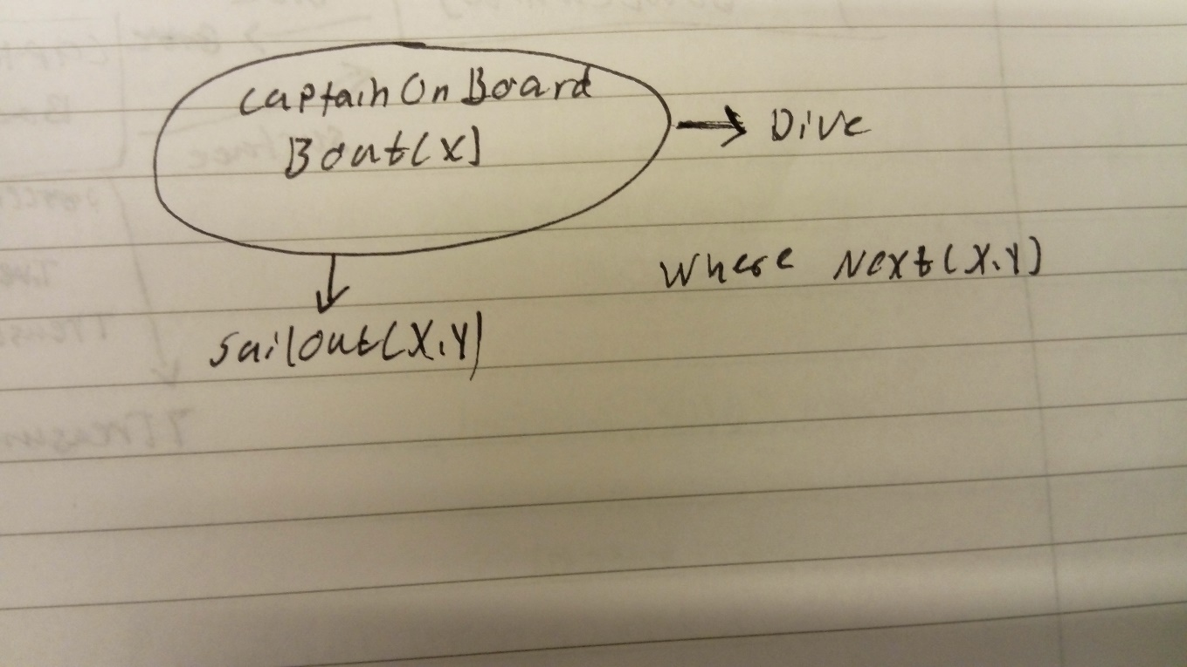

* 3 true fluents: Next(Bay, White), Next(White, Blue) and Next(Blue, Green)

3 false fluents: TreasureAtBottom(Bay), TreasureAtBottom(White) and TreasureAtBottom(Green)

* There are four possible positions of the ship at the initial state, hence the initial belief state has 4 physical states
* There are no action plans that lead to goal state since the captain can never sail anywhere
* Since the captain cannot sail anywhere, there exist no action plan that is optimal

3.4

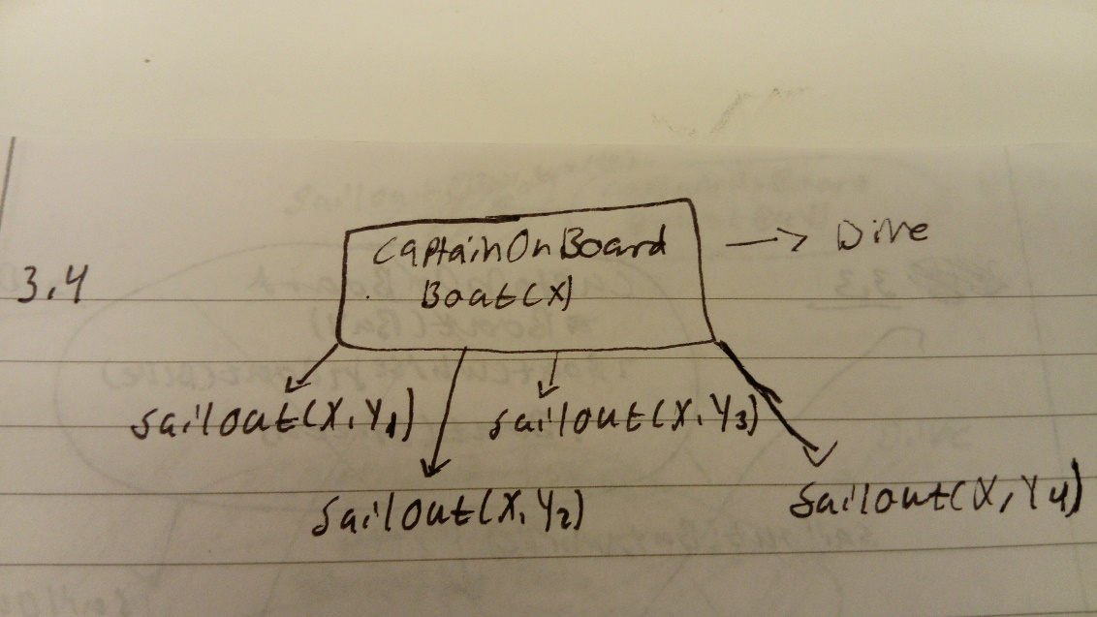

* 4 physical states
* Infinite number of action plans since loops exists
* The optimal plan requires 4 steps

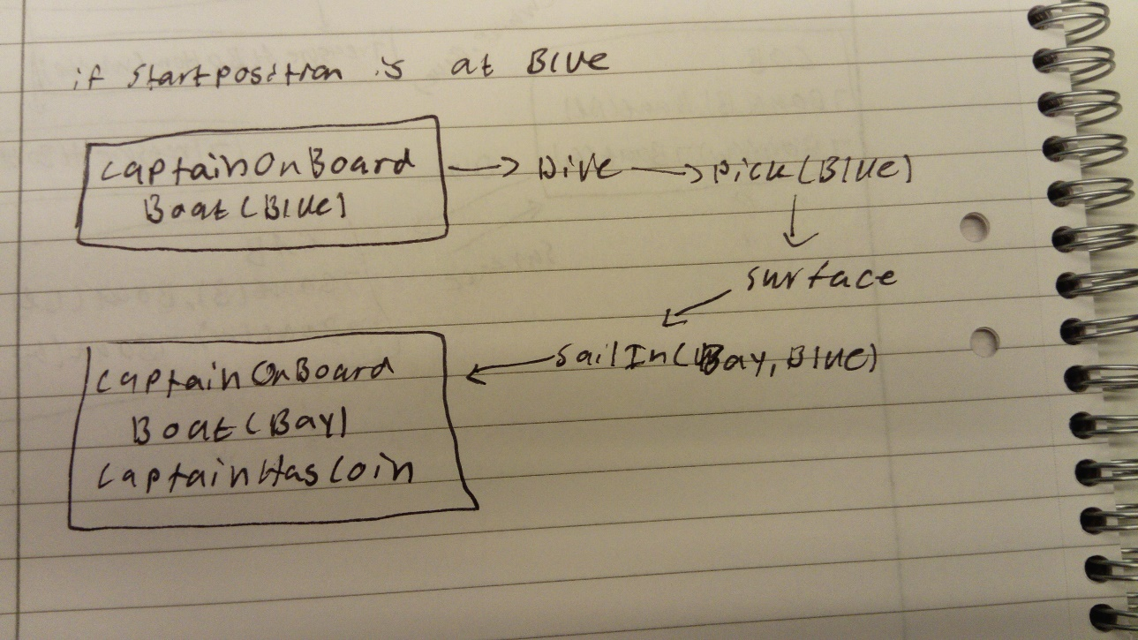

3.5

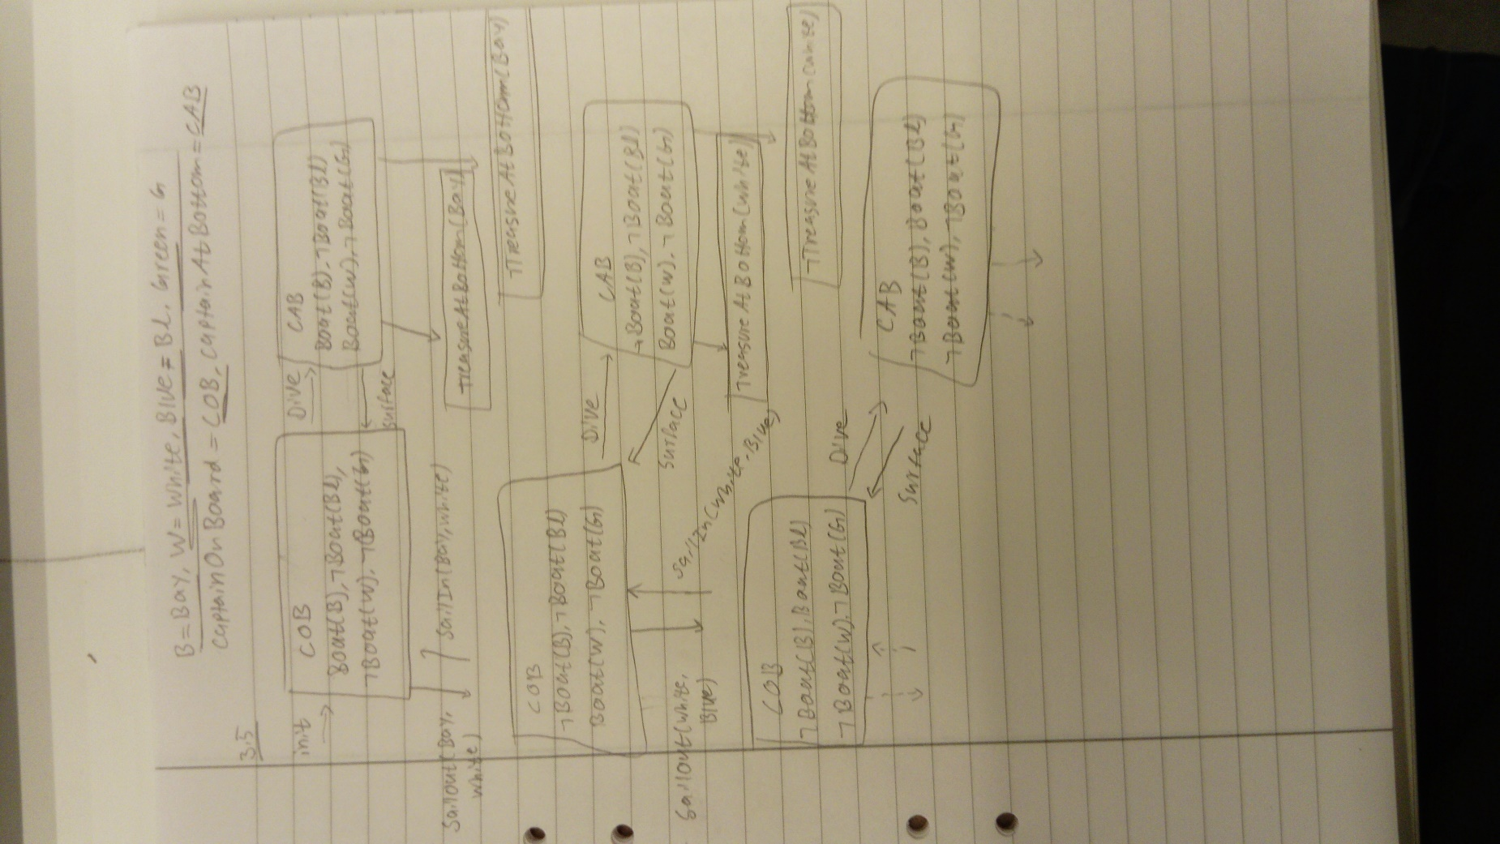

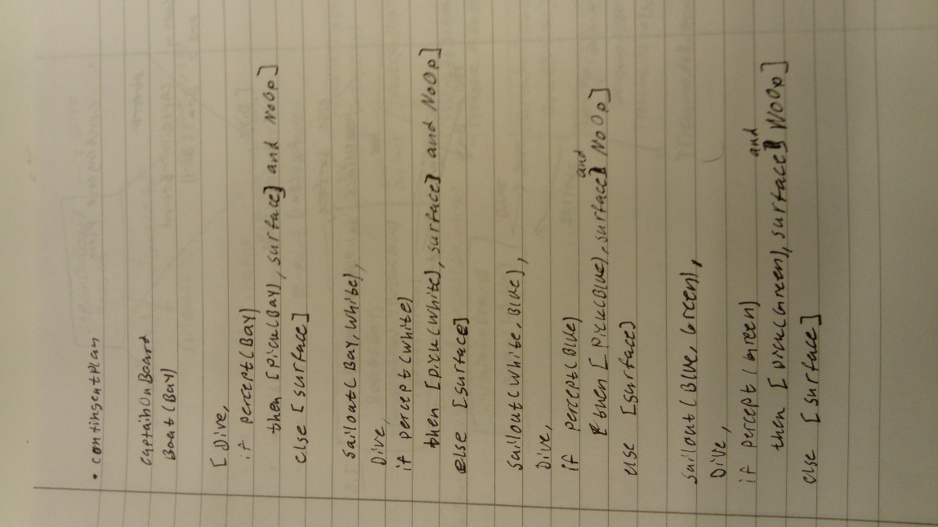

4.1

In this task, we want a heuristic that is dependent on the number of steps that is required to complete the goal. The lower steps required the better.

* h1 has a heuristic of 6
* h2 has a heuristic of 36
* h3 has a heuristic of 26
* h4 has a heuristic of 36
* yes, h1 dominates h2 since its movements can be limited to pick and drop
* yes, h3 dominates h4 because h3 allows the robot to have a presence in the starting position despite moving from it which means the return steps are not needed
* no, since the only difference is that h2 also leave an object in the same position while picking it up.