1 Task.

1. var name = prompt("Enter your name: "); alert("Hello " + name);
2. var name = prompt("Enter your name: ");
3. var nameup= name.charAt(0).toUpperCase();
4. var namedown= name.toLowerCase();
5. var namelower= namedown.slice(1);
6. alert("Hello " + nameup+namelower);

2 Task.

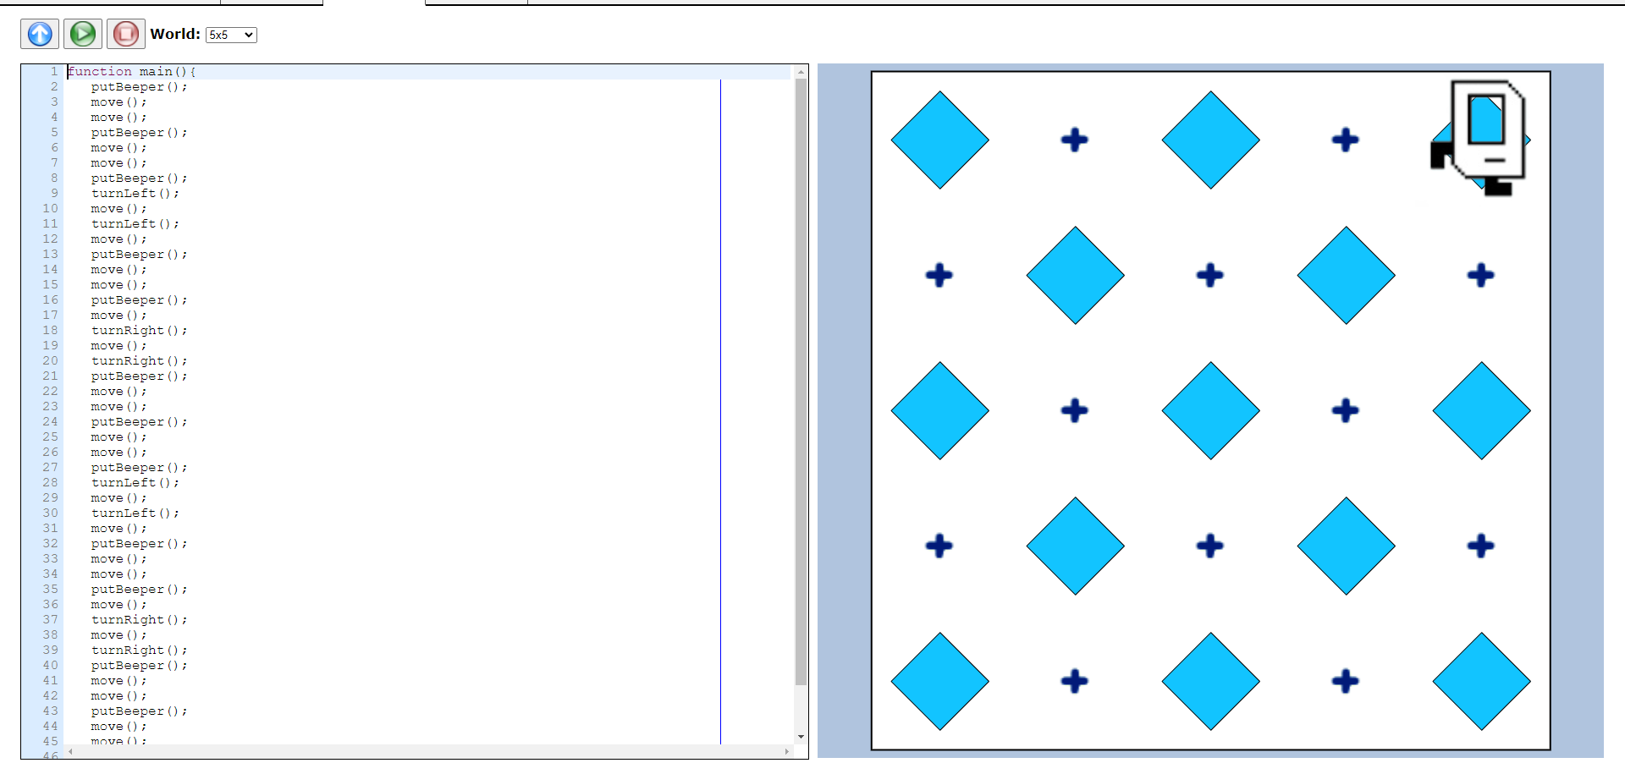

Task 3

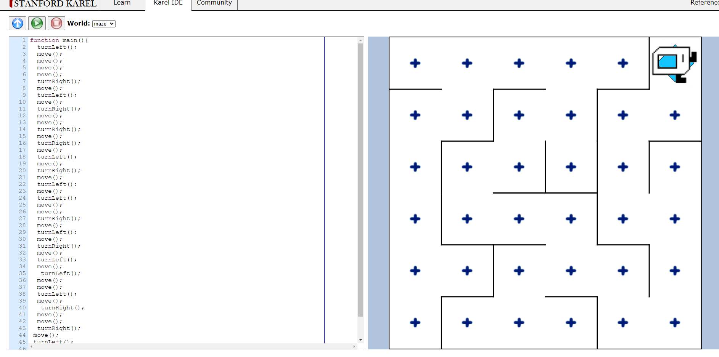

Task 7

const names = ["Marat", "Beka", "Adina", "Tomiris", "Diana"];

const random = Math.floor(Math.random() \* names.length);

alert(names[random]+ " is going to buy lunch today");

Task 6

var year= prompt("Enter the year:");

if((year % 4== 0 && year%100 !=100) || (year %400)){

alert(year + " is a leap year");

}

else{

alert(year + " is not a leap year");

}

Task 5

var weight= prompt("Enter your weight:");

var height= prompt("Enter your height in SI:");

var BMI = weight / (height \* height);

if(BMI< 18.5)

{

alert( "Your BMI is " + BMI + " ,so you are underweight");

}

else if(BMI >= 18.5 && BMI < 24.9)

{

alert( "Your BMI is " + BMI + " ,so you have a noraml weight");

}

else if(BMI > 24.9){

alert( "Your BMI is " + BMI + " ,so you are overweight");

}

Task 4

var year=prompt ("Enter your age:");

var end= 90;

var yearx= year\* 365;

var endx= (90 \* 365) - yearx;

var endy = (end \* 52)- (year \* 52);

var endz= (end \* 12)-(year\*12);

alert("You have "+ endx+ " days, "+ endy+ " weeks, "+ endz+" month left.");

Task 8

const number = parseInt(prompt('Enter the number of terms: '));

let n1 = 0, n2 = 1, nextTerm;

console.log('Fibonacci Series:');

for (let i = 1; i <= number; i++) {

console.log(n1);

nextTerm = n1 + n2;

n1 = n2;

n2 = nextTerm;

}