**Project proposal**

“Restaurant website”

💖RobloxTeam💖 CS-2309

Islam Kairolla

Zhansaya Minbayeva

Aidana Zhandossova

Astana 2024

a. Why this topic was chosen (project relevance)   
  
In Kazakhstan, despite the high level of digitalization in various areas, many restaurant websites do not meet this standard. Restaurants offer excellent service and high-quality food, but their online presence is often limited and inconvenient for modern users. The lack of online table reservations, the inability to choose dishes taking into account dietary preferences, and insufficient optimization create inconveniences for customers expecting modern and convenient service.  
  
The choice of this topic is due to our desire to solve these problems and improve the level of digital services in restaurants in Kazakhstan. Creating a convenient and interactive web application meets the needs of consumers who value time and comfort. By providing the ability to easily book a table, view the menu, select dishes taking into account dietary preferences and take advantage of special offers, we strive to attract more customers, increase their loyalty and meet the high standards of digitalization in the country.

b. Similar projects in Kazakhstan and to which extent your app can be competitive against these projects. (analysis of competitors) (с презы)  
  
There are websites such as redtable.kz and individual restaurant websites such as Line Brew on the Kazakhstan market. Redtable.kz provides reviews of restaurants, cafes and bars in Astana, helping users choose a place to visit. The Line Brew website offers menu information, interior photos and contact details for booking a table. However, these websites are limited to providing static information without interactive capabilities.  
  
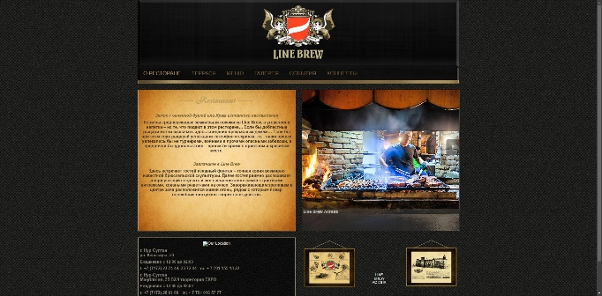 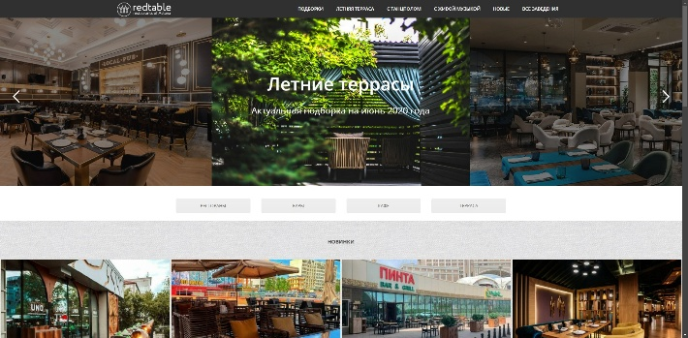  
  
<http://line-brew.kz/index.php>  
https://redtable.kz/

Our project is different in that it provides a full-fledged platform for interaction with the restaurant. Unlike existing sites, we offer direct online table reservations with instant confirmation, the ability to order delivery directly from the site, and a loyalty program for regular customers. In addition, people will be able to leave their own recipes on our site, sharing culinary ideas with the community. We create an interactive experience that allows guests not only to receive information, but also to actively participate in the life of the restaurant, performing the necessary actions directly on our site.

In addition, our site provides users with the ability to add their own recipes and offers a personalized approach to each user, which makes it more convenient and attractive to the modern client. With expanded functionality and improved user experience, our application is able to successfully compete with existing projects and meet the growing needs of the market.

c. Project auditory (know who your target is)   
  
Our target audience is modern urban residents of Kazakhstan, mainly from Astana, aged 22 to 40, who actively use the Internet and mobile applications to solve everyday problems. These are young professionals and specialists who have started their careers and have a stable income, who value the ability to quickly and conveniently book a table or order food online. These are also married couples and groups of friends who prefer to plan joint outings in advance and regularly visit restaurants. Also, foreign tourists who need a convenient and understandable service in several languages for booking and ordering in an unfamiliar city are also included in our target audience. In addition, these are people with special dietary preferences who are looking for restaurants that offer dishes that match their diet and appreciate the ability to filter the menu by these criteria.

Our goal is to provide this audience with an intuitive and functional tool for interacting with the restaurant, which will facilitate the process of choosing, booking and ordering. We strive to make visiting a restaurant the most comfortable and enjoyable experience for people who value quality service and the convenience of modern technology.

d. Project features (eye-catching functionality/design ideas of your project)

Our project aims to create an intuitively and aesthetically pleasing restaurant website that provides a pleasant and convenient user experience. One of the key features of our site is the ability for visitors to leave their own recipes.

1**. Publication of good recipes**: users can share their favorite dishes, upload photos and describe the cooking process in detail.

2**. Interaction with other users**: the ability to comment and rate recipes of other participants, create an active culinary community.

3**. Selection of the best restaurant recipes**: the most popular or interesting recipes can be included in a special restaurant menu with an author's reward or discount.

Project implementation period (October 7 - November 17)

1**. October 7 - 14**: choosing topic of project and brainstorm ideas.

2. **October 15 - 28**: developed mvp.

3. **October 29 - November 7**: development of database, frotend part and backend part.

4. **November 8–12**: testing functionality, fixing detected errors and changing ui to pink theme.

5. **November 13–15**: filling the site with content - adding photos of dishes, descriptions, prices, and information about the restaurant.  
6. **November 16–17**: final testing, checking the correct operation of all functions, preparing for the launch and presentation of the project.

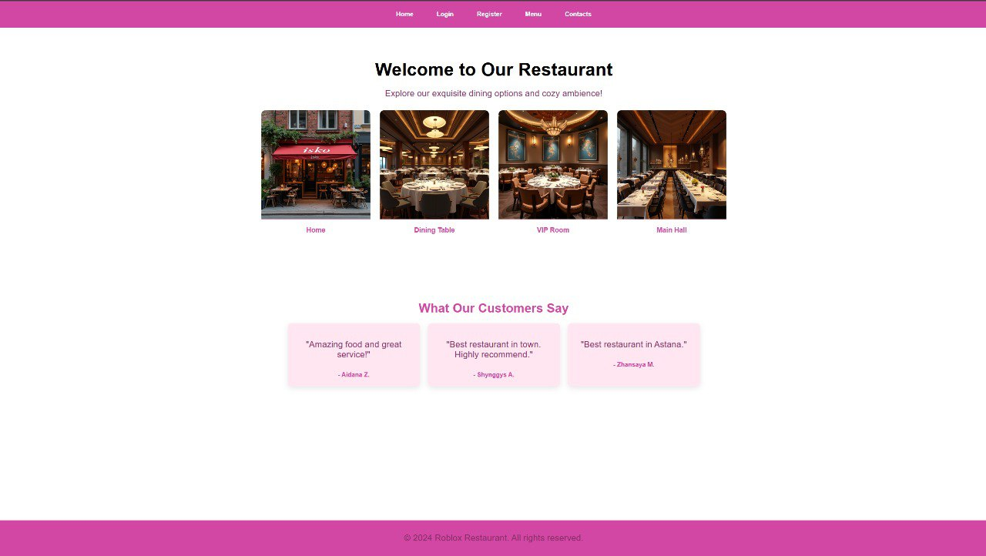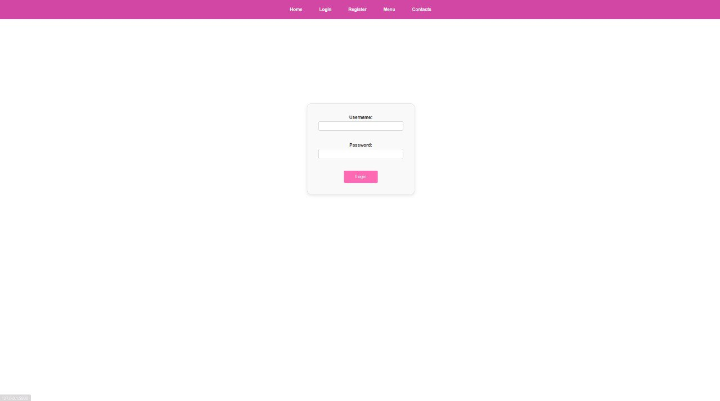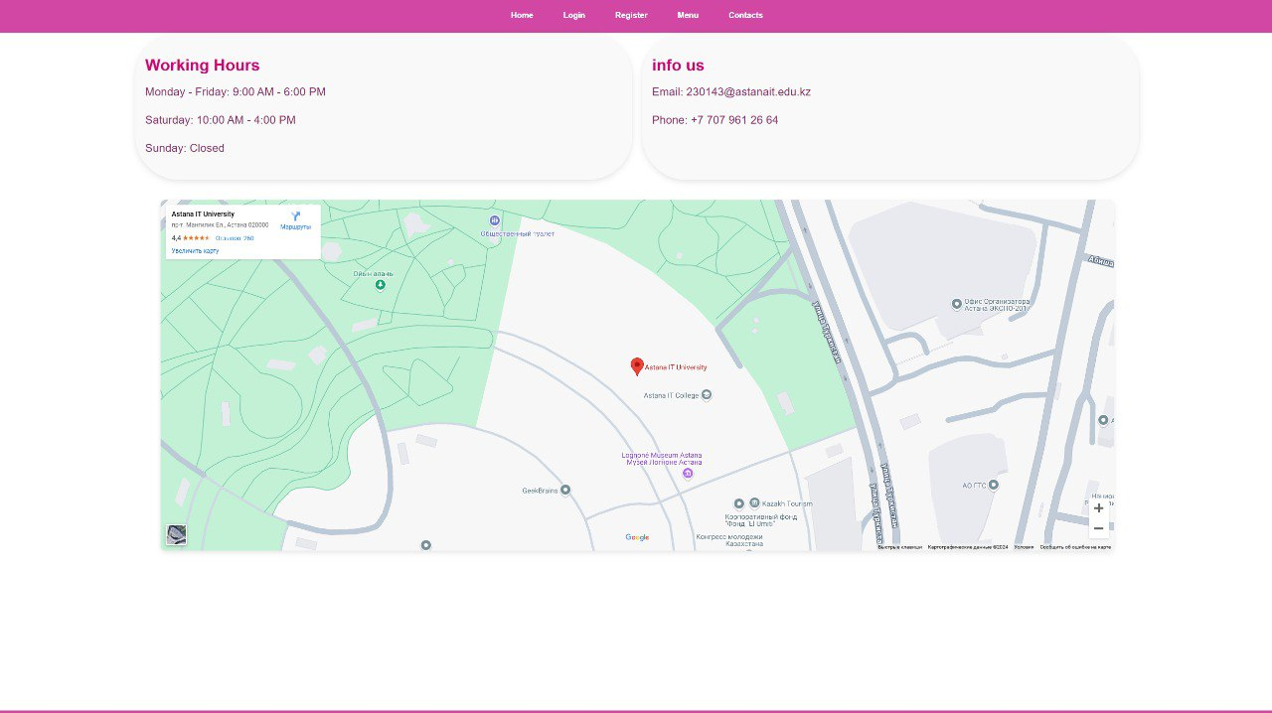

**In addition, we conducted a survey and had 100 responses.**

**Here is What We Learned and How We’re Making Things Better:**

Half of the responses were about perfect photos of dishes. Gorgeous food interacts with more people, so we have made sure our website is packed with beautiful, high-quality photos to get our guests excited about your visit.

We have added a way for customers to share their favorite recipes with us! If their recipe gets the most positive comments, we will add it to our menu - and even name it after them. It is a great way to make you feel like part of our restaurant family and let your creativity shine.

Many of your respondents said that they enjoy learning about restaurant specials and even trying out recipes. We will keep sharing offers, tips, and behind-the-scenes stories to keep you connected to what we do.

While online reservations are nice, many guests told us they prefer something more personal—like using WhatsApp, Instagram messages, or a quick phone call. We have made sure our web site includes these options, so you can reserve your spot in the way that feels easiest for you by social messengers. We will give you all contacts in one place on the contacts page.

