Define the following classes:

* Dataset - abstract class with the following methods that need to be overriden
  + _fetch_data()
  + save_data()
  + _transform_data()
  + _clean_data()
* CSVDataset(src_filepath, target_filepath) – inherits Dataset and implements all its methods
  + Define properties(getters, setters) for the src_filepath and target_filepath
  + Implement __str__ magic method
  + Implement __repr__ magic method
  + _fetch_data() – reads data from the [employment-data.csv](https://alearnbg.adastragrp.com/pluginfile.php/63067/mod_page/content/8/employement-data.csv) file
  + _clean_data() – drops na values
  + _transform_data() – at this point in time, add a current timestamp column to the end of the dataframe
  + save_data() – saves the transformed data to the target location as csv

Example class instance and method usage:

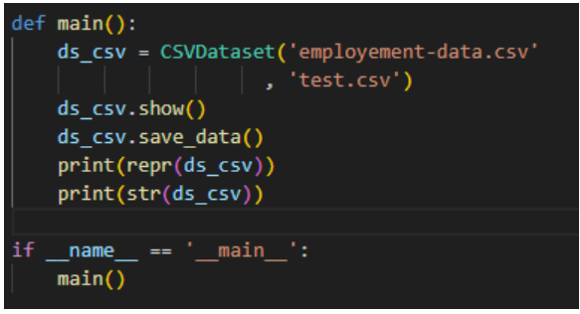

Notes:

* Use pandas / polars / other dataframe library to read, save and apply operations on the file
* Use ABC library for abstract classes and methods